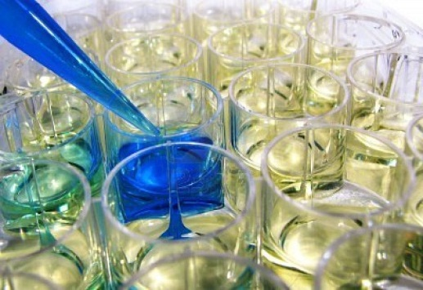
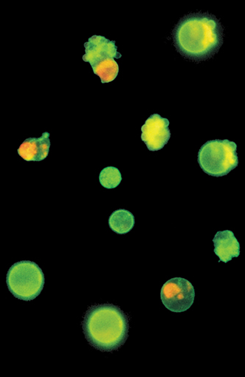
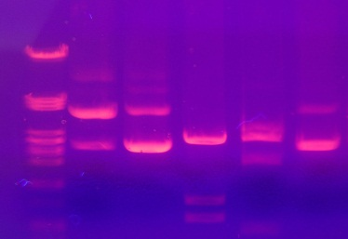
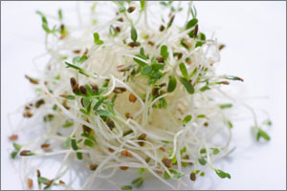
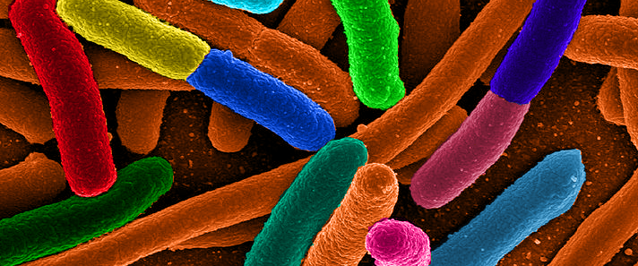
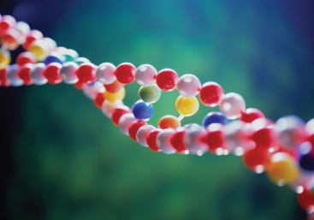
∘ Calvin College ∘ Spring 2018 ∘
Instructor’s Manual for
Cellular and Genetic Systems
Biology 161
Table of Contents
About this Course and Lab Manual 1
Why and How this Course Came to Be 1
Student Learning Outcomes for Biology 161 Lab 1
Interdisciplinary Content 2
Module Descriptions 2
A Cognitive Model for Promoting Effective Learning 3
Learning = A Change in Long-term Memory 3
Long-Term Memory vs Working Memory 3
Cognitive Load 3
Recommended Resources 4
MODULE ONE: How Do Food Preparation Parameters Affect Nutraceutical Properties of Broccoli? 5
Week 1: Digging into the Relevant Literature 6
Week 2: Pipetting, Spectroscopy, and Graphing 8
Week 3: Performing Simple and Serial Dilutions 10
Week 4: Extracting and Quantifying Proteins 12
Week 5: Testing the Effects of Cooking on Proteins 15
Week 6: Testing the Effects of Cooking on Myrosinase Activity 17
Week 7: Analyzing Our Results 19
Week 8: Lab Practical Exam 22
MODULE TWO: How Do Isothiocyanates Affect the Proliferation of Cancer Cells? 23
Week 1: Learning the Literature and Cell Culture 24
Week 2: Measuring the Effects of ITCs on Cell Viability 25
Week 3: Extracting and Analyzing DNA 26
Week 4: Assessing Evidence of Cell Life and Death 28
Week 5: Lab Final Exam 29

About this Course and Lab Manual

Why and How this Course Came to Be
We designed the laboratory portion of Biology 161 in response to two prominent national reports: A New Biology for the 21st Century (published by the National Research Council in 2009) and Vision and Change in Undergraduate Biology Education (published by the American Association for the Advancement of Science in 2010). The investigations in this course address the challenges and opportunities outlined in these reports.
We aim to answer New Biology’s call for “an integrated, problem-focused approach to science that is entirely consistent with research on how students learn best.” These reforms are needed to prepare you for the kind collaborative work it will take to address New Biology’s complex global challenges: food, energy, health, and environment. We also value Vision and Change’s call for education reforms that teach essential scientific competencies and biological literacy concepts (underlined below). In other words, the competencies and concepts you will learn in this course constitute a foundation for thinking and working as a “new biologist.”
The research projects in Biology 161 were developed in the summer of 2012 by an interdisciplinary team of Calvin College students and faculty with support from a grant (DUE-1140767) from the National Science Foundation’s TUES program (http://www.nsf.gov/funding/pgm_summ.jsp?pims_id=5741). The knowledge and “21st century skills” learned while conducting these projects will prepare you for diverse careers in biology and related fields (http://www.aibs.org/careers/).

Student Learning Outcomes for Biology 161 Lab
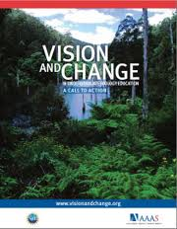
As called for in the AAAS (2011) Vision and Change report, students who successfully complete this course will have the ability to:
- apply the process of science
- use quantitative reasoning
- tap into the interdisciplinary nature of science
- understand the relationship between science and society
To accomplish this, we replaced the traditional lab exercises that relate in some way to weekly lecture topics with multi-week lab modules that are interdisciplinary and investigative. In each module, the learning process ensures the development of competencies, mastery of prevailing lab methods, and their application in designing and conducting experiments.
In light of increasing public interest in food-health interrelationships and a growing body of evidence that whole-food plant-based diets offer significant health benefits, we opted to focus these modules on testing the nutraceutical properties of broccoli.

Interdisciplinary Content
The lab modules of this course make use of prevailing methods in cellular and molecular biology that are based on principles and competencies from general chemistry and basic statistics.
Cellular and Molecular Biology
- Extract compounds from biological samples
- Use spectrophotometers and microplate readers to conduct protein and enzyme assays
General Chemistry
- Perform dilution techniques, unit conversions, and calculations
- Correctly execute quantitative transfers with appropriate micropipettes
- Prepare and use standard curves (Beer’s Law)
Statistics and Graphing
- Use Excel and/or R Studio software
- Calculate central tendency and statistical dispersion (variance)
- Construct and correctly interpret graphs

Module Descriptions
Each lab module addresses a central research question and follows a learning progression: 1) master essential skills, 2) learn methods, and then 3) apply these to conduct an experimental investigation.
Module 1: How do food preparation parameters affect nutraceutical properties of broccoli?
  - Weeks 1-3: Master essential skills
    - Scientific literature, microliter pipetting, dilutions, spectroscopy, graphing
  - Weeks 4 & 6: Learn methods
    - Protein extraction and Bradford assay, myrosinase (glucose production, see Figure 1) assay
  - Weeks 5 & 7: Investigate cooking parameters and their effects on myrosinase activity
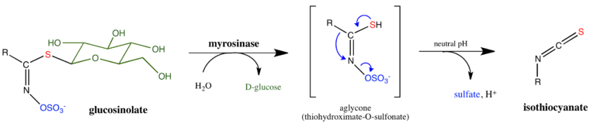
Figure 1. The Myrosinase Reaction. Myrosinase catalyzes the hydrolysis of glucosinolates when tissues are disrupted (as when chewing). The resulting isothiocyanates (ITCs) give cruciferous vegetables their characteristic flavors. ITCs also have nutraceutical properties. Diagram from Wikipedia
Module 2: How do isothiocyanates (ITCs) affect the proliferation of human (Jurkat) cancer cells?
  - Weeks 1-2: Master essential skills
    - Scientific literature, microscopy, sterile technique
  - Weeks 2-4: Learn methods
    - Human cell culture, hemocytometer use, microplate-based cell viability assay; DNA extraction, gel electrophoresis
  - Weeks 2 & 4: Investigate effects of ITCs on apoptosis (DNA fragmentation and cell death) of Jurkat cells

A Cognitive Model for Promoting Effective Learning

Learning = A Change in Long-term Memory
Learning is usually described in terms of an observable outcome, such as when one acquires a new skill, or it is equated to knowing or understanding something that was not known before. In cognitive science, learning can be equated to a change in long-term memory. Long term memory equates to learning in that it can be called upon to evaluate new material in light of previous understandings. It is a mental model, or framework, that one has organized as a way to make sense of concepts and other forms of information form which one can derive meaning. Mindfulness – paying careful attention to what we are doing/thinking – largely determines what we will remember long-term.

Long-Term Memory vs Working Memory
Long-term memory is one’s mental model of a knowledge set, comprised of how one organizes information into a meaningful construct that can be called upon to analyze new information. Working memory is one’s active thinking space, where new ideas are compared against one’s existing understandings. One is using working memory when she is practicing mindfulness, thinking about the meaning of information rather than simply trying to memorize “random facts.” Working memory can be considered the bottleneck of the brain because it is limited by various forms of cognitive load.
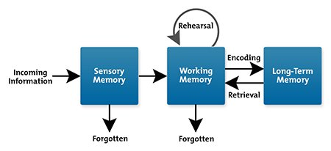
https://www.mindtools.com/pages/article/cognitive-load-theory.htm

Cognitive Load
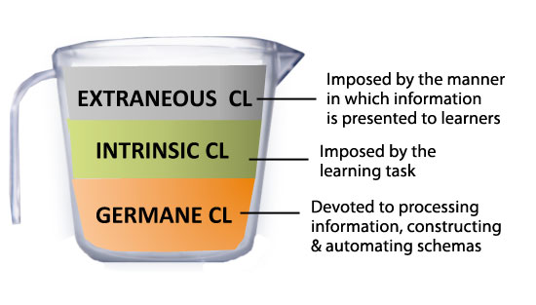
Cognitive load refers to the amount of effort employed by your working memory. For a student in your class, the cognitive load she experiences comes from one of three sources:
- Intrinsic Cognitive Load (ICL) is a function of the nature of the material one is trying to learn; some things are intrinsically harder to understand. Instructors have little control over this.
http://theelearningcoach.com/learning/what-is-cognitive-load
- Extraneous Cognitive Load (ECL) is a function of the constraints a particular learning environment places on the learning process; some types of environments (or the way a learning task is constructed) make learning more difficult. To promote effective learning, instructors want ECL to be low. They can do this by constructing learning tasks that recognize working memory limits and strengthen connections to long-term memory.
- Germane Cognitive Load (GCL) is a function of the working memory efforts needed to facilitate the construction of mental models in the learning process. To promote effective learning, instructors want this to be high; GCL is the fuel that empowers effective learning.
For effective teaching of this course, instructors need to bear in mind these sources of cognitive load and constantly monitor for cognitive overload as the students are working on their laboratory assignments. Cognitive overload occurs when the ECL is too high and/or the GCL is too low to make room for the ICL of a particular learning task. Each week this manual includes a set of Teaching Tips for avoiding cognitive overload and promoting effective learning.
Students come to the laboratory classroom with different degrees of pertinent experience that affect how quickly they can understand new methods, apply concepts, and recognize patterns in data. For experts, familiarity with these often results in subconscious decision-making. As a result, experts tend to underestimate the ICL and ECL challenges that novices face in learning new skills and methods. Especially in a laboratory course centered on investigative learning, instructors will need to be particularly mindful about observing ECL challenges of different student subpopulations, and then adjust their teaching to enhance these students’ GCL.

Recommended Resources
Brown, Peter C., et al. Make It Stick: the Science of Successful Learning. The Belknap Press of Harvard University Press, 2014.
Lang, James M. Small Teaching: Everyday Lessons from the Science of Learning. Jossey-Bass, 2016.
Mayer, Richard E., and Susan A. Ambrose. How Learning Works: Seven Research-Based Principles for Smart Teaching. Jossey-Bass, 2010.

MODULE ONE: How Do Food Preparation Parameters Affect Nutraceutical Properties of Broccoli?

This module runs for eight weeks. Students learning focuses on the core competency of scientific processes such as use of literature, essential laboratory equipment use skills, quantitative graphing and statistics skills to test the effects of food preparation methods on the nutritional quality of broccoli. Along the way connections are made to the interdisciplinary nature of science.

Week 1: Digging into the Relevant Literature
This week’s activities familiarize students with the project and scientific literature that provides background for the experiments that will be performed in the module. In addition to developing skills required for effectively searching and reading scientific literature, students also use the article by Yuan et al. (2009) to become familiar with the different sections of a primary research paper, focusing especially on the experimental questions, methods, results, and conclusions.
Pre-Lab Preparation
There no supplies to prepare for today’s lab. Students will use computers to search scientific literature and access the primary research article:
- Yuan G, Sun B, Yuan J, Wang Q. 2009. Effects of different cooking methods on health-promoting compounds of broccoli. Journal of Zhejiang University Science B 10: 580–588. Accessible via: https://www.ncbi.nlm.nih.gov/pmc/articles/PMC2722699/
Teaching Tips
Instructors should highlight the information on pages 1 and 2 of this manual (also included in the lab manual) to orient the students to this laboratory course and to investigative module #1. Students probably expect the lab portion of a course to be based on a weekly topic discussed in the lecture portion of the course. Explain to them that this is course different in that it follows instead the pattern inherent in laboratory-based scientific research:
- First, they will be analyzing literature that is pertinent to our research question. (As you introduce this, have students search the internet to find out what a nutraceutical is.)
- Next, they will be learning essential laboratory skills and methods.
- Then, they will be applying #1 and #2 to design and conduct an experiment.
- Finally, they will use their knowledge of concepts taught in lecture to interpret their results.

For many students in this course, this is probably their first formal introduction to scientific literature. These students will be unfamiliar with the differences between primary research articles and review articles and with the typical Introduction, Methodology, Results, Discussion (IMRD) format of scientific articles. Today’s activity is designed to help students discover these things, so don’t spoil the active learning opportunity by simply telling them.

Sources of intrinsic cognitive load (ICL) that present challenges and opportunities for learning:
- Familiarity with using keywords with online search engines.
- Understanding the purpose of different types of scientific literature.
- Understanding key features (axis labels, error bars, etc.) of a scientific graph.
- Recognizing the crucial interrelationship between data and scientific inferences.
- Lack of familiarity with the different sections of a scientific paper and how they are used.

Factors that might undesirably increase the extraneous cognitive load (ECL):
- Familiarity/unfamiliarity with others sitting at the same table.
- Bad prior experiences with collaborative learning.
- Distractions in the classroom.
- Students rushing to finish without taking time to process and reflect on learning tasks.

Ideas for increasing the germane cognitive load (GCL):
- Give students the opportunity to introduce themselves.
- Have teams identify some goals and effective learning practices.
- Without answering assignment questions directly, ask probing questions that lead students mindfully towards a clearer understanding of the assigned question’s focus.
- Help students to pause and reflect on what they are learning and how it will help them to conduct investigative projects in this course.

At the end of lab, lead the class through a reflective discussion based on today’s SLOs:
- How is a PubMed search different from a Google search? Discuss the different purposes and results obtained with each type of search.
- What is the best way to read a scientific paper and how does this differ from reading a short story? Correlate each section of a scientific paper with the types of questions it answers.

Week 2: Pipetting, Spectroscopy, and Graphing
This week’s activities add three new essential skills to the student’s repertoire: micropipetting, use and calibration of a spectrophotometer, and graphing of absorbance as a function of solute concentration (as predicted by Beer’s Law). Students are introduced to these skills by means of explanations in the lab manual and instructional videos. Then they are given opportunities to practice them in exercises that foreshadow the methodologies they will be using in subsequent weeks.
Pre-Lab Preparation
The following materials are needed so that students can work individually this week.
SUPPLY ITEM | Per Table of 4 Students
Spec 20 | 2
Kimwipes | 2 boxes
13x100 test tubes | 1 box
Test tube rack | 4
0.1% methylene blue in 12x75 snap cap | 4
dH2O, 125mL | 4
Set of Pipetman (P1000, 200, 20, 10) | 1 set of 4
Tips, all sizes | 2 boxes ea
Tip disposal container | 2
Teaching Tips
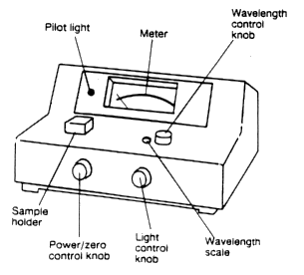
Spectronic 20 instruments may be “old school”, but they are superior to fully automated instruments for one purpose: helping novices to understand the principles, practices, and limitations of spectroscopy. In fact, our department uses Spec 20 instruments with an analog readout to also help students realize that, since absorbance is a logarithmic scale, absorbance values greater than 2 are imprecise. Even if students have used spectrophotometers in their prerequisite General Chemistry course, they will likely benefit from a refresher in how to calibrate the instrument: first set the wavelength, then “zero” with the zero control knob, and then “blank” with the light control knob. Make sure they do so in that order to avoid erroneous results. Encourage students to recalibrate periodically.

Probably no more than a few students have prior experience with microliter pipets. Thus, instructors should have the whole class watch this video (http://www.youtube.com/watch?v=uEy_NGDfo_8), and then review the main points together before they start the lab exercises. Remind students periodically of the importance of 1) using the plunger stopping points correctly and 2) watching as liquid enters the pipet tip to ensure accuracy by avoiding bubbles.

Most students have experience using Excel for graphing; few a probably comfortable with R-based graphing at this point. For this exercise, they can choose either program. Once they do this, they should copy their graph into a Word document and then add an appropriate title and figure legend; have them consult the article by Yuan et al. (see Week One) for examples of acceptable titles and figure legends.

Sources of intrinsic cognitive load (ICL) that present challenges and opportunities for learning:
- Unfamiliarity with microliter pipets.
- Prior experience with spectrophotometry, but failure to fully understand and consider the implications of Beer’s Law.
- Prior experience with graphing but little experience writing titles and figure legends that conform to scientific practices.

Factors that might undesirably increase the extraneous cognitive load (ECL):
- Instrument malfunctions that may or may not reflect user errors.
- Students may fail to recognize the importance of following instructions carefully and sequentially. Frustration may build if they aimlessly try to remedy their mistakes.
- Students may struggle with using aspects of software that are unfamiliar to them.

Ideas for increasing the germane cognitive load (GCL):
- Review spectrophotometer calibration procedures and discuss the micropipetting video with the whole class before students begin the exercises.
- Encourage students to ask questions about procedures and graphing and/or have the instructor or TA double-check instrument settings.
- Periodically remind students that it is important to follow procedures mindfully as this affects accuracy when calibrating a spectrophotometer and when micropipetting.

At the end of lab, lead the class through a reflective discussion based on today’s SLOs:
- What would happen if you consistently pushed the plunger on the micropipettor down to the SECOND STOP when preparing to draw up solution into the micropipettor tip?
- You pick up a micropipettor and the numbers 0-5-0 appear in the window. One of the numbers is red, but you have forgotten what the red coloring signifies. How can you figure out what volume will be dispensed?
- Beer’s Law states that there is a direct relationship between absorbance and solute concentration. Does this mean that you can determine the concentration of a solution by simply measuring the absorbance of the sample? Why or why not?

Week 3: Performing Simple and Serial Dilutions
This week’s activities focus on simple and serial dilutions. Since dilutions and unit conversions often seem to be particularly challenging for students (even though they were developed in a prerequisite chemistry course), we provide analogies that aid conceptualization. Practice problems are designed to strengthen two key Vision & Change competencies: the ability to use quantitative reasoning and the ability to tap into the interdisciplinary nature of science.
Pre-Lab Preparation
The following materials are needed so that students can work individually this week.
SUPPLY ITEM | Per Table of 4 Students
Spec 20 | 1-2
Kimwipes | 2 boxes
13x100 test tubes | 1 box
Test tube rack | 4
2% safranin in 12x75 snap cap | 4
dH2O, 125mL | 4
5ml pipet labeled dH₂O | 4
PiPump | 4
Set of Pipetman (P1000, 200, 20, 10) | 1 set of 4
Tips, all sizes | 2 ea
Tip disposal container | 2
Sharpies/wax pencils  Unknown A (0.01% safranin, 100 mL)  Unknown B (0.002% safranin, 100 mL) | 2  1  1
Teaching Tips
Most students were taught how to calculate and prepare simple dilutions in the prerequisite chemistry course, where concentrations are typically expressed as moles/liter and volumes are typically expressed in liters. Because a variety of concentration and volume units are used in cell biology, these often cause confusion because students fail to recognize how these units apply to the c_{i}v_{i} = c_{f}v_{f} equation. Instructors should therefore spend some time explaining units such as % w/v, which is based on the assumption that 1 mL of aqueous solution weighs 1 g. They should also emphasize the importance of:
- Checking concentration units to make sure they are the same. Likewise, check volume units.
- Using appropriate equivalences to convert units, as needed.
- Writing out calculations that include units to ensure that they factor out correctly.

In chemistry, students are also taught not to assume that volumes are additive. However, when dealing with the microliter volumes that are typical in cell biology, one often has no choice but to make this assumption. Microliter volumetric flasks do not exist. Also, with dilute aqueous solutions, volume additivity is an excellent approximation. It is helpful to discuss this to students, drawing them to discover why they can add 50 µL of an aqueous solution + 50 µL of water and then assume that they now have 100 µL of a solution that is half-strength. This would also be a good time to explain why we call this a 1:2 dilution (in terms of v_{i}/v_{f}).

Students may not have been introduced to serial dilutions in their chemistry course, so they will need to be taught why and when this approach is used. One reason: Some dilutions require volumes that are too small to pipet accurately. Don’t assume, however, that they will immediately recognize the impossibility of accurately micropipetting volumes that are less than 1 µL. They also might struggle to understand why serial dilutions can improve the accuracy of diluting by 1,000-fold or more. Both of these difficulties are related to their inexperience with microliter pipetting. Instructors might consider illustrating this by having several teams make a 1000-fold dilution of a dye, some by using simple dilution and others by using serial dilution. Then use a spectrophotometer to measure the variation in absorbances of the resulting solutions. The risk, however, is that serial dilutions are prone to error due to incomplete mixing or to inaccurate pipetting – both of which are likely with inexperienced students.

Sources of intrinsic cognitive load (ICL) that present challenges and opportunities for learning:
- Unfamiliarity with microliter pipets.
- Prior experience with simple dilutions, but unfamiliarity with the diverse array of units encountered in cell biology.
- Challenges associated with unit conversions, especially when students are insufficiently familiar with those units or the metric system.
- Unfamiliarity with the ‘why’ and ‘how’ of serial dilutions.

Factors that might undesirably increase the extraneous cognitive load (ECL):
- Math phobias and anxieties.
- Rushing with calculations instead of working methodically first to identify known variables before solving the c_{i}v_{i} = c_{f}v_{f} equation for the unknown variable. (Some students also struggle to comprehend that v_{i} = the volume to be pipetted, not the volume of stock solution.)

Ideas for increasing the germane cognitive load (GCL):
- Often simple everyday dilutions, like the example in the lab manual with Grandma’s tea, can help students to understand the “deep structure” (or underlying pattern) in every dilution problem. Lead the class through this example, and then subsequently remind confused students about the logic of the different dilutions in this example.
- While explaining serial dilutions, work through an example with the whole class. You might consider “performing” a serial dilution with a dye solution so that they can witness the procedure and the resulting series of increasingly dilute solutions.

At the end of lab, lead the class through a reflective discussion based on today’s SLOs:
- What are some tips you’ve learned that help to master the process of calculating dilutions?
- What is the purpose of making serial dilutions? Do serial dilutions always need to be 10-fold dilutions?

Week 4: Extracting and Quantifying Proteins
In this week’s activities, students conduct a trial protein extraction and Bradford assay to determine optimal dilutions for their subsequent experimentation. The students are then given the general question: “Do food preparation parameters affect the nutraceutical properties of broccoli?” To reinforce their understanding of the connection between protein content and nutraceutical properties, students are reminded that the enzyme, myrosinase, is required to produce ITCs with reputed health properties. Each group of three or four students then writes an experimental proposal to answer a unique question not addressed by Yuan et al. (2009) about the effect of a particular cooking method (boiling, steaming, baking, stir-frying, etc.) and length of cooking time on the nutritional properties of broccoli.
Pre-Lab Preparation
The following materials are needed so that students can work in pairs.
SUPPLY ITEM | Per Table | Per pair
Head of broccoli | (1 medium-sized is sufficient for 4-5 lab sections)
Spec 20 | 2 | 1
Kimwipes | 2 boxes
Mortar and pestle | 2 | 1
Box of 13x100 test tubes | 1
Test tube rack for 13x100 tubes | 2 | 1
Spatula | 2 | 1
Amicon filter/collection tube  + 1 extra collection tube | 2 | 1
1.5mL microfuge tubes | 1 weigh boat filled
Microfuge rack | 2 | 1
Extraction Buffer, 60mL | 2 | 1
Protein (BSA) stock, 1000 µg/mL, 30 mL** | 2 | 1
Bradford reagent, 125 mL | 2 | 1
5 mL pipet labeled Bradford | 2 | 1
PiPump | 2 | 1
Pipetman and tips | (side benches for students to use as needed)
Tip disposal container, tall | 2 | 1
Gloves | 1 box all sizes
Balance and weigh boat for broccoli | 1 in the lab
Microfuge | 1-2 in the lab
**in Potassium Phosphate Buffer. See Lab Ref handbook, p. 15
Bradford Reagent
- Dissolve 100mg of Coomassie Blue G in 50 mL EtOH
- Add 100 mL 85% phosphoric acid (stock is 85%)
- Q.s. to 1 liter. Bradford Reagent MUST be filtered prior to use.
Potassium Phosphate Buffer
- 4.5 g KH₂PO₄
- 11.6g K₂HPO₄ in 1L dH₂O
Teaching Tips
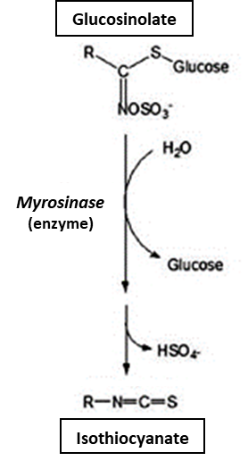
It pays to take some time at the beginning of this lab to carefully explain the various methods students will be learning this week and using next week. The focus this week is to learn the protein extraction and purification method and to learn and optimize the Bradford assay; the focus next week is to use these optimized methods to conduct an experiment designed by the students.

The protein extraction procedure is a bit more complicated than the normal “quick and dirty” method that is often used for simple quantitation. Normally, plant scientists use an extraction buffer containing a detergent (to lyse membranes) and a centrifugation step to remove cell debris (including cell walls). In our case, we must use a detergent-free buffer and Amicon Ultra 10 kDa spin columns for our protein extraction because in two weeks, students will be performing a myrosinase enzyme assay. The detergent-free buffer is needed to avoid protein denaturation that would inhibit enzyme activity. The spin columns are needed to remove endogenous glucosinolates, which are substrates of the myrosinase enzyme whose activity students will be assaying. (This step would not be necessary if we were to measure glucosinolate levels first, but this would require more sophisticated procedures.) Thus to extract large proteins (including myrosinase, a dimer comprised of 60-70 kDa subunits) and remove glucosinolates, students will need to conduct three centrifugations:
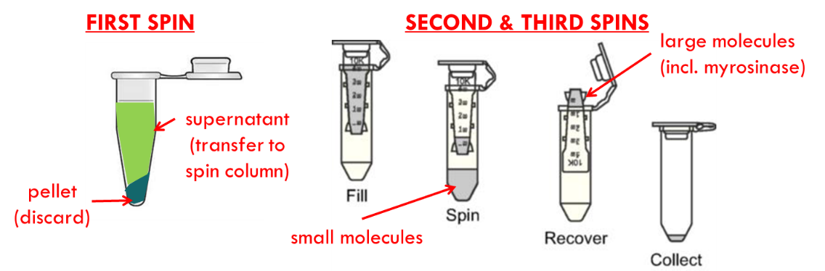

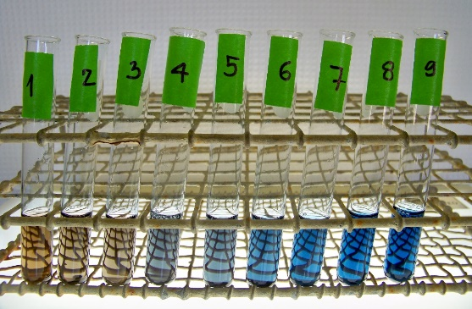
Students typically struggle to comprehend the concept of a standard curve and its use for calculating the concentration of an unknown solution. It helps, when they have prepared their diluted protein standards and then added Bradford reagent to these, to line them up in order of increasing protein concentration. Once they have added Bradford reagent to them as well, have the students hold up their diluted broccoli extracts next to these standards to see if they can find a color match. Help them understand that this is, in effect, what they will be doing when:
- They graph the absorbance (y-axis) compared to the concentration (x-axis) of each standard.
- They use linear regression to find the equation of the best-fit line through those data points.
- They use that equation to find the concentration of their unknown by plugging their unknown’s absorbance into y and then rearranging the equation to solve for x.

Students will also be designing an experiment this week that is to be used as the basis of their investigations for the next three weeks. If they have designed experiments previously, they will correctly surmise that they need a control group and multiple replicates of each treatment. However, there is a cost limitation that they need to consider: Amicon spin columns cost about $3 each. Thus, it is best for teams of students to collaborate to design an experiment that tests one broccoli cooking method (e.g., baking) and four different parameters (e.g., temperature or duration). One of these parameters must be a negative control; let the students figure out that this usually will be raw broccoli. The experiment should be set up so that each student does one extraction the following week. It is helpful to have students submit a short research proposal this week so that you can provide feedback before next week and to ensure that the necessary resources are available. To focus students on the essential information for their proposal, instructors should set up a convenient Google Form with prompts like these:
- List all members of your team:
- What is your research question, the basis for your cooking experiment?
  - Make sure students clearly indicate the cooking method in their response.
- With respect to protein content and myrosinase activity, what is your hypothesis?
- What parameter are you testing? In other words, what is the one thing that will vary from one treatment to the next?
- What conditions are you using for your negative control? Plan that one person at each table will work with this control sample.
- What range of experimental values are you going to test? Plan that everyone else will each work with one of these samples.
- What are your anticipated results?
- If you have any questions about this experiment for your instructor, list them here:

Sources of intrinsic cognitive load (ICL) that present challenges and opportunities for learning:
- Lack of familiarity with the methods
- Relatively weak quantitative reasoning skills hamper comprehension of standard curves
- Interest in cooking

Factors that might undesirably increase the extraneous cognitive load (ECL):
- Rushing instead of following directions carefully and sequentially
- Tendency of teams to adopt a divide-and-conquer approach that hampers individual’s abilities to comprehend methods and procedures

Ideas for increasing the germane cognitive load (GCL):
- Identify junctures in the procedures to have students give you a progress report; ask them questions at those points to test their understanding.
- Encourage students to ask questions about procedures; offer to double-check their calculations.

At the end of lab, lead the class through a reflective discussion based on today’s SLOs:
- Thinking back over the essential skills we learned in previous weeks, how was each skill used today to accomplish the protein extraction and quantification?
- Explain the role of these factors in determining the protein content of your broccoli florets:
  - The standard curve
  - The dilutions of our broccoli extract
  - The volume of our broccoli extract
  - The weight of broccoli tissue
- What is the value of writing a research proposal? Explain how this relates to the different sections of the proposal.

Week 5: Testing the Effects of Cooking on Proteins
This week’s activities begin with a whole-class examination of the different research questions, hypotheses, and cooking parameters of the proposed experiments. Once their proposal has been tweaked to conform to accepted practices and resource constraints, each group begins conducting their proposed experiments: cooking broccoli samples, executing protein extractions, and performing Bradford assays.
Students work in pairs
Pre-Lab Preparation
Students work in pairs
SUPPLY ITEM Per Table Per pair
Head of broccoli (1 medium-sized head is sufficient for 4-6 lab sections)
Mortar and pestle 2 1
Spatula 2 1
Amicon filter/collection tube + 1xtra col tube 2 1
1.5mL microfuge tubes weigh boat
Microfuge rack 2 1
Extraction Buffer 60mL 2 1
Protein (BSA) stock**, 1000ug/mL, 30mL 2 1
Bradford reagent, 125mL 2 1
48 well culture plate for making dilutions 2 1
96 well assay plate for Bradford’s assay 1 per lab
Pipetman and tips (leave these on side benches; they can take what they need)
Tip disposal container, tall 2 1
Gloves 1 box all sizes
Balance and weigh boat for broccoli 1 in the lab
mIcrofuge 1-2 in the lab

Bradford Reagent
Dissolve 100mg Coomassie Blue G in 50mL EtOH
Add 100mL 85% phosphoric acid (stock is 85%)
q.s. to 1liter. Bradfords MUST be filtered prior to use.

**in K phosphate Buffer. See Lab Ref handbook, p. 15
4.5 g KH₂PO₄
11.6g K₂HPO₄ in 1L dH₂O

Teaching Tips
Before lab, review the Google form that students have used to convey their proposed experimental design. Note any clarifications or modifications so that experiments conform to the stipulations:
- Each student performs one protein extraction. Thus, the number of broccoli samples tested must equal the number of students on the team. It is advisable to have teams collaborate so that there are sufficient replicates (at least 3) for each cooking parameter tested.
- There should be a negative control group. Typically, this will be raw broccoli.
- Advise students that they will be working with small (1 g) samples of broccoli. These will cook much faster than a typical “serving size” of broccoli. Thus, they should think about cooking for fractions of a minute to test the effect of cooking time. To compare cooking methods or temperatures, they should keep to a pre-determined time, such as 30 or 60 seconds. (Note about baking: start with the lowest temperature to be tested and then increase the oven temperature for successive treatments, allowing the oven to reach the target temperature before beginning each treatment.)

This is the first week that students will be using an electronic lab notebook (ELN). Using Appendix B as a guide, set up an ELN template in a Google Doc. Share the link for this template with your students, but make it available so that they can view but not edit it. They should be able to make an editable team copy that they can share with team members as their Team ELN.

Review the ELN instructions and grading rubric with your class to make sure they understand the different sections of the ELN, their purpose, and your expectations. Record-keeping for the Methods section should get special emphasis as most students do not recognize the importance of detail. It helps to tell them that a good ELN has enough detail that anyone could repeat that experiment without resorting to any additional information source, including the Lab Manual. It must record all data that were collected. For this week, however, most of the data collection occurs via the plate reader.

Using a plate reader allows us to “miniaturize” the experiment, saving a bit on the costs of reagents. More importantly, it facilitates automated reading of absorbances for the Bradford assay, automated generation of the standard curve, and automated calculation of protein concentrations in the “unknown” samples. Students should appreciate this after working with spectrophotometers.

After performing the Bradford assay with a small aliquot of their protein extracts, make sure that students freeze the remainder of these extracts to next week’s myrosinase assay. Post results from the microplate reader in an accessible location. All data will be analyzed in Week 7.

Sources of intrinsic cognitive load (ICL) that present challenges and opportunities for learning:
- Methods are still relatively new to the students; don’t expect them to remember from last week.
- Students tend to “do the experiment first” and “write up the results later,” which produces difficulty in remembering details when documenting their experiment in the ELN

Factors that might undesirably increase the extraneous cognitive load (ECL):
- Individuals may work at different paces on the same team, which can exacerbate the tendency to rush and result in more methodological errors.

Ideas for increasing the germane cognitive load (GCL):
- Encourage students to “chip away” at their ELN as they go through the experiment. Point out that it will make finishing the write up trivial at the end of the experiment.
- Encourage students in the same team to work at the same pace, assisting each other as they go.
- Encourage students to ask questions about procedures; offer to double-check their dilution calculations.

Week 6: Testing the Effects of Cooking on Myrosinase Activity
This week’s activities instruct the students on a method we developed using the Amplex Red Glucose Assay (Invitrogen) to measure myrosinase activity. Through an inquiry-based approach, students use data from optimization experiments (conducted by the students who developed the lab manual in the summer of 2012) to collectively decide which assay parameters will enable optimal measurement of myrosinase activity in their own broccoli extract samples.
Students work individually
Pre-Lab Preparation
Students work in pairs
SUPPLY ITEM Per person Per Table
Microfuge rack 2
300 µM Sinigrin*, 1.5mL ion 2mL microfuge tube 1
(In 1X rxn buffer from Amplex Red kit)
Foil for covering incubating rxns 1
0.5mL microfuge tubes, weigh boat 1
Tip disposal container, tall 1 2
Pipetman and tips in side cabinet - they can take what they need
96 well plate 1 per lab

REAGENTS
- Sinigrin stock, 30 mM (in 1x Rxn Buffer)
- Glucose stock, 400 µM, and 1X Rxn Buffer from Amplex Red kit for making dilutions. Lab assistant will make dilutions for the group.
- Amplex Red Reagent* 1 tube in frig, wrapped in foil

This lab requires Life Tech Amplex Red Glucose/Glucose Oxidase assay, 500 rxns A22189.
Each section uses 100 rxns.

*Make Amplex Red stock reagent according to package instructions.
Reconstitute glucose oxidase and HRP according to directions and then dispense into 100 µL aliquots; one for each lab section. This will avoid repeated freeze-thaw of the stock.

Make 1 batch of Amplex Red reagent just prior to each lab.
Make ~ 35mL of 1X Reaction Buffer. (from Amplex Red kit)
Teaching Tips
Using the protein extracts frozen away last week, this week students will measure myrosinase activity using the Amplex Red glucose assay kit. Review the myrosinase reaction with them at the beginning of lab so that they know why glucose production correlates with myrosinase activity. Remind them also that we used the Amicon Ultra spin columns during the protein extraction to remove the glucosinolate substrates that were in the broccoli – thereby eliminating an unknown quantity. By adding a known volume of protein extract to a known quantity of sinigrin, a glucosinolate, we can measure myrosinase activity fairly accurately.

Because the Amplex Red kit is fairly expensive, students will not be doing their own assay optimizations this week. Instead, we have provided data from our course development team, which created the assay. Students use these data to identify parameters that they should follow in conducting the assay. Based on those data, students should arrive at these parameters:
- Wash steps (already completed during the extraction process): 1
- Broccoli extract volume: 1 µL
- Sinigrin concentration: 150 µM
- Ascorbic acid concentration: 0 µM
For each experiment, stress that all assays need to conform to the same set of parameters to enable comparisons among samples.

For the Amplex red glucose assay, timing is very important. Since all samples will be loaded into a appropriate wells in a microplate and then read at the same time, it is important to:
- Have the entire class start their reactions at the same time. Keep a record of elapsed time.
- Have each student take turns loading their sample into the appropriate well of the microplate, starting right away so that the entire plate can be loaded within 30 minutes.
- Set up the plate reader to measure A₅₆₀ and check that the reader software’s plate template matches the template in the Lab Manual. Note: fluorescence could also be measured, but there may be signal “bleed over” between wells that could affect accuracy. Furthermore, this would require re-optimization of the reaction conditions.
- Have the plate reader measure A₅₆₀ within 30-50 minutes after starting the reaction. (Record the elapsed time.) Note: after approximately 60 minutes the reaction in some wells may reach saturation and the absorbance may begin to decline.
Post results from the microplate reader in an accessible location. All data will be analyzed next week.

Sources of intrinsic cognitive load (ICL) that present challenges and opportunities for learning:
- Students will have no prior practice with this method; they will be learning it as they conduct it.
- Students may struggle to understand why timing is important in an enzyme assay.

Factors that might undesirably increase the extraneous cognitive load (ECL):
- Individuals may work at different paces on the same team, which can exacerbate the tendency to rush and result in more methodological errors.
- If students do not start their reactions at the same time, then there will be variation in the elapsed time from sample to sample. This will greatly reduce the accuracy of this assay.

Ideas for increasing the germane cognitive load (GCL):
- Review the Amplex Red assay reaction diagram with the class at the beginning of the lab.
- To help them to comprehend the importance of timing, ask the class to predict how the A₅₆₀ will change with time for a sample that has high myrosinase activity and for a sample that has low myrosinase activity. Plot these in a “prediction graph” on the board.
- Encourage students in the same team to work at the same pace, assisting each other as they go.
- Before students start mixing components for the assay, confer with them about the optimal assay parameters and procedures.

Week 7: Analyzing Our Results
In this week’s activities, students calculate protein content (mg • gram fresh weight⁻¹) and myrosinase activity (nmol of glucose • min⁻¹ • gram fresh weight ⁻¹) in their samples based on their Bradford assay and Amplex Red Glucose Assay results, respectively. The students receive guidance about how to report their findings (using basic statistical analyses to construct box-and-whisker plots) and use them to draw appropriate conclusions with respect to their research question and hypothesis.
Pre-Lab Preparation
Post results from the Bradford assay and Amplex Red assay in an accessible location.
Teaching Tips
Students probably have no prior experience with the types of calculations they will be conducting this week. Furthermore, they probably have only a vague notion of how the lab activities of the past few weeks interrelate with each other. In light of this, you should spend some time “walking the class through” a guided analysis process:
- Ask students to think together about the connections between their research question, cooking experiment, protein extraction, Bradford assay, and myrosinase assay. To make sure they are “all on the same page”, show them a map like this:
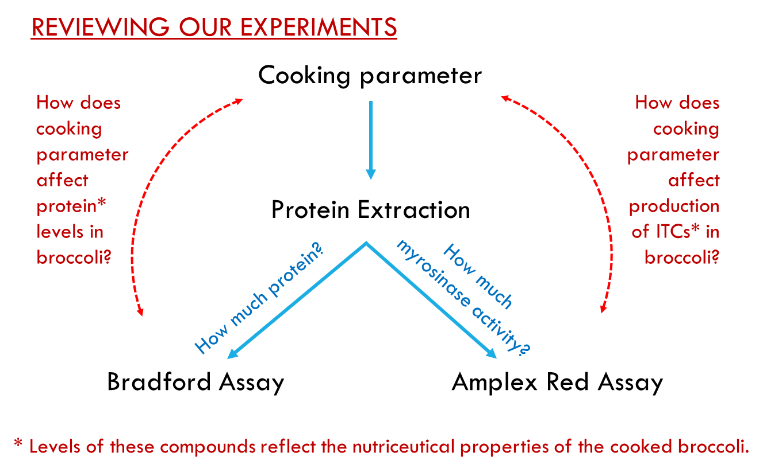
- Next show the students the data from the microplate reader and ask them to explain:
  - For the Bradford assay, what is the relationship between the “595” value and the “Blank 595” value and how does it relate to the microplate set-up?
  - For standard curves, what is the significance of these graphs? What do they show? What are the units for the values on the x-axis? y-axis? What values are plotted on this graph and how do these relate to the rest of our data? Which data are needed to evaluate our hypothesis?
- Based on the above discussion, have students answer questions 1 and 2 from the Lab Manual in a separate lab write-up.
- Next, have the class discuss how the following affected their data:
The cooking process
  - How much broccoli was in each sample?
The extraction process
  - Did we dilute our sample in the process?
  - What was the final volume of our broccoli extract?
The Bradford assay
  - Did we dilute our sample in the process?
The Amplex Red assay
  - Did we dilute our sample in the process?
- On the basis of that discussion, have students answer question 3 from the Lab Manual in their lab write-up.
- Next, “walk them through” the purpose and process of standardizing their data:
Purpose
  - Facilitate comparisons from one experiment to the next and between laboratories.
  - Reduce variability within and between experiments.
How?
  - Use standard methods that have been optimized.
  - Convert raw data to a form that uses standard units.
  - Use a standard measure, such as the fresh weight (gFW) of the starting tissue, as a basis for comparisons.
    - Protein content: mg of protein per gFW
    - Myrosinase activity: nmol of glucose/min per gFW
- Now give them “scaffolds” (stepwise strategies) that help them understand how to calculate:
Protein content
What do we have? Protein concentration (µg/mL)
What do we need? Protein amount (mg) / gram of broccoli
Steps needed to get us there:
- Determine what is known from the standard curve & sample data.
- Take into account the sample dilution (V_{i}/V_{f}).
For example, if you diluted 1:10, then you need to multiply by 10 to figure out the protein concentration of your broccoli extract.
- Convert your protein concentration to a weight (mg) of protein.
Multiply the concentration by the volume and make sure your units “factor out.”
- Divide by the amount of broccoli tissue in your extract.
Myrosinase activity
What do we have? Glucose concentration (µM)
What do we need? Units of myrosinase / gram of broccoli
Steps needed to get us there:
- Determine what is known from the standard curve & sample data.
- Take into account the sample dilution (V_{i}/V_{f}).
- Convert your glucose concentration to an amount (nmol) of glucose produced by the myrosinase.
Multiply the concentration by the volume and make sure your units “factor out.”
- Divide by the total reaction time (min).
This yields a rate of glucose production per minute.
Note: 1 unit of myrosinase = 1 nmol of glucose/min
- Divide by the amount of broccoli tissue (or protein) in your extract
Worked examples of the above calculations are included in Appendix C of the Lab Manual.
- Have each team prepare two graphs (box-and-whisker plots, or column graphs with error bars that reflect the mean and standard deviation values for each treatment):
  - Protein content plotted as a function of their cooking parameter
  - Myrosinase activity plotted as a function of their cooking parameter
- Finally, have each team formulate conclusions by analyzing their data with respect to their hypothesis. For students who have taken a Statistics course, it would be useful to have them use an appropriate test, such as ANOVA, to determine if variations among the treatments are significant.
Remind students that all of the above calculations, raw data, standardized data, graphs, statistical test results (if assigned), and conclusions need to be included in their Electronic Laboratory Notebooks. It is helpful to point out the ELN checklist in the Lab Manual and grading rubric (Appendix B).

Sources of intrinsic cognitive load (ICL) that present challenges and opportunities for learning:
- Students will very likely have no prior practice with these types of calculates.
- The calculations are inherently complex, requiring an understanding of how the experimental parameters affect the data and how to interpret data based on standard curves.

Factors that might undesirably increase the extraneous cognitive load (ECL):
- Math anxiety is the elephant in the room.

Ideas for increasing the germane cognitive load (GCL):
- Work through the above 9-step process together as a class. It will reduce the stress and improve students’ abilities to perform the calculations correctly.

Week 8: Lab Practical Exam
A lab practical exam is administered in which each student moves among different stations in the lab to demonstrate their mastery of essential skills (pipetting, dilutions, graphing), methods (spectrophotometry, Bradford assay), and core competencies (calculations, graphical interpretation) – all based on practices and procedures learned in this module.

MODULE TWO: How Do Isothiocyanates Affect the Proliferation of Cancer Cells?
This module runs for five weeks. Students first learn additional essential skills and methods and then apply these to test a specific health claim that raw broccoli possesses anti-cancer qualities (Moreno et al. 2006, Hwang and Lim 2015).

Week 1: Learning the Literature and Cell Culture
Week One again focuses on scientific literature and exploring previous research centered on the topic of ITCs and cancer. Students are introduced to another essential skill, microscopy and two new methodologies: working with mammalian cells and using a hemocytometer. Using these new skills and methodologies, the students are taught how to calculate cell density and viability. At the end of the period, lab groups are given an inquiry task—they are asked to develop an original research proposal to address the general question, “What effects do isothiocyanates have on cultured Jurkat cancer cells?” Based on this, groups are asked to define a more specific research question concerning any two of the four ITCs available for testing and they are required to specify ITC exposure parameters. Students are coached to use the article by Thomson et al. (2006) as a guide for designing this experiment.
Pre-Lab Preparation
Students work in pairs
SUPPLY ITEM Per Table
2 trays/table each with:
- Microfuge rack 1
- P20 pipet 1
- Tips 1
- Hemacytometer 1
On table also:
- Rack with tube of Trypan Blue 1
- Dish of 0.5mL microfuge tubes 1
- Tip disposal container 2
- Lens paper 1
Teaching Tips
This is probably the first time any of the student have cultured human cells. It may also be their first time performing detailed microscopy or using a hemocytometer. They should be reminded to be patient and the follow the lab manual closely for guidance, but some verbal guidance and some Youtube videos will also be helpful. The lab ends with preparation of a proposal. Do not leave this too open-ended, or students can feel lost.

For culturing human cells, reassure students that working with this cell line does not present serious risks to you as long as you pay attention to the safety guidelines and follow the aseptic procedures detailed in the manual.

For using a microscope, we would recommend talking through a Powerpoint slide with tips for finding the cells such as:
- 1) Start with the lowest power objective lens.
- 2) Use the dimmer to reduce the light level.
- 3) Use the iris diaphragm to improve contrast.
- 4) Start with the stage at the highest level and SLOWLY move it down with the coarse focus.
- 5) Use the fine focus for final adjustments.

Finally, for using the hemocytometer, our students have found the following Youtube videos helpful for avoiding common problems:
- Loading the hemocytometer correctly: https://www.youtube.com/watch?v=PPhE8I-dpp4
- Problems with loading: https://www.youtube.com/watch?v=sMWHpZSfjtw
- Counting cells with a hemocytometer: https://www.youtube.com/watch?v=pP0xERLUhyc

Sources of intrinsic cognitive load (ICL) that present challenges and opportunities for learning:
- Students will very likely have no prior practice with all or some of these techniques
- Preparing a proposal for next week can be intimidating.

Factors that might undesirably increase the extraneous cognitive load (ECL):
- Students may be overconfident using the microscope because they have used them in the past, but perhaps not with this level of precision.
- The quantitative aspects are not difficult this week, but math-phobic students can still be overwhelmed.
- If groups have not established good collaboration skills by this point, the preparation of the proposal could be a distraction.

Ideas for increasing the germane cognitive load (GCL):
- Guide students to be careful and patient in all the techniques. Do not use overly bright light with the microscope or scroll through levels of magnification too quickly.
- Consider giving the students a simple form to fill out in order to prepare their proposal. We used a Google form with the following prompts:
What is your research question, the basis for your dose-response experiment?
With respect to Jurkat cell viability, what is your hypothesis?
What conditions are you using for your control?
Which two ITCs are you going to test?
Allyl ITC
Benzoyl ITC
Phenethyl ITC
Sulfurophane
What range of experimental values (ITC concentrations) are you going to test?
What are your anticipated results?

Week 2: Measuring the Effects of ITCs on Cell Viability
Week Two introduces the students to working in a tissue culture hood and using sterile technique through instructor direction and video resources. The lab groups conduct their proposed experiments and evaluate the results using both microscopy and a CellTiter Glo assay that assesses cell viability through ATP quantitation. Student groups save portions of their ITC-treated Jurkat cells for use in week three.
Pre-Lab Preparation
Students work in groups of four.
6 T25 flasks of Jurkat cells (1/table) I provided 5ml’s at 1x106
1 microfuge tube of 2mM ITC’s (Sulforophane, AITC, BITC ,PEITC) for each of 8 stations in the hood
ITC’s are diluted** (from 50mM previously prepared stocks) in RPMI
1 microfuge tube DMSO
1 60mL bottle of RPMI media for each of 8 stations in the hood
1 tub of sterile 1.5mL microfuge tubes/hood
1 sterile trough per group for preparing cell dilutions??
1 12 well plate/group
2 96well luminometer plates/lab

IN CELL CULTURE LAB
Centrifuges and microfuge tubes for spinning down cells from 12 well plate cultures.
Each table needs supplies for cell counting
Cell Titer Glo reagent available for 24 hour read. In prep room frig.
Remember to thaw/equilibrate Cell Titer Glo reagent.
1 stock of 1uM ATP (disodium salt) Make 1000X (1mM. 5.5mg in 10mL RPMI. Then dilute 10uL stock in 10mL RPMI for 1uM ATP stock). Have RPMI available for making the ATP dilutions for the standard curve.
Tub for cell culture plate disposal
** 50mM stock to 2mM stock. 400uL 50mM ITC in 9.6mL’s RPMI
Sulforophane 500uL in 5mg bottle = 56mM. Therefore 56mM stock to 2mM stock 360uL in 9.64 mL’s RPMI.
Teaching Tips
There are many “moving parts” for this lab. Encourage students to come prepared by watching a video on sterile techniques (http://www.youtube.com/watch?v=yJ_acpKglto) and performing their calculations before coming to lab. Although this is the students’ first time working with a dosage curve, most students find it intuitive.
This week is a good time to remind students to update their Electronic Lab Notebook (ELN) as they work. To include in the ELN this week:
- Record all procedures…
  - Cell culture conditions and ITC dosages
  - Trypan blue staining and cell counting
  - CellTiter Glo assay
  - Centrifugation of your Jurkat cultures (in prep for DNA extraction)
- observations…
  - Any signs of pH (color) changes or contamination in the culture medium?
  - Any signs of apoptosis?
- and results.
  - Cell viability and cell density data
  - CellTiter Glo data
Sources of intrinsic cognitive load (ICL) that present challenges and opportunities for learning:
- Many students do not appreciate that the mechanism of cell death at low dose (apoptosis) vs. high dose (toxicity) might not be the same.
- Using sterile techniques does not come naturally to some students who are not accustomed to being careful and intentional with manual manipulations in the laboratory.
- Some students still may not be comfortable performing necessary calculations.

Factors that might undesirably increase the extraneous cognitive load (ECL):
- Working in a new environment (the hood) can be a distraction to students who have grown accustomed to their previous work space.
- Some students can become anxious about contamination given the necessary emphasis on sterile techniques.
- Some students are confused about the different roles of the 12-well and the 96-well plates.

Ideas for increasing the germane cognitive load (GCL):
- Give explicit instruction regarding the differences between apoptosis and toxicity.
- Preparing for lab ahead of time can lighten the intrinsic load (calculations and sterile techniques).
- Reassure students that if they patiently follow the lab manual, they will likely produce good results.

Week 3: Extracting and Analyzing DNA
Week Three introduces students to two new experimental methods: DNA extraction and gel electrophoresis. Under guidance from the lab manual and the instructor, students extract DNA from their ITC-treated Jurkat cells and store them for DNA electrophoresis (in week four). Students also conduct an experiment to determine the optimal agarose concentration for separation of apoptotic DNA fragments.
Pre-Lab Preparation
Students work in groups of four.
DNA extraction used Qiagen DNeasy blood and tissue kit (69506).
Each table does 7 extractions
Per Table:
Vortex mixer
Temp block set at 56C
1 ea 1KB ladder and 100bp ladder in 0.5mL microfuge tube, 150uL each
4 microfuge racks
2 sets of Qiagen reagents:
PBS
BufferAL
Ethanol (reagent)
Buffer AW1
Buffer AW2
Buffer AE
Proteinase K
7 DNeasy spin columns
Bag of collection tubes
Dish of 1.5mL microfuge tubes
2 sets of pipets (P1000, P200, P20) and tips
Tip disposal

IN THE LAB:
3-4 Microfuge centrifuges
Agarose Gel Prep
Per table:
125mL glass bottle
5X TBE, 60mL
dH2O, 500mL
50mL grad cylinder
Gel casting tray
IN THE LAB:
Electrophoresis boxes and power supplies
100bp and 1kb ladder
Microwave
Sybr Safe with P20 pipet, tips and tip disposal
Balance with weigh boats and agarose
Teaching Tips
This lab should be very collaborative both within groups and between groups. Encourage students to “divide and conquer” between groups (to find the best %agarose for separation) and to multitask within their group (to be productive while waiting for development of gels and centrifuging).

In preparation for the lab, it is helpful to make sure that the cell density in the starter culture is quite high, e.g. 1 x 10⁶ cells/mL. It may take some practice to prepare this culture. Expect that 0.8% to 1% agarose will work best for separating the DNA fragments into distinct bands (let the students discover this on their own!).

Students may also prepare for lab by viewing the following:
- Preparing an Agarose Gel: http://www.youtube.com/watch?v=wXiiTW3pflM
- Running an Agarose Gel: http://www.youtube.com/watch?v=U2-5ukpKg_Q

Sources of intrinsic cognitive load (ICL) that present challenges and opportunities for learning:
- Students may have difficulty seeing the big picture: how is DNA extraction and fragmentation and electrophoresis connected?
- It can be physically challenging for some students to pipette accurately. It can be tricky to deliver the sample to the well, and to do it without puncturing the bottom of the well.
Factors that might undesirably increase the extraneous cognitive load (ECL):
- The novelty of making a gel and using a microwave for scientific purposes can distract students.
- Coordinating efforts between groups can be difficult.
Ideas for increasing the germane cognitive load (GCL):
- Although this is the first time for many students to extra DNA, the use of a kit helps them to focus on acquiring the fragments they need for analysis.
- Be explicit about the benefits of “divide and conquer,” but that it may require patience.
- Be explicit about the benefits of multitasking while students are waiting for gels to develop and for centrifuges to complete their spins.

Week 4: Assessing Evidence of Cell Life and Death
Week Four begins with the electrophoresis of the DNA extracted from ITC-treated Jurkat cells, using this as a tool to assess whether the death of their Jurkat cells can be attributed to apoptosis. While the gels are running, students are tasked with reading and answering questions about the paper by Huang et al. (2013). The students are then asked to draw conclusions about the effect of ITCs on cancer cells using the data collected from their CellTiter Glo Assay, their gel electrophoresis results, and insights gained by reading from the article by Huang et al.

Pre-Lab Preparation
Students work in groups of four.
Per Table:
1KB ladder, 75uL each
Loading dye, 1 vial
2 microfuge racks
2 P20 pipets and tips
Tip disposal
125mL glass bottle
5X TBE, 60mL
dH2O, 500mL
50mL grad cylinder
Gel casting tray

IN THE LAB:
Electrophoresis boxes and power supplies
Microwave
Sybr Safe with P20 pipet, tips and tip disposal
Balance with weigh boats and agarose
Teaching Tips
This week’s lab is split between performing the gel electrophoresis of the DNA extracted from the Jurkat Cells and discussing a research article (Huang, et. al). Last week should have prepared students to choose which %agarose that is best to use and introduced them to how to run a gel. As the gels are running, the paper can be discussed. Have the students primarily focus on the Figures (rather then the text) of the paper.

Sources of intrinsic cognitive load (ICL) that present challenges and opportunities for learning:
- Students will struggle with reading a scientific paper, especially given that some of the techniques (e.g. flow cytometry) and symbols (e.g. error bars, asterisks) are unfamiliar.
- Pipetting for sample delivery into the gel will remain challenging for some students.

Factors that might undesirably increase the extraneous cognitive load (ECL):
- Students are tired near the end of the semester and have a tendency to rush. Haste makes waste.
- Students can get hung up on details and lose the forest for the trees: e.g. “How did the cytometer do this?”

Ideas for increasing the germane cognitive load (GCL):
- Have the students focus on the figures in the paper. These can convey the essential results, even if they do not understand all of the sentences in the text.
- Reassure the students that they do not need to understand details of cytometry. Focus on the change for each treatment vs. control. Explain the use of the asterisk to indicate significant differences.

Week 5: Lab Final Exam
Week Five involves a lab final exam comprised of short-answer questions that assess students’ understanding of ITC biology and mastery of core competencies.

NRC (2009) A New Biology for the 21st Century, Washington, DC: National Academies Press, p. 79

