**SUPPLEMENTAL MATERIAL**

**Making an Inexpensive T-Maze for Classroom Use**

If school has a wood shop, students could build this as a special project.

**Tools Required:**

Table-saw or circular-saw & straight-edge

Cut-off saw or miter-box

Drill-press or hand-drill

3/32 , 5/32 , 5/16” Drill-bits

7/8” Hole-saw & arbor or spade-bit

Counter-sink bit

Screw-gun or Phillips screw-driver

3 (minimum) – 5” Clamps

2” Brush for polyurethane

Caulking-gun

Belt-sander or hand-file

Vertical band-saw or utility-knife

**Materials List**:

1 – 18 x 24 x 1” End-glued pine board

1 – 36 4 x 4” Post1

2 – 36 x 5/16” diameter dowel

1 – 72 x 1 x 4” pine-board

1 - #4 Rubber-stopper

⅟16 – 1/8”-Thick, clear acrylic sheet

Wood glue

1-qt. urethane wood finish (Marine Grade)

50 – #8 x 1-¼” Flat-head screws

Aquarium-safe, silicone caulk

Mineral spirits

**Cut List:**

1 – 18 x 24” Pine base plate

1 – 18-½” 4x4 Post fixture

1 – 12” 4x4 Post fixture

16 – 3-7/8” Dowel door guides

3 – 3-½” Pine board end caps

2 – 11-½” Pine board long walls

2 – 8-¼” Pine board short walls

1 – 20” Pine board back wall

4 – 3-⅜ x 3-⅜” clear acrylic doors

1 A length of 2x4 or left-over 1x4 pieces can also be used. They can also be shorter than the specified lengths.

**Instructions:**

**Refer to Figures A-C to see how pieces fit together.**

* Cut boards to length, making sure that 3-½ x 3-½” pieces are same width as 4x4 pieces. Ensure that all ends are square to ease assembly and reduce leaks. Cut shortest pieces first.
* Bevel short, vertical edges of 4x4 posts so that glue from walls’ inside corners won’t contact 4x4 posts during assembly.
* Clamp walls of maze onto 4x4 fixtures and dry-assemble to check for fit. Ensure that bottoms of all wall sections sit flush with each other. Rest assembly on flat, smooth table surface.
* Drill pilot-holes through assembled wall sections into their adjoining piece using 3/32” drill-bit.
* Mark and dissemble wall sections.
* With the 5/32” bit, drill and counter-sink holes in side walls’ short axis to allow screws to pass through (Fig. B). Not all holes in 8-¼” piece are counter-sunk from the same side. Leave holes in end-grain at smaller size.
* Using mating marks, glue/screw walls according to numbered sequence (Fig. C) with 4x4s as squaring fixtures. Ensure that bottom wall surfaces are flush. They MUST sit flat on base to prevent leaks. Be aware of order pieces are screwed together, as some hole-locations will become inaccessible as you attach wall sections to base.
* Trace assembled maze walls’ interior/exterior outlines onto base-plate’s top surface. Use this to locate and drill hole locations for screws that will attach wall assembly to base. Drill 3/32” holes through base at these locations.
* Clamp wall assembly to base. Transfer hole-locations to it with 3/32” drill.
* Separate two assemblies. Enlarge holes in base to 5/32”.
* Counter-sink holes from base’s underside.
* Drill a 7/8” hole through base for drain plug, ensuring that stopper fits properly.
* Attach wall-assembly to base. If you have a longer drill bit, skip next step and drill dowel holes’ locations directly, using walls’ inside surface as a guide.
* Mark dowelhole locations; should rest against walls’ inner surface and be far enough apart to allow doors to slide freely.
* Don’t drill through base. This will help prevent leaks, and make assembly and finishing easier.
* Glue/assemble everything, making sure that walls don’t overlap holes for dowels.
* Apply minimum 3 coats of Marine Grade urethane to all surfaces to waterproof.
* After urethane has cured, caulk all joints to prevent leaking.
* Cut acrylic doors. Must fit between the dowel/guides. Beveling edges with a file may help them slide more easily.

**A.** View of completed T-maze apparatus



**B.** Pilot hole locations-walls (scale: 1” = 3”)

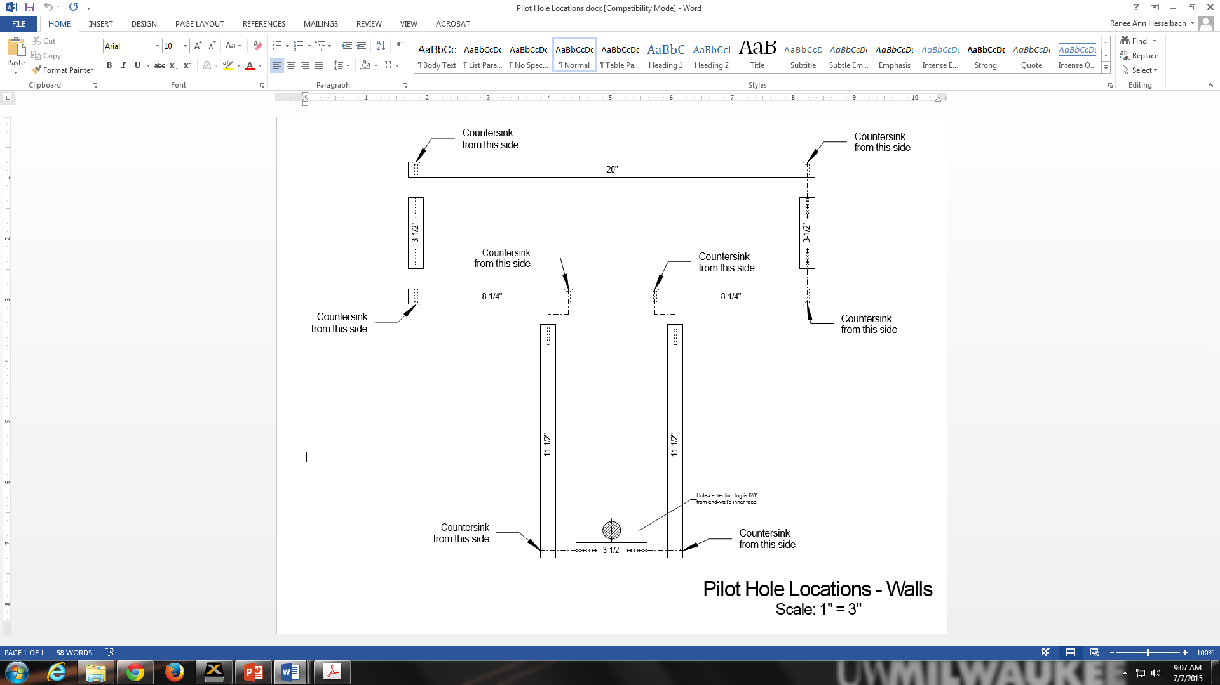

**C.** Wall assembly sequence (scale: 1” = 3”) 