Appendix A
Planaria Model
How Planaria Can Be Used as a Model for Studying Addiction Behavior

Planarian Behavior
Student Worksheet
Keywords: planarian, morphology, ventral, dorsal, posterior, anterior, bilateral symmetry, central nervous system (CNS), cephalization, eyespots, tropism, neuroscience, taxis, tropism, phototaxis, phototropism
Look at the image Human vs. Planarian Nervous System and the Planarian Diagram.
- What unique structures are found in planaria?
- What systems are similar between humans and planaria?

Learning Objectives | Assessment Criteria
Explain the variety of behavioral effects when planaria are exposed to caffeine and sugar. | Descriptions can include:  - Chemicals can change physical abilities.  - New knowledge can change attitudes.
Identify why planaria are used in drug research. | Reasons can include:  - Planarian behaviors are simple and easy to observe  - Planaria are simple and cheap to obtain, house and care for; little equipment is required to develop behavioral experiments.  - Because planaria are invertebrates, research presents fewer ethical and legal issues.
Develop testable hypotheses | Students will develop reasonable, testable hypotheses with an explanation based on facts and research.
Carry out experiments, collect data and analyze results | An experiment is designed that tests one variable at a time. Data table is constructed to communicate results clearly. Graphs are labeled appropriately with independent and dependent variable placed on the x- and y-axis. Results may support or not support the hypotheses, but is supported by data collected.

How Planaria Can Be Used as a Model for Studying Addiction Behavior
- Why do you think neuroscientists would want to use planaria in research?
Part 1: Observing Your Planarian
(Fill in answers and observations in Table 1).
- Using the pipette, carefully transfer your planarian to a petri dish containing spring water.
- Observe your worm using a microscope.
- Sketch the planarian. Label the eyespots. Label the anterior (front) and the posterior (rear) ends. See diagram.
- What kind of symmetry does a planarian exhibit? See diagram.
- Measure your planarian. (You can do this by removing some of the water from the petri dish and waiting for the worm to stretch out. Measure the length of the worm in millimeters.) Always replace the water. You can use the dish lid to transfer water.
- Record the length of your planarian on the classroom board. When all the lengths are recorded, determine the average planarian length.
- Using your pipette, carefully move the planarian to the center of the petri dish. Place a lid on top that has been partially covered with black paper. Record in Table 1 which type of lighting your planarian seems to spend most of its time. Observe for a few minutes to determine this.
Phototropism is the orientation of a plant or other organism in response to light, either toward the source of light (positive phototropism) or away from it (negative phototropism). Does a planarian exhibit positive or negative phototropism?
Phototaxis is the bodily movement of a motile organism in response to light, either toward the source of light (positive phototaxis) or away from it (negative phototaxis). Does a planarian exhibit positive or negative phototaxis?

How Planaria Can Be Used as a Model for Studying Addiction Behavior

Table 1: Planarian Observations
Characteristics of Flatworms
a.
b.
c.
Type of Symmetry:
Sketch and Label Your Planaria:
Length of Planarian | Average Length of Planarian
(mm): | (mm):
Does a planarian prefer light or dark environments? Explain based on your observations.

How A Planaria Can Be Used as a Model for Studying Addiction Behavior
Human vs. Planarian Nervous System
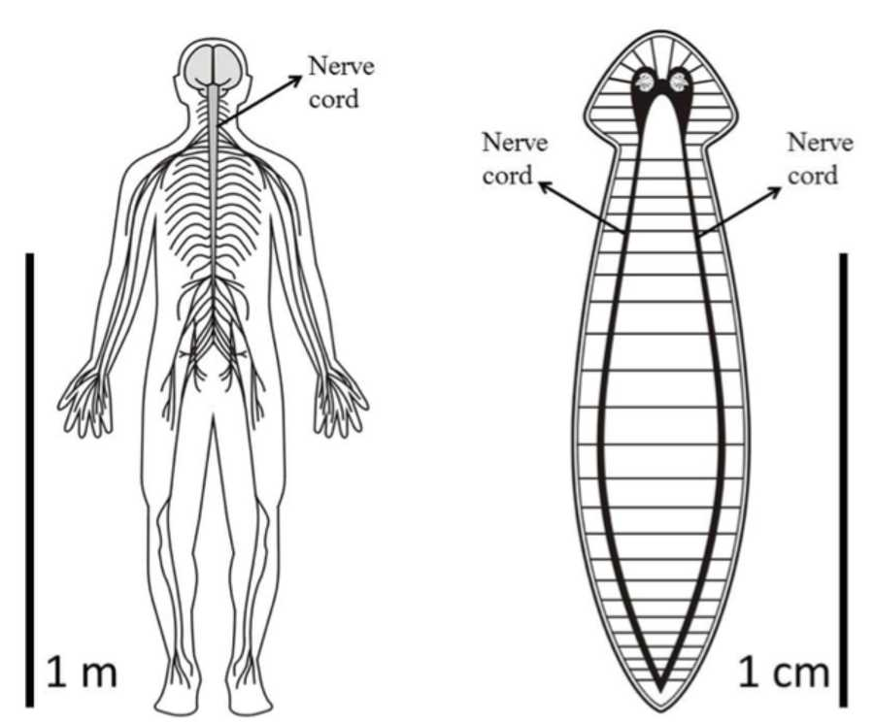

How Planaria Can Be Used as a Model for Studying Addiction Behavior
Planarian Diagram
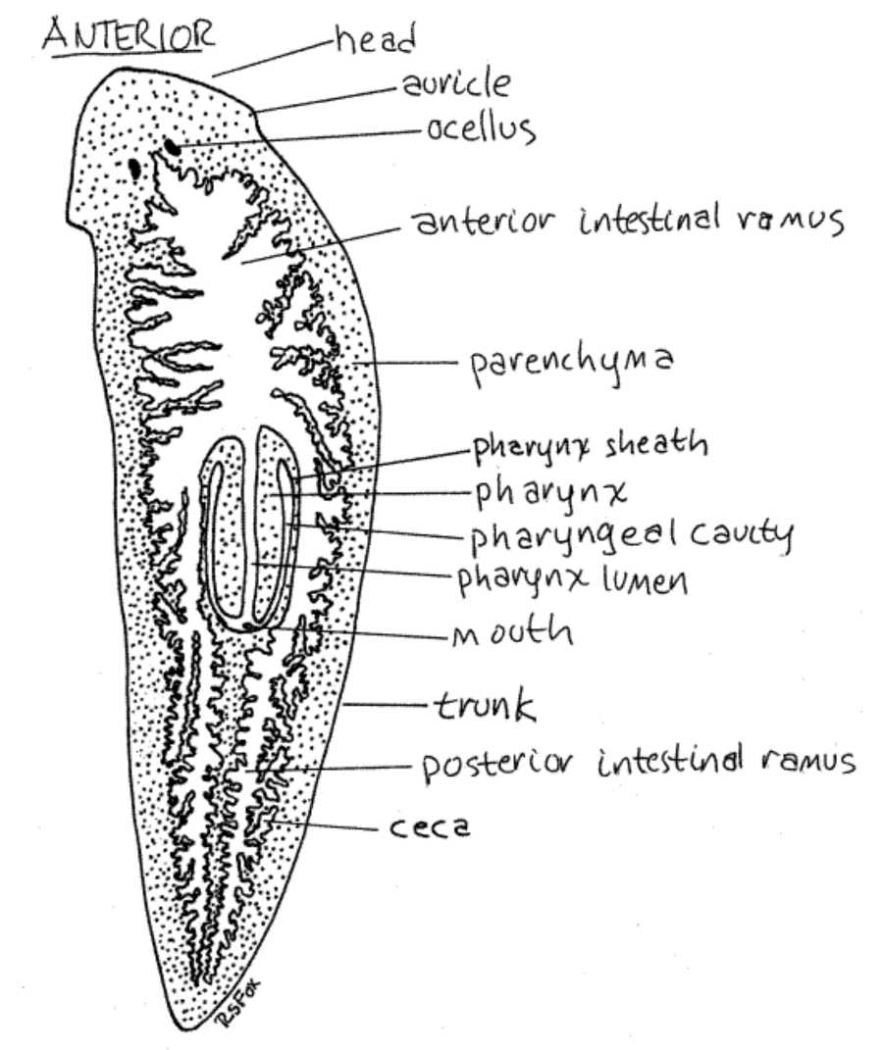
http://lanwebs.lander.edu/faculty/rsfox/invertebrates/dugesia.html

How Planaria Can Be Used as a Model for Studying Addiction Behavior
Animal Symmetry
beetle has
a coral polyp has
a sponge has
bilateral symmetry
radial symmetry
no symmetry
Animals with bilateral symmetry have one line that divides them into two mirror images. Look at a butterfly. If you drew a line exactly down the center of its body from its head to its tail, the two halves would be the same, but mirror images of each other. There is only one line of symmetry where this is true. In spite of the complexity of some butterflies' patterns, symmetry exists. People, dogs, cats, and elephants all have bilateral symmetry.
Animals with radial symmetry have body parts arranged around a central point. Any line drawn from one side through the center to the opposite side will divide the animal into two symmetrical halves. Animals with radial symmetry have many lines of symmetry. Because of the circular arrangement of their parts, radially symmetrical animals do not have distinct front or back ends. They may have distinct top and bottom sides. Some examples of these animals are jellyfish, sea urchins, corals, and sea anemones. A bicycle wheel also has radial symmetry.

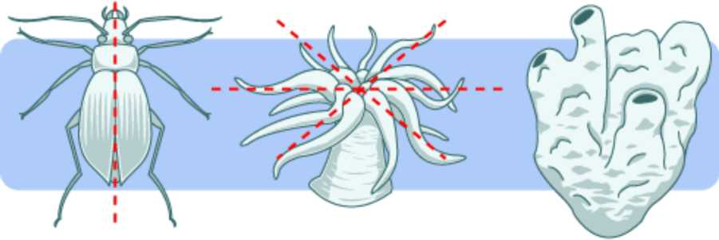

Appendix B
Introductory Student Laboratory Investigations
Motility: Planarian Perspective

Materials:
Spring Water Timer/stopwatch
10mL graduated cylinder Drawing pencil
Planaria (Dugesia Dorotocephala) Plain white paper
Graph paper (gridlines -spaced 0.5 cm apart) Petri dish
Scoopula
Different concentrations of solutions caffeine or sucrose
Pipette (optional)

Engagement: What do you know about Planaria (do NOT look up this information in a book, do NOT use the internet or do NOT ask the teacher) ___________________________________________________________________
Exploration Laboratory 1: Motility in spring water
Prediction: How many times will your planarian move across the graph paper?

- Label the petri dish spring water
- Using a clean graduated cylinder pour _____ mL(this depends on size of petri dish- want to have enough liquid for the planarian to move) of spring water into the petri dish
- Use your clean scoopula to gently remove a different planarian from the home jar
- On a one sheet of the graph paper place your planarian in a petri dish
- Count how many times the planarian crosses or re-crosses a line in a 3 min
- Record your observations

Exploration Laboratory 1: Motility in different concentrations of __________of___________
- Label the petri dish with the name and concentration of the solution being added
- Pour _____mL (this depends on size of petri dish- want to have enough liquid for the planaria to move) ______ of ______________ into the petri dish
- Use your clean scoopula to remove a different planarian from the home jar
- On a one sheet of the graph paper place your planarian in a petri dish
- Count how many times the planarian anterior crosses or re-crosses a line in a 3 min
- Record your observations

If time permits
- Label the petri dish with the name and different concentration of the solution being added
- Pour _____mL(this depends on size of petri dish. You want to have enough liquid for the planaria to move) ____ of _______________ into the petri dish
- Use your scoopula to remove one planarian from the home jar
- On a one sheet of the graph paper place your planarian in a petri dish
- Count how many times the planarian anterior crosses or re-crosses a line in a 3 min
- Record your observations

Be prepared to tell a member of your group, the teacher or class what you observed
Explanation: Why did what you observe happen in each of the of the above laboratory investigations?
Elaboration: What other chemical or combination of chemical(s) can you record observations?
Evaluation: Your teacher will determine your evaluation for this lesson.
Your teacher will prepare the solutions for you or you will be asked to prepare the different concentrations.
Appendix C
Correlation with NGSS Standard MS-LS1-1: From Molecules to Organisms: Structures and Processes

Performance Expectations MS-LS1-8: Gather and synthesize information that sensory receptors respond to stimuli by sending messages to the brain for immediate behavior or storage as memories
Dimension | Name and NGSS code/citation | Specific connections to classroom activity
Science and Engineering Practices | Planning and Carrying Out Investigations  Conduct an investigation to produce data to serve as the basis for evidence that meet the goals of an investigation. (MS-LS1-1) | Students planned and conducted investigations using planarians and different levels of sucrose, caffeine, and energy drink. Students recorded data on the velocity of planarians in different concentrations of each substance as evidence to support their conclusions.
Disciplinary Core Idea | LS1.A: Structure and Function  Feedback mechanisms maintain a living system’s internal conditions within certain limits and mediate behaviors, allowing it to remain alive and functional even as external conditions change within some range. Feedback mechanisms can encourage (through positive feedback) or discourage (negative feedback) what is going on inside the living system. | Students observe the stimulus- response of planarians in the substances sucrose, caffeine, and Monster Energy drink.
Crosscutting Concepts | Cause and Effect  Cause and effect relationships may be used to predict phenomena in natural systems. | Students used their results to predict how these substances affect humans

Appendix D

Learning Objectives & Assessment Criteria

Learning Objectives | Assessment Criteria
Explain the variety of behavioral effects when planarians are exposed to caffeine and sugar. | Descriptions can include:  - Chemicals can change physical abilities.  - New knowledge can change attitudes.
Identify why planarians are used in drug research. | Reasons can include:  - Planarian behaviors are simple and easy to observe  - Planarians are simple and cheap to obtain, house and care for; little equipment is required to develop behavioral experiments.  - Because planarians are invertebrates, research presents fewer ethical and legal issues.
Develop testable hypotheses | Students will develop reasonable, testable hypotheses with an explanation based on facts and research.
Carry out experiments, collect data and analyze results | An experiment is designed that tests one variable at a time. Data table is constructed to communicate results clearly. Graphs are labeled appropriately with independent and dependent variable placed on the x- and y-axis. Results may support or not support the hypotheses, but is supported by data collected.

Appendix E

Student Assessment Test Questions

Answer Key = Statements highlighted in yellow are correct answers

1. Drug addiction is best defined as:
- a bad habit
- a disease that is characterized by occasional drug use that temporarily changes a person’s behavior
- a disease that is characterized by the controlled use of drugs
- a disease that is characterized by an uncontrollable, compulsive urge to seek and use drugs

2. Which of the following substances are considered a drug?
- alcohol
- caffeine
- nicotine
- all of the above

3. Which of the following is categorized as a depressant?
- energy drink
- beer
- coffee
- all of the above

4. When someone uses drugs repeatedly, their brain ______.
- is not changed
- becomes larger than before
- becomes trained to crave the drug
- all of the above

5. Repeated drug abuse can change the brain and “hijack” the brain’s reward system. This means:
- large amounts of the chemical dopamine flood your system, creating the “high”
- things that normally make you happy aren’t fun anymore
- drug cravings become nearly impossible to ignore
- all of the above

6. Drugs of abuse create intense feelings because they _____.
- depress the nervous system
- shut off receptors in the occipital lobe
- increase levels of dopamine in the limbic system
- none of the above

7. Humans are in their early to mid-twenties before their brain is fully matured. This is why people get concerned when teens use drugs, because chemicals can affect the developing brain. The last part of the brain to mature is the:
- limbic system
- nervous system
- prefrontal cortex
- none of the above

8. Biomedical research is the broad area of science that looks for ways to prevent and treat diseases that cause illness and death in people and in animals. Thus, biomedical researchers _____.
- study the effects of various chemicals on the human body
- investigate new technologies or disease treatment methods
- conduct research on animals and/or on human subjects
- all of the above

9. Why are mice often associated with medical research?
- they are widely considered to be a prime model of inherited human disease
- they share 75% of their genome with humans
- they share 99% of their genes with humans
- all of the above

10. Planarians are ideal for biomedical research because they _______________.
- are mammals
- are similar to humans in terms of their eating and sleeping patterns
- display addiction-like behaviors to many drugs abused by humans
- all of the above

11. Which of the following would NOT be a career related to biomedical research?
- meteorologist
- pharmacologist
- physiologist
- forensic scientist

12. Which of the following are factors in whether someone becomes addicted to drugs?
- genes
- environment
- age of first use
- all of the above

