Supplementary material

This file contains of two appendixes

a) the working booklet: The material to be printed for the students groups. It contains solutions for the teacher in italic that need to be removed before printing the working booklet for students.

b) the teacher guidelines: A description of material to organize for the course as well as information on the teachers’ role in the structured inquiry based course.

Appendix A: Working booklet with solutions

Hearing:
An Inquiry Based Learning Module Linking Biology and Physics

This is your scientific journal for this course.
Bring it with you each time.

Date: _______.Your group (nr.____) has 4 team members:
1.___________ 2. __________ 3. __________ 4. ___________
Your team will investigate together on all days of this course. Discuss questions in your group first and try to solve them together.

Most questions in life you can solve yourself!

Each team member has a certain task.

#1 reads the task.
#2 gets and puts up the setup.
#3 executes the task.
#4 writes down the answer of the group.
Rotate these tasks with each new experiment.
The information texts are to be read by everybody.

Content
Learning station I – What is Sound 3
1. Sound is a vibration 3
2. How the vibration is passed on 3
2.1 Experiment 1: Rubber band guitar 3
4. Sound measurement 4
4.1 Experiment 3: The difference between noise and tone 4
4.2 Experiment 4: Frequency 5
4.3 Experiment 6: Amplitude 6
Learning station II – How do we hear? 7
1. The outer ear: Ear flap and hearing canal 8
2. The middle ear 8
2.1 The eardrum 8
2.2 The Eustachian Tube 9
2.3 The ossicles 9
2.3.1 Experiment 1: The lever amplification of the ossicles 10
2.3.2 Experiment 2: From the ear drum to the stirrup footplate 11
Learning station III – how do we distinguish frequencies? 13
1. Resonance and Eigen frequency 13
1.1 Experiment 1: Resonance 13
2.1 The Cochlea 15
3. The organ of Corti – the frequency detector 16
2.2 The ground membrane 17
2.2.1 Experiment 2: The metallophone in your ear 17
Learning station IV - The limits of hearing 19
1. Natural limits of hearing 19
1.1 Experiment 1: Limits of hearing 19
2. Hearing problems due to too loud sounds 19
2.1 Protecting your ear from damage 20
2.1.1 Experiment 2: Healthy ear 21

Learning station I – What is Sound
We need sound to communicate with each other, to recognize danger, to enjoy music… But what is sound exactly and how can we look at it in a scientific way?

Sound is a vibration
Sound is generated when an item is put into vibration. Think for instance of a window that starts to rattle when a heavy truck passes by your house. The glass is vibrating because it is set in motion by the vibrations the truck produces. Apparently, this causes a sound we can hear.

How the vibration is passed on
Sound originates from the vibration of an object. But how does the sound get from the vibrating object to our ear? Scientists call the form of sound it travels in sonic.

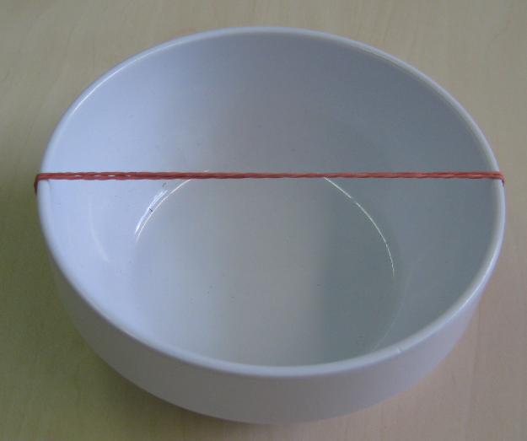
Experiment 1: Rubber band guitar
Figure 1: A rubber band guitar.
The place where the sound is coming from is called sound source. To get from the sound source to our ear, the sound needs to cross the air in the room.
Even though you are unable to see it, surrounding air consists of tiny particles! The particles can hit each other all the time. It’s a bit like marbles (small balls) in a jar.

Question: What happens to the air particles around the sound source, when sound is formed?

Preparation:
Tighten the rubber band around the small box to play the rubber band.

Interpretation:
- What do you think happens to the air particles that surround the rubber band when you play it?

Everywhere around the rubber band are air particles. When the rubber band vibrates, it crashes into the particles. These start vibrating as well and pass on this vibration to other air particles.__________________________________________

Now you know that air particles play an important role for the movement of the sound.

Passage 3 (Transportation of sound) is not part of this publication. It can be found in the appendix of Schmid und Bogner (2015). Free access at https://www.ijlter.org/index.php/ijlter/article/view/289.

Schmid, S.; Bogner, F. X. (2015): Does Inquiry-Learning Support Long-Term Retention of Knowledge? In: International Journal of Learning, Teaching and Educational Research 10 (4), S. 51–70.

Sound measurement
Open the software “Visual Analyser” on your PC. Visual Analyser is a software to analyse sounds waves. Do not forget to switch “ON” the microphone in the programme in the upper left corner and ensure that your PCs microphone is on as well. When you know play a sound, the graph in the upper window should move. If not, ask your teacher for help. Do only pay attention to the graph in the upper window.

In the upper measurement window of Visual Analyzer you see how the air pressure varies over time on the X-axis.
On the vertical Y-axis you can see the air pressure difference with respect to the normal background air pressure. The maximal pressure difference is the amplitude (A).
On the X-axis you see the time.
Figure 4: The presentation of a sound wave in a picture is called graph. It is drawn in a coordination system with x- and y- axis. The wave resembles the vibrations of each air particle within a sound wave.
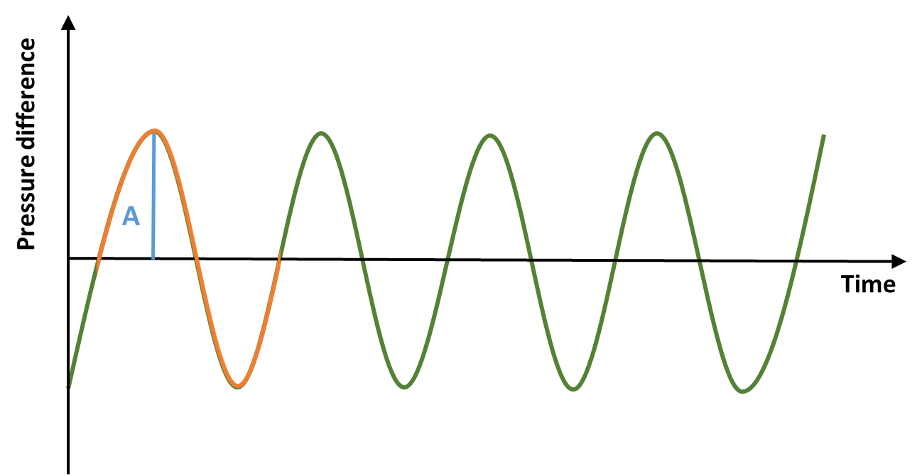

A full vibration is done, when the wave has completed a full cycle. The air particle then has returned to its starting position. A wave in the graph consists of a full hill and a full valley. On which part of the wave the cycle starts does not matter, e.g. from one hilltop to the next. In the graph you see about 3 full vibrations.

Experiment 3: The difference between noise and tone
You now know enough to start exploring the interesting world of sounds. Paste the screenshot you are asked for in an empty text-writing document. We will the file “screenshot-file” from now on. Save it on the desktop of your PC.

A screenshot is made by pressing the “print” button of your keyboard, and right click “paste” afterwards in your screenshot file.

Attention!
- Wait one second after making a tone, before you do a shreenshot for a better graph
- Play the metalophone bars softly! Do not strike them with too much power!
- If the graph is too small, set the “zoom” from 1 to 5 on the right site of the program.
- Show consideration for other groups and only use the instruments for the experiments.

Question: Sonic can be distinguished in sound and in noise. But how?

- a) Wrinkle a paper, b) play a tone on an instrument. Make screenshots for each sound you make. Label each screenshot with the sound you made.

- Compare the graphs of the sounds. Which are sounds, which are noises?
Wrinkling paper is noise

- Describe the differences between graphs of sounds and noises.
For noise, there is no pattern repeating in the graph you can see in Visual Analyser.

We can describe the frequency of a sound. You will find out in the next experiment what that is. This means, you can link a tone to a certain frequency. We cannot link a certain frequency to a noise, because they are a more complicated form of sound wave.

Experiment 4: Frequency
Scientists call the pattern of a sound wave frequency. Each tone has a certain frequency.
The frequency is the number of vibrations per second, and its unit is Hertz (Hz):

A tone has the frequency of 1 Hertz, meaning it vibrates 1 time per second.

Question: What does the frequency tell you about the pitch of a sound?
Paste the graph of a high and low tone of the metallophone in your screen shot file. Always label which graph is which tone.

- Describe the graph of a high tone. Its graph shows a high frequency.
The pattern is being repeated often within a certain amount of time.

- Describe the graph of a low tone. Its graph shows a lower frequency.
The pattern is being repeated less often within a certain amount of time.

- Describe what the frequency informs you about in the context of the pitch of the tone, and the number of vibrations in the graph of the sound wave.
The more repetitions, the higher the pitch of the tone, the higher the frequency.

- What is described when you use the term frequency?
The number of __________vibrations per second the air particles undergo is what we call frequency.
- Which unit does the frequency have?
Hertz (hz)

- How often does an air particle vibrate when its frequency is 3 Hertz?
3 times per second

Experiment 6: Amplitude
Question: What happens with the graph when you play a tone with different loudness?

Paste a screenshot of a loud and less loud played tone on the metallophone to your screenshot file. Make sure to indicate which tone is the softer and which is the louder note in your document. Use the same tone twice.

- What is the difference between the graph of the louder and the softer identical tone?
The graph of the sound wave of the louder sound shows more deviation in the vertical direction (is higher), than the wave of the more softly played sound.

- What does the amplitude inform you about?
How loud a sound is.

- Does the frequency change when the amplitude changes, and the other way around?
No, frequency and amplitude are not dependent.

Learning station II – How do we hear?

The human ear is a detector that collects and analyses the incoming sound waves by their frequency and amplitude.
In this section we are going to see which role the form and the different parts of the ear play in the detection of the tiny particle vibrations of the sound wave.

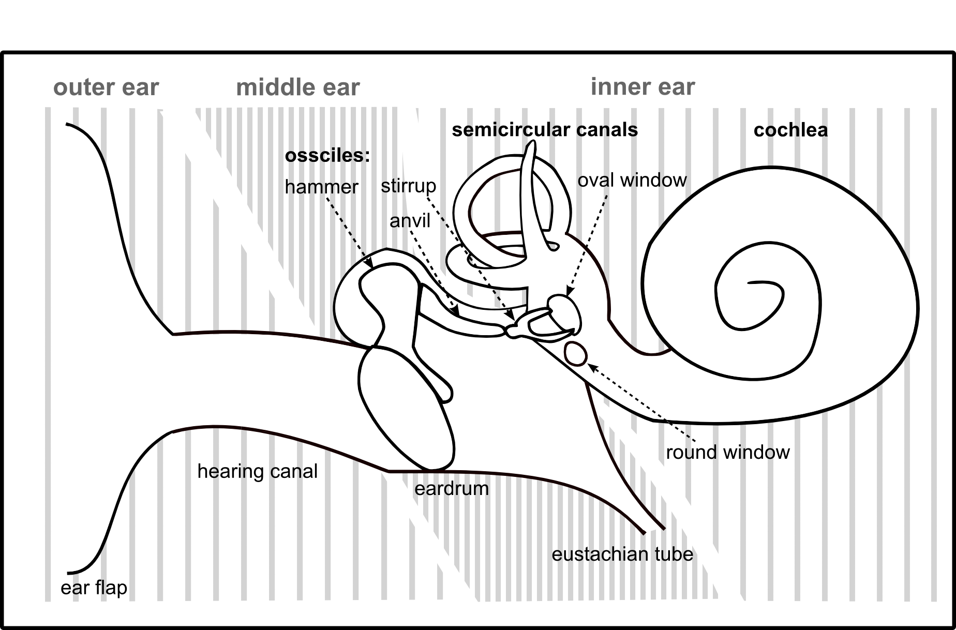
The ear consists of three parts – the outer, middle and inner ear. Each part has a certain function. The manner in which the information of the soundwave is passed through the ear changes. It changes from the outer to the middle ear, from the middle to the inner ear and from the inner ear to the brain.
Figure 5: Overview of the parts of the ear: outer, middle and inner ear. The stripes in the background indicate which parts belong to the three sections.
The outer and middle ear are air filled parts. The inner ear is filled with a fluid.

The task of the outer ear is to collect sound waves. The form of the sound wave is still of compressed and relaxed air – remember the spiral. The middle ear transforms the sound wave in movements of the ossicles. This movement is then transformed to a wave in the fluid of the inner ear. In the inner ear this wave is transformed to electrical nerve impulses, which are sent to the brain.

We will have a closer look at each part, beginning with the outer ear, and then follow the way of the sound through the ear.

The outer ear: Ear flap and hearing canal

The part of the ear that we see, the outer ear, consists of the earflap and the ear canal. The earflap has the task to channel as much of the sound wave as possible into the ear canal.
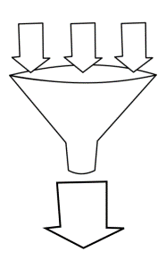
The ear canals ends after 2.4cm with the ear drum, the beginning of the middle ear. While the tone is in the outer ear it still has the form of the sound wave. The first transmission of the information in the sound wave happens at the ear drum.
Figure 6: Imagine the ear flap as a funnel, catching as much sound as possible, leading it into your ear canal.
outer ear
sound
sound
sound
sound
ear canal
ear flap

The middle ear
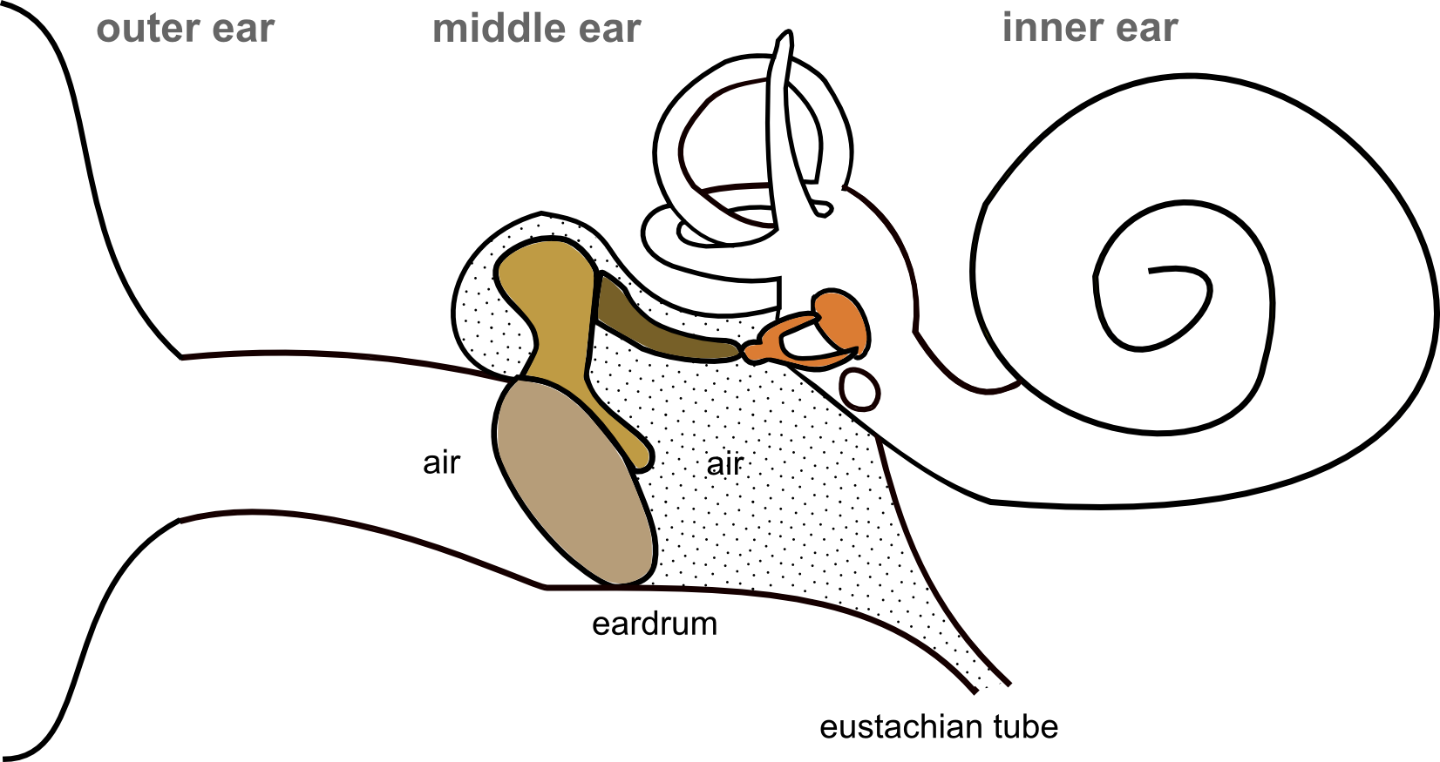
The middle ear is an air-filled room. It starts at the eardrum, where the three beaded ossicles reach the inner ear. Furthermore, there is the Eustachian Tube, an opening of the middle ear to the air around our head.
Figure 7: Dotted area: the air-filled middle ear with the Eustachian tube:
A connection to the air surrounding your head.

The eardrum
The eardrum is a thin and tightly stretched membrane placed at the end of the earing canal. It is only 0.1mm thick, as narrow as a hair. When the sound wave reaches the eardrum, the air particles push against it in the rhythm of the frequency. By this, the eardrum starts to move as well. It vibrates exactly in the frequency of the sound wave.

The Eustachian Tube
The Eustachian Tube is an opening in the middle ear that links it with the mouth. By this, the air pressure in the middle ear is always the same as the air pressure around our head. If the air pressure would not be the same, the eardrum could not vibrate that easy, when a sound wave pushes rhythmically on it.

The ossicles
After the sound wave brought the eardrum to vibrate, these vibrations need to be transferred through the middle ear. The transfer happens by the help of three tiny bones in the middle ear: the ossicles – hammer, ambos and stirrup.
The first of them, the hammer, makes direct contact with the eardrum on the one side, and with the anvil on the other side. The anvil is attached to the last ossicle, the stirrup. Look at the graph below and colour the ossicles.
The movement of the ear drum brings the chain of hammer, ambos and stirrup into movement. By this, the incoming sound waves are transformed into mechanical movements of the ossicular chain.
The stirrup ends with an oval foot plate on a flexible membrane, the oval window, the beginning of the inner ear. Like the ear drum, this membrane vibrates in the rhythm of the frequency of the sound wave as well. So the frequency does not change, despite the transition from dense and less dense air to the mechanical movement of the ossicles!
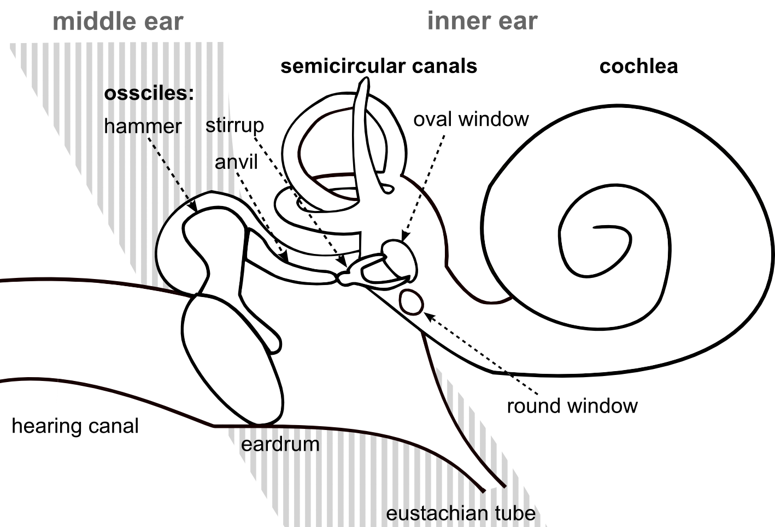
Figure 8: The middle ear with the 3 ossicles: hammer, anvil and stirrup. The lever system begins at the circular ear drum and ends at the oval window at the inner ear.

Now you know how the vibrations are passed through the middle ear. But there is still a problem: The movements of the ear drum are still very small. They are about the size of the air particles, which are so small that you cannot even see them! Because of this, the movement of the eardrum needs to be amplified so that the inner ear can detect them.

The pressure with which the stirrup presses on the oval window, the beginning of the inner ear, is amplified by two mechanisms.
- The force is amplified by a lever system
- The force is applied on a smaller surface

Experiment 1: The lever amplification of the ossicles

Put an edgy pencil on the table and place the ruler over it, forming a plus “+”. The middle of the ruler needs to be exactly over the pen. Now the ruler is floating in the air, neither end is touching the desk any more. You can start exploring!

What you additionally need are three paper clips, acting as the weights of the rocker. One alone is the light weight and represents the light pressure the ear drum puts on the first ossicle. Two paper clips together act as the heavy weight and resemble the increased pressure at the end of the ossicular chain. The pressure of the stirrup on the oval window is a lot stronger than the pressure the ear drum pushes on the hammer.

A lever is a solid bar that makes contact to the ground in one point. A rocker is an example. Each lever does have a left and right lever arm, exactly like the two sides of the ruler.
Question: How can you lift a heavy weight with a light weight by using a lever?
Since the light pressure of the ear drum on the hammer leads to the increased pressure of the stirrup on the oval window. But how does that work?

- How can you lift a heavy weight with a less heavy weight? – Maybe you already know this from the playground, when you were with less and more heavy friends on the rocker. Write down your suggestion!

Test your suggestion!
Place the large weight (2 paper clips) somewhere along the one side of the scale. Now try to find a position for the small weight (1 paper clip) on the other arm in a way that the large weight is lifted.

Interpretation

- Describe the distance of each weight to the middle of the scale, and cross out the wrong words in brackets.
The heavier weight is placed ______ cm away from the middle of the scale.
The lighter weight is placed ______ cm away from the middle of the scale.
“Thus, the distance of the more heavy weight to the centre of the scale is (longer/ shorter) than the way of the less heavy weight.”
“We call the distance from the weight to the centre of the scale the length of the lever. Thus, a large distance from the weight to the centre of the scale is a (big/small) lever. “

Now you know how the soft pressure of the ear drum leads to the increased pressure on the oval window by the help of the lever of the ossicles.

- Cross out the wrong words in brackets to write down your conclusions:
The hammer and the anvil are the most important parts of the lever system in the middle ear. The hammer is the longer lever arm. The ambos is the shorter one.

“So the longer lever arm of your rocker represents the (ambos/ hammer)”
The ear drum only moves a little bit when a sound wave enters our ear canal. This tiny motion is given to the hammer.
“The low force with which the ear drum pushes on the hammer is resembled by the (light/ heavy) weight in your rocker.”
When the long hammer is moved with a small force, the shorter ambos automatically moves with a high force.
“The (lighter/ heavier) weight on the rocker resembles the increased force at the end of the ambos”
The ambos gives this increased force to the stirrup. The force with which the stirrup presses against the inner ear is a lot higher than the force the ear drum pressed against the hammer.

Experiment 2: From the ear drum to the stirrup footplate

Question: Why is the area of the oval window actually smaller than the ear drum?

Experiment 1:
Take your open palm and press it against your other open palm. Keep in mind how that feels and go on with experiment 2.

Experiment 2:
Take one of your pens and press its back against your palm with the same force you used before.

- Describe the difference you felt between the two experiments.
Palm against pencil did “hurt” more than palm against palm, although we used the same force.
- Explain which feature of the experiment changed between experiment one and two?
The size of the surface we used. The palm is bigger than the pencil top.
- Discuss in your group what may be the reason for the different outcome.

We applied the same force to the palm, once via another palm, once via a pencil. However, the pressure of the pencil was way stronger on the receiving palm. The reason is that the force was concentrated on one spot (the area of the pencil top), and no longer evenly spread across the big palm area. Thus, a reduction of a bigger area, with the same applied force, results in a stronger pressure on the reduced area.

- Look at the graph and cross out the wrong words:
“On a large object the force distributes evenly across the whole surface. On a pointed object the same force is concentrated on a much smaller surface. Through this concentration of the force to one point, the pressure on this point (increases/ decreases) a lot.”
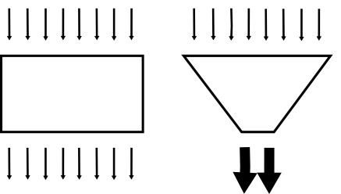
“This is the reason why a pin is (easily/ difficult to be) pushed into the pin board. It has a broad head to push it and a very small needle to move into the board. The force on the tip of the needle is (concentrated/ spread out) when we push the pin. The force per unit of surface is what we in general call pressure.”
Figure 1: How the force (arrows) is passed on by object forms.
“This means for the middle ear: When the low force of the tiny movement of the ear drum needs to be increased, the oval window needs to be (smaller/ larger) than the hearing drum.”

Now we have accompanied the sound through the outer and the middle ear. In the next step it enters the inner ear.

Learning station III – how do we distinguish frequencies?

Have you ever wondered how our ear manages to differentiate among so many tones or frequencies? The inner ear is responsible for this. But how does it do this? To understand this, we first need to meet Eigen frequency and Resonance.

Resonance and Eigen frequency
The frequency is the number of vibrations per second. Remember: The graph of a tone with a high frequency had a lot more vibrations than one with a low frequency. Each tone has a certain frequency.

Each object has its own frequency as well. That is the frequency of the tone that sounds when you hit the object. Scientists call this own frequency as the Eigen Frequency of the object. “Eigen” is German for “own”.

Resonance means that an object makes a sound although you did not hit it. But the object is hit by a tone of another object! Under certain circumstances it starts to vibrate itself, through which it makes a sound.

In the following experiment you can test when resonance appears, and what Eigen frequency has to do with it.

Experiment 1: Resonance

The next experiment is conducted by one group in your class. The other groups watch carefully and answer the questions below. If you are the presenting group: prepare and conduct the experiment so everybody can see it and answer the questions yourself.

Part A
Question: What happens when a tone reaches an object?
For this experiment we will be using two identical tuning forks mounted on wooden boxes.
Everybody in the class needs to be extra quiet now.

Execution:
- Remove any clamps on the 2 tuning forks.
- Put the tuning forks on the wooden boxes.
- Place the wooden boxes with their openings facing each other.
- The distance between them should be about 5cm. Everybody needs to be quiet now!
- Play one of the tuning forks and immediately touch it afterwards to stop it.

Observations:
- What do you hear?
The identical sound of tuning fork one, although it does not sound anymore!

- Where is this coming from?
From the second tuning fork.

- Explain the phenomenon that the second tuning fork emits its sound without being stuck!
This happens, because the second tuning fork has the same Eigen frequency than the first. So the inner frequency of the second tuning fork is the same than the frequency emitted by the first tuning fork. – Is an object reached by a frequency that is equal with its Eigen frequency, it emits this frequency itself.

Are all groups done? Then let’s explore part B!

Part B
Repeat the experiment, but this time put a clamp on one of the tuning forks. Listen to the tuning fork with the clamp, and repeat the experiment.

Observation:
- What do you hear after you stop the tuning fork you hit?
Nothing. Both tuning forks are silent.

- What is the difference to the first experiment?
With a clamp on it, the second tuning fork does not emit the sound of the hit (first) tuning fork. Without it does.

- Explain the phenomenon that the second tuning fork does not emit a sound any more, without being hit!
In the second experiment, the second (not hit) tuning fork does not sound anymore because the addition of the clamp has changed its Eigen frequency. Thus, the sound from the first (hit) tuning fork is no longer the same as the Eigen frequency of the second (not hit) tuning fork.

Additional conclusion: A resonating system can detect an incoming sound wave. It is a frequency detector. Either the frequency of the incoming sound wave is the same as the Eigen frequency of the object, or not.

Part C
So that the inner ear knows which frequencies the played tone has, it has a row of such frequency detectors within it. These detectors are arranged in a certain sequence. To each position in the row a certain frequency of a tone can be combined. This kind of coding is called spatial coding.

Each group carries out the following experiments on their own again.
Rotate the task of reading the texts in the next section.
2. The parts of the inner ear
The inner ear consists of the cochlea (responsible for hearing) and the semi-circular canals (responsible for maintaining our balance and detecting acceleration). Cochlea is Latin for snail shell, and the structure of the inner ear is named that way because of its look.
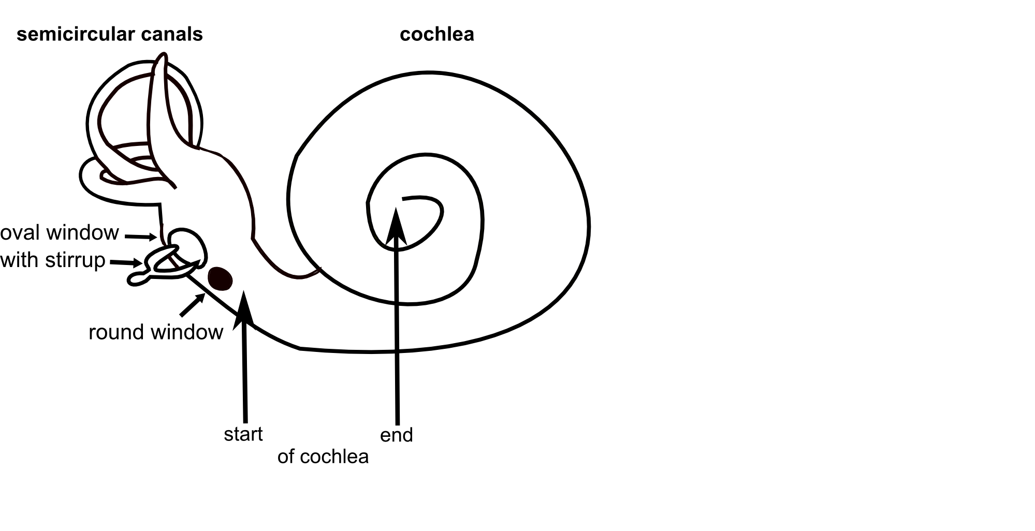
The cochlea is essential for hearing. The frequency detectors are placed in it. Furthermore, there is another transformation of the information form at the beginning and at its end. After the information of the sound wave is analysed in the cochlea, it is forwarded to the brain.
Figure 9: Overview of the inner ear. Left: semicircular canals to maintain balance. Right: the cochlea in its wind up structure.

The Cochlea
The cochlea looks like a little snail shell with 2.5 windings. It is filled with a fluid and is divided into three canals that run through it – just like three drinking straws hold as a pack. They are named upper, middle and lower canal, and each is ~30mm long. The upper and lower canal are liked at the end of the upper canal. The middle canal is not connected to the others. It holds the organ of Corti, the actual area of frequency detection.
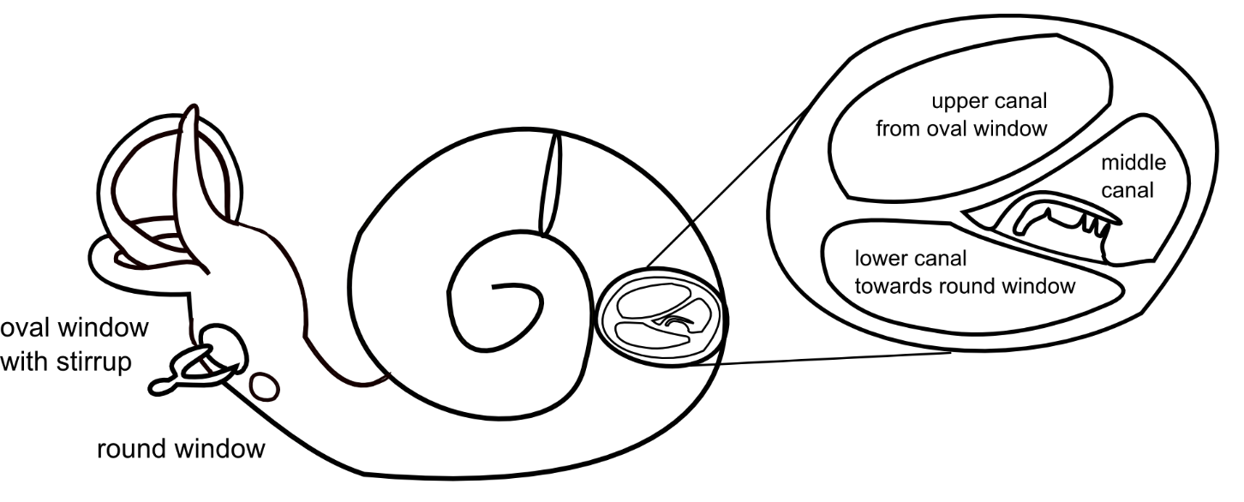
Figure 10: Overview of the inner ear.
Left the organ of balance, right the cochlea in its original curled up shape.
In the section on the right side you can see the three compartments: Upper, middle and lower canal.

The cochlea is made of skin and as small as a pea. Since it is made of skin, it is surrounded by hard bones of the skull. The skull has two openings where the skin is not covered with bone. One you already know: The oval window. It is the place where the stirrup ends and on which it presses in the rhythm of the frequency. It sits at the beginning of the cochlea, at the beginning of the upper canal. There starts the transport of the sound-information through the inner ear. The second opening sits at the end of the lower canal and is called round window.
The vibrations of the stirrup at the oval window cause a wave within the fluid in the upper canal. From there it moves through the lower canal. That means that the mechanical movement was transformed into a fluid wave.
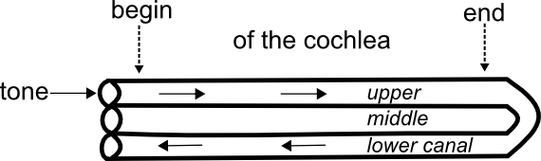
Figure 11: The three canals of the cochlea when unrolled. The tone enters at the oval window, moves from the upper to the lower canal and ends at the round window. The middle canal is not connected to the other canals.

The organ of Corti – the frequency detector
Depending on the frequency of the stirrup, the wave which is formed in the fluid of the cochlea is largest on a certain defined place along the cochlea. For each frequency the highest point of the wave is at another point! This signal is then passed to the brain. Since each frequency is connected to a certain place along the organ of corti, we know which tone we heard; this kind of coding is called spatial coding.
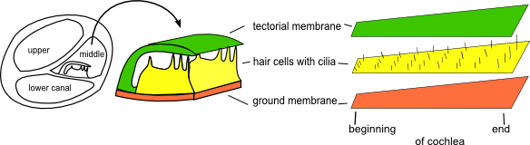
Figure 12: Left: A cut through the three canals of the cochlea. Middle: Enlarged organ of Corti from middle canal. Right: Parts of the organ of Corti: Groundmembrane, hair cells, tectorial membrane.

Where is the signal created?

When a wave is created, it moves from the upper to the lower canal, where it presses on the middle canal.
On the bottom of the middle canal are the parts of the frequency detector, which is called Organ of Corti: the flexible ground membrane on the very bottom, a layer of sensitive nerve cells, which are called hair cells, on top of it, and a stiff membrane on the very top, called tectorial membrane.

The fluid wave bends the ground membrane on a specific part. By this, the hair cells above it are pressed against the tectorial membrane above them. When this happens an electrical signal is sent to the brain.
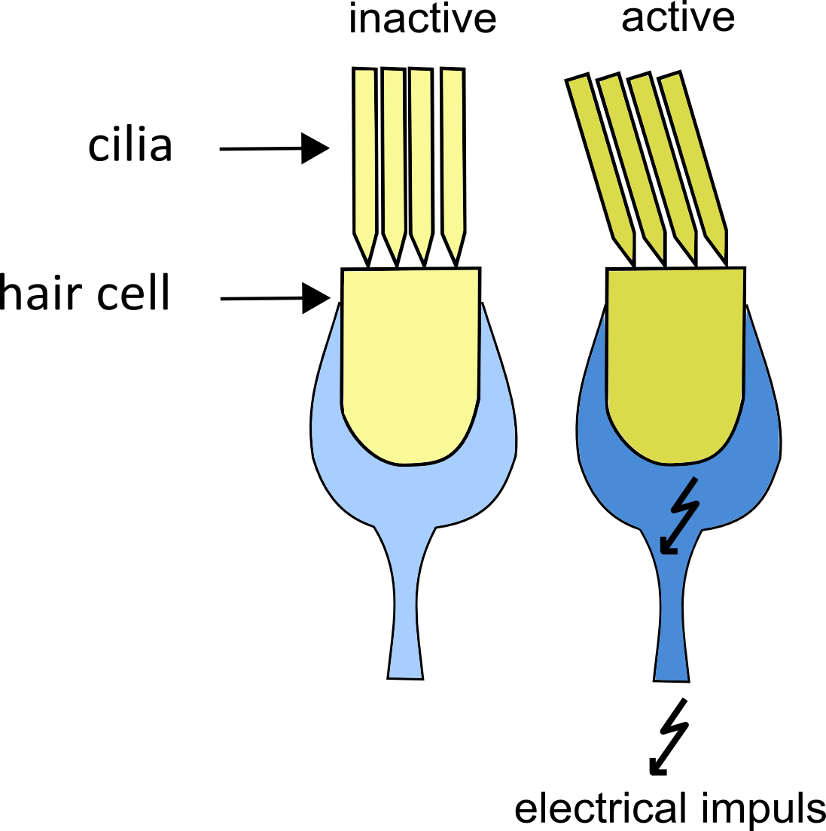
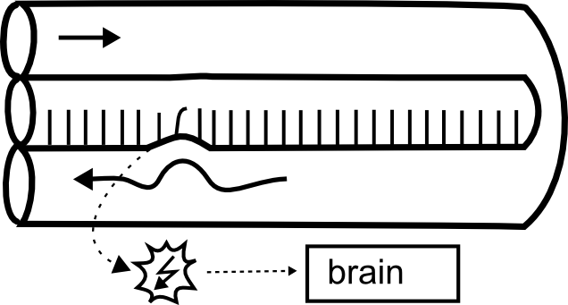
Figure 13: Hair cells - The right one detects a sound and sends an electrical signal to the brain.
Figure 14: In the middle canal lays the Organ of Corti. The fluid wave in the lower canal moves the ground membrane. An electric signal is sent to the brain.

What leads to the sending of the electric signal?

The electrical signal is sent by the hair cells, special nerve cells. With their help the information of the sound wave, which entered the outer ear, is transformed a last time: From the fluid wave in the canals of the cochlea into an electric signal.

There are about 15.000 hair cells. They are named “hair cell” because on the top of each cell there are many little hairs. They are called cilia. When the cilia are bent, the hair cell gets activated. Only then it will send an electric signal through the hearing nerve to the brain, and inform us about the frequency of the heard tone.

The ground membrane
The ground membrane lays in the middle canal. It begins below the oval window and ends at the end of the cochlea, where the windings are the smallest.

The properties of the ground membrane vary along its length. It is stiffer at its beginning than at its end. Furthermore, the ground membrane does not have the shape of a rectangle, but more of a trapezoid. It is only 0.08mm broad in the beginning and gets 0.5mm wide at its end. That means that the beginning is shorter in width and stiffer, and the end is broader and more flexible.
As a result of these properties, the ground membrane reacts to high frequency tones at its beginning and low frequency tones at its end.

Experiment 2: The metallophone in your ear
Take a look at the metallophone in front of you. The ground membrane is built up alike a metallophone. Each plate of the metallophone produces a certain tone when played. The frequency of this tone is the same frequency as the Eigen frequency of this plate.

Question: Which features does the ground membrane share with a metallophone?

- The bars have different lengths. In which way are the bars sorted?
The bars are sorted from long to short.

- Play different bars of the metallophone. Which relationship do the different bar lengths have with the pitch of the tones?
The longer bars produce lower pitch sounds than the shorter bars.

- Imagine the metallophone as the ground membrane in the cochlea. Label the two ends of the metallophone with the corresponding parts “beginning of the ground membrane” and “end of the ground membrane”. Use the cards.
The side with the shorter bars will be labelled “beginning”, the side with the longer bars will be labelled “end of the ground membrane”.

Now we can say that the Organ of Corti is the part of the ear where the different frequencies are differentiated. With its help we can differentiate different tones. When we hear music we hear several frequencies at the same time. The ground membrane is then moved on different places along its length at the same time. Thanks to the spatial coding, our brain can relate which frequencies where contained in the music. You can imagine this like playing a song on the metallophone. Depending on the position of the plates on the metallophone you know which tone it will emit.

Learning station IV - The limits of hearing

Humans can hear high and low pitch tones, but there are tones that are so high, or so low that we cannot hear them, although our ears are healthy. But although we can not hear them they still exist! Many animals for example can hear them.
On the other hand your hearing ability can be reduced when you do not pay attention to the health of your ears. Through noise, too loud sounds, it can happen that you get deaf for some or even all tones.

Natural limits of hearing
The lowest frequency humans can hear is about 20 Hertz. That are only 20 vibrations in one second. For this reason these are the lowest pitch tones you can hear! Your ground membrane is then moved at its very end; so to say at the last metallophone bar. Tones which have a frequency below 20 Hertz are called infrasound, since they are too low to be heard.

The highest frequency humans can hear is about 20.000 Hertz. That are the highest pitched tones you can hear! Your ground membrane reacts to this at its very beginning. Frequencies above 20.000 Hertz are called ultrasound, since they are too high pitched to be heard. This upper hearing limit declines when getting older.

Although humans cannot hear these sounds, there are many animals that can. Elephants for example can hear infrasound as low as 5 Hertz. Sounds where the air particles only vibrate 5 times per second! Bats on the other hand can hear ultrasound, frequencies as high as 120000 Hertz.

  - Experiment 1: Limits of hearing
To understand why our hearing is limited, take another look at the metallophone as a model for the ground membrane.

- Use the cards “ultrasound” and “infrasound” to indicate which high and low tones we cannot hear anymore. Discuss in your group and place them at the correct site of the metallophone model of the ground membrane.
“Ultrasound” needs to be at the site of the short bars, as this is where the high frequencies are detected. Ultrasound are frequencies higher than we can detect them. Infrasound ~ long bar site ~ low frequencies ~ lower than detectable.

- Cross out the wrong word in brackets.
““ultrasound” needs to be at the side of the ground membrane model with the (long / short) bars. There the (high/ low) pitched tones are detected. Ultrasound are frequencies that are (higher/ lower) than the human ground membrane can detect.”

“ “Infrasound” needs to be at the side of the ground membrane model with the (long / short) bars. Infrasound are frequencies which are (higher/ lower) than the human ground membrane can detect.”

Hearing problems due to too loud sounds
Exposure to very loud sounds causes permanent damage of the inner ear, mainly by destruction of hair cells. The louder the noise, the more the ground membrane presses the cilia of the hair cells against the tectorial membrane. But hair cells are sensible and must be bent too much; otherwise they would break off.

A hair cell with no cilia cannot detect and pass the information about the movement of the ground membrane to the brain anymore. You will be deaf for the frequencies at the position of these hair cells.

Normally, not all cilia break off at the same time, so you hear worse and worse over time. That is dangerous, because the damage of the ear is then (normally) detected when a bigger damage already exists. The problem is that a once destructed hair cell stays destructed. They do not grow back. That leads to a worse hearing ability that stays forever. For this reason it is very important to protect your ears from noise and too loud sounds.

Through a too heavy bending of the cilia of the hair cells also tinnitus can arise. When you have tinnitus you will hear a ringing in your ear, although the room around you is totally silent. Tinnitus can be temporary, for example in the hours after a concert. But tinnitus can also stay for weeks, months and years. The inner ear constantly reports to the brain that a sound wave is entering the ear, although this is not the case.

  - Protecting your ear from damage
The best way to protect your ears is not to expose them to loud sounds in the first place. The next best way to protect your ears is to reduce the volume of the sound source. That means: listen to music less loud. Simply reducing the volume will already help a lot in protecting your hair cells.
When it is not you who is responsible for making the sound it is important to protect your ears. Too loud sounds for example are: construction works on the street or at home, or music in discotheques. When you cannot leave the area, there are easy ways to protect your ears, too.

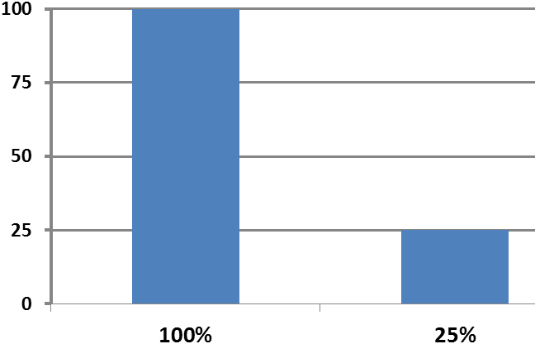
- Make the distance to the sound source larger. For example leave the area near the speakers in a discotheque. The further you are away from the sound source, the lower the energy of the sound wave, and the less the cilia of the hair cells are bent. Scientists have shown: double the distance to the sound source and the energy of the sound wave drops to a quarter! That means that the energy of the sound wave is reduced from 100% to 25%.
The reason is that when you double the distance the energy can distribute to an area 4 times as big as before. The ear then only catches the 4th part of the energy.

- Use ear plugs. Ear plugs are available in every drug store and can reduce the sound intensity by 20 to 30 decibel (dB). Decibel is the unit of the physical quantity called intensity, which is related to energy.
But what actually is decibel?

The intensity of a sound is measured in decibel (dB). You can find decibel numbers for example in the manual of your ear phones and of your mp3-player, on ear plug descriptions or in laws for noise levels at work. The louder a sound, the higher is its intensity, the higher is the decibel number.

But with a rising decibel number the intensity increases a lot more than the loudness.

The rules:
- With each increase of 10dB the loudness is perceived as double as loud as before.
- With each increase of 10dB the sound intensity is increased by the tenfold!

It is exactly this intensity of the sound wave though which the sensitive cilia of the hair cells can break off. The higher the intensity the higher the amplitude of the fluid wave within the inner ear that pushes the ground membrane against the tectorial membrane.

An example:
The loudness of 1 guitar is 60dB.
The loudness of 10 guitars is “only” 10dB higher, thus 60dB + 10dB = 70dB.
But:
The sound intensity of 10 guitars is 10 times as big as of one guitar.

Earplugs that reduce by 30dB reduce the intensity by 10*10*10 = 1000 times!

Always remember that even a very small change in the decibel-number has a very big effect on the intensity of the sound! That is why it is so important that you take responsibility for protecting your ears from loud sounds. A health risk already exists at 85dB!

Experiment 2: Healthy ear
Use your metallophone model of the ground membrane again to think about solutions for the following research questions.

- When some hair cells along the ground membrane would stop functioning or would not exist, what would it mean for your hearing ability?
The sound or frequency of the part on the ground membrane where the missing hair cells are could not be reported to the brain anymore, thus we would not hear these frequencies anymore. / You would become deaf for certain frequencies.

- What would happen if there were no hair cells at all left on the ground membrane?
You would become deaf for all the frequencies and thus become unable to hear, because the movement of the ground membrane could not be reported to the brain at any point.

- Based on your knowledge of hair cells, can you think of a reason why elderly people cannot hear high pitch sounds, like the songs of grass hoppers or bat calls anymore?
With older people, the hair cells for high tones often don’t function that good anymore. Because of that reason, they could have difficulties hearing these frequencies or they might be unable to hear these frequencies at all.

- How can your hair cells be destroyed?
By too loud sounds / too intense sounds, since the louder the sound the higher the ground membrane is moved, resulting in a much bigger movement of the hair cells below it, eventually destroying them,

- Why should you protect your ears from too loud sounds?
When you don’t protect your ears enough against loud sounds, than your hair cells will get damaged. You might get partially or entirely impaired in your hearing.

- Which two easy methods for daily life do you know to protect your ears in loud environment?
You could reduce your distance to the sound source, and you could use ear plugs to decrease the intensity of the sound.

- Imagine you are at a very loud sound source of 100dB. Time to wear ear your plugs! When your ear plugs reduce the sound intensity by 20dB, how much less is the intensity of the sound wave than before?
A reduction of 10dB is a reduction of times 10. Thus a reduction of 20dB is a reduction of 10*10 = 100 times.
The sound intensity is ____a 100____ times less when you wear ear plugs that reduce the sound by 20dB!

Appendix B: Teacher guidelines

Teacher guidelines

Do’s and Don’ts when doing the course
&
Material needed

A: Do’s & Don’ts when doing the course:

- Students work in groups of 4.
  - The teams must be put together identically each lesson and/ or experiment and group work.
  - Each team writes down their names on the front page of their working booklet, to make it easy to keep track of who is in which group.
  - Students can form the groups themselves to rise motivation. But it must not be more/ less than 4 working together (except for an uneven number of pupils in class)
  - Why? Keeping the groups the same strengthens the group’s team feeling and behaviour.
  - Each group has a number (1,2,3,4,5…), which the group will write on the front page of the working booklet.

- Do not answer questions of your students directly. “I don’t know the answer! / What is the answer?”
  - Why? Students need to read the text and use time thinking and discussing in their group to find the answers to the given questions. This system might be new for them and it is therefore even more important that answers are not distributed by the teacher.
  - Instead, encourage the student to think about the task or problem again and encourage them to discuss with the other group members.
  - Encourage them to precisely formulate their problem, so they may realize that the answer is manageable and can be recognized by themselves.
  - Finding solutions for problems themselves boosts the self-esteem of students.
  - Not getting the answer immediately form their teacher forces them to start to process the task again, following the different knowledge steps and finally come to a point where they may have a problem with. It trains their problem identifying and pinpointing of questions that describe their problem way more detailed than a simple “I can’t find the answer!”.
  - Eventually, after these steps are taken and a precise problem is formulated and discussed in the student’s group, the teacher may give a hint that leads them to recognize the answer to their problem, but may not give the answer away. Knowing the answer is only half the price, recognizing and understanding the solution why this is the answer is the other, even more important part.

- Each team member has a certain role.
  - 1. Reading the question or task – making sure everybody has understood it,
  - 2. Checking for equipment completeness – making sure the experiment can be done,
  - 3. Conducting the experiment – making sure that it is done the right way
  - 4. Writing down the groups answer – ensuring the group has agreed on an answer after discussion.
  - These roles will be distributed among the 4 team members at the beginning of the course and should be changed each time an experiment is done or after a longer text passage.
  - Why? To ensure that everybody in a group is on the task with his thoughts and energy
  - To ensure that everybody works and adds to the group work
  - To ensure shy students are not overtaken by a “stronger” team member. Everybody should have the opportunity to participate in each role equally.
  - The texts will be read by one student while the others listen. On long texts this task can be done by several students of course.

- At the end of the lesson collect all journals and provide them in the next lesson
  - Why? So students cannot forget them at home.
  - This is only neccessary if the four stations are not conducted in a row.

- Introduce the lesson
  - Tell them to put on the PCs already (so they are ready to use when the students need them)
  - Tell the students that
    - they will discover how we can hear in the next few lessons.
    - there will be experiments. And science is a serious business and nothing to play around. So they shall not work too loud to not disturb their class mates.
    - they work in groups
    - they work on their own (student centred)
  - Put the box with experimental set ups at your desk or on the floor where everybody can get to it.
    - Tell them they can get all the set up they need for the experiments in this box. And that they need to bring the things back after the used them.
  - Divide the class in groups of 4 or even better, let the students form them on their own.
  - Let one of them come to catch the working booklet.
  - Let the groups write down their names, group number and encourage them to start reading the working booklet.
  - You may need to tell them that they shall reduce the volume of the PC before they play a video. So that the class sound level does not become too loud.
  - You may allow the groups to work in different rooms when this is applicable. So they can concentrate better in case of a large class and small rooms.

B: Requirements for the course

- Experimental setups needed for each Station
All stations and experiments are self-explanatory for the students. Students can solve them on their own with their team. Each group does all the experiments in parallel.

PCs or Laptops
- One for each group.
- PC/laptops are needed in the first station
- If your school can not provide them, some students may be so kind to bring theirs
- They need to be equipped with:
  - Visual Analyser. Transforms sounds via a microphone into graphs. The freeware can be downloaded here: http://www.sillanumsoft.org/download.htm
  - Screenshot file: A blank text-writing file to were students can paste their screenshots. If MS-Word is not available, freeware (e.g., open office or lible office) or word-pad should be made available.

Station 1: What is sound

Experiment 1: Rubber band guitar:
- rubber band
- lunch box (or another kind of box)

Experiment 2: The spring
- Slinky spring / spiral toy with a marked point in its middle
- A table to lay the slinky on for stabilisation

Experiment 3: The difference between noise and tone
- PC or laptop
- PC-program Visual Analyser
- External Microphone (if the laptops internal microphone won’t work)
- Xylophone
- Screenshot file

Experiment 4: Frequency
- PC or laptop
- Visual Analyser
- Microphone
- Xylophone
- Screenshot file

Experiment 5: Amplitude
- PC or laptop
- Visual Analyser
- External Microphone (if the laptops internal microphone won’t work)
- Xylophone
- Screenshot file

Infos about the PC Program “Visual Analyser”:
- Visual Analyser (VA) is a simple to use freeware software to analyse sounds that will be used in Station 1. VA uses the data it gets from the microphone and plots it into a graph.
- Only the upper window in the program is needed. Do not pay attention to the lower window.
- On the right upper side you may enlarge the “zoom” from 1 to 5. Students tend to overlook this information, although it is provided in their working booklet where needed.
- Only play the xylophone soft. Students tend to hit it like it’s a hammer and an anvil. Smashing on the plates will result in bad graphs. You may need to remind them of playing soft tones.

Infos about screen shots:
- Students need to make screenshot of their graphs in Visual Analyser.
- They shall wait one second between playing the tone and pressing the screen-print button to obtain a better photo. This info is in their journal text at the right place.
- Make sure that VA has detected the signal. You will see the curve moving when this is the case.
  - Problem solutions when the graph does not move:
    - the “ON” Button in the program’s upper left corner is not clicked
    - the microphone is not plugged in / or in the wrong plug
    - the program Visual Analyser is not started
    - the external microphone body is turned off (the microphone may have a small switch)
    - the microphone in the PC (software) is turned off. Start menu Software Audio ensure microphone is “on”. (This last point may be time consuming and it’s rather better when the group uses the PC of a group that is finished with this task already).
- How to do a screen shot:
  - Make sure that Visual Analyzer (VA) is visible on your screen.
  - Strike the note or make the noise you want to measure.
  - Press the Print Screen button on your keyboard (“PrtSc”). It’s next to the “F12” in the upper row of keys.
    - Sometimes on laptops you need to hold a coloured key at the left lower part of the keyboard to activate everything written in this colour on the keyboard, including the screenshot key.
  - Go to the screen-shot file and paste it here (right click, paste).

Station 2 – How do we hear?

Experiment 1: Lever amplification of the ossicles
- 30cm ruler
- edged pen
- 3 identical paper clips

Experiment 2: from the ear drum to the stirrup footplate
- your hands and a pen

Station 3 – How do we distinguish frequencies?

Experiment 1: Resonance (this is the only experiment that one group does for all groups. It is not the teacher who is doing this experiment)
- One pair of identical tuning forks, both mounted on a wooded resonator box. One clamp to change the frequency of one of the tuning forks. A beater to strike the tuning forks.

Experiment 2: The metallophone in your ear
- Xylophone & beater
- Cards with the labels “base of the basilar membrane” & “top of the basilar membrane”

Station4 - The limits of hearing

Experiment 1: Limits of hearing
- Xylophone
- Cards with the labels “Infrasound” & “Ultrasound”

Experiment 3: Healthy ear
- Xylophone

For Station 3 – Experiment 1: The xylophone in your ear
Class set of labelled cards “base of the basilar membrane” & “top of the basilar membrane”.
Cut cards and give to each team one pair.
Base of the  basilar membrane | Top of the  basilar membrane
Base of the  basilar membrane | Top of the  basilar membrane
Base of the  basilar membrane | Top of the  basilar membrane
Base of the  basilar membrane | Top of the  basilar membrane
Base of the  basilar membrane | Top of the  basilar membrane

For Station 3 – Experiment2: Limits of hearing
Class set of labelled pair of cards “Infrasound” & “Ultrasound”.
Cut cards and give to each team one pair.
Infrasound | Ultrasound
Infrasound | Ultrasound
Infrasound | Ultrasound
Infrasound | Ultrasound
Infrasound | Ultrasound

