Appendix 1: Teamwork Teaching Unit

Table of Contents
Skills learning Goals 2
Example Syllabus Inclusion Statement….…………...………………………………...3
Example Teaching Schedules Related to Teamwork...………………………………...4
Student Pre-reading: Conducting Biology Research in Teams 5
Student Pre-reading: Practicing Effective Teamwork and Leadership 6
Teamwork Exercise 1 – Moon Landing 8
Teamwork Exercise 2 – Conflict Management 9
Teamwork Exercise 3 – Team Ground Rules Contract Form 12
Teamwork Exercise 4 – What makes an Effective Team? 14
Teamwork Exercise 5 – Teamwork Reflection 16

Skills Learning Goals
~~~~~~~~~~~~~~~~~~~~~~~~~~~~~~~~~~~~~~~~~~~~~~~~~~~~~~~~~~~~~~~~~~~~~~~~
The following learning goals are what the Lyman Briggs College faculty would like our students to learn by the end of the biology lab sequence. Therefore, classes are geared toward advancing these goals, such that by the end of the sequence, all students should excel at:

- Science process skills for biology, such as:

  - Making close observations.
  - Forming, evaluating, and testing questions and hypotheses.
  - Designing research, such as experiments, field studies, and modeling.
  - Conducting research, such as lab skills, data science skills, and field techniques.
  - Using data, such as data management, visualization, statistical analysis and interpretation.

- Effective teamwork and team management, such as:
  - Modeling behaviors of inclusion and ethics.
  - Using leadership skills to foster problem solving, team communication, conflict management, consensus building, and idea generation.

- Communication aimed at a variety of audiences, such as:
  - Speaking: speaking with and listening to others in large and small groups, oral communication of findings to various audiences.
  - Reading: careful and critical reading of text, identification of important data and ideas, as well as intentional and deliberate reading and interpretation of figures and graphs.
  - Writing: composition of text, writing questions and hypotheses, building figures and graphs, using data in evidence-based arguments.

Example Inclusion Statement for Lab Syllabus
~~~~~~~~~~~~~~~~~~~~~~~~~~~~~~~~~~~~~~~~~~~~~~~~~~~~~~~~~~~~~~~~~~~~~~~~
Your Learning Environment
Throughout this course, we will work together to create an inclusive learning environment in which all individuals are included, valued, and respected. Members of the teaching team and the student population come from a variety of educational and cultural backgrounds and hold diverse beliefs. We will encourage the exploration of and engagement in both divergent scientific approaches and diverse learning methods. Indeed, diversity is an essential component of scientific endeavor. Dr. Scott Page, professor of political science sums up the value of diversity as follows.
“The problems we face in the world are very complicated. Any one of us can get stuck. If we’re in an organization where everyone thinks in the same way, everyone will get stuck in the same place. But if we have people with diverse tools, they’ll get stuck in different places. One person can do their best, and then someone else can come in and improve on it. …Breakthroughs in science increasingly come from teams of bright, diverse people.”
To create an environment that appeals to a variety of learners, the scientific material in this course will be presented in a variety of formats. A range of teaching methods shown through educational research to be effective for student learning will be used including various active learning methods, group learning, and guided, inquiry-based laboratory investigations. Despite diligent efforts, these methods will not necessarily appeal to all learners. If you find you are struggling with the material, even with the different approaches employed, you are encouraged to discuss your difficulties with your lead lab instructor or another member of the teaching team. We want everyone to succeed.
We want to support each student to their fullest potential. That is why we strive to create an inclusive learning environment. There will never (ever ever) be any penalty for asking the instructor for special accommodations, extensions, etc., whether or not the request is ultimately granted. However, it is your responsibility to let your lead lab instructor know right away if you have a disability, religious observance, or other situation that requires regular or periodic accommodation.
Another significant component of an inclusive learning environment includes classroom conduct. It is essential that students are respectful of other students as well as the teaching team (and vice versa). Students are expected to refrain from behaviors that disrupt other students and the teaching team. Please respect and abide by the following in order to ensure a positive learning environment:
- Listen and remain silent when the teaching team and your classmates are presenting material or asking/answering questions.
- Respect the opinions and input of your classmates. Ideas, questions, or responses from your peers should never be met with disapproving or mocking gestures or comments.
- Respect your instructors. Pay attention and participate during labs. Full participation by all creates a more inclusive learning environment and improves learning.
In return, the teaching team will be respectful of all students. We will:
- Respect the work and input of students. We will not demean or degrade students.
- Maintain a respectful and inclusive lab environment.

Two examples of a semester-long schedule of teamwork-related activities.
~~~~~~~~~~~~~~~~~~~~~~~~~~~~~~~~~~~~~~~~~~~~~~~~~~~~~~~~~~~~~~~~~~~~~~~~~~

1. With the teaching of teamwork how’s and why’s done in 1-3 hour module.
Activity | Week(s)
Attitudes pre-test | 1
Form teams* | 2
Informal teamwork assessment and team dysfunction troubleshooting | 1-15
Teach ‘why’s and how’s of effective teamwork’ | 2
Formative biology assessment | 6, 10
Formative teamwork assessment | 7,11
Attitudes post-test | 15
Summative biology assessment | 14, 16

2. With the teaching of teamwork how’s and why’s done as 3-1 hour modules.
Activity | Week(s)
Attitudes pre-test | 1
Form teams* | 2
Informal teamwork assessment and team dysfunction troubleshooting | 1-15
Teach ‘why’s and how’s of effective teamwork’ | 1-3
Formative biology assessment | 6, 10
Formative teamwork assessment | 7,11
Attitudes post-test | 15
Summative biology assessment | 14, 16

* Note that teams can be formed during week 1 if class lists are stable.
Conducting Biology Research in Teams
~~~~~~~~~~~~~~~~~~~~~~~~~~~~~~~~~~~~~~~~~~~~~~~~~~~~~~~~~~~~~~~~~~~~~~~~~~

You will work as part of a team to conduct research in this lab. In fact, you will be placed into semester-long teams based on your responses to an online survey. We use an online survey to help us form these teams to ensure that students have compatible schedules and bring different skills and perspectives to the team. The Research Teams will usually consist of 4 individuals. When an assignment is listed as a ‘team assignment’, you are expected to help out on all tasks. When an assignment is listed as an ‘individual assignment’, you are expected to complete the assignment with no help from others (on your team or otherwise). Note that some assignments will include a mixture of individual and team components.

Practicing Effective Teamwork and Leadership
~~~~~~~~~~~~~~~~~~~~~~~~~~~~~~~~~~~~~~~~~~~~~~~~~~~~~~~~~~~~~~~~~~~~~~~

Inspiration: Dr. Karl Smith, Purdue University, and these sources:
- Smith, K. A. 2007a. Teamwork. Ch 2 in: Teamwork and Project Management. K. A. Smith and P. K. Imbrie, eds., 3rd ed. McGraw Hill, Boston, MA.
- Smith, K. A. 2007b. Teamwork skills and problem solving. Ch 3 in: Teamwork and Project Management. K. A. Smith and P. K. Imbrie, eds., 3rd ed. McGraw Hill, Boston, MA.
- Smith, K.A. 2013. Teamwork and Project Management 4th edition. McGraw-Hill Higher Education, Boston, MA.

This week, you will be placed into semester-long teams based on your responses to an online survey you completed (survey link provided in an email from the CATME system; www.catme.org). We use this online survey to help us form teams to ensure that students have compatible schedules and bring different skills and perspectives to the team. During lab, we will spend time learning about how to effectively work in a science team.

We define a team as “a small number of people with complementary skills who are committed to a common purpose, performance goals, and approach for which they hold themselves mutually accountable” (Smith 2007). One of the goals for this course is for you to learn to work effectively as part of a team. This goal exists because scientific innovation and discovery happen by teams. For example, in Figure 1-4, you can see that for the two most premiere scientific journals (Science and Nature), very few research articles are published with a single or two authors. In fact, an overwhelming majority of science published in these journals is conducted by large, collaborative teams. A somewhat silly, but demonstrative, example of this fact is shown by the following article citation:

Merchant, S.S., S.E. Prochnik, O. Vallon, E.H. Harris, S.J. Karpowicz, G.B. Witman, A. Terry, A. Salamov, L.K. Fritz-Laylin, L. Maréchal-Drouard, W.F. Marshall, L. Hu Qu, D.R. Nelson, A.A. Sanderfoot, M.H. Spalding, V.V. Kapitonov, Q. Ren, P. Ferris, E. Lindquist, H. Shapiro, S.M. Lucas, J. Grimwood, J. Schmutz, P. Cardol, H. Cerutti, G. Chanfreau, C. Chen, V. Cognat, M.T. Croft, R. Dent, S. Dutcher, E. Fernández, H. Fukuzawa, D. González-Ballester, D. González-Halphen, A. Hallmann, M. Hanikenne, M. Hippler, W. Inwood, K. Jabbari, M. Kalanon, R. Kuras, P.A. Lefebvre, S.D. Lemaire, A.V. Lobanov, M. Lohr, A. Manuell, I. Meier, L. Mets, M. Mittag, T. Mittelmeier, J.V. Moroney, J. Moseley, C. Napoli, A.M. Nedelcu, K. Niyogi, S.V. Novoselov, I.T. Paulsen, G. Pazour, S. Purton, J. Ral, D.M. Riaño-Pachón, W. Riekhof, L. Rymarquis, M. Schroda, D. Stern, J. Umen, R. Willows, N. Wilson, S.L. Zimmer, J. Allmer, J. Balk, K. Bisova, C. Chen, M. Elias, K. Gendler, C. Hauser, M.R. Lamb, H. Ledford, J.C. Long, J. Minagawa, M.D. Page, J. Pan, W. Pootakham, S. Roje, A. Rose, E. Stahlberg, A.M. Terauchi, P. Yang, S. Ball, C. Bowler, C.L. Dieckmann, V.N. Gladyshev, P. Green, R. Jorgensen, S. Mayfield, B. Mueller-Roeber, S. Rajamani, R.T. Sayre, P. Brokstein, I. Dubchak, D. Goodstein, L. Hornick, Y.W. Huang, J. Jhaveri, Y. Luo, D. Martínez, W.C.A. Ngau, B. Otillar, A. Poliakov, A. Porter, L. Szajkowski, G. Werner, K. Zhou, I.V. Grigoriev, D.S. Rokhsar, and A.R. Grossman. 2007. The Chlamydomonas Genome Reveals the Evolution of Key Animal and Plant Functions. Science 318: 245-250.

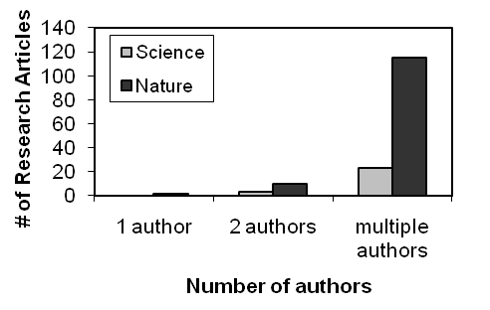
Figure 1-4. The value of teamwork for premiere scientific publishing. Number of research articles in Science and Nature with 1, 2, and multiple authors for the time period of August-December 2007.

Although we know that teamwork is important for science, many of us have experienced frustrating situations when working in teams. For example, maybe you can think of a time when you were part of a team that got the job done (wrote the report, finished a project, completed a lab assignment) but that ended up with members hating each other so intensely that they never wanted to see each other again. Or, maybe you’ve been part of a team whose members really enjoyed one another’s company and had a great time socially, but in the end hadn’t finished the project (or did poorly on it). These situations are frustrating for all involved (teachers and students). Therefore, we aim to provide you with tools and training to help your teams work effectively, such as communication skills, setting realistic, achievable and mutually acceptable goals, and keeping all individuals accountable and integrated into the team.

At this point, please locate and either save or print the journal article by Cheruvelil et al. (2014) that was part of a special issue about Macrosystems Ecology and is freely available on the Frontiers in Ecology and the Environment website. Go to http://www.esajournals.org/toc/fron/12/1 for table of contents, find Cheruvelil et al. 2014 (Creating and maintaining high-performing collaborative research teams: the importance of diversity and interpersonal skills) and locate the pdf and the web supplements. Carefully read the entire article and the first 6 pages of the web supplement before you attend lab. Take notes and reflect on what you learn. For example, below are some questions that you should be able to answer after having completed this reading. Remember to take notes in your lab notebook.
- What prior experiences have you had working in teams (scientific or otherwise)?
- What are some of the most common challenges you’ve encountered in these teams?
- What sorts of teamwork skills are you most interested to learn and practice?
- What are your feelings about the conflicts that arise when working in teams?

We will be forming our semester-long base groups this week. Therefore, you will make a lasting first impression on your teammates and begin forging a relationship with them in lab this week. Coming to lab prepared to work effectively with your team (by completing your reading) will set a good precedent and be appreciated by your teammates.

Teamwork Exercise 1
~~~~~~~~~~~~~~~~~~~~~~~~~~~~~~~~~~~~~~~~~~~~~~~~~~~~~~~~~~~~~~~~~~~~~~~~~~

What Makes an Effective Team?
Adapted from K. Smith (2007)

Purpose: To determine characteristics of an effective team and get to know your teammates.

Directions:
Individually, and with no discussion with your teammates, think about a really effective team you’ve been a member of, a team that accomplished extraordinary things. Start by thinking about teams in an academic, professional, or work setting. If no examples come to mind, then think about social or community-based teams. If still unsuccessful, think about sports teams. Still no luck? Imagine yourself as a member of a really effective team. Picture the team in your mind and try to identify the specific characteristics of that team that made it so effective. Make a list of characteristics that would make your team effective, and be specific (Example: rather than listing “good listening”, list what it takes to be a good listener). Now, recall a team that you were on that you considered to be highly ineffective. What characteristics do you believe made that team ineffective? Make a list of the attributes that you think describes a really ineffective team, and be specific. When told by your instructor, discuss these scenarios and lists with your teammates. Compile a master list of the characteristics that make a team effective. Your team will report back to the class about this list.

Scenario 1: Effective team Scenario 2: Ineffective team

Characteristics of scenario 1’s team: Characteristics of scenario 2’s team:

Master list of characteristics of an effective team from all teams in lab:

By listing all members of your team on the assignment, you are indicating that all team members actively participated in this assignment and are responsible for its contents (quality and originality).
Teamwork Exercise 2
~~~~~~~~~~~~~~~~~~~~~~~~~~~~~~~~~~~~~~~~~~~~~~~~~~~~~~~~~~~~~~~~~~~~~~~~~~

Moon Landing
Adapted from activities obtained from: http://www.nasa.gov/audience/foreducators/topnav/materials/listbysubject/Moon_landingpage.html

Purpose: To demonstrate that group collaboration usually leads to a better outcome than individual work, practice resolving differences and influencing others to maximize teamwork and group processes, and practice being a team player.

You are a member of a space crew scheduled to rendezvous with a mother ship on the lighted surface of the moon. However, due to mechanical difficulties, your own ship was forced to land at a spot 320 km (200 miles) from the rendezvous point. During re-entry and landing, much of the equipment aboard was damaged and, since survival depends on reaching the mother ship, the most critical items available must be chosen for the 320 km trip. 15 items are listed as being intact and undamaged after landing. Your task is to rank them in order of their importance for allowing your crew to reach the rendezvous point.

Directions:
1) Using the ‘STEP 1’ column of the table on the next page, and with no consultation with your teammates (individually), place the number 1 by the most important item, the number 2 by the second most important, and so on through to number 15 for the least important item to help the crew reach the rendezvous site. You should make the following assumptions: the number in the crew is the same as the number on your team, you are the actual people in the situation, the team has agreed to stick together, and all 15 items are in good condition. Do not discuss the situation or the task until each of your team members has finished the individual ranking.
2) Once all individuals are completed with Step 1, come together as a team and assign the following roles:
- Person with the birthday latest in the year is task manager and should make sure that each step is done.
- Person with the birthday earliest in the year is timekeeper and must keep the team on schedule.
- Person with second earliest birthday is reporter who will keep notes and report out to the class on the process and outcomes of the activity.
- If you have a team of four, the remaining person is moderator and should make sure that everyone gets a chance to speak in turn and that consensus is reached. If you have fewer than four people in your team, it is each person’s responsibility to be sure that all team members are contributing.
3) Step 2 is to rank order the 15 items as a team (place numbers in the ‘STEP 2’ column of the table). Once discussion begins, don’t change your individual ranking. Avoid taking votes and work toward a consensus.
4) Once your team has completed Step 2, skip down to Steps 7-8 to individually complete the team process check and come up with ways to answer the debrief questions, then discuss your ideas for Steps 7-8 with your teammates.

 | STEP 1 Individual Ranking | STEP 2 Team Ranking | STEP 3 Planning Experts’ Ranking | STEP 4 Difference between Steps 1 and 3 | STEP 5 Difference between Steps 2 and 3
Box of matches
Food concentrate
20 meters of nylon rope
Parachute silk
Portable heating unit
Two .45 caliber pistols
One case of dehydrated milk
Two 50 kg tanks of oxygen
Stellar map (of the moon’s constellations)
Life raft
Magnetic compass
25 liters of water
Signal flares
First aid kit with hypodermic needle
Solar-powered FM receiver/ transmitter
 |  |  | TOTAL | Your score | Team Score

STEP 6 Total the absolute difference of Steps 4 and 5 (the lower the score the better):

STEP 7 Team Process Check: Individually circle the number that you feel best describes how your team worked together.
Disagree Agree
All team members participated | 1 | 2 | 3 | 4 | 5
The members with roles did their jobs | 1 | 2 | 3 | 4 | 5
The group stayed focused on task | 1 | 2 | 3 | 4 | 5
The group decisions were consensus | 1 | 2 | 3 | 4 | 5
Overall, the team functioned well while performing this task | 1 | 2 | 3 | 4 | 5

Notes:
STEP 8 Team and Class Debrief: Each team will be asked to report back what they found out about problem solving, decision making, and teamwork and group dynamics during this exercise. To prepare for this class discussion, how would your team answer the following questions:

- How did your team come to decisions? Did this work well for everyone?

- How well did your team share ideas and listen to each other? Was there an issue with anyone dominating the discussion? Were all ideas heard?

- What made it difficult or easy to collaborate?

- On a scale of 1 (dissatisfied) to 10 (very satisfied) how do you feel about the processes used to come to consensus? Are you satisfied with the outcome (the team ranking)?

- What could be improved for future team activities?

By listing all members of your team on the assignment, you are indicating that all team members actively participated in this assignment and are responsible for its contents (quality and originality).

Teamwork Exercise 3
~~~~~~~~~~~~~~~~~~~~~~~~~~~~~~~~~~~~~~~~~~~~~~~~~~~~~~~~~~~~~~~~~~~~~~~~~~

Conflict Management

Adapted from Smith (2007)

Purpose: To assess how you and your teammates typically act in conflict situations and help you develop a set of skills and procedures for guiding conflict along a more constructive path.

Individual Directions:
- Take a few minutes to complete the “2. How I Act in Conflict” questionnaire on the next page (from Smith 2007). Try to use professional conflicts and not personal conflicts as your point of reference.
- Score your answers:
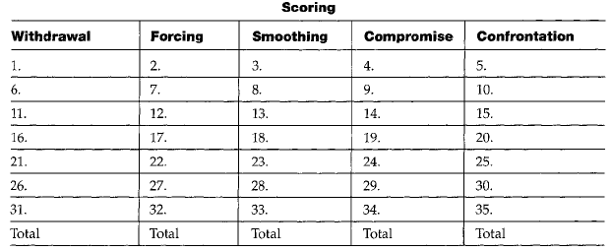
- What are your top two dominant modes of dealing with conflict?

- How do these results surprise you or confirm what you already knew about yourself?

Team Directions: Share and discuss the results of the questionnaire with your teammates. Discuss each of the possible ways to resolve the conflict, similarities and differences in the order in which each team member might use the different strategies, and the relative effectiveness of each for different situations.

By listing all members of your team on the assignment, you are indicating that all team members actively participated in this assignment and are responsible for its contents (quality and originality).
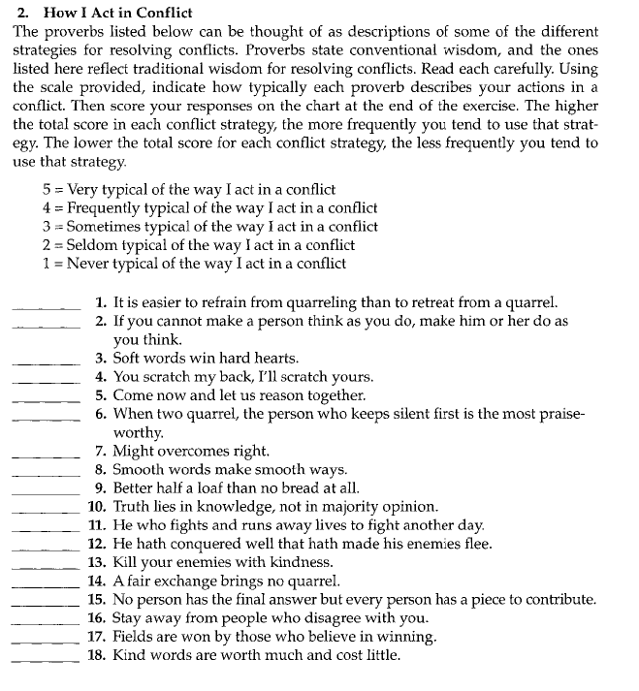
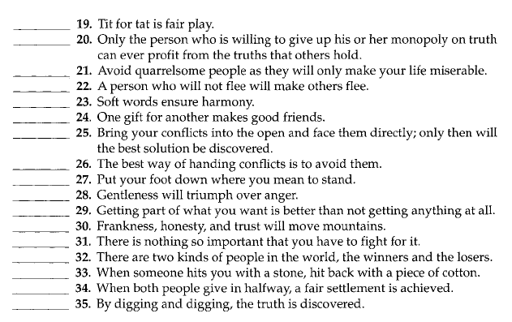
Teamwork Exercise 4
~~~~~~~~~~~~~~~~~~~~~~~~~~~~~~~~~~~~~~~~~~~~~~~~~~~~~~~~~~~~~~~~~~~~~~~~~~

Team Ground Rules Contract Form

Adapted from forms developed by Dr. Deborah Allen, University

of Delaware and Dr. Rique Campa, Michigan State University

Purpose: To establish team norms in order to promote more constructive and productive teamwork.

Directions:
Project groups are an effective aid to learning, but to work best they require that all team members clearly understand their responsibilities to one another. These team ground rules describe the general responsibilities of every member to the team. You can adopt additional ground rules if your group believes they are needed. Your signature on this contract form signifies your commitment to adhere to these rules and expectations.

Some questions to discuss when thinking about these rules:
1) What are your professional goals (i.e., what would you like to do following graduation)? How will working in a team help you achieve some of your professional goals?
2) Besides class time, when are you available to work with your team members (exchange your class and work schedules)?
3) What is the best method(s) and time for your team members to contact you? Share the necessary phone number(s), e-mail addresses, etc... NOTE: This contact information is private, so should not be shared with others outside of your team, and should only be used for class-related communication.

All group members agree to:
- Come to class and team meetings on time.
- Come to class and team meetings with assignments and other necessary preparations correctly and thoughtfully completed.

Additional ground rules (add as many as you like; see examples on pp 36-38 of Smith (2007)):
If a member of the team repeatedly fails to meet these ground rules, other members of the group are expected to take the actions below. When filling in the “If not resolved” sections, think about how, when, and who will communicate dissatisfaction to offending team members. Reflect back on what you’ve learned thus far about your teammates in terms of what previous team experiences they have had, how you have worked together as a group thus far, and how each member tends to feel and deal with conflict.

Step 1:

If not resolved, what will your team do? How? When?:

Step 2: Meet as a team with your lab instructor.

If not resolved, what will your team do? How? When?:

Step 3: The quit or fire clause: If the steps above have been completed without resolving the problem, any team member may quit the team. Alternatively, if all other team members are in agreement, the offending team member may be fired from the team. In either case, the individual no longer working as part of a team is required to complete the remaining lab activities/assignments and research project tasks individually.

The LB 144 teaching team reserves the right to make final decisions to resolve difficulties that arise within a team. Before this becomes necessary, the team should try to find a fair and equitable solution to the problem.

Group Name:______________

Member’s Names (printed), Signatures, and date:

1.____________________________

2.____________________________

3.____________________________

4.____________________________

Teamwork Exercise 5
~~~~~~~~~~~~~~~~~~~~~~~~~~~~~~~~~~~~~~~~~~~~~~~~~~~~~~~~~~~~~~~~~~~~~~~~~~
Teamwork Reflection (Completed twice during semester)

Purpose: To assess team functioning, revisit team processes, and revise team protocols as needed.

Developing good teamwork skills is essential for any professional scientist, regardless of career choice or discipline. These skills take time to develop and also require exposure to a number of different people and different working styles. Not only is it useful for you to evaluate your team’s overall performance, it is also useful to reflect on your own performance relative to the group and how you can modify your own behavior to help your team become more effective.

You recently completed a CATME survey that allows you to rate your team’s performance as a whole as well as provide feedback to the other members of your team. Your instructor has released this feedback to you (you will have received a link via email from catme.org). Now it is time to reflect on the feedback provided by your teammates. Scientists perform these types of personal performance assessments all the time, and you may find this exercise helpful for your professional school applications or resume. The most important aspect of this assessment is for you to identify an area that you need to improve on, and then document how you plan to accomplish this improvement. To do so, open the feedback provided by the CATME survey, print out the report, read and reflect on the results, and then answer the following questions. Use one page total to answer the four questions below. You will turn in your printed report and your answers to these 4 questions to your lab instructors at the beginning of lab.

Individual HW Questions - Answer on a different piece of paper:
          - How does your working style compare/contrast to that of your teammates (similarities and differences)?
          - After reading and reflecting on your teammates' evaluation of your performance, in what ways were you surprised by their assessments of you?
          - For any feedback that was negative, how can you improve?
          - Regardless of feedback, what do you think that YOU can do to make your team work more efficiently and productively for the rest of the semester?

Team assignment: Discuss the ideas that you and your teammates came up with individually for the questions above. Choose 3 specific approaches that you will take to improve your team effectiveness during the rest of the semester. Share this list with your instructor and get approval of your team's plan for improvement. You will revisit this plan later in the semester to evaluate your team's progress.
1.

2.

3.

Instructor Signature _________________________

