Teacher’s guide
Water balloon eye model

Dr. Kwok-chi, LAU
The Chinese University of Hong Kong
laukwokchi@cuhk.edu.hk

Materials each group:
- white balloon (10 inches)
- convex lens (small magnifying glass with high convexity to focus on the back of the balloon, about 6cm of focal length)
- LED torch with changeable focus
- marker pens
- convex and concave lenses for the correction of shortsightedness or long-sightedness

Procedure of making the eyeball model:
4
3
2
1

- Wet the lens and the inside of the balloon neck. Stretch the balloon neck as wide as possible and push the lens into the balloon. Be careful not to cut open the balloon by the sharp edge of the lens.
- Fill the balloon with water until about 12cm in diameter in the sink. While keeping the neck of the balloon twisted and closed, turn the water-filled balloon upside down. The lens inside the balloon will sink to cover the mouth of the balloon. Move the lens to make it center just under the mouth. Untwist the balloon neck in the sink. The water pressure will push the lens to close the mouth.
- Cut away the neck to make a hole (pupil) above the lens.
- Cut out a paper ‘iris’ about half of the diameter of the balloon. Stick it around the pupil with glue.
- Place the balloon eyeball onto a 500ml beaker in a tray - the balloon may ‘pop’ easily.

Representation of the eyeball model:
Figure 5

Part of the eyeball model | Part of human eye
The balloon | Eyeball / sclera
The lens | lens
The paper circle around the hole | iris
The hole allowing light to pass through the lens | Pupil
Inner bottom of the balloon | retina
Centre of the bottom of the balloon | Yellow spot
Water in the balloon | Vitreous humor

Modeling of seeing

- Draw a letter 'F' on the lens of a LED torch with a marker.
- Shine the light of the torch toward the hole of the model.
- Adjust the distance and focus of the torch until a clear image is seen at the bottom of the balloon. If a sharp image cannot be formed, it is likely that the image has been focused behind the balloon. Put another convex lens in front of the balloon to help focus the image (Figure 5).

How is the image formed different from the drawing on the torch?
Left and right reversed and upside down (Figure 6)
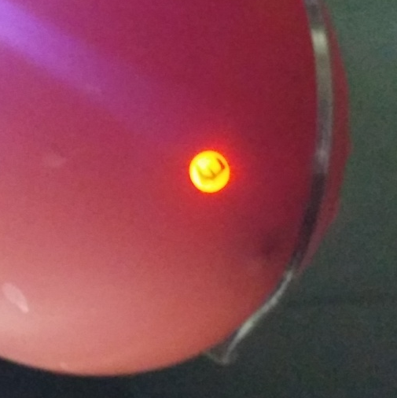
Figure 5
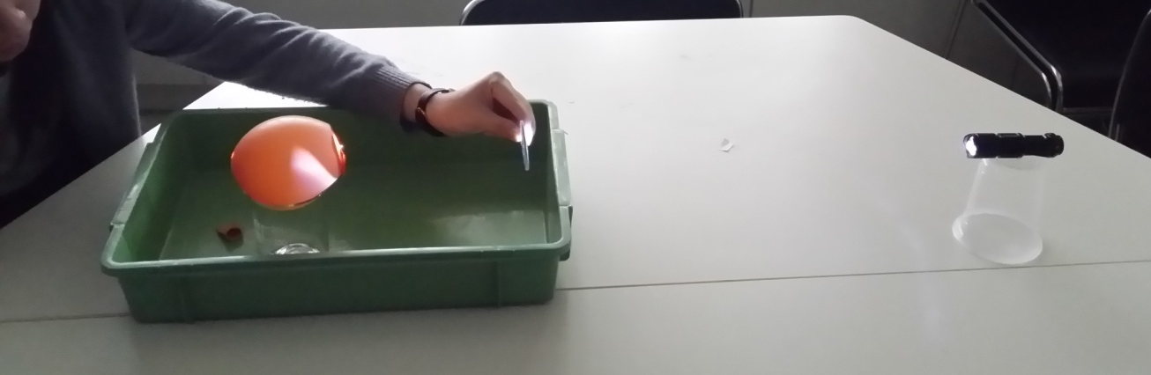
Figure 6

Modeling of shortsighted and longsighted eyes:

- After the image has been focused, compress the balloon to make it longer.
- What happens to the image at the bottom of the balloon? Blurred
- Is it simulating shortsighted and longsighted eyes? Shortsighted eyes

- After the image has been focused, compress the balloon to make it shorter.
- What happens to the image at the bottom of the balloon? Blurred
- Is it simulating shortsighted and longsighted eyes? Longsighted eyes

- Use concave or convex lenses to correct the above shortsighted and longsighted eyes.
- Which lens, concave or convex, can correct the shortsighted eye? Convex lens
- Which lens, concave or convex, can correct the longsighted eye? Concave lens

Safety precaution:
Pressing the balloon too hard may burst it and push the lens out in high speed

Simulation of glaucoma
- Use hands to feel the pressure at the back of the balloon.
- If the balloon is not allowed to expand any further by an inelastic outer coat (sclera), what will happen to the pressure felt when more water is added into the balloon? Harder with greater pressure
- If that happens in the eyeball, what will happen to the blood vessels inside the eyeball? What will then happen to the rod and cone cells at the retina? The blood vessels are compressed and less blood flow will cause the death of rod and cone cells

Limitations of the model

In what aspects does the working of the model not represent that of the human eyes?
- The human eye has lens that can changes its convexity for accommodation, while the lens of the model is fixed in thickness.
- In human eye, the outside layer, sclera, does not allow light to pass through so the image cannot be seen from the bottom of the eyeball. Also, sclera is tough and inelastic, making the eyeball much harder than the balloon eyeball.
- In human eye, the light is refracted mainly by the cornea, which is absent in the model.

