Supplemental Material: Drosophila Cultures, Equipment and Supplies

Obtaining and Caring for Drosophila melanogaster Cultures

Drosophila melanogaster cultures were obtained from Carolina Biological. We reared flies on Genesee Nutri-fly BF media at 25°C. Generation time was reliably 14 days, allowing for easy splitting of cultures at 4 weeks and again at 2 weeks before lab to create large numbers of flies for bait and trap testing. Flies were anesthetized using a FlyNap kit and a minimum of 4 males and 4 females were used to set up each new culture. Alternatively, vials can be placed into the freezer for 30-60 seconds to knock out flies briefly for easy sub-culturing.

Forty standard vials or three large cultures of wild type flies were released directly into an insect proof tent to test the effectiveness of student built traps. Four vials of flightless vestigial-winged flies were provided to each group during bait testing trails to reduce the chance of escape during handling. We assumed that the vestigial gene mutation only affected mobility and did not alter behavior toward attractants.

Used cultures were placed into a freezer (-20°C) for several days before disposing as biohazard waste. Flies released into the SansBug tents were left without food or water for several days before disposing in the same fashion.

Materials and Cultures

D. melanogaster Wild type (Carolina 172100)
D. melanogaster Flightless vestigial mutant (Carolina 172460)
Genesee Scientific Nutri-fly BF OR (Genesee 66-112)
Formula 4-24 Instant Drosophila Medium (Carolina 173202)
Drosophila Vials Wide 28.5 mm Polystyrene (VWR 75813-166)
Drosophila Vial Plugs, Cellulose acetate (VWR 89168-888)
FlyNap Anesthetic Kit (Carolina 173010)

Optional Large Cultures
Creating a smaller number of large cultures for trap testing can reduce material costs and waste compared to vials. Deli containers 32 oz. and vented lids (LLLReptile) hold approx. 150 ml of fly food. Placing aspen excelsior or autoclaved pine straw into the media provided more surface area for larva when they migrated out of the food layer to pupate increasing yields. Numbers of flies observed from these large cultures was on the order of 700 to 1400 compared to 40 to 60 flies per vial.

Optional Mutant Cultures
The genetic component of trap attraction can be explored in more depth by including additional mutant strains of flies. White eyed flies are available from Carolina Biological (172220 and 172720) that lack the pigment necessary for red eyes. This vision variant can be used to explore color and shape attraction compared to bait attraction. The authors are in the process of experimenting with an olfactory (Orco gene deletion) mutant line available from the Bloomington Drosophila Stock Center (23129).
Fly Trap Testing Tent

Any large mosquito proof enclosure is suitable for containing fruit flies during trap testing. Boxes of various sizes were provided so that trap height could be tested as a variable. Because our strains were laboratory raised and included mutant lines, significant measures were taken to prevent individuals from escaping into both the lab space and the environment.

For simplicity, we modified two SansBug 1-person mosquito proof tents instead of constructing a fly-proof enclosure from scratch. This had mesh-covered armholes added to reduce the chance of flies escaping when traps were moved into or out of the tent. To create armholes, a hole was cut into the mesh side of the tent and reinforced with the rim of a 5-gallon Home Depot bucket which was secured using two 7-inch metal band clamps. Wrapping the bucket rim in three-quarters of a yard of mesh fabric before securing created a sleeve-like opening. This was successful at blocking direct escape of flies for the duration of the experiment. Modified SansBug tents maintain their ability to fold flat for compact storage.

Materials

SansBug 1-person pop-up mosquito tent 86”L x 39”W x 35”H
Metal band clamps 7 inches
5-gallon plastic bucket rim
Flexible mesh fabric
Boxes of various sizes

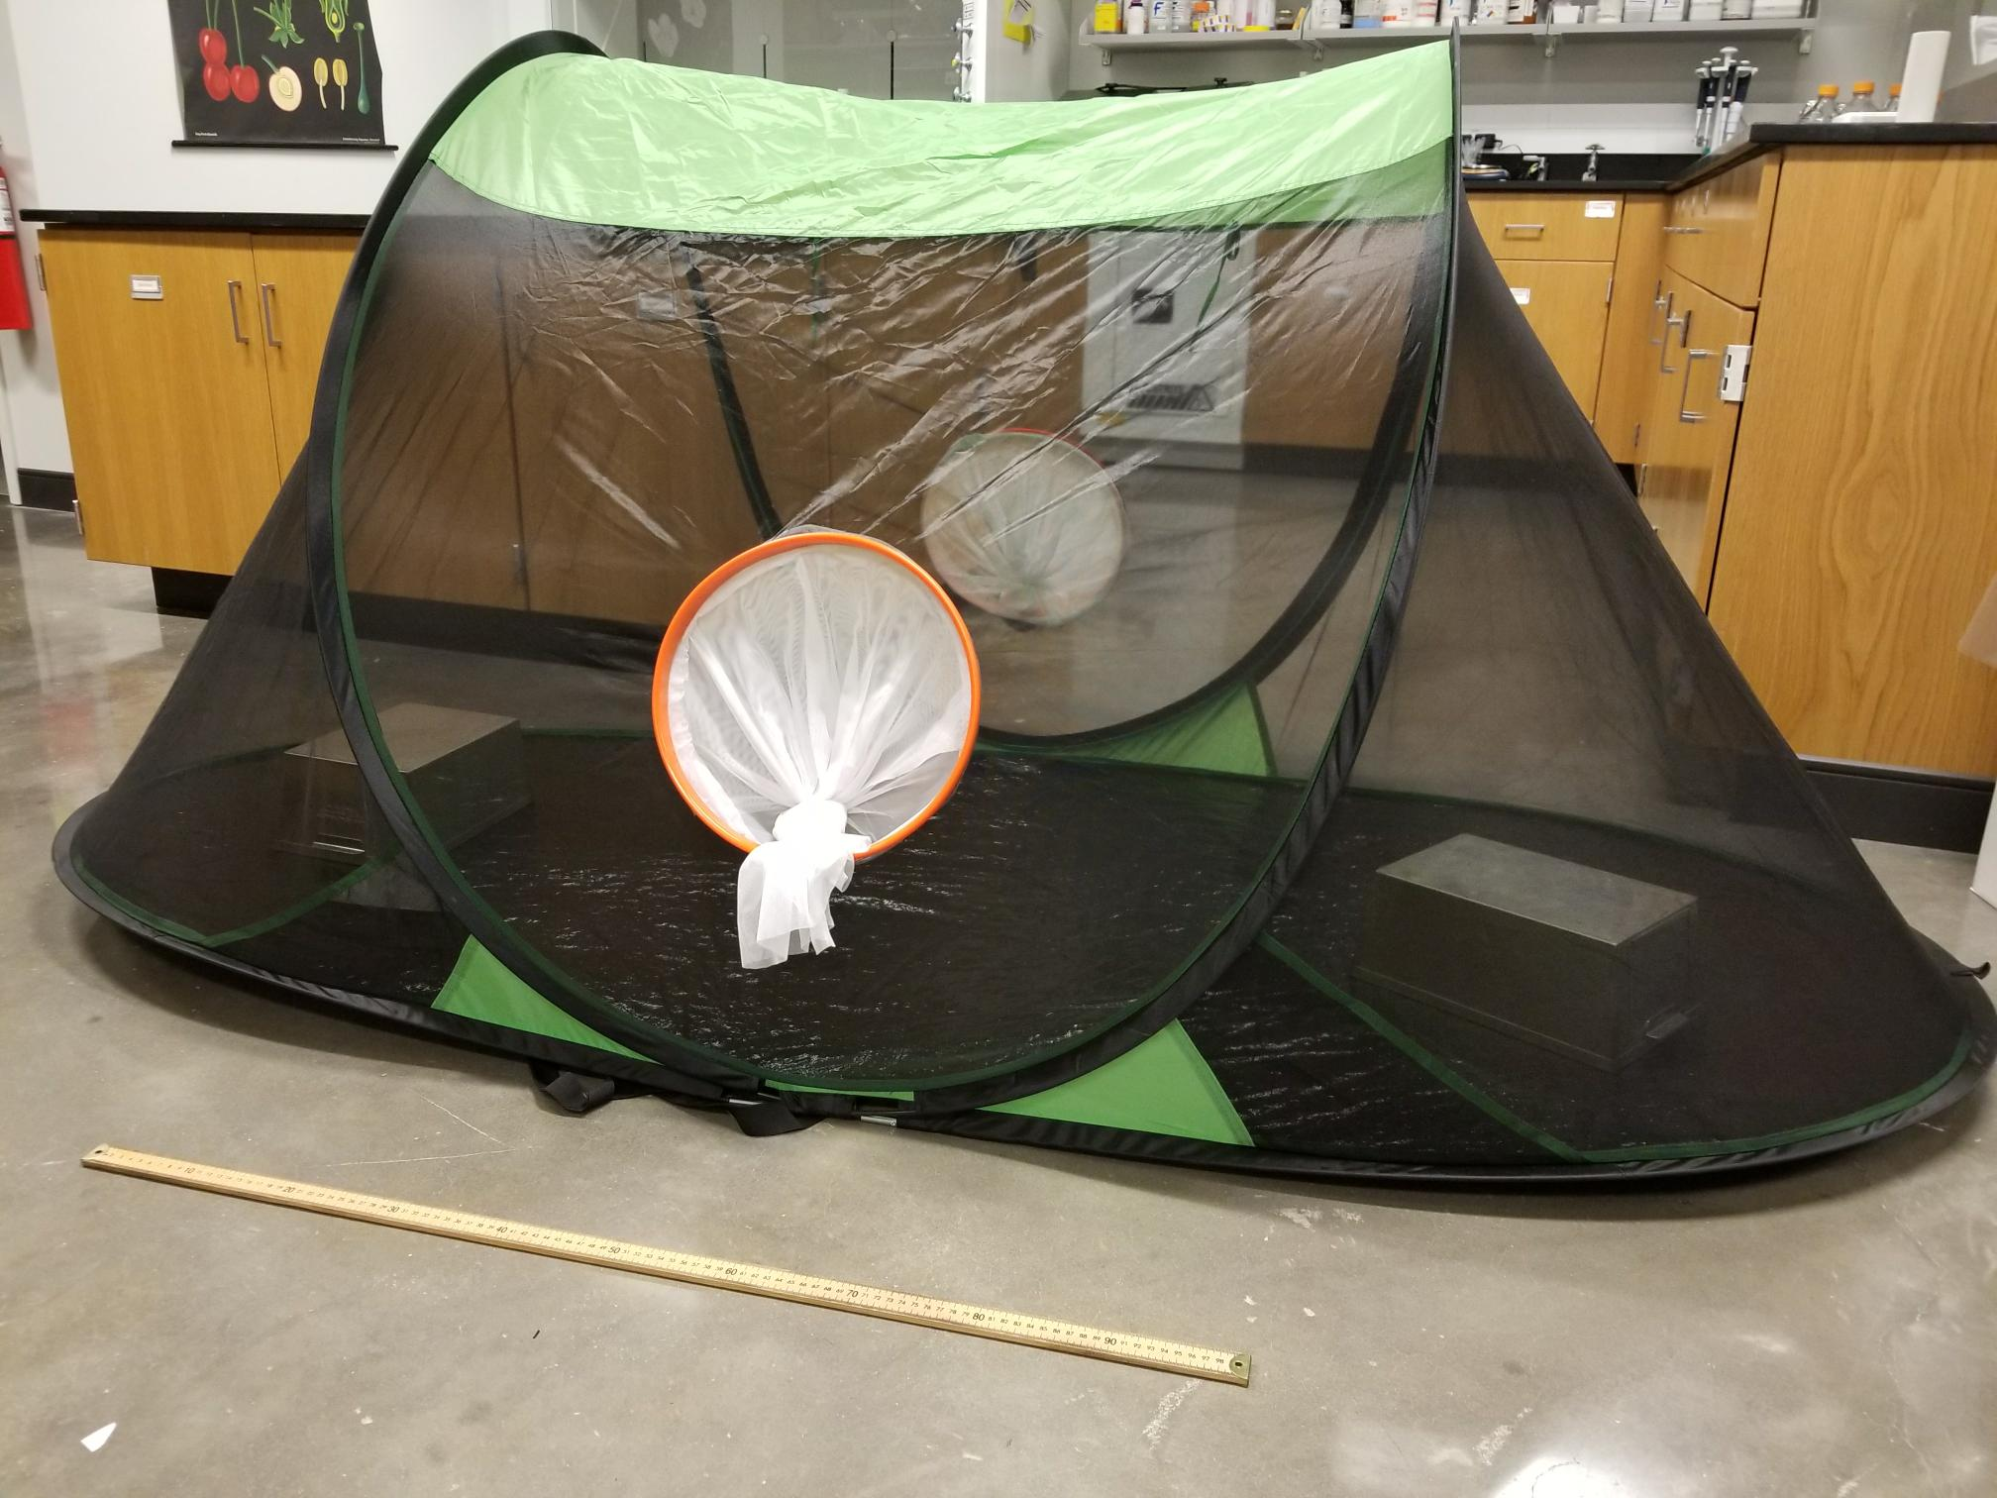
Figure 1: The modified SansBug one person tent [shown collapsed and in the set up position] contains two mesh lined arm holes that allow traps to be added and removed without release of flies.
Photo credit: Alison Onstine

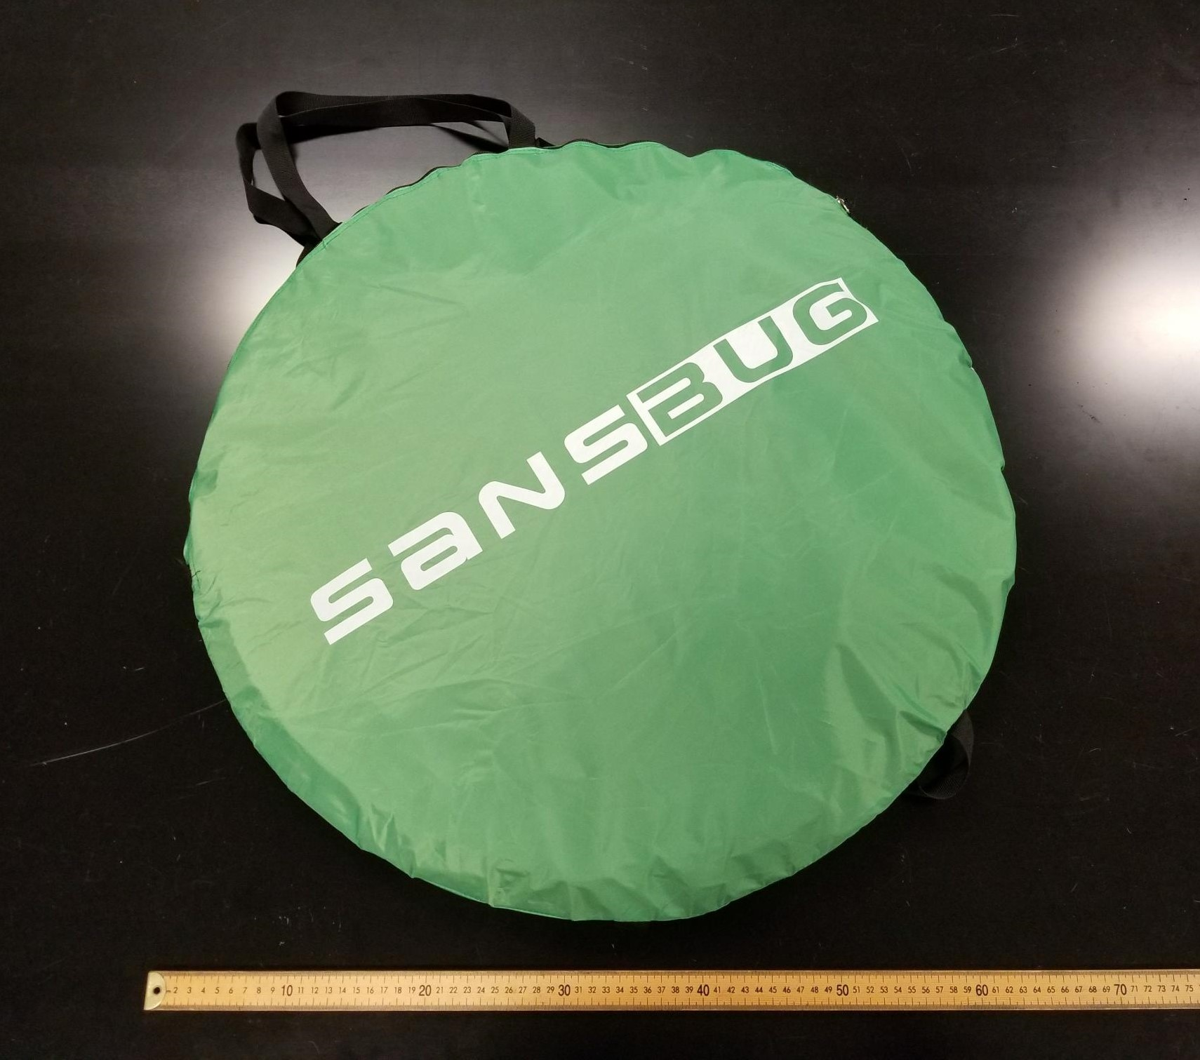

Scent Choice Apparatus

The scent choice apparatus is a T-shaped tube that attaches to three glass vials and allows flies to choose between two different odorant options. Flies were anesthetized briefly by placing them into a freezer for 30-60 seconds before loading approximately 20 individuals into an empty glass vial using a small funnel. A plastic t-connector was used to join this vial with two additional vials containing a small amount of bait. Flies could easily travel from the starting point to visit each of the two bait options. After a fixed period of time experiments were placed into the freezer for easy quantification. A follow up spray with 70% ethanol was used to kill flies for easy viewing under the microscope.

Alternatively, a simpler apparatus can be constructed to test one bait option at a time (Vang et al., 2012). Here a large glass culture tube is divided into several sections with a cotton ball at one end containing a single bait option. Flies signal their interest by their proximity to the bait. After a set amount of time, the number of flies located in each section is counted. Flies can be sexed by placing the apparatus into a freezer and removing flies one section at a time with a paintbrush.

T-Maze Materials

Untapered T-connector joint 10 mm (VWR 46600-060)
Glass vials, screw-cap 3 dram (19x65mm) 15-425 cap size (VWR 66011-100)
Small funnels

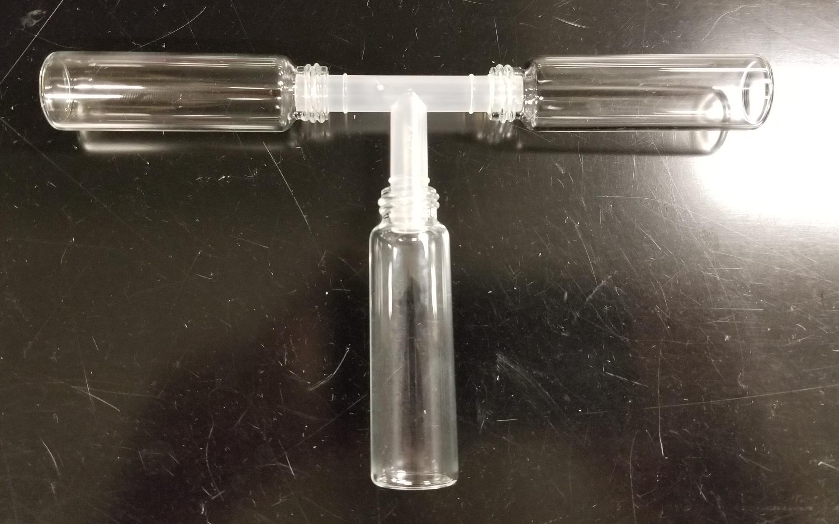
Figure 2: Details of the components of the scent choice apparatus. This T-maze is easy to construct from lab supplies.
Photo credit: Alison Onstine

Alternative Proximity Test

Glass culture tubes 20 x 150 mm (Fisher 1496133)
Culture tube cap Kim-Kap 18 mm (Fisher 1495791B)
Cotton balls
Small funnels

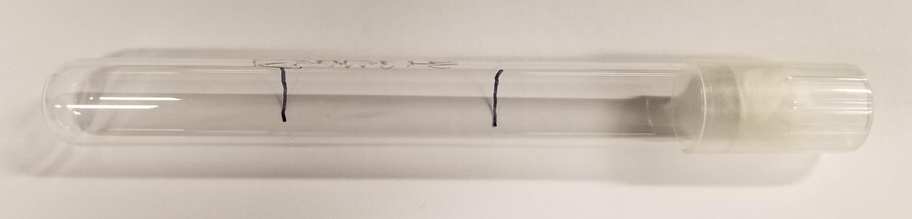
Figure 3: Details of the proximity test.
Photo credit: Alison Onstine

Observing and Quantifying Flies

Providing students with the opportunity to closely examine the morphology of flies after capture or bait testing allows them to include the sex of flies as a variable. Capturing female flies as a means of controlling fly populations was emphasized in our activity. To help with this task, students were provided with images of male and female flies as well as sealed demo plates containing living examples of each sex.

Ethanol was provided to spray traps as they were being removed from the fly tent to kill any associated flies that might be trapped on sticky paper or in the bait solution. Empty petri plates and paintbrushes were used to manipulate flies in solution under the microscope. Liquid waste was collected and disposed of as chemical waste.

Materials
Stereomicroscopes – One per pair of students. Olympus SZ51 Zoom range 0.8X – 4X
Examples of living male and female flies
Spray bottles with ethanol - 70%
Paint brushes and small dishes to manipulate flies while viewing

Additional Materials

Trap Construction Materials

Plastic cups many sizes
Cellophane (red, yellow, green, and blue)
Colored paper
Aluminum foil
Yellow sticky insect paper
Tape
Scissors
Small mirrors
Assorted pipe cleaners

Bait & Attractant Suggestions

Acetic acid solutions
Apple cider vinegar
Red wine vinegar
Fruit juices
Fresh and rotten fruit
Honey
Corn syrup
Molasses
Sucrose
Glucose
Fructose
Nutritional yeast, inactive dry
Baker’s yeast, rehydrated in warm water, living
Ethanol 100%
Commercial fruit fly trap bait

References

Vang, L. L., Medvedev, A. V., & Adler, J. (2012). Simple ways to measure behavioral responses of Drosophila to stimuli and use of these methods to characterize a novel mutant. PLoS ONE 7(5):e37495.

