Translation Model

Objectives
- Convert information on translation into a physical model.
- Describe how mRNA, tRNAs, and ribosomes are used in translation.
- Recognize that start and stop codons are only used in translation.
- Describe how translation starts and ends.
- Describe the anatomy of a tRNA.
- Interpret a codon-amino acid chart.

Part 1
Before starting on the function, answer these questions.
- Create a sequence of four amino acids, starting with the amino acid that is coded by a start codon.

- Then write out the corresponding mRNA sequence- do not forget about the stop codon.

- What will be the tRNAs for this mRNA sequence? Complete the tRNAs below by adding the anticodons (bottom of each tRNA) and amino acids (top of each tRNA). Note that the amino acid chart uses the mRNA codon sequence, not the tRNA anti-codon sequence.

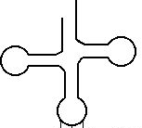

Part 2
- Now it is time to develop the components of the translation model. Some parts have already been given to you.
- This model will be a functional model. Each team is given a kit of four tRNAs, 4 pieces of paper with paperclips (for the amino acids), different colored pipe cleaners to create tRNA bases, and a paper ribosome, release factor, and mRNA.

- First, create the tRNAs. You will model the base sequence of each tRNA by designating one color for each base (U, A, G, C). Create a key below:

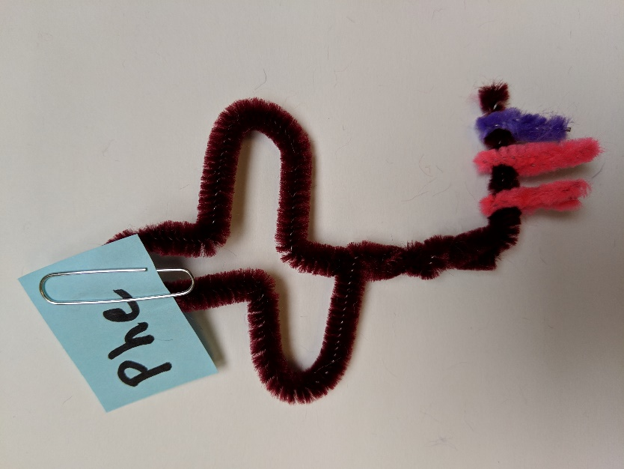
- Next, attach a small square to each tRNA and write the amino acid name on each corresponding small piece of paper.

- Then fill in the mRNA sequence. Make sure that the mRNA sequence will align with the tRNA sequence. In other words, make sure that the spacing between bases is the same.

- Then develop your translation model. In addition to incorporating the items mentioned above, your functional model should answer the following questions:
  - What does the mRNA look like when it is being used in translation?
  - Where does translation take place?
  - What are the A, P, and E sites on a ribosome?
  - What happens to the amino acids as tRNAs move through the model?
  - What happens when a stop codon is reached?

- Each team member should work through the model, teaching the rest of the team how the process works. For participation credit, take at least three photographs of the process (have a piece of paper with team member names in the picture). It might also be helpful to take a video of the modeling process.

