****

**Workbook**

name: \_\_\_\_\_\_\_\_\_\_\_\_\_\_\_\_\_\_\_\_\_\_\_\_\_\_\_\_\_\_\_\_\_\_\_\_\_\_\_\_\_

class: \_\_\_\_\_\_\_\_\_\_\_\_\_\_\_\_\_\_\_\_\_\_\_\_\_\_\_\_\_\_\_\_\_\_\_\_\_\_\_\_\_

date: \_\_\_\_\_\_\_\_\_\_\_\_\_\_\_\_\_\_\_\_\_\_\_\_\_\_\_\_\_\_\_\_\_\_\_\_\_\_\_\_\_

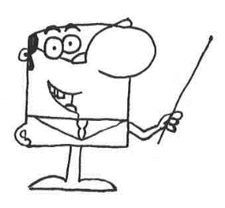

Dear student,

This workbook will accompany you through the individual stations in the room. For each station, there are tasks that you solve in this workbook. So you learn a lot about the current topic of microplastics.

Some information about the implementation:

* Start with the station assigned to you. Then work the stations in sequence, for example: 1 🡪 2 🡪 3 🡪 4 🡪 5
* The work materials and work instructions can be found in the workplace of the station.
* Exception: Station 4 is processed by all groups at the end.
* Edit a station entirely before starting a new one. After finishing a station, put everything back the way you found it.
* Tick already completed stations in the table below.

**I wish you a lot of fun, and I am glad that you work with me today.**

**Your Mr. Experto**

|  |  |
| --- | --- |
|  | QualitÃ¤t, Haken, HÃ¤kchen, Abgehakt, Ja, Zustimmung**Done:** |
| **Station 1** |  |
| **Station 2** |  |
| **Station 3** |  |
| **Station 4** |  |
| **Station 5** |  |
| **Station 6** |  |
| **Station 7** |  |

**Introduction: What is microplastic?**

Answer the following questions.

1. Which things that you own or use are made out of plastic?

\_\_\_\_\_\_\_\_\_\_\_\_\_\_\_\_\_\_\_\_\_\_\_\_\_\_\_\_\_\_\_\_\_\_\_\_\_\_\_\_\_\_\_\_\_\_\_\_\_\_\_\_\_\_\_\_\_\_\_\_\_\_\_\_\_\_\_\_\_\_\_\_\_\_\_\_\_\_\_\_\_\_\_\_\_\_\_\_\_\_\_\_\_\_\_\_\_\_\_\_\_\_\_\_\_\_\_\_\_\_\_\_\_\_\_\_\_\_\_\_\_\_\_\_\_\_\_\_\_\_\_\_\_\_\_\_\_\_\_\_\_\_\_\_\_\_\_\_\_\_\_\_\_\_\_\_\_\_\_\_\_\_\_\_\_\_\_\_\_\_\_\_\_\_\_\_\_\_\_\_\_\_\_\_\_\_\_\_\_\_\_\_\_\_\_\_\_\_\_\_\_\_\_\_\_\_\_\_\_\_\_\_\_\_\_\_\_\_\_\_

1. Where in the environment have you seen plastic or microplastic?

\_\_\_\_\_\_\_\_\_\_\_\_\_\_\_\_\_\_\_\_\_\_\_\_\_\_\_\_\_\_\_\_\_\_\_\_\_\_\_\_\_\_\_\_\_\_\_\_\_\_\_\_\_\_\_\_\_\_\_\_\_\_\_\_\_\_\_\_\_\_\_\_\_\_\_\_\_\_\_\_\_\_\_\_\_\_\_\_\_\_\_\_\_\_\_\_\_\_\_\_\_\_\_\_\_\_\_\_\_\_\_\_\_\_\_\_\_\_\_\_\_\_\_\_\_\_\_\_\_\_\_\_\_\_\_\_\_\_\_\_\_\_\_\_\_\_\_\_\_\_\_\_\_\_\_\_\_\_\_\_\_\_\_\_\_\_\_\_\_\_\_\_\_\_\_\_\_\_\_\_\_\_\_\_\_\_\_\_\_\_\_\_\_\_\_\_\_\_\_\_\_\_\_\_\_\_\_\_\_\_\_\_\_\_\_\_\_\_\_\_

1. Diagram how plastic or microplastic might get from your house to the beach.

**Introduction: What is microplastic?**

1. What will happen to Emma and Lenny’s beach toys, if they forget them on the beach? Collect ideas with your group.

\_\_\_\_\_\_\_\_\_\_\_\_\_\_\_\_\_\_\_\_\_\_\_\_\_\_\_\_\_\_\_\_\_\_\_\_\_\_\_\_\_\_\_\_\_\_\_\_\_\_\_\_\_\_\_\_\_\_\_\_\_\_\_\_\_\_\_\_\_\_\_\_\_\_\_\_\_\_\_\_\_\_\_\_\_\_\_\_\_\_\_\_\_\_\_\_\_\_\_\_\_\_\_\_\_\_\_\_\_\_\_\_\_\_\_\_\_\_\_\_\_\_\_\_\_\_\_\_\_\_\_\_\_\_\_\_\_\_\_\_\_\_\_\_\_\_\_\_\_\_\_\_\_\_\_\_\_\_\_\_\_\_\_\_\_\_\_\_\_\_\_\_\_\_\_\_\_\_\_\_\_\_\_\_\_\_\_\_\_\_\_\_\_\_\_\_\_\_\_\_\_\_\_\_\_\_\_\_\_\_\_\_\_\_\_\_\_\_\_\_

1. Define the term microplastic.

\_\_\_\_\_\_\_\_\_\_\_\_\_\_\_\_\_\_\_\_\_\_\_\_\_\_\_\_\_\_\_\_\_\_\_\_\_\_\_\_\_\_\_\_\_\_\_\_\_\_\_\_\_\_\_\_\_\_\_\_\_\_\_\_\_\_\_\_\_\_\_\_\_\_\_\_\_\_\_\_\_\_\_\_\_\_\_\_\_\_\_\_\_\_\_\_\_\_\_\_\_\_\_\_\_\_\_\_\_\_\_\_\_\_\_\_\_\_\_\_\_\_\_\_\_\_\_\_\_\_\_\_\_\_\_\_\_\_\_\_\_\_\_\_\_\_\_\_\_\_\_\_\_\_\_\_\_\_\_\_\_\_\_\_\_\_\_\_\_\_\_\_\_\_\_\_\_\_\_\_\_\_\_\_\_\_\_\_\_\_\_\_\_\_\_\_\_\_\_\_\_\_\_\_\_\_\_\_\_\_\_\_\_\_\_\_\_\_\_\_

****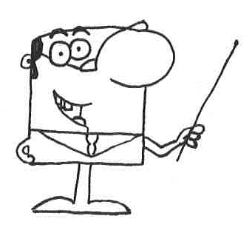

**Let’s start!**

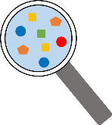**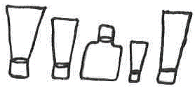Station 1: Examination of exfoliating cream**

Task 1:

1. Part A: Carry out the experiment according to the instructions.
2. Part B: Carry out the experiment according to the instructions.

Write down your observations.

|  |
| --- |
| **Plastic in cosmetics** |
| polyethylene |
| polypropylene |
| polyethylene terephthalate |
| nylon-12 |
| nylon-6 |
| polyurethane |
| acrylate copolymer |
| acrylate crosspolymer |
| polyacrylate |
| polymethylmethacrylate |
| polystyrene |
| polyquaternium |

\_\_\_\_\_\_\_\_\_\_\_\_\_\_\_\_\_\_\_\_\_\_\_\_\_\_\_\_\_\_\_\_\_\_\_\_\_\_\_\_\_\_\_\_\_\_\_\_\_\_\_\_\_\_\_\_\_\_\_\_\_\_\_\_\_\_\_\_\_\_\_\_\_\_\_\_\_\_\_\_\_\_\_\_\_\_\_\_\_\_\_\_\_\_\_\_\_\_\_\_\_\_\_\_\_\_\_\_\_\_\_\_\_\_\_\_\_\_\_\_\_\_\_\_\_\_\_\_\_\_\_\_\_\_\_\_\_\_\_\_\_\_\_\_\_\_\_\_\_\_\_\_\_\_\_\_\_\_\_\_\_\_\_\_\_\_\_\_\_\_\_\_\_\_\_\_\_\_\_\_\_\_\_\_\_\_\_\_\_\_\_\_\_\_\_\_\_\_\_\_\_\_\_\_\_\_\_\_\_\_\_\_\_\_\_\_\_\_\_\_

1. What could be the residue?

Examine the ingredients on the exfoliating cream package and compare it to the plastic list.

Can you identify the material?

The exfoliating cream contains microplastic called \_\_\_\_\_\_\_\_\_\_\_\_\_\_\_\_\_\_\_.

Task 2: Are plastic particles in wastewater a problem?

Use the word box and the card to fill in the blanks.

Word box: environment, microplastics, wastewater, sewage treatment plant, microbeads

Cosmetics may contain \_\_\_\_\_\_\_\_\_\_\_\_. Exfoliating creams clean the skin with the help of abrasives (e.g., \_\_\_\_\_\_\_\_\_\_\_\_\_\_). Via \_\_\_\_\_\_\_\_\_\_\_\_, the microbeads are transferred to the \_\_\_\_\_\_\_\_\_\_\_\_\_\_\_\_\_\_\_\_. The sewage treatment plant cannot completely retain the microplastics, so some small plastic particles get into the \_\_\_\_\_\_\_\_\_\_\_\_\_\_\_\_\_\_\_.

**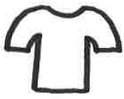Station 2: Examination of textiles**

Task 1:

1. Part A: Carry out the experiment according to the instructions.
2. Part B: Carry out the experiment according to the instructions.

Write down your oberservations.

\_\_\_\_\_\_\_\_\_\_\_\_\_\_\_\_\_\_\_\_\_\_\_\_\_\_\_\_\_\_\_\_\_\_\_\_\_\_\_\_\_\_\_\_\_\_\_\_\_\_\_\_\_\_\_\_\_\_\_\_\_\_\_\_\_\_\_\_\_\_\_\_\_\_\_\_\_\_\_\_\_\_\_\_\_\_\_\_\_\_\_\_\_\_\_\_\_\_\_\_\_\_\_\_\_\_\_\_\_\_\_\_\_\_\_\_\_\_\_\_\_\_\_\_\_\_\_\_\_\_\_\_\_\_\_\_\_\_\_\_\_\_\_\_\_\_\_\_\_\_\_\_\_\_\_\_\_\_\_\_\_\_\_\_\_\_\_\_\_\_\_\_\_\_\_\_\_\_\_\_\_\_\_\_\_\_\_\_\_\_\_\_\_\_\_\_\_\_\_\_\_\_\_\_\_\_\_\_\_\_\_\_\_\_\_\_\_\_\_\_

1. What could be the residue?

Find out about the composition of the substance on the label.

The fabric is 100% \_\_\_\_\_\_\_\_\_\_\_\_\_\_\_\_\_\_\_.

Task 2: Are plastic particles in the laundry a problem?

Use the word box and the card to fill in the blanks. Orally explain the effects of plastic particles in the wash.

Word box: plastic, lints, sewage treatment plant, wastewater, environment, plastic particles

From the fabric (plastic fibers), which consists of \_\_\_\_\_\_\_\_\_\_\_\_\_\_, \_\_\_\_\_\_\_\_\_\_\_\_\_\_\_\_\_\_ dissolve. These \_\_\_\_\_\_\_\_\_\_\_\_\_\_\_\_\_\_\_ flow via the washing machine and its \_\_\_\_\_\_\_\_\_\_\_\_\_\_\_\_\_\_\_\_\_\_\_ into the \_\_\_\_\_\_\_\_\_\_\_\_\_\_\_\_\_\_\_\_\_\_\_\_\_\_\_\_. The sewage treatment plant cannot completely retain the microplastics, so some small plastic particles get into the \_\_\_\_\_\_\_\_\_\_\_\_\_\_\_\_\_\_\_\_\_.

**Station 3: Mr. Experto looking for traces   
in the drugstore**

Task:

Mr. Experto has recently been shopping in the drugstore.

Look at the ingredients of the purchased items and use the plastic list to identify the products that contain plastic. Write down these articles.

Share the work in the group and then exchange it.

|  |  |  |
| --- | --- | --- |
| Article | Plastic contained? | |
|  | YES | NO |
|  |  |  |
|  |  |  |
|  |  |  |
|  |  |  |
|  |  |  |
|  |  |  |
|  |  |  |
|  |  |  |

Warnung, Schild, Gefahr, Achtung, StraÃenschild

**Attention, tell a friend!**

Look at the ingredients when buying cosmetics. If plastic is included, then do not buy the item.

**Tip:** Words that contain "poly" are an indication of plastic.

**Station 4: How does the microplastic get to the beach?**

Task 1: Watch the short information film.

Task 2: Sort the laminated images into a flowchart. The lower scheme will help you.

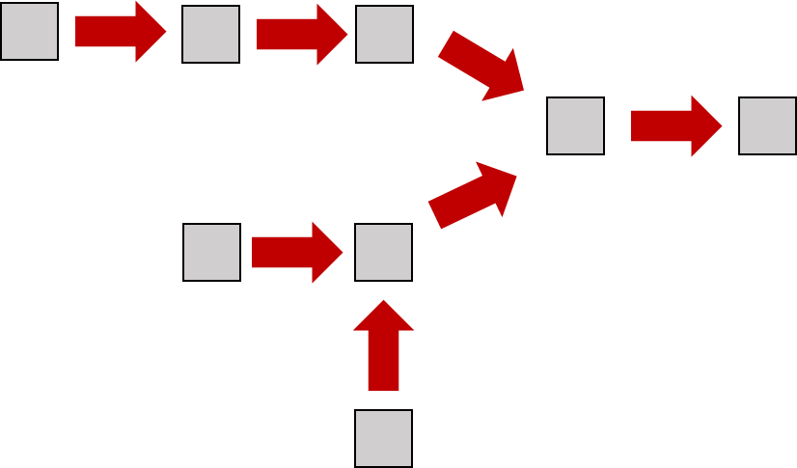

Paste the sample solution here:

sample solution

Task 3: After you've laid and checked the pictures, explain each other the question: "How does microplastics get to the beach?".

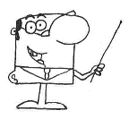

**For experts:**

Try to explain the terms **primary microplastics and secondary microplastics** using the graphic.

„primary“ = first available, „secundary“ = later added

\_\_\_\_\_\_\_\_\_\_\_\_\_\_\_\_\_\_\_\_\_\_\_\_\_\_\_\_\_\_\_\_\_\_\_\_\_\_\_\_\_\_\_\_\_\_\_\_\_\_\_\_\_\_\_\_\_\_\_\_\_\_\_\_\_\_\_\_\_\_\_\_\_\_\_\_\_\_\_\_\_\_\_\_\_\_\_\_\_\_\_\_\_\_\_\_\_\_\_\_\_\_\_\_\_\_\_\_\_\_\_\_\_\_\_\_\_\_\_\_\_\_\_\_\_\_\_\_\_\_\_\_\_\_\_\_\_\_\_\_\_\_\_\_\_\_\_\_\_\_\_\_\_\_\_\_\_\_\_\_\_\_\_\_\_\_\_\_\_\_\_\_\_\_\_\_\_\_\_\_\_\_\_\_\_\_\_\_\_\_\_\_\_\_\_\_\_\_\_\_\_\_\_\_\_\_\_\_\_\_\_\_\_\_\_\_\_\_\_\_\_\_\_\_\_\_\_\_\_\_\_\_\_\_\_\_\_\_\_\_\_\_\_\_\_\_\_\_\_\_\_\_

**Station 5: Microplastic in the environment – so what?!**

Task 1: Take the roles of the animals in "Conference of Animals in the Sea".

Read the text and answer the following questions.

1. Why are the animals meeting for a conference?

\_\_\_\_\_\_\_\_\_\_\_\_\_\_\_\_\_\_\_\_\_\_\_\_\_\_\_\_\_\_\_\_\_\_\_\_\_\_\_\_\_\_\_\_\_\_\_\_\_\_\_\_\_\_\_\_\_\_\_\_\_\_\_\_\_\_\_\_\_\_\_\_\_\_\_\_\_\_\_\_\_\_\_\_\_\_\_\_\_\_\_\_\_\_\_\_\_\_\_\_\_\_\_\_\_\_\_\_\_\_\_\_\_\_\_\_\_\_\_\_\_\_\_\_\_\_\_\_\_\_\_\_\_\_\_\_\_\_\_\_\_\_\_\_\_\_\_\_\_\_\_\_\_\_\_\_\_\_\_\_\_\_\_\_\_

1. What problem of the animals stood out to you?

\_\_\_\_\_\_\_\_\_\_\_\_\_\_\_\_\_\_\_\_\_\_\_\_\_\_\_\_\_\_\_\_\_\_\_\_\_\_\_\_\_\_\_\_\_\_\_\_\_\_\_\_\_\_\_\_\_\_\_\_\_\_\_\_\_\_\_\_\_\_\_\_\_\_\_\_\_\_\_\_\_\_\_\_\_\_\_\_\_\_\_\_\_\_\_\_\_\_\_\_\_\_\_\_\_\_\_\_\_\_\_\_\_\_\_\_\_\_\_\_\_\_\_\_\_\_\_\_\_\_\_\_\_\_\_\_\_\_\_\_\_\_\_\_\_\_\_\_\_\_\_\_\_\_\_\_\_\_\_\_\_\_\_\_\_

1. Which animal do you think is struggling the most? Explain why.

\_\_\_\_\_\_\_\_\_\_\_\_\_\_\_\_\_\_\_\_\_\_\_\_\_\_\_\_\_\_\_\_\_\_\_\_\_\_\_\_\_\_\_\_\_\_\_\_\_\_\_\_\_\_\_\_\_\_\_\_\_\_\_\_\_\_\_\_\_\_\_\_\_\_\_\_\_\_\_\_\_\_\_\_\_\_\_\_\_\_\_\_\_\_\_\_\_\_\_\_\_\_\_\_\_\_\_\_\_\_\_\_\_\_\_\_\_\_\_\_\_\_\_\_\_\_\_\_\_\_\_\_\_\_\_\_\_\_\_\_\_\_\_\_\_\_\_\_\_\_\_\_\_\_\_\_\_\_\_\_\_\_\_\_\_

1. What problems do the animals have with the microplastic (plastic particles smaller than 5 mm)? Tick ​​the right sentences.

|  |  |  |  |
| --- | --- | --- | --- |
|  | Plastic can be confused with food. |  | If an animal dies, it can affect other  animals (food web). |
|  | Microplastics can be digested  by fish. |  | Humans also consume microplastic via food. |
|  | Microplastics can accumulate toxic  substances that endanger animals. |  | Humans protect animals from  microplastics. |
|  | Animals need microplastics as food. |  | Plastic is indigestible and does not  provide energy. |
|  | Animals can get caught in plastic  and hurt. |  | Animals need plastic for swimming. |

**Station 5: Microplastic in the environment – so what?!**

Task 2:

1. Write down the food web beginning with plankton (small crustaceans). Take the text as an aid and fill in the boxes below.

Words: blue whale, herring, plankton, tuna

C:\Users\bt305302\Documents\03_Daten\02_American Biology Teacher\Major Revisions\Manuscript Revisions\Station 3_Nahrungskette_Englisch\Folie1.TIF

1. If microplastic is present in the plankton, then it can enter the food web. Use a red pencil to surround animals burdened with microplastics.
2. Does it affect humans when microplastics are in the food web? Discuss with your group members which marine animals you like to eat and consider whether humans are also burdened by microplastics (possibly red box).

\_\_\_\_\_\_\_\_\_\_\_\_\_\_\_\_\_\_\_\_\_\_\_\_\_\_\_\_\_\_\_\_\_\_\_\_\_\_\_\_\_\_\_\_\_\_\_\_\_\_\_\_\_\_\_\_\_\_\_\_\_\_\_\_\_\_\_\_\_\_\_\_\_\_\_\_\_\_\_\_\_\_\_\_\_\_\_\_\_\_\_\_\_\_\_\_\_\_\_\_\_\_\_\_\_\_\_\_\_\_\_\_\_\_\_\_\_\_\_\_\_\_\_\_\_\_\_\_\_\_\_\_\_\_\_\_\_\_\_\_\_\_\_\_\_\_\_\_\_\_\_\_\_\_\_\_\_\_\_\_\_\_\_\_\_

**Station 6: Is there an alternative?**

Task 1: Play the plastic-memory and match the related single-use, multiple-use and alternative products, respectively the least to the most sustainable products.

Task 2: Paste the sample solution here.

Write down the pros and cons of the products (e.g., concerning price, weight, durability, amount of garbage, single-use/multiple-use).

|  |  |  |
| --- | --- | --- |
| \_\_\_\_\_\_\_\_\_\_\_\_\_\_\_\_\_\_\_\_\_\_\_\_\_\_\_\_\_\_\_\_\_\_\_\_\_\_  \_\_\_\_\_\_\_\_\_\_\_\_\_\_\_\_\_\_\_\_\_\_\_\_\_\_\_\_\_\_\_\_\_\_\_\_\_\_ | \_\_\_\_\_\_\_\_\_\_\_\_\_\_\_\_\_\_\_\_\_\_\_\_\_\_\_\_\_\_\_\_\_\_\_\_\_\_  \_\_\_\_\_\_\_\_\_\_\_\_\_\_\_\_\_\_\_\_\_\_\_\_\_\_\_\_\_\_\_\_\_\_\_\_\_\_ | \_\_\_\_\_\_\_\_\_\_\_\_\_\_\_\_\_\_\_\_\_\_\_\_\_\_\_\_\_\_\_\_\_\_\_\_\_\_  \_\_\_\_\_\_\_\_\_\_\_\_\_\_\_\_\_\_\_\_\_\_\_\_\_\_\_\_\_\_\_\_\_\_\_\_\_\_ |
| \_\_\_\_\_\_\_\_\_\_\_\_\_\_\_\_\_\_\_\_\_\_\_\_\_\_\_\_\_\_\_\_\_\_\_\_\_\_  \_\_\_\_\_\_\_\_\_\_\_\_\_\_\_\_\_\_\_\_\_\_\_\_\_\_\_\_\_\_\_\_\_\_\_\_\_\_\_\_\_\_\_\_\_\_\_\_\_\_\_\_\_\_\_\_\_ | \_\_\_\_\_\_\_\_\_\_\_\_\_\_\_\_\_\_\_\_\_\_\_\_\_\_\_\_\_\_\_\_\_\_\_\_\_\_  \_\_\_\_\_\_\_\_\_\_\_\_\_\_\_\_\_\_\_\_\_\_\_\_\_\_\_\_\_\_\_\_\_\_\_\_\_\_\_\_\_\_\_\_\_\_\_\_\_\_\_\_\_\_\_\_\_ | \_\_\_\_\_\_\_\_\_\_\_\_\_\_\_\_\_\_\_\_\_\_\_\_\_\_\_\_\_\_\_\_\_\_\_\_\_\_  \_\_\_\_\_\_\_\_\_\_\_\_\_\_\_\_\_\_\_\_\_\_\_\_\_\_\_\_\_\_\_\_\_\_\_\_\_\_\_\_\_\_\_\_\_\_\_\_\_\_\_\_\_\_\_\_\_ |
| \_\_\_\_\_\_\_\_\_\_\_\_\_\_\_\_\_\_\_\_\_\_\_\_\_\_\_\_\_\_\_\_\_\_\_\_\_\_  \_\_\_\_\_\_\_\_\_\_\_\_\_\_\_\_\_\_\_\_\_\_\_\_\_\_\_\_\_\_\_\_\_\_\_\_\_\_\_\_\_\_\_\_\_\_\_\_\_\_\_\_\_\_\_\_\_ | \_\_\_\_\_\_\_\_\_\_\_\_\_\_\_\_\_\_\_\_\_\_\_\_\_\_\_\_\_\_\_\_\_\_\_\_\_\_  \_\_\_\_\_\_\_\_\_\_\_\_\_\_\_\_\_\_\_\_\_\_\_\_\_\_\_\_\_\_\_\_\_\_\_\_\_\_\_\_\_\_\_\_\_\_\_\_\_\_\_\_\_\_\_\_\_ | \_\_\_\_\_\_\_\_\_\_\_\_\_\_\_\_\_\_\_\_\_\_\_\_\_\_\_\_\_\_\_\_\_\_\_\_\_\_  \_\_\_\_\_\_\_\_\_\_\_\_\_\_\_\_\_\_\_\_\_\_\_\_\_\_\_\_\_\_\_\_\_\_\_\_\_\_\_\_\_\_\_\_\_\_\_\_\_\_\_\_\_\_\_\_\_ |
| \_\_\_\_\_\_\_\_\_\_\_\_\_\_\_\_\_\_\_\_\_\_\_\_\_\_\_\_\_\_\_\_\_\_\_\_\_\_  \_\_\_\_\_\_\_\_\_\_\_\_\_\_\_\_\_\_\_\_\_\_\_\_\_\_\_\_\_\_\_\_\_\_\_\_\_\_\_\_\_\_\_\_\_\_\_\_\_\_\_\_\_\_\_\_\_ | \_\_\_\_\_\_\_\_\_\_\_\_\_\_\_\_\_\_\_\_\_\_\_\_\_\_\_\_\_\_\_\_\_\_\_\_\_\_  \_\_\_\_\_\_\_\_\_\_\_\_\_\_\_\_\_\_\_\_\_\_\_\_\_\_\_\_\_\_\_\_\_\_\_\_\_\_\_\_\_\_\_\_\_\_\_\_\_\_\_\_\_\_\_\_\_ | \_\_\_\_\_\_\_\_\_\_\_\_\_\_\_\_\_\_\_\_\_\_\_\_\_\_\_\_\_\_\_\_\_\_\_\_\_\_  \_\_\_\_\_\_\_\_\_\_\_\_\_\_\_\_\_\_\_\_\_\_\_\_\_\_\_\_\_\_\_\_\_\_\_\_\_\_\_\_\_\_\_\_\_\_\_\_\_\_\_\_\_\_\_\_\_ |
| \_\_\_\_\_\_\_\_\_\_\_\_\_\_\_\_\_\_\_\_\_\_\_\_\_\_\_\_\_\_\_\_\_\_\_\_\_\_  \_\_\_\_\_\_\_\_\_\_\_\_\_\_\_\_\_\_\_\_\_\_\_\_\_\_\_\_\_\_\_\_\_\_\_\_\_\_\_\_\_\_\_\_\_\_\_\_\_\_\_\_\_\_\_\_\_ | \_\_\_\_\_\_\_\_\_\_\_\_\_\_\_\_\_\_\_\_\_\_\_\_\_\_\_\_\_\_\_\_\_\_\_\_\_\_  \_\_\_\_\_\_\_\_\_\_\_\_\_\_\_\_\_\_\_\_\_\_\_\_\_\_\_\_\_\_\_\_\_\_\_\_\_\_\_\_\_\_\_\_\_\_\_\_\_\_\_\_\_\_\_\_\_ | \_\_\_\_\_\_\_\_\_\_\_\_\_\_\_\_\_\_\_\_\_\_\_\_\_\_\_\_\_\_\_\_\_\_\_\_\_\_  \_\_\_\_\_\_\_\_\_\_\_\_\_\_\_\_\_\_\_\_\_\_\_\_\_\_\_\_\_\_\_\_\_\_\_\_\_\_\_\_\_\_\_\_\_\_\_\_\_\_\_\_\_\_\_\_\_ |
| \_\_\_\_\_\_\_\_\_\_\_\_\_\_\_\_\_\_\_\_\_\_\_\_\_\_\_\_\_\_\_\_\_\_\_\_\_\_  \_\_\_\_\_\_\_\_\_\_\_\_\_\_\_\_\_\_\_\_\_\_\_\_\_\_\_\_\_\_\_\_\_\_\_\_\_\_\_\_\_\_\_\_\_\_\_\_\_\_\_\_\_\_\_\_\_ | \_\_\_\_\_\_\_\_\_\_\_\_\_\_\_\_\_\_\_\_\_\_\_\_\_\_\_\_\_\_\_\_\_\_\_\_\_\_  \_\_\_\_\_\_\_\_\_\_\_\_\_\_\_\_\_\_\_\_\_\_\_\_\_\_\_\_\_\_\_\_\_\_\_\_\_\_\_\_\_\_\_\_\_\_\_\_\_\_\_\_\_\_\_\_\_ | \_\_\_\_\_\_\_\_\_\_\_\_\_\_\_\_\_\_\_\_\_\_\_\_\_\_\_\_\_\_\_\_\_\_\_\_\_\_  \_\_\_\_\_\_\_\_\_\_\_\_\_\_\_\_\_\_\_\_\_\_\_\_\_\_\_\_\_\_\_\_\_\_\_\_\_\_\_\_\_\_\_\_\_\_\_\_\_\_\_\_\_\_\_\_\_ |
| \_\_\_\_\_\_\_\_\_\_\_\_\_\_\_\_\_\_\_\_\_\_\_\_\_\_\_\_\_\_\_\_\_\_\_\_\_\_  \_\_\_\_\_\_\_\_\_\_\_\_\_\_\_\_\_\_\_\_\_\_\_\_\_\_\_\_\_\_\_\_\_\_\_\_\_\_\_\_\_\_\_\_\_\_\_\_\_\_\_\_\_\_\_\_\_ | \_\_\_\_\_\_\_\_\_\_\_\_\_\_\_\_\_\_\_\_\_\_\_\_\_\_\_\_\_\_\_\_\_\_\_\_\_\_  \_\_\_\_\_\_\_\_\_\_\_\_\_\_\_\_\_\_\_\_\_\_\_\_\_\_\_\_\_\_\_\_\_\_\_\_\_\_\_\_\_\_\_\_\_\_\_\_\_\_\_\_\_\_\_\_\_ | \_\_\_\_\_\_\_\_\_\_\_\_\_\_\_\_\_\_\_\_\_\_\_\_\_\_\_\_\_\_\_\_\_\_\_\_\_\_  \_\_\_\_\_\_\_\_\_\_\_\_\_\_\_\_\_\_\_\_\_\_\_\_\_\_\_\_\_\_\_\_\_\_\_\_\_\_\_\_\_\_\_\_\_\_\_\_\_\_\_\_\_\_\_\_\_ |
| \_\_\_\_\_\_\_\_\_\_\_\_\_\_\_\_\_\_\_\_\_\_\_\_\_\_\_\_\_\_\_\_\_\_\_\_\_\_  \_\_\_\_\_\_\_\_\_\_\_\_\_\_\_\_\_\_\_\_\_\_\_\_\_\_\_\_\_\_\_\_\_\_\_\_\_\_\_\_\_\_\_\_\_\_\_\_\_\_\_\_\_\_\_\_\_ | \_\_\_\_\_\_\_\_\_\_\_\_\_\_\_\_\_\_\_\_\_\_\_\_\_\_\_\_\_\_\_\_\_\_\_\_\_\_  \_\_\_\_\_\_\_\_\_\_\_\_\_\_\_\_\_\_\_\_\_\_\_\_\_\_\_\_\_\_\_\_\_\_\_\_\_\_\_\_\_\_\_\_\_\_\_\_\_\_\_\_\_\_\_\_\_ | \_\_\_\_\_\_\_\_\_\_\_\_\_\_\_\_\_\_\_\_\_\_\_\_\_\_\_\_\_\_\_\_\_\_\_\_\_\_  \_\_\_\_\_\_\_\_\_\_\_\_\_\_\_\_\_\_\_\_\_\_\_\_\_\_\_\_\_\_\_\_\_\_\_\_\_\_\_\_\_\_\_\_\_\_\_\_\_\_\_\_\_\_\_\_\_ |

**Station 7: Minimizing the problem**

Task 1: Answer the following questions again.

1. Which things that you own or use are made out of plastic?

\_\_\_\_\_\_\_\_\_\_\_\_\_\_\_\_\_\_\_\_\_\_\_\_\_\_\_\_\_\_\_\_\_\_\_\_\_\_\_\_\_\_\_\_\_\_\_\_\_\_\_\_\_\_\_\_\_\_\_\_\_\_\_\_\_\_\_\_\_\_\_\_\_\_\_\_\_\_\_\_\_\_\_\_\_\_\_\_\_\_\_\_\_\_\_\_\_\_\_\_\_\_\_\_\_\_\_\_\_\_\_\_\_\_\_\_\_\_\_\_\_\_\_\_\_\_\_\_\_\_\_\_\_\_\_\_\_\_\_\_\_\_\_\_\_\_\_\_\_\_\_\_\_\_\_\_\_\_\_\_\_\_\_\_\_

1. Where in the environment have you seen plastic or microplastic?

\_\_\_\_\_\_\_\_\_\_\_\_\_\_\_\_\_\_\_\_\_\_\_\_\_\_\_\_\_\_\_\_\_\_\_\_\_\_\_\_\_\_\_\_\_\_\_\_\_\_\_\_\_\_\_\_\_\_\_\_\_\_\_\_\_\_\_\_\_\_\_\_\_\_\_\_\_\_\_\_\_\_\_\_\_\_\_\_\_\_\_\_\_\_\_\_\_\_\_\_\_\_\_\_\_\_\_\_\_\_\_\_\_\_\_\_\_\_\_\_\_\_\_\_\_\_\_\_\_\_\_\_\_\_\_\_\_\_\_\_\_\_\_\_\_\_\_\_\_\_\_\_\_\_\_\_\_\_\_\_\_\_\_\_\_

1. Diagram how plastic or microplastic might get from your house to the beach.

d) Compare your initial with your final answers. Talk about your newly acquired knowledge with your group. Finally, we will talk about it together in class.

**Station 7: Minimizing the problem**

Task 2:

In more and more ecosystems, such as rivers and seas, microplastic is found.

What can you do, so that less plastic/microplastic gets into the environment? Write down your suggestions on the leaflets and keep them until debriefing.

Finally, we will talk about the subject together and create a poster that you can hang in the classroom.

**Station 1: Examination of exfoliating cream**

Instruction – Part A

1. Carefully pour a drop of exfoliating cream into a beaker. Add 30 ml of water to the beaker with the measuring cylinder.
2. Stir the mixture with the teaspoon until the exfoliating cream is completely dissolved.
3. Put a filter paper in the funnel and place it in an Erlenmeyer flask.
4. Slowly pour the entire exfoliant-water mixture into the filter paper.
5. Consider the residue in the filter.

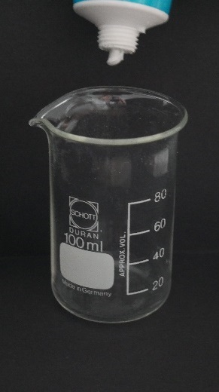

|  |  |
| --- | --- |
|  |  |
|  |  |

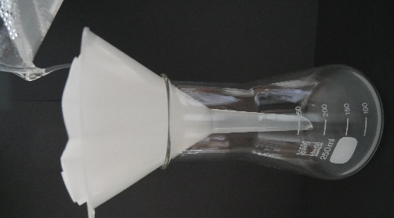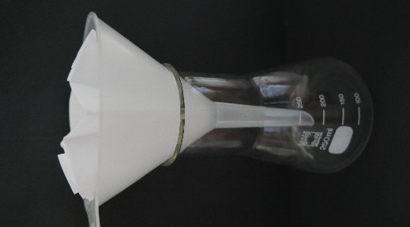

**Station 1: Examination of exfoliating cream**

Instruction – Part B

**3**

**4**

Put the filter paper in a plastic dish and place it under the microscope. Look into the microscope and focus on the image with the help of the adjusting screw.

Look at the residue with the microscope. Describe your observation and record it in your workbook.

C:\Users\bt305302\Documents\03_Daten\02_American Biology Teacher\Major Revisions\Manuscript Revisions\Binocular_Englisch_Major Revisions.tif

**Station 1: Examination of exfoliating cream**

**Info: Cosmetics**

Cosmetics are body and beauty care products, which can be bought in the drugstore.

****

**Info: Exfoliating cream**

* Exfoliating cream is a cosmetic product, which is used to clean the skin. For this purpose, it contains small particles (abrasives) that eliminate skin impurities by applying it in circling movements.
* Abrasives can be of natural or artificial offspring:
  + Natural abrasives: e.g., sea salt, bamboo granulate, coffee
  + Synthetic abrasives: microbeads (e.g., polyethylene)
* The cosmetics industry often uses microbeads instead of natural abrasives because microbeads clean the skin thoroughly and are cheap.

**Station 2: Examination of textiles**

Instruction – Part A

1. Take a beaker, add a bit of soap ("a splash") and 30 ml of water with the measuring cylinder.
2. A small piece of cloth (Fleece®) is then placed in the soapy water and stirred well with the teaspoon.
3. Put a filter paper in the funnel and place it in an Erlenmeyer flask.
4. Slowly pour the entire wash into the filter paper.
5. Consider the residue in the filter paper.

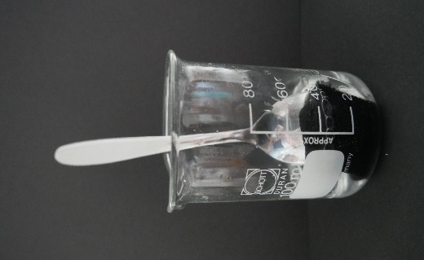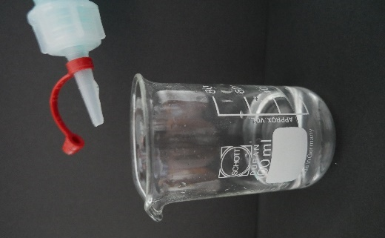

**Station 2: Examination of textiles**

Instruction – Part B

Put the filter paper in a plastic dish and place it under the microscope. Look into the microscope and focus on the image with the help of the adjusting screw.

Look at the residue with the microscope. Describe your observation and record it in your workbook.

C:\Users\bt305302\Documents\03_Daten\02_American Biology Teacher\Major Revisions\Manuscript Revisions\Binocular_Englisch_Major Revisions.tif

**Station 2: Examination of textiles**

**Info: Textiles**

Textiles are, for example, clothes or blankets made out of fabric.

C:\Users\bt305302\Documents\03_Daten\02_American Biology Teacher\Major Revisions\Manuscript Revisions\Info Textiles.tif

**Info: Polyester**

* Polyester is a plastic, from which, among other things, many garments are made.
* From such materials (plastic fibers) lint can dissolve during washing.

Lint in the sewage of the washing machine

Sewage treatment plant

Environment

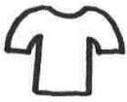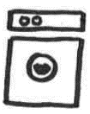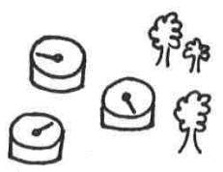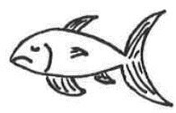

**Station 3: Mr. Experto looking for traces   
in the drugstore**

**The most common plastics in cosmetics and their abbreviations**

|  |  |
| --- | --- |
| **plastic** | **abbreviation** |
| polyethylene | PE |
| polypropylene | PP |
| polyethylene terephthalate | PET |
| nylon-12 | Nylon-12 |
| nylon-6 | Nylon-6 |
| polyurethane | PUR |
| acrylate copolymer | AC |
| acrylate crosspolymer | ACS |
| polyacrylate | PA |
| polymethylmethacrylate | PMMA |
| polystyrene | PS |
| polyquaternium | PQ |

**Source:** Ziebarth, N. (2019). Mikroplastik und andere Kunststoffe in Kosmetika: Der BUND-Einkaufsratgeber. Bund für Umwelt und Naturschutz Deutschland: <https://www.bund.net/fileadmin/user_upload_bund/publikationen/meere/meere_mikroplastik_einkaufsfuehrer.pdf> (online 01.08.2019)

**Station 4: How does the microplastic get to the beach?**

C:\Users\bt305302\Documents\03_Daten\02_American Biology Teacher\Major Revisions\Manuscript Revisions\Station 2_Legespiel_Wege des Mikroplastiks mit Musterlösung_Englisch_eigene Abbildungen\Folie5.TIF**Images for the flowchart:**

C:\Users\bt305302\Documents\03_Daten\02_American Biology Teacher\Major Revisions\Manuscript Revisions\Station 2_Legespiel_Wege des Mikroplastiks mit Musterlösung_Englisch_eigene Abbildungen\Folie7.TIFC:\Users\bt305302\Documents\03_Daten\02_American Biology Teacher\Major Revisions\Manuscript Revisions\Station 2_Legespiel_Wege des Mikroplastiks mit Musterlösung_Englisch_eigene Abbildungen\Folie3.TIFC:\Users\bt305302\Documents\03_Daten\02_American Biology Teacher\Major Revisions\Manuscript Revisions\Station 2_Legespiel_Wege des Mikroplastiks mit Musterlösung_Englisch_eigene Abbildungen\Folie2.TIFC:\Users\bt305302\Documents\03_Daten\02_American Biology Teacher\Major Revisions\Manuscript Revisions\Station 2_Legespiel_Wege des Mikroplastiks mit Musterlösung_Englisch_eigene Abbildungen\Folie1.TIF

C:\Users\bt305302\Documents\03_Daten\02_American Biology Teacher\Major Revisions\Manuscript Revisions\Station 2_Legespiel_Wege des Mikroplastiks mit Musterlösung_Englisch_eigene Abbildungen\Folie9.TIF

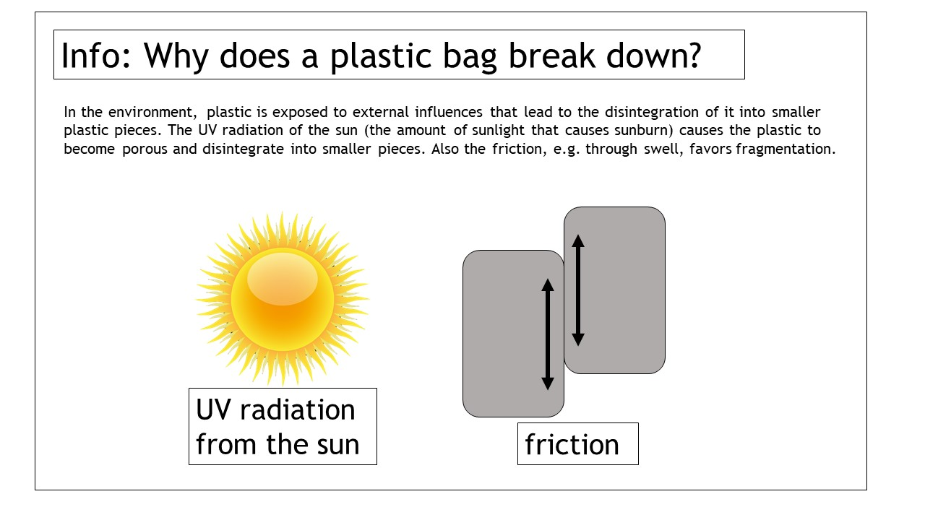

**Station 4: How does the microplastic get to the beach?**

**Sample solution for workbook:**

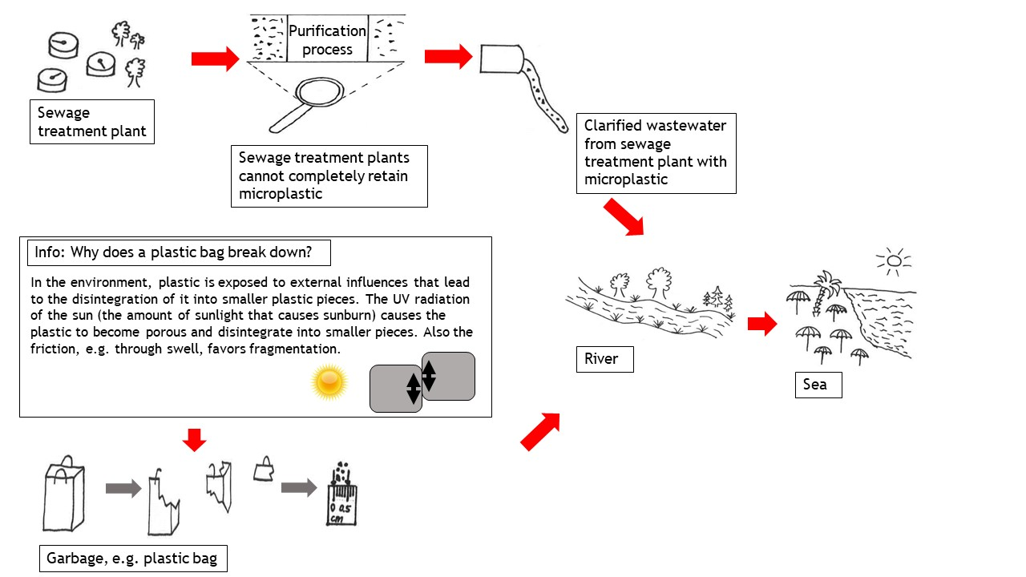

**Station 5: Microplastic in the environment – so what?!**

**Conference of animals in the sea**

*In the sea, there are more and more environmental problems that affect marine life. Therefore, some sea creatures meet, although some would like to eat each other. They talk about their problems due to the growing plastic pollution.*

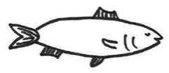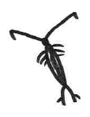**Fred,** the little herring: “Hello, my name is Fred, and I live in the sea. I like to eat plankton. Do you know what plankton is? These are tiny crustaceans floating in the sea. For a few years, I sometimes accidentally eat small plastic particles (microplastics). I was told it's called microplastic. I can eat it, but I cannot digest it. So although I eat a lot, I'm not energized. If I continue to eat microplastics now, I'll probably starve to death.“

Figure 1: Plankton.

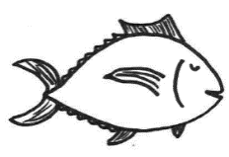**Fridolin,** the big tuna: “Oh, that would be a pity. I love to eat small herrings. I eat fish, digest it, and get my energy. I can only live if I can eat enough smaller fish like Fred. If Fred and the other little fish were to die, then I would always be hungry.“

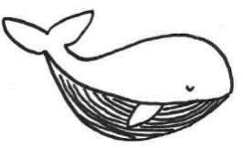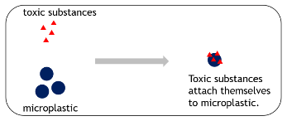**Berta,** the blue whale**:** “What are you saying, Fred? There are small plastic particles in plankton? I eat plankton and live on it. A smart fish told me that toxic substances could adhere to tiny plastic particles (microplastics). I’m afraid I’m going to poison myself!“

Figure 1: Microplastic can transport toxic substances.

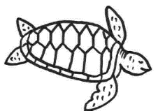

**Sarah,** the sea turtle: “A few days ago, I saw a turtle caught in a large plastic piece. Her whole body was deformed. If she keeps growing, she will probably die.“

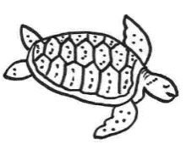**Martin,** the sea turtle: “That's terrible. Something happened to me this morning, too. I wanted to eat a jellyfish for breakfast, and I noticed just in time that this jellyfish was not a jellyfish. It was a plastic bag floating in the sea. Imagine what could have happened?“

**Fred,** the little herring: “Listening to all this, I realize that we all have many problems due to the pollution caused by humans. I've seen people on a boat trip who just threw their plastic wrappers of the food in the sea. And some friends of mine even got caught by old fishing nets which got lost. These so-called ghost nets float uncontrollably in the sea, capturing all kinds of animals, which cannot extricate themselves out of the net and presumably die. If these nets are not removed by humans, they continue to fish for decades or longer.“

**Berta,** the blue whale: “I cannot believe that humans behave as if they were alone in the world. But why do they think that they can do what they want? Sooner or later, humans will also suffer from our problems. Humans like to eat fish, and if they eat me, then they also take up microplastic. So far, no one knows concrete consequences.“

**Sarah,** the sea turtle: “Humans should change their behavior to help us and eventually themselves.“

**Station 6: Is there an alternative?**

|  |  |  |  |  |
| --- | --- | --- | --- | --- |
| Disposable bottle | Reusable plastic bottle | | Glass bottle | |
| Foil | Plastic lunch box | | Stainless steel lunch box | |
| Chocolate surprise egg | Plastic toy | | Wooden toy | |
| Plastic soap dispenser | Refill pack | | Bar of soap | |
| Plastic bag | | Reusable plastic bag | | Jute bag | |
| Food package | | Plastic string bag | | Cotton string bag | |
| Synthetic clothes | | Clothes: synthetic/natural blend | | Natural clothes | |
| Exfoliating cream  with microplastic | | Exfoliating cream  without microplastic | | Homemade exfoliating cream with natural ingredients (coffee) | |

**Station 7: Minimizing the problem**

**Poster**



****

**Workbook**

name: \_\_\_\_\_\_\_\_\_\_\_\_\_\_\_\_\_\_\_\_\_\_\_\_\_\_\_\_\_\_\_\_\_\_\_\_\_\_\_\_\_

class: \_\_\_\_\_\_\_\_\_\_\_\_\_\_\_\_\_\_\_\_\_\_\_\_\_\_\_\_\_\_\_\_\_\_\_\_\_\_\_\_\_

date: \_\_\_\_\_\_\_\_\_\_\_\_\_\_\_\_\_\_\_\_\_\_\_\_\_\_\_\_\_\_\_\_\_\_\_\_\_\_\_\_\_



Dear student,

This workbook will accompany you through the individual stations in the room. For each station, there are tasks that you solve in this workbook. So you learn a lot about the current topic of microplastics.

Some information about the implementation:

* Start with the station assigned to you. Then work the stations in sequence, for example: 1 🡪 2 🡪 3 🡪 4 🡪 5
* The work materials and work instructions can be found in the workplace of the station.
* Exception: Station 4 is processed by all groups at the end.
* Edit a station entirely before starting a new one. After finishing a station, put everything back the way you found it.
* Tick already completed stations in the table below.

**I wish you a lot of fun, and I am glad that you work with me today.**

**Your Mr. Experto**

|  |  |
| --- | --- |
|  | QualitÃ¤t, Haken, HÃ¤kchen, Abgehakt, Ja, Zustimmung**Done:** |
| **Station 1** |  |
| **Station 2** |  |
| **Station 3** |  |
| **Station 4** |  |
| **Station 5** |  |
| **Station 6** |  |
| **Station 7** |  |

**Introduction: What is microplastic?**

Answer the following questions.

1. Which things that you own or use are made out of plastic?

Personal opinion of the students.

For example: toothbrush, toys, water bottle, lunchbox, pens, ruler

1. Where in the environment have you seen plastic or microplastic?

Personal experience of the students.

For example: beach, meadow, forest, river, sea, roadside

1. 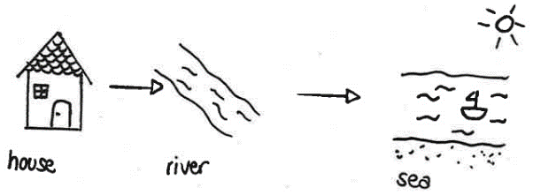Diagram how plastic or microplastic might get from your house to the beach.

**Introduction: What is microplastic?**

1. What will happen to Emma and Lenny’s beach toys, if they forget them on the beach?

If nobody takes the toys with him, they will lie on the beach and disintegrate into smaller pieces, e.g., through sunlight and friction.

1. Define the term microplastic.

Plastic particles that are smaller than 5 mm are called microplastic.

****

**Let’s start!**

**Station 1: Examination of exfoliating cream**



Task 1:

1. Part A: Carry out the experiment according to the instructions.
2. Part B: Carry out the experiment according to the instructions.

Write down your observations.

|  |
| --- |
| **Plastic in cosmetics** |
| polyethylene |
| polypropylene |
| polyethylene terephthalate |
| nylon-12 |
| nylon-6 |
| polyurethane |
| acrylate copolymer |
| acrylate crosspolymer |
| polyacrylate |
| polymethylmethacrylate |
| polystyrene |
| polyquaternium |

When filtering the exfoliating cream, small particles remain on the filter paper. These look like little blue grains under the microscope.

1. What could be the residue?

Examine the ingredients on the exfoliating cream package and compare it to the plastic list.

Can you identify the material?

The exfoliating cream contains microplastic called polyethylene.

Task 2: Are plastic particles in wastewater a problem?

Use the word box and the card to fill in the blanks.

Word box: environment, microplastics, wastewater, sewage treatment plant, microbeads

Cosmetics may contain \_microplastics\_. Exfoliating creams clean the skin with the help of abrasives (e.g., \_microbeads\_). Via \_wastewater\_, the microbeads are transferred to the \_sewage treatment plant\_. The sewage treatment plant cannot completely retain the microplastics, so some small plastic particles get into the \_\_\_environment\_\_\_.

**Station 2: Examination of textiles**

Task 1:

1. Part A: Carry out the experiment according to the instructions.
2. Part B: Carry out the experiment according to the instructions.

Write down your observations.

From the black fleece fabric, small fibers are released during washing.

These look like short black hair under the microscope.



1. What could be the residue?

Find out about the composition of the substance on the label.

The fabric is 100% Polyester.

Task 2: Are plastic particles in the laundry a problem?

Use the word box and the card to fill in the blanks. Orally explain the effects of plastic particles in the wash.

Word box: plastic, lints, sewage treatment plant, wastewater, environment, plastic particles

From the fabric (plastic fibers), which consists of \_\_\_\_\_plastic\_\_\_\_, \_\_\_\_\_lints\_\_\_\_\_\_ dissolve. These \_\_\_\_\_\_plastic particles\_\_\_\_\_\_ flow via the washing machine and its \_\_\_\_wastewater\_\_\_\_\_\_\_ into the \_\_\_\_\_sewage\_\_\_ \_\_\_treatment plant\_\_\_\_\_\_\_. The sewage treatment plant cannot completely retain the microplastics, so some small plastic particles get into the \_\_\_\_environment\_\_\_.

**Station 3: Mr. Experto looking for traces   
in the drugstore**



Task:

Mr. Experto has recently been shopping in the drugstore.

Look at the ingredients of the purchased items and use the plastic list to identify the products that contain plastic. Write down these articles.

Share the work in the group and then exchange it.

|  |  |  |
| --- | --- | --- |
| Article | Plastic contained? | |
| Examples of drugstore articles: | YES | NO |
| Toothpaste (Rossmann: Perlodent med, Sensitiv) |  | X |
| Eyeshadow (Catrice: The Fresh Nude Collection Eyeshadow Palette) | X |  |
| Make-Up (Maybelline: Fit me, Matte+Poreless, 120) | X |  |
| Detergent (Ariel: heavy-duty detergent) |  | X |
| Washing Gel (Balea: Clarifying wash gel with fruit acid, combination skin) |  | X |
| Soap (Balea: Savona Cream Soap: Milk & Honey) |  | X |
| Powder (Manhatten: Soft Compact Powder, Natural Look, Naturelle) | X |  |



**Attention, tell a friend!**

Look at the ingredients when buying cosmetics. If plastic is included, then do not buy the item better.

**Tip:** Words that contain "poly" are an indication of plastic.

**Station 4: How does the microplastic get to the beach?**

Task 1: Watch the short information film.

Task 2: Sort the laminated images into a flowchart. The lower scheme will help you.



Paste the sample solution here:

Task 3: After you've laid and checked the pictures, explain each other the question: "How does microplastics get to the beach?".

**For experts:**

Try to explain the terms **primary microplastics and secondary microplastics** using the graphic.

„primary" = first available, „secondary" = later added

Primary microplastics are fine plastic particles, e.g., for the cosmetics industry. Secondary microplastics are fine plastic particles that result from the disintegration of large pieces of plastic.**Station 5: Microplastic in the environment – so what?!**

Task 1: Take the roles of the animals in "Conference of Animals in the Sea".

Read the text and answer the following questions.

1. Why are the animals meeting for a conference?

The animals are meeting for a conference to talk about their experiences due to the growing plastic pollution in their habitat.

1. What problem of the animals stood out to you?

Personal opinion of the students.  
For example: The animals eat microplastic without noticing and probably starve to death because of it.

1. Which animal do you think is struggling the most? Explain why.

Personal opinion of the students.  
For example: I think the whale is struggling the most because it is at the end of the food web.

1. What problems do the animals have with the microplastic (plastic particles smaller than 5 mm)? Tick the right sentences.

|  |  |  |  |
| --- | --- | --- | --- |
| X | Plastic can be confused with food. | X | If an animal dies, it can affect other animals (food web). |
|  | Microplastics can be digested  by fish. | X | Humans also consume microplastic via food. |
| X | Microplastics can accumulate toxic substances that endanger animals. |  | Humans protect animals from  microplastics. |
|  | Animals need microplastics as food. | X | Plastic is indigestible and does not provide energy. |
| X | Animals can get caught in plastic and hurt. |  | Animals need plastic for swimming. |

**Station 5: Microplastic in the environment – so what?!**

Task 2:

1. Write down the food web beginning with plankton (small crustaceans). Take the text as an aid and fill in the boxes below.

Words: blue whale, herring, plankton, tuna

C:\Users\bt305302\Documents\03_Daten\02_American Biology Teacher\Major Revisions\Manuscript Revisions\Station 3_Nahrungskette_Englisch\Folie2.TIF

1. If microplastic is present in the plankton, then it can enter the food web. Use a red pencil to surround animals burdened with microplastics.
2. Does it affect humans when microplastics are in the food web? Discuss with your group members which marine animals you like to eat and consider whether humans are also burdened by microplastics (possibly red box).

Yes, it can affect humans.

Personal taste or nutritional habits of the students.

For example: I like to eat fish and mussels. If I eat a mussel, which has filtered microplastic, I also eat microplastic.

**Station 6: Is there an alternative?**

Task 1: Play the plastic-memory and match the related single-use, multiple-use and alternative products, respectively the least to the most sustainable products.

Task 2: Paste the sample solution here.

Write down the pros and cons of the products (e.g., concerning price, weight, durability, amount of garbage, single-use/multiple-use).

|  |  |  |
| --- | --- | --- |
| **Disposable bottle**  Disposable bottle  light  cheap  unbreakable  single-use  a lot of garbage | **Reusable plastic bottle**  Reusable plastic bottle  light  nonrecurring acquisition costs  +/- unbreakable  multiple-use  +/- garbage | **Glass bottle**  Glass bottle  heavy  nonrecurring acquisition costs  fragile  multiple-use  no garbage |
| **Foil**  Foil  light  cheap  hygienic  leaking  single-use  a lot of garbage | **Plastic lunch box**  Plastic lunch box  light  nonrecurring acquisition costs  daily rinsing  tight  multiple-use  +/- garbage | **Stainless steel lunch box**  Stainless steel lunch box  light  nonrecurring acquisition costs  daily rinsing  leaking  multiple-use  no garbage |

|  |  |  |
| --- | --- | --- |
| Chocolate surprise egg  **Chocolate surprise egg**  cheap  nondurable  a lot of garbage | **Plastic toy**  Plastic toy  nonrecurring acquisition costs  durable  +/- garbage | **Wooden toy**  Wooden toy  nonrecurring acquisition costs  durable  no garbage |
| **Plastic soap dispenser**  Plastic soap dispenser  cheap  hygienic  plastic packaging  a lot of garbage | **Refillable soap dispenser + refill pack**  Refill pack  cheap refill  hygienic  plastic packaging  +/- garbage | **Bar of soap**  Bar of soap  cheap  hygienic  paper packaging  no garbage |
| **Plastic bag**  Plastic bag  light  free  single-use  a lot of garbage | **Reuseable plastic bag**  Reusable plastic bag  light  nonrecurring acquisition costs  multiple-use  +/- garbage | **Jute bag**  Jute bag  light  nonrecurring acquisition costs  multiple-use  no garbage |

|  |  |  |
| --- | --- | --- |
| **Food package**  Food package  light  free  single-use  a lot of garbage | **Plastic string bag**  Plastic string bag  light  nonrecurring acquisition costs  multiple-use  +/- garbage | **Cotton string bag**  Cotton string bag  light  nonrecurring acquisition costs  multiple-use  no garbage |
| **Synthetic clothes**  Synthetic clothes  light  cheap  functional  carefree | **Clothes: synthetic/natural blend**  Clothes: synthetic/natural blend  +/- light  cheap  functional  carefree | **Natural clothes**  Natural clothes  +/- heavy  +/- expensive  functional  +/- carefree |
| **Cosmetic with microplastic**  Exfoliating cream  with microplastic  cheap  environmentally unfriendly | **Cosmetic without microplastic**  Exfoliating cream  without microplastic  cheap  +/- environmentally unfriendly | **Natural cosmetics**  Homemade exfoliating cream with natural ingredients (coffee)  cheap  environmentally friendly |

**Station 7: Minimizing the problem**

Task 1: Answer the following questions again.

1. Which things that you own or use are made out of plastic?

Personal opinion of the students.

For example: toothbrush, toys, water bottle, lunchbox, pens, ruler, food packaging, exercise book cover, clothes, shoes, laminated handouts, plastic equipment of experiments, shampoo and shower gel packaging, toothpaste tube

1. Where in the environment have you seen plastic or microplastic?

Personal experience of the students.

For example: beach, meadow, forest, river, sea, roadside, park, forest, lakeshore, field, riverbank

1. 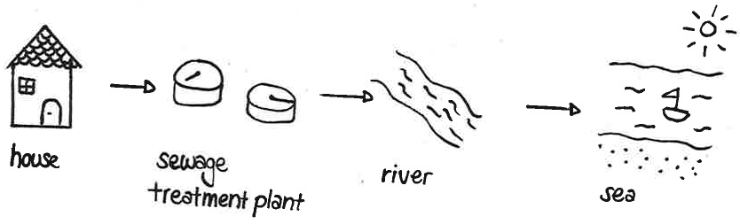Diagram how plastic or microplastic might get from your house to the beach.
2. Compare your initial with your final answers. Talk about your newly acquired knowledge with your group. Finally, we will talk about it together in class.

**Station 7: Minimizing the problem**

Task 2:

In more and more ecosystems, such as rivers and seas, microplastic is found.

What can you do, so that less plastic/microplastic gets into the environment? Write down your suggestions on the leaflets and keep them until debriefing.

Finally, we will talk about the subject together and create a poster that you can hang in the classroom.

**Introductory PowerPoint Presentation**



















