Research Introduction

MEEt Dr. Adams
Assistant Professor, Dept. of Plant Biology, Ecology, and Evolution
Oklahoma State University

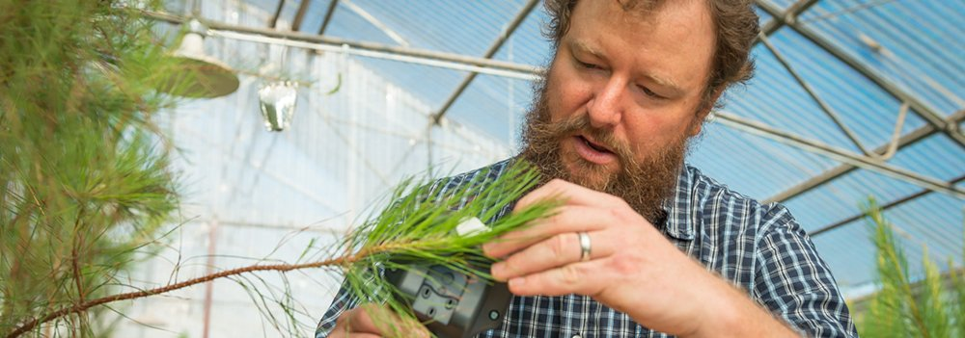

“I am a plant ecologist broadly interested in how organisms interact with their environment. Much of my research is in global change ecology, specifically on plant responses to climate-related disturbances. My research has focused on drought-induced tree mortality—including the physiological process of death from drought and its sensitivity to temperature, tree growth and phenological response to drought, and the ecosystem and earth system consequences of forest disturbance. My research approaches span subdisciplines, including plant physiological ecology, dendroecology, ecosystem ecology, and ecohydrology. I seek to increase understanding of the sensitivities and mechanisms of climate-related ecological responses with an application toward improved prediction of climate change and its effects on the biosphere and earth system.” – Dr. Adams
Images and text retrieved from the Environmental Ecology Lab website: http://henrydadams.com/research.html
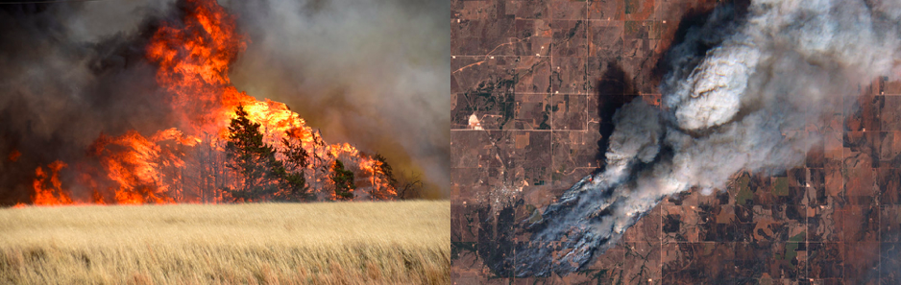
THE ROLE OF DROUGHT IN FIRE RISK FROM EASTERN REDCEDAR
Photo credit: Nick Oxford / Reuters Photo credit: European Space Agency.

Invasion and expansion of eastern redcedar (Juniperus viriginia) is the greatest land management challenge facing states in the Great Plains and Midwest US. Woody encroachment from this species causes economic losses through reduction of forage for grazing, alters hydrological flows to negatively affect water resources, increases allergenic pollen counts, degrades wildlife habitat, and increases the risk of catastrophic wildfire. In Oklahoma, eastern redcedar threatens conversion of much of the state from grassland to woodland over the next 10-20 years. Eastern redcedar is considered a fire-intolerant species but it has a dynamic relationship with fire. The frequent low-intensity fires that were typical in Oklahoma prior to Euro-American settlement severely restricted the range of eastern redcedar, as its seedlings and saplings are very vulnerable to fire. Larger eastern redcedar trees are much more resistant to fire, especially during ideal conditions for prescribed fire when foliar moisture content is high. However, eastern redcedar is a highly drought-tolerant tree species that can survive relatively low tissue water content. During drought, when foliar moisture is low, eastern redcedar becomes much more easily combusted, posing a risk to life and property during wildfire. Recent research has found a threshold in fire behavior at 60% foliar moisture, and below this threshold time to ignition rapidly declines and flame height rapidly increases with declining foliar moisture. Our research aims to determine how drought influences eastern redcedar foliar moisture to better assess the effect of this tree on wildfire risk across Oklahoma. This study uses a combination of field observations and greenhouse experiments to determine just how much drought stress it takes to increase fire risk from eastern redcedar.

Think About It: Summarize what Dr. Adams does and what his overall research goal is. In your own words, describe his research regarding drought and eastern redcedar. For more information about the lab’s research visit: http://henrydadams.com/research.html
Planting Phase

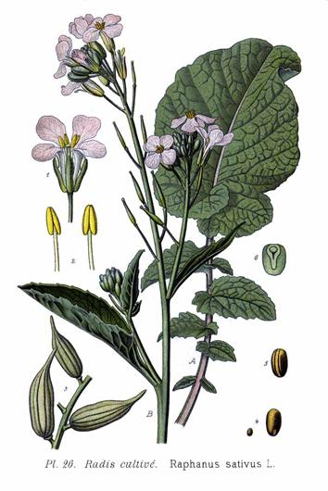
Materials:
- Raphanus sativus (radish) seeds – 80 per group
- Glass beaker or bottle
- Water
- Fertilized potting mix (e.g. Miracle Gro)
- Large plastic tub (alt: plastic box)
- Plastic square planting pots – 20 per group (alt: egg cartoons with tops cut off)
- Planting trays – 2 per group (alt: plastic box lids)
- Plant markers – 20 per group (alt: popsicle sticks)
- Sharpie – 1 per group
- Light source
- Water
- Lab binder – 1 per group
- Data Sheets
Image retrieved from: http://powo.science.kew.org/taxon/urn:lsid:ipni.org:names:77159305-1

Planting Instructions:

- Soak all the radish seeds in water for 6-12 hours before planting. Empty seeds into glass container and fill with water. Teacher may want to do this the night before the planting phase. Be sure to remove floating seeds and not use these in experiment.

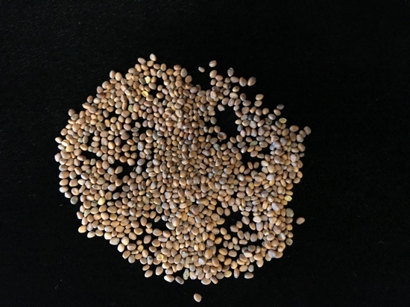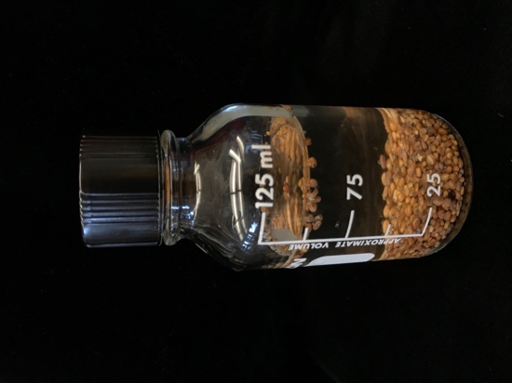
Radish seeds Radish seeds in 100mL of water

- Mix fertilized potting soil with water in a large plastic tub. Be sure to shave students saturate the entirety of the mix with water but not to a point that it is soaking wet. A good measure of this is when the soil is able to hold water and not drip when held, but loses much water when squeezed.

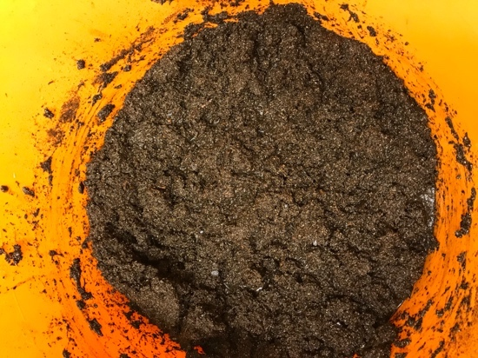
Fertilized potting mix saturated with water

- Hand each lab group 20 plastic pots, 2 planting trays, 80 radish seeds, 20 plant markers, and 1 sharpie.

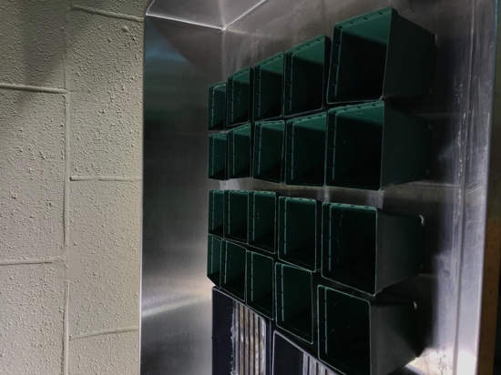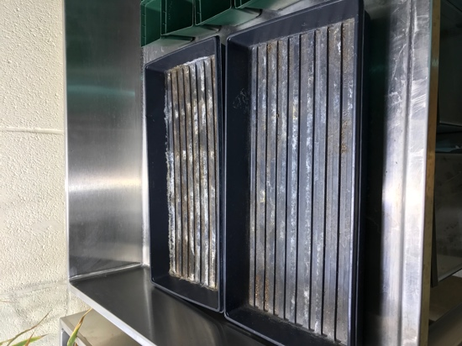
Square plastic pots Planting trays

- Each lab group fills 20 pots with the saturated soil and disperse the pots into the planting trays evenly.

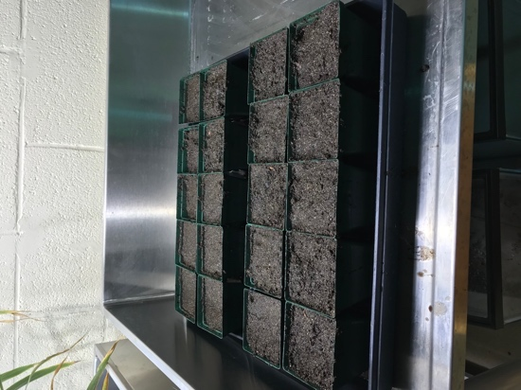
Soil filled pots in planting trays

- Each lab group plants ~4 seeds in each of the pots. Seeds should be planted about 1-2 cm deep in the middle of the pot. Be sure to not compact the soil over the seeds, but loosely push the soil back over the seeds.

- Each lab group labels 10 of their pots as “drought” and the other 10 as “control” with one marker per pot.

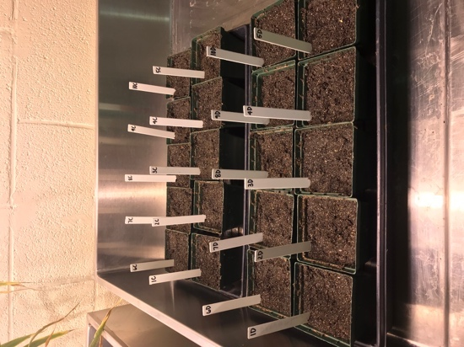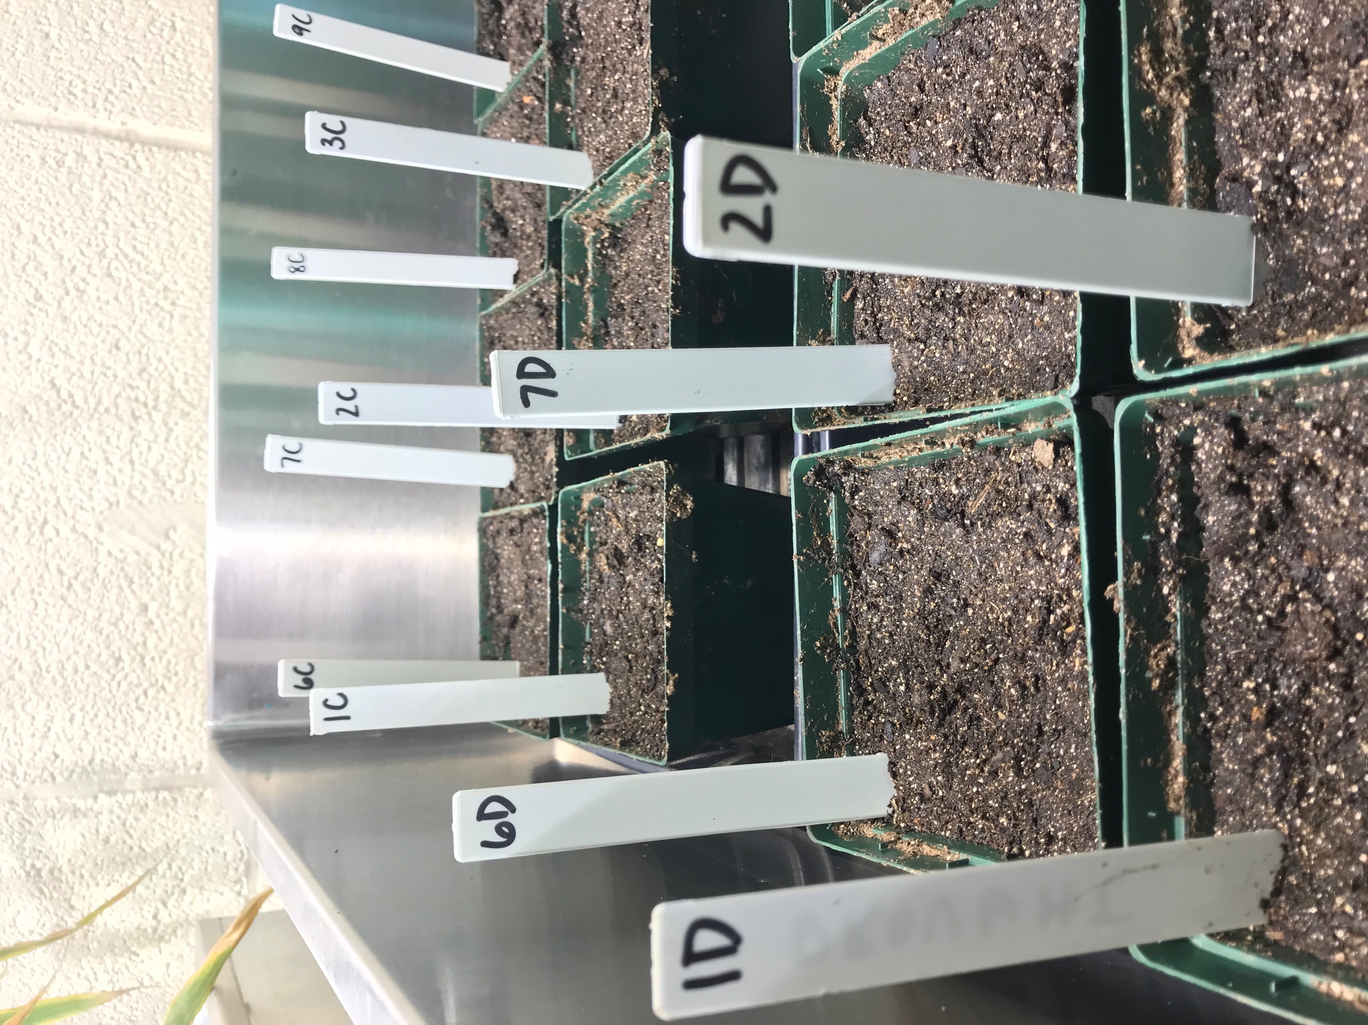
Pots marked sample# and D or C (drought or control). E.g. 1D stands for sample 1 drought group.

- Leave planting trays full of pots near good light source. Either in a lab directly under a light source for 12-hour periods to mimic day cycles or near a window which receives direct sunlight.

- After three-six days of growth, small sprouts began to appear. For pots which have multiple sprouts, remove all but the strongest/tallest shoot. Pull out excess plants (more than one) sooner than later to prevent roots from becoming too established and entangled with one another.

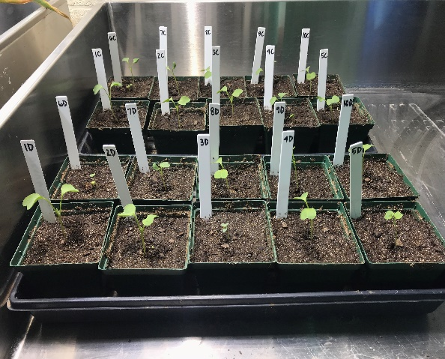
Six days after seeds were planted

Watering: During the planting phase of the experiment, each lab group collaborates and writes out who will water their plants during the first two weeks of the experiment until the drought stress begins. Seeds are watered when needed. A good determinant is when the top soil begins drying. This seems to be approximately every three days. Lab groups will plan out who is going to water and when in their lab group’s binder. Remember that both groups – drought and control – are watered during this phase.

Plant # | Date

Proposal Phase

Purpose: Now that your plants have been growing well in watered conditions for two weeks, it is time to implement drought. Before we do this, your lab group needs to collaborate together to decide what methods you will use in your experiment. Keep in mind the purpose of this experiment is to find an effective method for detecting drought stress that could be later applied to a large-scale study to mitigate climate change.

What is an experimental method? A collection of research designs, guidelines for using them, principles and procedures for determining statistical significance, and criteria for determining the quality of the study
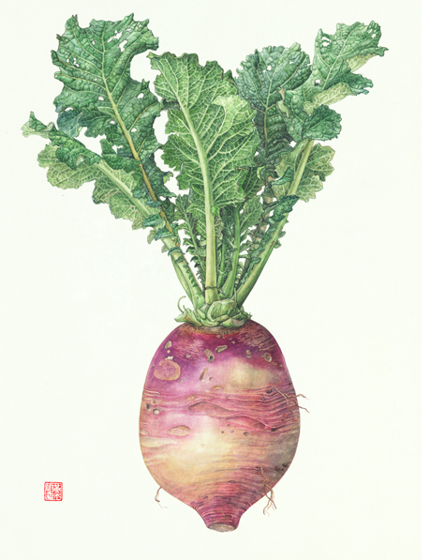

Lab materials available:
Coin envelopes
Safranin Dye
Scintillation vials
Microscopes
Microscope slides
Microscope covers
Razor blades

Rulers
Tape measures
Calipers
Scale
Scissors
Plastic vials
Refrigerator
Oven

Image retrieved from: http://greenasas.com/works/root-vegetables/

Experimental method examples:

- Stem height – Measure from soil level to the top of the plant.
- Stem diameter – Measure the stem 1 cm from the soil level.
- Leaf count – Count the number of leaves growing from each bud of each individual plant.
- Leaf length* or width – Measure the longest part of the leaf from the base of the stem to the top and then the widest part across the leaf.
- Biomass (EOE) – Cut the stem at soil level. Gently shake roots free of all soil. Lay shoot and roots flat to dry out for ~72 hours. Weigh mass of shoot and roots for plant biomass.
- Percent wilted leaves (EOE) - Measure by counting the number of wilted leaves on each individual plant and then dividing by the total amount of leaves. Multiply by 100 to attain percentage.
- Relative water content (EOE) – Measure fresh weight, turgid weight and dry weight to determine RWC percentage. **
- Transpiration Stain (EOE) – Cut petiole with leaf from stem and let sit in safranin solution for ~1 hour. Then prepare wet mount and observe stained vascular bundles under microscope. Take photo of stained stem cross section to determine percentage of vascular bundles over total stem area. **

* All groups must choose Leaf Length as one of their methods as it will used as a measurable proxy for drought stress.
** Further detailed equipment set up and measurement methods are included in StudentExplorationHandout5-PlantPhysiologyLabNotes

EOE – End of Experiment measurement. All lab groups will need to choose at least one EOE method.

What are vascular bundles? A strand of conducting vessels in vascular plants that transports water and nutrients from the roots to the leaves. Includes phloem and xylem.

Write a one-page research proposal describing the purpose of the study, detailed methods and what you predict to uncover and why.

Research proposal will include:
- What measurements will be taken? (Must include leaf width [proxy measurement] and one EOE measurement)
- What materials or equipment will you use?
- When and how frequently will the measurements be taken?
- What is the significance of taking these measurements? (What will the results tell us about drought?)
- Which method do you hypothesize will be the most effective drought detector? Why?
- How much drought stress will you implement? No water, one watering a week, watered control group?
- Include a schedule of who will water and take measurements for the duration of the experiment.

Plant Physiology Lab Notes

Relative Water Content
Background: Relative Water Content (RWC) is a measure of the amount of water in a leaf compared to maximum water capacity when turgid. This is a simple method to determine the level of drought stress. Due to the senesced nature of leaves under drought, it is important to take these measurements as quickly as possible. There are three different types of measurements needed for this method: Fresh, Turgid, and Dry. Fresh measurements are taken directly after leaves are cut. Turgid measurements will be left in water for 24 hours to allow the leaf to absorb water to its maximum. Dry measurements will be taken after turgid samples have been left in an oven to dry for 24 hours.

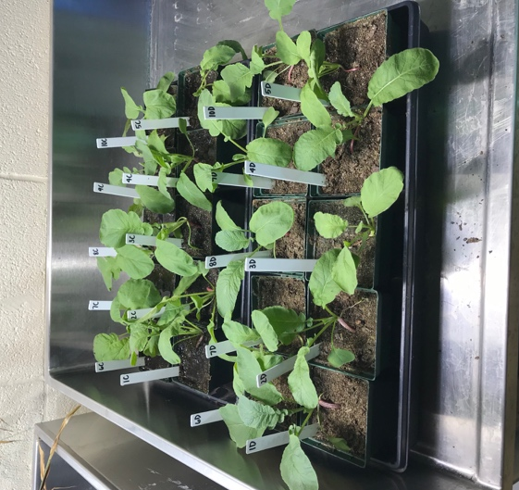
Materials:
- Scissors
- Labeled sample vials (one per leaf)
- Scale (to 3 decimal places)
- Water
- Refrigerator
- Paper towels
- Labeled coin envelopes (one per leaf)
- Oven

Procedure:
Fresh measurements
- Cut the best representative (meaning the leaf is a good example of what the entire plant looks like) leaf off the stem from each plant with scissors. Make cut in the middle of the petiole (stalk that connects leaf to stem).
- Immediately weigh the fresh samples to three decimal places. Make sure to keep track of which leaves came from which plants.
- Record fresh weight on data sheet. (FW = fresh weight)

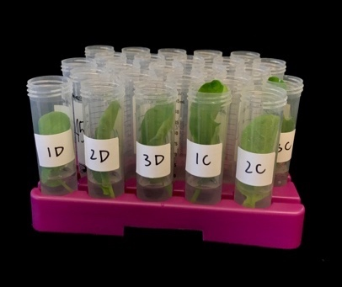
Turgid measurements
- Label each plastic vial accordingly, including the plant number and treatment group (e.g. 1C).
- Add 15 ml of water to each vial.
- Gently drop leaves in matching vials, ensuring that the bottoms of the petioles touch the bottoms of the vials.
- Once all vials are filled, tightened the caps and place in refrigerator for ~24 hours to allow leaves to reach full turgor.
- After 24 hours, take a leaf out of the tubes. Gently and quickly blot the leaf dry with paper towels.
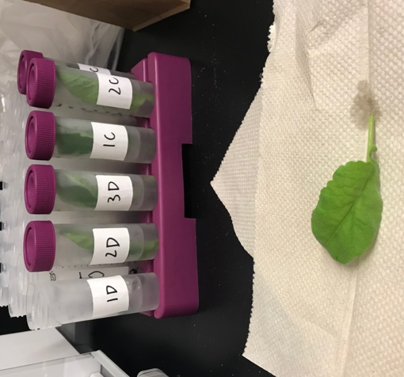
- Weigh the turgid leaf and record to three decimal places. (TW = turgid weight)
- Continue patting the leaves dry and weighing them for the remainder of the samples.
- Notes: Weighing the leaves quickly is an important step, as the weight will continue to drop as more water continues to leave the leaves as they are out of the water. The turgid weight should be higher than the fresh weight.

Dry measurements
- Put weighed turgid samples into labeled envelopes and dry in oven at 70° C for 24 hours. (If low temperature oven is not available, leaves could be left out on paper towels to dry under a light source for a couple of days)
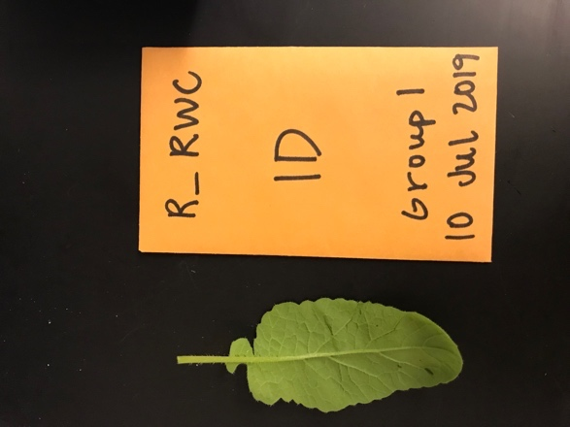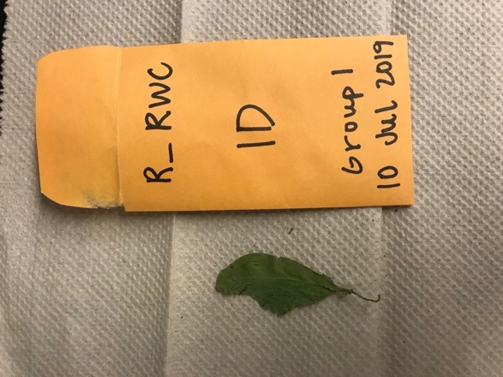
Before drying (left side) and after drying (right side)
- Weigh the dry samples and record to three decimal places (DW = dry weight).
- Note: leaves will become brittle and fall apart, so be sure to dump the entire contents of the envelope onto the scale to measure all the leaf. Dried weight should be lower than the fresh weight.
Calculations
Find leaf Relative Water Content:
leaf RWC(%) = ((FW-DW)/(TW-DW)) x 100
FW= fresh weight; DW= dry weight; TW= turgid weight
E.g. 1D RWC = ((.3781 - .0277) / (.4022 - .0277)) x 100
RWC = 93.56% [This result is makes sense because drought had just begun when leaf samples were collected. We would predict a lower percentage as drought is intensified.]
Results
Typical RWC values of turgid or transpiring leaves is around 98%, of severely desiccated or senescing leaves is around 40%, and of wilting leaves is around 60-70%.

Transpiration Stain
Materials for Stain Solution
- Safranin O, Reddish, 1% Aqueous, Laboratory Grade
- Erlenmeyer flask
- Water
Materials for Staining Manifold.
- Labeled scintillation vials
- Gloves
- 0.1% safranin solution
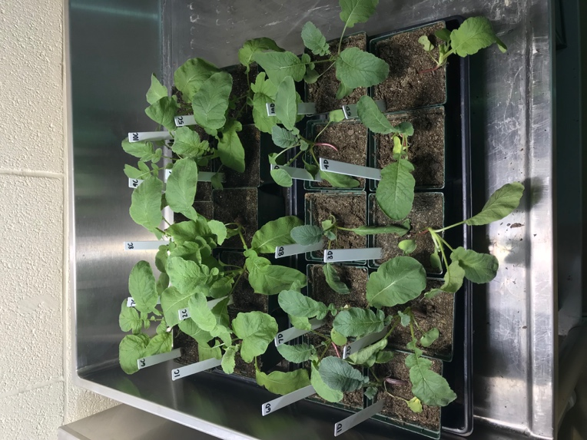
- Razor blades
- Leaf samples
Materials for Active Xylem Viewing
- Paper towels
- Gloves
- Razor blades
- Water
- Pipet
- Paint Brush
- Microscope slides
- Microscope cover slips
- Microscopes
- Camera (smartphones)
- Grid
Procedure
Preparing the 0.1% Stain Solution
- Wear gloves whenever working with safranin. Safranin will not come out of clothing so be sure to wear a lab coat or old clothing.
- Add 10mL of safranin 1% stock solution to 90mL of water in Erlenmeyer flask to create 0.1% safranin solution.
- Mix solution for 2 minutes until the color is consistent throughout solution

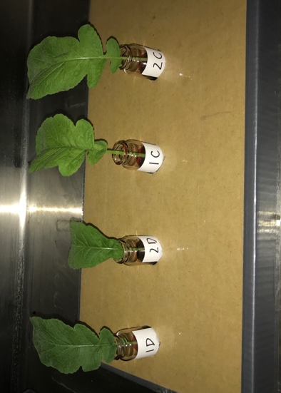
Setting up the Staining Manifold
- Label scintillation vials with appropriate plant numbers and treatment group (e.g. 1D)
- Wearing gloves, pour 0.1% safranin solution into vials, filling them halfway.
- Cut true leaves (not cotyledons, unless measuring cotyledon transpiration) from base of petiole (leafstalk) with razor blade.
- Safety: Always be careful when working with blades. Pinch fingers in and make short downward strokes. Dispose razor blades in appropriate waste bins after use.
- Place leaves in halfway filled labeled vials accordingly.
- Allow leaves to sit in solution for approximately 1 hour under light source.
Viewing the Transpiration Stain
- After the staining period, remove the sample from the vial with gloves.
- Gently dab sample dry with paper towels.
- Slice the bottom portion of the stem off, where the exterior is stained.
- To cut stem cross section, move blade in a diagonal motion forward and down.
- Cut a couple sections, try to get them as thin as possible but containing the entirety of the diameter of the stem.
- To make a wet mount, use the pipet to add one drop of water to the center of a microscope slide.
- Wet the paintbrush and pick up the best-looking section by scooping it up from the bottom.
- Place the section onto the drop of water on the microscope slide.
- Drop the microscope cover onto the section, first by dropping one side of the cover on a far side of the water drop. Once one side is touching the slide, drop the rest of the slip slowly like dropping a hinged door.
- Place wet mount under microscope to view the stained vascular bundles.
- Take picture of cross section using smartphone.
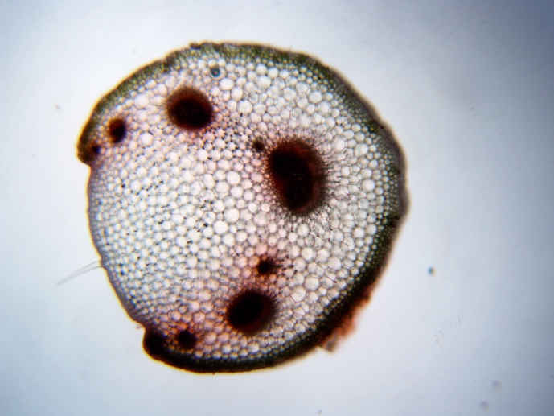

Calculations
- Open Microsoft Word. Check ‘Gridlines’ under the ‘View’ tab.
- Insert the stained stem cross section photo onto the page.
- Click on the photo, under ‘Picture Format’ select ‘Transparency’ and make the photo transparent enough to see both the gridlines and still be able to see the stained vascular bundles.
- Calculate the area of the stem cross section by counting the boxes filled (if at least half of a box is filled consider this box in the area).
- Calculate the area of vascular bundles by counting the boxes dyed with safranin (again, consider all boxes that are at least halfway filled).
- Divide the vascular bundle area by the stem area to determine the percentage of the transpiration stain.
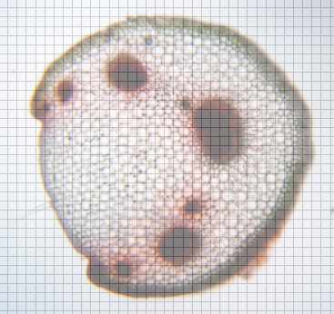
Excel Example

Purpose: Now that all data has been collected the next step is to figure out what does all this data mean. The first step in this process is to transfer all your lab binder data into an excel spreadsheet file. There only needs to be one excel file per group. Save the document as a .csv file in order to be opened by software for analysis later. Save the file as labgroup# _rde.csv (rde = radish drought experiment).

For Example: labgroup4 _rde.csv

Follow the following format precisely when keying in data into excel for all three methods. Everyone will have leaf.length as it will be used a proxy for data analysis.

Installing R and RStudio

Source: Instructions for downloading R and RStudio are modified from: https://www.andrewheiss.com/blog/2012/04/17/install-r-rstudio-r-commander-windows-osx/
“R is an incredibly powerful open source program for statistics and graphics. It can run on pretty much any computer and has a very active and friendly support community online. Graphics created by R are extremely extensible and are used in high level publications like the New York Times…
RStudio is an integrated development environment (IDE) for R. It’s basically a nice front-end for R, giving you a console, a scripting window, a graphics window, and an R workspace, among other options.” -Andrew Heiss

Install R, RStudio, and R Commander in Windows:
- Download R from http://cran.us.r-project.org/ (click on “Download R for Windows” > “base” > “Download R 2.x.x for Windows”)
- Install R. Leave all default settings in the installation options.
- Download RStudio from http://rstudio.org/download/desktop and install it. Leave all default settings in the installation options.
- Open RStudio.

Install R, RStudio, and R Commander in Mac OS X:
- Download R from http://cran.us.r-project.org/ (click on “Download R for Mac OS X” > “R-2.x.x.pkg (latest version)”)
- Install R.
- Download RStudio from http://rstudio.org/download/desktop.
- Install RStudio by dragging the application icon to your Applications folder.
After Installation: After R and R studio has been installed, students can analyze data using a prewritten R script. To run data, students will need to save their data in excel as a ‘.csv’ file.
To use R scripts for data analysis:
- Open RStudio.
- Select ‘file’ at the top bar of the screen in the tool bar.
- From under the ‘file’ tab, select ‘open file’ and select the favored R script file (StudentExplanationHandout3-RScript) and click ‘open.’
- Once the R script file is opened on RStudio, it will be visible in the top left portion of the screen.
- Begin to read the script from line 1. The “####” at the beginning of the lines distinguish instructions for you to read and follow from the code lines with do not have “####.”
- Follow the comments (#### lines) to upload your .csv data file to run your data analysis.
- Your final products from this ANOVA test will be: F value and P value for each variable, a boxplot comparing drought groups to control groups for each method (3 total).

For more information on R and R studio check out https://www.rstudio.com for troubleshooting and useful tips.

#### Upload your .csv data file (following the exact format as the sample data file)
#### by clicking "df <- read.csv(file.choose())" [line 4] and hitting command and enter (for mac) or ctrl and enter (for pc).
#### A pop-up window will appear allowing you to select your saved data .csv file, select 'open'
df <- read.csv(file.choose())

#### The line of code below [line 9] runs ANOVA test.
#### Rename the variables based on the methods you decided to test matching your .csv data file.
#### Be sure to keep the spacing and formating identical to the example line of code.
anova.model <- aov(leaf.length ~ leaf.rwc + treatment + leaf.drymass, data = df)

#### The summary line below [line 15] provides you with statistical results.
#### The first column describes the variable tested
#### We are looking at the F Value (column 5) and P value (column 6). Record these values.
#### [note: the p-value is labeled as Pr(>F) as it is the probability of the F-statistic]
summary(anova.model)

#### The next three lines [lines 19,20,21] of code graph your data for each variable in a boxplot.
#### To save your boxplots, select "export" in the tool bar right above the boxplot in the lower right side window
boxplot(leaf.length~treatment, data=df, main="Boxplot of Leaf Length (mm)")
boxplot(leaf.drymass~treatment, data=df, main="Boxplot of Leaf Dry Mass (g)")
boxplot(leaf.rwc~treatment, data=df, main="Boxplot of Leaf Relative Water Content (%)")

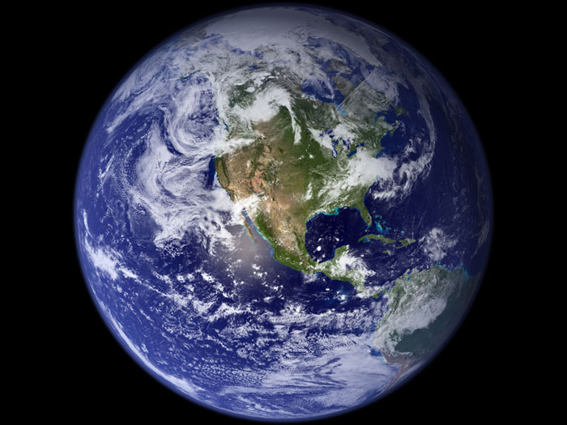
Vital Signs of the Planet

Research the following NASA website: https://climate.nasa.gov/evidence/ to answer questions about climate change, human activity and their effects on biodiversity. Begin exploring the page under the “facts” tab.

Climate Change: How Do We Know?
  - Do you agree or disagree that our planet’s climate is rapidly changing? Provide evidence to support your claim.

Causes of Climate Change
  - What causes the Earth’s temperature to rise? What gases contribute to this effect?

  - Over the last century, what has caused a change in the natural greenhouse effect?

  - How have industrial human activities affected the Earth’s atmosphere?

  - Do you agree or disagree that the sun’s energy output is causing the current warming of the globe? Provide evidence to support your claim.

Effects of Climate Change
6. What do scientists predict will be some long-term effects of climate change for the U.S.?

7. If these predictions hold true, how will the region you live in be affected? Have you observed any of these changes/events first hand? How did this affect biodiversity?

Scientific Consensus
8. What is the scientific consensus regarding human-induced climate change? What percentage of active climate scientists agree?
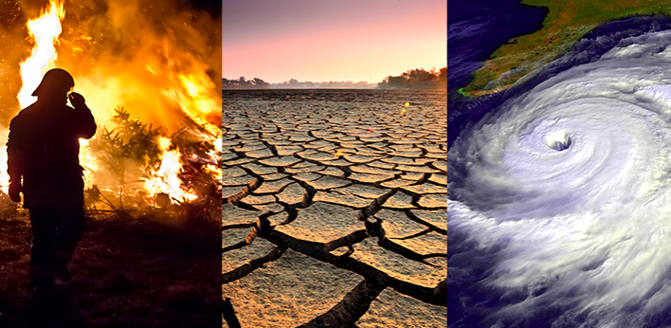

Image retrieved from: https://climate.nasa.gov/effects/

NASA Global Climate Change: Climate Time Machine Interactive

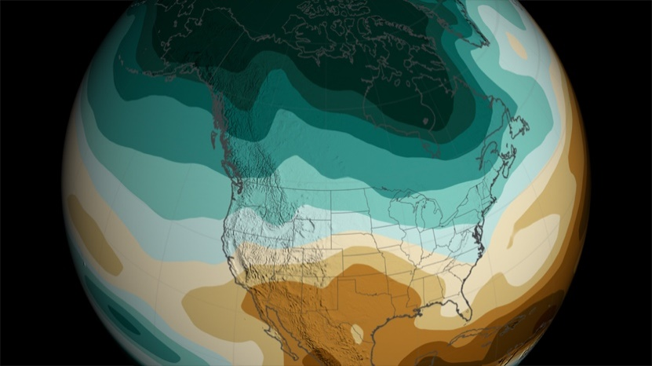
Image retrieved from: https://svs.gsfc.nasa.gov/11281

Now go to: https://climate.nasa.gov/interactives/climate-time-machine

- Choose two of the four topics: Sea Ice, Sea Level, Carbon Dioxide, Global Temperature.
- Click on the topic you wish to research and explore the interactive by watching the visualization change as you manipulate the time/distance.
- Answer the following questions for both topics that you have selected.

Topic 1:

- Define the time/distance range of the visualization and what the various colors represent
- Record three different noteworthy events (year/distance) where major change occurred and explain where on the map it occurred and what happened.

- What overall trend does the visualization support?

- If this trend continues, what are some potential consequences affecting biodiversity? List three examples.

Topic 2:

- Define the time/distance range of the visualization and what the various colors represent
- Record three different noteworthy events (year/distance) where major change occurred and explain where on the map it occurred and what happened.

- What overall trend does the visualization support?

- If this trend continues, what are some potential consequences affecting biodiversity? List three examples.

NASA Images of Change/Solutions Discussion

Now go to: https://climate.nasa.gov/images-of-change?id=672#672-sierra-nevada-snowpack-increases (also accessible under the “Explore” tab and then under the “Images of Change” subtab) and independently go through the photographs comparing before and after shots of the same location. Prepare to share your observations regarding biodiversity.

Now go to: https://climate.nasa.gov/solutions/adaptation-mitigation/ (also accessible under the “Solutions” tab and then under the “Mitigation and Adaptation” subtab) and scan the paragraphs under the heading “Mitigation and Adaptation” independently. Prepare to discuss how you could provide solutions for climate change in your city.

Drought Research Presentation Guidelines

Purpose: You will work with your original lab groups and present your drought experiment research to the class. You will have one week to put together a slideshow presentation to share your drought study. In research, it is vital for scientists to share their findings for the advancement of science and giving presentations is just one way this can be done.
Keep in mind as you’re preparing your presentation that if you’re interested in sharing your drought research or want to know more about what the Environmental Ecology Lab at Oklahoma State University is up to tweet a picture of your drought study at:

Dr. Henry Adams @EnvEcoLab
William Hammond @wmhammond
#StressedAboutDroughtStress

Presentation Guidelines:
- You will work with your original lab groups.

- Each group will include the following into their presentation:

- Stance on climate change. Must provide scientific evidence to support claim.

- Reason for conducting this research. What was the point of this research?

- Experimental Design. Define IV, DV, measurement frequency and the reason why you developed your specific experimental design.

- Methods. What were the three experimental methods your group tested? What was your end of experiment method? Provide detailed information on how you conducted each so as to provide enough information for your experiment to be replicable. What kind of data did you collect?

- Results. What did the data mean? What statistical test did you use? How did you run this statistical test? Were your results significant?

- Conclusion. Based on your results which method was found to be the most effective drought detector? Why do you think this was? Are there any other experiments that support this?

- Future direction. How could you further this research or implement it into the real word to provide a solution to detect drought as a result of human induced climate change?

- Students will be scored on their oral presentation and the slideshow’s visual aesthetic including grammar.

- The presentations should be 7-10 minutes long with all lab members participating equally.

- At the end of the presentation, the floor will be opened for questions.
Drought Research Presentation Rubric
Criteria | Below Average Performance (0-1) | Average Performance (2-3) | Above Average Performance (4) | Points
Climate Change Evidence | No scientific evidence to support claim | Some incorrect evidence to support claim | Correct scientific evidence to support claim
Reason for Conducting Research | Background for study is weak and not clear; or does not relate to research | Background for study is stated and is relevant to the research, but some pieces missing | Explicit, thorough background for study is stated with a strong, clear relation to the research
Experimental Design | Experimental design is incomplete or incorrect | Experimental design is mostly complete, but some pieces missing | Design is correct, complete, and contains explanation of the thought process behind each method
Methods | Methods are incomplete and/or incorrect | Methods are complete and correct | Methods are complete, correct and are clearly stated, with descriptive details for each method with visual aid
Results | Results are incomplete or incorrect | Results are complete and correct | Results are complete, correct, and organized in a clear format that is easily read; graphs are present
Conclusion | Conclusion is incomplete and/or does not correlate with results; most effective method is not stated | Conclusion is complete and correlates with results; Most effective method is stated but does not explain how the conclusion was reached using the statistical test values | Conclusion is complete and correlates correctly with results; Most effective method is stated and explains how the conclusion was reached (statistical test value = significant or not significant)
Further implications | No further implications are given or implications provided are incoherent with study | Further implications are given but explanation of how they would be implemented in a real-world example is missing | Detailed coherent further implications are given along with an explanation of how this would be implemented in a real-world example
Oral Presentation | Word for word reading off the slide; hard to hear; presenter faces the board | Presenter is familiar with slides; speaks in a clear manner | Clear, audible, well-articulated statements; no reading word for word off the slides; speaks to the audience
Visual Aesthetic | Disorganized slides; grammar mistakes; hard to see colors and graphics/no graphics | Slides are organized; some grammar mistakes; thoughtful color and graphic choices; some graphics | Slides are organized, no grammar mistakes, tasteful colors and graphics, slides adhere to an aesthetically pleasing theme, sharp images
Presentation Time | Under 5 minutes | 5-7 minutes | 7-10 minutes
Team Work | Not all group members orally present to the class | All group members present orally but presentation is not divided fairly between members | All group members present and presentation is divided fairly between members

