Watered vs. Drought Demonstration

Purpose: This is a teacher demonstration for the first part of the Engagement Phase of the lesson. The teacher lights two different small branches on fire to demonstrate the fire hazard between watered trees and trees under drought stress.

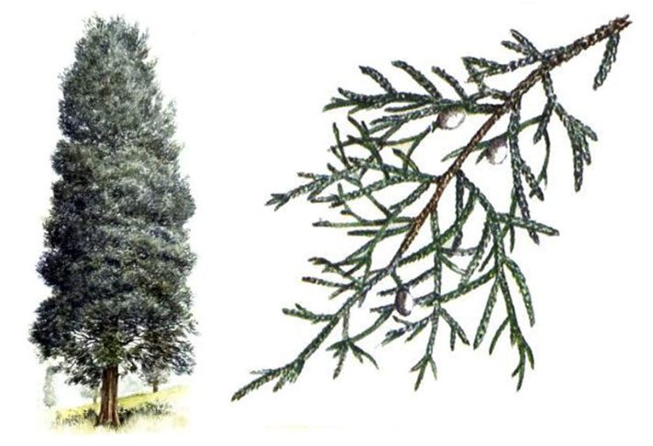
Materials:
- 2 small eastern redcedar* branches of approximately the same size
- Large Ziploc bag with dampened paper towels
- Microwave
- Microwaveable container of water
- One large baking sheet lined with aluminum foil
- Matches
- Bucket of water
* Eastern redcedar is a preferable species to use for this demo but the teacher may try out other species for this demo if desired.
Image retrieved from: https://www.woodmagazine.com/materials-guide/lumber/wood-species-2/eastern-red-cedar

Set up:
- Collect two branches approximately the same size from tree and place them into a Ziploc bag with dampened paper towels. Keep bag in refrigerator until ready for demonstration.
- Dry one of the branches in the microwave.

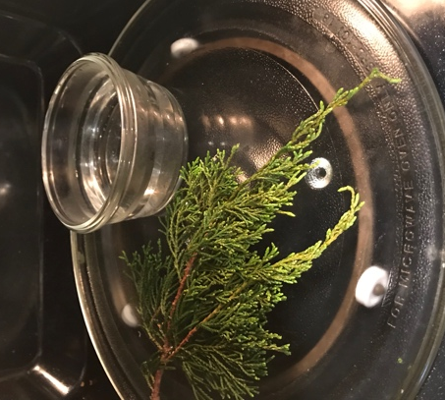
1. Set microwavable container filled with water in microwave with the branch.
2. Microwave* the branch for approximately 15 minutes, stopping every 30 seconds to allow the branch to cool in between to prevent from catching on fire.
- Drying time may vary depending on size of branch and water content.
- Keep drying until branch flattens and needles become brittle.
* Never leave branch in microwave unattended as it may catch on fire. If you notice smoke stop the microwave immediately.

- Keep watered branch in bag to retain moisture up until ready to light it on fire.
- Keep bucket of water next to the baking sheet to put out fire.
- Safety: make sure baking sheets are on flat, level surface with nothing inflammable near them.

Teacher Facilitation:
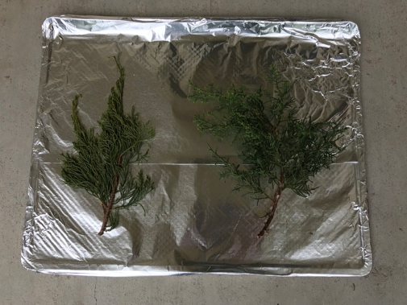
- Display both the watered branch and dry branch on the baking sheet for students to see.
- Ask students to make observations and predictions of the two different branches.
- Remove dry branch from baking sheet and center watered branch.
- Light match and try to catch the branch on fire (Branch should not catch flame).
Dry branch on left & watered branch on right

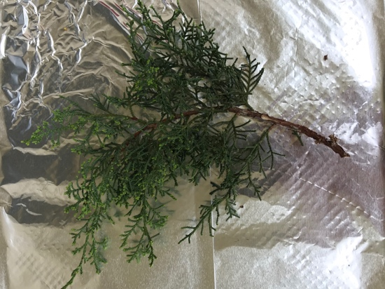

Watered branch after lighting match

- Remove watered branch and replace it with the dry branch.
- Light match and catch the dry branch on fire.
- Light dry branch on fire (watch as branch burns, keeping flame at a safe size).

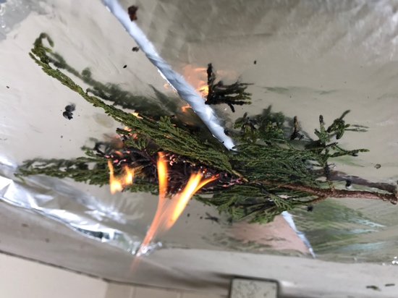
Dry branch after lighting match

- Dump water on branch to extinguish any flame.

California Wildfires

Purpose: This is a class discussion activity for the second part of the Engagement Phase of the lesson. The teacher shows a short video clip from Time Magazine and students discuss in their groups and then bring the conversation to the class level. This is to provide students with a real-world example of why this lesson on drought and climate change is relevant to them.

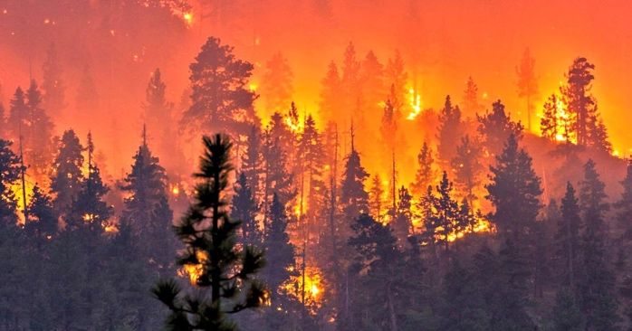
Materials:
- Time Magazine Video “California's Wildfires Have Become Bigger, Deadlier, and More Costly. Here's Why” http://time.com/4985252/california-wildfires-fires-climate-change/
- Discussion Questions Slides

Set Up:
Image retrieved from: https://www.zerohedge.com/news/2017-10-16/15-shocking-videos-expose-reality-surviving-california-wildfires
- Project slides to Smartboard.
- Assign students to groups of 3-4 students per table.
- Tell every student to get out paper and pencil to write out their answers to the discussion questions.

Teacher Facilitation:
- Play the video clip (1 min 24 sec)
- Pull up Discussion Question #1 from the slides.
- Ask students to write down their answers.
- Ask students to discuss their answers with their group members.
- Ask groups to share their answers with class.
- Repeat this process for all the Discussion Questions.

Discussion Questions:
- What are some observations you made from the video?
- What are some consequences of the wildfires?
- What do you think causes these wildfires to become bigger, deadlier, and costlier?
- Do you think there are ways that we can prevent these wildfires from becoming worse? If so, how?
- What are some short-term solutions to this issue? Long-term solutions?
- What could be done to detect areas of high wildfire risk?
- What is global warming? What is climate change?

Slide 1

Research Introduction

Purpose: Students learn about current research at the Environmental Ecology Lab at Oklahoma State University led by Dr. Henry Adams This eastern redcedar background not only exposes students to real research but also sets up the Exploration Phase of the lesson. During this phase, students follow Dr. Adams study’s footsteps and design their own experiment to find an effective drought detector of radish plants.

The following images and text are from the Environmental Ecology Lab website: http://henrydadams.com/research.html

Facilitation: Have students read about Dr. Adams’s work and the dynamic role of eastern redcedar in the Great Plains and Midwest. Allow students to discuss this research in their groups and then bring the discussion to the class level. After discussion, introduce that in the next several weeks students work with their lab groups following the scope of the lab’s research. Many of the research methods used in the Environmental Ecology Lab at Oklahoma State University are included in this lesson. The objective of the experiment is to determine an effective drought detector of radish plants that could be potentially be applied to a larger scale to monitor climate change.

MEET Dr. Adams
Assistant Professor, Dept. of Plant Biology, Ecology, and Evolution
Oklahoma State University
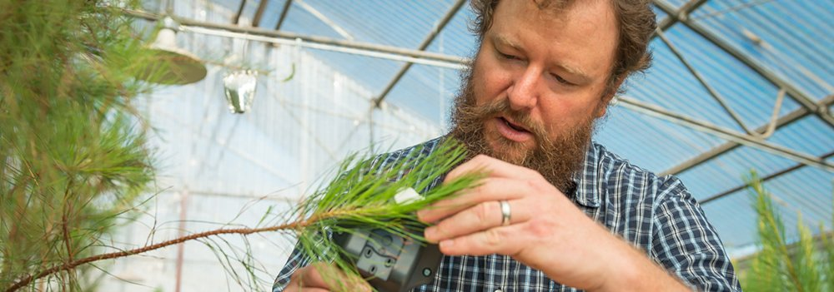

“I am a plant ecologist broadly interested in how organisms interact with their environment. Much of my research is in global change ecology, specifically on plant responses to climate-related disturbances. My research has focused on drought-induced tree mortality—including the physiological process of death from drought and its sensitivity to temperature, tree growth and phenological response to drought, and the ecosystem and earth system consequences of forest disturbance. My research approaches span subdisciplines, including plant physiological ecology, dendroecology, ecosystem ecology, and ecohydrology. I seek to increase understanding of the sensitivities and mechanisms of climate-related ecological responses with an application toward improved prediction of climate change and its effects on the biosphere and earth system.” - Dr. Adams

Teacher Notes: The following is a current research project from the Environmental Ecology Lab also found on the lab website.
THE ROLE OF DROUGHT IN FIRE RISK FROM EASTERN REDCEDAR

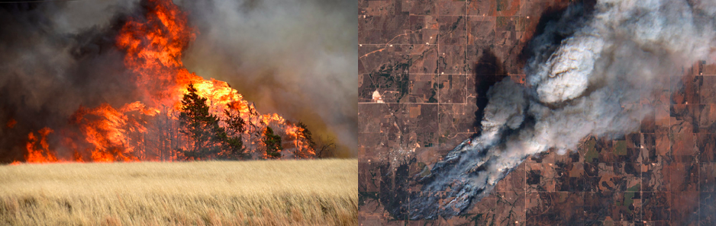
Photo credit: Nick Oxford / Reuters Photo credit: European Space Agency.

Invasion and expansion of eastern redcedar (Juniperus virginiana) is the greatest land management challenge facing states in the Great Plains and Midwest US. Woody encroachment from this species causes economic losses through reduction of forage for grazing, alters hydrological flows to negatively affect water resources, increases allergenic pollen counts, degrades wildlife habitat, and increases the risk of catastrophic wildfire. In Oklahoma, eastern redcedar threatens conversion of much of the state from grassland to woodland over the next 10-20 years. Eastern redcedar is considered a fire-intolerant species but it has a dynamic relationship with fire. The frequent low-intensity fires that were typical in Oklahoma prior to Euro-American settlement severely restricted the range of eastern redcedar, as its seedlings and saplings are very vulnerable to fire. Larger eastern redcedar trees are much more resistant to fire, especially during ideal conditions for prescribed fire when foliar moisture content is high. However, eastern redcedar is a highly drought-tolerant tree species that can survive relatively low tissue water content. During drought, when foliar moisture is low, eastern redcedar becomes much more easily combusted, posing a risk to life and property during wildfire. Recent research has found a threshold in fire behavior at 60% foliar moisture, and below this threshold time to ignition rapidly declines and flame height rapidly increases with declining foliar moisture. Our research aims to determine how drought influences eastern redcedar foliar moisture to better assess the effect of this tree on wildfire risk across Oklahoma. This study uses a combination of field observations and greenhouse experiments to determine just how much drought stress it takes to increase fire risk from eastern redcedar.

Teacher Notes: Ask students to summarize the lab’s work. What is the big question they are studying and the aim of their research? Ask students to describe what is happening with eastern redcedar in their own words. How is drought affecting this situation? What are some negative outcomes related to this?

Transition to Set-up Experiment: "For the next several weeks, our class will be collaborating with the Environmental Ecology Lab at Oklahoma State University. You will work in lab groups of 3-4 to design an experiment to determine an effective drought detector for radish plants. You will be given notes describing methods used in the Environmental Ecology Lab. Data will be statistically analyzed using R – a software. After data are analyzed your lab group will give a presentation of your research findings.”

You will present:
1. Your conclusion of climate change.
2. Your research findings.
3. How this method could be implemented to a larger scale to detect drought.

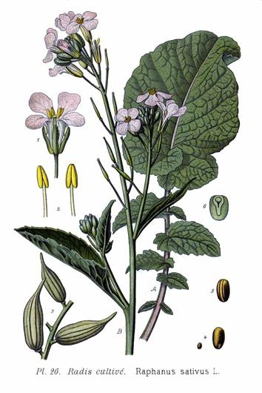
Planting Phase

Purpose: This is the first phase of the Exploration Phase of the lesson. During this part students plant their Raphanus sativus (radish) seeds in order to later implement drought stress in the experiment.

Set Up: Teacher prepares a planting station in the lab with all the materials for students to plant their seeds placed out on a table. Lab groups are established (3-4 students per group). Planting should be done in lab or outside, as potting mix will be messy.

Materials:
- Raphanus sativus (radish) seeds – 80 per group
- Glass beaker or bottle
- Water
- 80L bag of fertilized potting mix (e.g. Miracle Gro) – ~2 per class
- Large plastic tub (alt: plastic box)
- Plastic square planting pots – 20 per group (alt: egg cartoons with tops cut off)
- Planting trays – 2 per group (alt: plastic box lids)
- Plant markers – 20 per group (alt: popsicle sticks)
- Sharpie – 1 per group
- Light source
- Water
- Lab binder – 1 per group
- Data Sheets (StudentExplorationHandout3-DataSheet)

Image retrieved from: http://powo.science.kew.org/taxon/urn:lsid:ipni.org:names:77159305-1
Planting Instructions:

- Soak all the radish seeds in water for 6-12 hours before planting. Empty seeds into glass container and fill with water. Teacher may want to do this the night before the planting phase. Be sure to remove floating seeds and not use these in experiment.

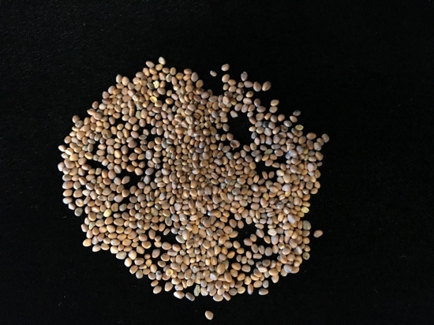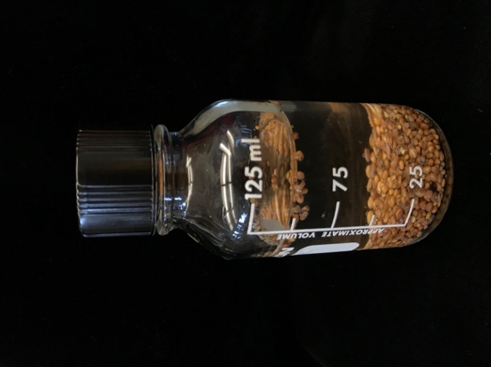
Radish seeds Radish seeds in 100mL of water

- Mix fertilized potting soil with water in a large plastic tub. Be sure to shave students saturate the entirety of the mix with water but not to a point that it is soaking wet. A good measure of this is when the soil is able to hold water and not drip when held, but loses much water when squeezed.

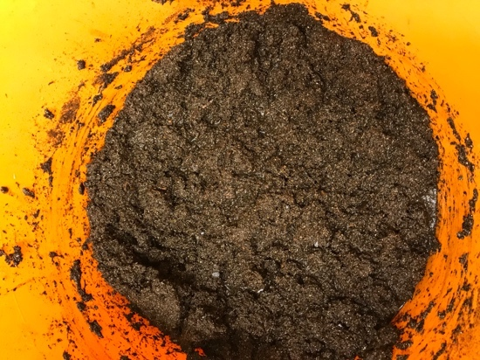
Fertilized potting mix saturated with water

- Hand each lab group 20 plastic pots, 2 planting trays, 80 radish seeds, 20 plant markers, and 1 sharpie.

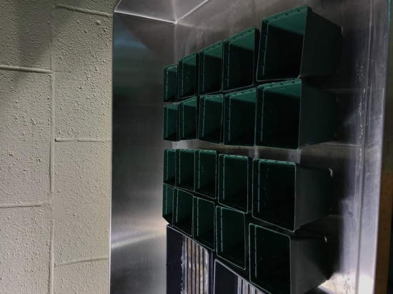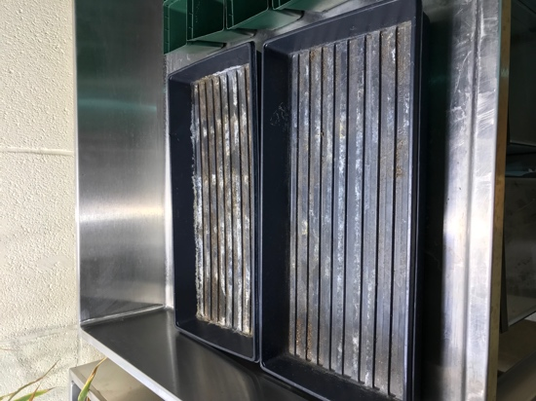
Square plastic pots Planting trays

- Each lab group fills 20 pots with the saturated soil and disperse the pots into the planting trays evenly.

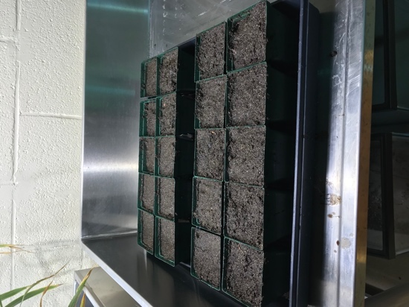
Soil filled pots in planting trays

- Each lab group plants ~4 seeds in each of the pots. Seeds should be planted about 1-2 cm deep in the middle of the pot. Be sure to not compact the soil over the seeds, but loosely push the soil back over the seeds.

- Each lab group labels 10 of their pots as “drought” and the other 10 as “control” with one marker per pot.

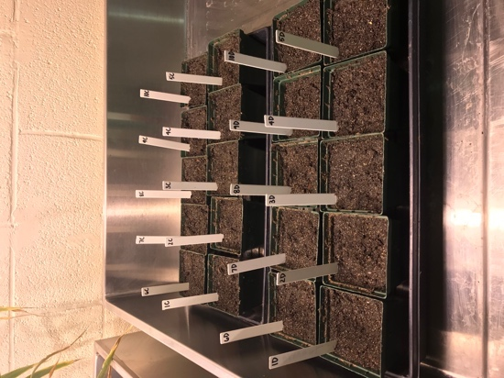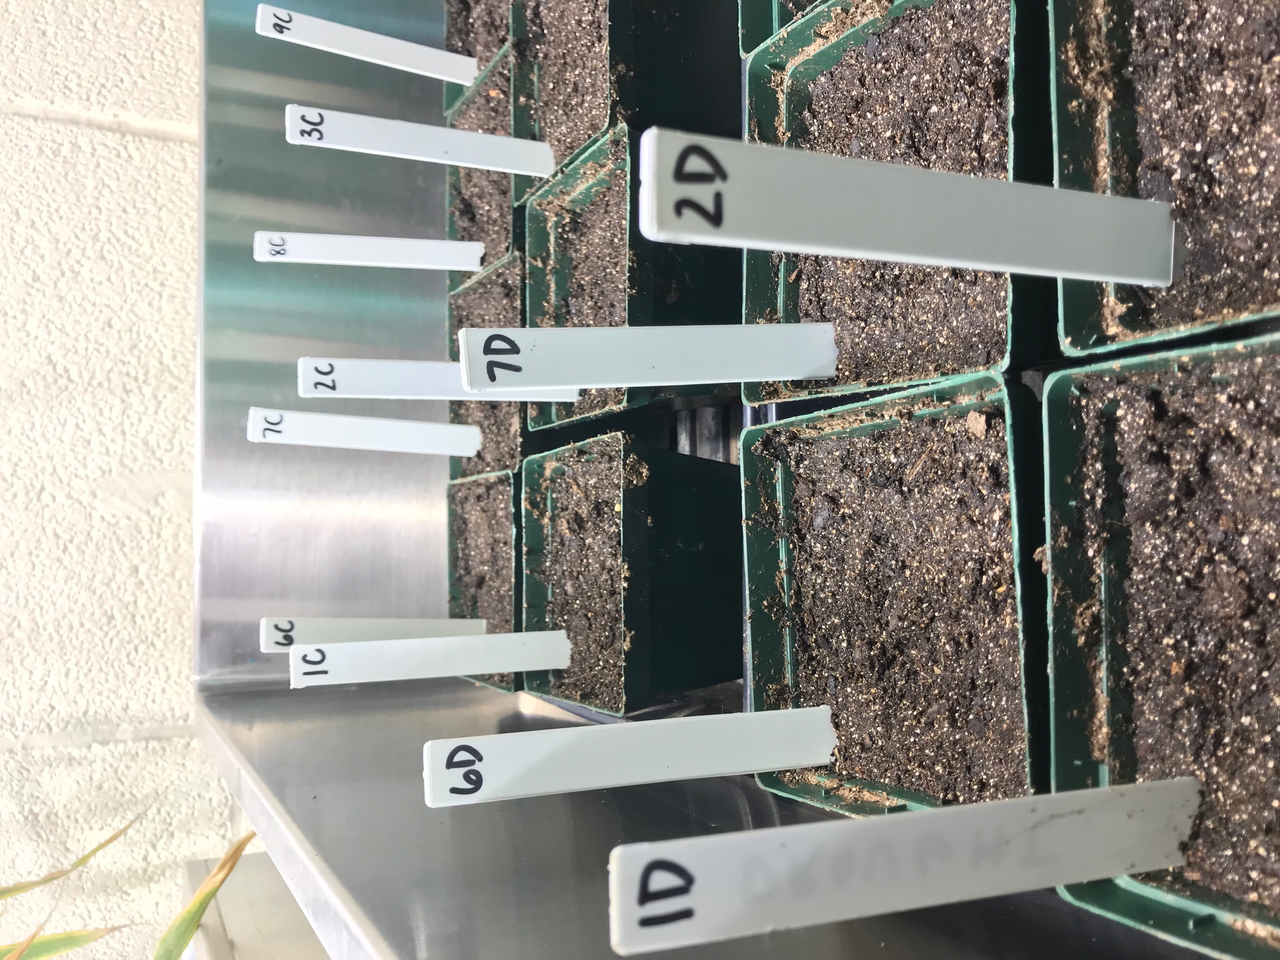
Pots marked sample# and D or C (drought or control). E.g. 1D stands for sample 1 drought group.

- Leave planting trays full of pots near good light source. Either in a lab directly under a light source for 12-hour periods to mimic day cycles or near a window which receives direct sunlight.

- After six days of growth, small sprouts began to appear. For pots which have multiple sprouts, remove all but the strongest/tallest shoot. Pull out excess plants (more than one) sooner than later to prevent roots from becoming too established and entangled with one another.

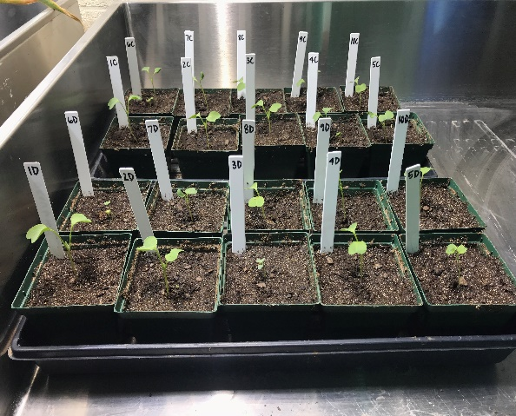
Six days after seeds were planted

Watering: During the planting phase of the experiment, each lab group collaborates and writes out who will water their plants during the first two weeks of the experiment until the drought stress begins. Seeds are watered when needed. A good determinant is when the top soil begins drying. This seems to be approximately every three days. Lab groups will plan out who is going to water and when in their lab group’s binder. Remember that both groups – drought and control – are watered during this phase.

Proposal Phase

Purpose: So far, the Raphanus sativus seeds have been planted, watered ~every three days and have been growing for two weeks. During this phase, students collaborate with their lab group and write a research proposal describing their plan for determining an effective drought detector.

Set Up: To give students some ideas of types of measurements they may choose to take, go through the lab materials available to students before they plan out their research proposals. Students may use provided methods, but are not limited to only picking from the examples given. Each group needs to have at least three different methods for taking measurements. Each group needs to measure leaf length as it will be used as a measurable proxy for drought stress. One of these will also need to be one of the methods conducted at the end of experiment (EOE). Research proposals need to be approved by meeting all satisfactory criteria according to the Research Proposal Rubric before students begin taking measurements. Students record measurements on data sheets to be kept in their lab binders (StudentExplorationHandout3-DataSheet).
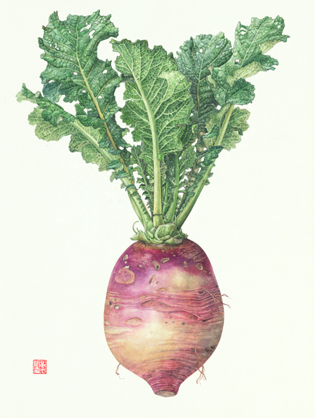
Lab materials available:
- Rulers
- Tape measures
- Calipers (alt: string, ruler, d=C/π)
- Scale
- Scissors
- Plastic vials (alt: empty spice jars)
- Refrigerator
- Oven
- Coin envelopes
- Safranin Dye
- Scintillation vials (alt: baby food jars)
- Microscopes
- Microscope slides
- Razor blades

Experiment method examples: Image retrieved from: http://greenasas.com/works/root-vegetables/

- Stem height – Measure from soil level to the top of the plant.
- Stem diameter – Measure the stem 1 cm from the soil level.
- Leaf count – Count the number of leaves growing from each bud of each individual plant.
- Leaf length* and width – Measure the longest part of the leaf from the base of the stem to the top and then the widest part across the leaf.
- Biomass (EOE) – Cut the stem at soil level. Gently shake roots free of all soil. Lay shoot and roots flat to dry out for ~72 hours. Weigh mass of shoot and roots for plant biomass.
- Percent wilted leaves (EOE) - Measure by counting the number of wilted leaves on each individual plant and then dividing by the total amount of leaves. Multiply by 100 to attain percentage.
- Relative water content (EOE) – Measure fresh weight, turgid weight and dry weight to determine RWC percentage. **
- Transpiration Stain (EOE) – Cut petiole with leaf from stem and let sit in safranin solution for ~1 hour. Then prepare wet mount and observe stained vascular bundles under microscope. Take photo of stained stem cross section to determine percentage of vascular bundles over total stem area. **

* All groups must choose Leaf Length as one of their methods as it will used as a measurable proxy for drought stress.
** Further detailed measurement methods and set up are included in TeacherExplorationHandout4-PlantPhysiologyLabNotes

EOE – End of Experiment measurement. All lab groups will need to choose at least one EOE method.

Research proposal will include:
- What measurements will be taken? (Must include leaf width [proxy measurement] and one EOE measurement)
- What materials or equipment will you use?
- When and how frequently will the measurements be taken?
- What is the significance of taking these measurements? (What will the results tell us about drought?)
- Which method do you hypothesize will be the most effective drought detector? Why?
- How much drought stress will you implement? No water, one watering a week, watered control group?
- Include a schedule of who will water and take measurements for the duration of the experiment.

Research Proposal Rubric

Criteria | Unsatisfactory | Satisfactory
Measurements | Less than 3 methods described; None of the methods are designated EOE measurements. | At least 3 methods described; At least one of the methods are designated EOE measurements
Materials/Equipment | Missing method descriptions specifying what materials/equipment will be used. | All methods are described specifying what instruments/equipment will be used.
Timing/frequency of measurements | Incomplete timing and frequency of measurement descriptions. | Complete timing and frequency of measurements descriptions for all methods.
Rationale of measurements | Missing measurement rationale. | Complete measurement rationale provided for all methods.
Hypothesis | Hypothesis missing. | Hypothesis present.
Level of drought | Level of drought not specified. | Level of drought specified.

Students must meet satisfactory in all criteria to have research proposal approved.

Plant Physiology Lab Notes

Relative Water Content
Background: Relative Water Content (RWC) is a measure of the amount of water in a leaf compared to maximum water capacity when turgid. This is a simple method to determine the level of drought stress. Due to the senesced nature of leaves under drought, it is important to take these measurements as quickly as possible. There are three different types of measurements needed for this method: Fresh, Turgid, and Dry. Fresh measurements are taken directly after leaves are cut. Turgid measurements will be left in water for 24 hours to allow the leaf to absorb water to its maximum. Dry measurements will be taken after turgid samples have been left in an oven to dry for 24 hours.

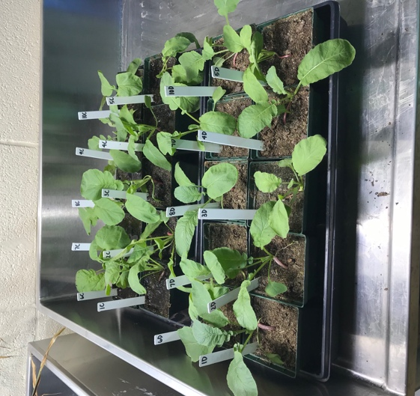
Materials:
- Scissors
- Labeled sample vials (one per leaf)
- Scale (to 3 decimal places)
- Water
- Refrigerator
- Paper towels
- Labeled coin envelopes (one per leaf)
- Oven

Procedure:
Fresh measurements
- Cut the best representative (meaning the leaf is a good example of what the entire plant looks like) leaf off the stem from each plant with scissors. Make cut in the middle of the petiole (stalk that connects leaf to stem).
- Immediately weigh the fresh samples to three decimal places. Make sure to keep track of which leaves came from which plants.
- Record fresh weight on data sheet. (FW = fresh weight)

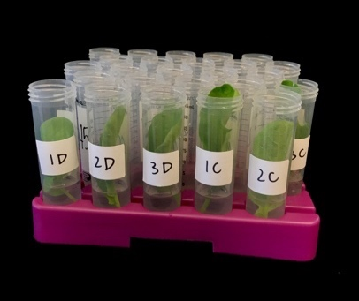
Turgid measurements
- Label each plastic vial accordingly, including the plant number and treatment group (e.g. 1C).
- Add 15 ml of water to each vial.
- Gently drop leaves in matching vials, ensuring that the bottoms of the petioles touch the bottoms of the vials.
- Once all vials are filled, tightened the caps and place in refrigerator for ~24 hours to allow leaves to reach full turgor.
- After 24 hours, take a leaf out of the tubes. Gently and quickly blot the leaf dry with paper towels.
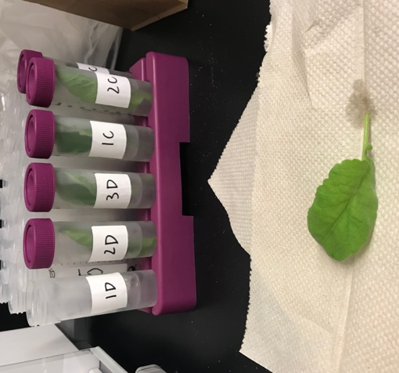
- Weigh the turgid leaf and record to three decimal places. (TW = turgid weight)
- Continue patting the leaves dry and weighing them for the remainder of the samples.
- Notes: Weighing the leaves quickly is an important step, as the weight will continue to drop as more water continues to leave the leaves as they are out of the water. The turgid weight should be higher than the fresh weight.

Dry measurements
- Put weighed turgid samples into labeled envelopes and dry in oven at 70° C for 24 hours. (If low temperature oven is not available, leaves could be left out on paper towels to dry under a light source for a couple of days)
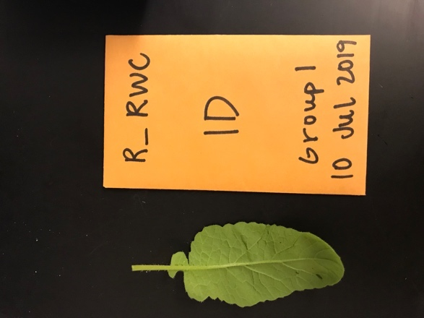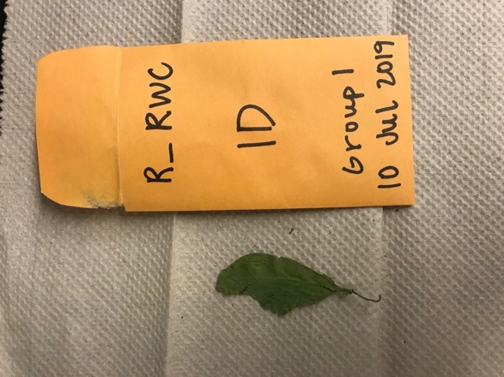
Before drying (left side) and after drying (right side)
- Weigh the dry samples and record to three decimal places (DW = dry weight).
- Note: leaves will become brittle and fall apart, so be sure to dump the entire contents of the envelope onto the scale to measure all the leaf. Dried weight should be lower than the fresh weight.
Calculations
Find leaf Relative Water Content:
leaf RWC(%) = ((FW-DW)/(TW-DW)) x 100
FW= fresh weight; DW= dry weight; TW= turgid weight
E.g. 1D RWC = ((.3781 - .0277) / (.4022 - .0277)) x 100
RWC = 93.56% [This result is makes sense because drought had just begun when leaf samples were collected. We would predict a lower percentage as drought is intensified.]
Results
Typical RWC values of turgid or transpiring leaves is around 98%, of severely desiccated or senescing leaves is around 40%, and of wilting leaves is around 60-70%.

Functional Xylem Area
Materials for Stain Solution
- Safranin O, Reddish, 1% Aqueous, Laboratory Grade
- Erlenmeyer flask
- Water
Materials for Staining Manifold
- Labeled scintillation vials
- Gloves
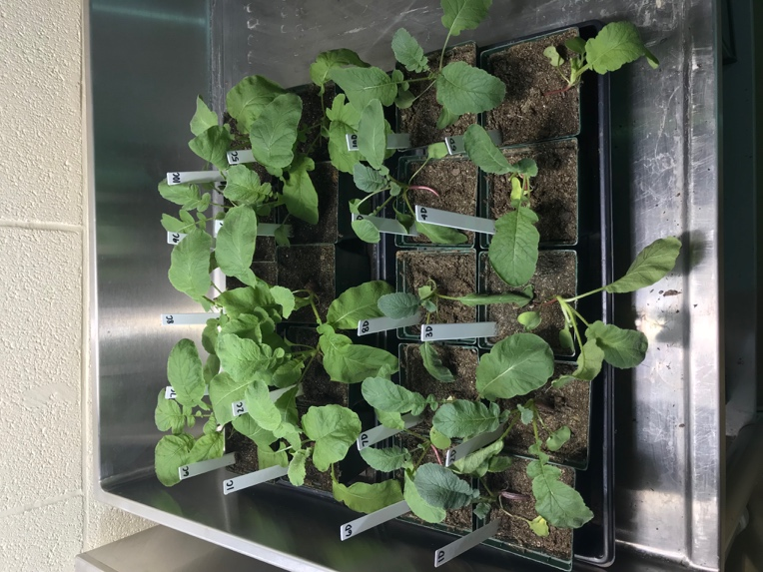
- 0.1% safranin solution
- Razor blades
- Leaf samples
Materials for Active Xylem Viewing
- Paper towels
- Gloves
- Razor blades
- Water
- Pipet
- Paint Brush
- Microscope slides
- Microscope cover slips
- Microscopes
- Camera (smartphones)
- Grid
Procedure
Preparing the 0.1% Stain Solution
- Wear gloves whenever working with safranin. Safranin will not come out of clothing so be sure to wear a lab coat or old clothing.
- Add 10mL of safranin 1% stock solution to 90mL of water in Erlenmeyer flask to create 0.1% safranin solution.
- Mix solution for 2 minutes until the color is consistent throughout solution
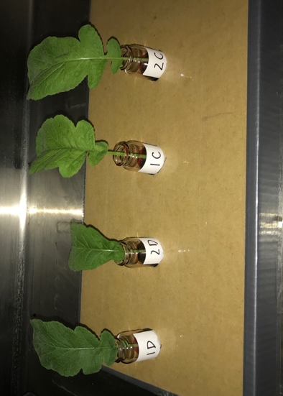
Setting up the Staining Manifold
- Label scintillation vials with appropriate plant numbers and treatment group (e.g. 1D)
- Wearing gloves, pour 0.1% safranin solution into vials, filling them halfway.
- Cut true leaves (not cotyledons, unless measuring cotyledon transpiration) from base of petiole (leafstalk) with razor blade.
- Safety: Always be careful when working with blades. Pinch fingers in and make short downward strokes. Dispose razor blades in appropriate waste bins after use.
- Place leaves in halfway filled labeled vials accordingly.
- Allow leaves to sit in solution for approximately 1 hour under light source.
Viewing the Transpiration Stain
- After the staining period, remove the sample from the vial with gloves.
- Gently dab sample dry with paper towels.
- Slice the bottom portion of the stem off, where the exterior is stained.
- To cut stem cross section, move blade in a diagonal motion forward and down.
- Cut a couple sections, try to get them as thin as possible but containing the entirety of the diameter of the stem.
- To make a wet mount, use the pipet to add one drop of water to the center of a microscope slide.
- Wet the paintbrush and pick up the best-looking section by scooping it up from the bottom.
- Place the section onto the drop of water on the microscope slide.
- Drop the microscope cover onto the section, first by dropping one side of the cover on a far side of the water drop. Once one side is touching the slide, drop the rest of the slip slowly like dropping a hinged door.
- Place wet mount under microscope to view the stained vascular bundles.
- Take picture of cross section using smartphone
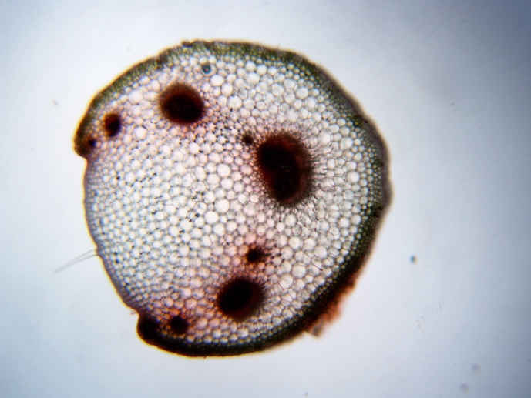

Calculations
- Open Microsoft Word. Check ‘Gridlines’ under the ‘View’ tab.
- Insert the stained stem cross section photo onto the page.
- Click on the photo, under ‘Picture Format’ select ‘Transparency’ and make the photo transparent enough to see both the gridlines and still be able to see the stained vascular bundles.
- Calculate the area of the stem cross section by counting the boxes filled (if at least half of a box is filled consider this box in the area).
- Calculate the area of vascular bundles by counting the boxes dyed with safranin (again, consider all boxes that are at least halfway filled).
- Divide the vascular bundle area by the stem area to determine the percentage of the transpiration stain.
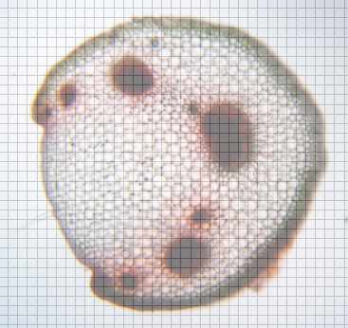

Statistical Analysis

Purpose: After students are finished collecting experimental data, including the EOE measurements, now it is time for statistical analysis. This purpose of this lesson is not to introduce students to statistical tests. It is assumed that students have been exposed to and understand ANOVA test. First students transfer their lab binder data onto an excel file. Then students follow the “Installing R and RStudio” handout to install the software. There is a video link at the bottom of this handout to introduce students to R. Lastly, students upload the Rscript file (StudentExplanationHandout1-RScript) to run the ANOVA test.

Materials:
- Class set of laptops or computers with Excel capabilities
- Statistical Analysis Review Slides: TeacherExplanationHandout2-StatisticalAnalysisReviewSlides

Facilitation: Teacher passes out a laptop to every student and instructs students to access Excel. Teacher allows time for students to key in data from their lab binder onto an Excel file and save file as a .csv document in order to be opened by software for data analysis later. Have students save file as labgroup#_rde.csv (rde = radish drought experiment).

For Example: labgroup4_rde.csv

This is the format students should key in their experimental data for all three methods.

Transition to Data Analysis: "Now that data collection is over, it is time for statistical analysis. In science, we analyze our data statistically to determine the significance of our results. ‘What do the results mean?’ The software we are going to download is called R. This program is used by scientists all over the world to analyze data and create graphs, including the Environmental Ecology Lab”

Installing R and RStudio

Purpose: To statistically analysis experimental data have students follow the instructions below to download R and RStudio to a class set of laptops or computers. Installation is only required for the first time R and RStudio are used. R is a program used by scientists to statistically analyze data and create graphs. RStudio is the workspace to run R.

Materials:
- Class set of internet accessible devices
- Installing R and RStudio Instructions
- Email R script for ANOVA to students (StudentExplanationHandout3-RScript)

Source: Instructions for downloading R and RStudio are modified from: https://www.andrewheiss.com/blog/2012/04/17/install-r-rstudio-r-commander-windows-osx/
“R is an incredibly powerful open source program for statistics and graphics. It can run on pretty much any computer and has a very active and friendly support community online. Graphics created by R are extremely extensible and are used in high level publications like the New York Times…
RStudio is an integrated development environment (IDE) for R. It’s basically a nice front-end for R, giving you a console, a scripting window, a graphics window, and an R workspace, among other options.” -Andrew Heiss

Install R, RStudio, and R Commander in Windows:
- Download R from http://cran.us.r-project.org/ (click on “Download R for Windows” > “base” > “Download R 2.x.x for Windows”)
- Install R. Leave all default settings in the installation options.
- Download RStudio from http://rstudio.org/download/desktop and install it. Leave all default settings in the installation options.
- Open RStudio.

Install R, RStudio, and R Commander in Mac OS X:
- Download R from http://cran.us.r-project.org/ (click on “Download R for Mac OS X” > “R-2.x.x.pkg (latest version)”)
- Install R.
- Download RStudio from http://rstudio.org/download/desktop.
- Install RStudio by dragging the application icon to your Applications folder.
After Installation: After R and R studio has been installed, students can analyze data using a prewritten R script. To run data, students will need to save their data in excel as a ‘.csv’ file.
To use R scripts for data analysis:
- Open RStudio.
- Select ‘file’ at the top bar of the screen in the tool bar.
- From under the ‘file’ tab, select ‘open file’ and select the favored R script file (StudentExplanationHandout3-RScript) and click ‘open.’
- Once the R script file is opened on RStudio, it will be visible in the top left portion of the screen.
- Begin to read the script from line 1. The “####” at the beginning of the lines distinguish instructions for you to read and follow from the code lines with do not have “####.”
- Follow the comments (#### lines) to upload your .csv data file to run your data analysis.
- Your final products from this ANOVA test will be: F value and P value for each variable, a boxplot comparing drought groups to control groups for each method (3 total).

For more information on R and R studio check out https://www.rstudio.com for troubleshooting and useful tips.

Helpful Video: https://www.youtube.com/watch?v=Uo1C7Iligw0 This 7 minute clip explains how to upload a file into R and how to navigate the RStudio.

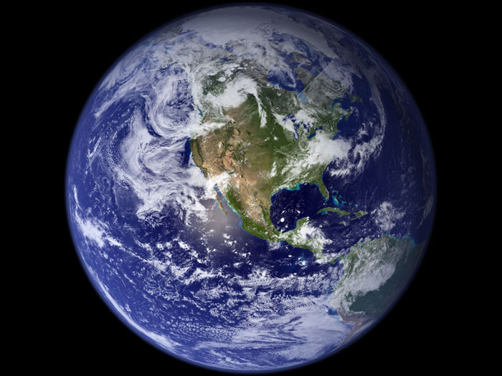
Vital Signs of the Planet

Purpose: Students explore NASA Global Climate Change Vital Signs of the Planet website interpreting climate data to determine for themselves whether the evidence supports the claim that the climate is indeed changing due to human activity. Students go through an online interactive to visualize how the climate has already changed. Finally, students discuss compelling satellite photographs and ways to mitigate or adapt to climate change.

Materials:
- Class set of internet accessible devices (e.g. laptops, computers, ipads)
- StudentElaborationHandout1-VitalSignsofthePlanet

Facilitation:
Send out the following link to students https://climate.nasa.gov/evidence/ and instruct students to work within their lab groups to read the website and answer the following questions from the NASA website. Answers will be found under the “facts” tab, under subtabs “evidence” through “scientific consensus.” Each student will turn in their own handout.

Climate Change: How Do We Know?
  - Do you agree or disagree that our planet’s climate is rapidly changing? Provide evidence to support your claim. Evidence for climate change includes: 1) Global temperature rise – Earth’s temperature has risen 1.62°F since the end of the 19th century. 2) Warming oceans – since 1969 the ocean has warmed over 0.4°F. 3) Shrinking ice sheets – between 1993 and 2016 Greenland lost 286 billion tons of ice and Antarctica lost 127 billion tons of ice. 4) Glacial retreat – glaciers are retreating in the Alps, Himalayas, Andes, Rockies, Alaska and Africa. 5) Decreased snow cover – less snow in Northern Hemisphere and snow is melting earlier. 6) Sea level rise – global sea level rose 8 inches last century. 7) Declining Arctic sea ice – decreased width and thickness of sea ice. 8) Extreme Events – U.S. has experienced more record-breaking high temperature events as well as intense rainfall events. 9) Ocean Acidification – since the Industrial Revolution the ocean’s acidity has increased by 30%.

Causes of Climate Change
  - What causes the Earth’s temperature to rise? What gases contribute to this effect? The Greenhouse Effect causes the Earth’s temperature to rise when the atmosphere traps heat radiating from Earth toward space. Water vapor, carbon dioxide, methane, nitrous oxide, and chlorofluorocarbons are involved in this effect.
  - Over the last century, what has caused a change in the natural greenhouse effect? Human activities such as burning coal and oil causes the carbon and oxygen in the air to combine to form carbon dioxide. Also, clearing of land for agricultural or industrial purposes has contributed to the levels of greenhouse gases.
  - How have industrial human activities affected the Earth’s atmosphere? In the last 150 years human activity has raised atmospheric carbon dioxide levels from 280 ppm to 400 ppm and caused the Earth’s temperature to warm.
  - Do you agree or disagree that the sun’s energy output is causing the current warming of the globe? Provide evidence to support your claim. The current global warming cannot be explained by changes in the energy from the sun because 1) the sun’s energy output has only increased slightly or remained constant since 1750 2) the atmospheric warming is only occurring in the lower atmosphere 3) climate models cannot explain the current trend without considering that greenhouse gas levels have increased.

Effects of Climate Change
6. What do scientists predict will be some long-term effects of climate change for the U.S.? Future effects include: 1) Temperatures will continue to rise – but not in a smooth uniform way due to the planet’s naturally varying climate. 2) Frost-free (and growing season) will lengthen – this is predicted to lengthen anywhere from one month to over eight weeks. 3) Changes in precipitation patterns – some areas will increase and other areas will decrease, but both will experience increased heavy precipitation events. 4) More droughts and heat waves – more intense in the Southwest U.S. 5) Hurricanes will become stronger and more intense –
hurricanes are predicted to occur more often for longer periods and become more intense. 6) Sea level will rise 1-4 feet by 2100 – due to melting of ice caps and expansion of seawater as it warms. 7) Arctic likely to become ice-free – Arctic ocean predicted to become ice-free in summer before 2050.
7. If these predictions hold true, how will the region you live in be affected? Have you observed any of these changes/events first hand?* How did this affect biodiversity?* Northeast. Heat waves, heavy downpours and sea level rise pose growing challenges to many aspects of life in the Northeast. Infrastructure, agriculture, fisheries and ecosystems will be increasingly compromised. Many states and cities are beginning to incorporate climate change into their planning. Northwest. Changes in the timing of streamflow reduce water supplies for competing demands. Sea level rise, erosion, inundation, risks to infrastructure and increasing ocean acidity pose major threats. Increasing wildfire, insect outbreaks and tree diseases are causing widespread tree die-off. Southeast. Sea level rise poses widespread and continuing threats to the region’s economy and environment. Extreme heat will affect health, energy, agriculture and more. Decreased water availability will have economic and environmental impacts.
Midwest. Extreme heat, heavy downpours and flooding will affect infrastructure, health, agriculture, forestry, transportation, air and water quality, and more. Climate change will also exacerbate a range of risks to the Great Lakes. Southwest. Increased heat, drought and insect outbreaks, all linked to climate change, have increased wildfires. Declining water supplies, reduced agricultural yields, health impacts in cities due to heat, and flooding and erosion in coastal areas are additional concerns.
*Last two questions vary from region to region.

Scientific Consensus
8. What is the scientific consensus regarding human-induced climate change? What percentage of active climate scientists agree? The majority of scientists agree that the climate is warming and this is extremely likely due to human activities. Ninety-seven percent of actively publishing climate scientists agree.

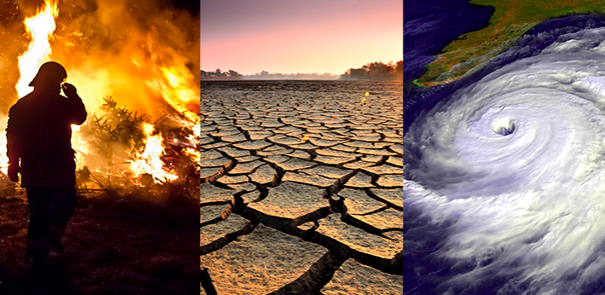
Image retrieved from: https://climate.nasa.gov/effects/

NASA Global Climate Change: Climate Time Machine Interactive

Teacher note: For the second part of the Elaboration Phase, have students go to: https://climate.nasa.gov/interactives/climate-time-machine and choose two of the four topics to research and make observations of.

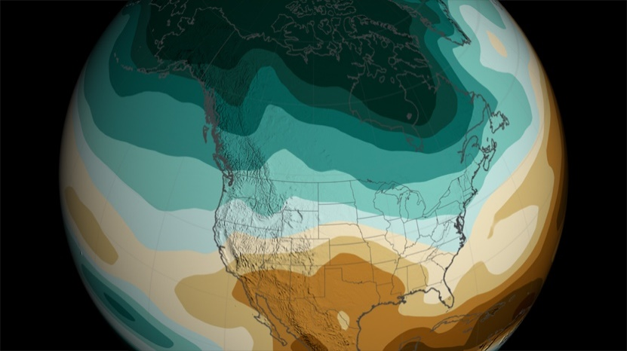
Image retrieved from: https://svs.gsfc.nasa.gov/11281

- Choose two of the four topics: Sea Ice, Sea Level, Carbon Dioxide, Global Temperature.
- Click on the topic you wish to research and explore the interactive by watching the visualization change as you manipulate the time/distance.
- Answer the following questions for both topics that you have selected.

Topic 1: Sea Ice

- Define the time/distance range of the visualization and what the various colors represent 1970 – 2018; white regions represent Arctic sea ice cover
- Record three different noteworthy events (year/distance) where major change occurred and explain where on the map it occurred and what happened.
- Answers will vary – E.g. 1990, first year of the interactive you can easily see a huge decrease of ice cover of the Arctic.

- What overall trend does the visualization support?
The visualization supports the steady decrease of sea ice cover of the Arctic since 1979.
- If this trend continues, what are some potential consequences affecting biodiversity? List three examples.
Answers will vary – E.g. If the ice continues to melt this will destroy habitats for native Arctic animals possibly leading to extinction of polar bears?

Topic 2:

- Define the time/distance range of the visualization and what the various colors represent
- Record three different noteworthy events (year/distance) where major change occurred and explain where on the map it occurred and what happened.

- What overall trend does the visualization support?

- If this trend continues, what are some potential consequences affecting biodiversity? List three examples.

*** Student answers will vary depending on which topics their group selected.

NASA Images of Change/Solutions Discussion

Teacher note:
1. Have students go to: https://climate.nasa.gov/images-of-change?id=672#672-sierra-nevada-snowpack-increases (also accessible under the “Explore” tab and then under the “Images of Change” subtab) and independently go through the photographs comparing before and after shots of the same location. After about 5 minutes have students share images that stood out to them in their lab groups. Have students describe their observations regarding biodiversity.

2. Have students go to: https://climate.nasa.gov/solutions/adaptation-mitigation/ (also accessible under the “Solutions” tab and then under the “Mitigation and Adaptation” subtab) and scan the paragraphs under the heading “Mitigation and Adaptation” independently.
- Ask students to describe what the terms mitigation and adaptation mean in regards to climate change.
- Ask students to work in their groups to think of ways climate change could be mitigated/adapted to in their city. Have groups share with the class.

** Sample answers to the handout questions sourced from the NASA Global Climate Change: Vitals Signs of the Planet website.

Drought Research Presentation Guidelines

Purpose: Students will work in their original lab groups and present their drought experiment research to the class as a summative assessment for the lesson. Students will have one week to put together a Slideshow presentation to share their drought study. The purpose of this Evaluation Phase is to teach students the importance of scientists sharing their findings for the advancement of science and giving presentations is just one way this can be done.

Facilitation: The teacher will provide students with the Drought Research Presentation Summative Assessment rubric as guidelines for creating and presenting their slideshow. As well as the following instructions:

- Students will work in their original lab groups.

- Each group will include the following into their presentation:

- Stance on climate change. Must provide scientific evidence to support claim.

- Reason for conducting this research. What was the point of this research?

- Experimental Design. Define IV, DV, measurement frequency and the reason why you developed your specific experimental design.

- Methods. What were the three experimental methods your group tested? What was your end of experiment method? Provide detailed information on how you conducted each so as to provide enough information for your experiment to be replicable. What kind of data did you collect?

- Results. What did the data mean? What statistical test did you use? How did you run this statistical test? Were your results significant?

- Conclusion. Based on your results which method was found to be the most effective drought detector? Why do you think this was? Are there any other experiments that support this?

- Further implications. How could you further this research or implement it into the real word to provide a solution to detect drought as a result of human induced climate change?

- Students will be scored on their oral presentation and the slideshow’s visual aesthetic including grammar.

- The presentations should be 7-10 minutes long with all lab members participating equally.

- At the end of the presentation, the floor will be opened for questions.

Teacher Note: Encourage students to tweet pictures of their research to either Dr. Adams or William Hammond. Scientists love to hear that their work is reaching students and bringing climate change awareness. This will excite students about presenting their drought study and further introduce them into the field of research.

Have students tweet drought study pictures to:

Dr. Henry Adams @EnvEcoLab
William Hammond @wmhammond
#stressedaboutdroughtstress

Criteria  Drought Research Presentation Summative Assessment Rubric | Below Average Performance (0-1) | Average Performance (2-3) | Above Average Performance (4) | Points
Climate Change Evidence | No scientific evidence to support claim | Some incorrect evidence to support claim | Correct scientific evidence to support claim
Reason for Conducting Research | Background for study is weak and not clear; or does not relate to research | Background for study is stated and is relevant to the research, but some pieces missing | Explicit, thorough background for study is stated with a strong, clear relation to the research
Experimental Design | Experimental design is incomplete or incorrect | Experimental design is mostly complete, but some pieces missing | Design is correct, complete, and contains explanation of the thought process behind each method
Methods | Methods are incomplete and/or incorrect | Methods are complete and correct | Methods are complete, correct and are clearly stated, with descriptive details for each method with visual aid
Results | Results are incomplete or incorrect | Results are complete and correct | Results are complete, correct, and organized in a clear format that is easily read; graphs are present
Conclusion | Conclusion is incomplete and/or does not correlate with results; most effective method is not stated | Conclusion is complete and correlates with results; Most effective method is stated but does not explain how the conclusion was reached using the statistical test values | Conclusion is complete and correlates correctly with results; Most effective method is stated and explains how the conclusion was reached (statistical test value = significant or not significant)
Further implications | No further implications are given or implications provided are incoherent with study | Further implications are given but explanation of how they would be implemented in a real-world example is missing | Detailed coherent further implications are given along with an explanation of how this would be implemented in a real-world example
Oral Presentation | Word for word reading off the slide; hard to hear; presenter faces the board | Presenter is familiar with slides; speaks in a clear manner | Clear, audible, well-articulated statements; no reading word for word off the slides; speaks to the audience
Visual Aesthetic | Disorganized slides; grammar mistakes; hard to see colors and graphics/no graphics | Slides are organized; some grammar mistakes; thoughtful color and graphic choices; some graphics | Slides are organized, no grammar mistakes, tasteful colors and graphics, slides adhere to an aesthetically pleasing theme, sharp images
Presentation Time | Under 5 minutes | 5-7 minutes | 7-10 minutes
Team Work | Not all group members orally present to the class | All group members present orally but presentation is not divided fairly between members | All group members present and presentation is divided fairly between members

