Name **___________________________**

**___________________________**

**Researcher Diary**

**Researcher Diary**

Grade **___________________________**

School **___________________________**

**___________________________**

Date **___________________________**

**Note for the teacher:**

This Researcher Diary was designed to lead the students through both learning units. The workbook was printed in brochure style. The colors on the front page and several other pages were orange, blue, black or grey. Therefore, the students were automatically and randomly assigned to different groups in certain parts of the module. The order of the two main courses “botany & location factors” and “agriculture & sustainability” can be varied. Therefore, there were eight different version of this workbook:

1. Meadow – Classroom –   
   Expert Group “Temperature & Farmer”
2. Meadow – Classroom –   
   Expert Group “Humidity & Politician”
3. Meadow – Classroom –   
   Expert Group “Light Intensity & Organic Farmer”
4. Meadow – Classroom –   
   Expert Group “Insects/Plants & NGO”
5. Classroom – Meadow –   
   Expert Group “Farmer & Temperature”
6. Classroom – Meadow –   
   Expert Group “Politician & Humidity”
7. Classroom – Meadow –   
   Expert Group “Organic Farmer & Light Intensity”
8. Classroom – Meadow –   
   Expert Group “NGO & Insects/Plants”

**Basic Info**

1. Color

**Chapter 1**

**Identification Key**

white yellow red pink blue green brown

The colored parts of a flower are called petals.

1. 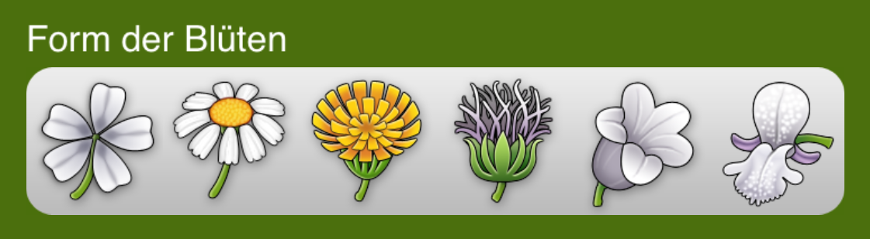Shape of the flower

normal composite upper & lower lip

spot the difference!

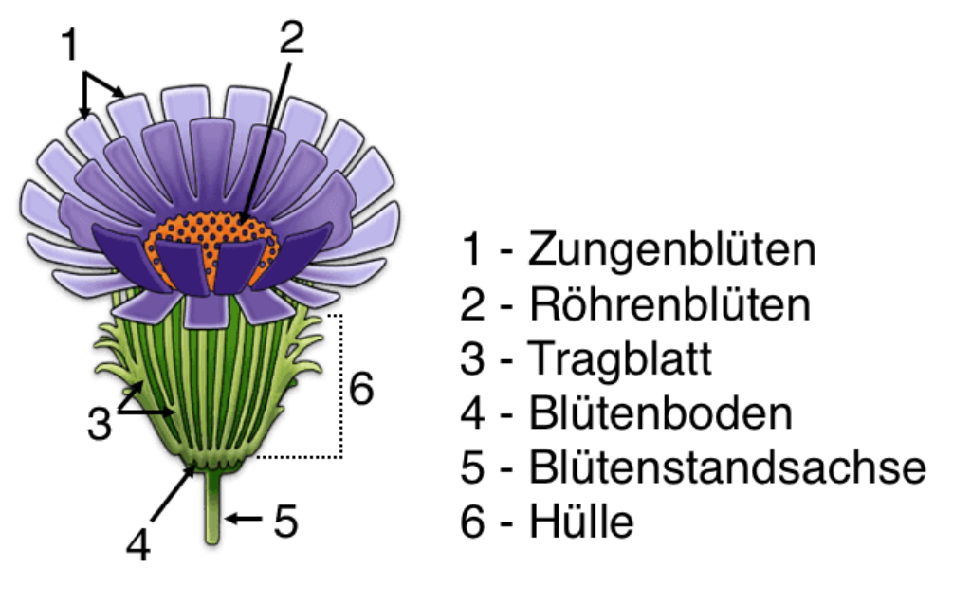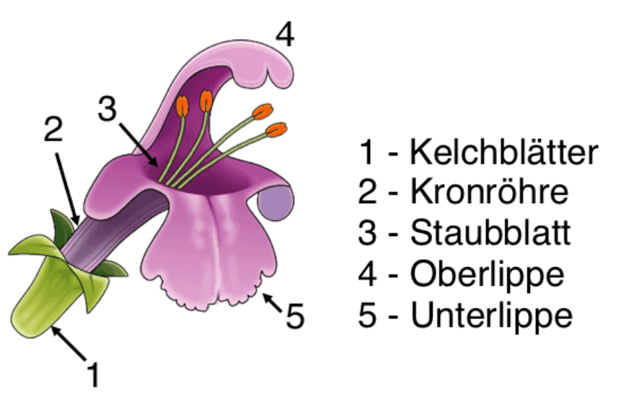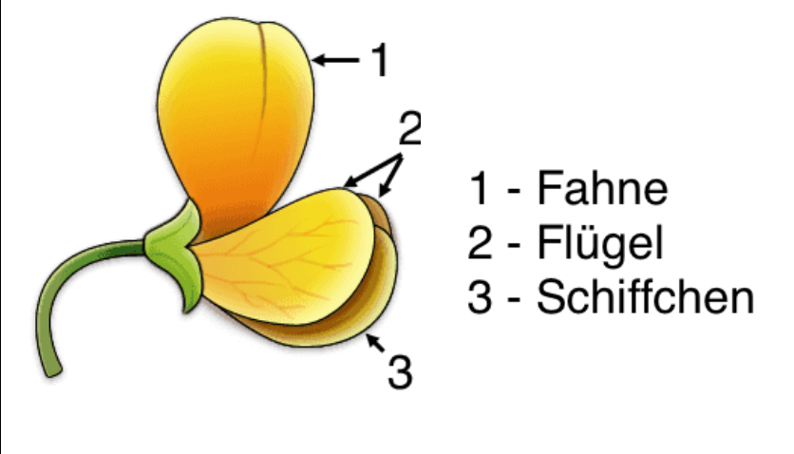

Composite flowers are the trickiest. They are also called **pseudanthium**, because their flowers look like petals.

Butterfly-like flowers have a special anatomy: there petals consist of a **banner**, **keel** and **wings**.

Plants from the mint family typically have an **upper** and a **lower** **lip** and hence are shapes like a C.

1. Appearance

**Chapter 1**

**Identification Key**

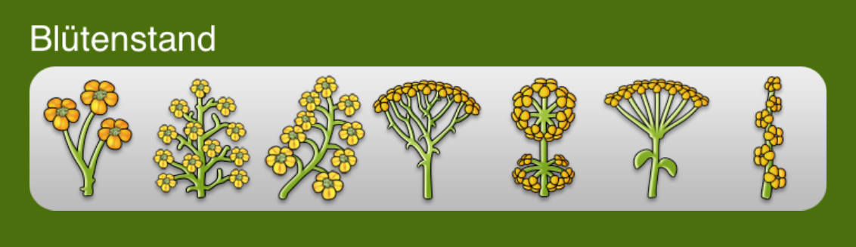

single panicles/ racemes balls/ umbels spikes

1. 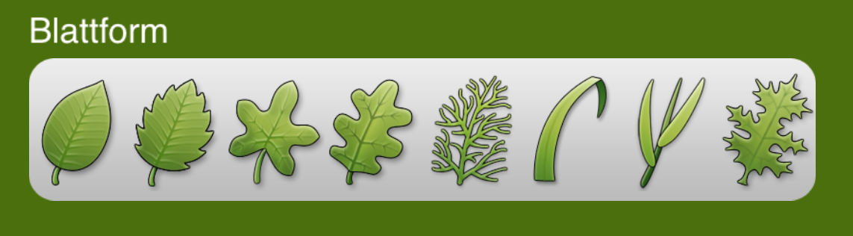Leaf Shape & Edge

digitate pennate simple notched

Once we determined the leaf position, it is important to look at the leaves themselves. They can be single leaves, or on petioles (see **digitate** and **pennate**). Their edges can also vary from **simple** to **notched**.

1. Leaf Position

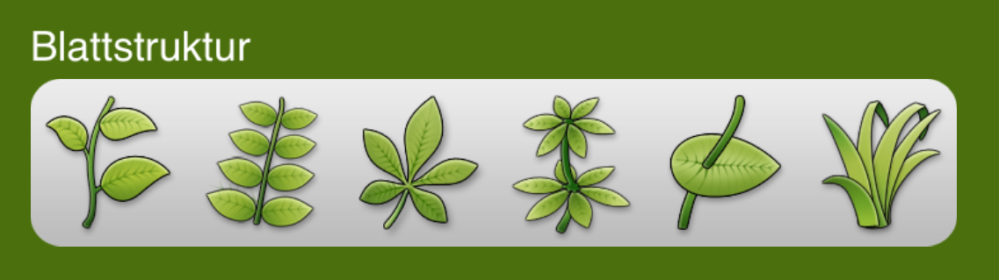single leaf multiple leaves

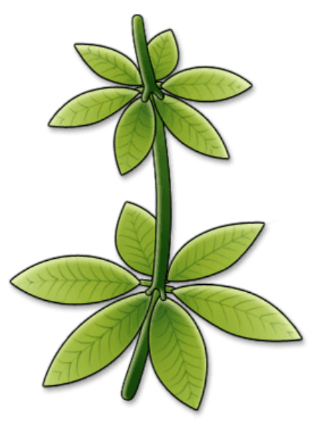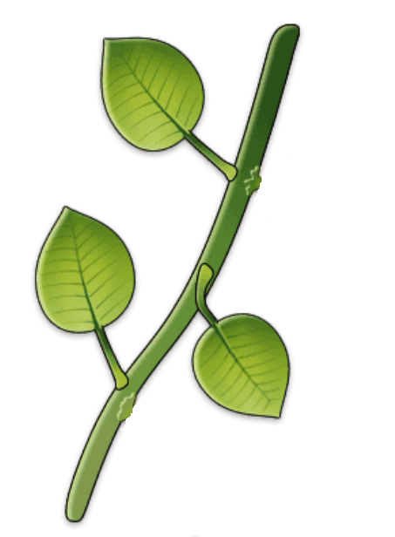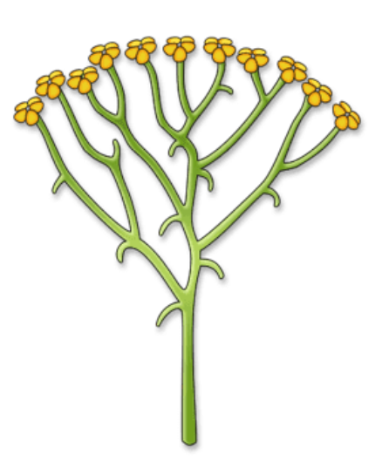

single leaf opposite alternate whorled

**Chapter 2**

**Identification**

**Chapter 2**

**Identification**

**Plant #1**

You received two pictures from your instructor. Try to find these two plants on the meadow and determine their botanical name with the help of the identification app on your tablet. Mark the most fitting feature with an X.

If you’re unsure about the meaning oft he symbols in the app, take a look at the identification key on pages 3 & 4.

|  |  |  |  |  |
| --- | --- | --- | --- | --- |
| **Appearance** | broadleaf tree | coniferous tree | flowering plant | grass |
| **Height** | < 5cm | 5-10 cm | 10-30cm | >30cm |
| **Color of Flower** | red | yellow/  orange | pink/  purple | blue |
| **Shape of Flower** | simple | composite | upper & lower lip | butterfly-like |
| **Appearance** | single | panicles/ racemes | balls/  umbels | spikes |
| **Leaf Shape** | single | digitate/ pennate | simple | notched |
| **Leaf Position** | single leaf | leaflets | opposite | alternate |

Botanical name of the plant:

________________________________________________

________________________________________________



**Chapter 2**

**Identification**

**Plant #2**

You received two pictures from your instructor. Try to find these two plants on the meadow and determine their botanical name with the help of the identification app on your tablet. Mark the most fitting feature with an X.

If you’re unsure about the meaning oft he symbols in the app, take a look at the identification key on pages 3 & 4.

|  |  |  |  |  |
| --- | --- | --- | --- | --- |
| **Appearance** | broadleaf tree | coniferous tree | flowering plant | grass |
| **Height** | < 5cm | 5-10 cm | 10-30cm | >30cm |
| **Color of Flower** | red | yellow/  orange | pink/  purple | blue |
| **Shape of Flower** | simple | composite | upper & lower lip | butterfly-like |
| **Appearance** | single | panicles/ racemes | balls/  umbels | spikes |
| **Leaf Shape** | single | digitate/ pennate | simple | notched |
| **Leaf Position** | single leaf | leaflets | opposite | alternate |

Botanical name of the plant:

________________________________________________

________________________________________________



**Family #1**

Some plants are related to each other. They share certain characteristics, which are derived from a common ancestor. We combine them in certain **plant** **families**.

Can you figure out which family your first plant belongs to?

|  |  |  |  |  |
| --- | --- | --- | --- | --- |
| **Plant family #1** | | | | |
| **Shape of Flower** | simple | composite | upper & lower lip | butterfly-like |
| **Leaf  Position** | single leaf | leaflets | opposite | alternate |
| Family Name: |  | | | |
| **Plant family #2** | | | | |
| **Shape of Flower** | simple | composite | upper & lower lip | butterfly-like |
| **Leaf  Position** | single leaf | leaflets | opposite | alternate |
| Family Name: |  | | | |

**Chapter 3**

**Plant Families**

A habitat is not only determined by the plants and animals living in it, but also by the so-called abiotic factors. These include parameters like light intensity, rainfall or soil quality.

In order to get to know some of the habitat specifications of our meadow we will determine the following abiotic and biotic factors:

**Humidity**

**Temperature**

**Light Intensity**

**Plants & Insects**

**Chapter 4**

**The Habitat „Pasture“**



Look at the following table. Write down the data you gathered and calculate the average number of insects and/or plants. Also note the location, where you made your measurements – the arrow marks the entrance of our field.

|  |  |  |
| --- | --- | --- |
| **Data Point** | **Value** | **Location** |
| **#1** |  |  |
| **#2** |  |  |
| **#3** |  |  |
| **#4** |  |  |

**average amount: ____________________**

The average amount of your data is determined by adding all numbers and then dividing it by the total number of data points. E.g. if you collected data in 4 different locations you divide the sum by 4.

**Chapter 4**

**Habitat Specifications**

abiotic factors

Share your average amount of plants & insects with members of the groups **humidity**, **temperature** and **light** **intensity**. Write down their average value and discuss the results together.

|  |  |  |
| --- | --- | --- |
| **Factor** | **Meadow** | **Forest** |
|  |  | **72,3 %** |
|  |  | **16,5°C** |
|  |  | **9560 Lux** |
|  |  | **unknown** |

**What differences do you notice when looking at the abiotic and biotic factors of a meadow and a forest?**

**Chapter 5**

**Meadow & Forest**

**Chapter 6**

**Summ ng**

Let’s summarize our findings!

You can see a big concept map on pages 11 &

Fill in the phrases from below into the orange boxes.

depends on the amount of

affect the

define the

**Kapit l 6**

**Zusa ary**

12. Connect the terms in the blue boxes.

boxes

live in the same

are the basic condition for any



Welcome to the Green Classroom!

Think bigger: We got a closer look at our own meadow so far, but what do other people do with meadows and pastures? Are there differences?

We will be working in groups for now. Once again, take a look at the color of the heading of this page, and find your work station:

* Orange belongs to #1 
* Blue belongs to #2 
* Black belongs to #3 
* Grey belongs to #4 

**Chapter 7**

**Agriculture**



This work station is dedicated to organic farmer Catherine, who uses extensive agricultural methods.

Open up the PowerPoint-App on your tablet. Watch Catherine’s videos and answer the following questions:

* What does Catherine need pastures for?
* What are the differences to “normal” farmers, who use intensive agricultural methods?
* What’s the use of an organic label?

You can rewatch each video as often as you need.

Working in groups:

Discuss and write down essential statements that you want to make about Catherine in a class discussion. How can you explain to your classmates, what an organic farmer does? Why are organic labels important?

**Chapter 8**

**Expert: Organic Farmer**

**Chapter 8**

**Taking Notes**

**Chapter 8**

**Taking Notes**

**Sustainability**

Use the terms: *generation* and *resources*.

**Intensive Agriculture**

Use the terms: *mowing*, *manure* and *yield*.

**Chapter 9**

**Summary**

**Extensive Agriculture**

Use the terms: *mowing*, *manure* and *yield*.

**Manure**

Use the terms: *nutrient excess*, *nutrient deficiency* and *organic manure*.

**Chapter 9**

**Summary**

**Measure #1:**



**Measure #2:**



**Chapter 10**

**Our Measures**

**Measure #3:**



**Measure #4:**

**Chapter 10**

**Our Measures**

Botanical Expert

Location Factor Specialist

Sustainability Pro

**My Awards**