How do they Know? Station Set Up - Teacher’s Notes

(Total cost $225 for 1st lab, includes re-useable materials for subsequent labs, each lab after needs fresh mealworms ($35) or Lima Beans and Owl Pellets (about $15-$25 per lab))

Station 1: Population Size ($35 per lab of 24-30 students for mealworms plus $80-100 of re-useable materials

Purchase: white (navy) beans (or mealworms), plastic cups, paper bags ($10 for 80 count, reusable), paint pens (beans) or paint markers (mealworms).

It will be $35 per lab for mealworms, the other stuff (markers, paper plates, etc – about $80-$100 initially) can be re-used.

If going the live mealworm route, get about 400 live mealworms (from a pet store, or biological supply company – you want the larval stage of the Darkling Beetle (genus Tenebrio) which look like little caterpillars. They don’t bite, but will crawl around trying to find something to hide under. $35 for a pack of $500 from Carolina Biological Supply Company.

Large white lima beans are about $5 per bag at Walmart, one bag per group (6 groups per lab = $30). (* note – if every group in one class uses the same color, you can re-use the beans with the next class, having them use a different color - the next class just ignores colors that aren’t theirs).

Each group needs:
  - Either mealworms or lima beans (in a paper bag),
  - calculators,
  - station 1 handouts, one per student,
Each station needs:
  - permanent markers or paint pens (one unique color per group). 6 color pack for $15, need 3-6 packs: $45-$75 – can be re-used.
  - 3-5 plastic cups, 12 oz or 16 oz (about $10 for 250, can be re-used).
  - Lego transect (steal Lego pieces from your kids, or get at a garage sale, off-brand works too!) 15-inch square Lego base is $15, 10 inch square for $8. You can get 1000 piece Lego bricks $22 from Amazon. e-bay sells them by the pound. Transects should have 5-7 different colored pieces scattered randomly on the base.
  - String.

Prepare Ahead: put newspaper down on desks or table at this station, or utilize paper plates,
etc. (paint markers will dry, but often not before a mealworm crawls away leaving a color trail). Make Lego “forest” transect. Cut string so that it is slightly longer than the Lego flat base (stretched across the diagonal).
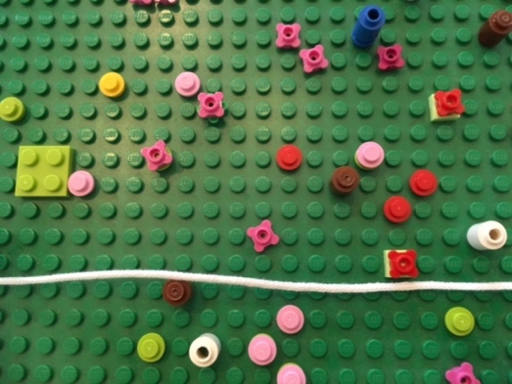
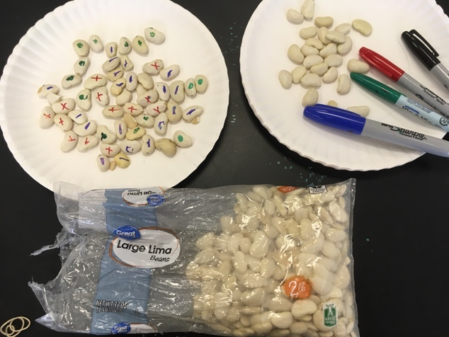

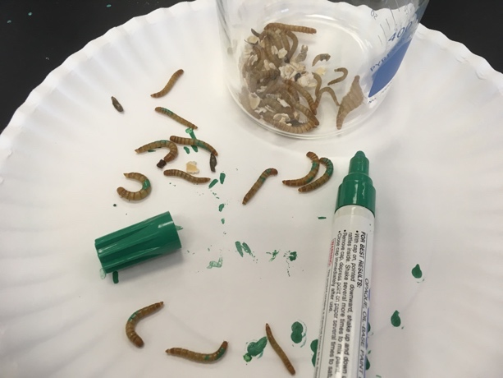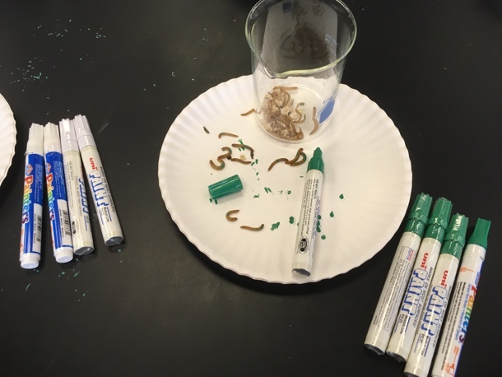

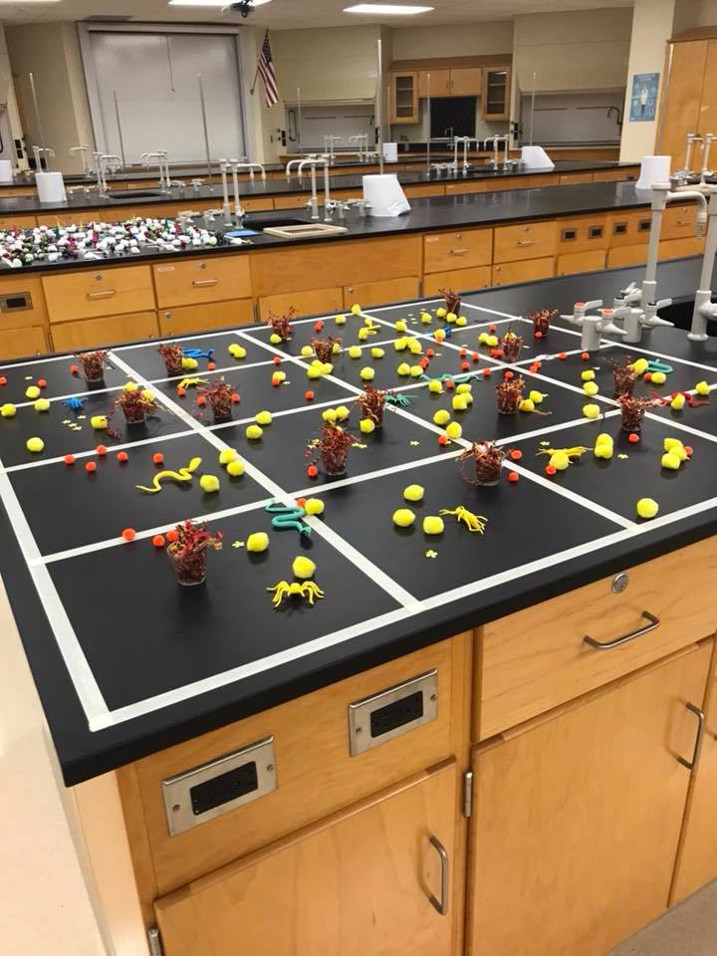
Station 2: Species Richness and Diversity ($25 for as many labs of 24 students as you want – all but masking tape can be re-used).

Purchase: craft materials to use as “species” inside quadrat (i.e., pom poms, pencil erasers, foam decorations) and masking tape $25

Each group needs:
- calculators
- station 2 handouts, one per student,

Each station needs:
- a larger area in which to make 1, 2, or more 4x4 quadrats. You can use a table, lab bench, or floor.
- Two paper bags: one with individual slips of paper with the letters A-D, one with the numbers 1- 4. Students will randomly select one letter / one number – this corresponds to the quadrat they sample. Students replace slips of paper and pull
out two more until they have 4 different quadrats to sample.

Prepare ahead: find a large area and tape off 4 x 4 quadrats, each approx. 12 inches by 12
Inches (30 cm x 30 cm). Inside the quadrats, scatter 5-6 “animal” and “plant” species (outside, you can look for different types of plants within your quadrats, like grass, dandelion, vetch, etc). This can be as large or as small as you have room for – with smaller quadrats, say 15 cm by 15 cm, or 30 cm by 30 cm, use smaller “species” – stuff like craft pom poms, rubber erasers, packing peanuts, toy/plastic animals, etc. Try to ensure that 2-3 species are common and found in many quadrats, and one species is rare, and one species is patchy (found in a couple quadrats but not all).

Station 3: Diet - for a lab of 24, with groups of 4 students – about 12 pellets, $25 per lab (plus $15-20 for the individual kits containing tools and charts that can be reused.)

Purchase: Owl pellets (1-2 per group, about $2 each)), purchase or download owl pellet bone charts. http://gameis.us/owl-pellet-bone-chart-printable# . I buy a few individual kits (it includes the bone chart, forceps, dissection probe, pellet and access to an online key) for $5, all tools/charts re-useable. Then, having some tools and bone charts, you can start buying bulk pellets at about $2 each).
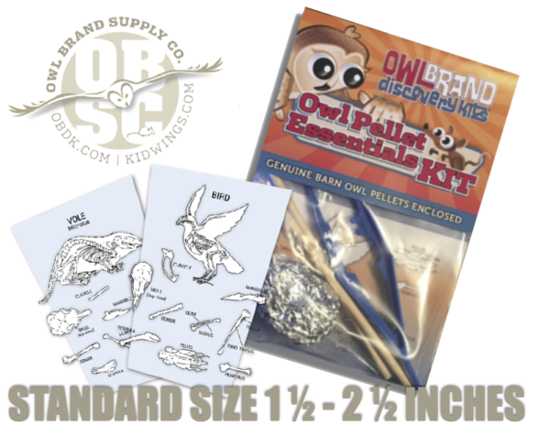
Each group needs:
- 1-2 owl pellets, diet handout. ($5-$8)
- station 3 handouts, one per student,
- calculators

Each station needs:
- 1-2 owl pellet bone charts,
- dissecting needles,
- forceps, and
- plastic sandwich bags to put collected bones into.

Prepare Ahead: purchase owl pellets

Station 4: Age and Survivorship ($15 for 10 labs of 24 students; plus costs to color print and laminate 10 photos)

Purchase: white paper plates ($15 for 250 at Walmart)

Each group needs:
- station 4 handouts, one per student,
- calculators,
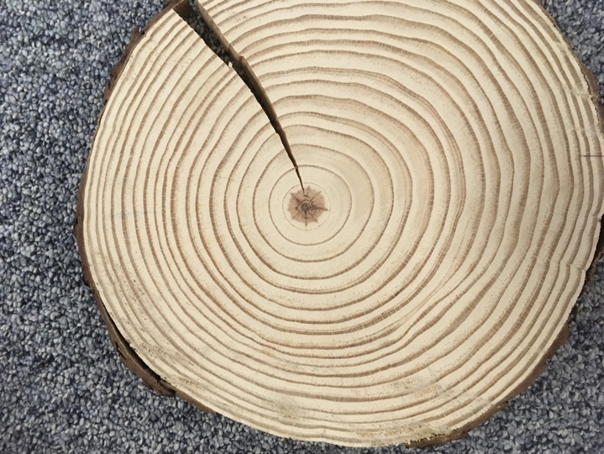
Each station needs:
- graph paper,
- Jumbo straws and permanent markers
- 5 tree cookies (laminated photos) and
- 5 Dall mountain sheep (laminated photos),
- laminated Dall mountain sheep age class data.
(* if you have your own tree cookies use them instead of photos! Just adjust your key.)

Prepare Ahead: print and laminate Tree Rings and Dall Sheep Horn handouts.

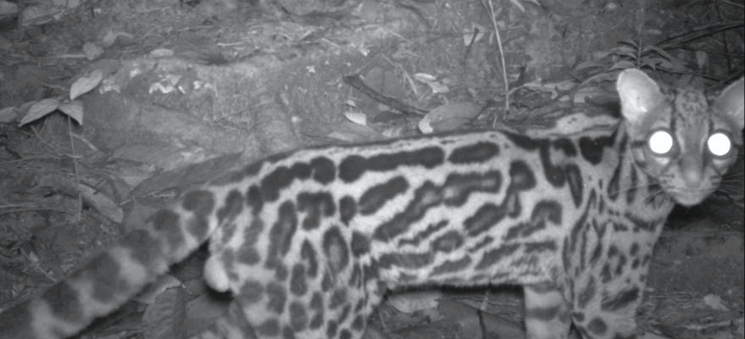
Station 5: Abundance ($ no cost)

Purchase: n/a

Each group needs: station 5 handouts, one per student.

Each station needs:
- magnifying glasses,
- laminated (or overhead transparency) set of 16 camera trap images from Wildsumaco, Ecuador. These photos are of 7 individual Margay cats,
- wet-erase markers,
- and a computer with internet access, loaded to the HHMI Gorongosa citizen science project (wildcamgorongosa.org).

Prepare Ahead: load website, and, it is a good idea to register on the site (as “Bio class_teacher
last name” or something like that – registering allows you to add comments, ask questions, and get credit for the work your class has done. Registering takes about 3 minutes.

Also, print / laminate margay photos (or print on transparency film) – students can use wet-erase markers to circle fur patterns as they try to decide if 2 cats are the same or not.

Station 6: Historical Distribution of Species ($ no cost)

Purchase: n/a
Each group needs:
- station 6 handouts, one per student, and
- each student in a group of 4-6 selects one core from the 10 at the station: one 3-layered core per students (students can randomly choose a core number by rolling 2 dice, with an 11 = core 1 and a 12 = roll again). Roll until all students have a different core (i.e., roll again if your number has already been selected). Students can have two cores each if you have time.

Each station needs:
- the laminated core sheet (cores printable.pdf), and
- laminated printout of the ocean transect (figure 1),
- laminated cut outs of cores (each with 3 layers), and
- laminated printout of the geologic eras (Table 3)
- laminated pictures of example foraminfera
- colored pencils.
- If you have it, an ipad or computer with a pre-loaded 2-minute video of ocean core drilling.

Prepare Ahead: Print and laminate 2 copies of the benthic cores (green, yellow, gray rectangles, each has two rows of 5 cores, 10 cores total), 1-2 copies of the geologic eras (Table 3), and 1 copy of the ocean floor transects. Save one copy of benthic cores to use at the station (to count all the species / individuals) and then cut out the other copy into the circular cores. Paper clip the 3 cores together (there is a yellow, green, and gray #1, a yellow, green, and gray #2, and so on). Each student at the station will get one (3-layered) core. In a group, all cores may not be used.

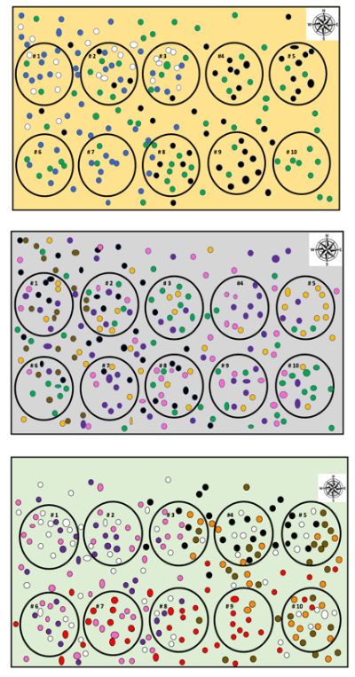
The benthic cores: Each color represents a layer. Which layer is the youngest? Oldest? Top? Bottom? The students will look at which forams are found in each layer to determine this.

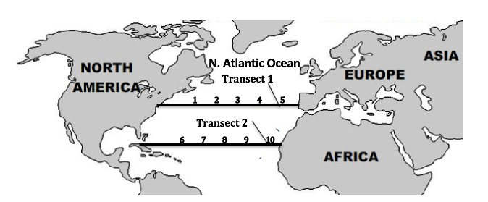
Figure 1. A map showing the Atlantic Ocean and the locations where the deep ocean cores were taken. Cores were taken along two transects with transect two in more tropical waters, and cores 1, 2, 6, and 7 in the Western North Atlantic and cores 4, 5, 9 and 10 in the Eastern North Atlantic.

Table 3 – Geologic Ages on Earth from http://scienceviews.com/dinosaurs/geologictime.html

Era | Period | Epoch | Time Frame (millions of years ago (ma)) | Climate
Cenozoic | Quaternary | Holocene | 8,000 years ago - present | Interglacial (little ice age 1300 AD)
 |  | Pleistocene | 1.8 ma – 8,000 years ago | Ice age
 | Neogene | Pliocene | 5.3-1.8 ma | Warm, with ice age 2.5 ma
 |  | Miocene | 23.8-5.3 ma | Warm
 | Paleogene | Oligocene | 33.7-23.8 ma | Warm
 |  | Eocene | 55.5-33.7 ma | Warm / Cooling around 49 ma / Warm
 |  | Paleocene | 65-55.5 ma | Tropical
Mesozoic | Cretaceous |  | 154-65 ma | Warm
 | Jurassic |  | 213-145 ma | Warm, Humid
 | Triassic |  | 248-213 ma | Warm, Dry
Paleozoic | Permean |  | 286-248 ma | Glacial beginning, Warming towards end
 | Carboniferous |  | 360-286 ma | Shifting Glacial Interglacial
 | Devonian |  | 410-360 ma | Warm

Copyright © 2019, SEPM STRATA Society for Sedimentary Geology

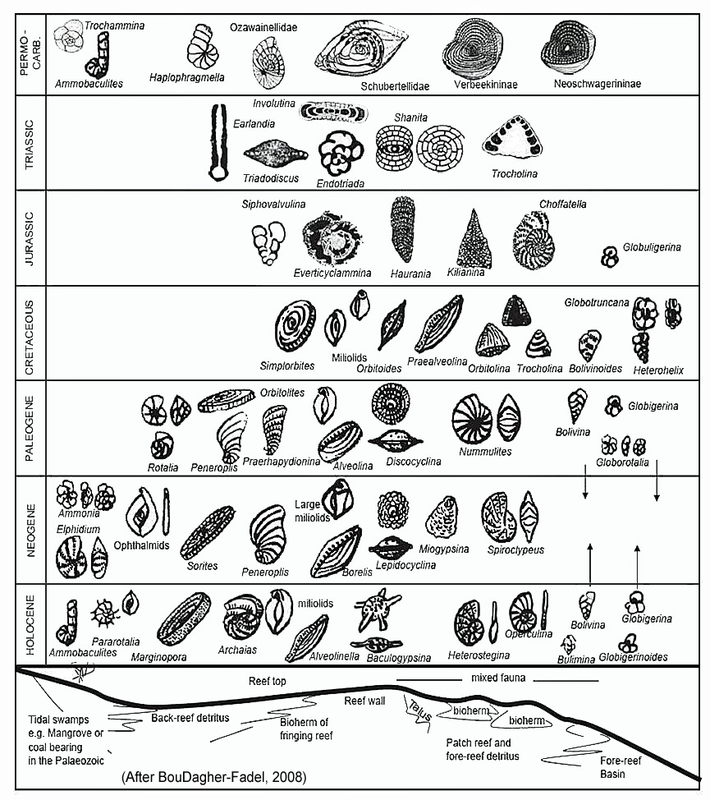

Rupertina

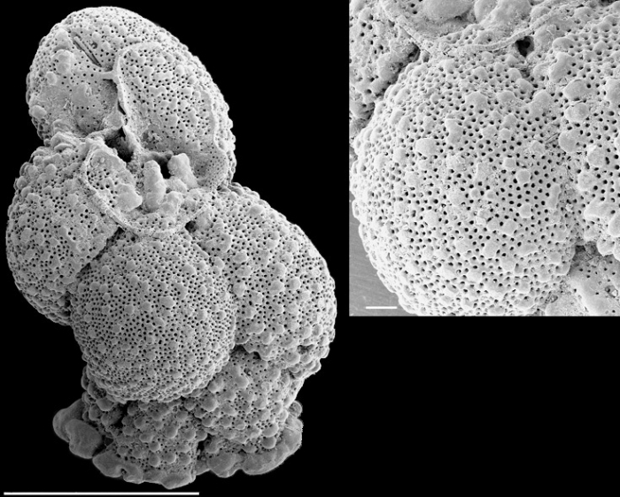

Coskinolina
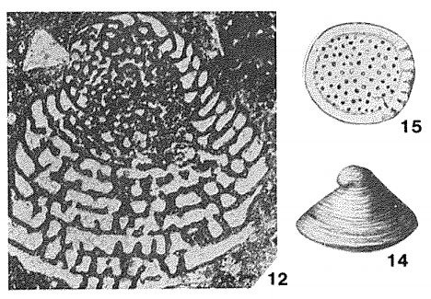
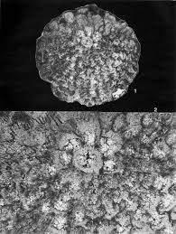
Alanlordia

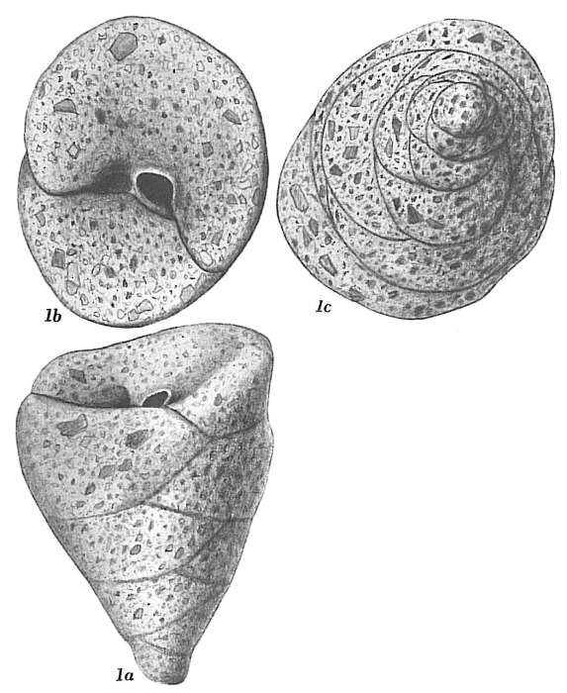Valvulina

Calcarina

