Dall sheep #1

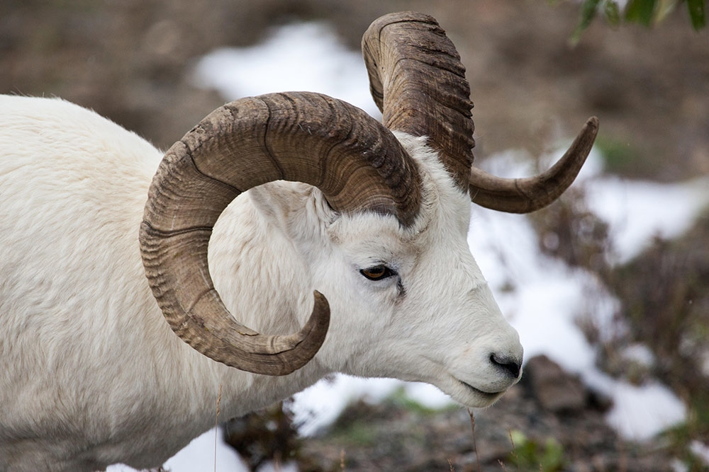

Dall sheep #2

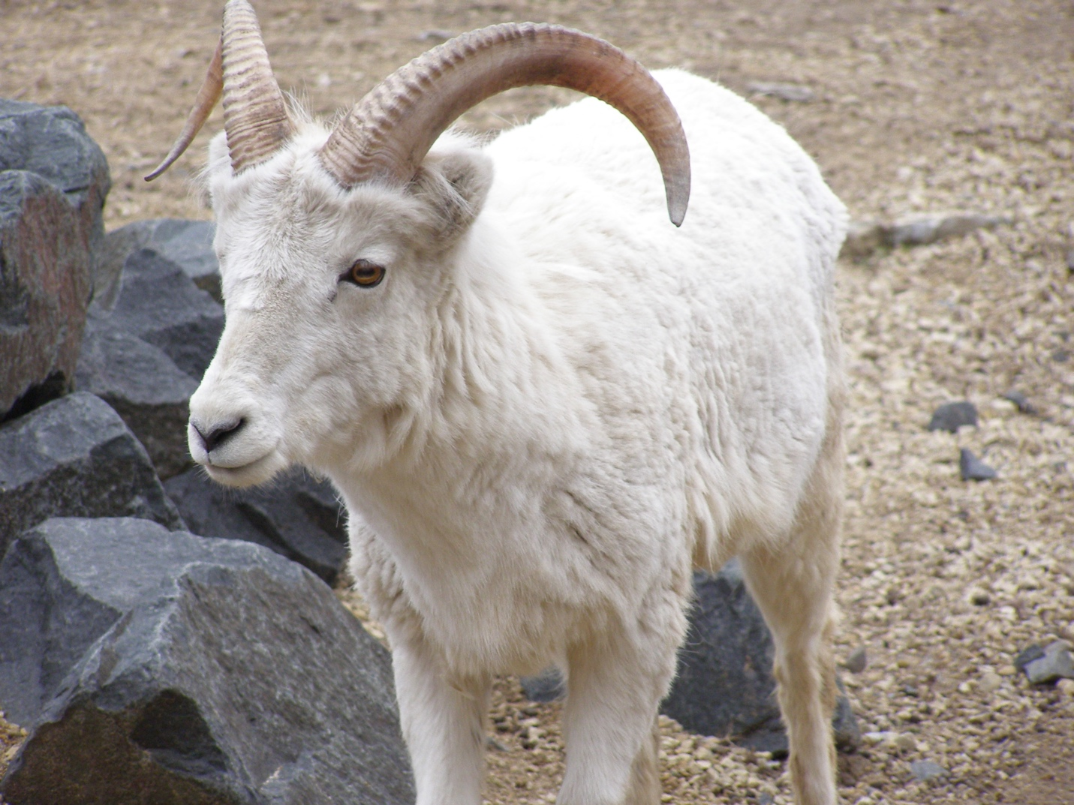

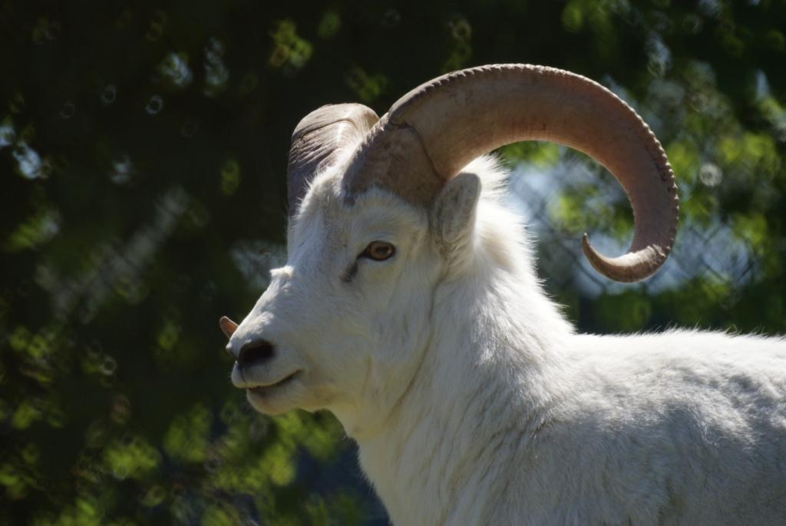

Dall sheep #3

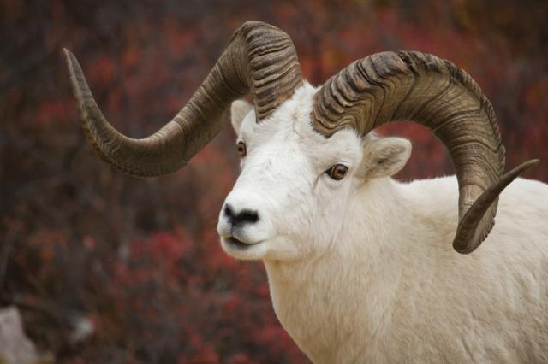

Dall sheep #4

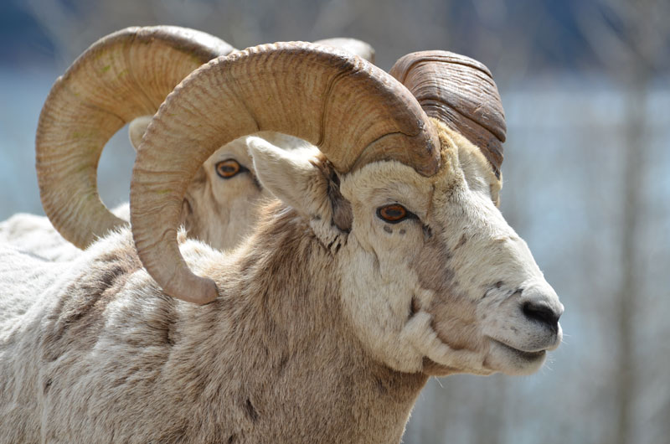

Dall sheep #5

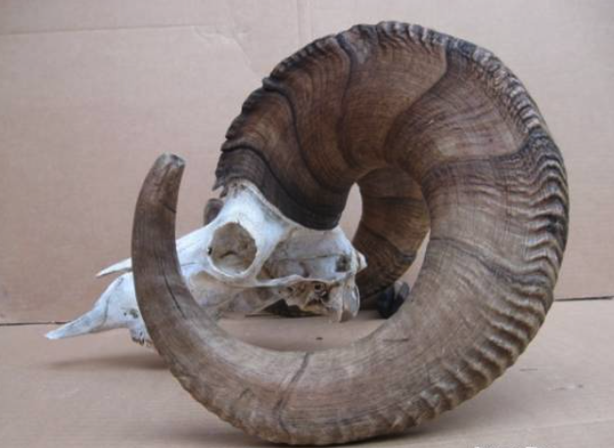 8 – 9 years old

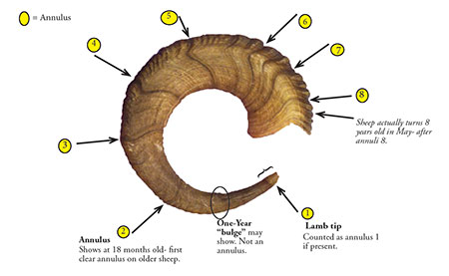

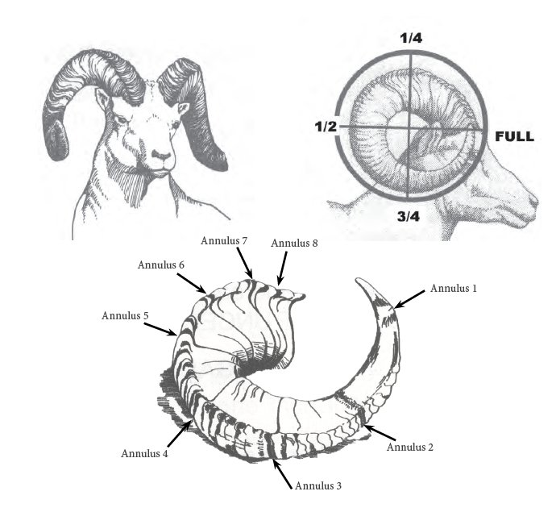



Females (ewes) – top: horns are slender, slightly curved, and don’t get as long as the rams. The 2 year old ram and the 8 year old ewe have horns about the same size.

Males (rams) – bottom: horns grow faster, are thicker at the base, and curl out from base. After the first few years the horns get a lot thicker, and the distance between annuli decreases. Ram horns grow longer than equally aged ewes.

Key:

Sheep 1 - 9-10 yrs

Sheep 2 - 2 yrs

Sheep 3 - 3 yrs

Sheep 4 – 8-9 yrs

Sheep 5 4 yrs