Supplemental File 2

Determining the Surface Area of the Leaves

Instructor directions:

1. Get some construction paper.
2. Cut out standard squares of construction paper 4, 6, 8, 10, and 12 cm on a side.
3. Either you can mass them, or it may be better to have a student come up to the front of the room during class and mass the squares on an electronic balance. That way students are a little more involved and the method of determining surface area becomes more transparent.
4. Record the masses in a spreadsheet like the one shown below as the student reads them from the balance.

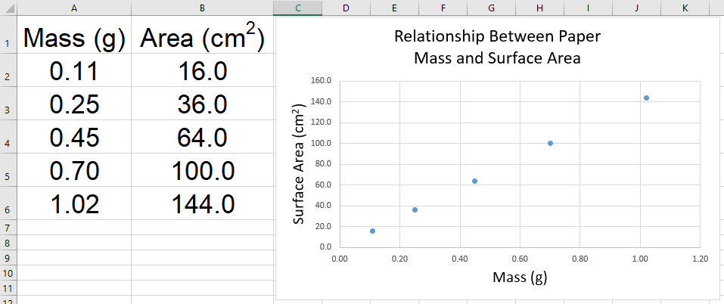

5. In the spreadsheet, right-click on a data point on the graph. Select “Add Trendline” from the menu that pops up.
6. In the dialog box that pops up, select a linear curve, then at the bottom of the box click the three check boxes, “Set intercept = 0.0,” “Display equation on chart,” and “Display R-squared value on chart.” Then click “OK.”
7. A line will appear on the graph along with an equation for the line and an R² value. The R² value is the “coefficient of determination,” and it reflects how well the line drawn fits the data. The values of R² range from 0 to 1. The closer to “0” the worse the fit of the line to the data. The closer to “1” the better the fit of the line to the data (i.e., most of the points fall on or very near the line drawn by the computer). In this particular case, the R² value should be very close to 1 if the standard squares are very carefully and accurately measured and cut out.
8. The equation should take the form y = mx, where m = the slope of the line. This equation can be used by the students to calculate the surface area of their leaves. The x value is the mass of each leaf (in grams) and the y value, determined by multiplying the mass of each leaf by m, is the surface area (in cm²) of the leaf. Note: Students must use the same construction paper that is used for the standard squares when they trace their leaves onto the paper.

