**Bird Identification Reference Guide**

This guide includes illustrations and diagnostic information for the identification of birds that could occur at the feeding stations included in our exercise. They are broken down by each location to help you narrow down the possibilities of which species may be present at each site, so use the guide for the particular camera you are reviewing. Keep in mind that learning to identify bird species is not one of the learning objectives of this lab exercise and is not something you will be tested on. We are using bird species for this lab for a practical purpose - because they are relatively easy to observe and identify at locations around the globe throughout the year. This is an important point. When designing an experiment, be careful to select a study system that will allow you to test your hypothesis within the constraints you are facing. All photos included are used with permission from the Macauley Library at the Cornell Laboratory of Ornithology.

**Notes on Dimorphism in Birds**

In this guide, you will see references to dimorphism and the coloration of males and females. This does not imply that birds have two genders or even that the concept of gender applies to birds (it does not). Sexual dimorphism refers to differences between sexes which are defined by the size of the gametes they produce. When a species is referred to as being sexually dimorphic, it is because the individuals we call males produce smaller gametes than the individuals we call females. Sometimes individuals that produce differently sized gametes also have other differences in phenotypic traits that are apparent to us, like Northern Cardinals in which the males (those that produce smaller gametes) are generally red and the females (those that produce larger gametes) are generally a beige color.

|  |  |
| --- | --- |
| This separation breaks down in reality; individuals known as gynandromorphs are not unusual in the wild and display traits associated with both males and females. I therefore have elected not to refer to phenotypic differences as sexual dimorphism, but describe the typical traits of birds that have been identified to produce male gametes and those that produce female gametes. | A gynandromorph Northern Cardinal |

# Antonina, Paraná, Brazil

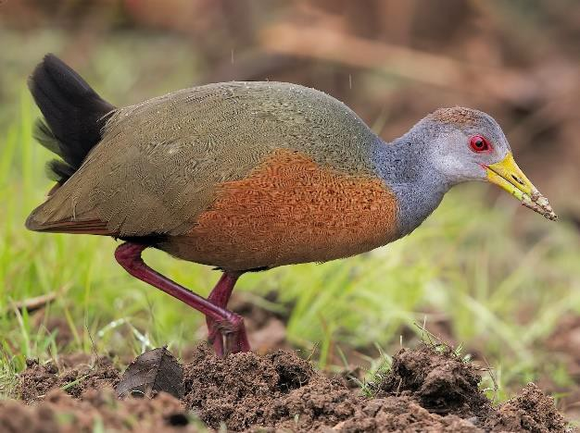

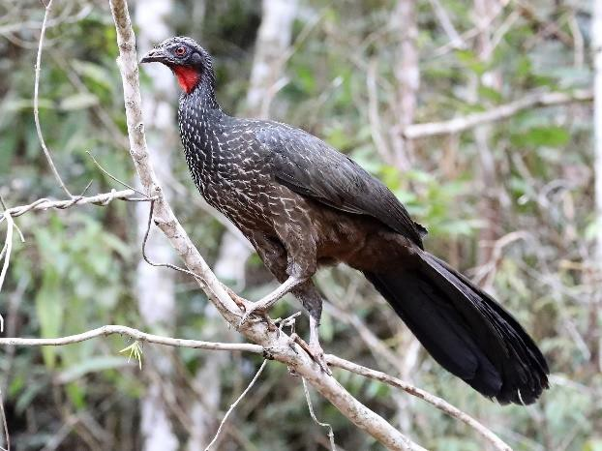

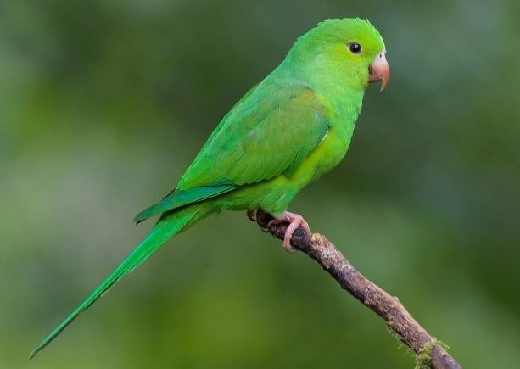

**Gray-Cowled Wood-Rail (*Aramides cajanea*) GCWR**Photo: ML206386901

This is one of the larger birds you would likely see on a feeding platform. The shape is quite distinct, as it looks like and is similar in size to a chicken (smaller and with a shorter neck than a chachalaca). The back may appear more reddish than is pictured here, but nothing else you would see would look similar.

**Dusky-Legged Guan (*Penelope obscura*) DLGU**Photo: ML139383161

Although the website says that it has erected a wire fence around the feeder to exclude this species, it nonetheless can get it in anyways. It is quite large and often travels in groups. It looks somewhat like a turkey. The top and back of the head is fringed by two pale stripes, which seem to stand out clearly on the webcam.

**Plain Parakeet (*Brotogeris tirica*) PLPA**Photo: ML61306761

The only parrot/parakeet you are likely to see at the feeders. This is a somewhat small species of parrot, similar in size to a lovebird. This bird is quite noisy and often comes in small groups. It is mostly green, with a striking pinkish bill.

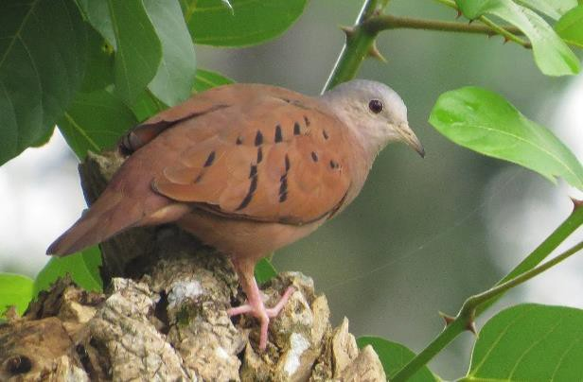**Ruddy Ground-Dove (*Columbina talpacoti*) RGDO**Photo: ML36313541

This pigeon looks a bit like a Mourning Dove, but smaller. The body is noticeably a rusty reddish color, with a distinctly more gray head. Like a Mourning Dove, it also has some black spots on the wings. It is the only pigeon you should see at this site.

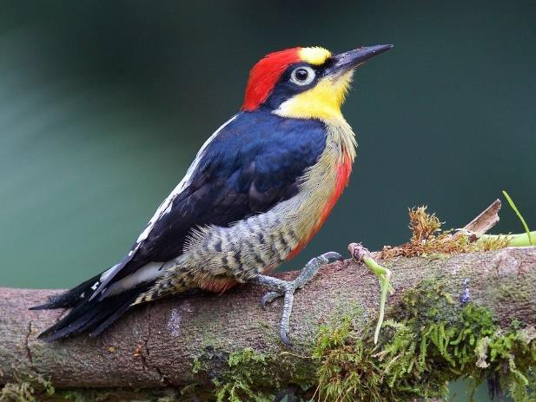**Yellow-Fronted Woodpecker (*Melanerpes flavifrons*)**

## YFWO Photo: ML61306721

This is a very colorful woodpecker that looks a bit different from the woodpeckers you may see in Vermont. It is more similar to an Acorn Woodpecker, if you are familiar with that species. The size, shape, and color pattern are quite distinct at this site however.

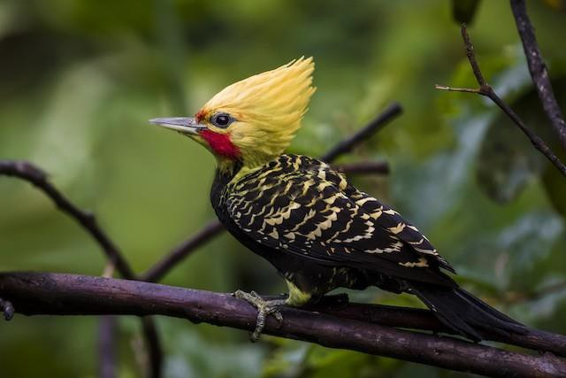**Blond-Crested Woodpecker (*Celeus flavescens*) BLCW**Photo: ML104927551

This species looks nothing like the other woodpeckers you may see. It is considerably larger, and as its name implies the majority of its head is a blondish-tan color. The body is mostly black. Males have a red patch below the eye.

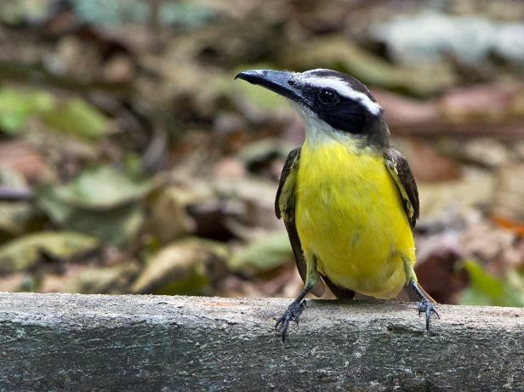**Boat-Billed Flycatcher (*Megarhynchus pitangua*) BOBF**Photo: ML28134271

This is a fairly large bird. Although its appearance is very similar to a number of other species of birds, the yellow body combined with the head pattern is distinct among birds you will likely see on the webcam. It is not clear in this photo, but the wings are a dull brown color

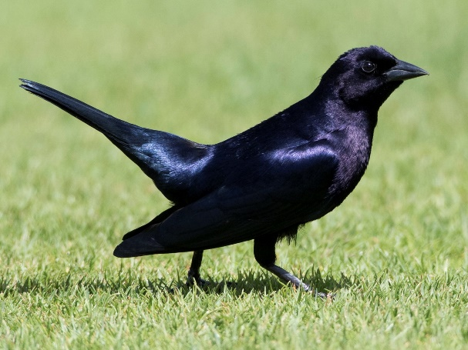**Shiny Cowbird (*Molothrus bonariensis*) SHCO**Photo: ML89283231

This is a fairly large, entirely black bird. The eye color is variable, and would be difficult to see at the resolution of this webcam anyways. If you are familiar with grackles, this bird is like a bit larger and chunkier relative of those.

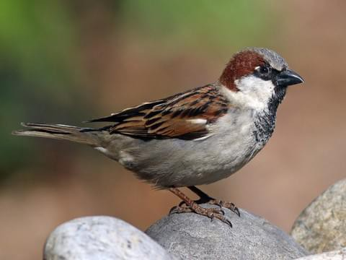**House Sparrow (*Passer domesticus*) HOSP**Photos: ML51357991, ML69514291

This is the same species you would see in Vermont or most places around the world. This species is dimorphic. The black patch on the face and chest of the male will be distinct, even at low resolution.

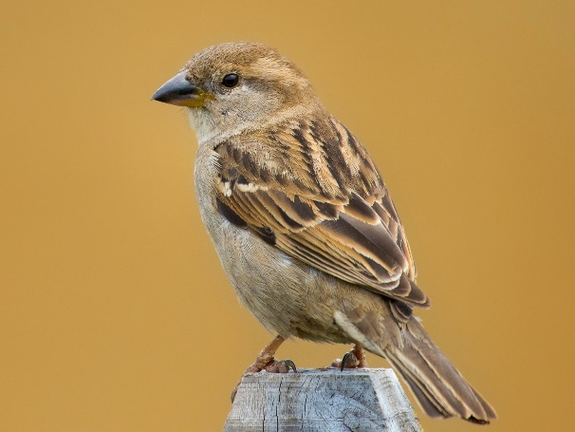Females are harder to distinguish. They are slightly larger than the similar-looking female Saffron Finch. It may also appear similar to the similarly-sized Rufous-Collared Sparrow, but you should be able to distinguish the distinct facial pattern and reddish collar of that species. You can also key in to the presence of the more easily identified males, as both Saffron Finches and House Sparrows often travel together in flocks. House Sparrows are not unusual at this feeder.

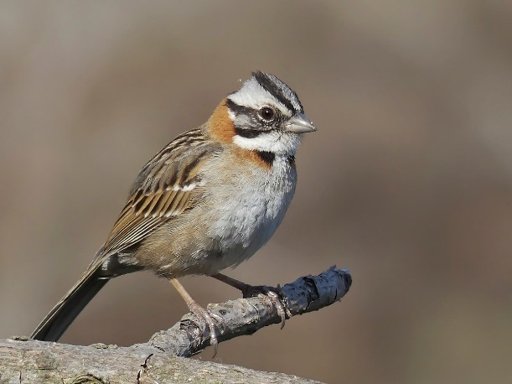  
  
  
**Rufous-Collared Sparrow (*Zonotrichia capensis*) RUSP**Photo: ML179489171

This species is similar in size to a House Sparrow, and the low resolution of this camera may make them hard to distinguish. The reddish collar around the back of the neck does stand out, and note the overall whiter color of the head. This species seems to be less common than House Sparrows, but it still fairly common at this feeder.

**Saffron Finch (*Sicalis flaveola*) SAFI**Photo: ML204741131

Males, like the one at the upper left, are distinctive because of their overall yellow color with a distinctly orange patch on top of the head. The yellow color may not be as bright as in the photo, but it is noticeably yellow. Females, like the one at the lower right, are a dull yellow-tan color, which will look very similar to a House Sparrow on the webcam. This species is noticeably smaller than House Sparrows, and females will almost always travel with males.

This species is very common at this feeder!

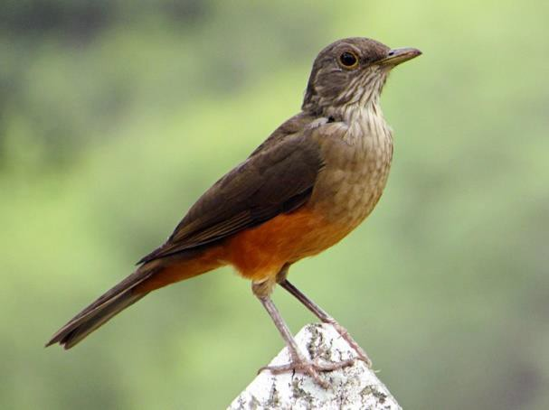**Rufous-Bellied Thrush (*Turdus rufiventris*) RBTH**Photo: ML32874381

This species looks like a slightly smaller and duller American Robin, to which it is fairly closely related. If you see a medium-sized brownish bird (larger than a sparrow or Saffron Finch), look closely for the reddish-orange belly to confirm this species.

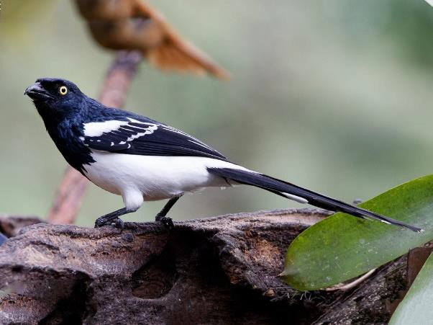**Magpie Tanager (*Cissopus leverianus*) MATA**Photo:ML70941261

This is a fairly large bird, and if anything you might think it looks kind of like a jay (or its relative the magpies, for which it is named) upon first seeing it. The combination of size, black and white coloration, long tail, and yellow eye make it distinctive.

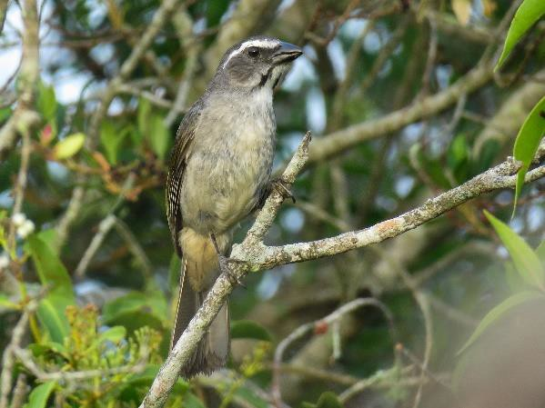**Green-Winged Saltator (*Saltator similis*) GWSA**Photo: ML 80045151

This species, which is a tanager, is best distinguished by the very obvious thick white “eyebrow” stripe and fairly thick beak. The wings are a dull greenish color as implied by the name.

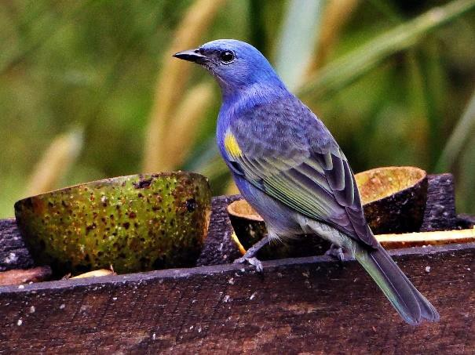**Golden-Chevroned Tanager (*Thraupis ornata*) GCTA**Photo: ML63018061

This species has a very distinct color pattern shared between males and females. The deep blue color with bright yellow “shoulder” patch should be easy to see even on this poor resolution webcam.

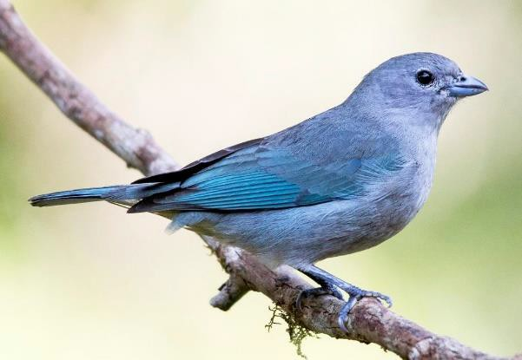**Sayaca Tanager (*Thraupis sayaca*) SATA**Photo: ML71489611

This might seem like an obvious species because of its distinct blue coloration, and in clear bright light this is the case. Poor lighting and low webcam resolution can make this species appear grayish and confusing however. Note that it is distinctly larger than House Sparrows and Saffron Finches, and lacks the dark patch at the rear of the wings that distinguishes Palm Tanagers.

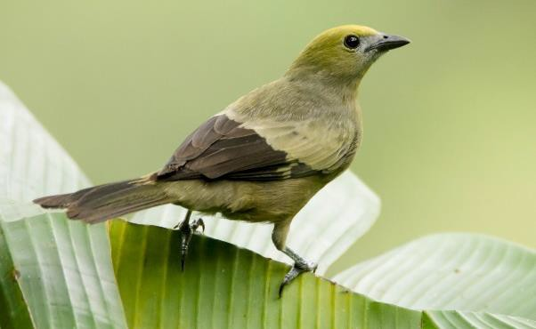**Palm Tanager (*Thraupis palmarum*) PATA**Photo: ML30318231

This species may appear fairly nondescript, but a surefire way to identify it is the sharply contrasting dark rear half of the wings which will stand out even in poor light and low resolution. It is slightly larger than a House Sparrow and clearly larger than a Saffron Finch.

**Ruby-Crowned Tanager (*Tachyphonus coronatus*)**

## RCTA Photos: ML364822371, ML185691321

This species is a bit challenging because it is dimorphic and its name does not reflect an obvious trait you would see on the webcam (the ruby crown is often hidden from obvious view). Males, such as the top photo, are mostly black. They are much smaller than the only other black bird at this site, the Shiny Cowbird. Females, such as the bottom image, are a bright brown color. They are distinctly larger than the common small brown birds like House Sparrows and Saffron Finches. Nonetheless, there is a chance you might confuse either morph with something else.

Potentially helping the matter, they do tend to travel in pairs so take note if you observe a black and brown bird near the same time that otherwise appear similar and are hard to identify. They may come at separate times but close together.

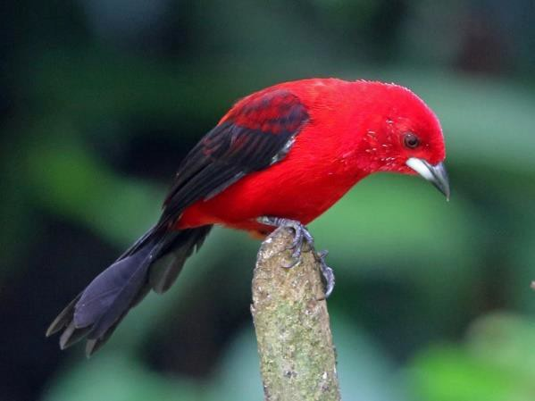**Brazilian Tanager (*Ramphocelus bresilius*) BRTA**Photos: ML47385421, ML51539651

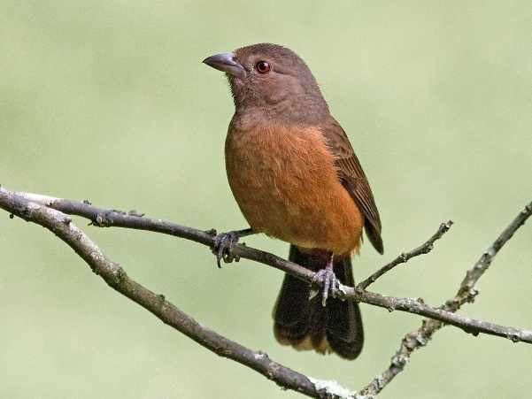This species is dimorphic. Males have a bright red body with black wings and tail, along with awhitish beak, which make them very distinct from anything else you would see at this site. Females, as shown in the bottom photo, are a duller red color without the sharp contrasting colors. They will often travel together with males, and can also be distinguished by the fact that they are larger than most other tanagers.

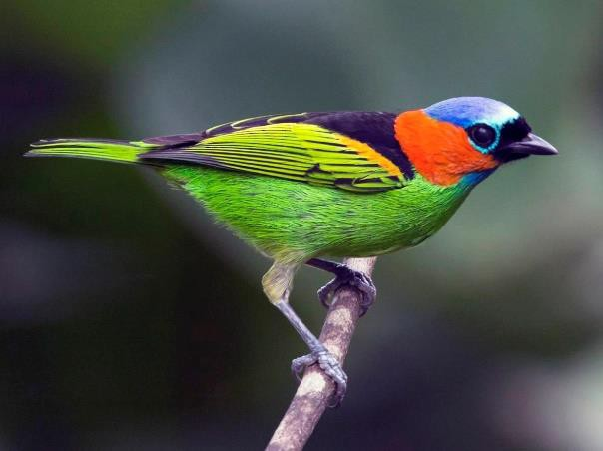**Red-Necked Tanager (*Tangara cyanocephala*) RNTA**Photo: ML56340241

Males and females of this species look the same, and their color pattern is very distinct. Contrast it with the Green-Headed Tanager based on the presence of the red neck patch.

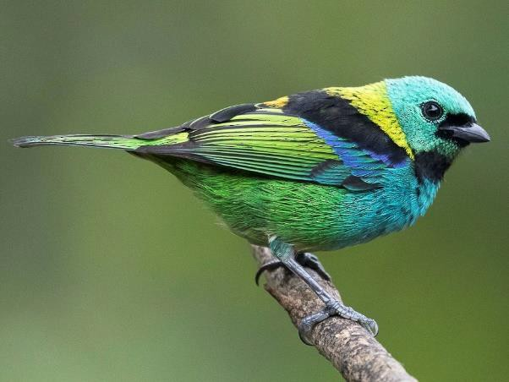**Green-Headed Tanager (*Tangara seledon*) GHTA**Photo: ML60052481

Unfortunately the beauty of this tanager is obscured by the poor resolution of this webcam, but it is nonetheless very distinct in its color pattern. Males and females look the same. It can be contrasted from the Red-Necked Tanager based on the lack of any red on the body. Juveniles appear more green and less black.

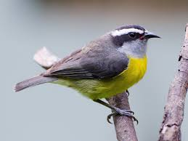**Bananaquit (*Coereba flaveola*)  
BANA**Photo: ML60052481

This is a fairly small bird with a very prominent white “eyebrow” stripe. It is smaller than a saltator, and unlike those species it has a bright yellow belly. Note also the curved and pointed shape of the beak of this species.

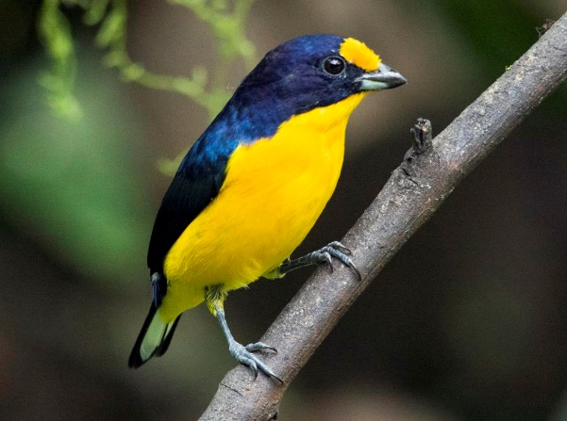**Violaceous Euphonia (*Euphonia violacea*)  
VIEU**Photos: ML56340581, ML59874261

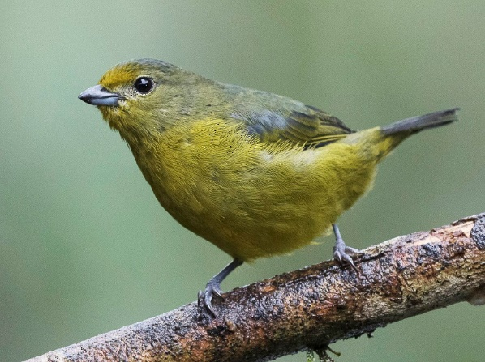This species is dimorphic and is rather small. Males, such as the top bird, have a bright yellow chest and spot on the head. Females, such as the bottom bird, are mostly a duller yellow color. They often travel together in pairs.

# El Valle de Antón, Coclé, Panamá

**Gray-Cowled Wood-Rail (*Aramides cajanea*) GCWR**Photo: ML206386901

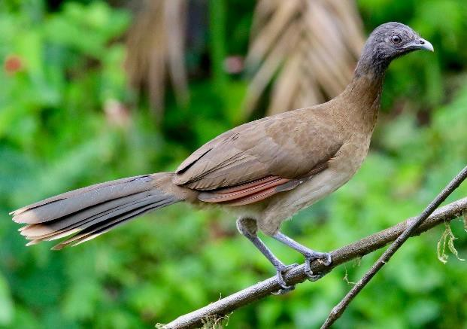

This is one of the larger birds you would likely see on a feeding platform. The shape is quite distinct, as it looks like and is similar in size to a chicken (smaller and with a shorter neck than a chachalaca). The back may appear more reddish than is pictured here, but nothing else you would see would look similar.

**Gray-Headed Chachalaca (*Ortalis cinereiceps*) GHEC**Photo: ML137176201

This species looks somewhat like a turkey, and is just a bit smaller than one. They often, but not always, come to feeders in groups and can be quite loud. They are the largest species you would see at this feeder, and they are fairly common.

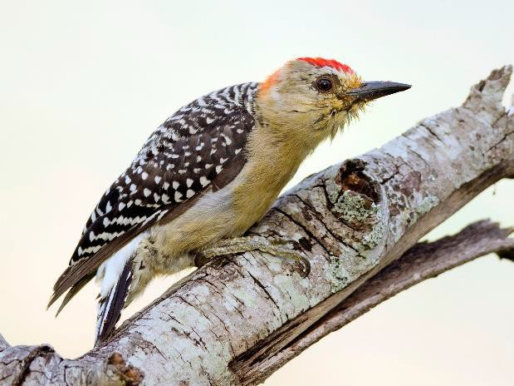**Red-Crowned Woodpecker (*Melanerpes rubricapillus*)**

## RCRW Photo: ML43090261

This species looks very similar to the Red-Bellied Woodpecker common in eastern North America, but is a bit smaller. It is the only woodpecker you would likely see at this feeder.

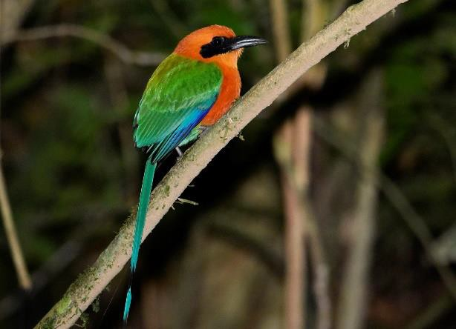**Rufous Motmot (*Baryphthengus martii*) RMOT**Photo: ML197457531

Besides having one of the better names among birds in this guide, this species stands out for its striking combination of orange and green. It is also rather large, being similar in size to a crow. Motmots exhibit an interesting behavior in which they sit still and wag their long tail back and forth, although you may not observe this at the feeder

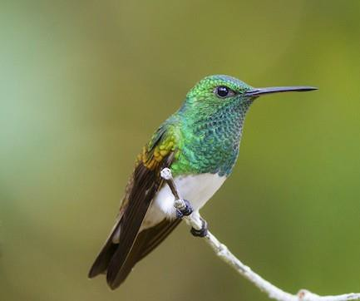**Snowy-Bellied Hummingbird (*Saucerottia edward*)**

## SBEH Photo: ML63329481

This small hummingbird has a sharply contrasting white belly, which is the source of its name. The tail feathers are a rusty red color which is not apparent in this photo. It has apparently been the most common hummingbird species at this feeder.

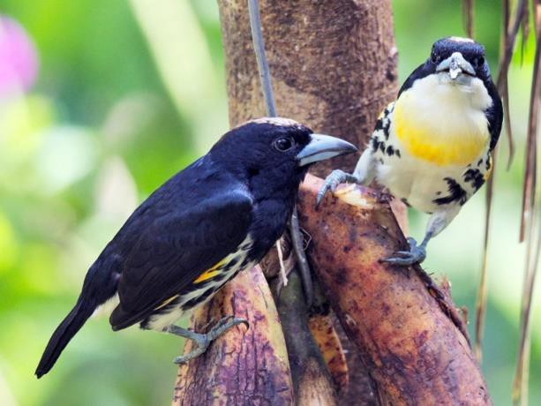**Spot-Crowned Barbet (*Capito maculicoronatus*) SCBA**Photo: ML45814371

This bird is a bit smaller than you might think, being similar to a robin in size. The males and females differ slightly in coloration as shown. Look at the beak shape and extent of white on the body to separate this from other black and yellow species like the Blue-Chested Jay or Flame-Rumped Tanager.

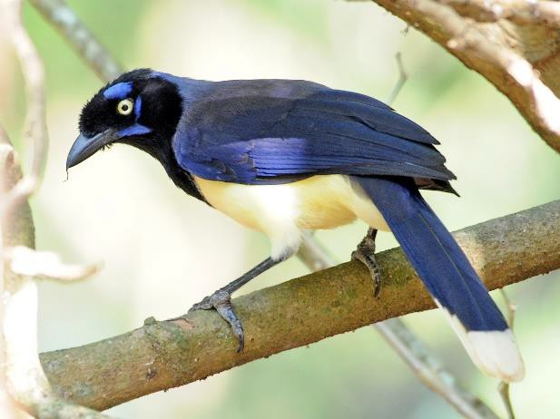**Black-Chested Jay (*Cyanocorax affinis*) BCHJ**Photo: ML146057401

This jay is considerably larger and bluer than a Spot- Crowned Barbet. The yellow eye against the black face is also quite striking.

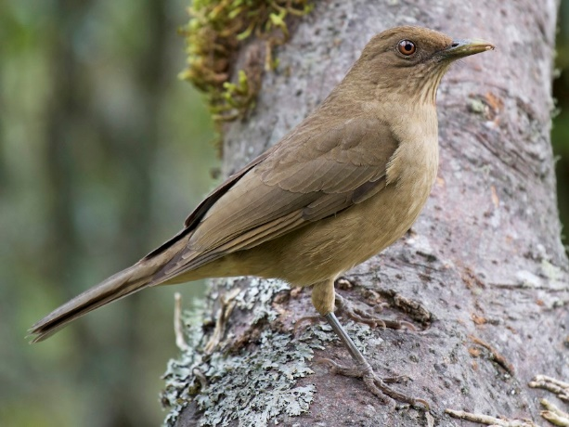

**Clay-Colored Thrush (*Turdus grayi*) CCTH**Photo: ML200409781

Is it a moderately sized nondescript brown bird? It’s probably a Clay-Colored Thrush! This less colorful relative of the American Robin is among the most common visitors to this feeder.

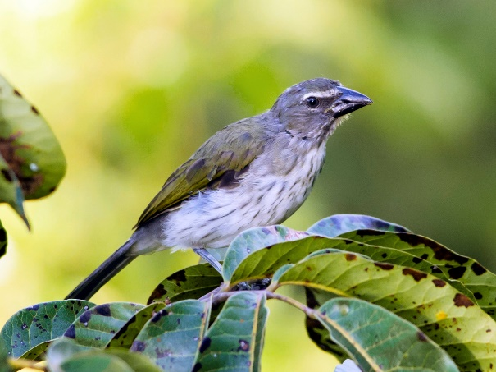**Streaked Saltator (*Saltator striatipectus*)  
SSAL**Photo: ML43087901

This species of tanager is medium-small in size. The brown streaks on the chest of the bird should be evident. This species has a white eyebrow stripe which is less prominent than that of the Buff-Throated Saltator. The back is olive-green, but also less prominently so than the Buff-Throated Saltator.

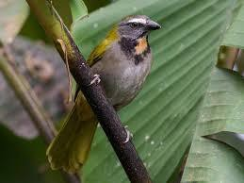**Buff-Throated Saltator (*Saltator maximus*) BTSA**Photo: ML81666431

This species of tanager is medium-small in size, and can be distinguished by the olive green coloration and particularly the white “eyebrow” stripe. The orange-colored throat patch is also helpful, but is not always visible depending on the angle of the bird.

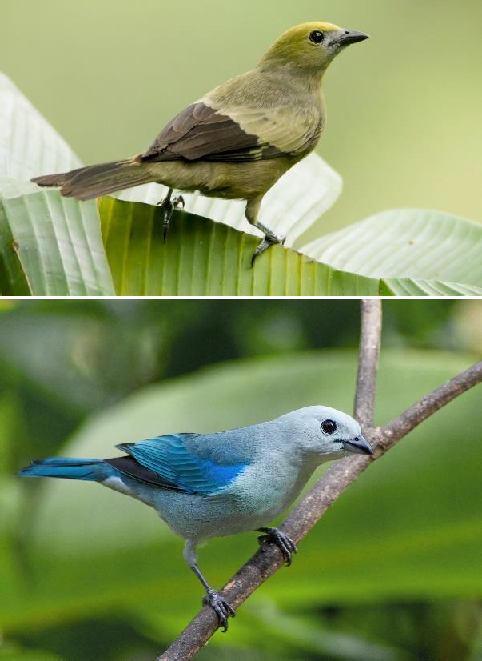

**Palm Tanager (*Thraupis palmarum*) PATA**Photo: ML30318231

This species may appear fairly nondescript, but a surefire way to identify it is the sharply contrasting dark rear half of the wings which will stand out even in poor light and low resolution.

**Blue-Gray Tanager (*Thraupis episcopus*) BGTA**Photo: ML35403231

This bird may seem obvious from the bright blue coloration in the photo, but the common name “Blue- Gray” is important…in poor lighting, it can appear quite grayish. It can always be distinguished from the similar Palm Tanager based on the wing pattern described above.

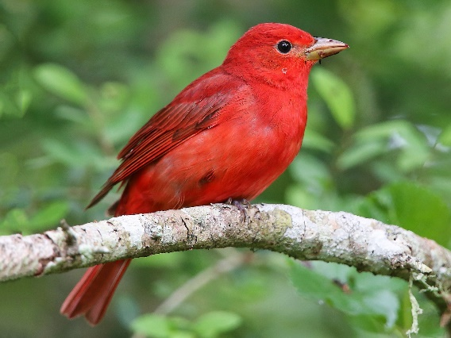**Summer Tanager (*Piranga rubra*) SUTA**Photos: ML63525591, ML22910171

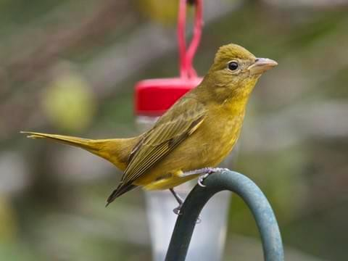Males, as in the top photo, are a bright orange-red. Females are shaped and sized similarly, but are entirely yellow as depicted in the bottom photo. You may see only one sex at a time. These birds are relatives of the cardinal rather than true tanagers, and are similar in size to a cardinal.

**Crimson-Backed Tanager (*Ramphocelus dimidiatus*)**

## Crimson-backed Tanager - eBirdCBTA Photos: ML38996081, ML206036761

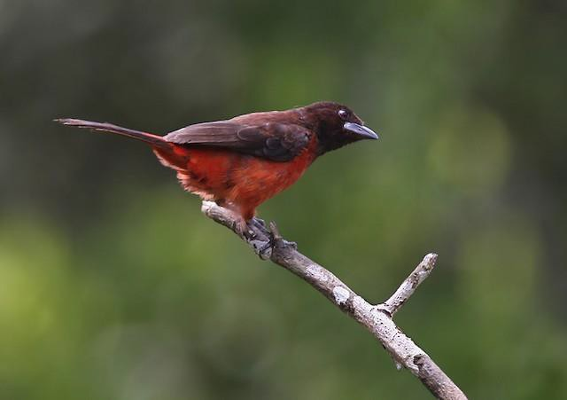This dimorphic species stands out for having very bright red males with black wings and bright white beaks, as seen in the top photo. Females appear as a dark, more muted red color without the white beak as seen in the bottom photo. Females are notably darker in color than a Summer Tanager. Often one male will travel together with a group of females.

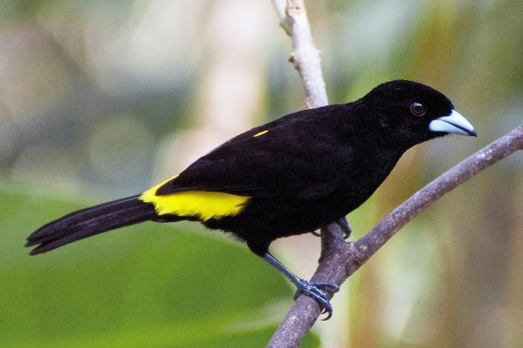**Flame-Rumped Tanager (*Ramphocelus flammigerus*)**

## FRTA Photos: ML35402341, ML35403521

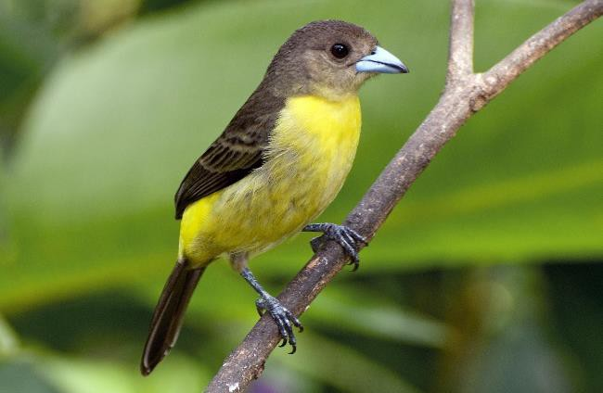This species is dimorphic. Males are almost entirely black except for a bright contrasting yellow patch on the back above the tail. Females are mostly yellow with a dark grayish-black head and wings. The dark coloration on the body will clearly contrast them with female Summer Tanagers. One male will often travel with a group of females.

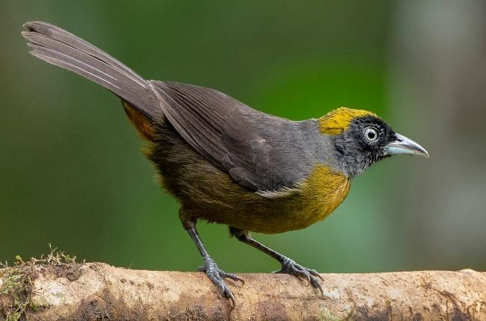**Dusky-Faced Tanager (*Mitrospingus cassinii*) DFTA**Photo: ML243993101

This species looks fairly dull, but the pattern of yellow on the head and chest make it distinct. The duller yellow on the top of the head will especially separate it from the Flame-Rumped Tanager, which is also larger than this species. Sexes appear similar, and you will often see a pair of birds.

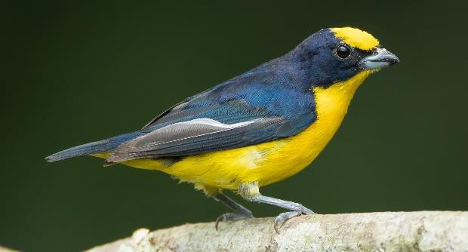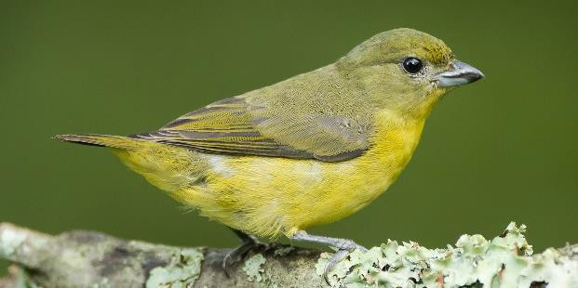

**Thick-Billed Euphonia (*Euphonia laniirostris*) TBEU**Photos: ML112808901, ML112808921

This species is dimorphic and is rather small. Males, such as the top bird, have a bright yellow chest and spot on the head. Females, such as the bottom bird, are mostly a duller yellow color. They often travel together in pairs.

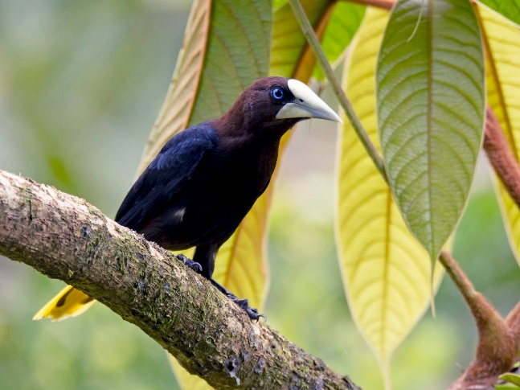**Chestnut-Headed Oropendola (*Psarocolius wagleri*)**  
**CHOR**Photo: ML30317321  
This large bird is mostly a glossy black with a duller brown head. The general coloration may look like a male Flame-Rumped Tanager, but the oropendola is larger, which a much larger bill, and with yellow on the tail feathers. Also note the distinct blue eye.

# Fort Davis, Texas, USA

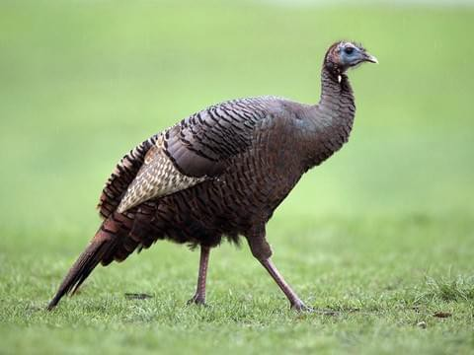

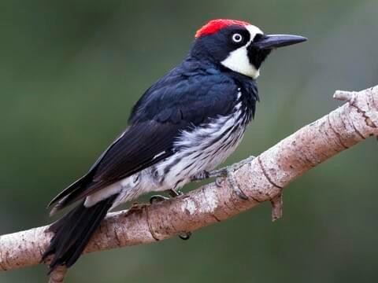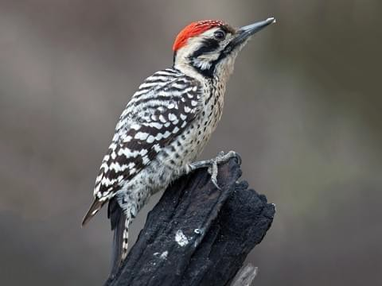

**Wild Turkey *(Meleagris gallopavo*) WITU**Photo: ML55399281

Wild turkeys can directly visit the feeders, but may also be seen feeding on seeds that have fallen below feeders. Keep your eyes out for large birds moving around on the ground below the feeders! They are not likely to be confused with any other species present on the webcam.

**Acorn Woodpecker (*Melanerpes formicivorus*) ACWO**Photo: ML27188071

This woodpecker has a mostly black back with a white face and black chest. The species is particularly noteworthy for its behavior of creating large caches of acorns. It is more common at this feeder than the Ladder-Backed Woodpecker, and its body is much clearly more black.

**Ladder-Backed Woodpecker (*Picoides scalaris*) LBWO**Photo: ML24759361

This woodpecker looks like the northeastern Downy or Hairy Woodpeckers in its shape and coloration. Males have an entirely red crown and all individuals have less black on the face. It is far less black overall than the Acorn Woodpecker.

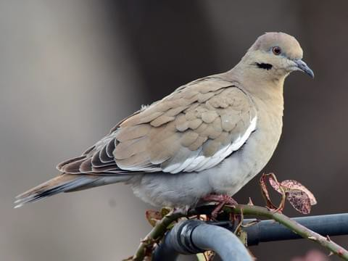**White-Winged Dove (*Zenaida asiatica*) WWDO**Photo: ML42421471

Made famous by Stevie Nicks, who had never actually heard this bird singing when writing about it in “Edge of Seventeen”, the actual bird is a large pigeon (larger than a Mourning Dove) with a distinct white stripe along the bottom of the wing and a black stripe below the eye.

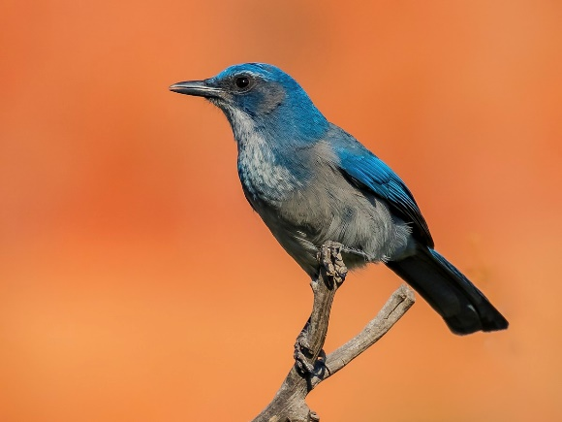**Woodhouses’s Scrub-Jay (*Aphelocoma woodhouseii*)**

## WOSJ Photo: ML114160231

Until recently known together with the California Scrub-Jay as the Western Scrub-Jay, this species looks like a Blue Jay but with a somewhat duller appearance and notably with no crest on the head. The large size and blue color will make this species fairly distinct at this site.

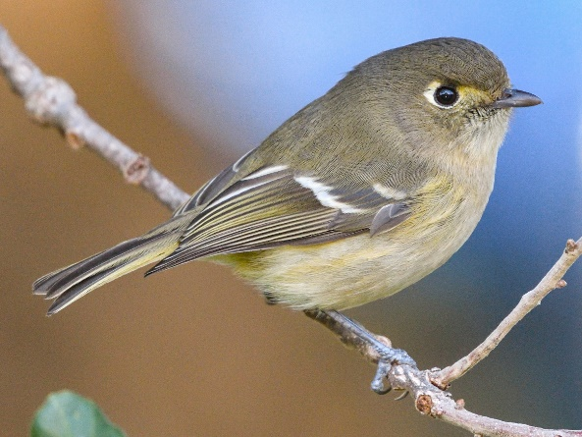**Hutton’s Vireo (*Vireo huttoni)*   
HUVI**Photo: ML195518471

The small size of this species is probably the most distinctive feature of this otherwise non-distinct bird. The white ring around the eye and two pale white bars on the wing are distinctive of the species. This bird also looks a lot like a Ruby-Crowned Kinglet, which is admittedly only helpful if you know what that is.

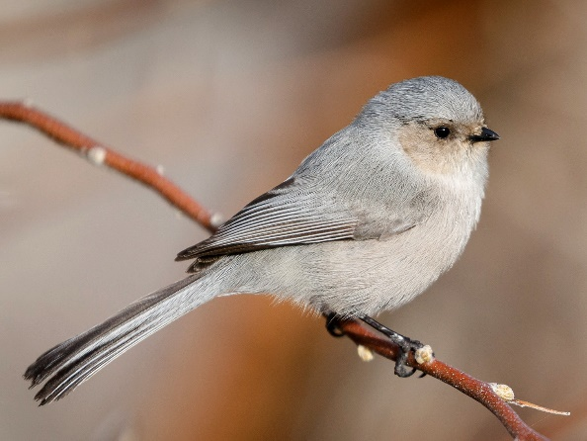**Bushtit (*Psaltriparus minimus*) BUSH**Photo: ML51178821

Another small and grayish bird, Bushtits lack a white eye ring or pale wing bars like the Hutton’s Vireo. Behaviorally, Bushtits differ in that they nearly always come to the feeder in groups while Hutton’s Vireo is more likely to appear individually. Note that it would not be unusual for both species to travel together in a flock however!

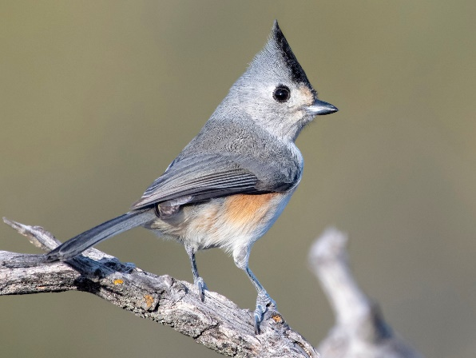

**Black-Crested Titmouse (*Baeolophus bicolor*) BCTI**Photo: ML197705091

Similar to the Tufted Titmouse seen often on Middlebury’s campus, but as its name implies it has a larger dark black crest. This species is a bit larger than the previous two gray species, and the crested appearance is distinct.

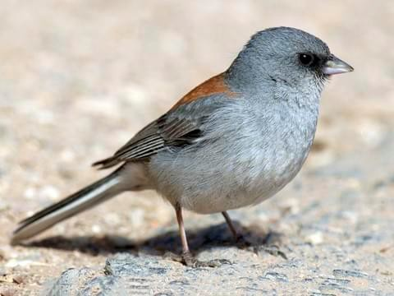**Dark-Eyed Junco (*Junco hyemalis*) DEJU**Photo: ML49230701

This species has many subspecies which appear quite different. The “Red-Backed” subspecies is the one you will most likely see at this site. One common feature in this species are the two outer feathers of the tail being white in sharp contrast to the inner grayish black feathers. This is very noticeable when a bird takes off or lands.

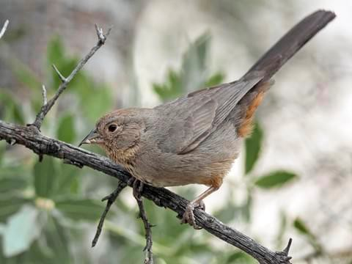**Canyon Towhee (*Melozone fusca*) CATO**Photo: ML56260811

This is a large and somewhat dull-looking sparrow. The body is entirely brown with a somewhat more orange- ish patch below the tail. There are some very faint streaks on the throat.

### Carolina Wren (*Thryothorus ludovicianus*) CARW Photo: ML188434041

The go-to species when a generic bird song is needed in movies and TV shows, the Carolina Wren is distinguished by the sharp white “eyebrow” stripe and contrasting dark brown back.

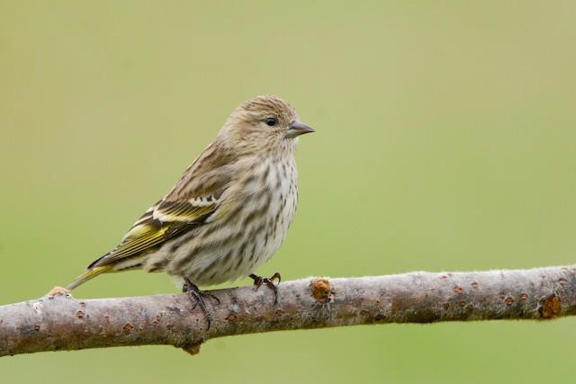**Pine Siskin (*Spinus pinus*) PISI**Photo: ML153986961

This small-ish bird almost always travels in flocks of several individuals. You can identify them clearly by the extensive streaking on the chest. The wings do have some yellow patches on them, but they may not be obvious depending on how the bird is oriented.

# Ithaca, NY, USA

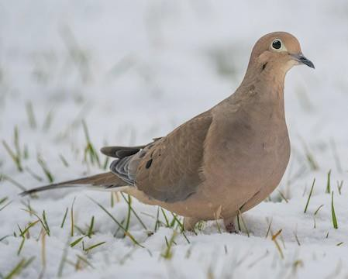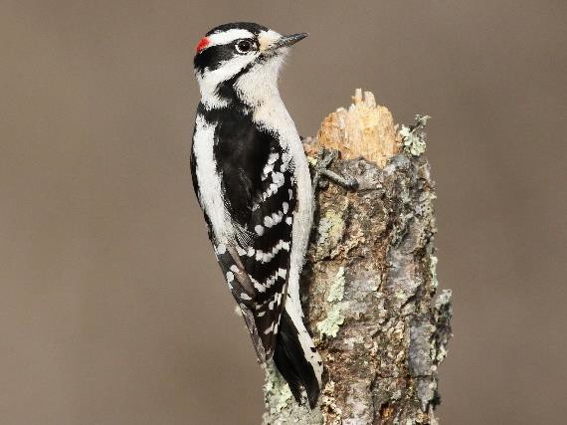

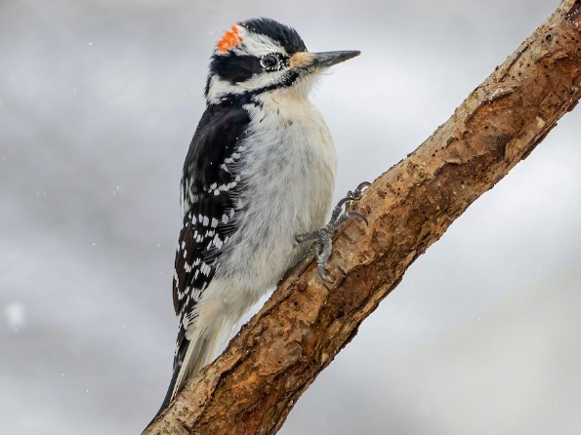

**Mourning Dove (*Zenaida macroura*) MODO**Photo: ML278637151

A familiar bird in Middlebury, this pigeon is a bit smaller than the common rock pigeon found in cities worldwide but is nevertheless larger than many birds seen at U.S. feeders. The gray color and distinct pigeon shape should make it stand out at this location.

**Downy Woodpecker (*Picoides pubescens*) DOWO**Photo: ML47227441

This is a common woodpecker in forests across North America. Unlike the previous woodpeckers listed, males have only a small patch of red on the back of its head and females have no red. Its body is entirely black and white. It is also a smaller species, being only slightly larger than a titmouse. Compare especially against Hairy Woodpecker based on size relative to other birds.

**Hairy Woodpecker (*Picoides villosus*) HAWO**Photo: ML 303463251

This species looks very similar to a Downy Woodpecker, but is very noticeably larger (almost as large as a robin) and has a noticeably heavier bill. This comparison is difficult to make when only one bird is seen. As with Downy Woodpecker, females lack the red spot on the head.

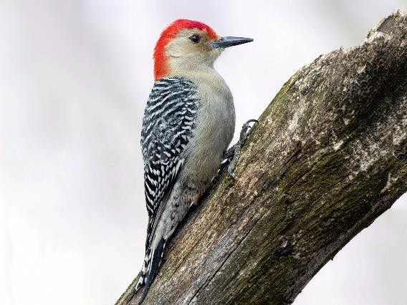**Red-Bellied Woodpecker (*Melanerpes carolinus*) RBWO**Photo: ML50106001

This is a familiar woodpecker in the northeast. It can be distinguished by a grayish body, black and gray striped back, and red spot on the back and top of the head.

The name “red-bellied” is a bit misleading because the reddish “belly” patch is not very conspicuous.

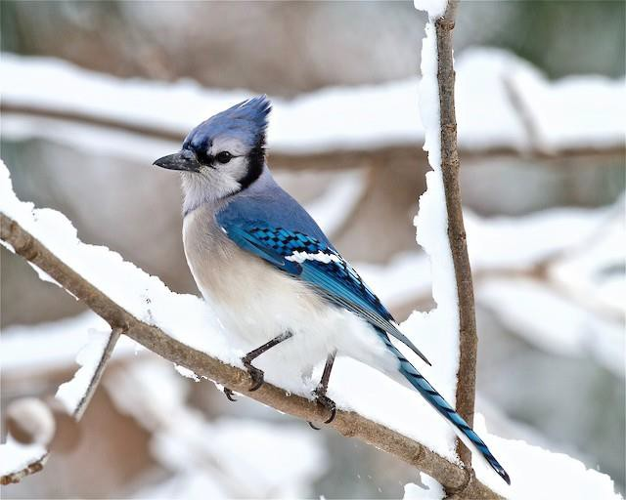**Blue Jay (*Cyanocitta cristata*) BLJA**Photo: ML132473891

The large size, blue body with white face and belly, and crested appearance are very distinctive. You will not likely see any other blue bird at this site, especially not one of this size. Also note this species is quite loud, and if you turn the sound on you will probably hear it when it is present.

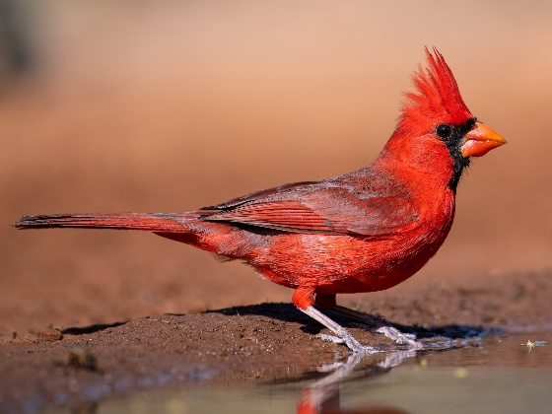**Northern Cardinal (*Cardinalis cardinalis*) NOCA**Photo: ML257386271

The striking bright red males could not be confused with any other species seen at this site. Females have the same shape and some reddish coloration (including the beak), but an overall browner body.

### Carolina Wren (*Thryothorus ludovicianus*) CARW Photo: ML188434041

The go-to species when a generic bird song is needed in movies and TV shows, the Carolina Wren is distinguished by the sharp white “eyebrow” stripe and contrasting dark brown back.

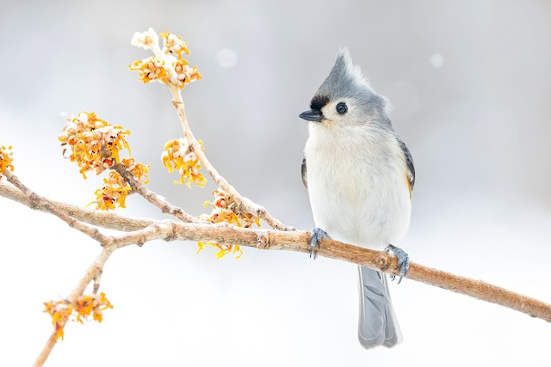**Tufted Titmouse (*Baeolophus bicolor*) TUTI**Photo: ML308500671

Although mostly grey, the combination of coloration and crested shape of the head make this species fairly distinctive. Also note that it is slightly larger than most other small birds like chickadees and nuthatches.

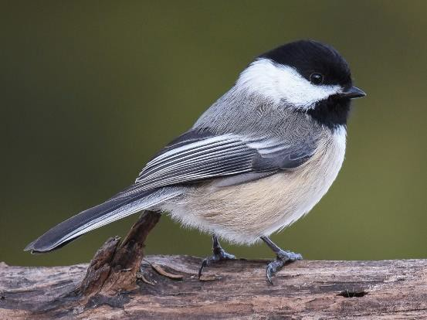**Black-Capped Chickadee (*Poecile atricapillus*) BCCH**Photo: ML47337851

Probably the most common bird species on Middlebury’s campus, it is equally common at this feeder location.

Look for both the top of the head and the throat to be black. The behavior of this species is also very different from the slightly similar looking White-Breasted Nuthatch.

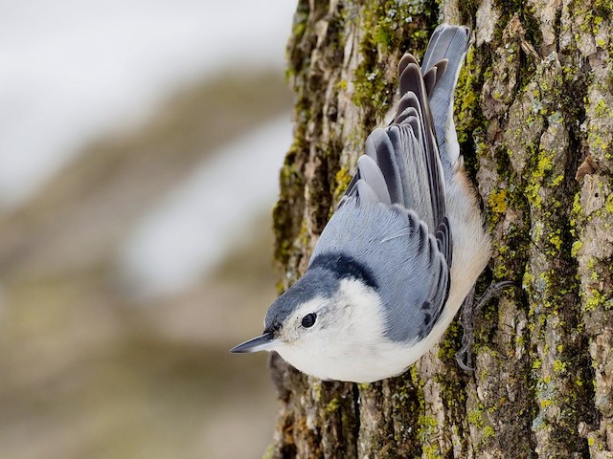

**White-Breasted Nuthatch (*Sitta carolinensis*) WBNU**Photo: ML290691521

This species may look superficially similar to the Black- Capped Chickadee, but unlike that species the throat is entirely white while the black extends all the way across the back of the head. Also note the behavior of this species – it very often sits sideways and slowly works its way down tree trunks (or feeders).

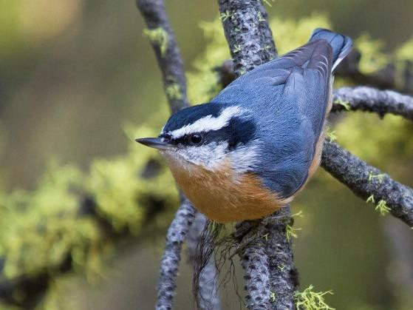**Red-Breasted Nuthatch (*Sitta canadensis*) RBNU**Photo: ML65671961

This nuthatch is quite different from the White-Breasted thanks to the reddish-orange chest and the black stripe going through the eye. It is also slightly smaller. It does however exhibit similar behavior to the White-Breasted Nuthatch.

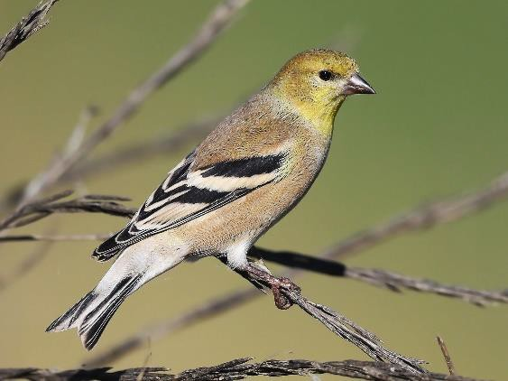**American Goldfinch (*Spinus tristus*) AMGO**Photo: ML39347111

You may know this species from its bright yellow summer plumage, but in the winter you will not see such a bright coloration. Birds will show a dull yellowish brown color, with white bars on the wings. Contrast with the similar-looking Pine Siskin, which has very obvious streaks on the chest as opposed to the lack of streaks in this species.

**Pine Siskin (*Spinus pinus*) PISI**Photo: ML153986961

This small-ish bird almost always travels in flocks of several individuals. You can identify them clearly by the extensive streaking on the chest. The wings do have some yellow patches on them, but they may not be obvious depending on how the bird is oriented.

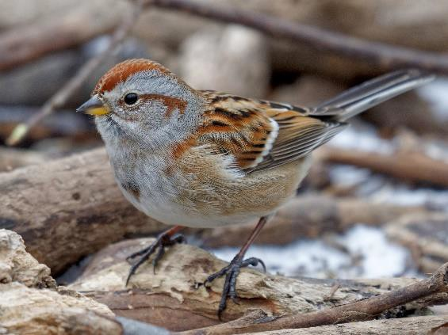**American Tree Sparrow (*Spizelloides arborea*) ATSP**Photo: ML292507431

This small nondescript bird is best distinguished by the dark spot on the chest. The whole body is generally “warmer” in color than a Chipping Sparrow. Note in particular the brownish eye stripe and lighter colored bill.

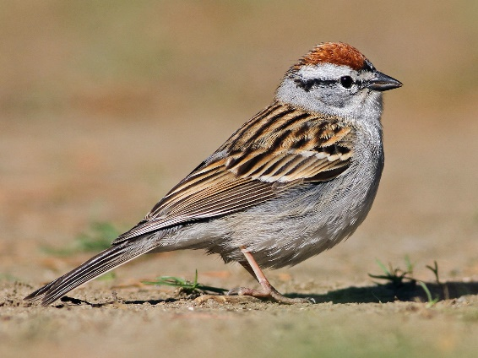

**Chipping Sparrow (*Spizella passerina*) CHSP**Photo: ML27961971

This small nondescript bird is best identified by the bright orange-red spot on the top of the head in contrast to a lack of any other orange/red/brown on the face. The eye stripe is distinctly black. It also lacks any chest spot, in contrast to the American Tree Sparrow.

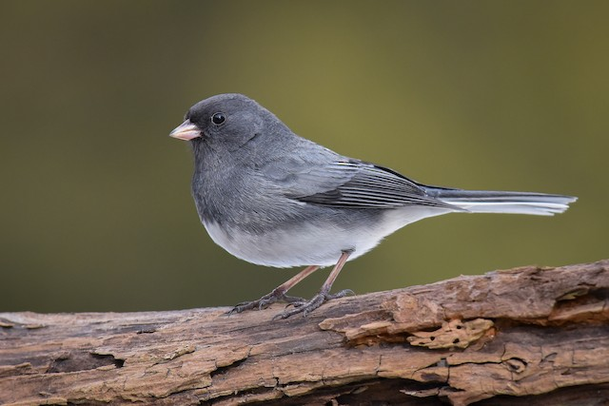**Dark-Eyed Junco (*Junco hyemalis*) DEJU**Photo: ML47337561

This species has many subspecies which appear quite different. The “Slate-Colored” subspecies is the one you will most likely see at this site. One common feature in this species are the two outer feathers of the tail being white in sharp contrast to the inner grayish black feathers. This is very noticeable when a bird takes off or lands.

# Manitouwadge, Ontario, Canada

**Blue Jay (*Cyanocitta cristata*) BLJA**Photo: ML132473891

The large size, blue body with white face and belly, and crested appearance are very distinctive. You will not likely see any other blue bird at this site, especially not one of this size. Also note this species is quite loud, and if you turn the sound on you will probably hear it when it is present.

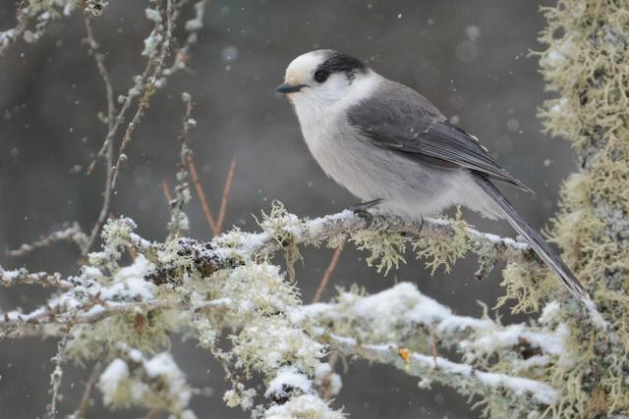**Canada Jay (*Perisoreus canadensis*) CAJA**Photo: ML199037861

Formerly known as the Gray Jay, this species is about the same size as a Blue Jay but is entirely grayish-black. You will not see any other large gray bird at this location.

### Common Raven (Corvus corax) CORA Photo: ML27299051

****Similar to a crow, but much larger, this bird is not likely to be mistaken for anything else. Crows would not likely occur this far north during the winter time.

**Black-Capped Chickadee (*Poecile atricapillus*) BCCH**Photo: ML47337851

Probably the most common bird species on Middlebury’s campus, it is equally common at this feeder location. Look for both the top of the head and the throat to be black.

**Red-Breasted Nuthatch (*Sitta canadensis*) RBNU**Photo: ML65671961

This nuthatch is quite different from the White-Breasted thanks to the reddish-orange chest and the black stripe going through the eye. It is also slightly smaller.

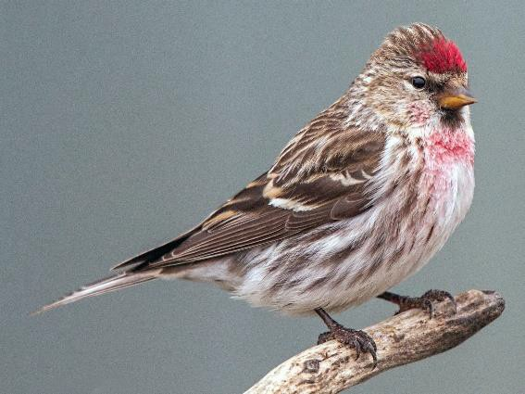**Common Redpoll (*Acanthis flammea*) CORE**Photo: ML64787461

The amount of red on this species can be variable, but the bright red “forehead” spot is consistent. The presence of this will set it apart from any superficially similar species like a Pine Siskin, which has no red, or a House Finch, which never has red only in that spot.

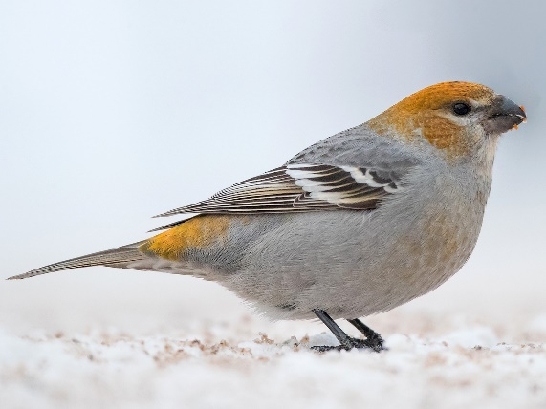**Pine Grosbeak (*Pinicola enucleator*)  
PIGR**Photos: ML83937401, ML64887111

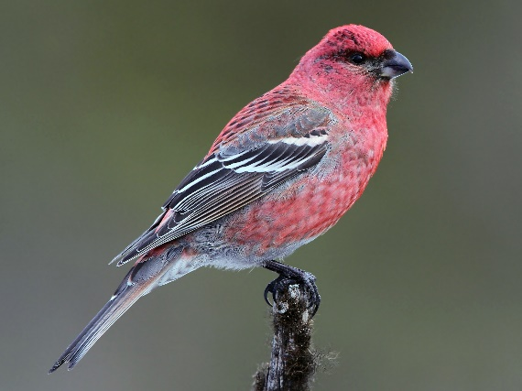This dimorphic species is notably larger than the other birds likely observed at this site except for the jays and ravens. The grayish plumage with a yellow-green head is most common, but you may observe some individuals with bright red coloration. It can be distinguished from a Common Redpoll by the more widespread red coloration, larger size, and gray rather than brown body color. This species often travels in groups.