Agency and experience ratings (Study 2).
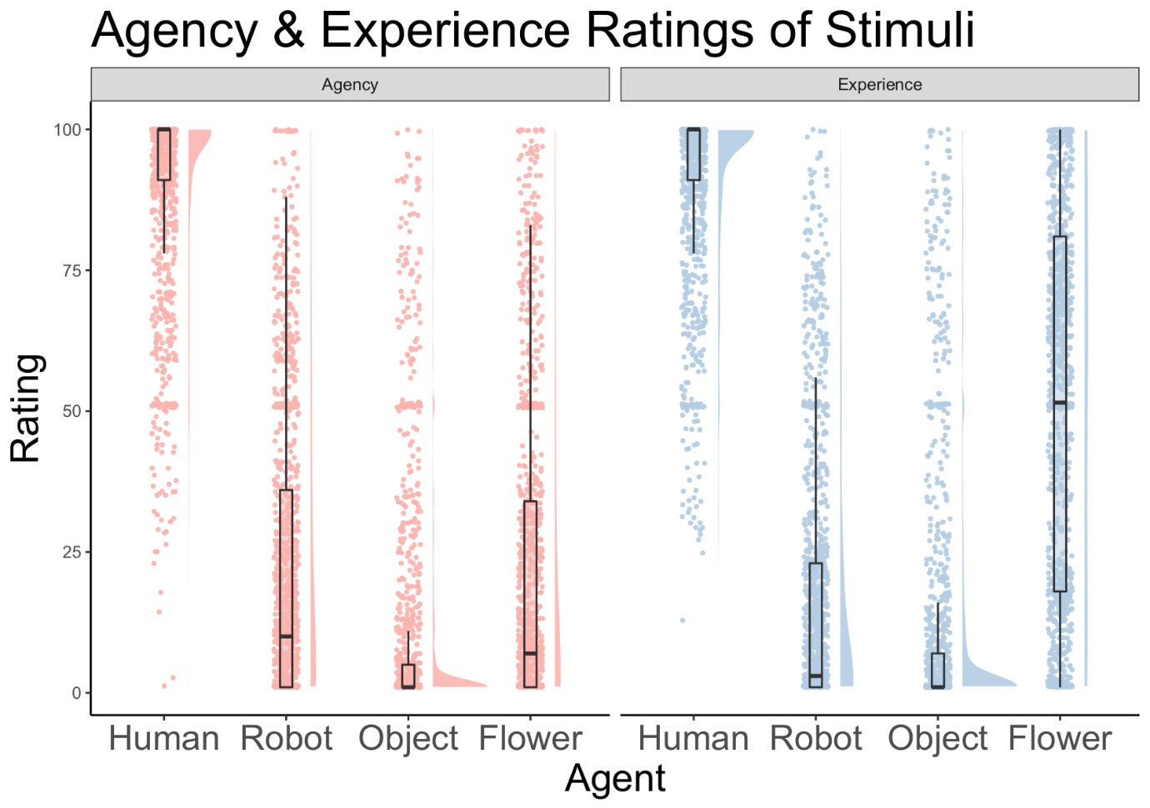
In conjunction with study 2, we included a second survey component, which required participants to rate all the unique (un-mirrored) images on agency and experience. Again, we used a bespoke rating scale modelled on the conceptual ideas of Gray, Gray and Wegner (2007), who define agency as the ability to plan and act and experience as the ability to sense and feel. The images and rating scales were presented via FormR (Arslan, Walther & Tata, 2019) and the one-sentence definitions of agency and experience were presented below each image. Fifty-one participants (the same sample as in Study 2) rated 96 unique images on agency and experience (24 per category, 4 categories). The three inbuilt attention checks (for example: “Did the last image show a) an objects or b) a human?” were all answered correctly by all subjects.
Figure S2. The agency and experience ratings of the 4 stimulus categories: human faces, robot faces, pareidolic faces (objects) and flowers. There is a clustering at the midpoint of the scale, which can be explained by the fact that the starting point of the rating scale was always at 50.
A within-subjects ANOVA conducted with the R package {ezAnova} suggests that there is a main effect of agent: F(3, 150) = 189.71, p<.001. Mauchly’s test for sphericity was significant, thus the assumption was violated (W) = 0.37, p < .001). The Greenhouse-Geisser estimate of sphericity (ε = 0.74) was used and the corrected p-value remains significant (p<.01). Upon inspecting figure 5, it appears that humans were rated highest on agency and experience, robots were attributed some agency and little experience, pareidolic faces rated lowest on both dimensions of mind and surprisingly there was a large spread of ratings for the ability of flowers to sense and feel. This satisfies our internal criterion for ‘category difference’, to ensure that each of the faces were sufficiently distinct.

