Pre-processing of Response Times.
Table S3.1 lists the number of remaining trials per experimental condition after applying our pre-registered trimming criterion in Experiment 1. Table S3.2 depicts the mean reaction times using our pre-registered standard deviation criterion and Figure S3.1 and S3.2 depict density plots of the response times for each of the pre-processing methods. Applying the suggested standard deviation per participant criterion resulted in overall slower reaction times (Table S3.3), compared to the original analysis (Table S3.2). As the pattern of results nonetheless looks similar to what we originally reported, and in the interest of adhering to our pre-registration, we decided to keep the current results section of Experiment 1 as it is.

Table S3.1. Experiment 1: Number of remaining trials per experimental condition after reaction time trimming using the pre-registered standard deviation criterion. 192 trials, 39 participants.
Condition | Total number of trials | Trials remaining | % of trials remaining
incongruent_human | 936 | 847 | 90.5
incongruent_robot | 936 | 835 | 89.2
incongruent_object | 936 | 857 | 91.6
incongruent_flower | 936 | 829 | 88.6
neutral_human | 936 | 883 | 94.3
neutral_robot | 936 | 870 | 92.9
neutral_object | 936 | 883 | 94.3
neutral_flower | 936 | 878 | 93.8
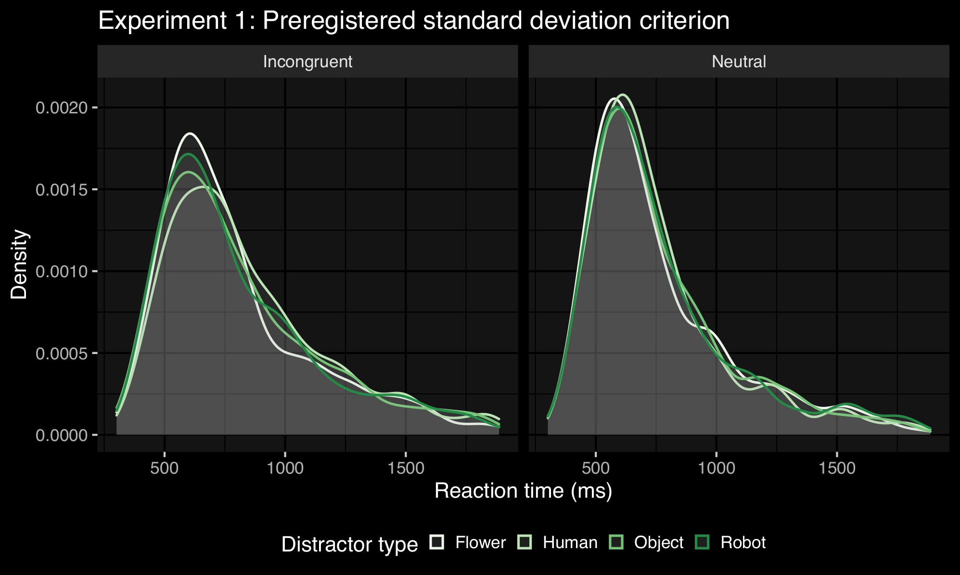
Figure S3.1. Density plots for reaction times (ms) in Experiment 1 with the pre-registered standard deviation trimming criterion.
Table S3.2. Experiment 1: Mean reaction times (in ms) per condition using the pre-registered standard deviation criterion.
 | Distractor
 | Human | Robot | Object | Flower
Incongruent target | 843 | 807 | 815 | 796
Neutral target | 753 | 768 | 763 | 760

Table S3.3. Experiment 1: Mean reaction times (in ms) per condition using the standard deviation per participant criterion.
 | Distractor
 | Human | Robot | Object | Flower
Incongruent target | 840 | 833 | 833 | 809
Neutral target | 769 | 770 | 780 | 776
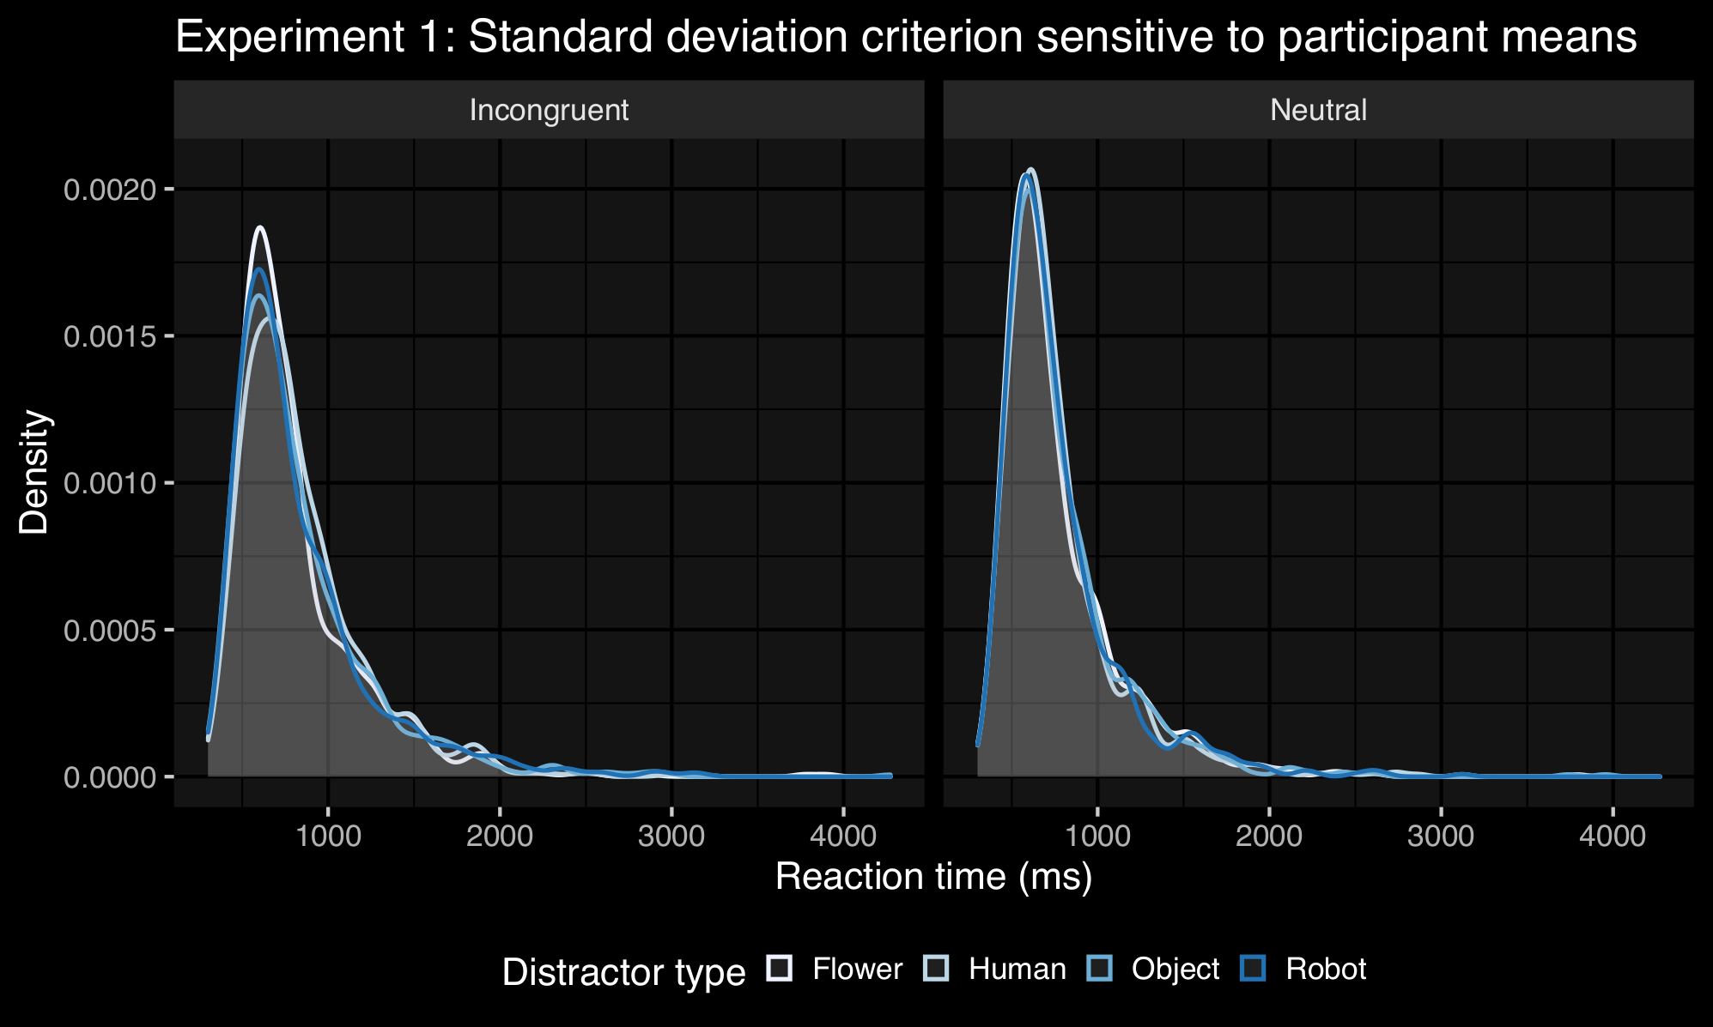
Figure S3.2. Density plots for reaction times (ms) in Experiment 1 with the participant-sensitive standard deviation trimming criterion.

Repeating the same procedure for Experiment 2, we find that with our pre-registered standard deviation criterion we discard 1061 trials (10.84%) in total (with the participant sensitive criterion we discard 11.35% of all trials). Again, we see that the overall patterns of results remain the same across these two pre-processing methods (illustrated in tables and figures below).

Table S3.4. Experiment 2: Number of remaining trials per experimental condition after reaction time trimming using the pre-registered standard deviation criterion. 192 trials, 51 participants.
Condition | Total number of trials | Trials remaining | % of trials remaining
incongruent_human | 1,224 | 1062 | 86.8
incongruent_robot | 1,224 | 1072 | 87.6
incongruent_object | 1,224 | 1061 | 86.7
incongruent_flower | 1,224 | 1056 | 86.3
neutral_human | 1,224 | 1120 | 91.5
neutral_robot | 1,224 | 1100 | 89.9
neutral_object | 1,224 | 1109 | 90.6
neutral_flower | 1,224 | 1101 | 90.0

Table S3.5. Experiment 2: Mean reaction times (in ms) per condition using the pre-registered standard deviation criterion (Experiment 2).
 | Distractor
 | Human | Robot | Object | Flower
Incongruent target | 811 | 808 | 809 | 816
Neutral target | 723 | 747 | 730 | 735

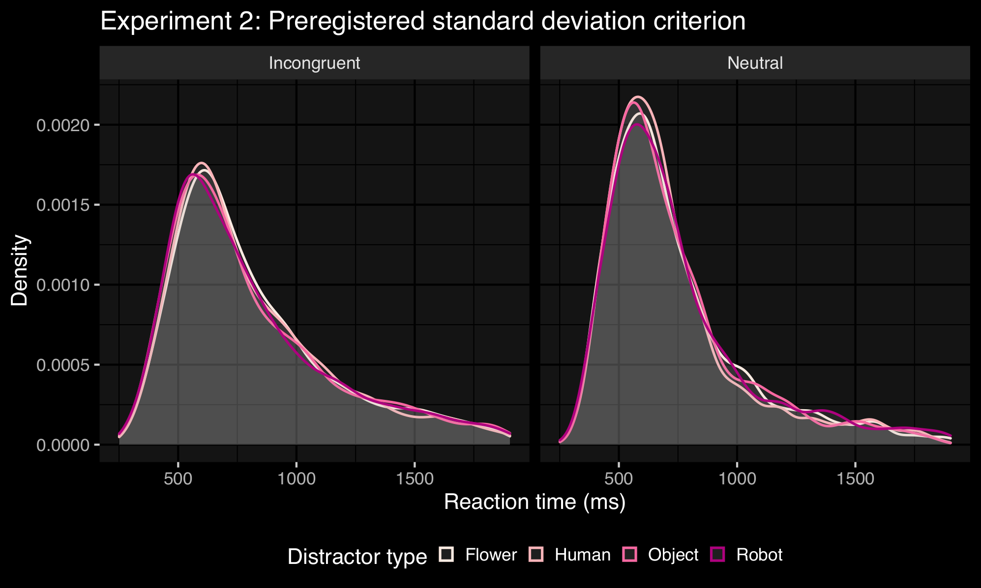
Figure S3.3. Density plots for reaction times (ms) in Experiment 2 with the pre-registered standard deviation trimming criterion.
Table S3.6. Experiment 2: Mean reaction times (in ms) per condition using the standard deviation per participant criterion.
 | Distractor
 | Human | Robot | Object | Flower
Incongruent target | 833 | 828 | 834 | 825
Neutral target | 748 | 755 | 750 | 749

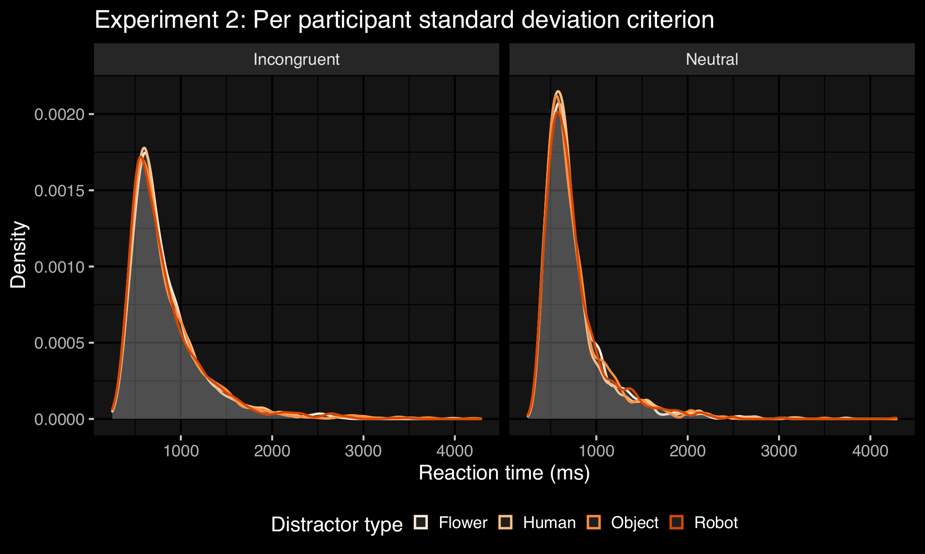
Figure S3.4. Density plots for reaction times (ms) in Experiment 2 with the per participant standard deviation trimming criterion.

