Supplementary materials
Feedback reports
Following the intervention period, participants indicated in a questionnaire, administered during debriefing (T1) which of the interim feedback reports (i.e., reports 1-3) they read. We investigated whether we could distinguish groups of participants who did and who did not read the interim reports; in case of substantive subgroups this allows us to explore the influence of number of reports read on momentary affect, and hence somewhat disentangle the effect of the feedback from the effect of the EMA measurements. The number of feedback reports participants indicated to have read are shown in Table S9. The first two feedback reports were well-read; the third report somewhat less, but still by about three quarters of the participants. Because we could not identify substantive subgroups of participants that did not read the feedback reports, we did not perform any exploratory analyses on the effect of number of reports read.

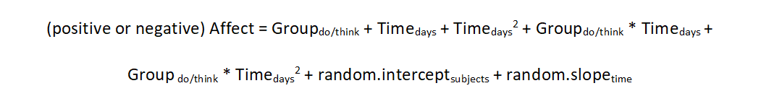
FIGURE S1 Linear mixed model specification for the positive and negative affect model
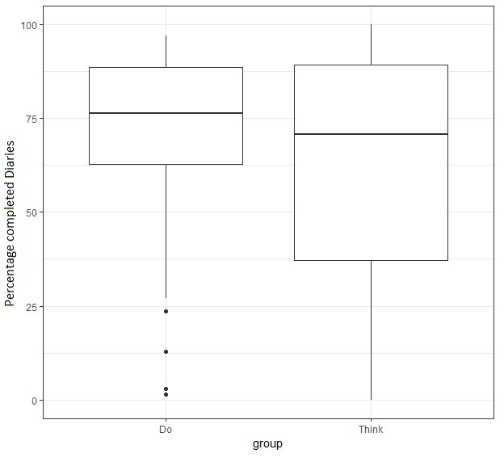
FIGURE S2 Boxplot of each participant’s percentage of completed diaries (100 % = 135 completed diaries), separated by group (N Do-module: 55, N Think-module: 55)

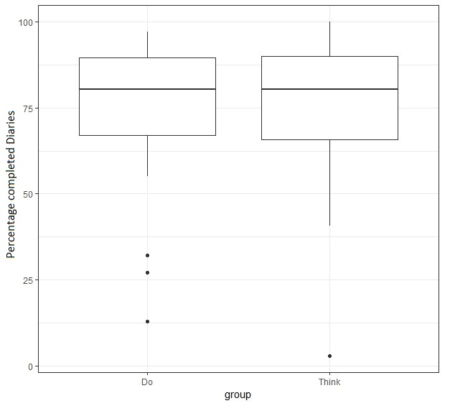
FIGURE S3 Boxplot of each participant’s percentage of completed diaries (100 % = 135 completed diaries), separated by group, with dropouts removed (N Do-module: 48, N Think-module: 42)

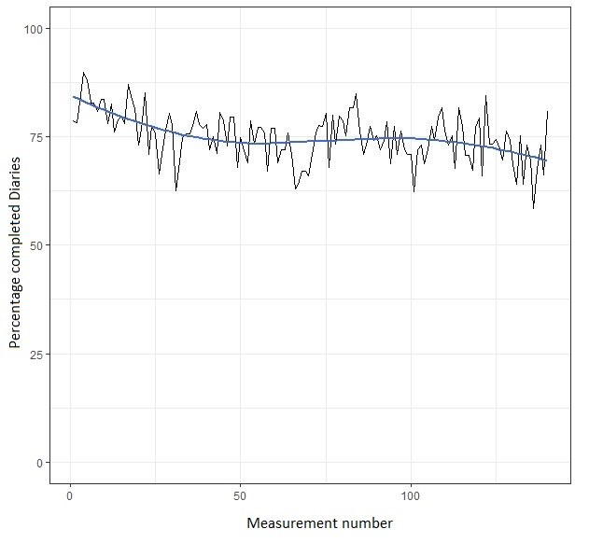
FIGURE S4 Percentage completed diaries at each measurement and fitted regression line, for all participants in both groups. Regression line was fitted using a loess curve (Jacoby, 2000), 100% represents 110 measurements at the first timepoint, decreasing to 90 at the last measurement due to dropouts over time.

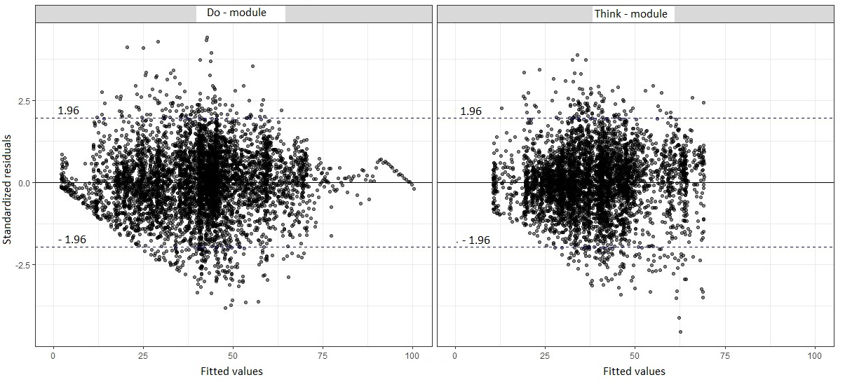
FIGURE S5 Model predicted values compared to standardized residuals for positive affect by
group. With good model fit, approximately 95% of the standardized residuals should fall within the dotted lines, denoting 1.96 * standard deviation. See table S2 for exact statistics.

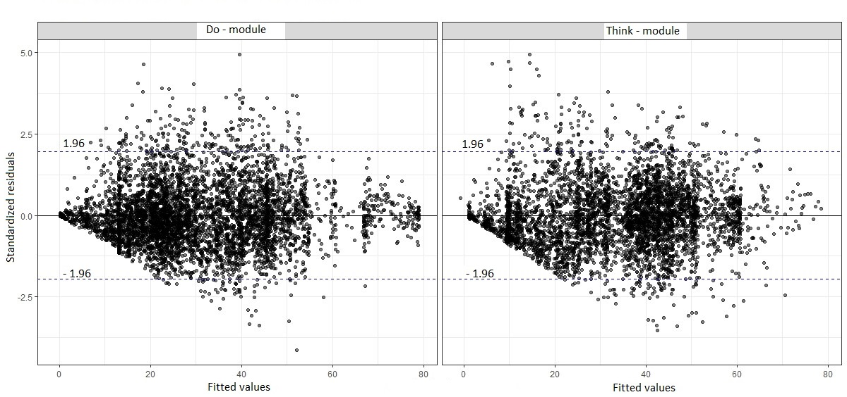
FIGURE S6 Model predicted values compared to standardized residuals for negative affect by
group. With good model fit, approximately 95% of the standardized residuals should fall within the dotted lines, denoting 1.96 * standard deviation. See table S2 for exact statistics.

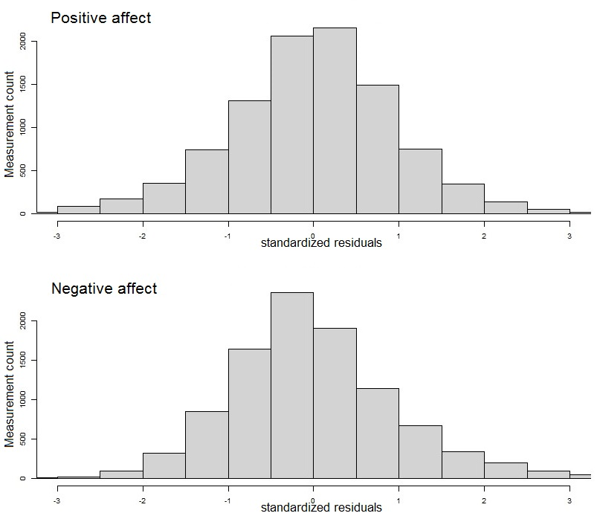
FIGURE S7 Standardized residuals for positive and negative affect models across
groups, showing normally distributed residuals in both PA and NA models.

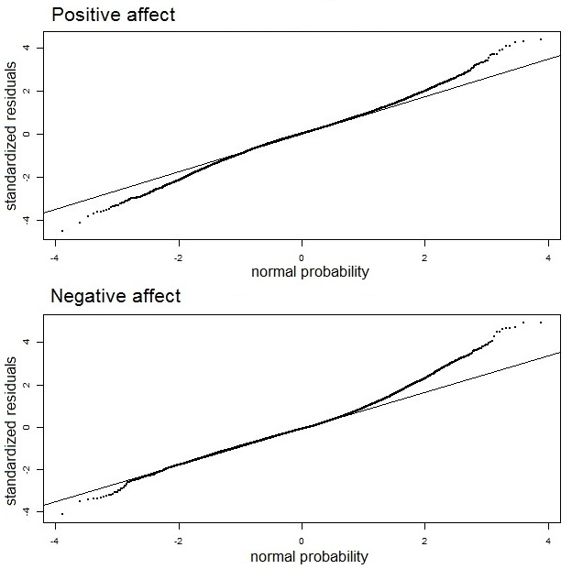
FIGURE S8 Normal probability plot of the standardized residuals for positive and negative affect
models across groups, showing an approximately normally distributed trend.

TABLE S1 Number and percentage of interim feedback reports read by group
Module | Report 1 | Report 2 | Report 3 | All reports read
Do (44) | 42 (95%) | 40 (91%) | 32 (73%) | 28 (64%)
Think (42) | 42 (100%) | 41 (98%) | 31 (74%) | 31 (74%)
Participants indicated in a questionnaire, administered during debriefing (T1), which of the three interim feedback reports they read. Due to drop-out (Do-module: 7, Think-module; 13) and non-response (Do-module: 4) total numbers shown are the number of participants that completed the questionnaire at T1.

TABLE S2 AIC and BIC values for selecting linear or quadratic mixed models for PA and NA
 | AIC† |  | BIC‡
 | linear model | Quadratic model | linear model | quadratic model
Positive Affect | 76453 | 76413 | 76503 | 76477
Negative Affect | 75179 | 75167 | 75229 | 75232
For both PA and NA the quadratic model was preferred by the AIC, shown by the smaller values. The BIC slightly preferred the linear model for NA. As preregistered, in the event of contradicting AIC and BIC indicators we selected the AIC preferred model (quadratic). † AIC = Akaike Information Criterion. ‡ BIC = Bayesian Information Criterion.

TABLE S3 Percentage of standardized residuals larger than 1.96
 | % standardized residuals > 1.96
Positive Affect model | 5.66
Negative Affect model | 5.35
With good model fit, the percentage of standardized residuals larger then ±1.96 * standard error should approach 5%

TABLE S4 Linear mixed model estimates for positive affect (N = 107), fitted with maximum likelihood estimation
Fixed effects (intercept, slopes) | Estimate (SE) | t (105,9602) | p | CI95
 |  |  |  | Lower bound | Upper bound
Intercept (level at T0) | 41.5 (1.7) | 24.6 | < .001 | 38.2 | 44.9
Time | -0.50 (0.12) | -4.3 | < .001 | -0.72 | -0.27
Time² | 0.016 (0.003) | 5.0 | < .001 | .010 | .022
Group | -1.32 (2.40) | -0.6 | 0.58 | -6.06 | 3.44
Group x Time | 0.02 (0.17) | 0.1 | .93 | -0,32 | 0.35
Group x Time² | -0.001 (0.005) | -0.3 | .78 | -0.010 | 0.008
Note. Do-module was used as reference group for between-group effects. Estimates for Time and Time² represent the effect of one day, with five measurements each day. Measurements on the first day were excluded, removing three participants who dropped out on the first day.

TABLE S5 Linear mixed model estimates for negative affect (N = 107), fitted with maximum
likelihood estimation
Fixed effects (intercept, slopes) | Estimate (SE) | t (105,9602) | p | CI95
 |  |  |  | Lower bound | Upper bound
Intercept (level at T0) | 31.7 (2.0) | 15.8 | < .001 | 27.7 | 35.7
Time | 0.18 (0.12) | 1.5 | .14 | -0.06 | 0.42
Time² | -0.005 (0.003) | -1.9 | .06 | -0.011 | < 0.001
Group | 2.15 (2.86) | 0.8 | .45 | -3.51 | 7.81
Group x Time | 0.17 (0.18) | 1.0 | .34 | -0.18 | 0.52
Group x Time² | -0.006 (0.004) | -1.32 | .19 | -0.014 | 0.003
Note. Do-module was used as reference group for between-group effects. Estimates for Time and Time² represent the effect of one day, with five measurements each day. Measurements on the first day were excluded, removing three participants who dropped out on the first day.

TABLE S6 Linear mixed model estimates for positive affect with first day measurements included (N = 110), fitted with restricted maximum likelihood estimation
Fixed effects (intercept, slopes) | Estimate (SE) | t (107, 10055) | p | CI95
 |  |  |  | Lower bound | Upper bound
Intercept (level at T0) | 41.4 (1.6) | 25.3 | < .001 | 38.2 | 44.6
Time | -0.43 (0.11 | -3.8 | < .001 | -0.65 | -0.21
Time² | 0.012 (0.003) | 4.3 | < .001 | 0.007 | 0.018
Group | -1.50 (2.33) | -0.6 | .52 | -6.06 | 3.07
Group x Time | 0.08 (0.17) | 0.5 | .63 | -0.24 | 0.40
Group x Time² | -0.003 (0.004) | -0.8 | .44 | -0.011 | 0.005
Note. Do-module was used as reference group for between-group effects. Estimates for Time and Time² represent the effect of one day, with five measurements each day.

TABLE S7 Linear mixed model estimates for negative affect with first day measurements included (N = 110), fitted with restricted maximum likelihood estimation
Fixed effects (intercept, slopes) | Estimate (SE) | t (107, 10055) | p | CI95
 |  |  |  | Lower bound | Upper bound
Intercept (level at T0) | 32.5 (1.9) | 17.1 | < .001 | 28.8 | 36.3
Time | 0.06 (0.12) | 0.5 | .59 | -0.17 | 0.30
Time² | -0.001 (0.003) | -0.4 | .70 | -0.006 | 0.004
Group | 2.43 (2.71) | 0.9 | .37 | -2.87 | 7.73
Group x Time | 0.08 (0.18) | 0.4 | .66 | -0.27 | 0.43
Group x Time² | -0.002 (0.004) | -0.5 | .65 | -0.010 | 0.006
Note. Do-module was used as reference group for between-group effects. Estimates for Time and Time² represent the effect of one day, with five measurements each day.

TABLE S8 Linear mixed model estimates for positive affect, with dropouts and first day removed (N = 90), fitted with restricted maximum likelihood estimation
Fixed effects (intercept, slopes) | Estimate (SE) | t (88,9179) | p | CI95
 |  |  |  | Lower bound | Upper bound
Intercept (level at T0) | 42.4 (1.8) | 23.8 | < .001 | 38.9 | 45.9
Time | -0.40 (0.11) | -3.5 | < .001 | -0.62 | -0.17
Time² | 0.015 (0.003) | 4.8 | < .001 | 0.009 | 0.021
Group | -1.18 (2.61) | -0.5 | .65 | -6.29 | 3.94
Group x Time | -0.04 (0.17) | -0.2 | ..81 | -0.37 | 0.29
Group x Time² | -0.001 (0.005) | -0.2 | .82 | -0.010 | 0.008
Note. Do-module was used as reference group for between-group effects. Estimates for Time and Time² represent the effect of one day, with five measurements each day.

TABLE S9 Linear mixed model estimates for negative affect, with dropouts and first day removed (N = 90), fitted with restricted maximum likelihood estimation
Fixed effects (intercept, slopes) | Estimate (SE) | t (88,9179) | p | CI95
 |  |  |  | Lower bound | Upper bound
Intercept (level at T0) | 30.6 (2.0) | 15.1 | < .001 | 26.6 | 34.6
Time | 0.04 (0.11) | 0.3 | .74 | -0.17 | 0.25
Time² | -0.005 (0.003) | -1.7 | .09 | -0.011 | 0.001
Group | 1.22 (2.98) | 0.4 | .68 | -4.61 | 7.06
Group x Time | 0.18 (0.16) | 1.1 | .25 | -0.13 | 0.49
Group x Time² | -0.005 (0.004) | -1.2 | .25 | -0.013 | 0.003
Note. Do-module was used as reference group for between-group effects. Estimates for Time and Time² represent the effect of one day, with five measurements each day.

TABLE S10 Linear mixed model estimates for positive affect (N = 107), with time of day added as dummy-variable, fitted with restricted maximum likelihood estimation
Fixed effects (intercept, slopes) | Estimate (SE) | t | p | CI95
 |  |  |  | Lower bound | Upper bound
Intercept (level at T0) | 40.8 (1.7) | 23.7 | < .001 | 37.4 | 44.1
Time | -0.50 (0.12) | -4.2 | <.001 | -0.73 | -0.27
Time² | 0.02 (0.00) | 5.1 | <.001 | 0.01 | 0.02
Group | -1.32 (2.4) | -0.5 | .59 | -6.06 | 3.43
Group x Time | 0.01 (0.17) | 0.1 | .95 | -0.33 | 0.35
Group x Time² | -0.001 (0.005) | -0.3 | .80 | -0.010 | 0.008
Time of day 2 | 0.98 (0.39) | 2.6 | .01 | 0.23 | 1.74
Time of day 3 | 1.09 (0.39) | 2.8 | <.01 | 0.33 | 1.85
Time of day 4 | 1.28 (0.39) | 3.3 | <.001 | 0.52 | 2.04
Time of day 5 | 0.62 (0.39) | 1.6 | .11 | -0.14 | 1.38
Note. Do-module was used as reference group for between-group effects. Estimates for Time and Time² represent the effect of one day, with five measurements each day. The Time of day dummy predictor corresponds to the measurement number (1 to 5) in a single day, where the first measurement was used as reference.

TABLE S11 Linear mixed model estimates for negative affect (N = 107), with time of day added as dummy-variable, fitted with restricted maximum likelihood estimation
Fixed effects (intercept, slopes) | Estimate (SE) | t | p | CI95
 |  |  |  | Lower bound | Upper bound
Intercept (level at T0) | 31.9 (2.0) | 15.6 | < .001 | 26.6 | 34.6
Time | 0.19 (0.12) | 1.6 | .12 | -0.17 | 0.25
Time² | -0.01 (0.00) | -2.0 | .05 | -0.011 | 0.001
Group | 2.19 (2.89) | 0.8 | .45 | -4.61 | 7.06
Group x Time | 0.17 (0.18) | 0.9 | .35 | -0.13 | 0.49
Group x Time² | -0.01 (0.0) | -1.3 | .19 | -0.013 | 0.003
Time of day 2 | 0.40 (0.40) | 1.1 | .27 | -0.31 | 1.10
Time of day 3 | 0.19 (0.36) | 0.5 | .61 | -0.52 | 0.90
Time of day 4 | -0.47 (0.36) | -1.3 | .19 | -1.18 | 0.24
Time of day 5 | -1.39 (0.36) | -3.9 | <.001 | -2.10 | -0.69
Note. Do-module was used as reference group for between-group effects. Estimates for Time and Time² represent the effect of one day, with five measurements each day. The Time of day dummy predictor corresponds to the measurement number (1 to 5) in a single day, where the first measurement was used as reference.

TABLE S12 Linear mixed model estimates for positive affect (N = 107), with weekday/weekend added as independent variable, fitted with restricted maximum likelihood estimation
Fixed effects (intercept, slopes) | Estimate (SE) | t | p | CI95
 |  |  |  | Lower bound | Upper bound
Intercept (level at T0) | 40.9 (1.7) | 24.1 | < .001 | 37.6 | 44.3
Time | -0.50 (0.12) | -4.2 | <.001 | -0.73 | -0.27
Time² | 0.01 (0.00) | 4.7 | <.001 | 0.01 | 0.02
Group | -1.19 (2.4) | -0.5 | .62 | -5.94 | 3.55
Group x Time | 0.01 (0.17) | -0.0 | .97 | -0.34 | 0.33
Group x Time² | -0.001 (0.005) | -0.2 | .80 | -0.010 | 0.010
Weekend | 2.95 (0.27) | 10.8 | <.001 | 2.42 | 3.49
Note. Do-module was used as reference group for between-group effects. Estimates for Time and Time² represent the effect of one day, with five measurements each day. The day of the week variable ‘weekend’ corresponds to the saturday and sunday. All participants started the ZELF-i protocol on monday.

TABLE S13 Linear mixed model estimates for negative affect (N = 107), with weekday/weekend added as independent variable, fitted with restricted maximum likelihood estimation
Fixed effects (intercept, slopes) | Estimate (SE) | t | p | CI95
 |  |  |  | Lower bound | Upper bound
Intercept (level at T0) | 32.2 (2.0) | 15.9 | < .001 | 28.3 | 36.2
Time | 0.19 (0.12) | 1.6 | .12 | -0.05 | 0.43
Time² | -0.00 (0.00) | -1.6 | .12 | -0.01 | 0.00
Group | 2.08 (2.88) | 0.7 | .47 | -3.56 | 7.73
Group x Time | 0.18 (0.18) | 1.0 | .30 | -0.17 | 0.53
Group x Time² | -0.01 (0.00) | -1.4 | .18 | -0.01 | 0.00
Weekend | -2.94 (0.26) | -11.5 | <.001 | -3.44 | -2.44
Note. Do-module was used as reference group for between-group effects. Estimates for Time and Time² represent the effect of one day, with five measurements each day. The day of the week variable ‘weekend’ corresponds to the saturday and sunday. All participants started the ZELF-i protocol on monday.

References
Jacoby, W. G. (2000). Electoral inquiry section Loess: A nonparametric, graphical tool for depicting relationships between variables q.

