Supplemental Materials

Race, Architecture, and Belonging: Divergent Perceptions of Antebellum Architecture
Sara Driskell* & Sophie Trawalter

Sara Driskell*
Department of Psychology
Auburn University, Auburn, Alabama, US
driskell@auburn.edu

Sophie Trawalter
Frank Batten School of Leadership and Public Policy & Department of Psychology

Study 1 Method
Additional Procedure details.
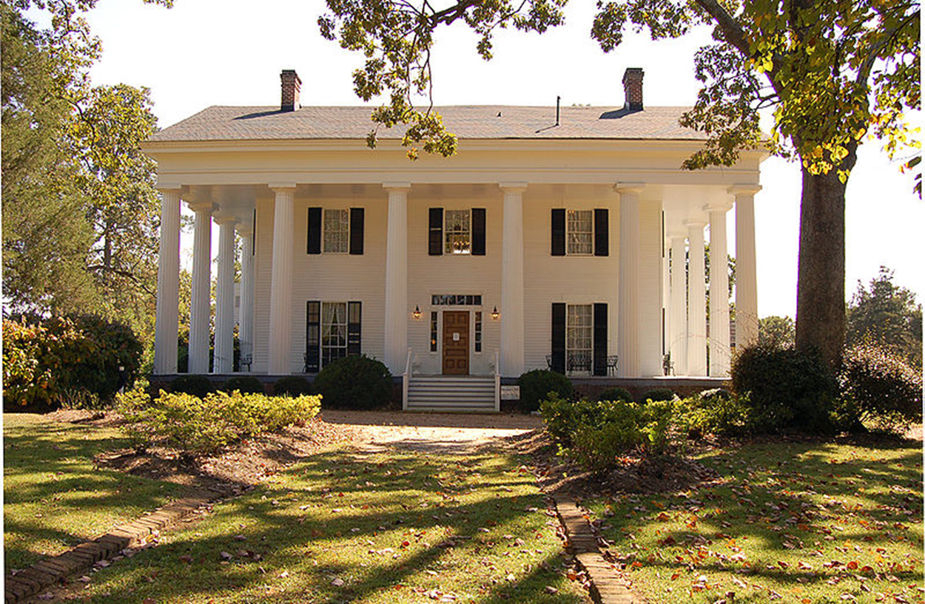
Study 1 image used for Antebellum-Old and Antebellum-Modern conditions. All images were found from publicly available websites focusing on architecture.
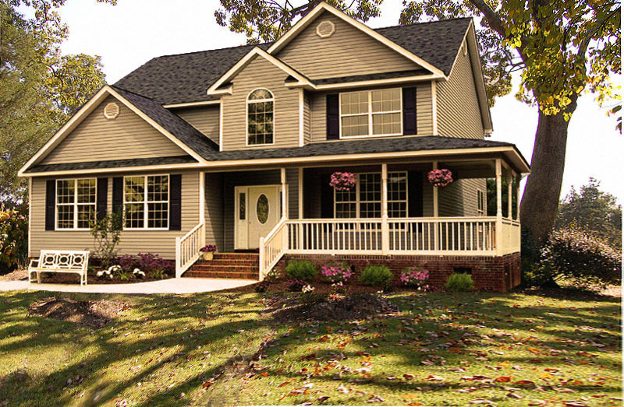
Study 1 image used for New American condition. All images were found from publicly available websites focusing on architecture.
Additional Measures.
Belonging. The items for the Belonging composite were:
- How much do you like this house?
- How comfortable would you feel visiting someone who owned this house?
- How much would you want to live in this house?
Additional Questions. These items were asked in Study 1 but not used in the analyses.
- How familiar are you with this kind of house? That is, have you seen this kind of house a lot?
- If you had to guess, how much do you think this house costs? (Please enter a dollar amount.)
- How much would you pay for this house? (Please enter a dollar amount.) If you were looking for a house, and if you had the money, would you consider this kind of house?
- Imagine the people who live in this house? What are they like? Check all that apply.
  - Married (1)
  - Unmarried (2)
  - Single (3)
  - Divorced (4)
  - Young adults (5)
  - Middle aged (6)
  - Elderly (7)
  - Traditional (8)
  - Non-traditional (9)
  - With Children (10)
  - Without children (11)
  - Owners (12)
  - Renters (13)
  - Liberal (14)
  - Conservative (15)
  - Independent (16)
  - Open minded (17)
  - Prejudiced (18)
  - Forward-thinking (19)
  - Nostalgic for the past (20)
  - Native American (21)
  - Asian (22)
  - Hispanic (23)
  - White (24)
  - Black (25)
  - Highly Educated (26)
  - Moderately Educated (27)
  - Less Educated (28)
  - Poor (29)
  - Lower Income (30)
  - Middle Income (31)
  - Middle Income (32)
  - Rich (33)
  - Likes music (34)
  - Likes books (35)
  - Likes tv / movies (36)
  - Likes to cook (37)
  - Likes to eat out (38)
  - Likes to try new things (39)
  - Likes having a routine (40)
  - Intelligent (41)
  - Stern (42)
  - Friendly (43)
  - Emotional (44)
  - Warm (45)
  - Authentic (46)
  - Compassionate (47)
  - Giving (48)
  - Closed-off (49)
- How often do you think about your own past?
- How often do you think about the distant past; that is, eras long gone by?
- Are you ever nostalgic for the past?
- Do you ever wonder what it would have been like living in the past?
- If so, what historical period (and in what part of the world) do you think you might have liked to live in?
- Do you ever feel guilty about past and present social inequalities of African Americans? If you are not White, you may skip this question and go on to the next one.
- Do you ever feel guilty about the benefits and privileges you might be receiving as a white American? If you are not White, you may skip this question and go on to the next one.
- Are you ever concerned that you will be the target of prejudice and discrimination?
- How often do you think about your own future?
- How often do you think about the distant future; that is, eras that you will not live to see?
- Do you ever wonder what it would be like to live in the future?
- If so, how far into the future (and in what part of the world) might you like to live in?
Study 2 Method
Additional Procedure details.
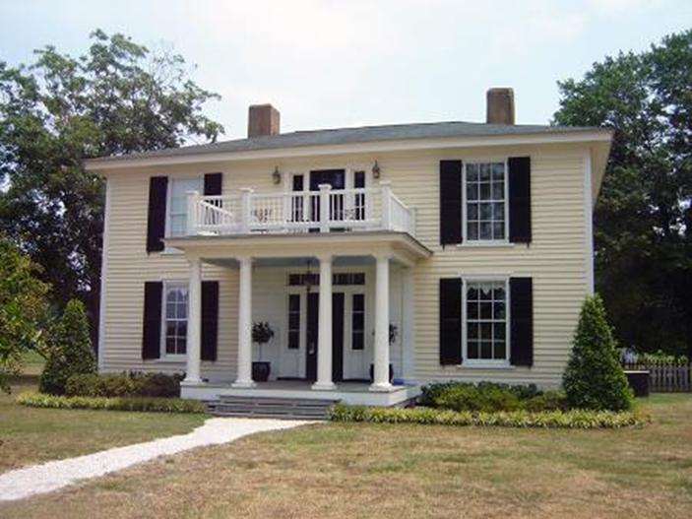
Study 2 image used for Antebellum-Old and Antebellum-Modern conditions. All images were found from publicly available websites focusing on architecture.
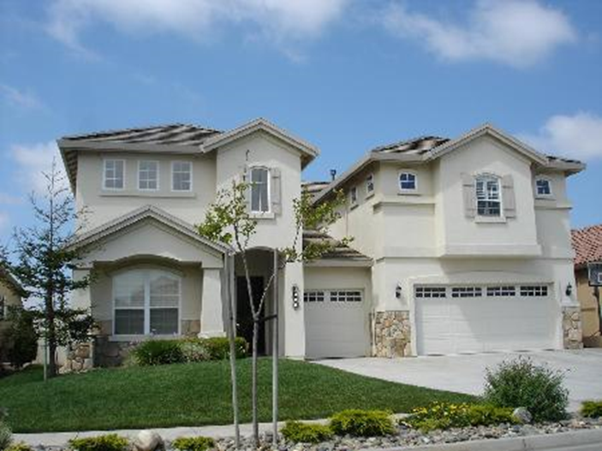
Study 2 image used for New American condition. All images were found from publicly available websites focusing on architecture.
Additional Questions. These items were asked in Study 2 but not used in the analyses.
- Imagine the people who live in this house? What are they like? Check all that apply.
  - Married (1)
  - Unmarried (2)
  - Single (3)
  - Divorced (4)
  - Young adults (5)
  - Middle aged (6)
  - Elderly (7)
  - Traditional (8)
  - Non-traditional (9)
  - With Children (10)
  - Without children (11)
  - Owners (12)
  - Renters (13)
  - Liberal (14)
  - Conservative (15)
  - Independent (16)
  - Open minded (17)
  - Biased (18)
  - Forward-thinking (19)
  - Nostalgic for the past (20)
  - Native American (21)
  - Asian (22)
  - Hispanic (23)
  - White (24)
  - Black (25)
  - Highly Educated (26)
  - Moderately Educated (27)
  - Less Educated (28)
  - Poor (29)
  - Lower Income (30)
  - Middle Income (31)
  - High Income (32)
  - Rich (33)
  - Likes music (34)
  - Likes books (35)
  - Likes tv / movies (36)
  - Likes to cook (37)
  - Likes to eat out (38)
  - Likes to try new things (39)
  - Likes having a routine (40)
  - Intelligent (41)
  - Stern (42)
  - Friendly (43)
  - Emotional (44)
  - Warm (45)
  - Authentic (46)
  - Compassionate (47)
  - Giving (48)
  - Closed-off (49)
- How much do you think the people who live in this house chose to live here?
- How much do you think the people who live in this house would like you?
- How much do you think the people who live in this house would respect you?
- How much do you think the people in this house would want you as a neighbor?
- If land was owned in a single family for generations, there would always be something of their ancestors on that land, even after it has changed ownership.
- If I wear my great grandmother’s wedding ring, I am able to keep some of her spirit with me.
- A piece of land on which my ancestors are buried contains something important of them, whether spirit or something else.
- It really bothers me when people sneeze without covering their mouths.
- I don’t like to write with a pencil someone else has obviously chewed on.
- I prefer to wash my hands pretty soon after shaking someone’s hand.
- I dislike wearing used clothes because you don’t know what the past person who wore it was like.
- My hands do not feel dirty after touching money.
- Many trends in American political life trace back to the era of slavery.
- The history of slavery in the US is no longer relevant in society today.
- America's past regarding slavery is historically important but has little relevance today.
- Economic and health disparities for Blacks today indicate that the remnants of slavery still impact our current society.
- Slavery is a problem of the past.
- The legacy of slavery continues to affect American politics.
- Racial disparities in health, wealth, and education stem from slavery and its legacy.
- Slavery is no longer a relevant factor in Black-White race relations today.
Study 2 Results

Table 1-Supplemental Materials
Study 2 Belonging Data by Condition
Condition | Race | Means | Standard Deviations | 95% CI  Lower Bounds | 95% CI  Upper Bounds | Ns
Old Antebellum | Black | 2.630 | 0.884 | 2.334 | 2.925 | 27
 | White | 3.345 | 0.861 | 3.060 | 3.630 | 29
Modern Antebellum | Black | 2.601 | 0.698 | 2.282 | 2.291 | 23
 | White | 3.406 | 0.986 | 3.135 | 3.677 | 32
Modern New American | Black | 3.910 | 0.585 | 3.609 | 4.211 | 26
 | White | 3.988 | 0.449 | 3.698 | 4.278 | 28

Table 2-Supplemental Materials
Study 2 Spontaneous Thoughts of Slavery Data by Condition
Condition | Race | Percent Mentioning Slavery
Old Antebellum | Black | 29.630
 | White | 3.448
Modern Antebellum | Black | 26.087
 | White | 3.125
Modern New American | Black | 0
 | White | 0

Study 3 Method
Additional Procedure details.
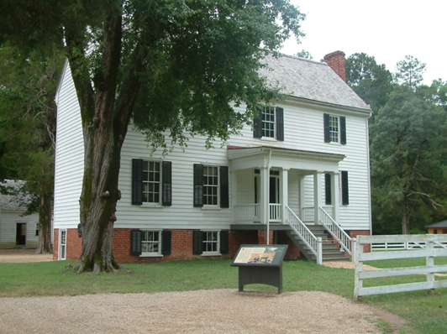
Study 3 image used for all three Linmore Plantation conditions. This image was labelled as “The Linmore Plantation”. All images were found from publicly available websites focusing on architecture.
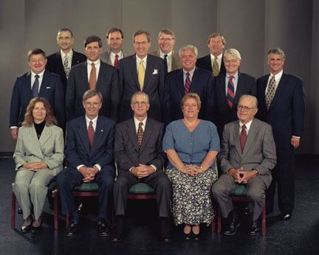
Study 3 image used for the White Board of Visitors condition. This image was labelled as “Linmore Plantation Board of Visitors and Members of the Linmore Historical Preservation Society”. All images were found from publicly available websites focusing on professional events.
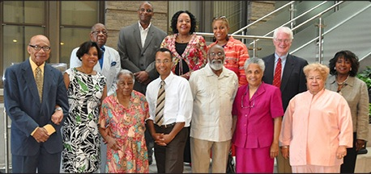
Study 3 image used for the two Black Board of Visitors conditions. This image was also labelled as “Linmore Plantation Board of Visitors and Members of the Linmore Historical Preservation Society”, identical to the description of the White Board. All images were found from publicly available websites focusing on professional events.
The Study 3 description of the No Redemption Condition read, “The Linmore Plantation was a central feature for life around Linmore, Virginia in the mid-1800s. Originally built in 1842, the Linmore Plantation was designed in the Neo-Classical and Greek Revival style, common in that period, before the Civil War. Then, it was the home of William Linmore and his family, as well as the slaves who worked on the property. Today, it houses one of the oldest museums in the country. Owned and operated by the Linmore Historical Preservation Society, the Linmore Plantation has been carefully restored to be authentic to its original appearance and has been furnished entirely with period antiques. Further, the Linmore Historical Preservation Society has shown a dedication to historical accuracy. The Linmore Plantation Museum's furnishings reflect its daily use and civilian history, and the Museum also features a reconstructed working kitchen and slave quarters. In developing materials for a new generation of museum-goers, the Linmore Historical Preservation Society has highlighted artifacts that allow visitors to explore the Southern agrarian way of life. The goal with this new program is to give visitors an authentic view of the daily work and life of people from this era of American history.”
The Study 3 description of the Redemption Condition read, “The Linmore Plantation was a central feature for life around Linmore, Virginia in the mid-1800s. Originally built in 1842, the Linmore Plantation was designed in the Neo-Classical and Greek Revival style, common in that period, before the Civil War. Then, it was the home of William Linmore and his family, as well as the slaves who worked on the property. Today, it houses one of the oldest museums in the country. Owned and operated by the [White Board: Linmore Historical Preservation Society; Black Board: African American Historical Preservation Society], the Linmore Plantation has been carefully restored to be authentic to its original appearance and has been furnished entirely with period antiques. Further, the [White Board: Linmore Historical Preservation Society; Black Board: African American Historical Preservation Society] has shown a dedication to addressing the plantation's more controversial history. They readily [White Board: admit that; Black Board: discuss how] the original plantation owners participated in the slave trade and kept a number of slaves on the property to run the plantation. In developing materials for a new generation of museum-goers, the [White Board: Linmore Historical Preservation Society; Black Board: African American Historical Preservation Society] has used this tragedy as an opportunity to teach visitors about the extent of the slave trade in America as well to illustrate the realities of daily life as a slave on the plantation. The goal with this new program is to change how visitors view their national identity and the history of this country.”
Additional Measures.
Belonging. The items for the Belonging composite were:
- How much do you think you would like visiting this museum?
- How comfortable would you feel visiting this museum?
- How much would you want to support this museum's mission?
Donation and Donation Amount. Participants rated their willingness to make a donation (“Would you be willing to make a donation to support this museum?”) on the same scale as above and, if so, listed a donation amount (“How much would you donate to this museum?”). Responses that were left blank were coded as zeroes.
Study 3 Results and Discussion
Donation and Donation Amount. Additionally, participants were more likely to report that they were willing to donate to the museum in the Redemption+Reclamation condition (M = 2.615, SD = 1.329), compared to the Control and Redemption Only conditions (M = 1.231, SD = 0.587; M = 1.387, SD = 0.615, respectively), which did not differ, F(2,80) = 19.027, p < .001, η² = .322 (see Figure 1-Supplementary Materials).

Figure 1-Supplemental Materials. Reported willingness to donate to the museum by condition for Study 3. Error bars are standard errors.

When asked about donation amounts, participants listed significantly higher amounts to the museum described in the Redemption+Reclamation condition (M = 42.038, SD = 102.706) than in the Control condition (M = 0.654, SD = 2.171), with the Redemption Only condition (M = 9.839, SD = 25.281) falling non-significantly between them, F(2,80) = 3.510, p = .035, η² = .081 (see Figure 2-Supplemental Materials).

Figure 2-Supplemental Materials. Reported donation amounts to the museum by condition for Study 3. Error bars are standard errors.

Donation Amount results were calculated by using $0.00 for participants who did not enter an amount. However, using only those who did enter an amount did not change the significance of the results. The data using only the entered amounts was as follows: When asked about donation amounts, participants listed higher amounts to the museum described in the Redemption+Reclamation condition (M = 60.722, SD = 119.629) than in the Control condition (M = 1.000, SD = 2.646), with the Redemption Only condition (M = 14.524, SD = 29.787) falling non-significantly between them, F(2,53) = 3.558, p = .035, η² = .118.

