Supplementary Materials

Excluded Participants

Over the three experiments, there were 47 participants excluded from the analyses: 42 for deception failure, 3 for inattentive task performance, and 2 for both deception failure and inattention.
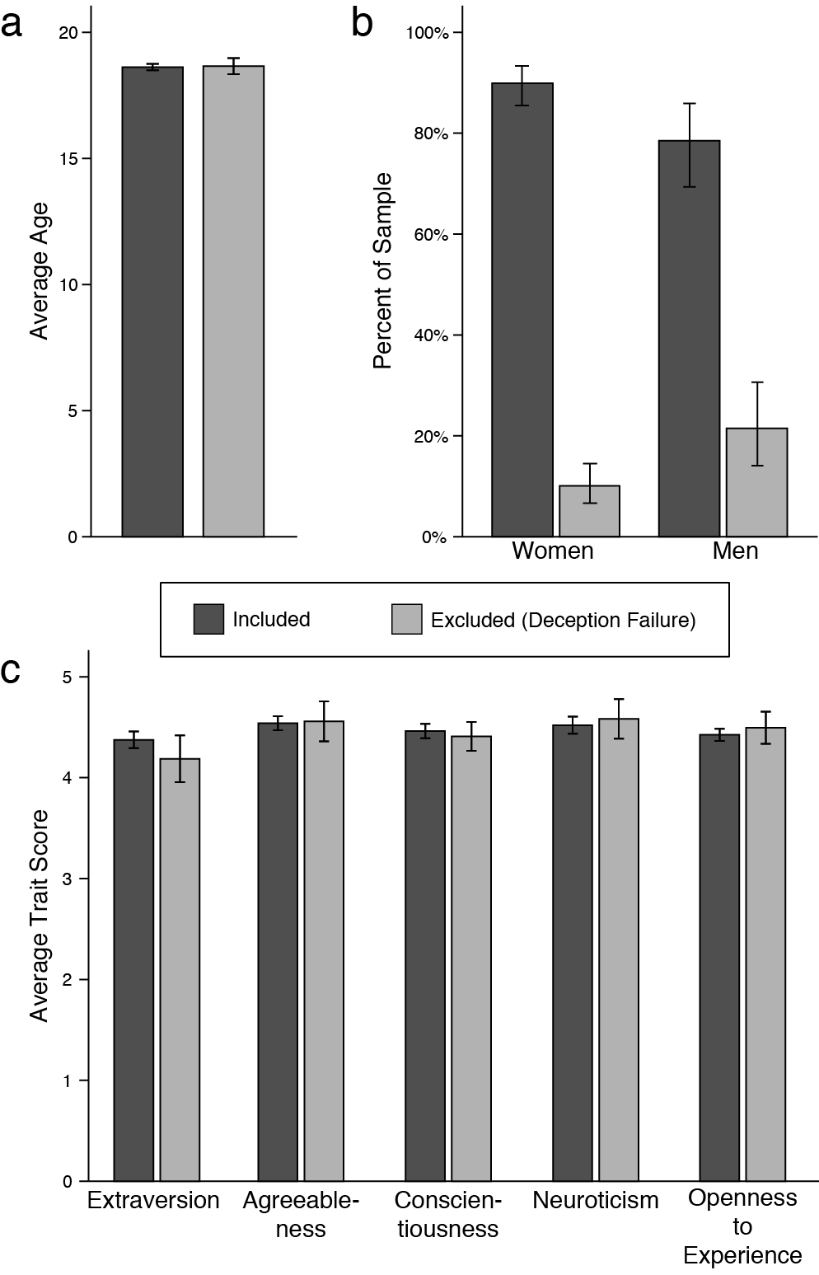
Figure S1. Demographic differences between participants who were included in the analysis and excluded for deception failure on a) age, b) gender, c) personality characteristics. Error bars show the 95% CI.
We tested whether individuals who were not included in our main analysis for deception failure (N = 44) differed from those who were included (N = 278) on age, gender, and personality (as measured by the Big Five Inventory: John & Srivastava, 1999). There were no significant differences between groups on age (see Figure S1a), t(317) = -.214, p = .831. However, we did find a significant gender difference between those who were included versus excluded for deception failure, χ²(1, N=228) = 7.423, p = .006 (Figure S1b). Specifically, male participants were more likely to be excluded from the main analysis due to deception failure than were female participants. The groups did not differ on any measured personality traits (Figure S1c), all p-values > .105.

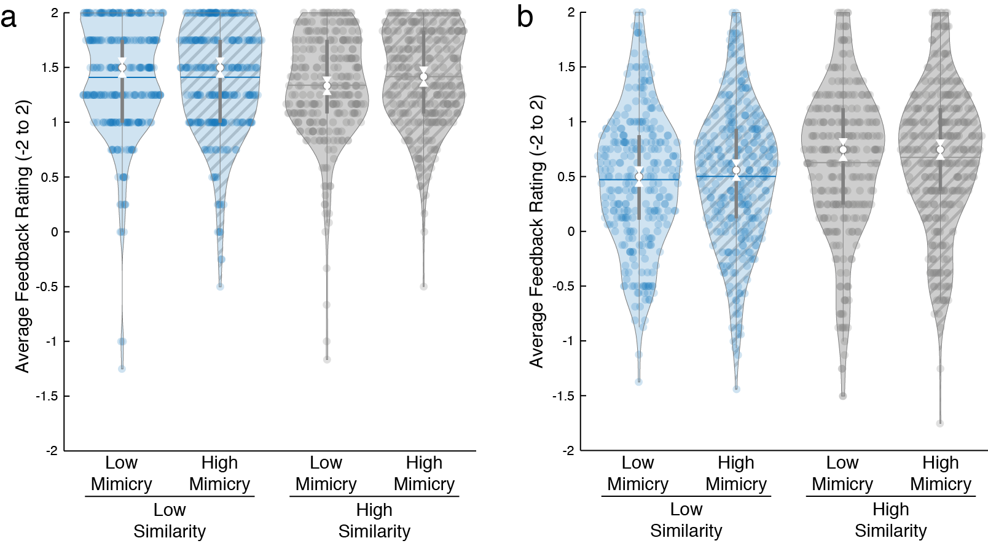
Figure S2. Average emoji feedback chosen by participants for each avatar a) when responses to the similarity manipulation matched and b) when responses to the similarity manipulation did not match. Blue fill represents low-similarity avatars and grey fill depicts high-similarity avatars. Hatched plots show high mimicry avatars and un-hatched plots denote low-mimicry avatars. Within each violin, white dots represent the median and the white notches the 95%CI of the median, the horizontal lines show the means, the dark gray bars represent the interquartile range (IQR), and the light gray lines represent 1.5 times the IQR. The shape of the violin shows the probability density function of the data distribution. Individual data points are represented by coloured dots.

