Supplemental Material
Psychological Effects of Hormonal Contraception
Laura J. Botzet, Tanja M. Gerlach, Julie C. Driebe, Lars Penke, and Ruben C. Arslan

Table S1
Counts, Means, Standard Deviations, and Comparisons Between Included and Excluded Participants
 | Included participants |  |  |  |  | Excluded participants
Variables | n |  | M | SD | n |  | M | SD |  | t | df | d [95% CI]
Age | 1,179 |  | 25.03 | 5.09 | 232 |  | 34.15 | 10.80 |  | -13.00 | 1409 | -1.43  [-1.62; -1.24]
Education | 1,179 |  | 15.07 | 4.73 | 232 |  | 15.58 | 5.02 |  | -1.40 | 1409 | -0.11  [-0.25; 0.03]
Relationship duration | 774 |  | 41.20 | 44.56 | 174 |  | 89.77 | 90.64 |  | -6.90 | 946 | -0.87  [-1.06; -0.68]
Extraversion | 1,179 |  | 3.46 | 0.78 | 232 |  | 3.35 | 0.84 |  | 1.90 | 1409 | 0.15  [-0.00; 0.29]
Neuroticism | 1,179 |  | 3.00 | 0.78 | 232 |  | 2.95 | 0.78 |  | 0.83 | 1409 | 0.06  [-0.0; 0.20]
Agreeableness | 1,179 |  | 3.68 | 0.62 | 232 |  | 3.67 | 0.63 |  | 0.10 | 1409 | 0.01  [-0.13; 0.15]
Conscientiousness | 1,179 |  | 3.53 | 0.66 | 232 |  | 3.60 | 0.66 |  | -1.50 | 1409 | -0.11  [-0.25; 0.03]
Openness | 1,179 |  | 3.78 | 0.61 | 232 |  | 3.78 | 0.68 |  | 0.01 | 1409 | 0.00  [-0.14; 0.14]
Religiosity | 1,179 |  | 2.20 | 1.34 | 232 |  | 2.33 | 1.44 |  | -1.20 | 1409 | -0.09  [-0.23; 0.05]
Perceived partner attractiveness | 774 |  | 4.25 | 0.74 | 174 |  | 4.29 | 0.78 |  | -0.54 | 946 | -0.05  [-0.22; 0.12]
Relationship satisfaction | 774 |  | 3.39 | 0.43 | 174 |  | 3.39 | 0.44 |  | 0.03 | 946 | 0.00  [-0.16; 0.17]
Sexual satisfaction | 774 |  | 4.00 | 1.05 | 174 |  | 3.98 | 1.13 |  | 0.27 | 946 | 0.02  [-0.14; 0.19]
Libido | 968 |  | 1.19 | 0.59 | 180 |  | 1.04 | 0.60 |  | 3.12 | 1146 | 0.25  [0.09; 0.42]
Frequency of vaginal intercourse | 897 |  | 7.27 | 7.19 | 148 |  | 6.14 | 6.98 |  | 1.80 | 1075 | 0.15  [-0.02; 0.32]
Frequency of masturbation | 897 |  | 6.96 | 7.21 | 148 |  | 6.48 | 7.32 |  | 0.37 | 1075 | 0.06  [-0.11; 0.,23]

Table S1 (continued)
Counts, Means, Standard Deviations, and Comparisons Between Included and Excluded Participants
Variables |  | n (percentage) |  |  |  | n (percentage) |  |  | X² |  | df | V [95% CI]
Income (monthly)  - <500€  - 500€‒1,000€  - 1,000€‒2,000€  - 2,000€‒3,000€  - >3,000€  - do not want to disclose |  | 287 (24%)  565 (48%)  215 (18%)  63 (5%)  16 (1%)  33 (3%) |  |  |  | 28 (12%)  61 (26%)  73 (31%)  26 (11%)  22 (9%)  22 (9%) |  |  | 130.45 |  | 5 | 0.30  [0.25; 0.37]
Relationship status  - Single  - Partnered |  | 405 (34%)  774 (66%) |  |  |  | 58 (25%)  174 (75%) |  |  | 7.27 |  | 1 | 0.07  [0.02; 0.12]
Note. Excluded participants include only participants who finished the initial survey and were excluded based on other criteria. Sample sizes differ because some variables were only answered by partnered women (affecting relationship duration, perceived partner attractiveness, relationship satisfaction, and sexual satisfaction), and not all participants were included for analyses based on the diary (affecting libido, frequency of vaginal intercourse, and frequency of masturbation). Bold variables indicate significant differences between included and excluded participants.
d = Cohen’s d; V = Cramér’s V.

Table S2
Variables Used for Analyses of Selection Effects, and Effects of Hormonal Contraception and Congruent Contraceptive
Variable | Scale / Item
Age (in years) | Your age:
Education (in years) | How many years of schooling (school, college/university, PhD, NOT vocational school) have you completed?
Income | How much money do you have at your disposal every month (net)?  Choices: <500€; 500‒1,000€; 1,000‒2,000€; 2,000‒3,000€;  >3,000€; do not want to disclose
Big Five personality  - Extraversion  - Neuroticism  - Agreeableness  - Conscientiousness  - Openness | German version of the Big Five Inventory (Lang et al., 2001)  Example Items:  I see myself as someone who is communicative, who likes to chat.  I see myself as someone who is depressed, who feels downcast.  I see myself as someone who is willing to help and selfless with others.  I see myself as someone who is original, who develops new ideas.  I see myself as someone who finishes their duties precisely.  Scale from 1 = does not apply at all to 5 = fully applies
Religiosity | How religious do you think you are?  Scale from 1 = non-religious to 5 = religious.
Relationship duration | How long have you been in your relationship?  Measured in years and months
Hormonal contraceptionª | What kind of contraception do you currently use?  - oral contraceptives (birth control pill); other hormonal contraception (depot syringe, hormone implant, contraceptive ring, contraceptive patch, hormonal spiral)  → hormonal contraception  - condoms; abandonment of penetrative sexual intercourse; other barrier methods (diaphragm, female condom, cervical cap); copper spiral or chain (intrauterine device); coitus interruptus; calendar method; temperature/Billings/symptothermal method; contraceptive computer (Persona, LadyComp, Cyclotest, ...); spermicides; chemical contraception  → no/nonhormonal contraception
Congruent use of hormonal contraception | Categorization into congruent and incongruent use of hormonal contraception based on hormonal contraception and the question  Were you using hormonal contraception (e.g., birth control pill) when you met your current partner?  0 = no; 1 = yes
Perceived partner attractiveness | Aggregated scale:  My partner’s face is very attractive.  My partner’s body is very attractive.  Scale from 1 = does not apply at all to 5 = fully applies
Table S2 (continued)
Variables Used for Analyses of Selection Effects, and Effects of Hormonal Contraception and Congruent Contraceptive
Variable | Scale / Item
Relationship satisfaction | Aggregated scale:  Overall, I am satisfied with my relationship.  My needs (e.g., for intimacy, mutuality, etc.) are fulfilled in my relationship.  Our relationship makes me very happy.  There are many problems in my relationship. (r)  There are many disputes/disagreements in my relationship. (r)  Scale from 1 = does not apply at all to 5 = fully applies
Sexual satisfaction | Sex with my partner is very satisfying.  Scale from 1 = does not apply at all to 5 = fully applies
Libido | Aggregated mean based on all days of the diary:  I experienced increased libido (desire to have sexual intercourse/masturbate/be sexually active).  Scale from 0 = not at all to 4 = very much
Frequency of vaginal intercourse | Aggregated sum based on all days of the diary:  I was sexually active (including masturbation and caressing) since the last time I filled out the diary.  0 = no; 1 = yes  The sexual activity/activities involved:  0 = kissing, cuddling etc., phone sex/webcam sex, masturbation, stimulated from partner by hand, stimulated my partner by hand,  stimulated my partner with my mouth,  stimulated by partner with his mouth, anal sex, toys (vibrator;...),  BDSM, masturbation;  1 = intercourse (penetrative)
Frequency of masturbation | Aggregated sum based on all days of the diary:  The sexual activity/activities involved:  0 = kissing, cuddling etc., phone sex/webcam sex, masturbation, stimulated from partner by hand, stimulated my partner by hand,  stimulated my partner with my mouth,  stimulated by partner with his mouth, anal sex, toys (vibrator;...),  BDSM, intercourse (penetrative);  1 = masturbation
Note. ª Participants could choose one or more of the alternatives for contraceptive methods. If choices include an alternative that was categorized as hormonal contraception, participants were categorized as using hormonal contraception.
r = reversed.

Figure S1
Relationship Duration Split Into Four Quartiles
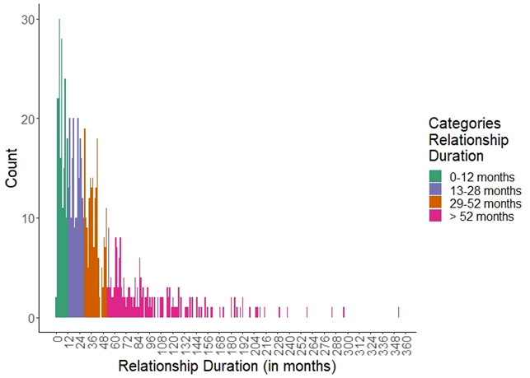

Figure S2
Allocation of Participants into Different Groups, Depending on their Choice of Contraception
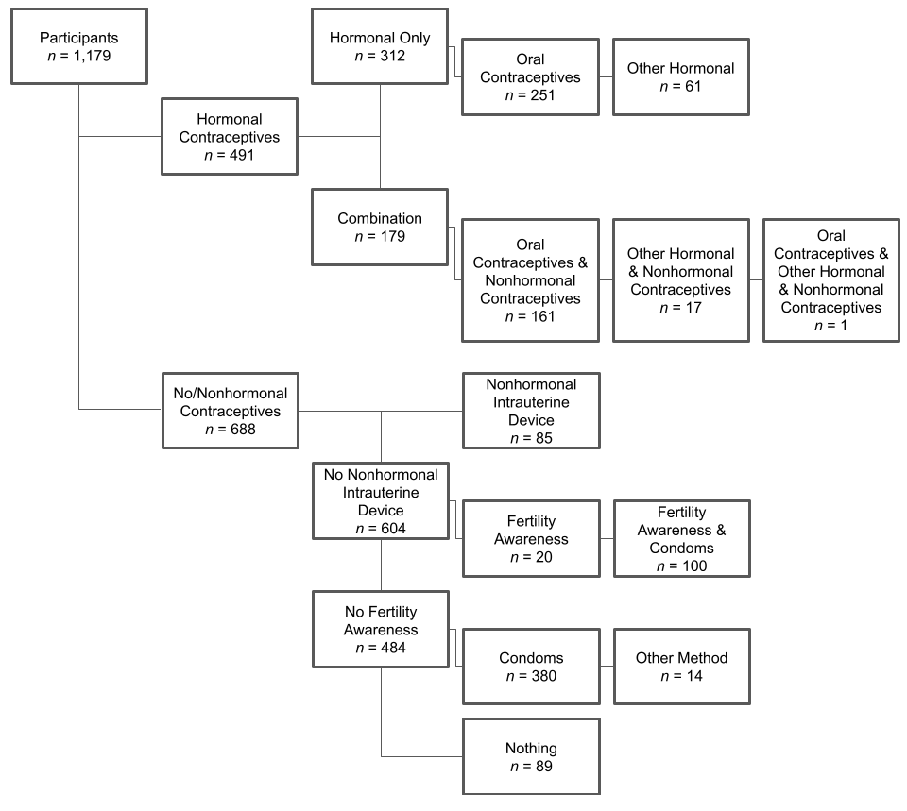
Note. “Other method” included participants indicating using only coitus interruptus (n = 12) or only other nonhormonal methods (n = 2). “Nothing” included participants who indicated using no contraceptive method at all (n = 5) and participants who indicated having no penetrative sexual intercourse at the moment (n = 84; these were excluded from all analyses with frequency of vaginal intercourse or frequency of masturbation as outcomes).

Table S3
Means and Standard Deviations for Selection Variables and Outcomes Separately for Singles and Partnered Women Divided by Current Contraceptive Method and Congruent Contraceptive Use
 | No/Nonhormonal Contraceptives |  |  | Hormonal Contraceptives
Variables | Singles | Incongruent | Congruent | Singles | Incongruent | Congruent
n | 287 | 150 | 251 | 118 | 133 | 240
Age (in years) | 24.19  (4.63) | 27.01  (5.64) | 26.59  (5.51) | 24.01 (4.34) | 23.81  (4.17) | 24.33  (4.89)
Education (in years) | 14.40  (5.25) | 15.20  (5.07) | 16.00  (4.71) | 14.50  (4.30) | 15.60  (4.17) | 14.80  (4.21)
Income  - <500€  - 500€‒1,000€  - 1,000€‒2,000€  - 2,000€‒3,000€  - >3,000€  - do not want to disclose | 72  162  35  8  1  9 | 25  62  39  16  4  4 | 53  119  52  15  4  8 | 32  58  22  2  1  3 | 38  59  19  9  3  5 | 67  105  48  13  3  4
Extraversion | 3.45  (0.74) | 3.46  (0.75) | 3.44  (0.80) | 3.55  (0.82) | 3.46  (0.78) | 3.47  (0.82)
Neuroticism | 2.96 (0.76) | 2.97  (0.79) | 3.03  (0.77) | 2.98 (0.84) | 3.01  (0.80) | 3.02  (0.77)
Agreeableness | 3.68  (0.60) | 3.59  (0.60) | 3.66  (0.60) | 3.68  (0.59) | 3.80  (0.62) | 3.66  (0.66)
Conscientiousness | 3.45  (0.63) | 3.49  (0.73) | 3.48  (0.64) | 3.54  (0.67) | 3.58  (0.65) | 3.67  (0.63)
Openness | 3.84  (0.60) | 3.77  (0.66) | 3.87  (0.57) | 3.84  (0.58) | 3.73  (0.60) | 3.63  (0.63)
Religiosity | 2.22  (1.33) | 2.16  (1.29) | 2.24  (1.37) | 2.03  (1.24) | 2.47  (1.47) | 2.12  (1.31)
Relationship duration  - Single  - 0‒12 months  - 13‒28 months  - 29‒52 months  - >52 months | 287 | 13  30  51  56 | 100  66  45  40 | 118 | 22  31  43  37 | 63  71  49  57
Perceived partner attractiveness |  | 4.13  (0.74) | 4.26  (0.75) |  | 4.29  (0.71) | 4.30  (0.73)
Relationship satisfaction |  | 3.42  (0.44) | 3.31  (0.46) |  | 3.47  (0.38) | 3.42  (0.39)
Sexual satisfaction |  | 3.84  (1.12) | 3.99  (1.05) |  | 4.02  (1.06) | 4.10  (1.00)
Table S3 (continued)
Means and Standard Deviations for Selection Variables and Outcomes Separately for Singles and Partnered Women Divided by Current Contraceptive Method and Congruent Contraceptive Use
 | No/Nonhormonal Contraceptives |  |  | Hormonal Contraceptives
Variables | Singles | Incongruent | Congruent | Singles | Incongruent | Congruent
n_{Diary} | 247 | 126 | 216 | 89 | 103 | 187
Libido | 1.02  (0.64) | 1.25  (0.57) | 1.32  (0.52) | 0.97  (0.61) | 1.24  (0.54) | 1.29  (0.56)
Frequency of vaginal intercourse | 2.89  (4.49) | 8.02  (6.15) | 9.16  (7.53) | 2.83  (4.27) | 10.02  (8.13) | 9.62  (7.30)
Frequency of masturbation | 10.06  (8.65) | 6.50  (6.50) | 7.56  (7.88) | 6.66  (6.00) | 4.61  (5.44) | 4.96  (5.37)
Note. Numbers in parentheses show standard deviations.
HCs = hormonal contraceptives.

Table S4
Zero-Order Correlations
Variable | (1) | (2) | (3) | (4) | (5) | (6) | (7) | (8) | (9) | (10) | (11) | (12) | (13)
(1) Age (in years)
(2) Education (in years) | .36  [.31; .41]
(3) Extraversion | -.03  [-.08; .03] | -.06  [-.11; -.00]
(4) Neuroticism | -.02  [-.08; .03] | .03  [-.03; .08] | -.36  [-.40; -.30]
(5) Agreeableness | -.10  [-.16; -.05] | -.09  [-.14; -.03] | .21  [.16; .27] | -.39  [-.44; -.34]
(6) Conscientious-ness | -.03  [-.09; .03] | -0.5  [-.11; .01] | .21  [.16; .27] | -.26  [-.32; -.21] | .20  [.14; .25]
(7) Openness | .10  [.04; .16] | .08  [.03; .14] | .20  [.14; .25] | -.07  [-.13; -.01] | .08  [.02; .13] | .05  [-.01; .11]
(8) Religiosity | -.05  [-.10; .01] | .01  [-.04; .07] | .06  [.00; .12] | -.05  [-.10; .01] | .10  [.04; .16] | .08  [.02; .14] | .01  [-.05; .07]
(9) Perceived partner attractiveness | -.03  [-.10; .04] | .02  [-.05; .09] | .09  [.02; .16] | -.05  [-.12; .02] | .10  [.03; .17] | .06  [-.01; .13] | .07  [.00; .14] | .01  [-.06; .08]
(10) Relationship satisfaction | -.11  [-.17; -.03] | -.07  [-.14; .00] | .03  [-.04; .10] | .06  [-.01; .13] | -.03  [-.10; .04] | .02  [-.05; .09] | -.04  [-.11; .03] | .10  [.03; .17] | .25  [.19; .32]
(11) Sexual satisfaction | -.06  [-.13; .01] | -.05  [-.12; .02] | .12  [.05; .19] | -.13  [-.19; -.06] | .12  [.05; .19] | .12  [.05; .19] | -.02  [-.09; .05] | .01  [-.06; .08] | .41  [.35; .47] | .33  [.27; .39]
(12) Libido | .07  [.01; .13] | .03  [-.03; .09] | .15  [.08; .21] | -.07  [-.13; -.01] | .09  [.02; .15] | -.05  [-.11; .02] | .13  [.07; .19] | -.01  [-.07; .05] | .09  [.01; .16] | .03  [-.05; .11] | .14  [.06; .21]
(13) Frequency of vaginal intercourse | .03  [-.03; .10] | -.01  [-.08; .05] | .02  [-.05; .08] | -.04  [-.10; .03] | .05  [-.01; .12] | .09  [.02; .15] | -.01  [-.08; .05] | .01  [-.05; .08] | .13  [.05; .20] | .13  [.05; .21] | .23  [.16; .31] | .39  [.34; .45]
(14) Frequency of Masturbation | .02  [-.04; .09] | .02  [-.04; .09] | -.01  [-.07; .06] | -.00  [-.07; .06] | -.01  [-.08; .05] | -.12  [-.19; -.06] | .13  [.06; .19] | -.10  [-.16; -.03] | -.10  [-.18; -.03] | -.19  [-.27; -.12] | -.11  [-.19; -.03] | .22  [.16; .29] | -.05  [-.11; .02]
Note. Categorical variables (income and relationship duration) are excluded. Numbers in brackets display 95% confidence intervals.

Relationships Between Income, Relationship Duration, and All Other Selection and Outcome Variables
For noncontinuous variables (income and relationship duration), we do not report correlations; rather, we analyzed linear regressions with the linear variable as an outcome and the noncontinuous variable as a predictor. For frequency of vaginal intercourse and frequency of masturbation as outcomes, generalized linear models based on Poisson distributions were analyzed. Income was associated with age (R²_{Adjusted} = .32 95% CI: [.28; .36]), education (R²_{Adjusted} = .04 [.02; .06), extraversion (R²_{Adjusted} = .01 [.00; .02]), agreeableness (R²_{Adjusted} = .01 [.00; .02]), libido (R²_{Adjusted} = .01 [.00; .02]), frequency of vaginal intercourse (Χ(5, N = 891) = 90.10, AIC = 8348), and frequency of masturbation (Χ(5, N = 891) = 109.00, AIC = 8394). Income was not associated with neuroticism, conscientiousness, openness, religiosity, perceived partner attractiveness, relationship satisfaction, and sexual satisfaction (all ps > .11). Relationship duration was associated with age (R²_{Adjusted} = .10, [.07; .13]), education (R²_{Adjusted} = .03, [.01, .05]), openness (R²_{Adjusted} = .01, [.00; .02]), perceived partner attractiveness (R²_{Adjusted} = .01, [.00; .02]), relationship satisfaction (R²_{Adjusted} = .03, [.01; .05]), sexual satisfaction (R²_{Adjusted} = .02, [.00; .04]), libido (R²_{Adjusted} = .06, [.03; .09]), frequency of vaginal intercourse (Χ(4, N = 892) = 1366.00, AIC = 7070), and frequency of masturbation (Χ(4, N = 892) = 288.00, AIC = 8213). Relationship duration was not associated with extraversion, agreeableness, conscientiousness, and religiosity (all ps > .25).

Selection Effects
The top row of Table S5 summarizes the model comparison between the simple model (including age, income, and relationship duration as predictors) and the complex model (additionally including education, openness, conscientiousness, extraversion, agreeableness, neuroticism, and religiosity as predictors) predicting current contraceptive use. As indicated by ELPD_{diff} compared to SE_{diff(ELPD)}, the simple model was not substantially improved by adding additional predictors. The middle row of Table S5 summarizes the comparison between the simple and the complex model predicting congruent contraceptive use. As before, including additional predictors led to no model improvement. Comparing the LOO-ICs descriptively, the simple model indicated even better model fit than the complex model. To investigate whether selection variables differentially explained incongruent contraceptive use in one direction but not in another (switching from no/nonhormonal to hormonal contraceptives, or vice versa) a third model with congruent contraceptive use as an outcome was analyzed. It also included contraceptive method when meeting one's partner (no/nonhormonal vs. hormonal) and its interaction with all other predictors. The bottom row of Table S5 summarizes the model comparison. The simple model including age, income, and relationship duration as well as contraceptive method when meeting one's partner and its interaction with all other predictors was compared to the more complex model including education, openness, conscientiousness, extraversion, agreeableness, neuroticism, and religiosity and their interaction with contraceptive method when meeting one's partner. As before, including additional predictors led to no model improvement and descriptively, LOO-ICs indicated even better model fit for the simple model.

Table S5
Differences in Simple and Complex Models Investigating Potential Selection Effects
Comparison | n | LOO-IC  Simple model | LOO-IC  Complex model | ELPD_{diff} | SE_{diff(ELPD)}
(1) Current  contraceptive method | 1,179 | 1530.00 | 1523.10 | -3.50 | 4.70
(2) Changes in  contraceptive method | 774 | 963.60 | 971.30 | 3.90 | 2.60
(3) Changes in  contraceptive method  separately for  non-HC/HC users | 774 | 933.80 | 941.30 | 3.73 | 5.42
Note. The simple model is based on probit regression using the predictors age, income, and relationship duration. The complex model is based on probit regression using the predictors age, education, income, openness, conscientiousness, extraversion, agreeableness, neuroticism, religiosity, and relationship duration. For model (3) the predictors additionally included contraceptive method when meeting partner (no/nonhormonal vs. hormonal) and its interaction with all other predictors. To show model improvement the absolute value of ELPD_{diff} needs to be twice SE_{diff(ELPD)}.
LOO-IC = leave-one-out cross-validation; ELPD_{diff} = difference in expected log pointwise predictive density; SE_{diff(ELPD)} = standard error of expected log pointwise predictive density.

