Supplementary Results
We ran an exploratory principle components analysis (PCA) to compare the underlying structure of the two scales. For both scales, (tables S1 and S2), there appears to be primarily one component of overall response to suggestion (see scree plots; figure S1 and S2); and a secondary small component that contrasts direct perceptual-cognitive suggestions with motor (/challenge) suggestions, supporting (as well as could be expected with only 10 suggestions) the motor vs perceptual-cognitive by challenge vs direct classification of Woody & Barnier (2008).

 |  | PC1 |  | PC2 |  | Uniqueness
1. Hand lowering |  | 0.697 |  | -0.348 |  | 0.393
2. Moving hands together |  | 0.648 |  | -0.341 |  | 0.464
3. Mosquito hallucination |  | 0.649 |  | 0.266 |  | 0.508
4. Taste hallucination |  | 0.646 |  | 0.375 |  | 0.442
5. Arm rigidity |  | 0.803 |  | -0.051 |  | 0.352
6. Arm immobilisation |  | 0.782 |  | -0.119 |  | 0.375
7. Music hallucination |  | 0.303 |  | 0.473 |  | 0.684
8. Negative visual hallucination |  | 0.251 |  | 0.615 |  | 0.558
9. Amnesia |  | 0.634 |  | -0.122 |  | 0.583
10. Post-session suggestion |  | 0.453 |  | -0.083 |  | 0.788
Note. No rotation method applied.

Table S1. PCA Component Loadings for SWASH

 |  | PC1 |  | PC2 |  | Uniqueness
1. Hand lowering |  | 0.588 |  | -0.480 |  | 0.423
2. Moving hands together |  | 0.475 |  | -0.446 |  | 0.576
3. Mosquito hallucination |  | 0.506 |  | 0.561 |  | 0.429
4. Taste hallucination |  | 0.530 |  | 0.301 |  | 0.628
5. Arm rigidity |  | 0.706 |  | -0.230 |  | 0.449
6. Arm immobilisation |  | 0.727 |  | -0.108 |  | 0.460
7. Music hallucination |  | 0.412 |  | 0.428 |  | 0.647
8. Negative visual hallucination |  | 0.187 |  | 0.426 |  | 0.784
9. Amnesia |  | 0.432 |  | -0.073 |  | 0.808
10. Post-session suggestion |  | 0.426 |  | 0.157 |  | 0.794
Note. No rotation method applied.
Table S2. PCA Component Loadings for PCS

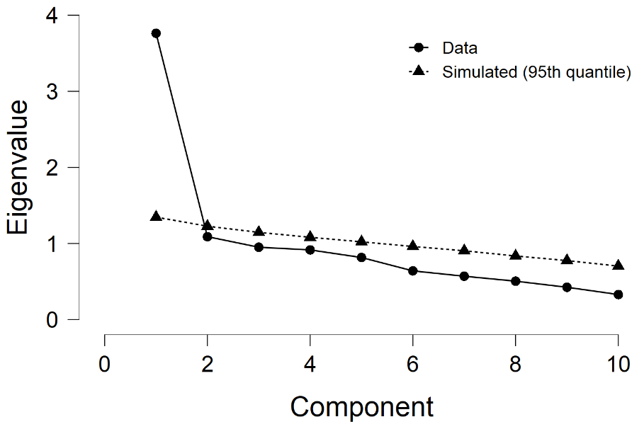
Figure S1. SWASH scree plot

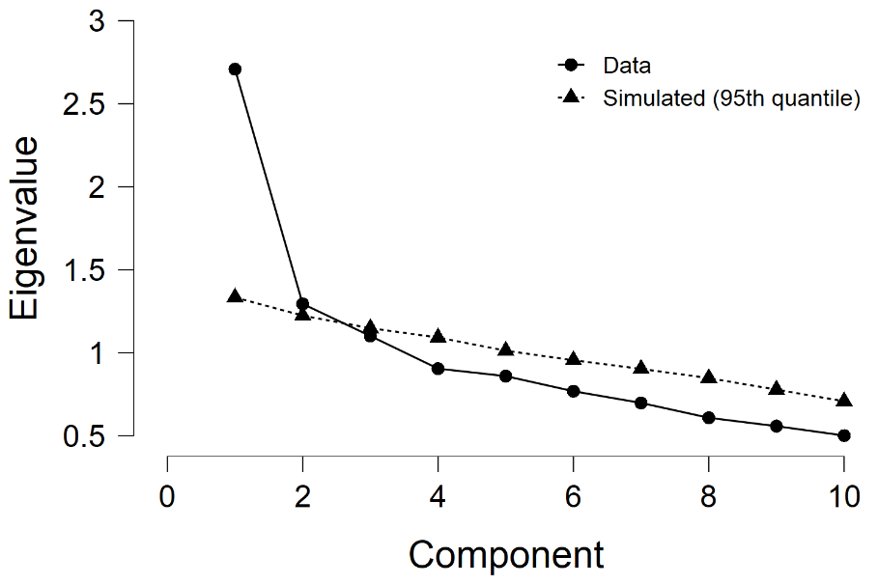
Figure S2. PCS scree plot

References
Woody, E. Z., & Barnier, A. J. (2008). Hypnosis scales for the twenty-first century: What do we need and how should we use them? Oxford University Press. https://doi.org/10.1093/oxfordhb/9780198570097.013.0010

