Appendix A. Stimuli in the present study.
Table A1. Dutch names of pictures per condition. For low name agreement pictures, first and second modal names are given. English translations appear in parentheses.
 | High Name Agreement |  | Low Name Agreement
Animal | dolfijn (dolphin)  vlinder (butterfly)  muis (mouse)  leeuw (lion) |  | varken / big (pig / piglet)  inktvis / octopus (squid / octopus)  gier / aasgier (vulture / Egyptian vulture)  kat / poes (cat / cat)
Body Parts | oor (ear)  neus (nose)  gezicht (face)  skelet (skeleton) |  | been / bovenbeen (leg / thigh)  kies / tand (molar / tooth)  vinger / wijsvinger (finger / index finger)  lippen / mond (lips / mouth)
Clothing | handschoen (glove)  sok (sock)  broek (pants)  masker (mask) |  | trui / hoodie (sweater / hoodie)  blouse / overhemd (blouse / shirt)  schoen / wandelschoen (shoe / hiking boot)  luier / pamper (diaper / pamper)
Tool | kam (comb)  schaar (scissors)  hamer (hammer)  weegschaal (weighing scale) |  | kwast / penseel (brush / paintbrush)  mes / zakmes (knife / pocket knife)  hengel / vishengel (rod / fishing rod)  tuinslang / slang (garden hose / hose)

Appendix B. Results for the analyses without the first row.
Table B1. Results of Bayesian mixed-effect models for all dependent variables calculated from the onset of naming the fifth picture.
 |  | Estimate | Est.error | 95% CI |  | Effective samples
 |  |  |  | lower | upper
Accuracy
Population-level effects | Intercept | 2.499 | 0.202 | 2.124 | 2.915 | 3733
 | Name Agreement | -0.306 | 0.206 | -0.718 | 0.099 | 10900
 | Semantic Context | -0.243 | 0.207 | -0.658 | 0.16 | 10714
 | NA × SC | 0.344 | 0.418 | -0.503 | 1.168 | 11416
Group-level effects | Participant_sd(Intercept) | 0.981 | 0.172 | 0.691 | 1.363 | 3744
 | Item_sd(Intercept) | 0.425 | 0.15 | 0.106 | 0.72 | 2874
Log-transformed utterance duration
Population-level effects | Intercept | 8.94 | 0.031 | 8.876 | 9 | 699
 | Name Agreement | -0.047 | 0.016 | -0.079 | -0.015 | 2655
 | Semantic Context | 0.038 | 0.016 | 0.006 | 0.071 | 2338
 | NA × SC | 0.021 | 0.032 | -0.042 | 0.083 | 2379
Group-level effects | Participant_sd(Intercept) | 0.182 | 0.023 | 0.143 | 0.233 | 1271
 | Item_sd(Intercept) | 0.051 | 0.007 | 0.04 | 0.066 | 2995
Log-transformed total pause time
Population-level effects | Intercept | 7.264 | 0.116 | 7.038 | 7.494 | 1176
 | Name Agreement | -0.211 | 0.076 | -0.359 | -0.062 | 5363
 | Semantic Context | 0.17 | 0.075 | 0.023 | 0.318 | 5468
 | NA × SC | -0.068 | 0.147 | -0.36 | 0.22 | 5188
Group-level effects | Participant_sd(Intercept) | 0.678 | 0.086 | 0.532 | 0.868 | 1933
 | Item_sd(Intercept) | 0.187 | 0.041 | 0.109 | 0.271 | 4212
Total chunk number
Population-level effects | Intercept | 1.38 | 0.068 | 1.242 | 1.511 | 1211
 | Name Agreement | -0.124 | 0.033 | -0.191 | -0.059 | 11383
 | Semantic Context | 0.07 | 0.034 | 0.003 | 0.136 | 10980
 | NA × SC | 0.052 | 0.066 | -0.079 | 0.183 | 11505
Group-level effects | Participant_sd(Intercept) | 0.407 | 0.05 | 0.321 | 0.518 | 2497
 | Item_sd(Intercept) | 0.078 | 0.019 | 0.043 | 0.117 | 4487
Note. The model for log-transformed utterance duration was run for 6000 iterations, and models for other dependent variables were run for 4000 iterations. Bolded values indicate effects where the 95% Cr.I does not contain zero. NA refers to name agreement, SC refers to semantic context.

Table B2. Bayes factors for all dependent variables calculated from the onset of naming the fifth picture.
 | NA effect | SC effect | Null Interaction
Accuracy | 1.48 | 0.97 | 0.66
Log-transformed utterance duration | 5.51 | 1.29 | 5.07
Log-transformed total pause time | 3.53 | 1.02 | 6.03
Total chunk number | 7.42 | 0.10 | 33.81
Note. NA refers to name agreement, SC refers to semantic context. Bolded values indicate at least moderate evidence in favour of the effects (BF > 3); Italicized values indicate moderate evidence against the effects (BF < 1/3); Regular values indicate only weak evidence in favour of or against the effects (1/3 < BF < 3).

Appendix C. Results of post-hoc power analyses on time measures calculated from the onset of naming the fifth picture.
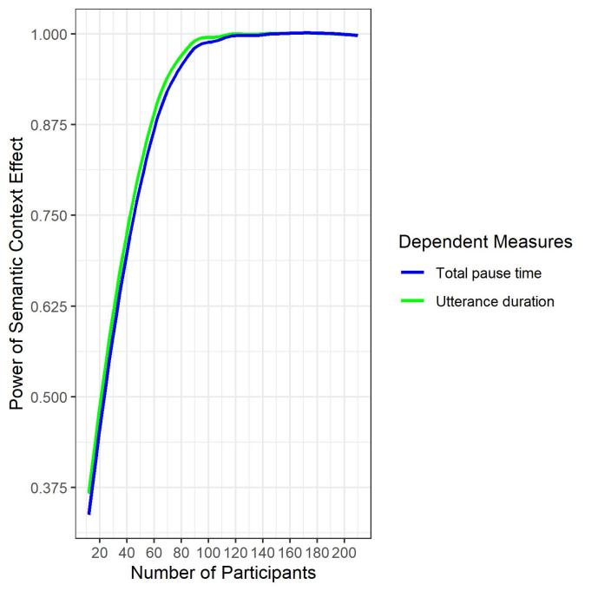
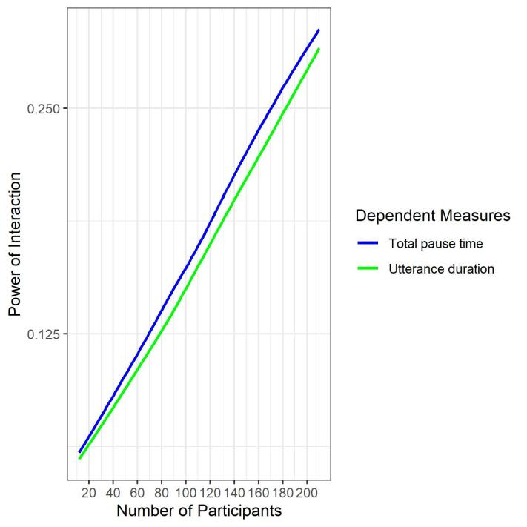

Figure C1. Results of post-hoc power analyses for the semantic context effects (left) and the interaction between name agreement and semantic context (right) on time measures calculated from the onset of naming the fifth picture.

