Appendix A
Hypotheses
We expected the sample mean of participants’ self-reported Agreeableness would be significantly higher than the mean perceived Agreeableness rating for targets.
Power Analyses
For our comparisons between self and target ratings on the IPIP-NEO-120, we conducted a power analysis for our matched samples t-test using an alpha of .01 (two-tailed) and an effect size of .207. The effect size was arrived at using the average of the SDs across facets as the group SDs (i.e., .90), a small correlation between groups (i.e., .01), and a difference of .25 on the five-point IPIP scale (i.e., 2.75 vs 3.0). Under these parameters, with 397 participants, we have 93.7% to detect an effect size of 2.07 or larger.
Similarity Analyses
Overall, the average self-report profile was dissimilar to the average target profile (r_{ICC} = -.68; Supplemental Table 1). Compared to participants’ self-reports, participants rated targets (i.e., “assholes”) lower on Agreeableness (d = -2.22), Conscientiousness (d = -1.13), and Openness (d = -.96), and higher on Neuroticism (d = .49). Large effects (|d| > .80; Cohen, 1988) were observed for 13 facets (~43%). Compared to participant self-ratings, targets were rated as being relatively high on the Neuroticism facet Anger (d = 1.30) and relatively low (ds = -.82 to -1.93) on Dutifulness (C), Altruism (A), Cooperation (A), Sympathy (A), Morality (A), Modesty (A), Artistic Interests (O), Cautiousness (C), Intellect (O), Self-Efficacy (C), Trust (A), and Achievement-Striving (C). Participants’ self-reports and their ratings of targets did not significantly differ on domain scores for Extraversion, and effects for its facets were small to medium in size (|d| = .28 to .70). Effect sizes for differences between participants’ self-reports and their ratings of targets are presented graphically in Supplemental Figure 1.

Supplemental Table 1
Five Factor Model Personality Profiles of Participant Self-Reports and “Asshole” Targets
Variable | Participant |  | Target (Asshole)
 | M | SD | M | SD | d (95% CI)
Neuroticism | 2.62 | 0.86 | 3.15 | 0.59 | 0.49 (0.38, 0.59)
Anxiety | 3.09 | 1.18 | 2.98 | 1.01 | -0.07 (-0.17, 0.03)
Anger | 2.51 | 1.09 | 4.34 | 0.83 | 1.30 (1.17, 1.44)
Depression | 2.40 | 1.23 | 2.54 | 0.99 | 0.08 (-0.02, 0.18)
Self-Consciousness | 2.73 | 1.01 | 2.25 | 0.82 | -0.34 (-0.45, -0.24)
Immoderation | 2.67 | 1.01 | 3.44 | 0.85 | 0.57 (0.48, 0.68)
Vulnerability | 2.30 | 0.94 | 3.34 | 0.90 | 0.76 (0.65, 0.88)
Extraversion | 3.09 | 0.76 | 3.21 | 0.68 | 0.12 (0.02, 0.21)
Friendliness | 3.29 | 1.12 | 2.82 | 1.07 | -0.28 (-0.38, -0.17)
Gregariousness | 2.31 | 1.13 | 3.48 | 1.11 | 0.70 (0.59, 0.83)
Assertiveness | 3.09 | 1.09 | 3.82 | 0.98 | 0.45 (0.34, 0.55)
Activity Level | 3.41 | 0.90 | 3.00 | 0.95 | -0.29 (-0.40, -0.19)
Excitement-Seeking | 2.92 | 0.88 | 3.41 | 0.93 | 0.38 (0.28, 0.49)
Cheerfulness | 3.51 | 0.88 | 2.75 | 0.85 | -0.63 (-0.75, -0.52)
Openness to Experience | 3.53 | 0.56 | 2.75 | 0.54 | -0.97 (-1.08, -0.85)
Imagination | 3.66 | 0.89 | 2.76 | 0.91 | -0.69 (-0.82, -0.58)
Artistic Interests | 3.96 | 0.86 | 2.47 | 0.87 | -1.21 (-1.36, -1.09)
Emotionality | 3.36 | 0.99 | 3.51 | 0.97 | 0.11 (0.01, 0.21)
Adventurousness | 2.86 | 0.94 | 2.45 | 0.89 | -0.30 (-0.41, -0.20)
Intellect | 3.98 | 0.95 | 2.56 | 1.04 | -0.98 (-1.10, -0.87)
Liberalism | 3.36 | 1.19 | 2.75 | 0.93 | -0.40 (-0.50, -0.31)
Agreeableness | 3.83 | 0.57 | 1.95 | 0.54 | -2.24 (-2.51, -2.04)
Trust | 3.28 | 1.02 | 2.19 | 0.88 | -0.84 (-0.97, -0.72)
Morality | 3.98 | 0.80 | 2.10 | 0.84 | -1.58 (-1.75, -1.41)
Altruism | 4.12 | 0.72 | 2.00 | 0.78 | -1.90 (-2.11, -1.70)
Cooperation | 4.18 | 0.81 | 1.86 | 0.80 | -1.85 (-2.08, -1.66)
Modesty | 3.50 | 0.95 | 1.60 | 0.71 | -1.52 (-1.68, -1.39)
Sympathy | 3.91 | 0.86 | 1.93 | 0.80 | -1.63 (-1.83, -1.44)
Conscientiousness | 3.92 | 0.66 | 2.66 | 0.76 | -1.13 (-1.26, -1.02)
Self-Efficacy | 4.02 | 0.79 | 2.85 | 1.02 | -0.88 (-1.01, -0.77)
Orderliness | 3.81 | 0.99 | 2.83 | 1.10 | -0.59 (-0.71, -0.49)
Dutifulness | 4.33 | 0.61 | 2.12 | 0.86 | -1.94 (-2.15, -1.76)
Achievement Striving | 3.94 | 0.81 | 2.88 | 0.97 | -0.82 (-0.94, -0.71)
Self-Discipline | 3.49 | 1.15 | 3.02 | 1.08 | -0.28 (-0.37, -0.18)
Cautiousness | 3.91 | 0.97 | 2.23 | 1.00 | -1.17 (-1.31, -1.04)
Note. Target ratings were provided by the nominating participants. Domain-level scores are presented for completeness and do not contribute to FFM profiles for the purpose of similarity analyses. Bolded ds are significant at p < .01. Bootstrapped confidence intervals calculated using ‘cohens_d’ from rstatix (v0.7.0; Kassambara, 2021). All ratings were made on a scale from 1 (Disagree Strongly) to 5 (Agree Strongly).

Supplemental Figure 1

Differences between Self-Reports and Ratings of “Asshole” Targets on the Five Factor Model of Personality
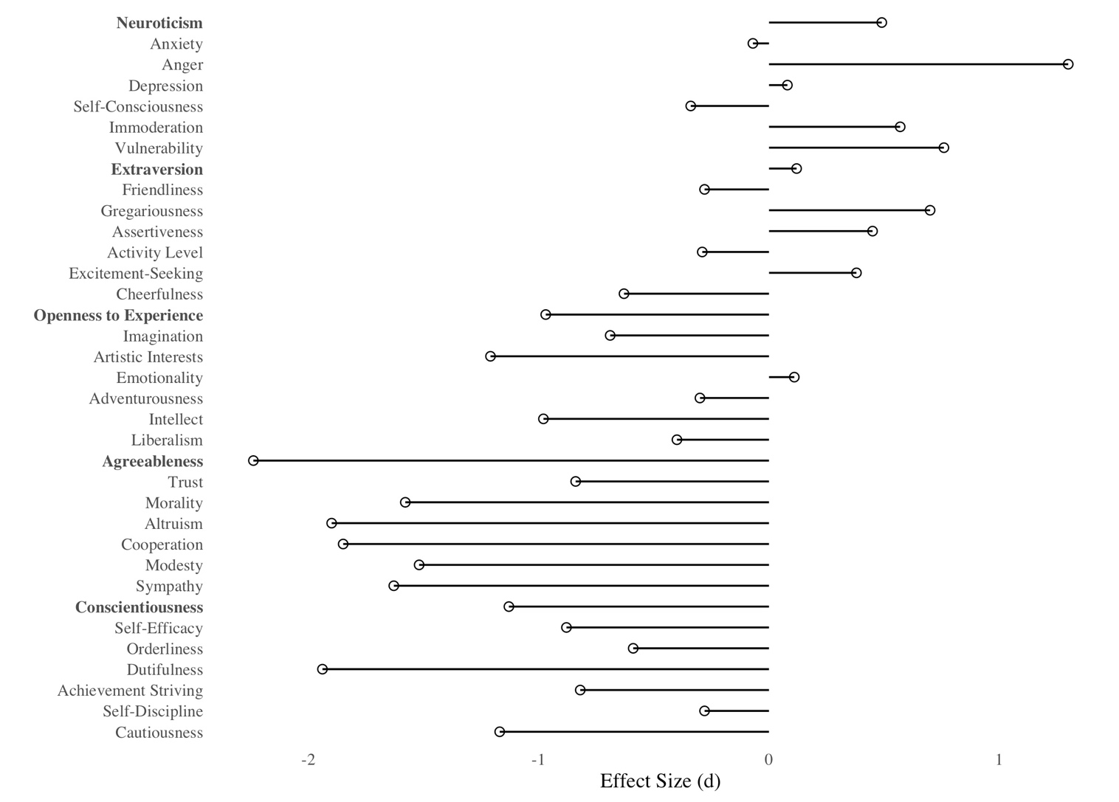
Note. Positive values of d reflect a higher rating for targets. Target ratings were provided by the nominating participants.

References
Kassambara, A. (2021). rstatix: Pipe-friendly framework for basic statistical tests (Version
0.7.0) [R package].

Appendix B

Please read the following descriptions of traits. For each listed behavior, select the trait and pole (low versus high) which is most strongly expressed by that behavior. If a listed behavior does not fit into any of the below categories, please mark “X” in the Cannot Rate column.
Neuroticism (N):
Individuals who are high on Neuroticism experience negative emotions more regularly and intensely (e.g., fear, sadness, embarrassment, anger, guilt). They also are self-conscious in social situations and sensitive to criticism.
Individuals who are low on Neuroticism are calm (even in stressful situations), even tempered, and relaxed.
Extraversion (E):
Individuals who are high on Extraversion are outgoing and prefer large groups and social situations. These individuals are assertive, active, and talkative, happier and more optimistic than others, and show a preference for exiting and stimulating activities.
Individuals who are low on Extraversion are quieter and more reserved in social situations and show a preference for independent or solitary activities. They also have less need for excitement or novel situations and are less likely to experience strong positive emotions (e.g., joy).
Openness to Experience (O):
Individuals who are high on Openness to Experience are curious and willing to consider new, unconventional ideas and values. They also are imaginative and prefer variety to routine.
Individuals who are low on Openness to Experience prefer familiarity and traditional ideas, values, and behaviors. They also tend to be socially and politically conservative.
Agreeableness (A):
Individuals who are high on Agreeableness tend to be sympathetic to others, willing to help others in need, and believe that others are generally honest and well-intentioned. They are also sincere, humble, and compliant with authority.
Individuals who are low on Agreeableness are arrogant, self-centered, and distrustful of others. They also view others through a competitive rather than cooperative lens in social situations. They are also more aggressive, willing to manipulate others for their benefit, and believe that they are superior to others.
Conscientiousness (C):
Individuals who are high on Conscientiousness are be reliable, ambitious, hardworking, and punctual. They are also cautious, stick to the rules and fulfill obligations, and consider possible consequences before acting.
Individuals who are low on Conscientiousness are carefree, impulsive, less organized, and are more likely to act quickly with less concern for possible consequences. They are also less reliable, less concerned with achieving substantial work/school success, and prone to procrastination.

