Evaluations of action and inaction decision-makers in risky decisions resulting in negative outcomes: Inaction agents are preferred to and perceived as more competent and normative than action agents

Supplementary

Contents
Supplementary 1
Open Science disclosures 2
Procedure and data disclosures 2
Data collection 2
Conditions reporting 2
Data exclusions 2
Variables reporting 2
Power-analysis 3
Study 1a 3
Study 1b 3
Study 2 3
Tables 4
Figures 8
One-way ANOVA Study 2 17
One-Way ANOVA 17
Post Hoc Tests 17
Reference 21

Open Science disclosures

Procedure and data disclosures

Data collection
Data collection was completed before analyzing the data.

Conditions reporting
All collected conditions are reported.

Data exclusions
Details are reported in the materials section of this document

Variables reporting
All variables collected for this study are reported and included in the provided data.

Power-analysis

Study 1a
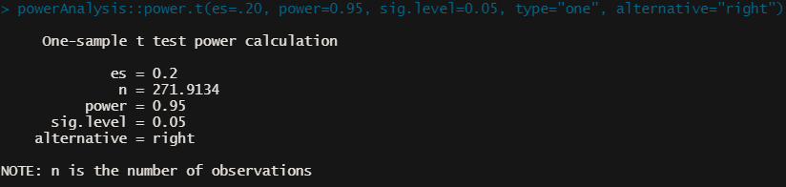

Study 1b
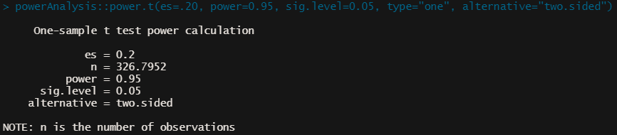

Study 2
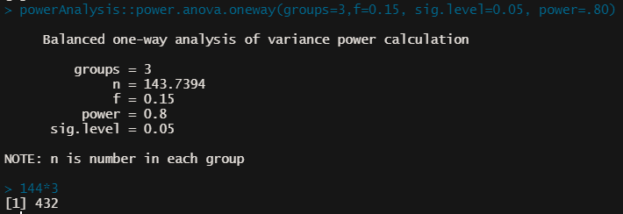

Tables

Table S1
Studies 1a/1b: Summary of one-sample t-tests
Variable | t | df | p | d | 95% CI
Study 1a (n = 339)
Preference | -7.73 | 255 | <.001 | -0.48 | [-0.61, -0.35]
Competence | -4.51 | 273 | <.001 | -0.27 | [-0.39, -0.15]
Normative | -4.26 | 270 | <.001 | -0.26 | [-0.38, -0.14]
Regret | 12.71 | 263 | <.001 | 0.78 | [0.64, 0.92]
Study 1b (n = 339)
Preference | -6.29 | 338 | <.001 | -0.34 | [-0.45, -0.23]
Competence | -4.00 | 338 | <.001 | -0.22 | [-0.33, -0.11]
Normative | -5.16 | 338 | <.001 | -0.28 | [-0.39, -0.17]
Regret | 14.01 | 338 | <.001 | 0.76 | [0.64, 0.88]
Note. t = one sample t-test against M = 0, df = degree of freedom, all ps <.001, d = Cohen’s d,
95% CI = 95% confidence interval around Cohen’s d.

Table S2
Study 2: Summary of one-sample t-tests
Variable | t | df | p | d | 95% CI
Preference | -3.91 | 455 | <.001 | -0.18 | [-0.28, -0.09]
Competence | -4.33 | 453 | <.001 | -0.20 | [-0.30, -0.11]
Descriptive norms | 1.21 | 455 | .23 | 0.06 | [-0.04, 0.15]
Injunctive norms | 6.13 | 455 | <.001 | 0.29 | [0.19, 0.38]
Regret | 16.71 | 456 | <.001 | 0.78 | [0.68, 0.89]
Joy | 4.45 | 454 | <.001 | 0.21 | [0.12, 0.30]
Note. t = one sample t-test against M = 0, df = degree of freedom, all ps <.001, d = Cohen’s d,
95% CI = 95% confidence interval around Cohen’s d.

Table S3
Study 2: Correlations table
Variables | Preference |  | Competence |  | Descriptive norms |  | Injunctive norms |  | Regret |  | Joy
 | r | p | r | p | r | p | r | p | r | p | r | p
Preference |  |  | .44 [.35, .50] | <.001 | .03 [-.07, .14] | .49 | -.34 [-.42, -.26] | <.001 | -.27 [-.35, -.18] | <.001 | .07 [-.03, .17] | .12
Competence |  |  |  |  | .15 [.06, .25] | .001 | -.28 [-.37, -.20] | <.001 | -.19 [-.28, -.09] | <.001 | .01 [-.09, .12] | .63
Descriptive  norms |  |  |  |  |  |  | -.25 [-.33, -.16] | < .001 | -.11 [-.21, -.01] | 0.02 | .06 [-.05, .16] | .28
Injunctive  norms |  |  |  |  |  |  |  |  | .24 [.16, .33] | <.001 | -.15 [-.24, -.05] | .004
Regret |  |  |  |  |  |  |  |  |  |  | .00 [-.10, .11] | .97
Joy
Note. N = 460. r = Pearson’s correlation. All measures were between -5 (Paul, Inaction) and +5 (George, Action). Values in brackets represent 95% interval confidence for Pearson’s r.

Table S4
Study 2: Experimental design
IV: No prior  (control / replication)  Paul and George are two financial advisors.  In the past, Paul invested his client's money in stocks in Company A and  George invested his client's money in Company B. | IV: Negative prior outcomes  Paul and George are two financial advisors.  In the past, Paul invested his client's money in stocks in Company A, and these investments usually lost money for the clients.  George invested his client's money in Company B, and these investments usually lost money for the clients. | IV: Positive prior  Paul and George are two financial advisors.  In the past, Paul invested his client's money in stocks in Company A, and these investments were usually profitable for the clients.  George invested his client's money in Company B, and these investments were usually profitable for the clients.
Manipulation check
"To what extent do you expect Paul and George to change their investment behavior in the future?
(-5 = definitely not changed their behavior, 5 = definitely changed their behavior)."

Scenario
Paul has continued to invest his client’s money in stocks in company A. During the past year he considered switching to stock in company B, but he decided against it. He now finds out that his client would have been better off by £1.2 million if he had switched to the stock of company B.

George has not continued to invest his client’s money in stocks in company B. During the past year he switched to stock in company A. He now finds out that his client would have been better off by £1.2 million if he had kept his stock in Company B.
Dependent variables
Orders presentation were randomized.
Scale: -5 = Definitely Paul who decided not to switch; 5 Definitely George who decided to switch.

Preference
Which advisor – Paul or George – would you prefer to hire in the future?
Competence
Which advisor – Paul or George – is more competent?
Descriptive norms
Whose behavior – Paul’s or George’s – is more common among financial advisors?
Injunctive norms
Whose behavior – Paul’s or George’s – will be more criticized among financial advisors?
Regret
Which advisor – Paul or George – regrets their decision more?
Joy
Which advisor – Paul or George - would have been likely to experience more joy if things had gone well?

Figures

Figure S1
Study 1a: Distribution plots
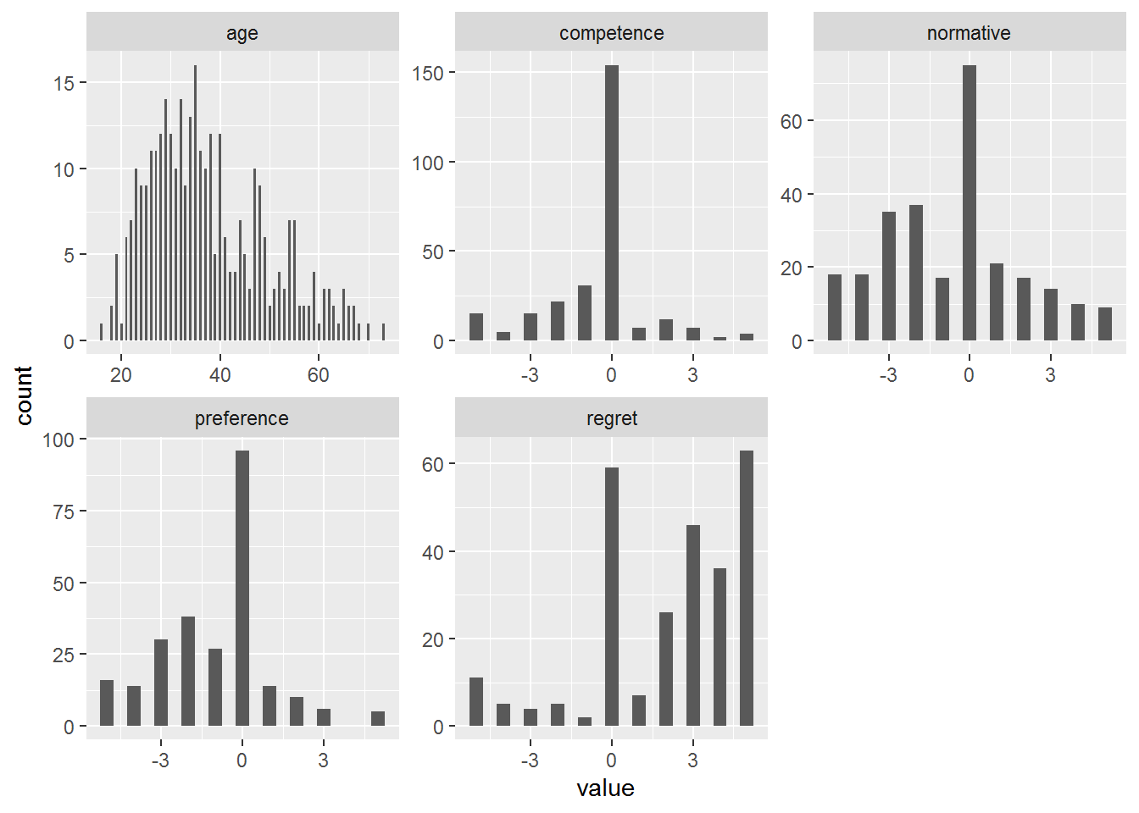

Figure S2
Study 1b: descriptives
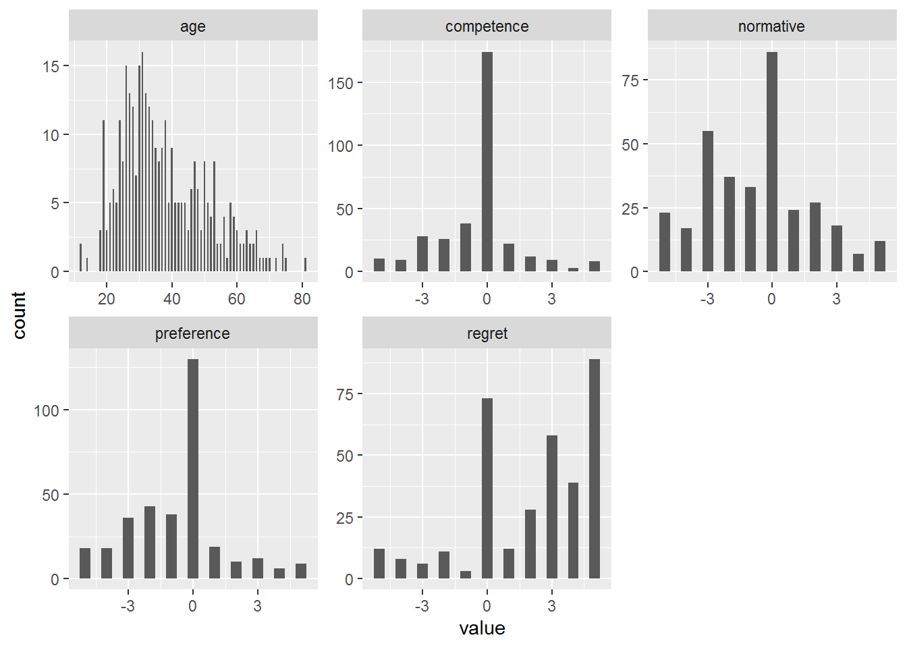

Figure S3
Study 2 descriptives
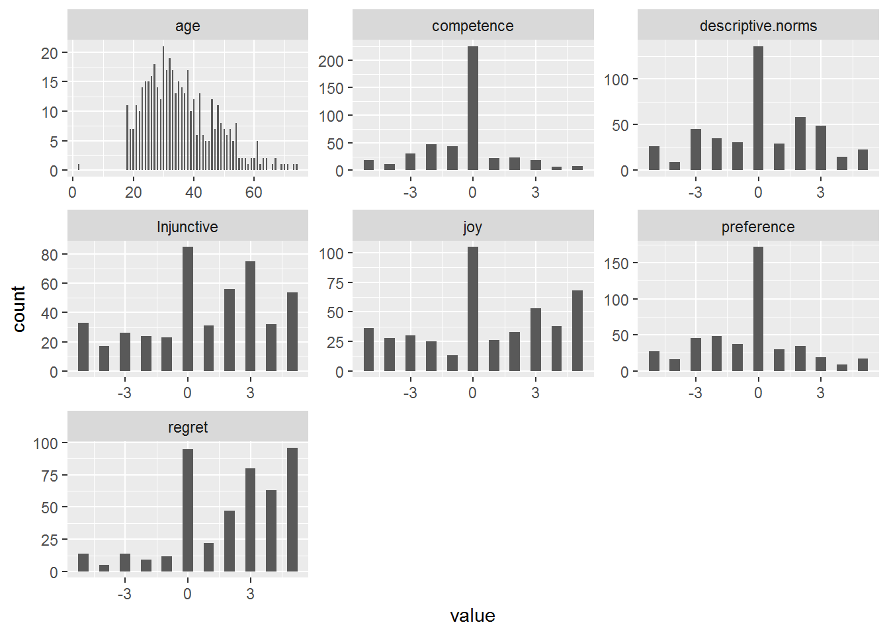

Figure S4
Study 1a: Correlations
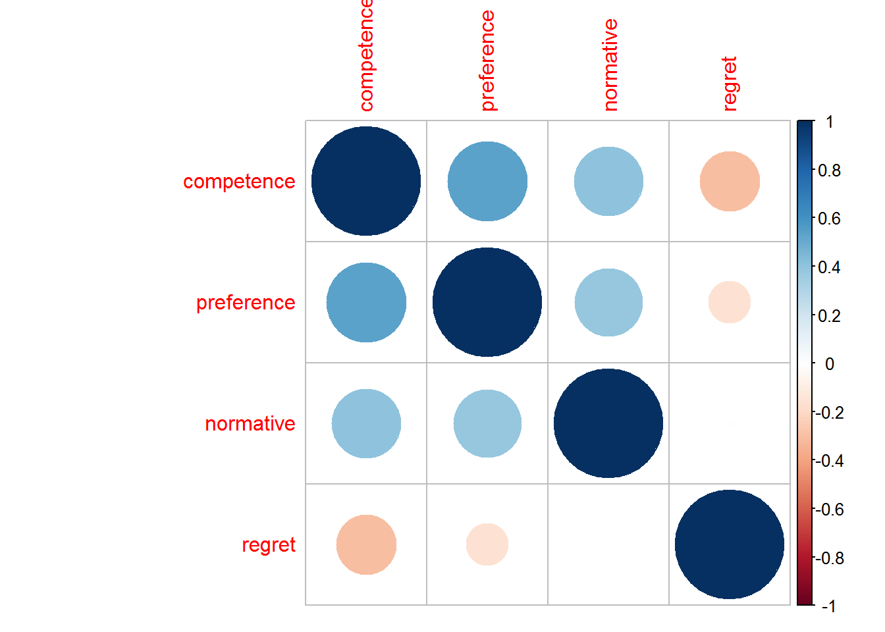

Figure S5
Study 1a: Correlations
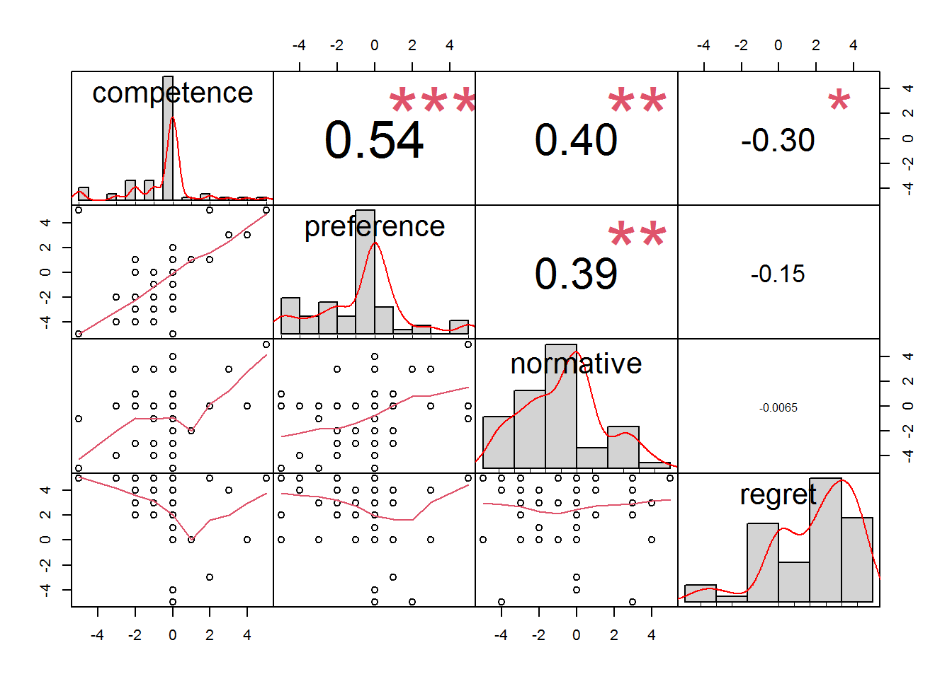

Figure S6
Study 1b: Correlations
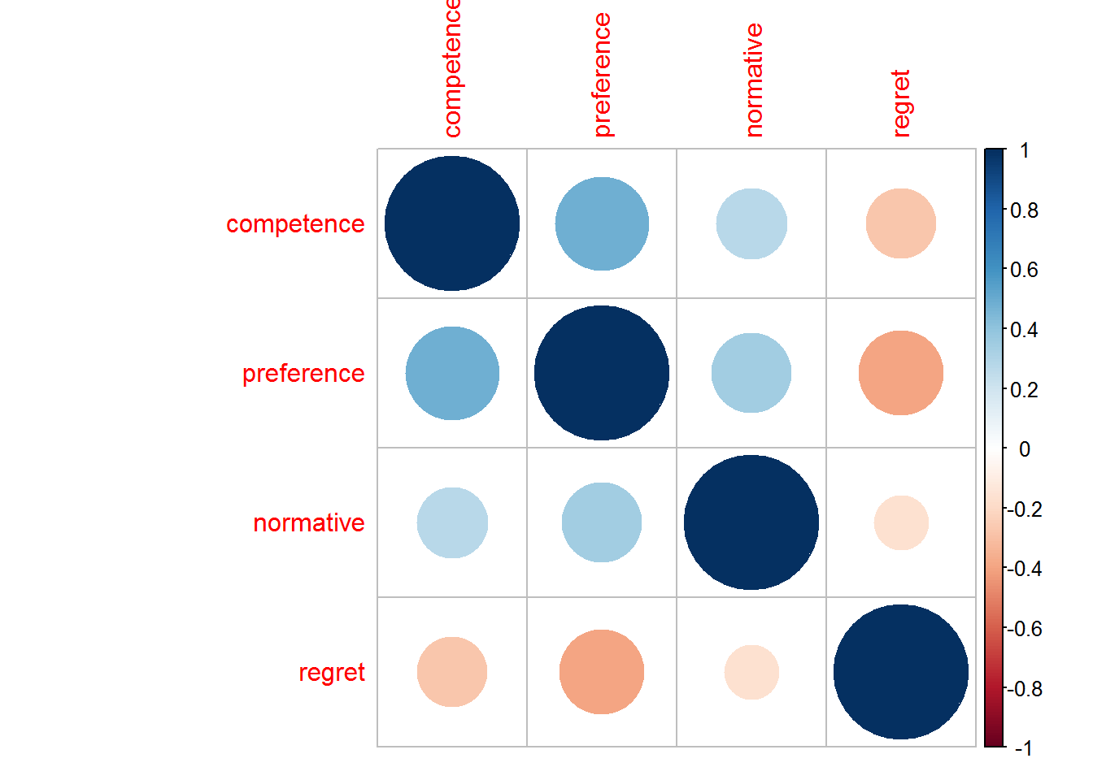

Figure S7
Study 1b: Correlations
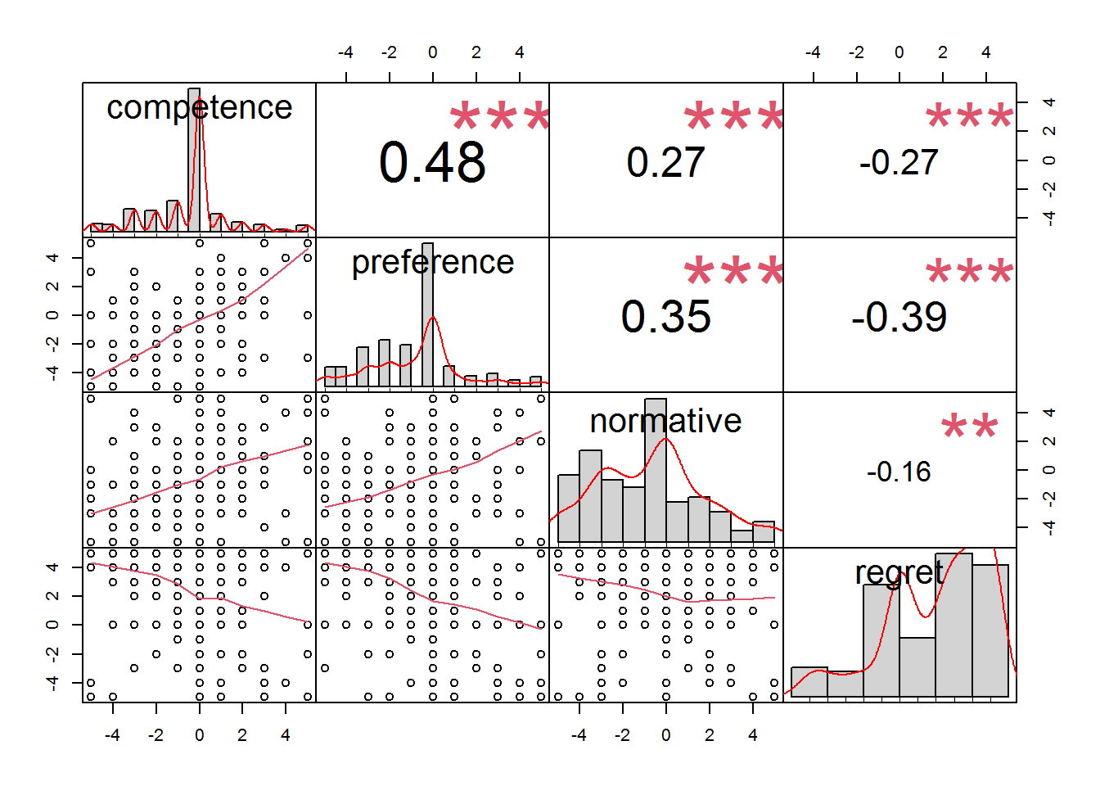

Figure S8
Study 2: Correlations
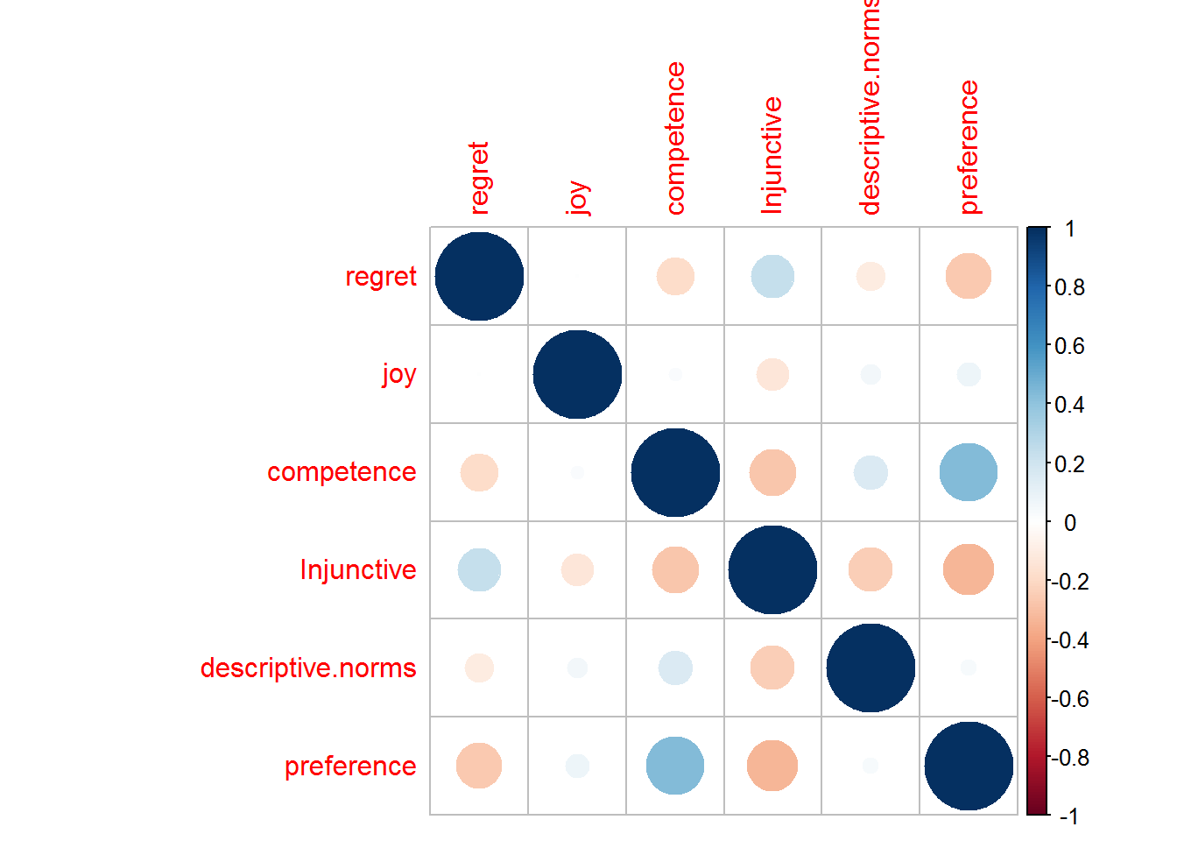

Figure S9
Study 2: Correlations
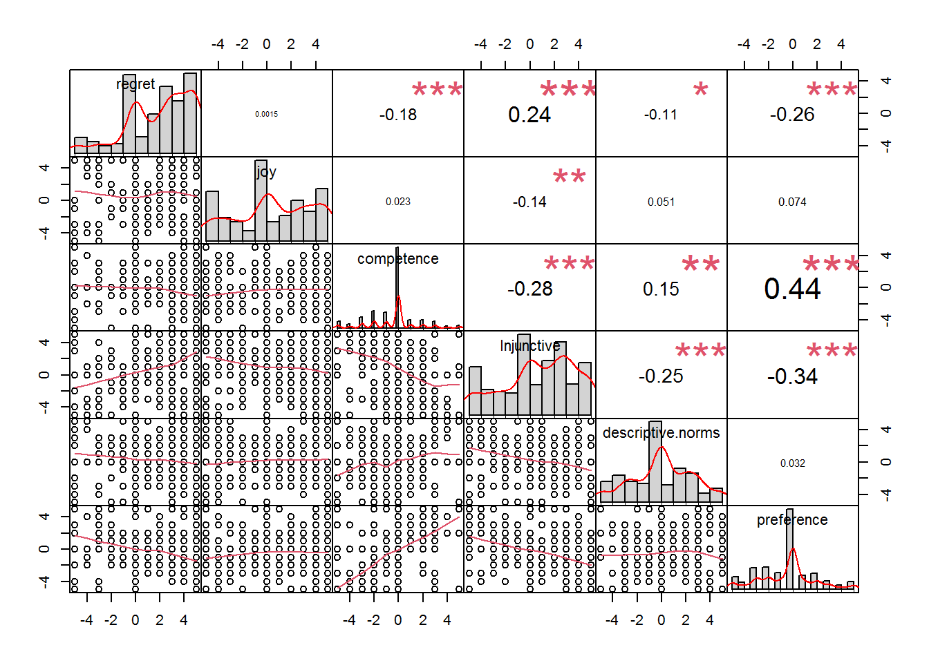

One-way ANOVA Study 2
The ANOVA revealed a difference between the three priors for preference, a difference between control + positive priors vs. negative prior for competence and injunctive norms, and no differences for descriptive norms, regret and joy.

One-Way ANOVA
One-Way ANOVA (Fisher's)
 |  | F |  | df1 |  | df2 |  | p
Preference |  | 24.245 |  | 2 |  | 450 |  | < .001
Competence |  | 17.608 |  | 2 |  | 448 |  | < .001
Descriptive norms |  | 0.476 |  | 2 |  | 450 |  | 0.621
Injunctive norms |  | 17.547 |  | 2 |  | 450 |  | < .001
Regret |  | 1.799 |  | 2 |  | 451 |  | 0.167
Joy |  | 2.115 |  | 2 |  | 449 |  | 0.122

Post Hoc Tests
Tukey Post-Hoc Test – preference
 |  |  |  | 1 |  | 2 |  | 3
1 |  | Mean difference |  | — |  | 0.762 | ** | -0.957 | ***
 |  | t-value |  | — |  | 3.04 |  | -3.74
 |  | df |  | — |  | 450 |  | 450
 |  | p-value |  | — |  | 0.007 |  | < .001
2 |  | Mean difference |  |  |  | — |  | -1.719 | ***
 |  | t-value |  |  |  | — |  | -6.96
 |  | df |  |  |  | — |  | 450
 |  | p-value |  |  |  | — |  | < .001
3 |  | Mean difference |  |  |  |  |  | —
 |  | t-value |  |  |  |  |  | —
 |  | df |  |  |  |  |  | —
 |  | p-value |  |  |  |  |  | —
Note. * p < .05, ** p < .01, *** p < .001

Tukey Post-Hoc Test – competence
 |  |  |  | 1 |  | 2 |  | 3
1 |  | Mean difference |  | — |  | 0.309 |  | -0.888 | ***
 |  | t-value |  | — |  | 1.46 |  | -4.12
 |  | df |  | — |  | 448 |  | 448
 |  | p-value |  | — |  | 0.309 |  | < .001
2 |  | Mean difference |  |  |  | — |  | -1.197 | ***
 |  | t-value |  |  |  | — |  | -5.76
 |  | df |  |  |  | — |  | 448
 |  | p-value |  |  |  | — |  | < .001
3 |  | Mean difference |  |  |  |  |  | —
 |  | t-value |  |  |  |  |  | —
 |  | df |  |  |  |  |  | —
 |  | p-value |  |  |  |  |  | —
Note. * p < .05, ** p < .01, *** p < .001

Tukey Post-Hoc Test – descriptive norms
 |  |  |  | 1 |  | 2 |  | 3
1 |  | Mean difference |  | — |  | 0.270 |  | 0.2185
 |  | t-value |  | — |  | 0.931 |  | 0.737
 |  | df |  | — |  | 450 |  | 450
 |  | p-value |  | — |  | 0.621 |  | 0.741
2 |  | Mean difference |  |  |  | — |  | -0.0516
 |  | t-value |  |  |  | — |  | -0.181
 |  | df |  |  |  | — |  | 450
 |  | p-value |  |  |  | — |  | 0.982
3 |  | Mean difference |  |  |  |  |  | —
 |  | t-value |  |  |  |  |  | —
 |  | df |  |  |  |  |  | —
 |  | p-value |  |  |  |  |  | —
Note. * p < .05, ** p < .01, *** p < .001

Tukey Post-Hoc Test – Injunctive
 |  |  |  | 1 |  | 2 |  | 3
1 |  | Mean difference |  | — |  | -0.718 |  | 1.17 | **
 |  | t-value |  | — |  | -2.21 |  | 3.52
 |  | df |  | — |  | 450 |  | 450
 |  | p-value |  | — |  | 0.071 |  | 0.001
2 |  | Mean difference |  |  |  | — |  | 1.89 | ***
 |  | t-value |  |  |  | — |  | 5.89
 |  | df |  |  |  | — |  | 450
 |  | p-value |  |  |  | — |  | < .001
3 |  | Mean difference |  |  |  |  |  | —
 |  | t-value |  |  |  |  |  | —
 |  | df |  |  |  |  |  | —
 |  | p-value |  |  |  |  |  | —
Note. * p < .05, ** p < .01, *** p < .001

Tukey Post-Hoc Test – regret
 |  |  |  | 1 |  | 2 |  | 3
1 |  | Mean difference |  | — |  | -0.279 |  | 0.276
 |  | t-value |  | — |  | -0.940 |  | 0.913
 |  | df |  | — |  | 451 |  | 451
 |  | p-value |  | — |  | 0.615 |  | 0.632
2 |  | Mean difference |  |  |  | — |  | 0.555
 |  | t-value |  |  |  | — |  | 1.896
 |  | df |  |  |  | — |  | 451
 |  | p-value |  |  |  | — |  | 0.141
3 |  | Mean difference |  |  |  |  |  | —
 |  | t-value |  |  |  |  |  | —
 |  | df |  |  |  |  |  | —
 |  | p-value |  |  |  |  |  | —
Note. * p < .05, ** p < .01, *** p < .001

Tukey Post-Hoc Test – joy
 |  |  |  | 1 |  | 2 |  | 3
1 |  | Mean difference |  | — |  | -0.0101 |  | -0.651
 |  | t-value |  | — |  | -0.0280 |  | -1.76
 |  | df |  | — |  | 449 |  | 449
 |  | p-value |  | — |  | 1.000 |  | 0.183
2 |  | Mean difference |  |  |  | — |  | -0.641
 |  | t-value |  |  |  | — |  | -1.80
 |  | df |  |  |  | — |  | 449
 |  | p-value |  |  |  | — |  | 0.170
3 |  | Mean difference |  |  |  |  |  | —
 |  | t-value |  |  |  |  |  | —
 |  | df |  |  |  |  |  | —
 |  | p-value |  |  |  |  |  | —
Note. * p < .05, ** p < .01, *** p < .001

Reference
Achim Zeileis and Gabor Grothendieck (2005). zoo: S3 Infrastructure for Regular and Irregular Time Series. Journal of Statistical Software, 14(6), 1-27. doi:10.18637/jss.v014.i06
Brian G. Peterson and Peter Carl (2020). PerformanceAnalytics: Econometric Tools for Performance and Risk Analysis. R package version 2.0.4. https://CRAN.R-project.org/package=PerformanceAnalytics
Frank E Harrell Jr, with contributions from Charles Dupont and many others. (2021). Hmisc: Harrell Miscellaneous. R package version 4.5-0. https://CRAN.R-project.org/package=Hmisc
H. Wickham. ggplot2: Elegant Graphics for Data Analysis. Springer-Verlag New York, 2016.
Hadley Wickham (2019). stringr: Simple, Consistent Wrappers for Common String Operations. R package version 1.4.0. https://CRAN.R-project.org/package=stringr
Hadley Wickham (2021). forcats: Tools for Working with Categorical Variables (Factors). R package version 0.5.1. https://CRAN.R-project.org/package=forcats
Hadley Wickham (2021). tidyr: Tidy Messy Data. R package version 1.1.3. https://CRAN.R-project.org/package=tidyr
Hadley Wickham and Jim Hester (2020). readr: Read Rectangular Text Data. R package version 1.4.0. https://CRAN.R-project.org/package=readr
Hadley Wickham, Romain François, Lionel Henry and Kirill Müller (2021). dplyr: A Grammar of Data Manipulation. R package version 1.0.6. https://CRAN.R-project.org/package=dplyr
Jeffrey A. Ryan and Joshua M. Ulrich (2020). xts: eXtensible Time Series. R package version 0.12.1. https://CRAN.R-project.org/package=xts
Kirill Müller and Hadley Wickham (2021). tibble: Simple Data Frames. R package version 3.1.2. https://CRAN.R-project.org/package=tibble
Lionel Henry and Hadley Wickham (2020). purrr: Functional Programming Tools. R package version 0.3.4. https://CRAN.R-project.org/package=purrr
Long JA (2020). _jtools: Analysis and Presentation of Social Scientific Data_. Rpackage version 2.1.0, <URL: https://cran.r-project.org/package=jtools>.
Makowski, D., Ben-Shachar, M.S., Patil, I. & Lüdecke, D. (2020). Automated Results Reporting as a Practical Tool to Improve Reproducibility and Methodological Best Practices Adoption. CRAN. Available from https://github.com/easystats/report. doi: .
Max Kuhn, Simon Jackson and Jorge Cimentada (2020). corrr: Correlations in R. R package version 0.4.3. https://CRAN.R-project.org/package=corrr
Olivoto, T., and Lúcio, A.D. (2020). metan: an R package for multi-environment trial analysis. Methods Ecol Evol. 11:783-789 doi:10.1111/2041-210X.13384
Patil, I. (2018). Visualizations with statistical details: The 'ggstatsplot' approach. PsyArxiv. doi:10.31234/osf.io/p7mku
R Core Team (2020). R: A language and environment for statistical computing. R Foundation for Statistical Computing, Vienna, Austria. URL https://www.R-project.org/.
Revelle, W. (2020) psych: Procedures for Personality and Psychological Research, Northwestern University, Evanston, Illinois, USA, https://CRAN.R-project.org/package=psych Version = 2.1.3,.
Sarkar, Deepayan (2008) Lattice: Multivariate Data Visualization with R. Springer, New York. ISBN 978-0-387-75968-5
Taiyun Wei and Viliam Simko (2021). R package "corrplot": Visualization of a Correlation Matrix (Version 0.89). Available from https://github.com/taiyun/corrplot
Therneau T (2021). _A Package for Survival Analysis in R_. R package version 3.2-11,<URL: https://CRAN.R-project.org/package=survival>.
Wickham et al., (2019). Welcome to the tidyverse. Journal of Open Source Software, 4(43), 1686, https://doi.org/10.21105/joss.01686
Zeileis A, Croissant Y (2010). “Extended Model Formulas in R: Multiple Parts andMultiple Responses.” _Journal of Statistical Software_, *34*(1), 1-13. doi:10.18637/jss.v034.i01 (URL: https://doi.org/10.18637/jss.v034.i01).

