**Supplemental Material**



**Figure S1. Time series of the particle chemistry from the ACSM compared with the SMPS volume concentration.** Major non-refractory components of particles smaller 700 nm vacuum aerodynamic diameter at Alert for March to May, 2011: organic component (green dots); sulphate components (red dots); nitrate components (blue dots). The black line is the volume concentration of particles with mobility diameters smaller than 500 nm.

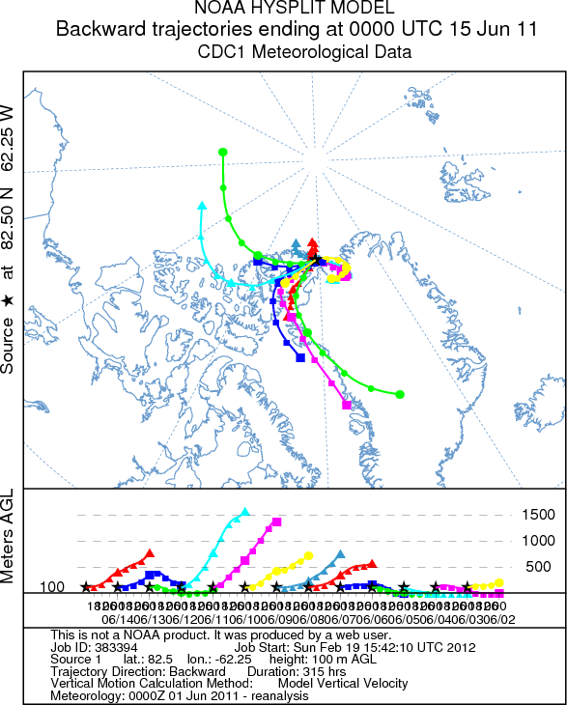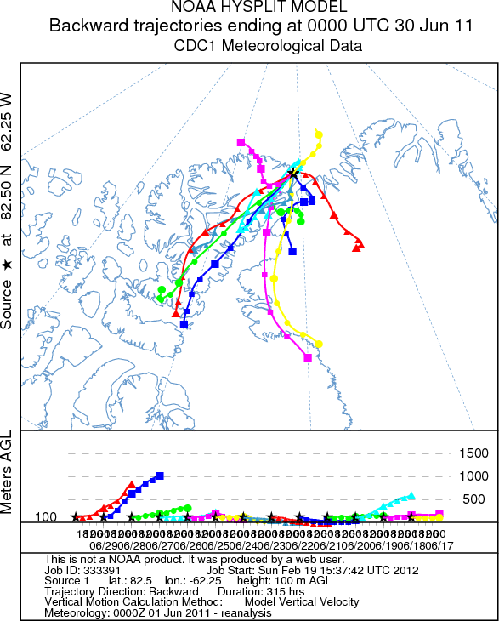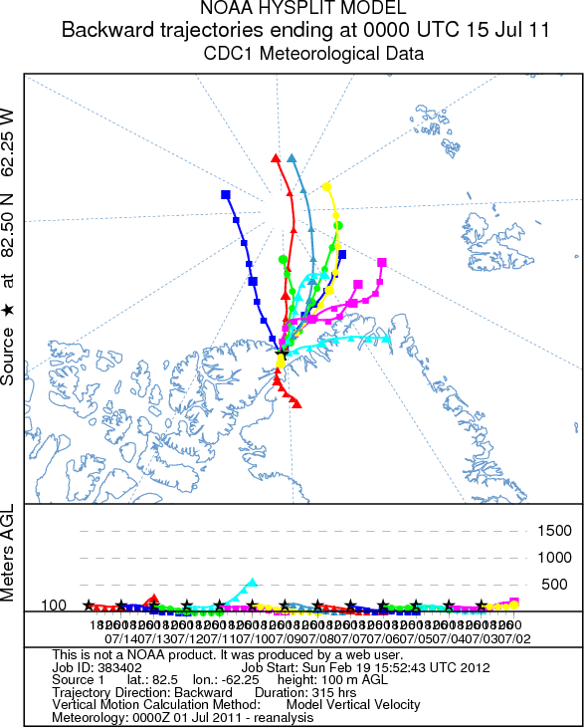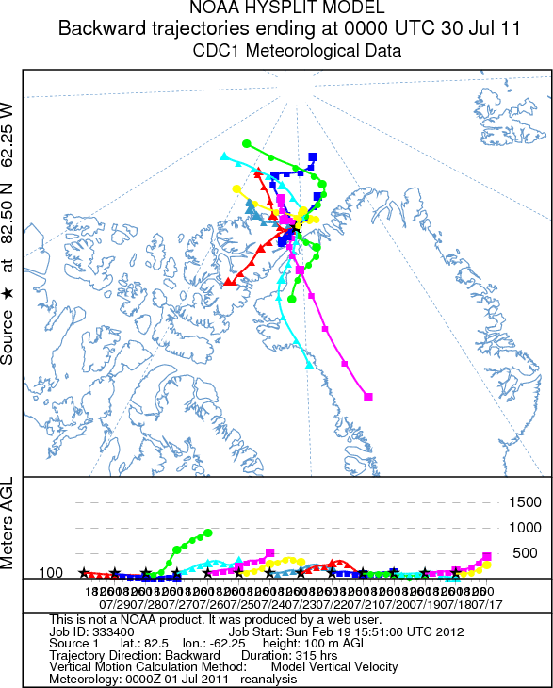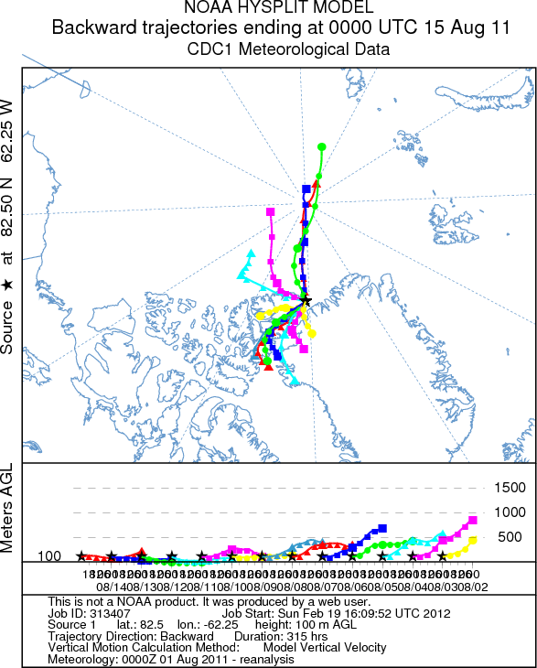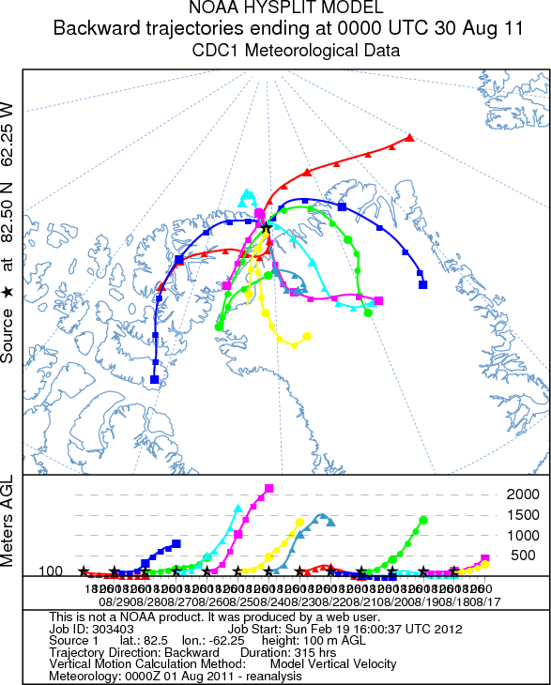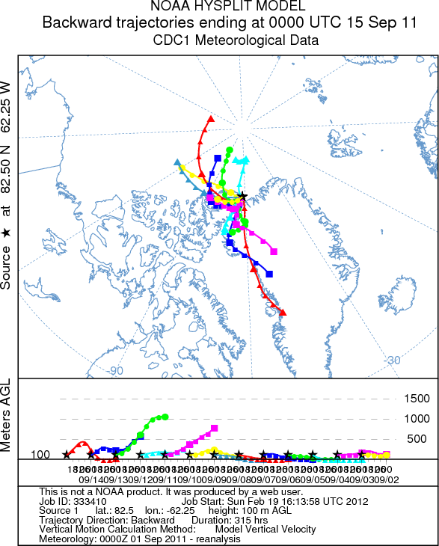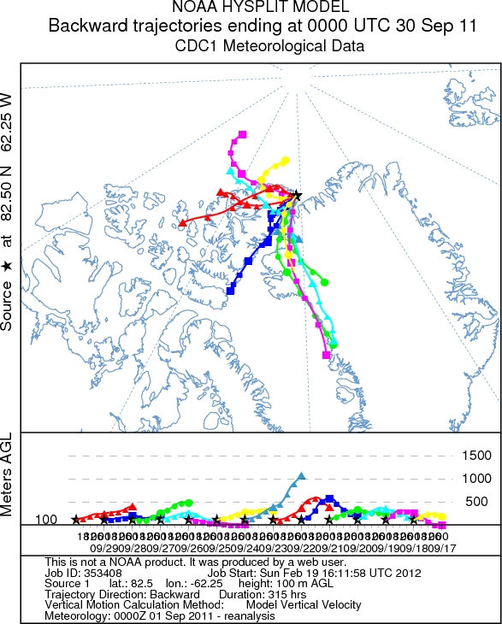

**Figure S2. Daily back trajectories air parcels arriving at Alert during June, July, August and September, 2011 from the NOAA Hysplit model.**