Supplementary Materials
The impact of oyster aquaculture on the estuarine carbonate system

Catherine M. Liberti^{1*}, Matthew W. Gray², Lawrence M. Mayer¹, Jeremy M. Testa³, Wei Liu³, and Damian C. Brady¹
¹ University of Maine School of Marine Sciences, Darling Marine Center, Walpole, ME 04573
² University of Maryland Center for Environmental Science Horn Point Laboratory, Cambridge, MD 21601
³ University of Maryland Center for Environmental Science, Chesapeake Biological Laboratory, Solomons, MD 20688
*Kate.Liberti@maine.edu
List of Contents:
Text S1. Description of hydrodynamic model used to compute residence time for GA.
Figure S1. Map of model domain and mesh.
Model grid and bathymetry for Mid-coast Maine (a). The red box shows the location of Damariscotta River estuary. Bathymetry for Damariscotta River estuary (b). Red dots show the location of the upper and middle Damariscotta Land Ocean Biogeochemical Observatories. Red bars indicate two cross-section locations.
Figure S2. Net ecosystem metabolism calculated for the DRE GA.
Net ecosystem metabolism calculated from the hourly dissolved oxygen measurements from the LOBO buoy in the GA. Measurements were detided to account for advection using the methods from Beck et al. (2015). The growing area is slightly night heterotrophic over the growing season: –3.7 mmol O₂ m^{–2} day^{–1}.

Text S1. Description of hydrodynamic model used to compute residence time for growing area.
We utilized the unstructured-grid Finite Volume Coastal Ocean Model (FVCOM) to develop a realistic three-dimensional hydrodynamic model for the mid-coast of Maine (Figure S1). The three-dimensional velocity and salinity field and sea level data from the FVCOM model were used for calculating residence time based on an isohaline framework that was first introduced by MacCready (2011). FVCOM has the advantage of more accurately following complicated coastlines by using unstructured triangular elements (Chen et al., 2003; Chen et al., 2004b). Huang et al. (2008) demonstrated that FVCOM provides overall a second-order spatial accuracy for the vertically averaged equations (i.e., external mode), and with increasing grid resolution the model-computed solutions show a fast convergence toward the analytic solutions regardless of the particular triangulation method. FVCOM has also taken advantage of new developments in computational fluid dynamics in resolving flow problems containing discontinuities. Thus, this model is capable of simulating hydrodynamics on a fine resolution mesh to resolve small-scale flows inside the fringing estuaries such as Damariscotta River estuary and simulate large-scale flows such as coastal currents in the Gulf of Maine.

The model domain (Figure S1a) covers a wide shelf area and six major estuaries including the Kennebec River, Androscoggin River, Sheepscot River, Damariscotta River, Medomak River, and St George River. The model has 165,637 mesh points, 322,565 triangular elements and 21 sigma levels in the vertical direction. The southern open boundary extends to Jordan Basin in the Gulf of Maine with the maximum depth of around 140 m. The range of latitude in the model is roughly from 43.5 to 44°N while the longitude varies from 69 to 70°W. The unstructured mesh allows for high spatial resolution of about 10 m in the estuaries.
We chose 2014 as our base simulation due to the availability of forcing conditions at the boundary. The open boundary conditions come from the Northeast Coastal Ocean Forecast System (NECOFS) Gulf of Maine FVCOM model (Chen et al., 2011; Li et al., 2017). The model is forced with offshore tides from NECOFS and river discharge from the six major estuaries including Damariscotta River. Discharge data were obtained from USGS stations in the Androscoggin, Kennebec, and Sheepscot Rivers. Discharge for ungaged systems, such as the Damariscotta, Medomak, and St. George rivers, were obtained using USGS StreamStats. In general, all six rivers show a seasonal variation of river runoff with the peaks in winter and early spring and the lowest flow in the late summer-early fall. In 2014, seven relatively large rain events dominate the hydrograph. However, river discharge for the Damariscotta River estuary is relatively small ranging from 2 to 20 m³ s^{–1}. The oyster aquaculture industry has generally targeted small watersheds with limited freshwater flow. A glacially sculpted catchment system gives Maine a large number of small coastal watersheds. Hydrodynamics in the Damariscotta River Estuary is essentially dominated by tidal transport. The FVCOM model output includes hourly data for sea level, temperature, salinity, and current velocity. Other than occasional heavy rain events, these five years of deployment demonstrate a remarkably consistent pattern in current speed and direction which was used to validate this FVCOM implementation.
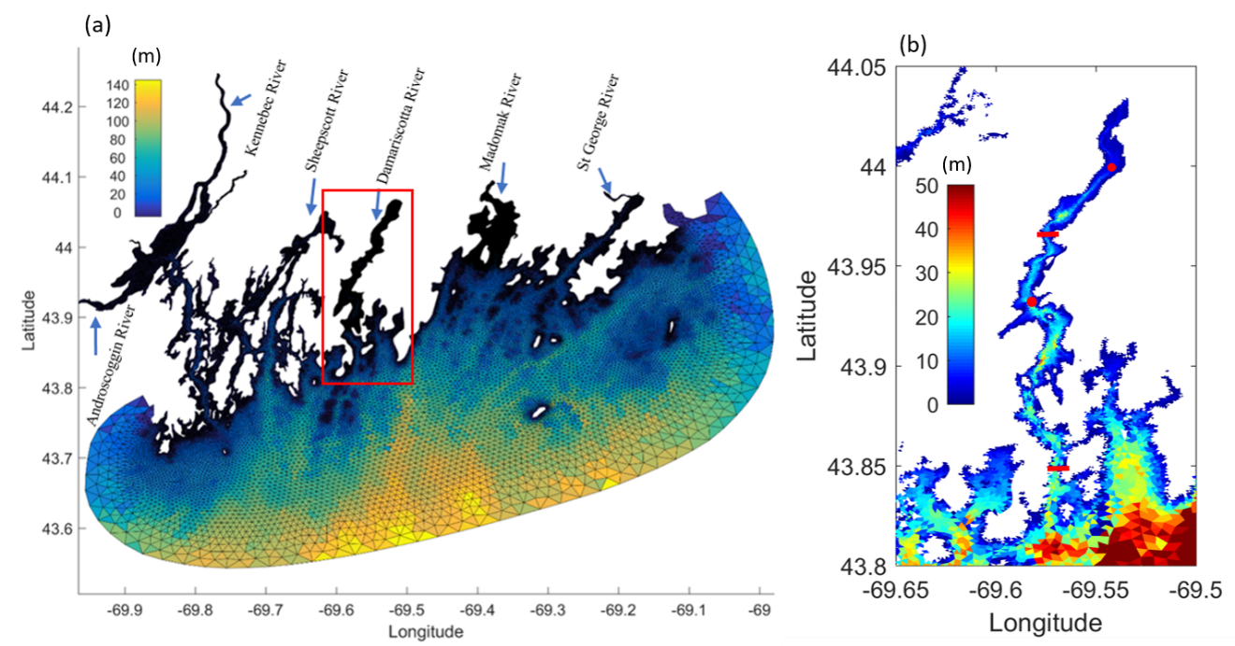
Figure S1. Map of model domain and mesh.
Model grid and bathymetry for Mid-coast Maine (a). The red box shows the location of Damariscotta River Estuary, depicted larger to the right (b). Red dots show the location of the upper and middle Damariscotta Land Ocean Biogeochemical Observatories; the upper location is the source of environmental data for the carbonate model. Red bars indicate two cross-section locations.
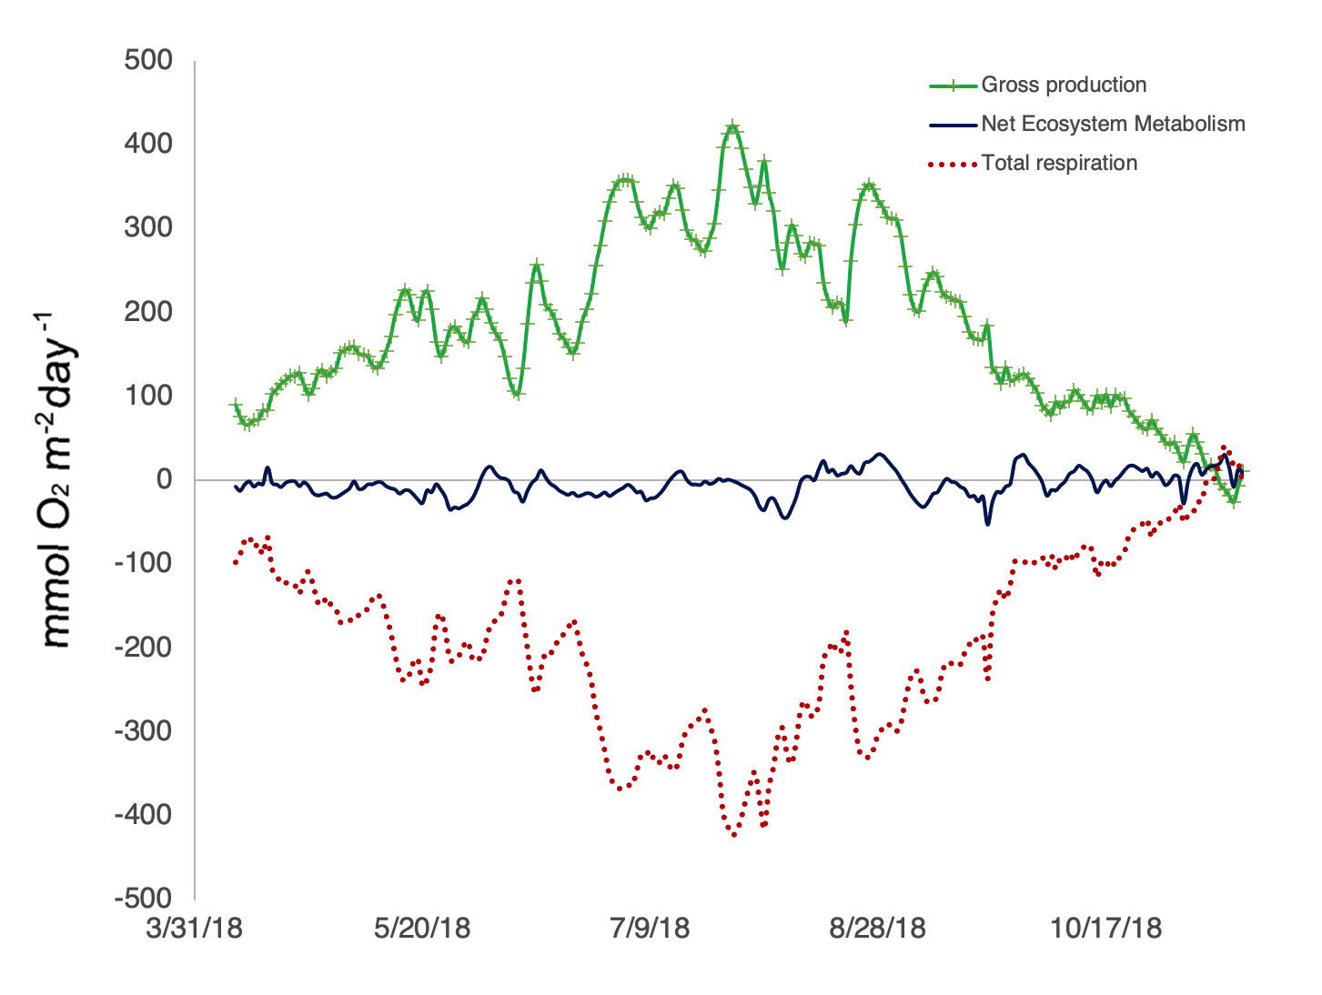
Figure S2. Net ecosystem metabolism calculated for the Damariscotta River Estuary growing area.
Net ecosystem metabolism calculated from the hourly dissolved oxygen measurements from the LOBO buoy in the growing area. Measurements were detided to account for advection using the methods from Beck et al. (2015). The growing area is slightly night heterotrophic over the growing season: averaging –3.7 mmol O₂ m^{–2} day^{–1}.
Beck, MW, Hagy, JD, Murrell, MC. 2015. Improving estimates of ecosystem metabolism by reducing effects of tidal advection on dissolved oxygen time series. Limnology Oceanography Methods 13(12): 731–745. doi: 10.1002/lom3.10062
Chen, C, Cowles, G, Beardsley, RC. 2004. An unstructured grid, finite-volume coastal ocean 694 model: FVCOM User Manual. SMAST/UMASSD. Report No.: 04–0601.
Chen, C, Huang, H, Beardsley, RC, Xu, Q, Limeburner, R, Cowles, GW, Sun, Y, Qi, J, Lin, H. 2011. Tidal dynamics in the Gulf of Maine and New England Shelf: An application of FVCOM. Journal of Geophysical Research Oceans 116(C12). doi: 10.1029/2011JC007054
Chen, C, Liu, H, Beardsley, RC. 2003. An unstructured grid, finite-volume, three-dimensional, primitive equations ocean model: application to coastal ocean and estuaries. Journal of Atmospheric Ocean Technology 20(1): 159–186.
Huang, H, Chen, C, Cowles, GW, Winant, CD, Beardsley, RC, Hedstrom, KS, Haidvogel, DB. 2008. FVCOM validation experiments: Comparisons with ROMS for three idealized barotropic test problems. Journal of Geophysical Research Oceans 113(C7). doi: 10.1029/2007JC004557
Li, B, Tanaka, KR, Chen, Y, Brady, DC, Thomas, AC. 2017. Assessing the quality of bottom water temperatures from the Finite-Volume Community Ocean Model (FVCOM) in the Northwest Atlantic Shelf region. Journal of Marine Systems 173: 21–30. doi: 10.1016/j.jmarsys.2017.04.001

