Overview of the MOSAiC expedition – Snow and Sea Ice

Supplemental material

Content of this document

Text S1 Sea ice and snow work and concept
Text S2 Methods and field setup details
Sea ice coring
Remotely Operated Vehicle (ROV)
On-ice remote sensing
Sea ice drift forecast
Technological challenges
References

S1 Sea ice and snow work and concept
The realization of the field program by the highly interdisciplinary ICE team required an extraordinary amount of coordination and interaction. This effort succeeded and initiated manifold new collaborations and scientific exchange. One of the main challenges was to ensure consistency in methodology and data quality of the individual observations over the year, typically including four to five different principal investigators on board and large teams on land, covering a broad range of expertise and specific questions to the same data set. As a result, the task structure, as described in Section 2, is not fully consistent as it merges topics, instruments and ice types, but was found to be most practical in the organization of the daily work in the field. This structure mostly represents how different groups structured their work (operational principles) and data sets.

During the field phase, the ICE team was represented with 12 (Leg 1), 14 (Leg 2), 11 (Leg 3), 14 (Leg 4), 11 (Leg5) berths on Polarstern and with 9 berths on Akademik Fedorov (Leg 1a). In addition, the ICE team was represented by (co-) cruise leaders on Legs 1 and 2 on board of Polarstern and Leg 1a on Akademik Fedorov. Overall, 66 different persons participated on both ice breakers. Beyond direct participation on board, strong support was given from land before, during and after the field experiment. Overall, approx. 150 people were involved in the snow and sea ice work and contributed in various ways to the planning, design and successful completion of the work program.

A particular preparation phase was based on the broad experience and expertise across the participating researchers. A main process was the agreement on observational protocols for all field tasks and methods prior to the expedition. Additional workshops and training programs for team members were critical components in preparation for the field experiment. Week-long field training courses were held to cross train team members on the full suite of snow and sea ice measurement protocols and to perform dedicated instrument tests. These courses were held in Hailuoto, Finland (February 22 to March 07, 2019) and Utqiagvik, Alaska (April 07 to 13, 2019). More specialized trainings were performed for flight training and system testing (particularly for navigation systems) for the unmanned aerial systems near Longyearbyen in April 2019. Various cross-calibration initiatives were also realized before and after the field phase.

During the drift, the daily work was organized along weekly plans with designated time slots per task. Each team member was assigned specific tasks on each day of the week. The same task was mostly carried out by the same people throughout each leg to maintain the highest possible consistency. The work on board was supported by the task members at home, especially by those who carried out the same measurements on earlier or later legs. Snow and sea ice tasks in the field were often supported by volunteers from the other scientific teams as well as by the logistics team. Intense observation periods or case studies were incorporated into the weekly routine to increase the spatial and/or temporal resolution of existing tasks or to capture certain events. A more detailed definition of events during MOSAiC is under development by the project coordinators. An example of an intense observation period is also discussed in Section 4.2.

Figure S1 shows how the work from the different tasks was distributed over the respective week. In addition to the task work (colored time slots), approximately 1/3 of the time slots were used for data work, basic tasks incl. supplemental observations, additional work without immediate task relation (FLEX time), and free time. The week of July 06, 2020, included an intensive observation period of a 24-hour continuous sampling to capture the diurnal cycle under polar day conditions, complementing a similar study during polar night on Leg 1. The different schedules for both case studies demonstrate the general realization of the work program organized through specific tasks over the entire year. The comparison of these two weeks shows how the weekly plans changed over seasons: additional optical measurements (‘OPTICS’) were carried out under daylight conditions. The rapid changing surface conditions daily snow pit (including surface properties), very frequent ‘TRANSECT’ and additional ‘POND’ work in July. The remote sensing work (‘REMOTE’) was allocated more time in January, for example when a larger suite of instruments was operated on the ice. Different project and process related foci were realized on individual legs like ‘RIDGE’ and ‘POND’ work in summer (Leg 4) or ‘DYNAMICS’ work in winter (Leg 2). The concept of ‘FLEX’ time, time that was not pre-allocated before the respective leg, turned out to be most beneficial and at the same time essential to enable the planned work program. This time allowed reaction on the continuous changes and challenges in the field. Also allocating sufficient time for in-field data documentation and early processing, as well as dedicated time slots for laboratory work were budgeted and needed. Pre-assigned half days off on Sunday mornings, or on other days when applicable, paid off given the long field phases and continuous high workloads.

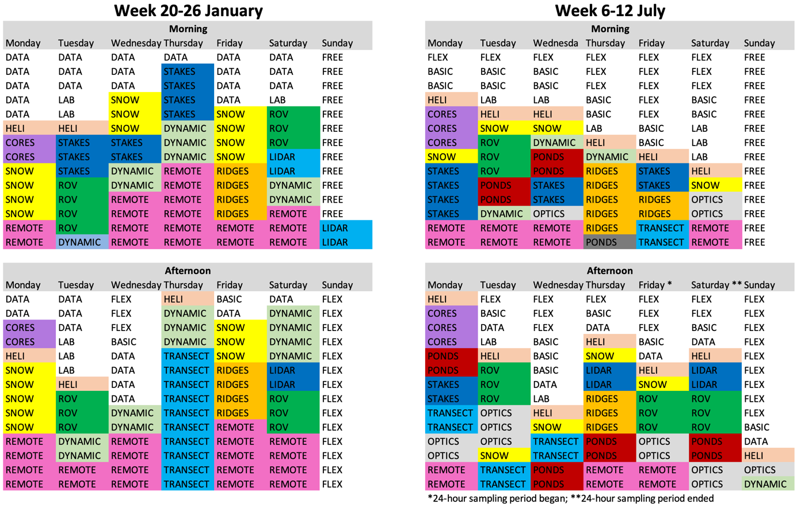
Figure S1: Weekly work plans for snow and sea ice observations.
Schematics from the weeks starting January 20, 2020, (left) and starting July 6, 2020, (right). Each line represents one person. Workdays were split into morning and afternoon blocks. Colors are consistent with the sites in Figure 2. Abbreviations refer to the tasks, as described in Section 2 of the main manuscript, in addition the following terms are used: ‘FLEX’ for flexible tasks, ‘DATA’ for data documentation and processing, ‘BASIC’ for routine work, ‘LAB’ for (freezer) laboratory work.

S2 Methods and field set-up details
The MOSAiC snow and sea ice program was based on a large number of specialized instruments and methods, which are usually referred to in abbreviations or acronyms. In addition, the field work concept included terminology (and abbreviations) that are unknown to many external readers. All these terms are compiled in Table S1 to ease reading of the manuscript. Abbreviations for all remote sensing instruments are given in Table 2 in the main text; here only names mentioned in the text are listed.

Table S1: Instrument names and abbreviations used in the text.
Short name | Full name / description
ALS | Airborne Laser Scanner
ARIEL | Airborne Radiometer in L-band / used on a mobile sled on transects
CO | Central Observatories (existence of CO1 to CO3)
DN | Distributed Network (existence of DN1 and DN2)
EM | Electro Magnetic
EM-Bird | Helicopter-towed electro-magnetic sounding instrument
FYI | First Year (sea) Ice
GEM | EM induction sounding instrument
GNSS (-R) | Global Navigation Satellite System (and Reflectrometry)
HELiPOD | Helicopter-towed atmospheric sensor suite
HUTRAD | Helsinki University of Technology Radiometer / Microwave radiometer at Remote Sensing site
IMB | (Sea) Ice Mass-balance Buoy
IR | Infrared
LIDAR | Light detection and ranging
Micro-CT | X-ray Micro Computer Tomograph
MOSAiC | Multidisciplinary drifting Observatory for the Study of Arctic Climate
NIR | Near Infrared
ROV | Remotely Operated Vehicle
RS | Remote Sensing
SAR | Synthetic Aperture Radar
SCAT | Scatterometer
SMP | Snow Micro Pen
SSL | Surface Scattering Layer
SYI | Second Year (sea) Ice
TIR | Thermal Infrared
TLS | Terrestrial Laser Scanner
UHI | Underwater Hyperspectral Imager

Sea ice coring
Photographs of the conditions at the coring sites from winter and early summer are shown in Figure S2. The sea ice data used to create Figure 15, is given in Tables S2 and S3.

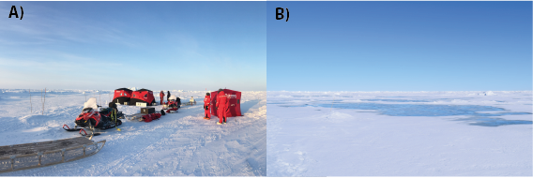
Figure S2: Sea ice coring sites.
Photographs of the coring site during (A) Leg 3 on March 21, 2020, and (B) Leg 4 on June 22, 2020. The photo from the spring Leg 3 also shows the shelters that were temporarily set up for the coring work.

Table S2: Sea ice core data: winter
Salinity (S) and temperature (T) profile for first year (FYI) and second year (SYI) of the 1_10 coring event on December 02, 2019. The upper (z0) and lower (z1) boundary of the salinity section depth, and the depth of temperature measurements (z) are given in m relatively to the ice surface. The graph is shown in Figure 16.

FYI |  |  |  |  | SYI
z₀ | z₁ | S | z | T | z₀ | z₁ | S | z | T
m | m | - | m | °C | m | m | - | m | °C
0.000 | 0.050 | 6.9 | 0.025 | -15.3 | 0.000 | 0.050 | 0.9 | 0.025 | -8.3
0.050 | 0.100 | 5.8 | 0.075 | -13.0 | 0.050 | 0.100 | 0.5 | 0.125 | -7.8
0.100 | 0.150 | 5.9 | 0.175 | -12.0 | 0.100 | 0.150 | 0.9 | 0.225 | -6.5
0.150 | 0.200 | 4.1 | 0.275 | -8.5 | 0.150 | 0.200 | 1.1 | 0.325 | -6.1
0.200 | 0.250 | 3.5 | 0.325 | -7.4 | 0.200 | 0.250 | 1.2 | 0.375 | -6.2
0.250 | 0.310 | 4.8 | 0.375 | -7.1 | 0.250 | 0.290 | 2.4 | 0.425 | -5.8
0.310 | 0.360 | 4.8 | 0.425 | -6.4 | 0.290 | 0.350 | 2.3 | 0.545 | -5.0
0.360 | 0.410 | 4.8 | 0.475 | -5.5 | 0.350 | 0.400 | 3.9 | 0.645 | -4.3
0.410 | 0.455 | 4.5 | 0.525 | -5.3 | 0.400 | 0.450 | 1.7 | 0.745 | -3.3
0.455 | 0.500 | 5.5 | 0.625 | -3.1 | 0.450 | 0.500 | 1.2 | 0.845 | -1.9
0.500 | 0.550 | 4.6 | 0.675 | -2.3 | 0.500 | 0.550 | 3.1 | 0.870 | -1.7
0.550 | 0.600 | 4.7 | 0.695 | -1.9 | 0.550 | 0.600 | 1.6
0.600 | 0.650 | 5.6 |  |  | 0.600 | 0.650 | 1.2
0.650 | 0.705 | 7.9 |  |  | 0.650 | 0.700 | 1.5
 |  |  |  |  | 0.700 | 0.750 | 3.4
 |  |  |  |  | 0.750 | 0.800 | 4.3
 |  |  |  |  | 0.800 | 0.850 | 5.3
 |  |  |  |  | 0.850 | 0.900 | 8.0

Table S3: Sea ice core data: summer
Salinity (S) and temperature (T) profile for first year (FYI) and second year (SYI) of the 4_46 coring event on July 06, 2020. The upper (z0) and lower (z1) boundary of the salinity section depth, and the depth of temperature measurements (z) are given in m relatively to the ice surface. The graph is shown in Figure 16.

FYI |  |  |  |  | SYI
z₀ | z₁ | S | z | T | z₀ | z₁ | S | z | T
m | m | - | m | °C | m | m | - | m | °C
0.000 | 0.050 | 0.2 | 0.025 | -0.1 | 0.000 | 0.050 | 0.2 | 0.025 | 0.1
0.050 | 0.105 | 0.3 | 0.050 | 0.1 | 0.050 | 0.100 | 0.0 | 0.125 | 0.5
0.105 | 0.160 | 0.3 | 0.150 | 0.0 | 0.090 | 0.150 | 0.0 | 0.225 | 0.0
0.160 | 0.210 | 0.8 | 0.250 | -0.1 | 0.140 | 0.200 | 0.1 | 0.325 | 0.0
0.210 | 0.260 | 1.9 | 0.350 | -0.5 | 0.190 | 0.250 | 0.1 | 0.425 | 0.0
0.260 | 0.310 | 2.8 | 0.450 | -0.7 | 0.240 | 0.300 | 0.1 | 0.525 | 0.0
0.310 | 0.360 | 3.3 | 0.550 | -0.6 | 0.290 | 0.350 | 0.1 | 0.625 | 0.0
0.360 | 0.410 | 3.6 | 0.650 | -1.0 | 0.340 | 0.400 | 0.1 | 0.725 | 0.0
0.410 | 0.460 | 3.8 | 0.750 | -1.1 | 0.390 | 0.450 | 0.1 | 0.790 | 0.0
0.460 | 0.510 | 4.3 | 0.850 | -1.2 | 0.440 | 0.500 | 0.1 | 0.850 | 0.0
0.510 | 0.560 | 4.3 | 0.950 | -1.3 | 0.490 | 0.550 | 0.1 | 0.925 | 0.0
0.560 | 0.610 | 4.9 | 1.050 | -1.4 | 0.540 | 0.600 | 0.1 | 1.025 | -0.1
0.610 | 0.660 | 4.1 | 1.150 | -1.1 | 0.590 | 0.650 | 0.1 | 1.100 | 0.0
0.660 | 0.710 | 4.3 | 1.250 | -1.1 | 0.640 | 0.700 | 0.2 | 1.150 | -0.1
0.710 | 0.760 | 4.3 | 1.350 | -0.9 | 0.690 | 0.750 | 0.2 | 1.225 | -0.1
0.760 | 0.810 | 4.3 | 1.450 | -0.7 | 0.740 | 0.800 | 0.4 | 1.325 | -0.3
0.810 | 0.860 | 4.0 | 1.550 | -0.7 | 0.790 | 0.850 | 0.3 | 1.425 | -0.2
0.860 | 0.910 | 4.0 | 1.620 | -0.5 | 0.840 | 0.900 | 0.1 | 1.525 | -0.1
0.910 | 0.960 | 3.8 |  |  | 0.890 | 0.950 | 0.1 | 1.625 | -0.5
0.960 | 1.010 | 3.7 |  |  | 0.940 | 1.000 | 0.2 | 1.725 | -0.9
1.010 | 1.060 | 3.9 |  |  | 0.990 | 1.050 | 0.2 | 1.825 | -1.0
1.060 | 1.110 | 3.5 |  |  | 1.040 | 1.100 | 0.2 | 1.925 | -1.2
1.110 | 1.160 | 3.5 |  |  | 1.090 | 1.150 | 0.2 | 2.025 | -1.4
1.160 | 1.210 | 3.6 |  |  | 1.140 | 1.210 | 0.2 | 2.125 | -1.4
1.210 | 1.260 | 3.5 |  |  | 1.190 | 1.260 | 0.3 | 2.210 | -1.2
1.260 | 1.310 | 3.1 |  |  | 1.240 | 1.310 | 0.2
1.310 | 1.360 | 3.2 |  |  | 1.290 | 1.360 | 1.1
1.360 | 1.410 | 2.9 |  |  | 1.340 | 1.410 | 1.7
1.410 | 1.460 | 3.2 |  |  | 1.390 | 1.460 | 1.0
1.460 | 1.510 | 2.6 |  |  | 1.440 | 1.510 | 2.3
1.510 | 1.545 | 1.6 |  |  | 1.490 | 1.560 | 2.0
1.545 | 1.605 | 2.2 |  |  | 1.540 | 1.610 | 0.2
 |  |  |  |  | 1.590 | 1.660 | 0.5
 |  |  |  |  | 1.640 | 1.710 | 1.1
 |  |  |  |  | 1.690 | 1.760 | 1.3
 |  |  |  |  | 1.750 | 1.810 | 1.3
 |  |  |  |  | 1.800 | 1.860 | 1.4
 |  |  |  |  | 1.850 | 1.910 | 3.3
 |  |  |  |  | 1.900 | 1.960 | 3.2
 |  |  |  |  | 1.950 | 2.010 | 3.4
 |  |  |  |  | 2.000 | 2.060 | 3.3
 |  |  |  |  | 2.050 | 2.110 | 2.9
 |  |  |  |  | 2.100 | 2.160 | 3.1

Remotely operated vehicle (ROV)
The ROV has been operated from different sites due to the dynamic icescape: Site ROV 1.0 was never used for scientific dives, being immediately replaced by ROV 2.0 during Leg 1 (CO1). Site ROV 3.0 was used on CO1 during Legs 2 and 3, sites ROV 4.0 and 4.5 were operated on CO2 during Leg 4, and site ROV 5.0 was operated on CO3 during Leg 5. Figure S3a shows exemplary photographs of the set up (Leg 2 and Leg 5) and maps to illustrate linkages to other measurements during spring.

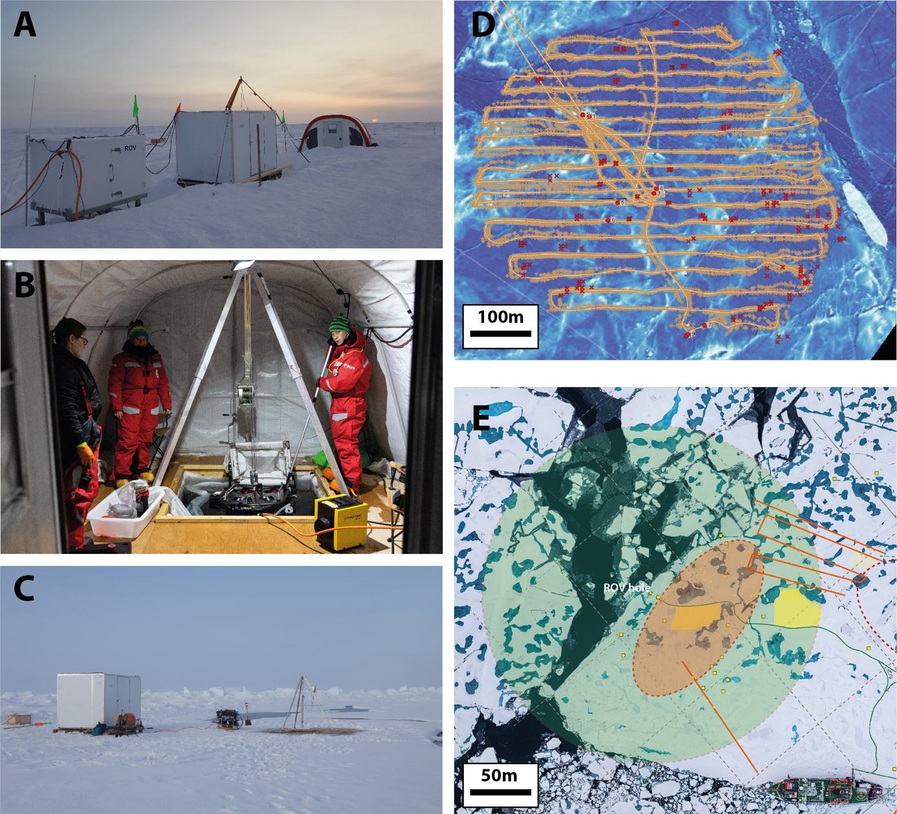
Figure S3: ROV observations.
(A) Remotely operated vehicle (ROV) site consisting of the power hub, the surface unit (white hut), the tent over the hole (photo March 14, 2020), (B) inside the ROV tent (photo December 07, 2019), (C) ROV site consisting of the surface unit and the hole without tent (photo August 25, 2020), (D) dive track (yellow line) and excluded acoustic navigation fixes (red dots) as overlay on the airborne laser scanner topography surface map (dive on February 04, 2020), (E) schematic overview of the ROV dive range (green circle) during autumn (Leg 5, aerial photo from September 06, 2020). Other sites: TLS area in orange ellipse, transects in orange lines, snow and surface studies in yellow patches, other installations and sites as small yellow squares.

On-ice remote sensing
The concept of the on-ice remote sensing measurements was to observe the same snow and sea ice surface, or at least the same surface type, with all instruments. In addition, other manual measurements were co-located on the same site (Figure 2) and ice conditions. Figure S4 shows the arrangement of the individual sensors around the observation site.

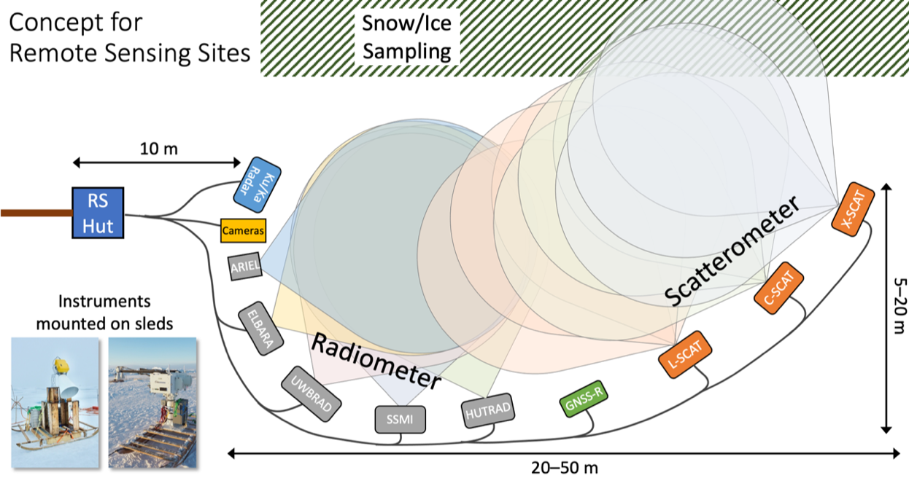
Figure S4: On-ice remote sensing concept.
Conceptual layout used for the Remote Sensing Sites on the MOSAiC ice floe. For comparability all instruments looked at similar ice and snow. Physical ice and snow properties were sampled in the vicinity. Photographs of the Remote Sensing Site are shown in Figure 10. Additional sea ice remote sensing observations were performed from Polarstern.

Sea ice drift forecasts
A near-real-time drift forecast product for the MOSAiC floe was provided by the Year of Polar Prediction (YOPP; Jung et al., 2016) Sea Ice Drift Forecast Experiment (SIDFEx). Several operational forecast centers and institutes contributed drift forecasts in near-real-time for lead times ranging from days to a year. For MOSAiC a consensus ensemble forecast product, based on the different forecast systems, was used. Typically, about five different short-term (7–10 days) single-trajectory forecasts, which in particular use recent wind forecasts for driving the ice drift, and one seasonal, climatological forecast were merged into a seamless ensemble forecast. The consensus forecasts were provided onboard Polarstern through the MapViewer system to support decision making, and on land through an online tool (https://sidfex.polarprediction.net), for placing orders for satellite imagery. Figure S5 exemplifies the consensus forecasts product, showing the forecast issued on February 24, 2020.

Beyond the drift phase, forecast products from fully coupled models were provided on a daily base as well as ensemble predictions of sea ice conditions for the coming months (https://nps.edu/web/rasm/predictions). All these sea ice model applications were most supportive for the highly complex logistical operations of the supply vessels. Advancing the fidelity of different models with the hierarchy will allow for the development of optimized observational networks, as they may be used for sea ice monitoring or advanced field programs in the future.

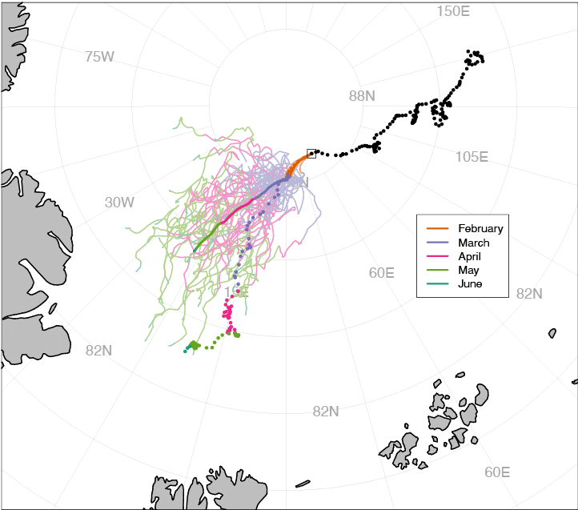
Figure S5: The SIDFEx consensus drift forecast for the MOSAiC central observatory (CO1).
The forecast of the Sea Ice Drift Forecast Experiment (SIDFEx, https://sidfex.polarprediction.net/) starts on February 24, 2020, at 00:00 UTC, when Polarstern was at the given position (grey square). Thin solid lines denote individual (merged) forecast ensemble members and the corresponding thick solid line denotes the ensemble mean (centroid). Lines are colored by calendar month. Dots denote daily observed positions of Polarstern before (black) and after (colored by calendar month) February 24, 2020.

Technological challenges
The year-long operations in the central Arctic resulted in specific (technological and methodological challenges), in particular with respect to automated systems.

Challenges were observed in flying the Mavic and Spectra drones close to the North Pole, where operators needed to apply the manual mode because the compass reading was not correct. However, similar problems were not encountered using the HELiX drone, albeit at lower latitudes. Future studies should consider developing and leveraging advanced navigation systems such as the D-GPS navigation employed by the DataHawk unmanned aerial system deployed to make atmospheric measurements, to avoid the challenges encountered by the Mavic and Spectra copters. In addition to challenges posed by the navigation systems, other factors, including fast ice drift velocities, fog, and icing conditions resulted in a difficult operating environment for drone systems. Despite these challenges, the systems deployed combined to provide unique perspectives on broadband and spectral albedo and their evolution during the melt and refreezing seasons.

Many complex instruments, e.g., most of the remote sensing sensors, were designed for shorter campaigns. Operating them continuously for a full year led to some instrument failures, which only partly could be repaired in the field, and thus led to data gaps or a complete stop of measurements for some channels (Figure 3b). This was partly compensated by the large suite of complementary measurements, but a larger pool of spare parts and more trained personnel could have reduced these downtimes.

References
Jung, T, Gordon, ND, Bauer, P, Bromwich, DH, Chevallier, M, Day, JJ, Dawson, J, Doblas-Reyes, F, Fairall, C, Goessling, HF, Holland, M, Inoue, J, Iversen, T, Klebe, S, Lemke, P, Losch, M, Makshtas, A, Mills, B, Nurmi, P, Perovich, D, Reid, P, Renfrew, IA, Smith, G, Svensson, G, Tolstykh, M, Yang, Q. 2016. Advancing Polar Prediction Capabilities on Daily to Seasonal Time Scales. B Am Meteorol Soc 97(9): 1631-1647. doi:10.1175/bams-d-14-00246.1.

