Supplementary Material

Elementa Science of Anthropocene, 10: 1. DOI: https://doi.org/10.1525/elementa.2021.000111

Methane and ethene emission quantifications from onshore oil and gas sites in Romania, using a tracer gas dispersion method

Antonio Delre ª, Arjan Hensen ^{b}, Ilona Velzeboer ^{b}, Pim van den Bulk ^{b}, Maklawe Essonanawe Edjabou ª, Charlotte Scheutz ª *
ª Department of Environmental Engineering, Technical University of Denmark, Denmark
^{b} Department of Environmental Modelling, Sensing & Analysis, TNO, the Netherlands
* chas@env.dtu.dk

Contents
S0. Example of a plume traverse 2
S1. Uncertainty budgets for the applied methods 3
S2. Gaussian Plume Modelling, using recorded or fitted peak concentrations 6
S3. Comparison between the Mobile Tracer gas Dispersion Method (MTDM) and other methods 7
S4. Dataset location 8
S5. CH₄ Emission rates 9
S5.1. Current study 9
S5.2. Correlation between CH₄ emission rates and production factors 13
S5.3. Comparison with CH₄ emission rates reported in the literature 14
S6. C₂H₆ emission rates 21
S7. C₂H₆-to-CH₄ molar ratio 24
S8. Non-producing wells 26
S9. Data 27
References 31

S0. Example of a plume traverse
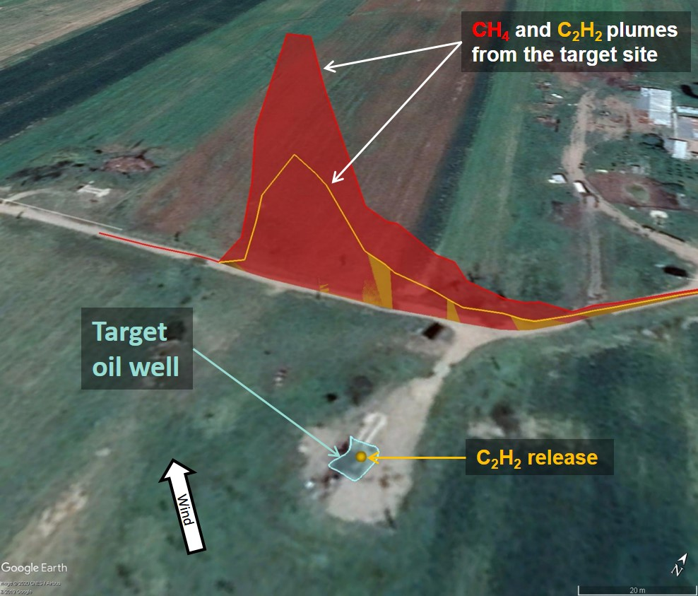
Figure S0. Example of a plume traverse. Measurements were performed at 50 m downwind from the target oil well at 17:10 on October 17th, 2019. Methane (CH₄) concentrations are marked with red, and showed above background level equal to 2.05 ppm with multiplication factor equal to 30. Acetylene (C₂H₂) concentrations are marked with yellow, and showed above background level equal to 0.5 ppm with multiplication factor equal to 0.2.

S1. Uncertainty budgets for the applied methods
The uncertainty of a performed quantification includes the uncertainty of the measurement method as well as variability in the quantification of the individual site. The uncertainty of the measurement method can be estimated by setting up an error budget, which includes the release of tracer gas (target gas simulation through the placement of tracer gas, flow meters and tracer gas purity), the calibration of analytical equipment (uncertainties about calibration gases and gas-mixing systems), data processing, etc. (Fredenslund et al., 2019). All of these uncertainties are random, and the total uncertainty of the measurement method can be determined by propagating individual uncertainties. The total uncertainty of the measurement method is thus calculated as the square root of the sum of the squares of the individual uncertainties (“Gaussian law of error propagation”). Variability in the quantification of an individual site – the variability of measured emission rates when performing multiple plume traverses – is calculated at a 95% confidence interval of emission rates calculated for each plume traverse. This variability changes from campaign to campaign, depending on the measurement conditions (changes in wind speed and direction, vehicle speed, measurement distance, background concentrations, etc.). The effect of changes in measurement conditions during an MTDM campaign will depend on site conditions and be site-specific (terrain, orientation of available measuring roads, etc.). Any variability in measured emissions caused through changes in conditions affecting the MTDM methodology itself should not be confused with variability due to temporal changes in the actual target site emission occurring during the measurement period. At sources with constant emissions, variability tends to decrease in line with the number of plume transects (Mønster et al., 2014). If variability is very high, this indicates that the source emission is not constant. The total uncertainty of a quantification is calculated as the square root of the sum of the squares of the uncertainty of the method and the variability in the quantification of the individual site. The total uncertainty of an MTDM quantification has been assessed at less than 20% in controlled release tests (Fredenslund et al., 2019). This uncertainty was comparable with the established theoretical error budget.
Table S1 provides an overview of the error budgets for the different methods applied in the study. When establishing an error budget for the MTDM, an important factor is source simulation. In this study, three different uncertainties were applied to the source simulation, depending on available information about emission sources and the possibility of actually simulating them. At oil and gas wells, it was possible to release tracer gas directly around the borehole where the main emission occurs. Thus, at this type of point source, a relatively low uncertainty of 5% for source simulation was adopted. At area sources (facilities), two different source simulation uncertainties were adopted according to the size of the target area and measurement distance. At relatively small facilities, where plume traverses were performed at an optimal distance due to the surrounding layout, an uncertainty of source simulation equal to 10% was adopted. At larger facilities, an uncertainty of source simulation equal to 15% was assumed, because plume traverses were performed at a non-optimal distance due to the surrounding layout, and the emission pattern was unknown due to not being granted site access.
A first attempt to assess the uncertainty of the other methods applied in this study is presented in Table S1. The uncertainty assessment is based on a compilation of factors potentially leading to errors, followed by error propagation (Fredenslund et al., 2019). Ideally, theoretical uncertainty should be compared to controlled release tests; however, this was outside the scope of this study.
Similar to the assessment of MTDM uncertainty, the uncertainty of the Gaussian Plume Model (GPM) was assessed via error budgeting (Table S1). Important errors included the choice of atmospheric stability class and the type of terrain as input parameters into the model, as these choices greatly affect the modelled emission rate. The potential error of the determination of the stability class and type of terrain was assessed by comparing emission rates, calculated using GPM and MTDM, at 41 sites. The percentage difference was calculated as 100⋅(GMP - MTDM)/MTDM, and the error was assessed as the standard deviation of the numerical values at a 95% confidence interval. Errors associated with choosing the stability class and type of terrain were 60.9%, and it was thus the most important parameter causing uncertainty when using GPM. Other factors that could introduce an error included the detection of CH₄ concentration, wind speed, measurement distance and data processing. The combined uncertainty of the GPM method was 61.4% (Table S1).
Only at three oil wells was the Static Tracer gas Dispersion Method (STDM) applied. The method uncertainty for the STDM was assumed to be the same as for MTDM. However, variability in quantification will often be higher in comparison to MTDM, as the measurements are often affected more by small changes in wind direction in comparison to the MTDM method, where the whole plume is traversed. In these specific cases, variability in the quantification of the individual site was assumed at 80% due a more poor correlation between the target and the tracer gas.
The estimate evaluation approach was applied at 70 O&G sites. Method uncertainty when applying the estimate was assumed similar to the GPM (i.e. 61.4%). However, assuming a constant source emission rate, variability in the quantification of the individual site would be higher for the estimate, since in this case the GPM was based only on one plume traverse (the first and often only one recorded). Increasing the number of plume traverses would reduce variability if the emission were constant (Mønster et al., 2014; Fredenslund et al., 2019). However, as only one plume was recorded, variability remained unknown. Estimate variability (48.6%) was appraised by using the average variability in the quantification of the individual site, obtained by applying GPM at 61 sites investigated during the ROMEO campaign.

Table S1. Overview of method uncertainties, assessed by a compilation of potential errors followed by error propagation (Fredenslund et al., 2019). The total uncertainty of a quantification is calculated as the square root of the sum of the squares of the uncertainty of the method and variability in the quantification of the individual site.
Method | Contributing factor | Uncertainty (%)
MTDM |  | Type 1: Point source with good emission simulation | Type 2: Area source with good emission simulation | Type 3: Area source with non-optimal emission simulation
 | Analytical instrument: tracer gas | 8 | 8 | 8
 | Analytical instrument: CH₄ | 2 | 2 | 2
 | Tracer release | 5 | 5 | 5
 | Source simulation | 5 | 10 | 15
 | Data processing | 2 | 2 | 2
 | Method uncertainty | 11.0 | 14.0 | 17.9
 | Variability in the quantification of the individual site⁽¹⁾ | Site-specific | Site-specific | Site-specific
GPM |  | Point or area sources with downwind plume traversed at sufficient distance
 | Analytical instrument: CH₄ | 2
 | Wind speed | 5
 | Measuring distance | 5
 | Data processing | 2
 | Choice of stability class and type of terrain | 60.9
 | Method uncertainty | 61.4
 | Variability in the quantification of the individual site⁽¹⁾ | Site-specific
STDM |  | Point sources where the plume could not be traversed and instead a stationary tracer approach was applied
 | Analytical instrument: tracer | 8
 | Analytical instrument: CH₄ | 2
 | Tracer release | 5
 | Source simulation | 5
 | Data processing | 2
 | Method uncertainty | 11.0
 | Variability in the quantification of the individual site⁽²⁾ | 80
Estimate |  | Point or area sources with downwind plume traversed at a sufficient distance
 | Analytical instrument: CH₄ | 2
 | Wind speed | 5
 | Measuring distance | 5
 | Data processing | 2
 | Choice of stability class and type of terrain | 60.9
 | Method uncertainty | 61.4
 | Variability in the quantification of the individual site⁽³⁾ | 48.6
MTDM: Mobile Tracer gas Dispersion Method; GPM: Gaussian Plume Method; GPM TSC: Gaussian Plume Method with the Tracer Stability Class information; STDM: Static Tracer gas Dispersion Method.
- For MTDM and GPM, variability in the quantification of the individual site is given by the 95% confidence interval (CI) of the multiple traverses performed at the specific site. This is obtained by multiplying for each site the Standard Error of the Mean (SEM) with 1.96, which is the value of the 97.5 percentile point of the normal distribution.
- The value is assumed to be 80% due to a poor correlation between the target and the tracer gas at the three sites where the method was applied.
- The variability of an estimate was appraised by using the average variability in the quantification of the individual site obtained, applying GPM at 61 sites investigated during the ROMEO campaign.

S2. Gaussian Plume Modelling, using recorded or fitted peak concentrations
The Gaussian Plume Model (GPM) was applied, using the peak concentration value of the plume traverse fitted with the Gaussian curve. The fitting operation was performed in OriginPro 2019 ®. In a plume traverse, the fitted peak concentration was preferred to the detected peak concentration, in order to include the effect of the whole plume traverse rather than a single detected concentration. To test this, the GPM was applied at 46 O&G sites, using both the fitted and the detected peak concentrations to calculate the emission rates of the known tracer release at the same site. The former was named “Fitted approach”, while the latter was named “Detected approach”. Errors in the tracer emission rate were calculated as 100⋅(GPM tracer quantification – Tracer release)/Tracer release), where “GPM tracer quantification” could be carried out using either “Fitted approach” or “Detected approach”. The test showed that at 80% of the sites, the fitted approach produced a smaller error than the detected approach. Figure S1 shows the better performance of the fitted approach compared to the detected approach. The tendency line of the fitted approach is closer to the equal slope than the tendency line of the detected approach (Figure S1).
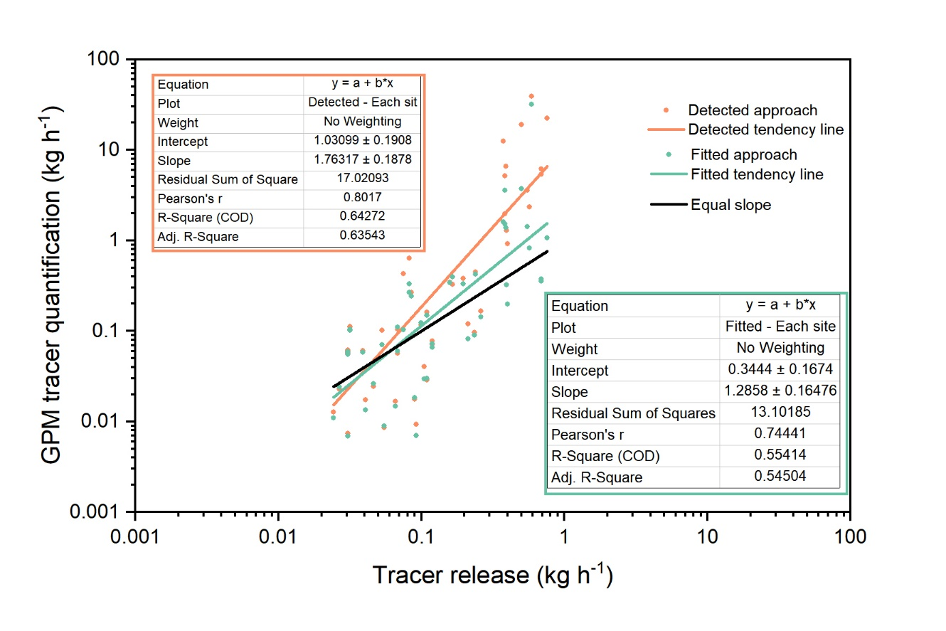
Figure S1. Tracer emission rate calculation, using the detected and the fitted approaches. Detected approach is shown in orange, while the fitted approach is shown in green.

S3. Comparison between the Mobile Tracer gas Dispersion Method (MTDM) and other methods
At 41 O&G sites, CH₄ emission rates were quantified using three different methods: MTDM, GPM and estimate (i.e. GPM based on a single plume). At 34 of the 41 sites, the CH₄ emission rate was lower when applying GPM in comparison to MTDM, whereas the same was the case at 32 sites for the estimate. Two important model input parameters, which can introduce significant error to GPM emission estimates, are the choice of atmospheric stability class and the choice of terrain type (Section S1 in SM). Consistent underestimation when using GPM and estimate in comparison to MTDM could be caused by the choice of terrain, which for most sites was set as “open country”. Changing the type of terrain from “open country” to “urban-like” significantly increased emission rates (on average by about 239%). The Gaussian model is intended for modelling plume concentrations from stack- or ground-level emissions at a greater distance away from the source (hundreds of metres to several kilometres), in comparison to this study, where measurements were performed often less than 100 m downwind of an oil or gas well. Considering this relatively small scale, it is possible that the type of terrain has features that are more urban than open country and that small bushes, trees and other obstacles could impinge on plume dispersion, thereby resulting in higher horizontal and vertical dispersion.
Monte Carlo simulation was used to generate synthetic emission rate datasets, which were subsequently used in a linear regression model to determine the correction factor for GPM and estimate, individually. This simulation consisted of 10,000 sampling times for each measurement method. In this case, the Monte Carlo simulation included the uncertainty attached to each calculated emission rate, as reported in section S1 in SM.
The statistical model provides the results reported in Table S2, whereas Eq. (S1) and Eq. (S2) report the relationship between MTDM and GPM, and MTDM and estimate, respectively.
Table S2. Results of the statistical model correlating MTDM vs GPM and MTDM vs estimate.
Method | Parameter name | Parameter value | Standard error | R²
GPM | Intercept | -0.343 | 0.001 | 0.70
 | Slope | 1.005 | 0.001
Estimate | Intercept | -0.409 | 0.001 | 0.61
 | Slope | 0.956 | 0.001
The standard error is the expression of uncertainty of the Parameter value.
All parameters had a p-value equal to zero, indicating that they were statistically significant.

${Log}_{10}\left(MTDM\right)= -0.343+ 1.005 {Log}_{10}\left(GPM\right)$ (Eq. S1)
${Log}_{10}\left(MTDM\right)= -0.409+ 0.956 {Log}_{10}\left(Estimate\right)$ (Eq. S2)
Eq. (S1) and Eq. (S2) were used to correct emission rates calculated using GPM and estimate.

S4. Dataset location
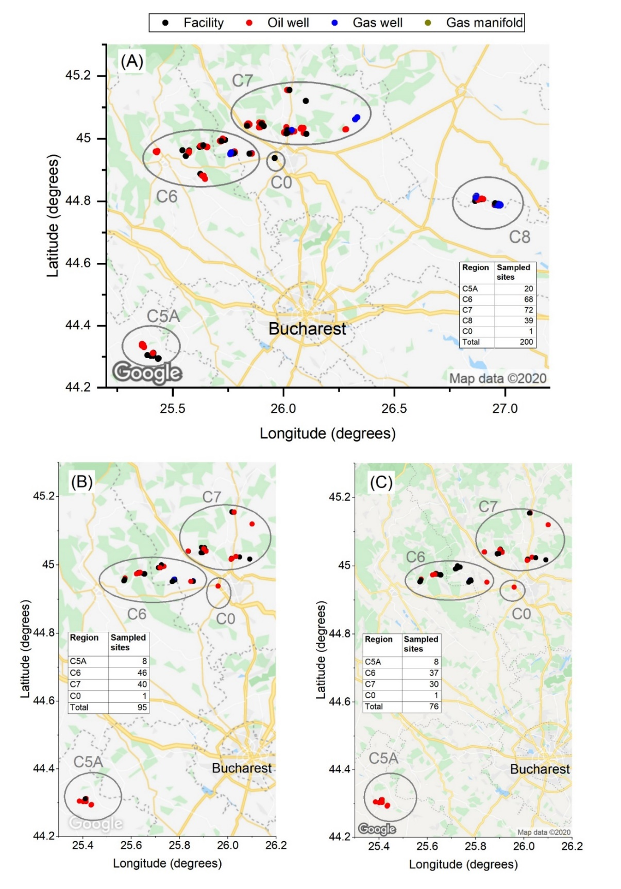
Figure S2. Site locations. (A) Location of sites where CH₄ emission rates were measured. (B) Location of sites where C₂H₆ emission rates were measured. (C) Location of sites where the C₂H₆-to-CH₄ molar ratio was measured. Map © Google

S5. CH₄ Emission rates

S5.1. Current study

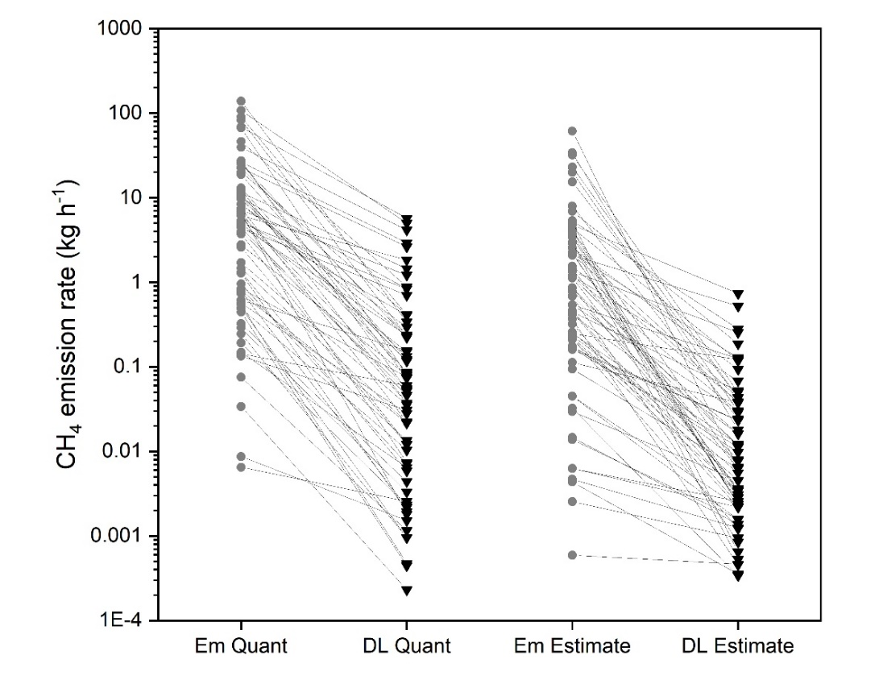
Figure S3. Comparison of emission rates quantified (via MTDM, GPM and STDM) and estimated with the site-specific detection limit (DL). Em stands for Emission, DL stands for Detection Limit, and Quant stands for Quantification.
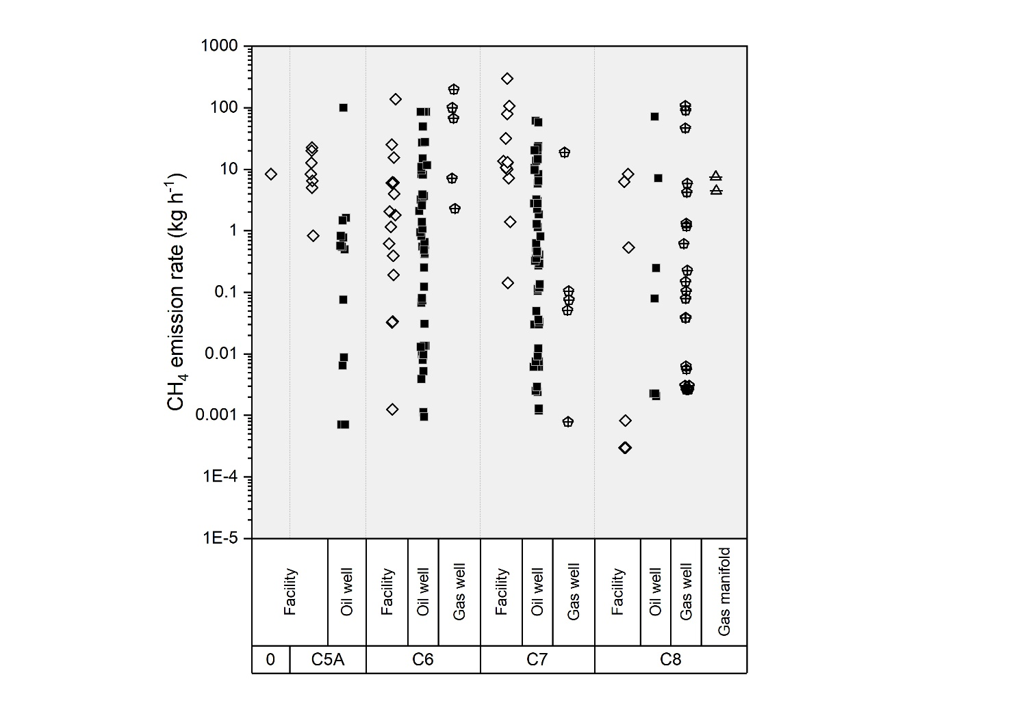
Figure S4. CH₄ emission rates according to region and site type. Two hundred CH₄ emission rates grouped by region and type of site (facility, oil and gas well).

Table S3 reports only the tests for lognormal and exponential distributions as these are the distributions previously reported in O&G methane emissions studies. Brantley et al. (2014). Rella et al. (2015), Yacovitch et al. (2017) and Zavala-Araiza et al. (2018) reported CH₄ emission rates following the lognormal distribution, whereas Yacovitch et al. (2015) reported CH₄ emission rates following the exponential distribution.
Table S3. Grouping of collected CH₄ emission dataset tested for lognormal and exponential distribution. The selected sub-datasets for different types of sites and different regions in the investigated area included all data.
Grouping | Test for the lognormal distribution ª |  | Test for the exponential distribution ^{b}
 | p-value | Dataset belonging to the  lognormal distribution?  (Yes/No) | p-value | Dataset belonging to the  exponential distribution?  (Yes/No)
Complete dataset | <0.0001 | No | <0.0001 | No
Complete dataset without BDL | 0.0013 | No | <0.0001 | No
Facilities in all regions | 0.0001 | No | <0.0001 | No
Gas wells in all regions | 0.0332 | No | <0.0001 | No
Oil wells in all regions | 0.0015 | No | <0.0001 | No
All sites in region C5A | 0.0028 | No | <0.0001 | No
All sites in region C6 | 0.0004 | No | <0.0001 | No
All sites in region C7 | 0.0004 | No | <0.0001 | No
All sites in region C8 | 0.0014 | No | <0.0001 | No
Gas wells in all regions without non-producing gas wells | 0.0332 | No | <0.0001 | No
Oil wells in all regions without non-producing oil wells | 0.0015 | No | <0.0001 | No
ª The godTest was used for testing lognormal distribution (Millard, 2013).
^{b} Kolmogorow-Smirov test for exponentially was applied to test exponential distribution (Henze and Meintanis 2005)

Table S4. CH₄ Emission factors (EFs) for several groupings of sampled O&G sites. The selected sub-datasets for different types of sites and different regions in the investigated area included all data.
Grouping | Number of  observations | EF  (kg h⁻¹ site⁻¹) | Lower 95% CI  (kg h⁻¹ site⁻¹) | Upper 95% CI  (kg h⁻¹ site⁻¹) | SD of EF  (kg h⁻¹ site⁻¹)
Complete dataset | 200 | 0.53 | 0.32 | 0.79 | 0.13
Complete dataset without BDL | 145 | 2.3 | 1.5 | 3.5 | 0.53
Facilities in all regions | 42 | 2.3 | 0.66 | 5.3 | 1.2
Gas wells in all regions | 33 | 0.29 | 0.06 | 0.90 | 0.22
Oil wells in all regions | 122 | 0.38 | 0.21 | 0.64 | 0.11
All sites in region C5A | 20 | 0.81 | 0.13 | 2.3 | 0.63
All sites in region C6 | 68 | 0.98 | 0.41 | 2.1 | 0.42
All sites in region C7 | 72 | 0.62 | 0.27 | 1.2 | 0.24
All sites in region C8 | 39 | 0.14 | 0.04 | 0.39 | 0.09
Gas wells in all regions without non-producing gas wells | 29 | 0.35 | 0.06 | 1.1 | 0.30
Oil wells in all regions without non-producing oil wells | 106 | 0.55 | 0.27 | 0.96 | 0.18
One observation in region C0 and three observations at gas manifolds were not included in the type of site and region subsets.
EF: Emission Factor; CI: Confidence interval; SD: Standard deviation

S5.2. Correlation between CH₄ emission rates and production factors
A Spearman’s rank order correlation test was run with OriginPro 2019 ® to investigate if the CH₄ emission rates were correlated to other factors such as production elements or site age. The test is the most common non-parametric measure used when data are not normally distributed (OriginLab, 2019). In statistics, the Spearman’s rank correlation coefficient r_{s} is a non-parametric measure of rank correlation (statistical dependence between the rankings of two variables) (Corder and Foreman, 2009), and it assesses how well the relationship between two variables can be described, using a monotonic function. The Spearman’s correlation between two variables is equal to the Pearson’s correlation between the rank values of those two variables; while the Pearson’s correlation assesses linear relationships, the Spearman’s correlation assesses monotonic relationships (whether linear or not). If there are no repeated data values, a perfect Spearman’s correlation of +1 or −1 occurs when each of the variables is a perfect monotone function of the other.
Via the Spearman's rank order correlation test run with OriginPro 2019 ®, the CH₄ emission rates sampled herein were found to be negatively correlated to wastewater produced at oil wells (r_{s} = -0.52). An overview of the test run in OriginPro 2019 is reported in Table S5.
Table S5. Spearman's rank correlation coefficient between site-specific CH₄ emission rates and site-specific parameters. Site-specific information was provided by the site managers.
Subset | Factor correlated with CH₄ emission rates
 | Gross volume  (m³) | Wastewater  (m³) | Oil  (Mg) | Condensate  (m³) | Natural gas  (Nm³) | Total  BOE | Age  (years)
All production sites | -0.10 | -0.13 | -0.01 | -0.06 | 0.001 | -0.01 | 0.12
Gas wells | -0.24 | -0.23 | NA | -0.06 | 0.16 | 0.16 | 0.13
Oil wells | -0.14 | -0.15 | -0.08 | NA | 0.01 | -0.08 | 0.13
All quantified production sites | -0.27 | -0.45 | -0.07 | -0.04 | 0.05 | 0.06 | 0.04
Quantified gas wells | 0.16 | 0.13 | NA | -0.05 | -0.08 | -0.08 | 0.24
Quantified oil wells | -0.29 | -0.52 | -0.03 | NA | 0.01 | -0.06 | -0.03
A perfect Spearman’s correlation of +1 or −1 occurs when each of the variables is a perfect monotone function of the other.
BOE: Barrel Oil Equivalent is the total energy produced from hydrocarbons produced on site.

S5.3. Comparison with CH₄ emission rates reported in the literature

Table S6. Information about the literature studies shown in Figure 3 of the article. The first part of the table shows studies where sites with emissions below detection level (DL) were included in the dataset.
Study | Location | # obs. | Method | Investigated sites  (type and number) | DL
Rella et al. (2015) ^{d} | USA:  Texas – Barnett Shale basin | 115 | Mobile Flux Plane technique | Well pads: 115 | Yes
Robertson et al. (2017)  FV | USA:  Arkansas – Fayetteville (FV) gas play | 53 | OTM 33A | O&G well pads: 53 ^{f} | Yes
Yacovitch et al. (2017)  FV | USA:  Arkansas – Fayetteville (FV) gas play | 49 | MTDM (double tracer) | Gathering facilities: 31  Production well pads: 14  Transmission (pipes): 4 | Yes
Caulton et al. (2018) | USA:  Pennsylvania - Marcellus Shale | 667 | GPM  LES | Gas wells: 667 | Yes
O’Connell et al. (2019)  Lloydminster | Canada:  Lloydminster (heavy oil) | 174 | GPM | Grouped sites | Yes
O’Connell et al. (2019)  Medicine Hat | Canada:  Medicine Hat (conventional gas) | 93 | GPM | Grouped sites | Yes
O’Connell et al. (2019)  Peace River | Canada:  Peace River (heavy oil/bitumen) | 37 | GPM | Grouped sites | Yes
Current study  Complete Dataset | Romania | 200 | MTDM mainly | Facilities: 42  Gas manifolds: 3  Gas wells: 33  Oil wells: 122 | Yes
Current study  Without BDL | Romania | 145 | MTDM mainly | Facilities: 37  Gas manifolds: 3  Gas wells: 17  Oil wells: 88 | No
Allen et al. (2013) ª | USA:  Midcontinent, Rocky Mountain, and Appalachian | 19 | MTDM (double tracer) | Well pads: 19  with from 1 to 6 wells per pad  total of 71 producing wells | No
Lan et al. (2015) | USA:  Texas – Barnett Shale basin | 43 | GPM | O&G well pads: 34  Compression stations: 7  Gas plants: 2 | No
Mitchell et al. (2015) | USA:  Texas – Barnett Shale basin | 131 | MTDM (double tracer) | Gathering facilities: 114  Processing facility: 16 | No
Yacovitch et al. (2015) | USA:  Texas – Barnett Shale basin | 169 | GPM | Well pads: 43  pipes: 13  Unknown: 46  Large Facilities: 63  Compressor Stations: 4 | No
Omara et al. (2016) | USA:  Pennsylvania and West Virginia (Marcellus Shale) | 35 | MTDM (double tracer) | UNG (Unconventional Natural Gas): 17  CvNG (Conventional Natural Gas): 18 | No
Lavoie et al. (2017) | USA:  Texas – Eagle Ford basin | 20 | Aircraft-Based Mass Balance:  Transect-Based Mass Balance Method,  Loop-Based Mass Balance Method. | Gathering facilities: 10 ^{e}  Oil well pad: 1  Gas processing plants: 4  Storage facility: 1  Unknown sites: 4 | No
Robertson et al. (2017)  DJ | USA:  Colorado – Denver-Julesburg (DJ) basin | 84 | OTM 33A | O&G well pads: 84  This study: 16  Brantley et al. (2014): 68 | No
Robertson et al. (2017)  UGR | USA:  Wyoming – Upper Green River (UGR) basin | 51 | OTM 33A | O&G well pads: 51 | No
Robertson et al. (2017)  Uintah | USA:  Utah – Uintah basin | 30 | OTM 33A | O&G well pads: 30 | No
Yacovitch et al. (2017)  DJ | USA:  Colorado – Denver-Julesburg (DJ) basin | 21 | MTDM (double tracer) | Gathering facilities: 12  Production well pads: 5  Processing plants: 4 | No
Yacovitch et al. (2018) | Netherlands  The Groningen field | 16 | GPM | Gas wells and gas facilities | No
Zavala-Araiza et al. (2018) | Canada:  Alberta – Red Deer | 55 | GPM (# 35)  MTDM (double tracer) (# 20) | O&G well pads: 55 | No
MTDM: Mobile Tracer gas Dispersion Method. OTM 33A (US EPA, 2014). GPM: Gaussian Plume Model. LES: Large Eddy Simulation. DL: Detection limit.
ª All investigated sites were based on hydraulic fracturing. ^{b} Not clear if included in the dataset provided. ^{c} Red Deer, Alberta — a region characterised by old natural gas production sites and light oil production. ^{d} Reported data are only detectable emissions. Sixty-seven well pads were below the detection limit and are not reported in the available dataset. ^{e} Repeated measurements at four gathering facilities were averaged over different measurement days. ^{f} Twelve below the detection limit (fixed at 0.01 g s⁻¹), and 41 detectable.

Table S7. Descriptive statistics for literature datasets reporting CH₄ emission rates.
Study | Number of  observations | Geometric mean  (kg h⁻¹) | Arithmetic mean  (kg h⁻¹) | Median  (kg h⁻¹) | Min  (kg h⁻¹) | Max  (kg h⁻¹) | Variance | Skew | Kurtosis
Rella et al. (2015) | 115 | 0.62 | 1.9 | 0.62 | 0.027 | 48 | 25 | 7.1 | 58
Robertson et al. (2017) FV | 53 | 0.18 | 1.9 | 0.14 | 0.004 | 68 | 88 | 6.7 | 45
Yacovitch et al. (2017) FV | 49 | 13 | 67 | 19 | 0.040 | 802 | 21210 | 3.8 | 15
Caulton et al. (2018) | 677 | 0.75 | 4.4 | 0.88 | 0.004 | 360 | 349 | 12.9 | 211
O’Connell et al. (2019) Lloydminster | 174 | 2.7 | 7.4 | 2.5 | 0.025 | 144 | 232 | 5.4 | 39
O’Connell et al. (2019) Medicine Hat | 93 | 0.54 | 1.2 | 0.52 | 0.026 | 24 | 7.8 | 6.5 | 49
O’Connell et al. (2019) Peace River | 37 | 3.0 | 4.7 | 2.6 | 0.38 | 26 | 31 | 2.5 | 6.2
Current study – Complete Dataset | 200 | 0.51 | 13 | 0.79 | 0.0003 | 297 | 1127 | 4.8 | 30
Current study – Without BDL | 145 | 2.3 | 17 | 3.2 | 0.001 | 297 | 1475 | 4.1 | 22
Allen et al. (2013) | 19 | 0.98 | 1.6 | 0.96 | 0.096 | 5.0 | 2.4 | 0.9 | -0.70
Lan et al. (2015) | 42 | 6.8 | 183 | 3.3 | 0.01 | 2119 | 252073 | 2.9 | 7.4
Mitchell et al. (2015) | 131 | 28 | 69 | 30 | 0.70 | 699 | 11304 | 3.3 | 14
Yacovitch et al. (2015) | 169 | 2.1 | 28 | 2.2 | 0.002 | 1360 | 13374 | 9.4 | 102
Omara et al. (2016) | 35 | 1.9 | 9.2 | 2.1 | 0.02 | 93 | 434 | 3.0 | 8.0
Lavoie et al. (2017) | 20 | 99 | 146 | 78 | 22 | 590 | 24065 | 1.8 | 2.2
Robertson et al. (2017) DJ | 84 | 0.54 | 1.4 | 0.55 | 0.05 | 26 | 9.7 | 6.3 | 46
Robertson et al. (2017) UGR | 51 | 1.4 | 2.2 | 1.3 | 0.13 | 9.0 | 4.4 | 1.4 | 1.2
Robertson et al. (2017) Uintah | 30 | 1.2 | 3.4 | 1.1 | 0.09 | 46 | 73 | 4.3 | 19
Yacovitch et al. (2017) DJ | 21 | 11 | 25 | 12 | 0.18 | 102 | 901 | 1.3 | 0.30
Yacovitch et al. (2018) | 16 | 0.55 | 1.1 | 0.77 | 0.03 | 5.0 | 1.6 | 1.4 | 1.1
Zavala-Araiza et al. (2018) | 60 | 1.4 | 5.5 | 1.4 | 0.02 | 80 | 142 | 4.5 | 24
The geometric mean is the exponential transformation applied to the mean of the log-transformed data and expressed as follows: $\hat{y} = \sqrt[n]{\prod{y.}}$
The arithmetic mean is the sum of the observations divided by the number of observations, and expressed as follow: $\overline{x}= \frac{1}{n} \sum_{i=1}^{n}{x_{i}}$
The kurtosis is a measure indicating whether the data distribution is flat or peaked (Reimann et al., 2008) (kurtosis equal to 0 indicates a normal distribution, whereas kurtosis (in absolute value) higher than ±2 is considered extreme).

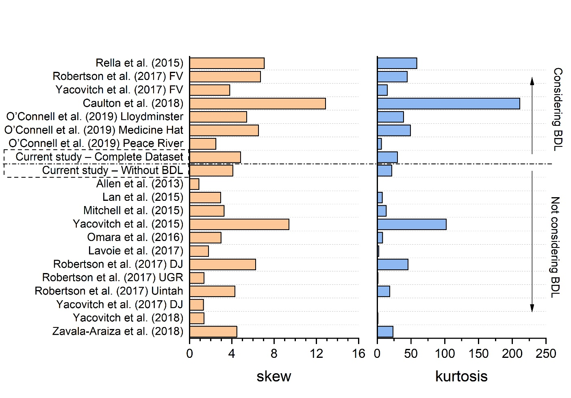
Figure S5. Skew and kurtosis of the available datasets from the literature. Data from Table S7.

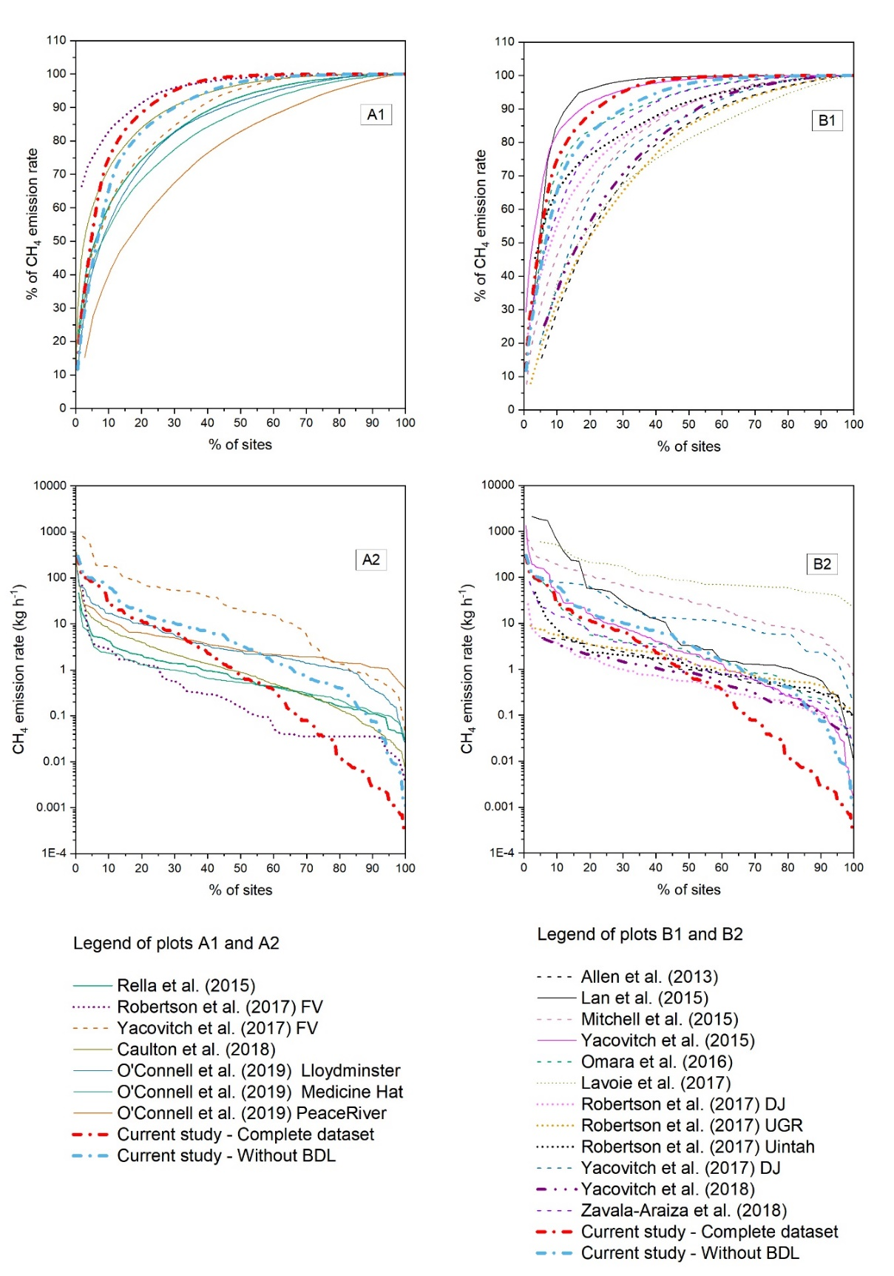
Figure S6. Comparison of CH₄ emission rates with available literature data. (A1) Skew in the CH₄ emission rates measured by studies including observations of BDL. CH₄ emission rates are ranked in descending order. (A2) Measured CH₄ emission rates ranked in descending order vs. cumulative percentage of sites in studies disregarding observations of BDL. (B1) Skew in the CH₄ emission rates measured by studies including observations of BDL. (B2) Measured CH₄ emission rates ranked in descending order vs. cumulative percentage of sites in studies disregarding observations of BDL.
Table S8. CH₄ emission factors based on available literature data. The first part of the table shows studies where sites with emissions below detection limit (DL) were included in the dataset. EFs were given as the geometric mean of the emission distribution, which was computed using non-parametric bootstrapping (based on 10,000 simulations).
DL | Study | Number of  observations | EF  (kg h⁻¹ site⁻¹) | Lower 95% CI  (kg h⁻¹ site⁻¹) | Upper 95% CI  (kg h⁻¹ site⁻¹) | SD of EF  (kg h⁻¹ site⁻¹)
Yes | Rella et al. (2015) | 115 | 0.63 | 0.48 | 0.82 | 0.09
 | Robertson et al. (2017) FV | 53 | 0.19 | 0.11 | 0.31 | 0.05
 | Yacovitch et al. (2017) FV | 49 | 14 | 7.1 | 24 | 4.4
 | Caulton et al. (2018) | 677 | 0.75 | 0.65 | 0.87 | 0.06
 | O'Connel et al. (2019) Lloydminster | 174 | 2.7 | 2.2 | 3.2 | 0.28
 | O'Connel et al. (2019) Medicine Hat | 93 | 0.54 | 0.42 | 0.69 | 0.07
 | O'Connel et al. (2019) Peace River | 37 | 3.1 | 2.3 | 4.1 | 0.47
 | Current study - Complete dataset | 200 | 0.53 | 0.32 | 0.79 | 0.13
No | Current study - Without BDL | 145 | 2.3 | 1.5 | 3.5 | 0.53
 | Allen et al. (2013) | 19 | 1.0 | 0.60 | 1.7 | 0.27
 | Lan et al. (2015) | 42 | 7.6 | 3.2 | 17 | 3.5
 | Mitchel et al. (2015) | 131 | 28 | 22 | 35 | 3.5
 | Yacovitch et al. (2015) | 169 | 2.1 | 1.4 | 2.9 | 0.38
 | Omara et al. (2016) | 35 | 2.0 | 1.0 | 3.5 | 0.65
 | Lavoie et al. (2017) | 20 | 101 | 68 | 146 | 19
 | Robertson et al. (2017) DJ | 84 | 0.55 | 0.41 | 0.71 | 0.08
 | Robertson et al. (2017) UGR | 51 | 1.4 | 1.0 | 1.8 | 0.20
 | Robertson et al. (2017) Uintah | 30 | 1.2 | 0.74 | 1.9 | 0.30
 | Yacovitch et al. (2017) DJ | 21 | 12 | 5.1 | 19 | 3.7
 | Yacovitch et al. (2018) | 16 | 0.59 | 0.26 | 1.1 | 0.22
 | Zavala-Araiza et al. (2018) | 60 | 1.4 | 0.90 | 2.1 | 0.33
DL: detection limit

Table S9. Overview of calculation of emission factors (EF) presented in the literature.
Method of EF calculation | Study | Distribution | Central value  used for the calculation  of the EF | Reported EF
Non-parametric bootstrapping | Brantley et al., 2014 | Lognormal | Geometric mean | Expressed as kg h⁻¹ site⁻¹ and 95% CI for the following basins:  - Barnett: 1.19 (0.83; 1.73)  - Denver-Julesburg: 0.5 (04; 0.68)  - Pinedale: 2.12 (1.69; 2.66)
 | Rella et al., 2015* | Lognormal | Geometric mean | 0.63±0.09 kg h⁻¹ site⁻¹  (uncertainty reported as 1-sigma)
 |  |  | Arithmetic mean | 1.74±0.35 kg h⁻¹ site⁻¹  (uncertainty reported as 1-sigma)
 | Brandt et al., 2016 | Not specified | Not specified | Not specified  It reviews numerous datasets.
 | Robertson et al., 2017 | Not specified | Median | Expressed as the total mass of methane emitted as a percent of gross methane produced, and 95% CI for the following basins:  - Fayetteville: 0.09% (0.05−0.15%)  - Upper Green River: 0.18% (0.12−0.29%)  - Denver-Julesburg: 2.1% (1.1−3.9%)  - Uintah: 2.8% (1.0−8.6%)
 | Riddick et al., 2019 | Not specified | Arithmetic mean | Expressed as kg h⁻¹ site⁻¹ for the following types of wells:  - Plugged wells: 0.0001  - Unplugged wells: 0.0032
Parametric inferring statistic | Brandt et al., 2016 | Not specified | Not specified | Not specified  It reviews numerous datasets.
 | Yacovitch et al., 2017 | Lognormal | Mode | Expressed as kg h⁻¹ site⁻¹ and 95% CI for the following site types and basins:  - Gathering facilities in Fayetteville: 40 (15–730)  - Gathering facilities in Denver-Julesburg: 11 (4.5–75)  - Production sites in Fayetteville: 1 (0.36–12)
 | Zavala-Araiza et al., 2018 | Lognormal | Mode | Expressed as kg h⁻¹ site⁻¹ and 95% CI for the following samples of production sites:  - Using systematic samples only: 2.2 (1.0–5.4)  - Integrating the systematic sample and the high emitter biased sample into a single distribution: 2.9 (1.3–6.8)
*It reports also the geometric standard deviation: 4.1±0.4 kg h-1 site-1 (uncertainty reported as 1-sigma)

S6. C₂H₆ emission rates
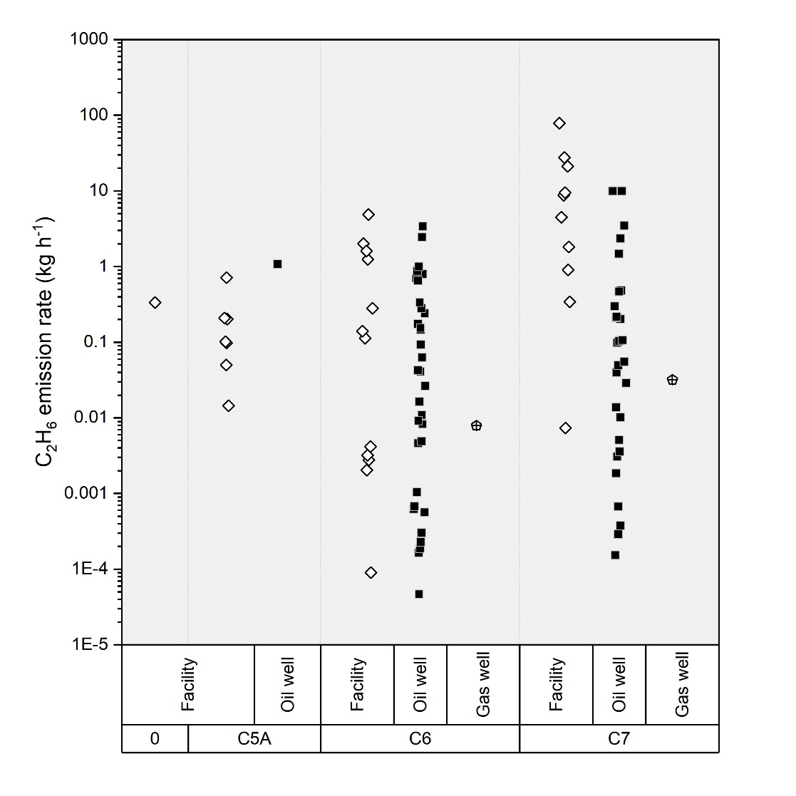
Figure S7. C₂H₆ emission rates according to location and site type. Ninety-five C₂H₆ investigations at O&G sites.

Table S10. Descriptive statistics for C₂H₆ emission rates grouped by type of site (facility, oil well and gas well) and region.
Grouping | Number of  observations | Geometric mean  (kg h⁻¹) | Arithmetic mean  (kg h⁻¹) | Median  (kg h⁻¹) | Min  (kg h⁻¹) | Max  (kg h⁻¹) | Variance | Skew | Kurtosis
Complete dataset | 95 | 0.07 | 2.3 | 0.10 | 0.0001 | 79 | 79 | 7.0 | 55
Facilities in all regions | 30 | 0.26 | 5.5 | 0.31 | 0.0001 | 79 | 232 | 3.8 | 15
Oil wells in all regions | 63 | 0.04 | 0.82 | 0.06 | 0.0001 | 9.8 | 4.7 | 3.5 | 12
All sites in region C5A | 8 | 0.15 | 0.31 | 0.15 | 0.02 | 1.1 | 0.14 | 1.0 | -0.70
All sites in region C6 | 46 | 0.03 | 0.47 | 0.04 | 0.0001 | 4.9 | 0.94 | 2.8 | 8.4
All sites in region C7 | 40 | 0.16 | 4.8 | 0.20 | 0.0002 | 79 | 179 | 4.4 | 21
Oil wells in all regions without non-producing oil wells | 56 | 0.04 | 0.92 | 0.10 | 0.0001 | 9.8 | 5.2 | 3.2 | 9.7
One observation in region C0 and two observations at gas wells were not included in the type of site and region subsets.
The geometric mean is the exponential transformation applied to the mean of the log-transformed data and expressed as follows: $\hat{y} = \sqrt[n]{\prod{y.}}$
The arithmetic mean is the sum of the observations divided by the number of observations, and expressed as follow: $\overline{x}= \frac{1}{n} \sum_{i=1}^{n}{x_{i}}$
The kurtosis is a measure that indicates whether the data distribution is flat or peaked (Reimann et al., 2008) (kurtosis equal to 0 indicates a normal distribution, whereas kurtosis (in absolute value) higher than ±2 is considered extreme).

Table S11. Descriptive statistics for literature datasets reporting C₂H₆ emission rates.
Grouping | Number of  observations | Geometric mean  (kg h⁻¹) | Arithmetic mean  (kg h⁻¹) | Median  (kg h⁻¹) | Min  (kg h⁻¹) | Max  (kg h⁻¹) | Variance | Skew | Kurtosis
Complete dataset | 95 | 0.07 | 2.3 | 0.10 | 0.0001 | 79 | 79 | 7.0 | 55
Yacovitch et al. (2015) | 166 | 0.11 | 1.1 | 0.12 | 0.00004 | 32 | 9.3 | 6.9 | 60
Yacovitch et al. (2017) DJ | 20 | 2.2 | 5.7 | 1.7 | 0.30 | 40 | 100 | 2.3 | 4.3
Yacovitch et al. (2017) FV | 47 | 0.23 | 1.0 | 0.32 | 0.004 | 12 | 4.3 | 3.6 | 14
The geometric mean is the exponential transformation applied to the mean of the log-transformed data and expressed as follows: $\hat{y} = \sqrt[n]{\prod{y.}}$
The arithmetic mean is the sum of the observations divided by the number of observations, and expressed as follow: $\overline{x}= \frac{1}{n} \sum_{i=1}^{n}{x_{i}}$
The kurtosis is a measure that indicates whether the data distribution is flat or peaked (Reimann et al., 2008) (kurtosis equal to 0 indicates a normal distribution, whereas kurtosis (in absolute value) higher than ±2 is considered extreme).

Table S12. C₂H₆ Emission factors (EFs) based on available literature data and the current study. EFs were given as the geometric mean of the emission distribution, which was computed using non-parametric bootstrapping (based on 10,000 simulations).
Study |  | Number of  observations | EF  (kg h⁻¹ site⁻¹) | Lower 95% CI  (kg h⁻¹ site⁻¹) | Upper 95% CI  (kg h⁻¹ site⁻¹) | SD of EF  (kg h⁻¹ site⁻¹)
Literature | Yacovitch et al. (2015) | 166 | 0.11 | 0.08 | 0.16 | 0.02
 | Yacovitch et al. (2017)  DJ | 20 | 2.3 | 1.3 | 3.9 | 0.70
 | Yacovitch et al. (2017)  FV | 47 | 0.25 | 0.13 | 0.42 | 0.08
Current study | Complete dataset | 95 | 0.07 | 0.04 | 0.13 | 0.03
 | Facility | 30 | 0.31 | 0.08 | 0.86 | 0.19
 | Oil well | 63 | 0.04 | 0.02 | 0.08 | 0.02
 | C5A | 8 | 0.16 | 0.06 | 0.36 | 0.08
 | C6 | 46 | 0.03 | 0.01 | 0.07 | 0.02
 | C7 | 40 | 0.19 | 0.05 | 0.49 | 0.12
 | Oil wells without non-producing oil wells | 56 | 0.05 | 0.02 | 0.10 | 0.02

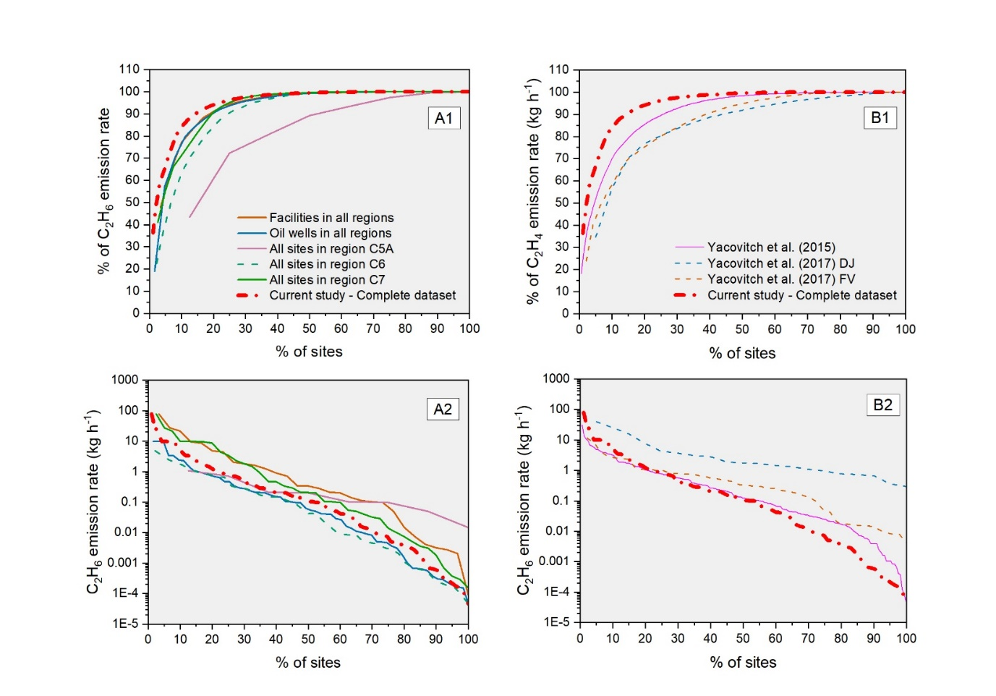
Figure S8. Comparison of C₂H₆ emission rate datasets in the current study with available literature data. (A1) Skew in the C₂H₆ emission rates grouped by region, type of site and complete dataset. C₂H₆ emission rates are ranked in descending order. (A2) Measured C₂H₆ emission rates ranked in descending order vs. cumulative percentage of sites. C₂H₆ emission rates are grouped by region, type of site and complete dataset. (B1) Skew in the C₂H₆ emission rates ranked in descending order. (B2) Measured C₂H₆ emission rates ranked in descending order vs. cumulative percentage of sites.

S7. C₂H₆-to-CH₄ molar ratio
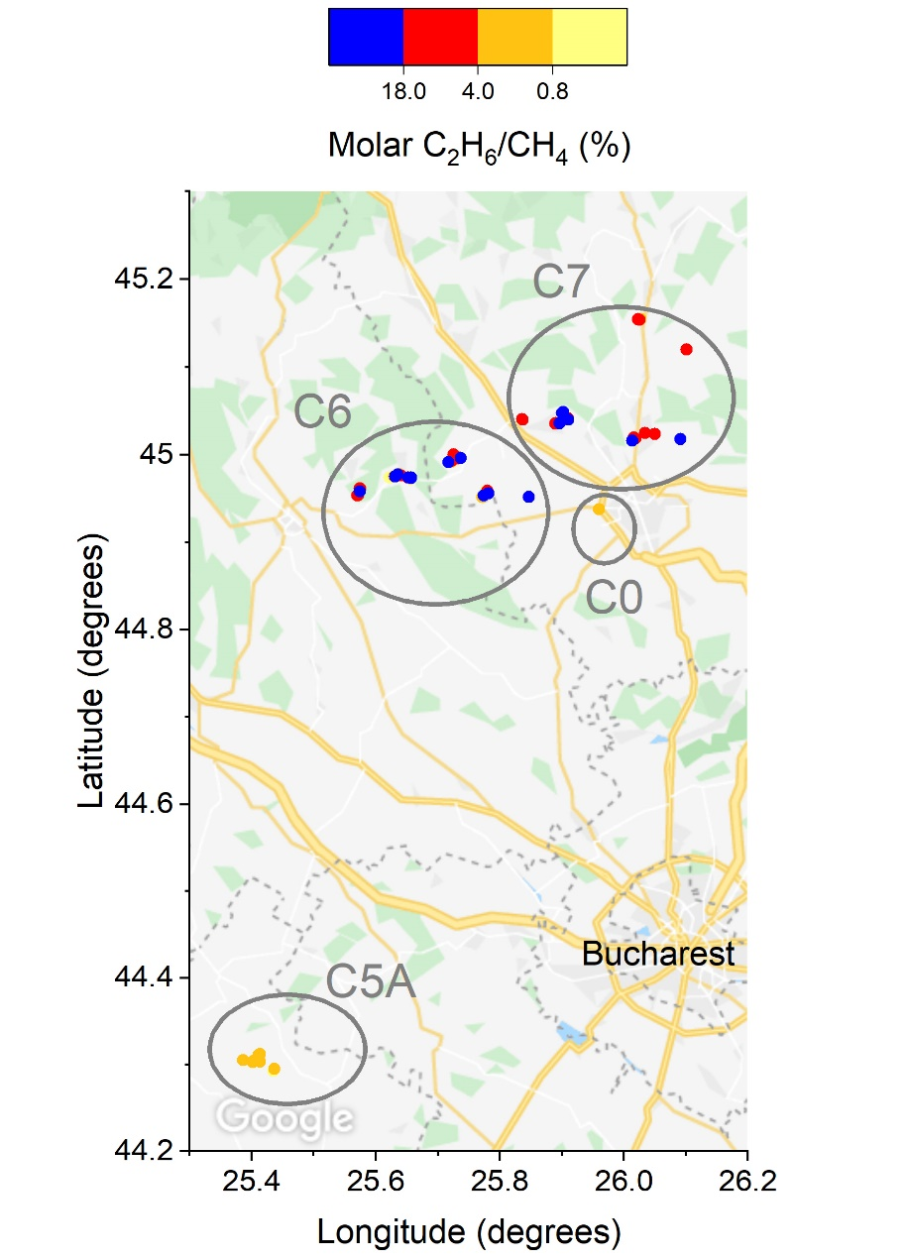
Figure S9. C₂H₆-to-CH₄ ratios and location of sites.

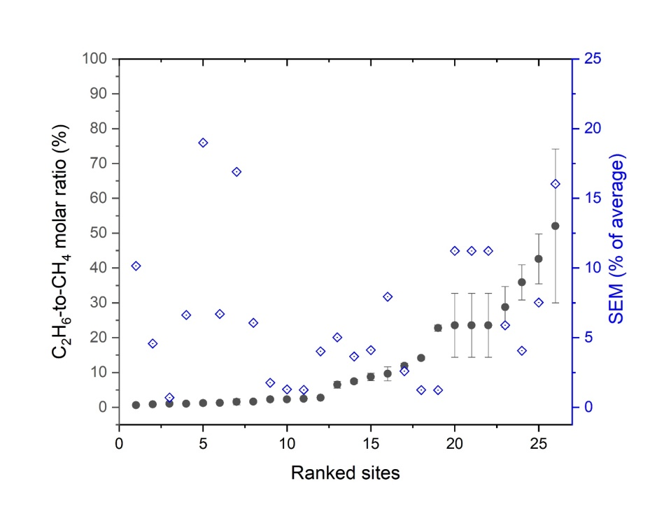
Figure S10. C₂H₆-to-CH₄ molar ratios and their variability measured at 26 sites. Sites were ranked from the smallest to the largest ratio. Vertical bars show variability in the C₂H₆-to-CH₄ molar ratio measured along numerous plume traverses and expressed as standard deviation. For each site, the Standard Error of Mean (SEM) of the C₂H₆-to-CH₄ molar ratio is also reported with blue diamonds.

S8. Non-producing wells
Table S13. Descriptive statistics for non-producing wells.
Dataset | Number of  observations | Geometric  mean  (kg h⁻¹) | Arithmetic  mean  (kg h⁻¹) | Median  (kg h⁻¹) | Min  (kg h⁻¹) | Max  (kg h⁻¹) | Variance | Skew | Kurtosis
Methane dataset | 20 | 0.04 | 0.11 | 0.06 | 0.001 | 0.58 | 0.02 | 1.9 | 2.4
Ethane dataset | 8 | 0.01 | 0.04 | 0.01 | 0.002 | 0.24 | 0.01 | 1.8 | 1.6
The geometric mean is the exponential transformation applied to the mean of the log-transformed data and expressed as follows: $\hat{y} = \sqrt[n]{\prod{y.}}$
The arithmetic mean is the sum of the observations divided by the number of observations, and expressed as follow:
$\overline{x}= \frac{1}{n} \sum_{i=1}^{n}{x_{i}}$
The kurtosis is a measure that indicates whether the data distribution is flat or peaked (Reimann et al., 2008) (kurtosis equal to 0 indicates a normal distribution, whereas kurtosis (in absolute value) higher than ±2 is considered extreme).

Table S14. CH₄ and C₂H₆ emission factors (EFs) for non-producing wells.
Dataset | Number of  observations | EF  (kg h⁻¹ site⁻¹) | Lower 95% CI  (kg h⁻¹ site⁻¹) | Upper 95% CI  (kg h⁻¹ site⁻¹) | SD of EF  (kg h⁻¹ site⁻¹)
Methane dataset | 20 | 0.04 | 0.02 | 0.08 | 0.02
Ethane dataset | 8 | 0.01 | 0.004 | 0.04 | 0.01

S9. Data
Table S15. Detailed emission dataset of this study.
Site ID | Region | Type of site | Method | Number of traverses | CH₄ emission (kg h⁻¹) |  | C₂H₆ emission (kg h⁻¹) |  | C₂H₆-to-CH₄ molar ratio (%)
 |  |  |  |  | Average | Standard deviation | Average | Standard deviation
S001 | C6 | Gas well | TDM | 10 | 66 | 25 | NA | NA | NA
S002 | C6 | Oil well | TDM | 12 | 2.6 | 0.91 | NA | NA | NA
S003 | C7 | Oil well | TDM | 9 | 0.13 | 0.15 | NA | NA | NA
S004 | C8 | Oil well | TDM | 15 | 0.24 | 0.07 | NA | NA | NA
S005 | C8 | Gas manifold | TDM | 11 | 4.4 | 1.6 | NA | NA | NA
S006 | C8 | Gas well | TDM | 10 | 0.62 | 0.46 | NA | NA | NA
S007 | C8 | Gas well | TDM | 11 | 90 | 94 | NA | NA | NA
S008 | C8 | Gas well | TDM | 11 | 0.15 | 0.08 | NA | NA | NA
S009 | C8 | Gas manifold | TDM | 12 | 7.5 | 2.6 | NA | NA | NA
S010 | C8 | Gas well | TDM | 12 | 1.3 | 0.99 | NA | NA | NA
S011 | C8 | Facility | TDM | 12 | 8.3 | 3.1 | NA | NA | NA
S012 | C7 | Gas manifold | TDM | 12 | 18 | 24 | NA | NA | NA
S013 | C7 | Facility | TDM | 9 | 7.1 | 5.9 | NA | NA | NA
S014 | C7 | Oil well | TDM | 10 | 1.3 | 0.24 | NA | NA | NA
S015 | C6 | Oil well | TDM | 5 | 11 | 12 | NA | NA | NA
S016 | C6 | Oil well | TDM | 2 | 27 | 6.3 | NA | NA | NA
S017 | C7 | Oil well | TDM | 13 | 6.4 | 5.6 | NA | NA | NA
S018 | C7 | Oil well | TDM | 10 | 9.5 | 7.0 | NA | NA | NA
S019 | C7 | Oil well | GPM | 10 | 14 | 11 | NA | NA | NA
S020 | C7 | Oil well | GPM | 10 | 22 | 4.0 | NA | NA | NA
S021 | C7 | Oil well | GPM | 10 | 57 | 20 | NA | NA | NA
S022 | C6 | Oil well | GPM | 11 | 27 | 10 | NA | NA | NA
S023 | C6 | Oil well | GPM | 10 | 49 | 20 | NA | NA | NA
S024 | C6 | Oil well | GPM | 5 | 85 | 20 | NA | NA | NA
S025 | C6 | Oil well | GPM | 5 | 85 | 20 | NA | NA | NA
S026 | C6 | Oil well | GPM | 5 | 85 | 20 | NA | NA | NA
S027 | C6 | Oil well | GPM | 10 | 9.6 | 2.0 | NA | NA | NA
S028 | C6 | Oil well | GPM | 6 | 11 | 4.8 | NA | NA | NA
S029 | C6 | Oil well | GPM | 9 | 2.1 | 0.44 | NA | NA | NA
S030 | C6 | Oil well | GPM | 7 | 8.1 | 3.7 | NA | NA | NA
S031 | C5A | Oil well | TDM | 12 | 0.57 | 0.34 | NA | NA | NA
S032 | C5A | Oil well | TDM | 12 | 0.82 | 0.85 | NA | NA | NA
S033 | C5A | Oil well | TDM | 8 | 1.5 | 0.45 | NA | NA | NA
S034 | C5A | Oil well | GPM | 5 | 1.2 | 0.29 | NA | NA | NA
S035 | C5A | Oil well | GPM | 5 | 0.08 | 0.02 | NA | NA | NA
S036 | C5A | Oil well | TDM | 6 | 0.54 | 0.12 | NA | NA | NA
S037 | C5A | Oil well | TDM | 6 | 0.49 | 0.08 | NA | NA | NA
S038 | C5A | Oil well | TDM | 6 | 0.78 | 0.15 | NA | NA | NA
S039 | C5A | Oil well | TDM | 5 | 0.01 | 0.002 | NA | NA | NA
S040 | C5A | Oil well | TDM | 5 | 0.01 | 0.01 | NA | NA | NA
S041 | C7 | Gas well | TDM | 8 | 0.08 | 0.06 | NA | NA | NA
S042 | C7 | Oil well | TDM | 11 | 0.44 | 0.20 | NA | NA | NA
S043 | C7 | Oil well | TDM | 11 | 0.29 | 0.13 | NA | NA | NA
S044 | C6 | Facility | TDM | 11 | 4.0 | 5.5 | NA | NA | NA
S045 | C6 | Facility | TDM | 11 | 25 | 24 | NA | NA | NA
S046 | C6 | Facility | TDM | 10 | 0.19 | 0.23 | NA | NA | NA
S047 | C7 | Facility | TDM | 7 | 11 | 8.7 | 9.5 | 8.9 | 52
S048 | C7 | Facility | TDM | 6 | 13 | 6.7 | 1.8 | 1.0 | 7.4
S049 | C7 | Oil well | STDM | NA | 0.04 | NA | 0.01 | NA | 15
S050 | C7 | Facility | GPM | 12 | 297 | 83 | 79 | 14 | 29
S051 | C7 | Oil well | TDM | 12 | 2.8 | 3.6 | 10 | 18 | 24
S052 | C7 | Oil well | TDM | 12 | 2.8 | 3.6 | 10 | 18 | 24
S053 | C7 | Oil well | TDM | 12 | 2.8 | 3.6 | 10 | 18 | 24
S054 | C7 | Facility | TDM | 10 | 10 | 5.5 | 4.5 | 2.1 | 23
S055 | C7 | Oil well | STDM | NA | 0.12 | NA | 0.03 | NA | 14
S056 | C7 | Facility | GPM | 9 | 79 | 33 | 8.8 | 3.3 | 6.5
S057 | C7 | Facility | GPM | 12 | 32 | 11 | 21 | 8 | 36
S058 | C7 | Facility | TDM | 6 | 107 | 111 | 28 | 21 | 12
S059 | C7 | Oil well | TDM | 9 | 20 | 15 | 3.5 | 2.8 | 8.7
S060 | C7 | Facility | TDM | 6 | 0.14 | 0.10 | 0.01 | 0.01 | 2.7
S061 | C7 | Facility | GPM | 9 | 14 | 3.9 | 0.34 | 0.09 | 2.5
S062 | C7 | Oil well | TDM | 7 | 0.32 | 0.17 | 0.01 | 0.01 | 2.3
S063 | 0 | Facility | GPM | 7 | 8.3 | 2.4 | 0.33 | 0.07 | 9.6
S064 | C6 | Facility | GPM | 11 | 137 | 53 | 2.0 | 1.3 | 1.6
S065 | C6 | Oil well | TDM | 5 | 0.49 | 0.48 | 0.64 | 0.50 | 43
S066 | C6 | Facility | TDM | 10 | 6.1 | 3.0 | 1.6 | 0.75 | 14
S067 | C5A | Facility | TDM | 12 | 23 | 16 | 0.71 | 0.60 | 1.7
S068 | C5A | Facility | TDM | 12 | 6.4 | 6.4 | 0.10 | 0.10 | 0.86
S069 | C5A | Facility | TDM | 6 | 0.83 | 1.1 | 0.01 | 0.02 | 1.2
S070 | C5A | Facility | TDM | 12 | 8.3 | 5.3 | 0.20 | 0.17 | 1.3
S071 | C5A | Oil well | GPM | 2 | 99 | 55 | 1.1 | 0.57 | 1.0
S072 | C5A | Facility | GPM | 6 | 20 | 5.3 | 0.10 | 0.02 | 1.0
S073 | C5A | Facility | GPM | 2 | 13 | 1.5 | 0.05 | 0.02 | 0.64
S074 | C5A | Facility | TDM | 10 | 5.0 | 1.3 | 0.21 | 0.06 | 2.3
S075 | C7 | Oil well | STDM | NA | 0.001 | NA | 0.001 | NA | 29
S076 | C6 | Facility | Estimate | NA | 1.2 | NA | NA | NA | NA
S077 | C7 | Facility | Estimate | NA | 1.4 | NA | NA | NA | NA
S078 | C7 | Oil well | Estimate | NA | 14 | NA | NA | NA | NA
S079 | C6 | Oil well | Estimate | NA | 3.2 | NA | NA | NA | NA
S080 | C8 | Gas well | Estimate | NA | 0.23 | NA | NA | NA | NA
S081 | C8 | Gas well | Estimate | NA | 107 | NA | NA | NA | NA
S082 | C8 | Gas well | Estimate | NA | 5.9 | NA | NA | NA | NA
S083 | C8 | Gas well | Estimate | NA | 1.2 | NA | NA | NA | NA
S084 | C8 | Gas well | Estimate | NA | 4.2 | NA | NA | NA | NA
S085 | C8 | Gas well | Estimate | NA | 0.10 | NA | NA | NA | NA
S086 | C8 | Oil well | Estimate | NA | 71 | NA | NA | NA | NA
S087 | C8 | Facility | Estimate | NA | 0.54 | NA | NA | NA | NA
S088 | C8 | Facility | Estimate | NA | 6.2 | NA | NA | NA | NA
S089 | C8 | Gas well | Estimate | NA | 47 | NA | NA | NA | NA
S090 | C8 | Oil well | Estimate | NA | 7.1 | NA | NA | NA | NA
S091 | C7 | Oil well | Estimate | NA | 61 | NA | NA | NA | NA
S092 | C7 | Oil well | Estimate | NA | 1.1 | NA | NA | NA | NA
S093 | C7 | Oil well | Estimate | NA | 11 | NA | NA | NA | NA
S094 | C7 | Oil well | Estimate | NA | 8.2 | NA | NA | NA | NA
S095 | C7 | Oil well | Estimate | NA | 10 | NA | NA | NA | NA
S096 | C6 | Gas well | Estimate | NA | 7.1 | NA | NA | NA | NA
S097 | C6 | Gas well | Estimate | NA | 198 | NA | NA | NA | NA
S098 | C6 | Gas well | Estimate | NA | 100 | NA | NA | NA | NA
S099 | C7 | Gas well | BDL | NA | 0.001 | NA | NA | NA | NA
S100 | C5A | Oil well | BDL | NA | 0.001 | NA | NA | NA | NA
S101 | C5A | Oil well | BDL | NA | 0.001 | NA | NA | NA | NA
S102 | C6 | Oil well | BDL | NA | 0.01 | NA | NA | NA | NA
S103 | C7 | Oil well | BDL | NA | 0.01 | NA | NA | NA | NA
S104 | C7 | Oil well | BDL | NA | 0.01 | NA | NA | NA | NA
S105 | C7 | Oil well | BDL | NA | 0.01 | NA | NA | NA | NA
S106 | C7 | Gas well | BDL | NA | 0.10 | NA | NA | NA | NA
S107 | C7 | Oil well | BDL | NA | 0.01 | NA | NA | NA | NA
S108 | C7 | Oil well | BDL | NA | 0.01 | NA | NA | NA | NA
S109 | C7 | Oil well | BDL | NA | 0.01 | NA | NA | NA | NA
S110 | C8 | Oil well | BDL | NA | 0.08 | NA | NA | NA | NA
S111 | C8 | Gas well | BDL | NA | 0.01 | NA | NA | NA | NA
S112 | C8 | Gas well | BDL | NA | 0.08 | NA | NA | NA | NA
S113 | C8 | Gas well | BDL | NA | 0.01 | NA | NA | NA | NA
S114 | C8 | Gas well | BDL | NA | 0.01 | NA | NA | NA | NA
S115 | C8 | Gas well | BDL | NA | 0.08 | NA | NA | NA | NA
S116 | C8 | Facility | BDL | NA | 0.0003 | NA | NA | NA | NA
S117 | C8 | Gas well | BDL | NA | 0.04 | NA | NA | NA | NA
S118 | C8 | Facility | BDL | NA | 0.0003 | NA | NA | NA | NA
S119 | C8 | Gas well | BDL | NA | 0.04 | NA | NA | NA | NA
S120 | C8 | Oil well | BDL | NA | 0.002 | NA | NA | NA | NA
S121 | C8 | Gas well | BDL | NA | 0.04 | NA | NA | NA | NA
S122 | C8 | Oil well | BDL | NA | 0.002 | NA | NA | NA | NA
S123 | C8 | Facility | BDL | NA | 0.001 | NA | NA | NA | NA
S124 | C8 | Gas well | BDL | NA | 0.003 | NA | NA | NA | NA
S125 | C8 | Gas well | BDL | NA | 0.003 | NA | NA | NA | NA
S126 | C8 | Oil well | BDL | NA | 0.002 | NA | NA | NA | NA
S127 | C8 | Gas well | BDL | NA | 0.003 | NA | NA | NA | NA
S128 | C8 | Gas well | BDL | NA | 0.003 | NA | NA | NA | NA
S129 | C8 | Gas well | BDL | NA | 0.003 | NA | NA | NA | NA
S130 | C7 | Oil well | BDL | NA | 0.003 | NA | NA | NA | NA
S131 | C7 | Oil well | BDL | NA | 0.03 | NA | NA | NA | NA
S132 | C7 | Oil well | BDL | NA | 0.002 | NA | NA | NA | NA
S133 | C7 | Oil well | BDL | NA | 0.03 | NA | NA | NA | NA
S134 | C7 | Oil well | BDL | NA | 0.03 | NA | NA | NA | NA
S135 | C7 | Oil well | Estimate | NA | 0.52 | NA | 0.48 | NA | 91
S136 | C7 | Oil well | Estimate | NA | 20 | NA | 1.5 | NA | 8
S137 | C7 | Facility | Estimate | NA | 12 | NA | 0.90 | NA | 8
S138 | C7 | Oil well | Estimate | NA | 5.8 | NA | 0.10 | NA | 2.1
S139 | C7 | Oil well | Estimate | NA | 0.41 | NA | 0.04 | NA | 11
S140 | C7 | Oil well | Estimate | NA | 24 | NA | 2.3 | NA | 11
S141 | C7 | Oil well | Estimate | NA | 3.0 | NA | 0.30 | NA | 11
S142 | C7 | Oil well | Estimate | NA | 0.10 | NA | 0.003 | NA | 3.4
S143 | C7 | Oil well | Estimate | NA | 3.2 | NA | 0.20 | NA | 7.0
S144 | C7 | Oil well | Estimate | NA | 0.62 | NA | 0.05 | NA | 8.9
S145 | C7 | Oil well | Estimate | NA | 0.27 | NA | 0.01 | NA | 2.2
S146 | C7 | Oil well | Estimate | NA | 1.8 | NA | 0.11 | NA | 6.6
S147 | C7 | Oil well | Estimate | NA | 2.3 | NA | 0.10 | NA | 5.0
S148 | C6 | Facility | Estimate | NA | 0.39 | NA | 0.002 | NA | 0.65
S149 | C6 | Oil well | Estimate | NA | 12 | NA | 0.03 | NA | 0.30
S150 | C6 | Oil well | Estimate | NA | 0.01 | NA | 0.0002 | NA | 2.3
S151 | C6 | Oil well | Estimate | NA | 0.82 | NA | 0.28 | NA | 36
S152 | C6 | Oil well | Estimate | NA | 8.3 | NA | 0.99 | NA | 13
S153 | C6 | Oil well | Estimate | NA | 1.4 | NA | 0.70 | NA | 52
S154 | C6 | Oil well | Estimate | NA | 0.58 | NA | 0.24 | NA | 43
S155 | C6 | Oil well | Estimate | NA | 12 | NA | 2.4 | NA | 22
S156 | C6 | Facility | Estimate | NA | 6.0 | NA | 1.2 | NA | 22
S157 | C6 | Oil well | Estimate | NA | 0.55 | NA | 0.17 | NA | 33
S158 | C6 | Oil well | Estimate | NA | 3.9 | NA | 0.79 | NA | 22
S159 | C6 | Facility | Estimate | NA | 16 | NA | 4.9 | NA | 33
S160 | C6 | Oil well | Estimate | NA | 1.1 | NA | 0.09 | NA | 9.8
S161 | C6 | Oil well | Estimate | NA | 0.65 | NA | 0.01 | NA | 2.0
S162 | C6 | Gas well | Estimate | NA | 2.3 | NA | 0.01 | NA | 0.44
S163 | C6 | Oil well | Estimate | NA | 0.01 | NA | 0.001 | NA | 5.3
S164 | C6 | Oil well | Estimate | NA | 0.01 | NA | 0.005 | NA | 38
S165 | C6 | Facility | Estimate | NA | 1.8 | NA | 0.28 | NA | 17
S166 | C6 | Oil well | Estimate | NA | 0.94 | NA | 0.15 | NA | 17
S167 | C6 | Oil well | Estimate | NA | 0.07 | NA | 0.02 | NA | 23
S168 | C6 | Oil well | Estimate | NA | 0.03 | NA | 0.01 | NA | 16
S169 | C6 | Oil well | Estimate | NA | 0.01 | NA | 0.001 | NA | 13
S170 | C6 | Oil well | Estimate | NA | 3.2 | NA | 0.34 | NA | 12
S171 | C6 | Oil well | Estimate | NA | 0.43 | NA | 0.06 | NA | 16
S172 | C6 | Oil well | Estimate | NA | 0.001 | NA | 0.0002 | NA | 16
S173 | C6 | Oil well | Estimate | NA | 15 | NA | 3.4 | NA | 24
S174 | C6 | Oil well | Estimate | NA | 0.01 | NA | 0.0001 | NA | 1.1
S175 | C6 | Facility | Estimate | NA | 0.62 | NA | 0.003 | NA | 0.65
S176 | C6 | Facility | Estimate | NA | 2.1 | NA | 0.14 | NA | 7.7
S177 | C6 | Facility | Estimate | NA | 0.03 | NA | 0.003 | NA | 10
S178 | C6 | Oil well | Estimate | NA | 0.07 | NA | 0.01 | NA | 13
S179 | C6 | Oil well | Estimate | NA | 0.41 | NA | 0.04 | NA | 11
S180 | C6 | Oil well | Estimate | NA | 3.7 | NA | 0.87 | NA | 25
S181 | C6 | Facility | Estimate | NA | 6.1 | NA | 0.11 | NA | 2.2
S182 | C7 | Oil well | BDL | NA | 0.11 | NA | 0.06 | NA | NA
S183 | C7 | Oil well | BDL | NA | 0.46 | NA | 0.22 | NA | NA
S184 | C7 | Gas well | BDL | NA | 0.05 | NA | 0.03 | NA | NA
S185 | C7 | Oil well | BDL | NA | 0.01 | NA | 0.0004 | NA | NA
S186 | C7 | Oil well | BDL | NA | 0.36 | NA | 0.21 | NA | NA
S187 | C7 | Oil well | BDL | NA | 0.80 | NA | 0.47 | NA | NA
S188 | C7 | Oil well | BDL | NA | 0.05 | NA | 0.002 | NA | NA
S189 | C7 | Oil well | BDL | NA | 0.03 | NA | 0.004 | NA | NA
S190 | C7 | Oil well | BDL | NA | 0.003 | NA | 0.0003 | NA | NA
S191 | C7 | Oil well | BDL | NA | 0.001 | NA | 0.0002 | NA | NA
S192 | C6 | Oil well | BDL | NA | 0.004 | NA | 0.0003 | NA | NA
S193 | C6 | Facility | BDL | NA | 0.001 | NA | 0.0001 | NA | NA
S194 | C6 | Oil well | BDL | NA | 0.01 | NA | 0.001 | NA | NA
S195 | C6 | Facility | BDL | NA | 0.03 | NA | 0.004 | NA | NA
S196 | C6 | Oil well | BDL | NA | 0.08 | NA | 0.01 | NA | NA
S197 | C6 | Oil well | BDL | NA | 0.25 | NA | 0.15 | NA | NA
S198 | C6 | Oil well | BDL | NA | 0.001 | NA | 0.0002 | NA | NA
S199 | C6 | Oil well | BDL | NA | 0.12 | NA | 0.04 | NA | NA
S200 | C6 | Oil well | BDL | NA | 0.01 | NA | 0.001 | NA | NA
NA: Not Available.

References
Allen DT, Torres VM, Thomas J, Sullivan DW, Harrison M, Hendler A, Herndon SC, Kolb CE, Fraser MP, Hill AD, et al. 2013. Measurements of methane emissions at natural gas production sites in the United States. Proc Natl Acad Sci U S A 110(44): 17768–17773. doi: 10.1073/pnas.1304880110
Brandt AR, Heath GA, Cooley D. 2016. Methane leaks from natural gas systems follow extreme distributions. Environ Sci Technol 50(22): 12512–12520. doi: 10.1021/acs.est.6b04303
Brantley HL, Thoma ED, Squier WC, Guven BB, Lyon D. 2014. Assessment of methane emissions from oil and gas production pads using mobile measurements. Environ Sci Technol 48(24): 14508–15. doi: 10.1021/es503070q
Caulton DR, Li Q, Bou-Zeid E, Fitts JP, Golston LM, Pan D, Lu J, Lane HM, Buchholz B, Guo X, et al. 2018. Quantifying uncertainties from mobile-laboratory-derived emissions of well pads using inverse Gaussian methods. Atmos Chem Phys 18(20): 15145–15168. doi: 10.5194/acp-18-15145-2018
Corder GW, Foreman DI. 2009. Nonparametric Statistics for Non-Statisticians - A Step-by-Step Approach. Hoboken, New Jersey: John Wiley & Sons, Inc.
Fredenslund AM, Rees-White TC, Beaven RP, Delre A, Finlayson A, Helmore J, Allen G, Scheutz C. 2019. Validation and error assessment of the mobile tracer gas dispersion method for measurement of fugitive emissions from area sources. Waste Manag 83: 68–78. Elsevier Ltd. doi: 10.1016/j.wasman.2018.10.036
Henze N, Meintanis SG. 2005. Recent and classical tests for exponentiality: A partial review with comparisons. Metrika 61(1): 29–45. doi: 10.1007/s001840400322
Lan X, Talbot R, Laine P, Torres A. 2015. Characterizing fugitive methane emissions in the Barnett Shale area using a mobile laboratory. Environ Sci Technol 49(13): 8139–8146. doi: 10.1021/es5063055
Lavoie TN, Shepson PB, Cambaliza MOL, Stirm BH, Conley S, Mehrotra S, Faloona IC, Lyon D. 2017. Spatiotemporal variability of methane emissions at oil and natural gas operations in the Eagle Ford basin. Environ Sci Technol 51(14): 8001–8009. doi: 10.1021/acs.est.7b00814
Millard SP. 2013. EnvStats: An R Package for Environmental Statistics. 2nd ed. New York: Springer, New York, NY. doi: 10.1007/978-1-4614-8456-1
Mitchell AL, Tkacik DS, Roscioli JR, Herndon SC, Yacovitch TI, Martinez DM, Vaughn TL, Williams LL, Sullivan MR, Floerchinger C, et al. 2015. Measurements of methane emissions from natural gas gathering facilities and processing plants: measurement results. Environ Sci Technol(49): 3219−3227. doi: 10.1021/es5052809
Mønster J, Samuelsson J, Kjeldsen P, Rella CW, Scheutz C. 2014. Quantifying methane emission from fugitive sources by combining tracer release and downwind measurements - a sensitivity analysis based on multiple field surveys. Waste Manag 34: 1416–1428. doi: 10.1016/j.wasman.2014.03.025
O’Connell E, Risk D, Atherton E, Bourlon E, Fougère C, Baillie J, Lowry D, Johnson J. 2019. Methane emissions from contrasting production regions within Alberta, Canada: Implications under incoming federal methane regulations. Elem Sci Anthr 7(3). doi: 10.1525/elementa.341
Omara M, Sullivan MR, Li X, Subramian R, Robinson AL, Presto AA. 2016. Methane emissions from conventional and unconventional natural gas production sites in the Marcellus Shale basin. Environ Sci Technol 50(4): 2099–2107. doi: 10.1021/acs.est.5b05503
OriginLab. 2019. Origin Pro. Available at https://www.originlab.com/. Accessed 2020 Oct 19.
Reimann C, Filzmoser P, Garrett RG, Dutter R. 2008. Statistical Data Analysis Explained: Applied Environmental Statistics With R. Statistical Data Analysis Explained: Applied Environmental Statistics With R. Chichester, UK: John Wiley & Sons, Ltd. doi: 10.1002/9780470987605
Rella CW, Tsai TR, Botkin CG, Crosson ER, Steele D. 2015. Measuring emissions from oil and natural gas well pads using the mobile flux plane technique. Environ Sci Technol 49(7): 4742–4748. doi: 10.1021/acs.est.5b00099
Riddick SN, Mauzerall DL, Celia MA, Kang M, Bressler K, Chu C, Gum CD. 2019. Measuring methane emissions from abandoned and active oil and gas wells in West Virginia. Sci Total Environ 651: 1849–1856. Elsevier B.V. doi: 10.1016/j.scitotenv.2018.10.082
Robertson AM, Edie R, Snare D, Soltis J, Field RA, Burkhart MD, Bell CS, Zimmerle D, Murphy SM. 2017. Variation in methane emission rates from well pads in four oil and gas basins with contrasting production volumes and compositions. Environ Sci Technol 51(15): 8832–8840. doi: 10.1021/acs.est.7b00571
US EPA. 2014. Other Test Method 33A: Geospatial Measurement of Air Pollution, Remote Emissions Quantification - Direct Assessment (GMAP-REQ-DA). Air Emission Measurement Center of US EPA. Available at https://www.epa.gov/sites/production/files/2020-08/documents/otm33a.pdf. Accessed 2020 Oct 19.
Yacovitch TI, Daube C, Vaughn TL, Bell CS, Roscioli JR, Knighton WB, Nelson DD, Zimmerle D, Pétron G, Herndon SC. 2017. Natural gas facility methane emissions: Measurements by tracer flux ratio in two US natural gas producing basins. Elem Sci Anthr 5(69). doi: 10.1525/elementa.251
Yacovitch TI, Herndon SC, Pétron G, Kofler J, Lyon D, Zahniser MS, Kolb CE. 2015. Mobile laboratory observations of methane emissions in the Barnett Shale region. Environ Sci Technol 49(13): 7889–7895. doi: 10.1021/es506352j
Yacovitch TI, Neininger B, Herndon SC, Van Der Gon HD, Jonkers S, Hulskotte J, Roscioli JR, Zavala-Araiza D. 2018. Methane emissions in the Netherlands: The Groningen field. Elementa 6. doi: 10.1525/elementa.308
Zavala-Araiza D, Herndon SC, Roscioli JR, Yacovitch TI, Johnson MR, Tyner DR, Omara M, Knighton B. 2018. Methane emissions from oil and gas production sites in Alberta, Canada. Elem Sci Anthr 6(27). doi: 10.1525/elementa.284

