Supplementary Material
Supplementary Methods
Text S1. Calculation of age-0 fish density from EK60 backscatter profiles
The EK60 echograms were all visually inspected in Echoview version 9. The ΔMVBS_{120–38} range of –10 to 5 dB re 1 m^{–1} used to isolate the signal of ichthyoplankton was empirically measured for Arctic cod, a swimbladdered-fish species. To verify if this range of ΔMVBS also selects for the acoustic signal of non-swimbladdered ichthyoplankton captured during this study, we modeled their target strength (TS) at 38 and 120 kHz using the Distorted-Wave Born Approximation (DWBA)-Based Fluid-Like Deformed Cylinder model for weak scatterers (Stanton et al., 1998; details in Table S1). The models suggest that the ΔMVBS_{120–38} for non-swimbladdered ichthyoplankton species was 2.57 dB, which is also within the –10 to 5 dB range. We can thus assume that our density profiles calculated from acoustics comprise all age-0 fish.
Table S1. Details MVBS_{120–38} calculations for non-swimbladdered ichthyoplankton species
Variable | Value | Reference
Average length | 24.02 mm | This study
SD length | 5.24 mm | This study
Average length | 6 mm | Derived from Lawson et al. (2004)
Density contrast (g) | 1.03 | Lawson et al. (2004)
Sound speed contrast (h) | 1.03 | Lawson et al. (2004)
TS at 120 kHz | -80.34 dB (re 1 m⁻¹) | Stanton et al. (1998)
TS at 38 kHz | -82.91 dB (re 1 m⁻¹) | Stanton et al. (1998)

For each station, TS-to-length relationships were used to transform the mean standard length (SL) of gadids and other fish measured from net collections into target strength values using the following equations. For gadids, TS_{cod} = 14.33 log₁₀ (mean SL of cods) – 65.13 (Geoffroy et al., 2016). For non-swimbladdered fishes, TS_{other} = 27.3 log₁₀ (mean SL of other species) – 94 (Gauthier and Horne, 2004). The backscattering cross-section (σ_{bs}, m²) for each species was then calculated from its TS (Simmonds and MacLennan, 2005) and a mean backscattering cross-section for all fish was calculated based on the relative abundance and σ_{bs} of each fish species. The mean volume backscattering coefficient (s_{v} in m^{–1}) for each 5 m depth strata between 14.5 m and 100 m and 5 nautical miles around each station (i.e., 2.5 miles before and after the station) was then divided by the mean backscattering cross-section for all age-0 fish at that station to obtain the abundance profiles at that station.

Text S2. Calculation of mesozooplankton density from WBAT backscatter profiles
The WBAT acoustic data were post-processed in the computer program LSSS (Large Scale Survey System; Korneliussen et al., 2006). The volume backscattering strength (S_{v}) was exported for each echo-integration cell. The signal of mesozooplankton was extracted by applying a S_{v} minimum threshold of –90 dB re 1 m^{–1}. An upper threshold of –55 dB re 1 m^{–1} was further applied to discard the potential signal of adult fish and artefact noise. The depth of the WBAT was obtained by synchronizing the time with the CTD, and S_{v} values were adjusted based on depth-dependent absorption coefficients. The S_{v} values at each depth were then averaged between 5 m to 90 m from the transducer (horizontally).

A single echo detection algorithm (Ona, 1999) in LSSS was used to detect single echoes from 0.5-20 m away from the WBAT (see Møller et al. (2019) for settings). A frequency of 200 kHz has a wavelength of approximately 7.5 mm (at a sound speed of 1500 m s^{–1}). Hence, single individuals of smaller mesozooplankton (< 3 mm) were believed to be difficult to detect, whereas larger mesozooplankton, such as Calanus spp. (> 3 mm) could be detected. We included single targets with TS values between –83 dB and –110 dB re 1 m² which were anticipated to comprise individuals of Calanus spp. The TS range was based on previous acoustic measurements of individual 6-mm Calanus hyperboreus females at 200 kHz, which resulted in TS values between approximately –80 and –100 dB with an average TS of –90 dB (E. Ona, unpublished data). Furthermore, model estimates of a 3-mm long C. finmarchicus gave TSs between approximately –98 and –110 dB at 200 kHz (Stanton and Chu, 2000). Stronger targets > –83 dB, likely macrozooplankton, were removed manually. TS measurements of single targets from each station were exported and the σ_{bs} for each target was calculated.

To obtain mesozooplankton abundance profiles (ind. m^{–3}) at each station, in order to have similar units as from multinet estimates, average S_{v} values (in the linear form s_{v} m² m^{–3}) were divided by the average σ_{bs} at that station (Simmonds and MacLennan, 2005). The WBAT likely provided conservative abundance estimates of zooplankton because we have applied an average σ_{bs} only including larger mesozooplankton (> 3 mm), while S_{v} values also included the backscattering from smaller mesozooplankton species. Nonetheless, this approach provides information on the high-resolution vertical distribution of the mesozooplankton community to be related to the distribution of fish larvae.

Supplementary Results

Table S2. Summary of barcoding results for the Gadidae collected in the Greenland Sea in August–September 2017, with number of fish genetically identified as Boreogadus saida and Arctogadus glacialis, and number of fish for which genotyping failed (no sequence).
 | Barcoding results |  |  | Gadidae not analysed | n Gadidae | % genotyped | % A. glacialis of genotyped
Stn | A. glacialis | B. saida | no sequence
3 | - | 25 | 1 | 31 | 57 | 46 | 0
6 | - | - | - | 86 | 86 | 0 | -
9 | - | - | - | 137 | 137 | 0 | -
12 | - | 3 | - | - | 3 | 100 | 0
15 | 1 | 22 | 2 | 20 | 45 | 56 | 4
18 | - | - | - | 14 | 14 | 0 | -
20 | - | - | - | 34 | 34 | 0 | -
23 | - | 10 | - | - | 10 | 100 | 0
27 | - | 14 | - | - | 14 | 100 | 0
29 | - | - | - | 6 | 6 | 0 | -
36 | - | 2 | - | - | 2 | 100 | 0
38 | 1 | 1 | - | - | 2 | 100 | 50
41 | 1 | - | - | - | 1 | 100 | 100
45 | 3 | 4 | - | - | 7 | 100 | 43
54 | 1 | - | - | - | 1 | 100 | 100
57 | 1 | - | - | - | 1 | 100 | 100
61 | - | 2 | - | - | 2 | 100 | 0
66 | - | - | - | 1 | 1 | 0 | -
74 | - | 21 | 4 | 1 | 26 | 96 | 0
76 | - | - | - | 5 | 5 | 0 | -
80 | - | - | - | 5 | 5 | 0 | -

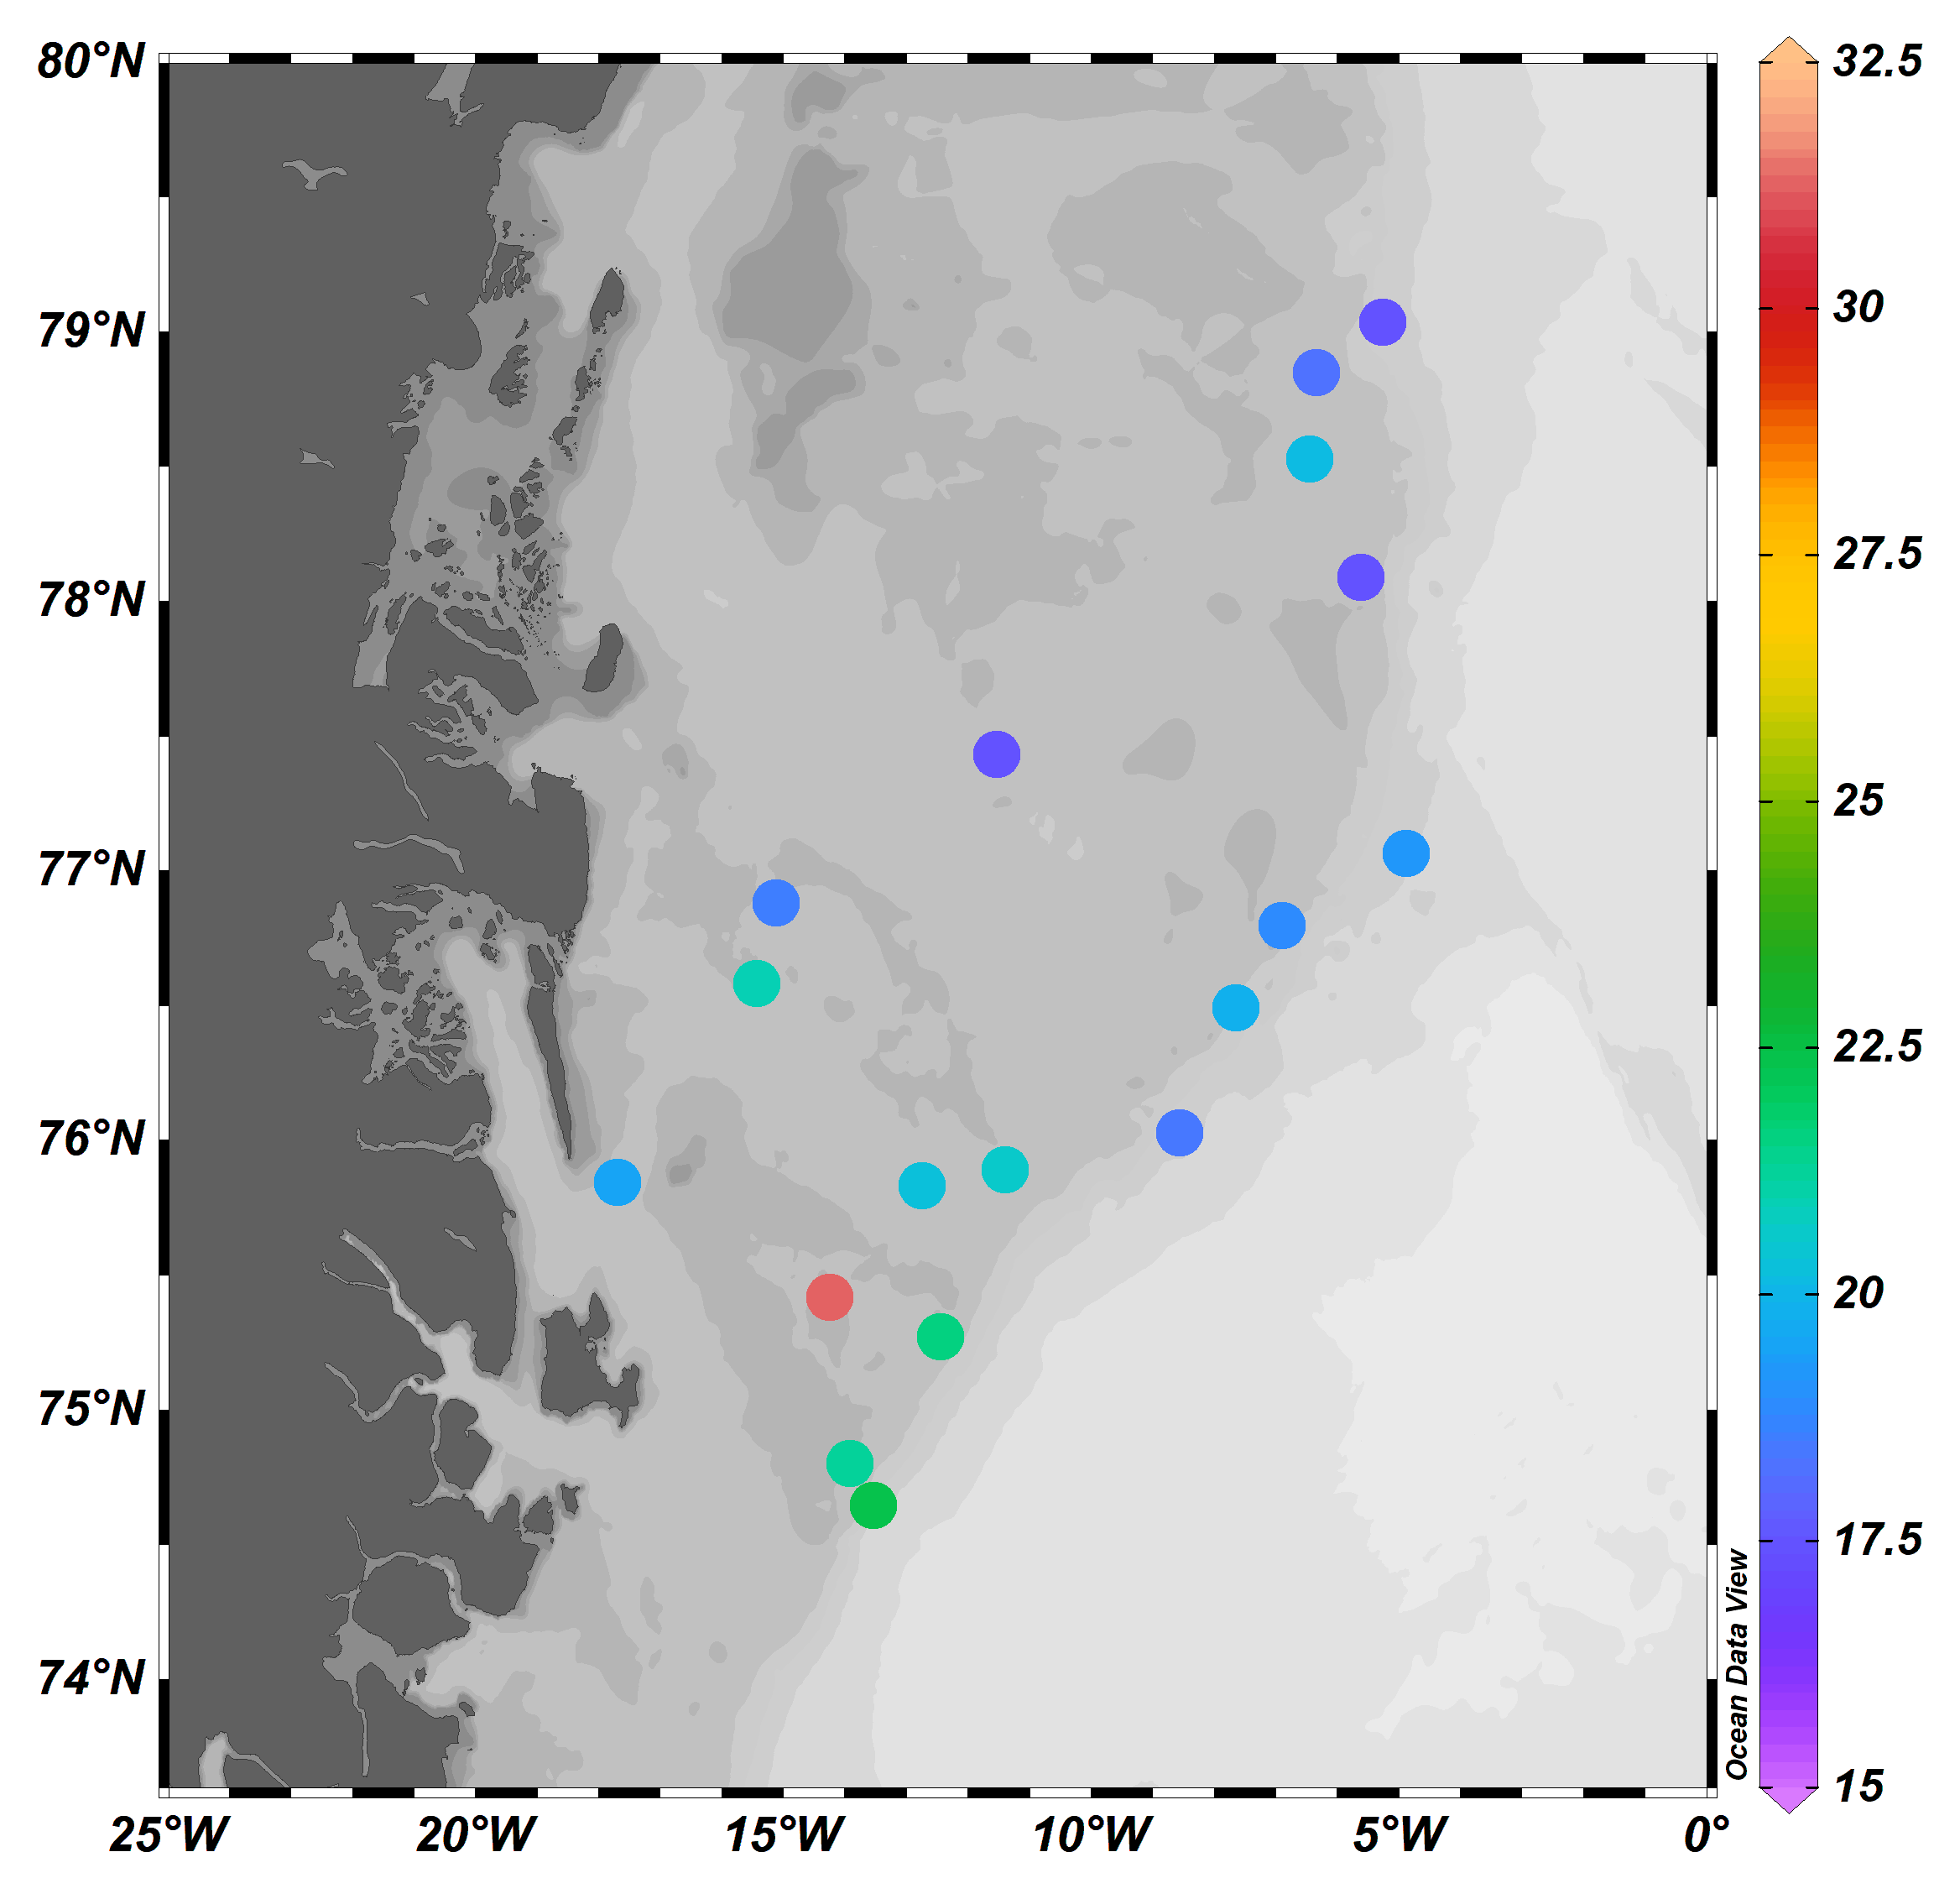
Figure S1. Average standard length (mm) of age-0 Boreogadus saida in the Greenland Sea in in August–September 2017.

Table S3. Median lengths of zooplankton taxa representing potential prey for age-0 fish in the Greenland Sea in August–September 2017. Prosome length for copepodites, carapace length for nauplii (µm), calculated from individuals collected between 0 and 100 m in the study area, by developmental stage. Taxa with average prosome length > 4 mm are not included. N: nauplii. C: copepodites. F: females
Taxon | Stage
 | N | C1 | C2 | C3 | C4 | C5 | F
Oithona similis | 170 | 260 | 325 | 375 | 425 | 480 | 525
Pseudocalanus spp. | 360 | 518 | 670 | 750 | 850 | 960 | -
Calanus spp. | 530 | 875 | 1250 | 1725 | 2025 | - | -
Calanus finmarchicus | - | - | - | - | - | 2500 | 2975
Calanus glacialis | - | - | - | - | - | 3475 | 3975
Calanus hyperboreus | - | - | 2250 | 3425 | - | - | -

References
Gauthier, S and Horne, JK. 2004. Potential acoustic discrimination within boreal fish assemblages. ICES J Mar Sci 61(5): 836-845. DOI:https://10.1016/j.icesjms.2004.03.033.
Geoffroy, M, Majewski, A, LeBlanc, M, Gauthier, S, Walkusz, W, Reist, JD, Fortier, L. 2016. Vertical segregation of age-0 and age-1+ polar cod (Boreogadus saida) over the annual cycle in the Canadian Beaufort Sea. Polar Biology 39(6): 1023–1037. DOI:https://10.1007/s00300-015-1811-z.
Lawson, GL, Wiebe, PH, Ashjian, CJ, Gallager, SM, Davis, CS, Warren, JD. 2004. Acoustically-inferred zooplankton distribution in relation to hydrography west of the Antarctic Peninsula. Deep Sea Research Part II: Topical Studies in Oceanography 51(17-19): 2041-2072.
Møller, E, Juul-Pedersen, T, Mohn, C, Dalgaard, M, Holding, J, Sejr, M, Schultz, M, Lemcke, S, Ratcliffe, N, Garbus, S, Clausen, D and Mosbech, A. 2019. Identification of offshore hot spots. An integrated biological oceanographic survey focusing on biodiversity, productivity and food chain relations. Aarhus, Denmark: Aarhus University, Danish Centre for Environment and Energy: Scientific Report No. 357. Available at http://dce2.au.dk/pub/SR357.pdf. Accessed 10 November 2020.
Ona, E. 1999. Methodology for target strength measurements. ICES Coop Res Rep 235: 59.
Simmonds, J, MacLennan, D. 2005. Fisheries acoustics: Theory and practice, 2nd edn. Oxford: Blackwell Publishing.
Stanton, TK, Chu, D and Wiebe, PH. 1998. Sound scattering by several zooplankton groups. II. Scattering models. J Acoust Soc Am 103(1): 236-53. DOI:https://10.1121/1.421110.
Stanton, TK and Chu, D. 2000. Review and recommendations for the modelling of acoustic scattering by fluid-like elongated zooplankton: euphausiids and copepods. ICES J Mar Sci 57(4): 793-807. DOI:https://10.1006/jmsc.1999.0517.

