Supplementary materials

Multi-scale temporal variability in biological-physical associations in a high latitude marine ecosystem
Silvana Gonzalez^{a*}, John Horneª, Seth L. Danielson^{b}, Lilian Lieber, Guzmán López
ªUniversity of Washington, School of Aquatic and Fishery Sciences, BOX 355020, Seattle, WA, 98195, USA
^{b}College of Fisheries and Ocean Sciences, University of Alaska Fairbanks, Fairbanks, AK, 99775, USA
^{c}Queen's University Belfast Marine Laboratory, The Strand, Portaferry BT22 1PF Northern Ireland, UK
^{d}Departamento de Modelización Estadística de Datos e Inteligencia Artificial (MEDIA), Centro Universitario Regional Este, Universidad de la República, Rocha, 27000, Uruguay
*Corresponding author: silgonz@gmail.com

Wavelet decomposition of acoustic backscatter data derived from acoustic Doppler current profiler (ADCP) measurements from transects conducted in the 2015 and 2017 Arctic Marine Biodiversity Observing Network (AMBON) cruises. These surveys were conducted during August 8th–September 5th in 2015 and August 5–24th in 2017. In the plots, the color bar represents wavelet power. The shaded area represents the cone of influence (edge effects) and the areas of significance are traced with a black line (95% confidence against white noise).
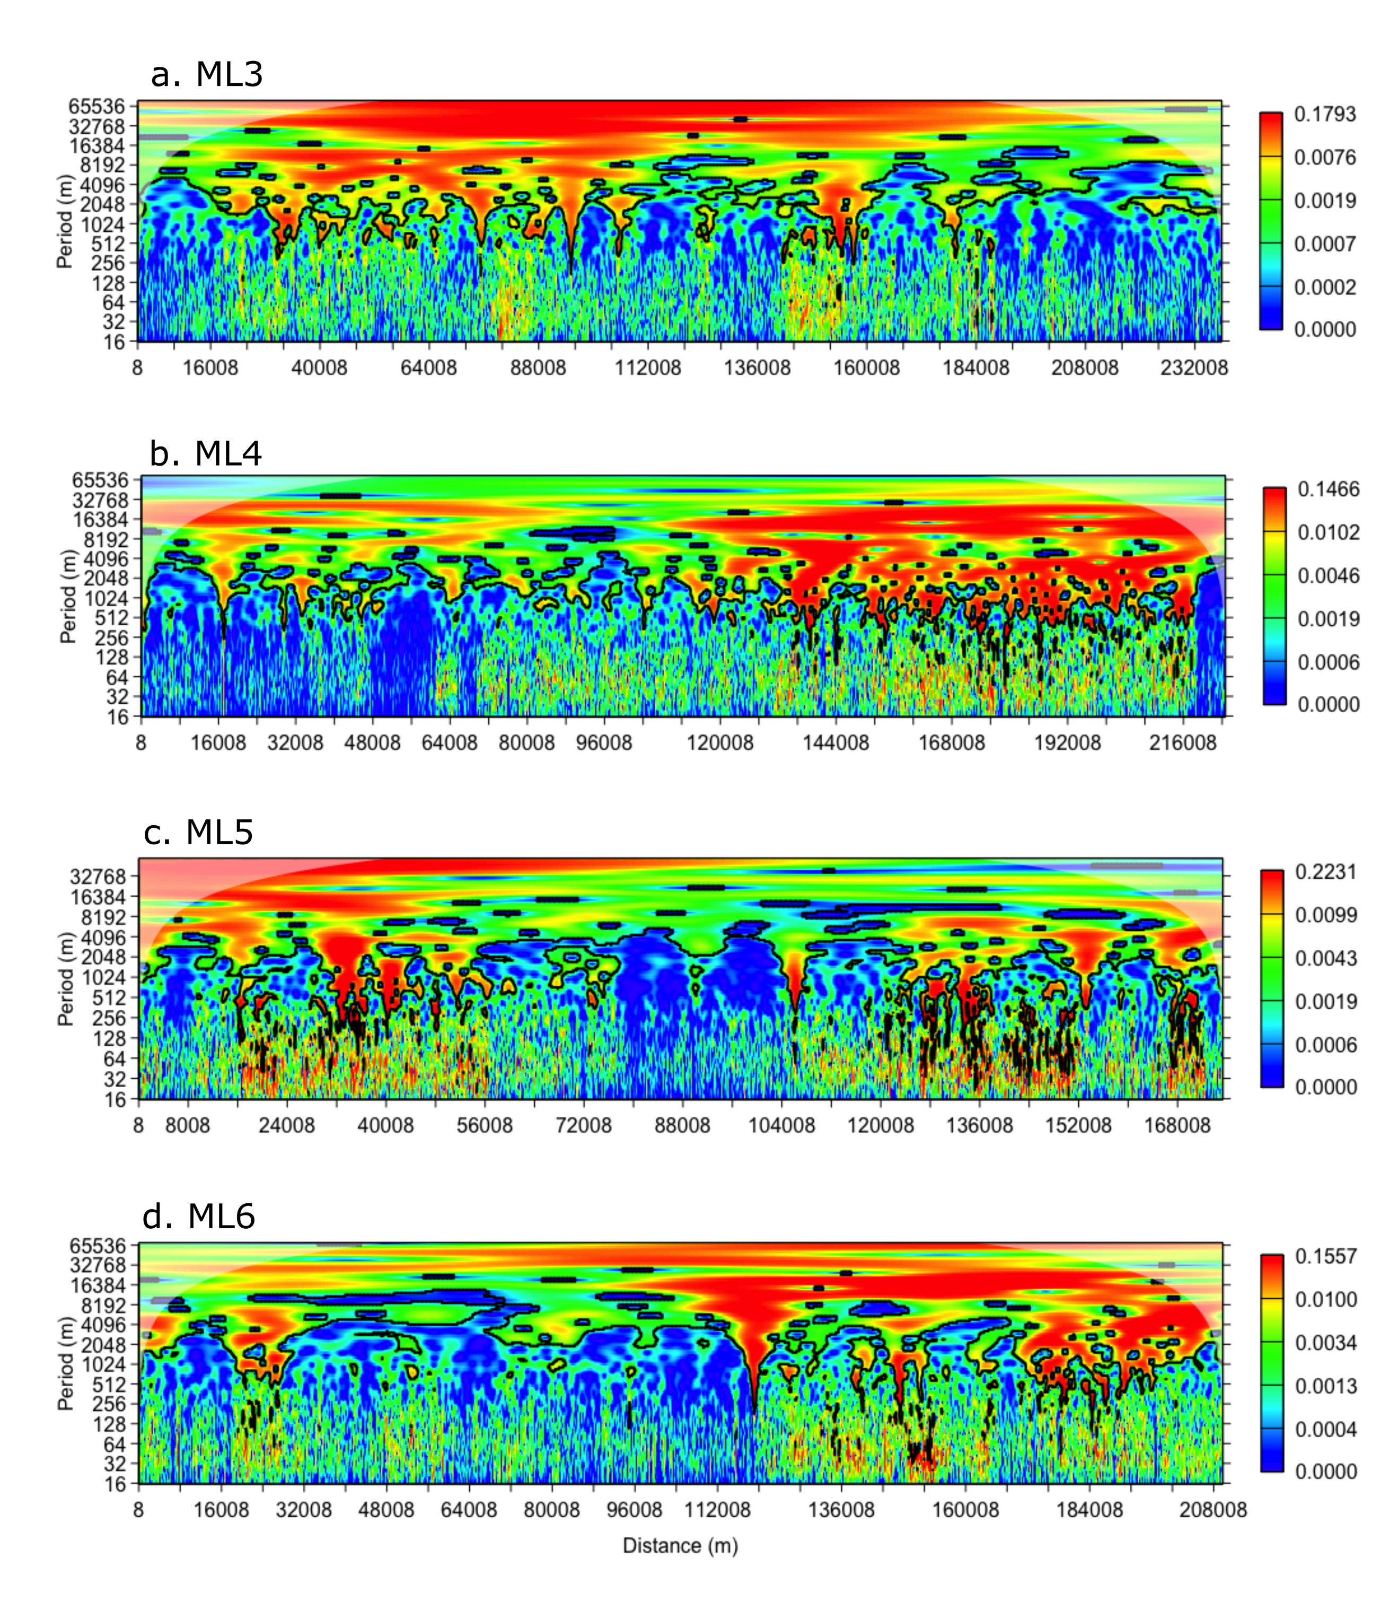
Figure S1. Wavelet decomposition of ADCP-derived acoustic backscatter data from the 2015 AMBON cruise transects: (a) ML3, (b) ML4, (c) ML5, and (d) ML6.

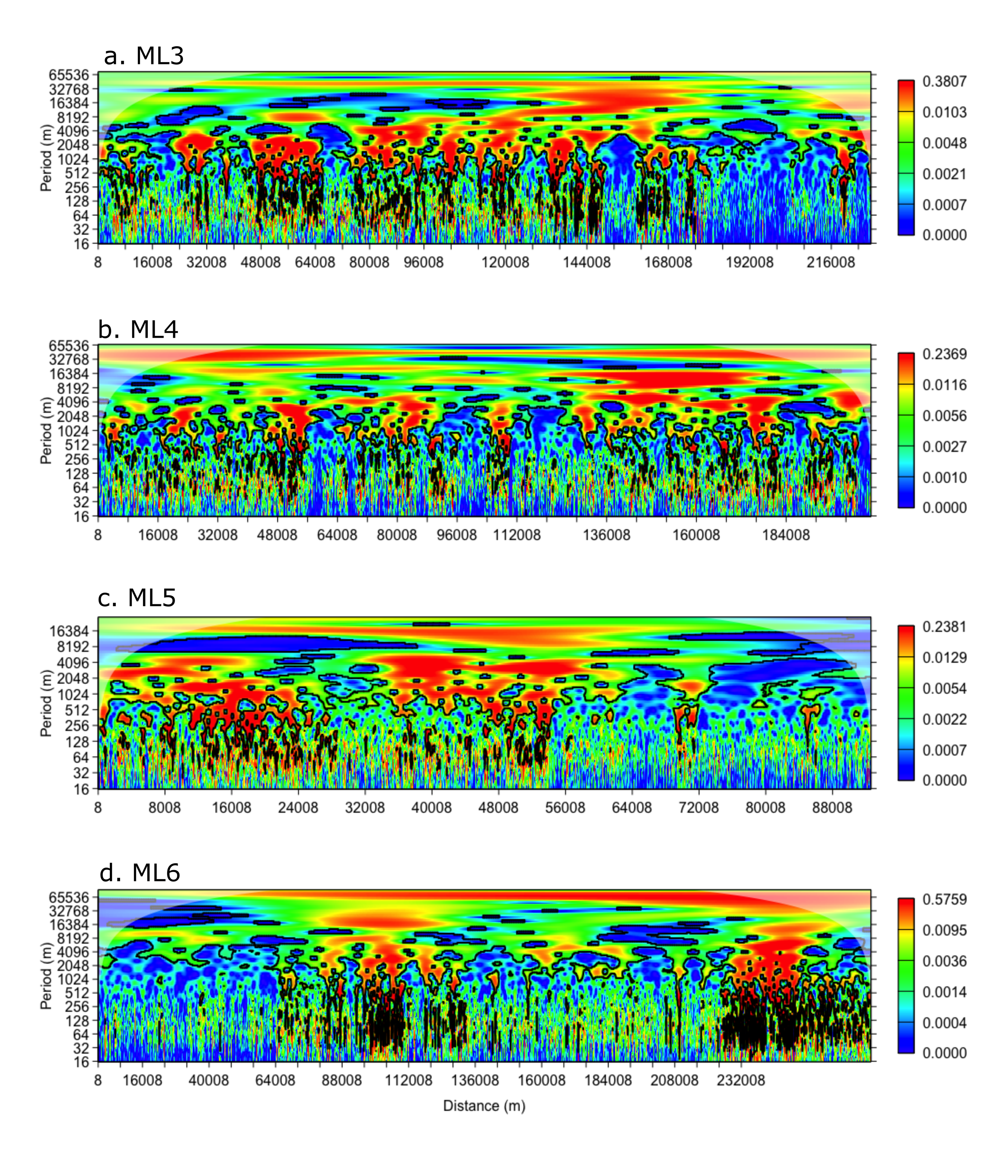
Figure S2. Wavelet decomposition of ADCP-derived acoustic backscatter data from the 2017 AMBON cruise transects: (a) ML3, (b) ML4, (c) ML5, and (d) ML6.

