Supplemental Material
A high-resolution gridded inventory of coal mine methane emissions for India and Australia
Pankaj Sadavarte*, Sudhanshu Pandey, Joannes D. Maasakkers, Hugo Denier van der Gon, Sander Houweling, Ilse Aben
¹SRON Netherlands Institute for Space Research, Utrecht, The Netherlands.
²Department of Climate, Air and Sustainability, TNO, Utrecht, The Netherlands.
³Department of Earth Sciences, Vrije Universiteit, Amsterdam, The Netherlands.
*Corresponding author: pankaj.sadavarte@gmail.com
List of Contents:
Figure S1. Top 5 coal producing countries in 2018. (a) Type of coal and (b) type of mine for top 5 coal producing countries in the year 2018. The annual coal production for China was compiled from Sheng et al., (2019), for India from provisional coal statistics (2018-19), MoC, 2019, for US from energy information administration (EIA) and for rest of the countries from https://yearbook.enerdata.net/coal-lignite/coal-production-data.html. The type of coal and type of mine categories were referred from global methane initiative country profiles report.
Figure S2. Trend in national coal production in India. Annual national coal production trend for India since 1996-97 in the categories of (a) types of coal – hard coal (bituminous/sub-bituminous) and brown coal (lignite) (b) type of mining – % national coal produced by surface and underground compiled from provisional coal statistics 2018-2019 report, MoC, 2019.
Figure S3. Trend in national coal production in Australia. Annual national raw coal production trend for Australia since 1996-97 in the categories of (a) types of coal – hard coal (bituminous/sub-bituminous) and brown coal (lignite) (b) type of mining – % national coal produced by surface and underground compiled from https://www.energy.gov.au/publications/australian-energy-update-2020, last accessed on 21st March 2021 and common report format (CRF) table 1.B.1 from national inventory report (NIR 2018, 2020).
Figure S4. Surface and underground coal mines. (a) Shown are surface mines in India. Similar patterns are found for surface coal mines in Australia (b) Underground coal mine in Australia. Parallel lines are found near underground mines in Australia which shows the panels below the surface where the longwall mining is done (c) Underground coal mine in India, an incline conveyor infrastructure is usually seen that forms the entry and exit point for the people and coal.
Figure S5. High methane emitting grids shown as fraction over India. Figures on the left top and bottom shows the methane emitting grids as fraction of the total coal mine methane emission from this study and EDGARv4.3.2. Large differences can be seen in the fractions and their spatial location. This study has identified location of surface and underground coal mines through various sources like Google Earth, annual reports and mining plans. Figure on the right shows the locations of coal deposits in India and the dotted box shows the region plotted for emission fraction comparison.
Figure S6. High methane emitting grids shown as fraction over Australia. Figures on the left top and bottom show the methane emitting grids from this study as fraction of the total coal mine methane emission over Queensland, New South Wales and Victoria from this study. Similarly, figures on right top and bottom are the emission fractions from EDGARv4.3.2. Large differences can be seen in the fractions and their spatial location. This study has identified locations of surface and underground coal mines through various sources like Google Earth, annual reports and mining plans. While Scarpelli et al., (2020) have re-distributed emissions as reported to UNFCCC using spatial proxies of EDGARv4.3.2.
Table S1. Coal mine methane emission estimates from various studies.
Table S2. Implied emission factor for Indian and Australian coal mines.
Table S3. Uncertainty assessment for India and Australia coal mines.

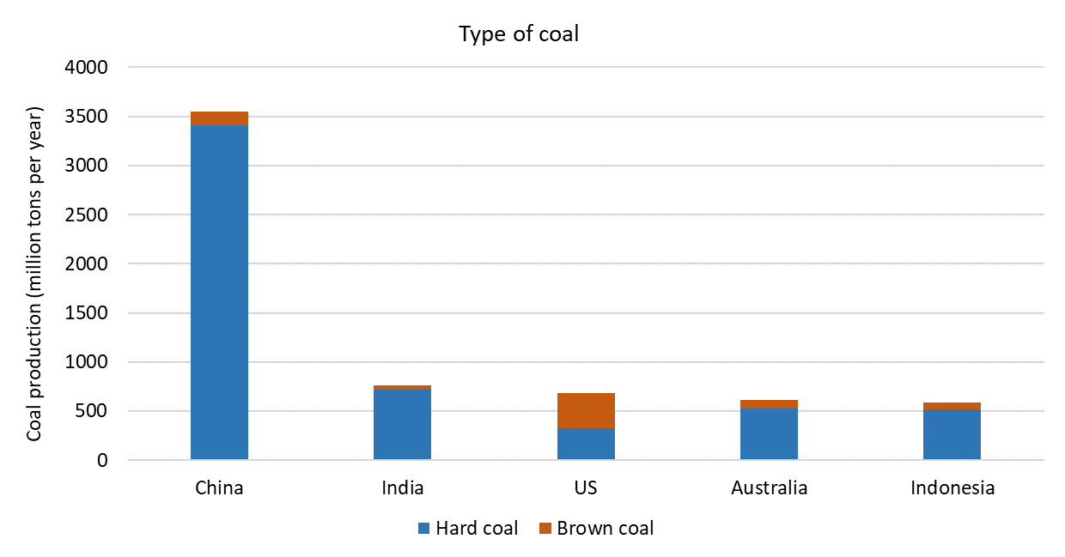
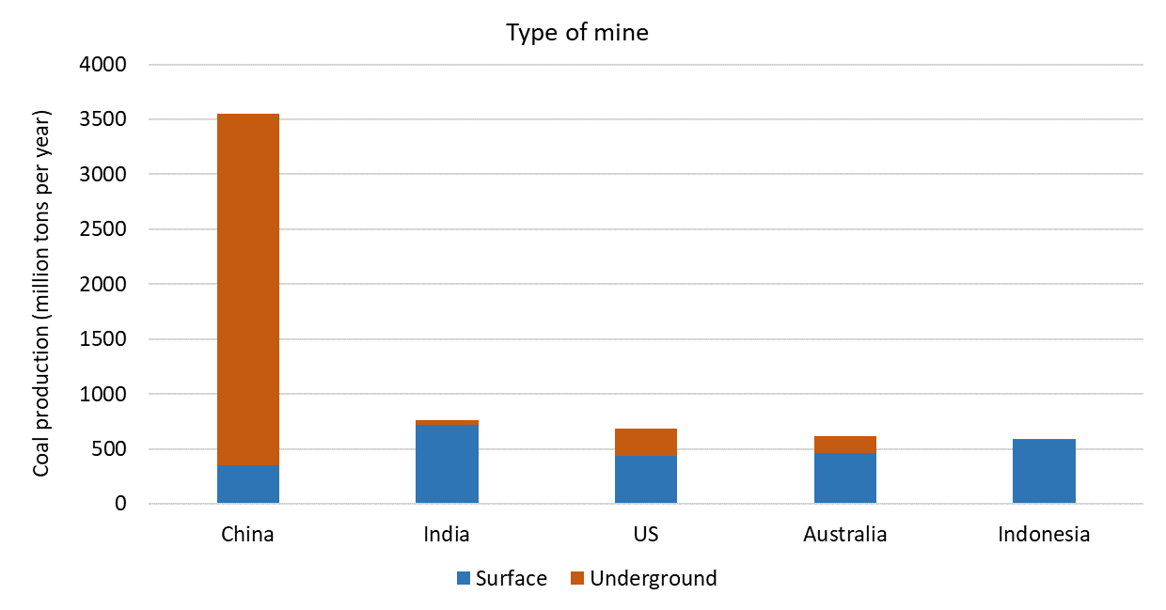
Figure S1. Top 5 coal producing countries in 2018. (a) Type of coal and (b) type of mine for top 5 coal producing countries in the year 2018. The annual coal production for China was compiled from Sheng et al., (2019), for India from provisional coal statistics (2018-19), MoC, 2019, for US from energy information administration (EIA) and for rest of the countries from https://yearbook.enerdata.net/coal-lignite/coal-production-data.html. The type of coal and type of mine categories were referred from global methane initiative country profiles report.

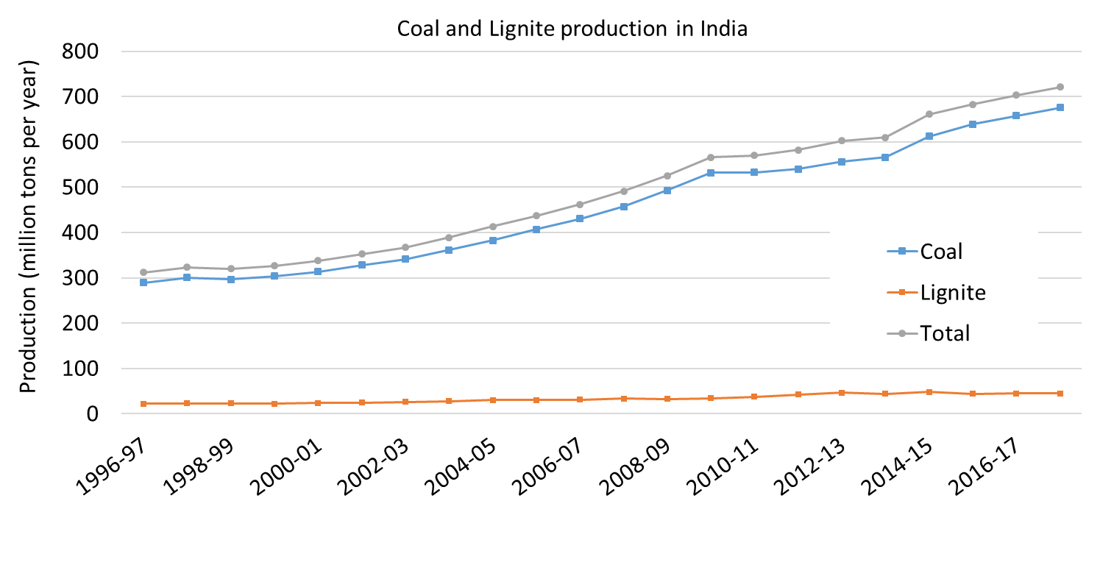
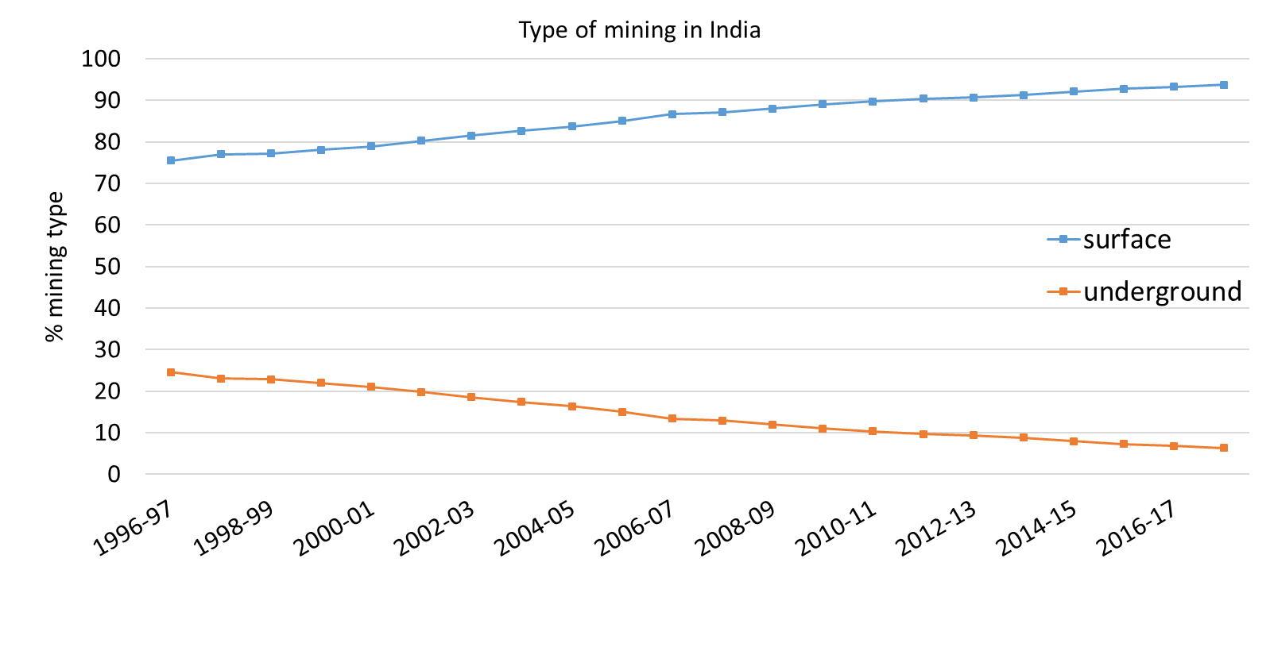
Figure S2. Trend in national coal production in India. Annual national coal production trend for India since 1996-97 in the categories of (a) types of coal – hard coal (bituminous/sub-bituminous) and brown coal (lignite) (b) type of mining – % national coal produced by surface and underground compiled from provisional coal statistics 2018-2019 report, MoC, 2019.

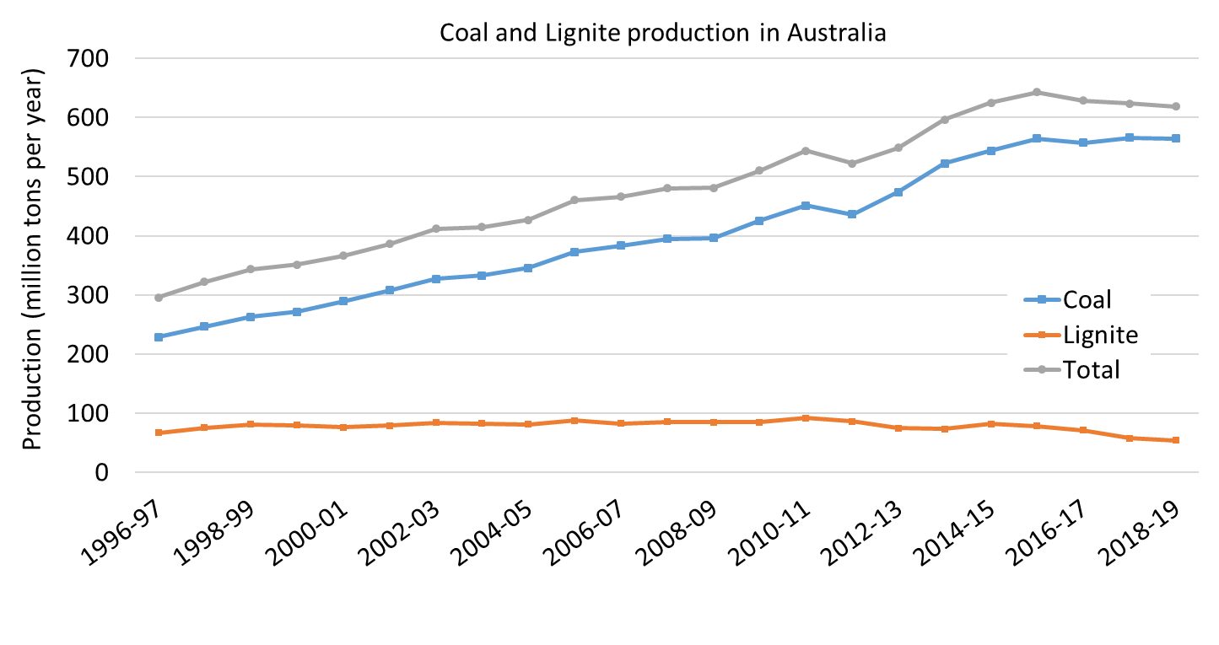
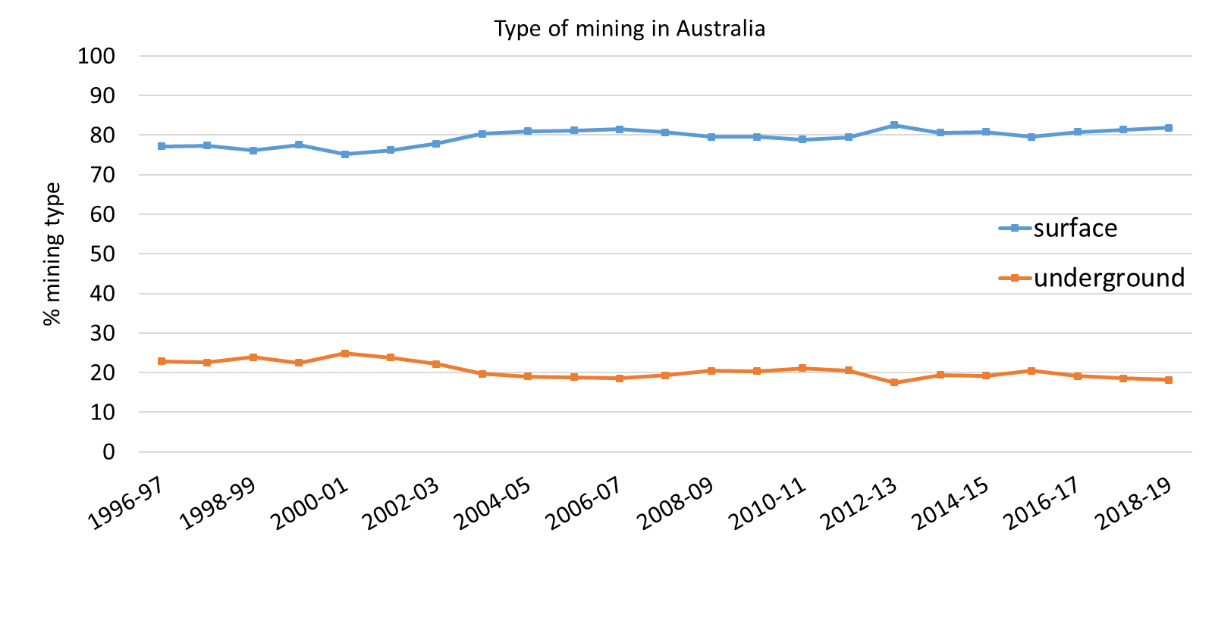
Figure S3. Trend in national coal production in Australia. Annual national raw coal production trend for Australia since 1996-97 in the categories of (a) types of coal – hard coal (bituminous/sub-bituminous) and brown coal (lignite) (b) type of mining – % national coal produced by surface and underground compiled from https://www.energy.gov.au/publications/australian-energy-update-2020, last accessed on 21st March 2021 and common report format (CRF) table 1.B.1 from national inventory report (NIR 2018, 2020).

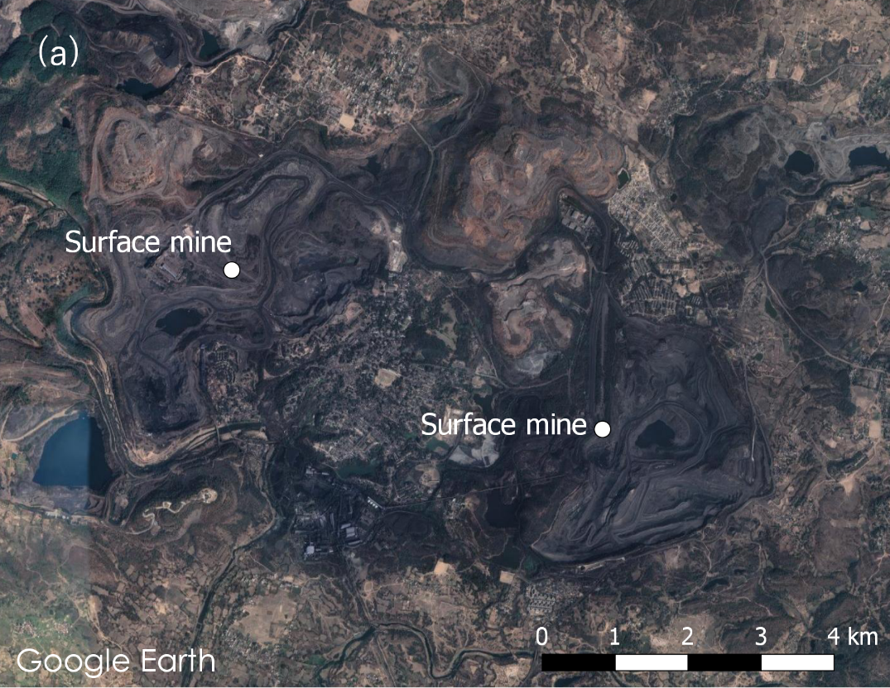
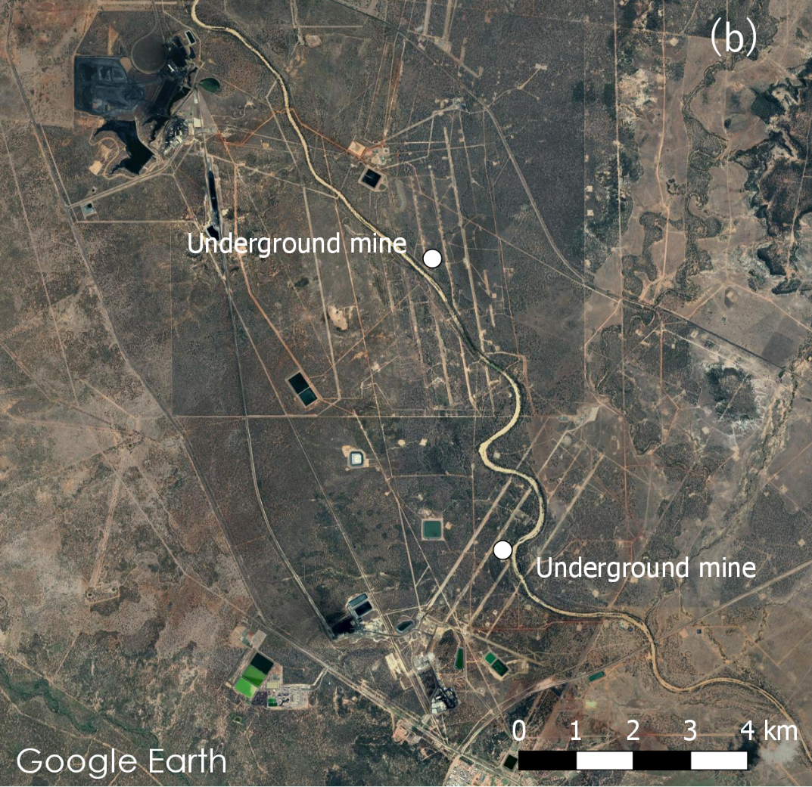

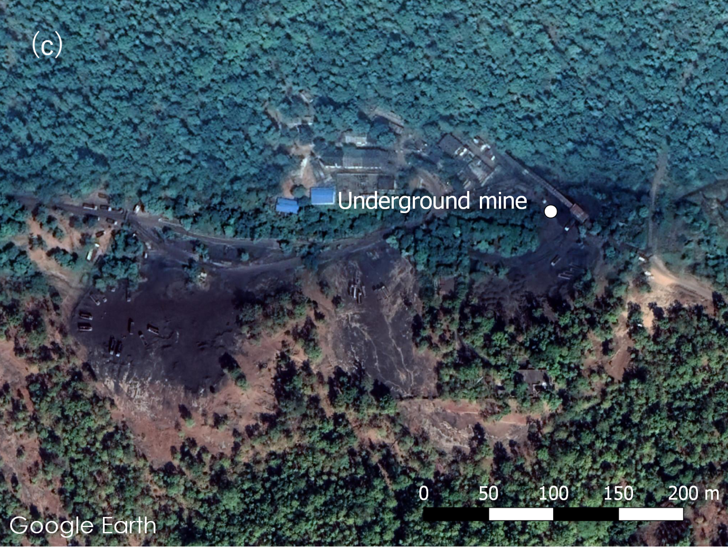
Figure S4. Surface and underground coal mines. (a) Shown are surface mines in India. Similar patterns are found for surface coal mines in Australia (b) Underground coal mine in Australia. Parallel lines are found near underground mines in Australia which shows the panels below the surface where the longwall mining is done (c) Underground coal mine in India, an incline conveyor infrastructure is usually seen that forms the entry and exit point for the people and coal.

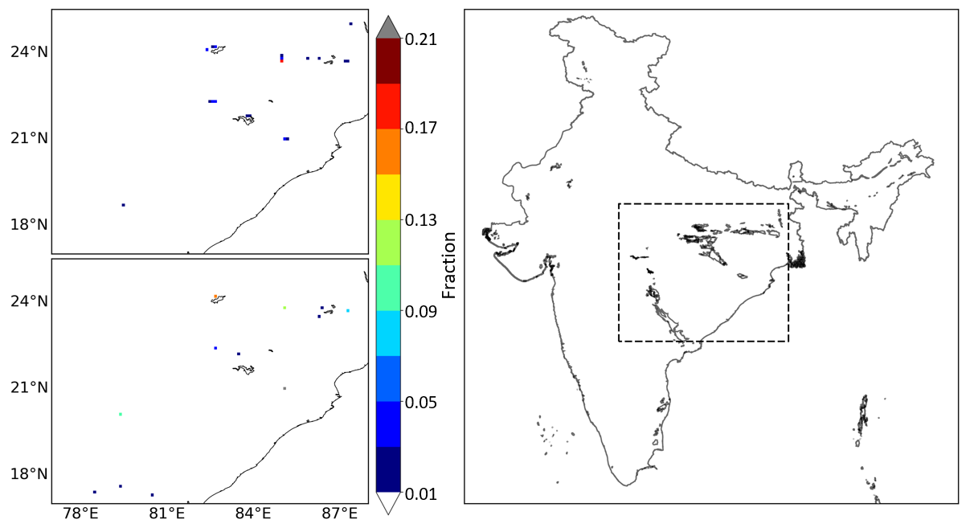
Figure S5. High methane emitting grids shown as fraction over India. Figures on the left top and bottom shows the methane emitting grids as fraction of the total coal mine methane emission from this study and EDGARv4.3.2. Large differences can be seen in the fractions and their spatial location. This study has identified location of surface and underground coal mines through various sources like Google Earth, annual reports and mining plans. Figure on the right shows the locations of coal deposits in India and the dotted box shows the region plotted for emission fraction comparison.
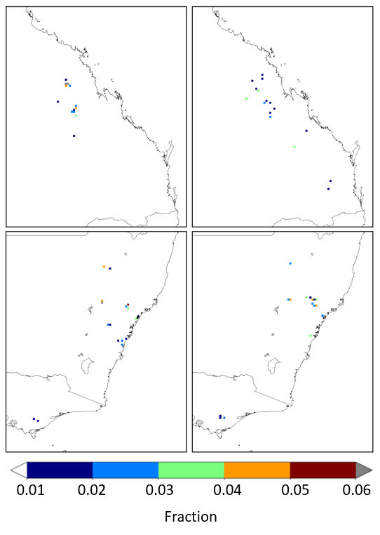
Figure S6. High methane emitting grids shown as fraction over Australia. Figures on the left top and bottom show the methane emitting grids from this study as fraction of the total coal mine methane emission over Queensland, New South Wales and Victoria from this study. Similarly, figures on right top and bottom are the emission fractions from EDGARv4.3.2. Large differences can be seen in the fractions and their spatial location. This study has identified locations of surface and underground coal mines through various sources like Google Earth, annual reports and mining plans. While Scarpelli et al., (2020) have re-distributed emissions as reported to UNFCCC using spatial proxies of EDGARv4.3.2.
Table S1. Coal mine methane emission estimates from various studies.
 | Methane emissions (Gg yr-1) for 2012
 | UNFCCC^{c} | EDGAR v4.3.2^{d} | GAINS^{e} | CEDS^{f} | Regional studies
China | 21015ª | 21701 | 24570 | 37736 | 17200^{g}
US | 2658 | 2527 | 2964 | 4594 | 2907^{h}
India | 788ª | 2333 | 1623 | 2569 | 770^{i}
Indonesia | 80^{b} | 2738 | 3400 | 1921
Australia | 1186 | 1228 | 1188 | 1212
ªEmissions from Second Biennial Update Report on Climate Change for base year 2014
^{b}Emissions from Second Biennial Update Report on Climate Change for base year 2012
^{c}Emissions compiled from National Inventory Report 2014 communicated to UNFCCC for base year 2012
^{d}Emissions from EDGARv4.3.2 global bottom-up inventory of greenhouse gases for year 2012
^{e}Emissions estimated using implied emission factor derived in Hoglund et al., 2012 and 2012 coal production data
^{f}Hosley et al., 2018
^{g}Sheng et al., 2019
^{h}Maasakkers et al., 2016
^{i}Singh et al., 2015

Table S2. Implied emission factor for Indian and Australian coal mines.

 | Year | Underground | Surface | National
IPCC defaultª
< 200m |  | 7.38 | 0.20
200-400m |  | 13.87 | 0.88
> 400m |  | 19.62 | 1.49
Kholod et al., 2020^{b}
< 200m |  | 10.08 | 2.03-3.38
200-400m |  | 12.79
> 400m |  | 14.62
Brown coal |  |  | 0.52
India
This study, Black coal | 2018 | 5.05 | 0.87 | 1.04
Brown coal | 2018 |  | 0.22
EDGARv4.3.2^{c} | 2012 |  |  | 3.87
EDGARv5.0^{d} | 2015 |  |  | 3.87
GAINS^{e} | 2012 |  |  | 2.70
CEDS^{f} | 2012 |  |  | 4.26
Australia
NIR^{g} | 2018 | 6.31 | 0.52 | 1.64
All units in kton CH₄ million ton-1 raw coal.
ª2006a IPCC guidelines for national greenhouse gas inventories, Vol. 2. Energy, Chapter 4, Fugitive emissions.
^{b}Kholod et al., 2020.
^{c}EDGARv4.3.2 CH₄ emissions for 2012 (Janssens-Maenhout, et al., 2019) and raw coal for corresponding year from provisional coal statistics 2018-2019.
^{d}EDGARv5.0 CH₄ emissions for 2015 and raw coal for corresponding year from provisional coal statistics 2018-2019.
^{e}Höglund-Isaksson, 2012 and raw coal for corresponding year from provisional coal statistics 2018-2019.
^{f}Hosley et al., 2018 and raw coal for corresponding year from provisional coal statistics 2018-2019.

Table S3. Uncertainty assessment for India and Australia coal mines.

Coal mines | CH₄ (Gg yr-1) | Uncertainty (%) in coal production | Uncertainty in emission factors | Propagated uncertainty | Fraction of total methane emission | Total uncertainty
Australia
Underground | 710.41 | 2.00ª | 10.00ª | 10.20ª | 7.45e | 11.20e
Surface | 262.58 | 6.30ª | 30.89ª | 31.53ª | 8.36e
Others |  | 5.00ª | 50.00ª | 50.25ª | 0.20e
India
Underground | 606.40 | 10.00^{b} | 100.00^{d} | 100.50 | 75.97e | 79.83e
Surface | 195.81 | 10.00^{b} | 100.00^{c} | 100.50 | 24.53e

ªNational inventory report, 2018, Volume-III, Annexes, page 137.
^{b}Solazzo et al., 2021, Table 1.
^{c}Third Biennial Update Report to The United Nations Framework Convention on Climate Change, Table 2.34.
^{d}Assumed similar to surface mining in India.
^{e}Calculated using IPCC Quantifying Uncertainties in Practice (Volume 1 Chapter 3 IPCC 2006b).

References:
NIR 2018. 2020. National Inventory Report 2018 – Volume III, Annexes, page 137. The Australian Government Submission to the United Nations Framework Convention on Climate Change, Australian National Greenhouse Accounts, May 2020.
Solazzo, E, Crippa, M, Guizzardi, D, Muntean, M, Choulga, M, and Janssens-Maenhout, G. 2021. Uncertainties in the Emissions Database for Global Atmospheric Research (EDGAR) emission inventory of greenhouse gases. Atmos. Chem. Phys., 21: 5655–5683.
IPCC. 2006b. Chapter 3 Uncertainties, in 2006 IPCC Guidelines for National Greenhouse Gas Inventories Volume 1: General Guidance and Reporting. Available at https://www.ipcc-nggip.iges.or.jp/public/2006gl/pdf/1_Volume1/V1_3_Ch3_Uncertainties.pdf.
Hoesly, RM, Smith, SJ, Feng, L, Klimont, Z, Janssens-Maenhout, G, Pitkanen, T, Seibert, JJ, Vu, L, Andres, RJ, Bolt, RM, Bond, TC, Dawidowski, L, Kholod, N, Kurokawa, JI, Li, M, Liu, L, Lu, Z, Moura, MCP, O’Rourke, PR, Zhang, Q. 2018. Historical (1750–2014) anthropogenic emissions of reactive gases and aerosols from the Community Emissions Data System (CEDS). Geosci. Model Dev. 11: 369–408.
Höglund-Isaksson L. 2012. Global anthropogenic methane emissions 2005-2030: Technical mitigation potentials and costs. Atmospheric Chemistry and Physics 12(19): 9079-9096.
Janssens-Maenhout, G, Crippa, M, Guizzardi, D, Muntean, M, Schaaf, E, Dentener, F, Bergamaschi, P, Pagliari, V, Olivier, JGJ, Peters, JAHW, van Aardenne, JA, Monni, S, Doering, U, Petrescu, AMR, Solazzo, E, Oreggioni, GD. 2019. EDGAR v4.3.2 Global Atlas of the three major greenhouse gas emissions for the period 1970–2012. Earth Syst. Sci. Data 11: 959–1002.
Kholod, N, Evans, M, Pilcher, RC, Roshchanka, V, Ruiz, F, Cote, M, Collings, R. 2020. Global methane emissions from coal mining to continue growing even with declining coal production. Journal of Cleaner Production 256: 1-12.
IPCC. 2006a. Chapter 4 Fugitive emissions, in 2006 IPCC Guidelines for National Greenhouse Gas Inventories Volume 2: Energy. Available at https://www.ipcc-nggip.iges.or.jp/public/2006gl/pdf/2_Volume2/V2_4_Ch4_Fugitive_Emissions.pdf
Sheng, J, Song, S, Zhang, Y, Prinn, RG, Janssens-Maenhout, G. 2019. Bottom-Up Estimates of Coal Mine Methane Emissions in China: A Gridded Inventory, Emission Factors, and Trends. Environ. Sci. Technol. Lett. 6: 473−478.
Maasakkers, JD, Jacob, DJ, Sulprizio, MP, Turner, AJ, Weitz, M, Wirth, T, Hight, C, DeFigueiredo, M, Desai, M, Schmeltz, R, Hockstad, L, Bloom, AA, Bowman, KW, Jeong, S, Fischer, ML. 2016. Gridded National Inventory of U.S. Methane Emissions. Environ. Sci. Technol. 50(23): 13123–13133.
Singh, H, Mallick, J. 2015. Utilization of Ventilation Air Methane in Indian Coal Mines: Prospects and Challenges. Procedia Earth and Planetary Science 11: 56–62.

