Supplemental Material

Soil volatile organic compound emissions in response to soil warming and nitrogen deposition
Romero-Olivares A.L.^{1a*}, Davie-Martin C.L.², Kramshøj M.^{2,3}, Rinnan R.^{2,3}, Frey S.D.¹
¹Department of Natural Resources and the Environment, University of New Hampshire, Durham, NH, 03824, USA
²Terrestrial Ecology Section, Department of Biology, University of Copenhagen, Universitetsparken 15, DK-2100 Copenhagen, Denmark
³Center for Permafrost (CENPERM), Department of Geosciences and Natural Resource Management, University of Copenhagen, Øster Voldgade 10, DK-1350Copenhagen, Denmark
ªCurrent address: Department of Biology, New Mexico State University, Las Cruces, NM, 88001, USA
*Corresponding author: alro@nmsu.edu

Supplementary Figure 1. Field setup and modified LI-COR used to collect VOCs; a) shows the field setup of the modified LI-COR connected to IRGA and a computer; b) shows a closeup of the modified LI-COR; c) specific modifications in tubing that allowed for insertion and removal of adsorbent tubes; d) an example of the inside of a soil collar where the modified LI-COR was places for collection of VOCs.

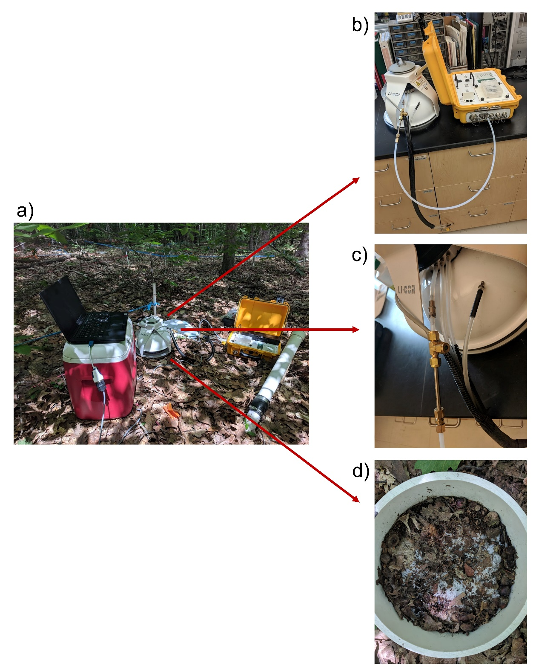

Supplementary Figure 2. Blank VOC emissions at the Soil Warming × Nitrogen Addition Study at Harvard Forest for each sampling time across two consecutive years. Total emissions (height of bars) are divided into VOC classes (denoted by different colors). Benzenoids (Bz), monoterpenoids (MT), sesquiterpenoids (ST).
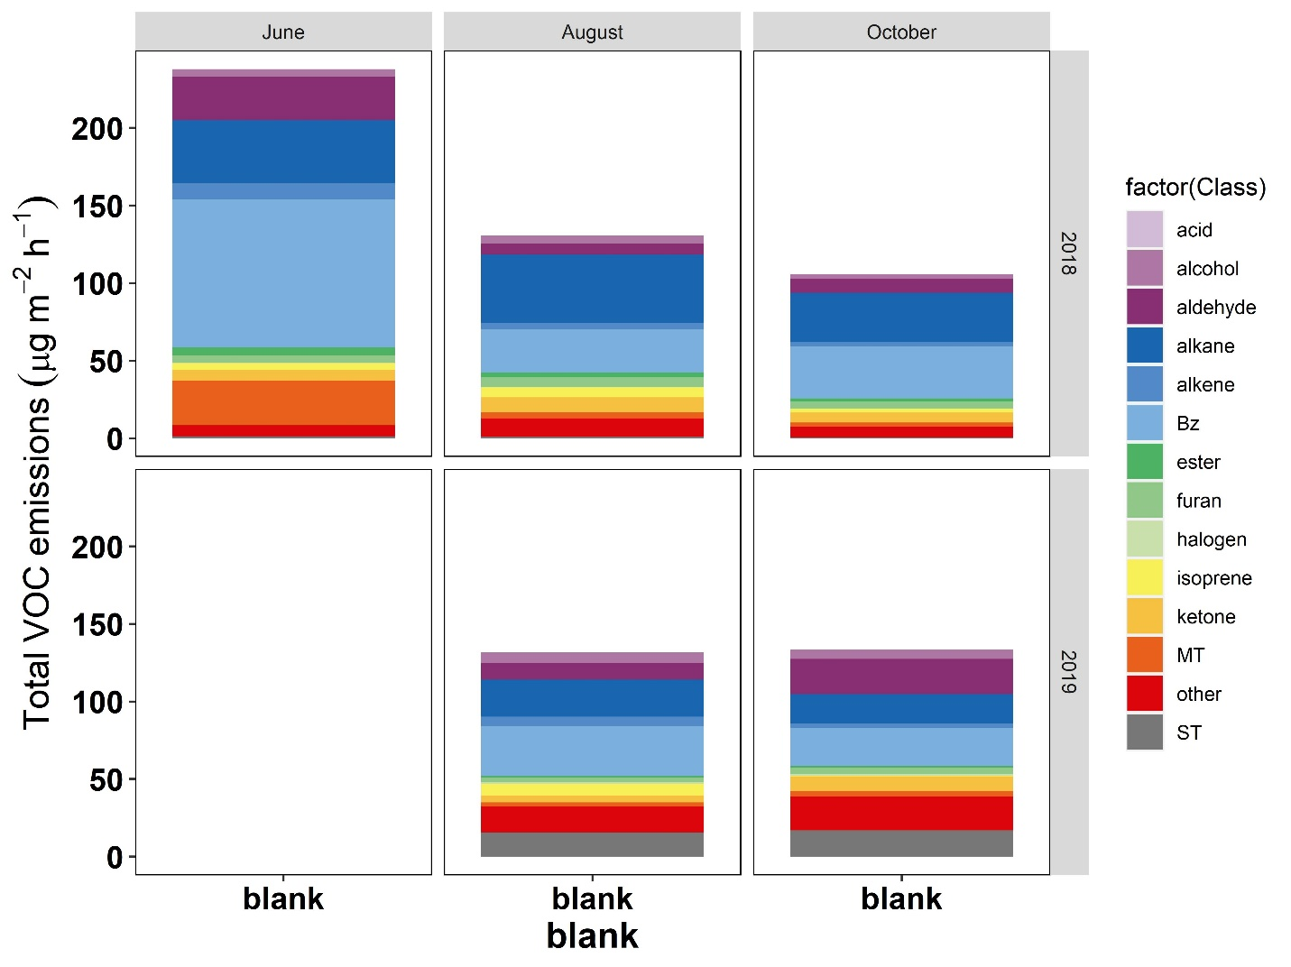

Supplementary Figure 3. Venn diagrams of the VOCs found in each sampling time (a, b, c, d, and e) and Venn diagram of the VOCs found in both years in all samplings (f). The complete list of VOCs, including unique VOCs per sampling time per treatment, can be found in Supplementary File 1. The areas in the diagram are not propotional to overlap.

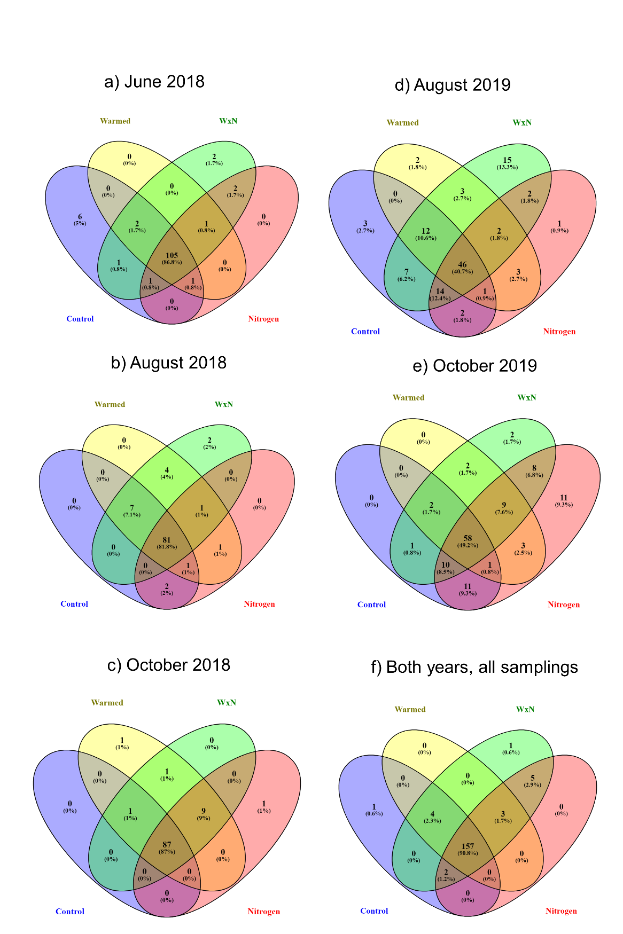

Supplementary Figure 4. Differences in VOC emissions between treatments and sampling times at the Soil Warming × Nitrogen Addition Study at Harvard Forest depicted by non-metric multidimensional scaling (NMDS) ordination. Different treatments are shown in different colors and different symbols represent each sampling time.

- Includes only the highest emitted VOCs (i.e., 50% of VOCs with total highest emissions across all sampling times)
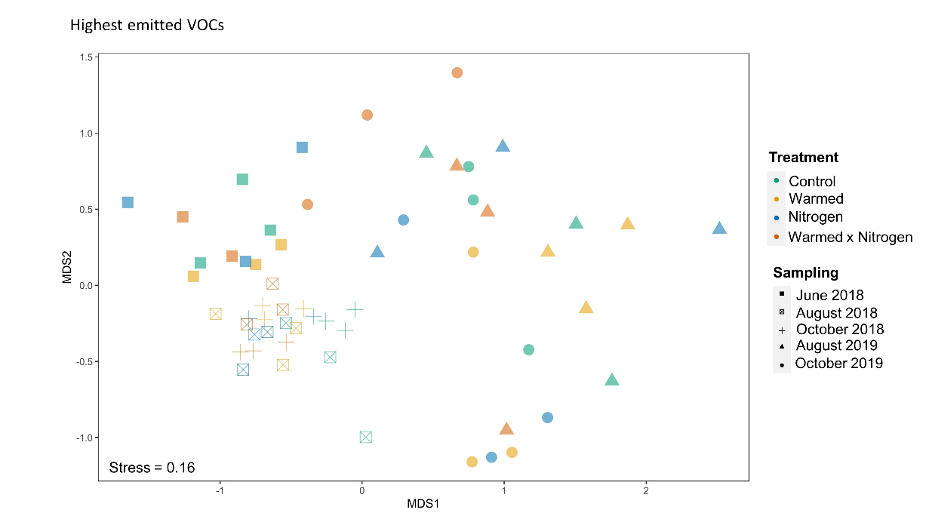
- Includes only the lowest emitted VOCs (i.e., 50% of VOCs with total lowest emissions across all sampling times)
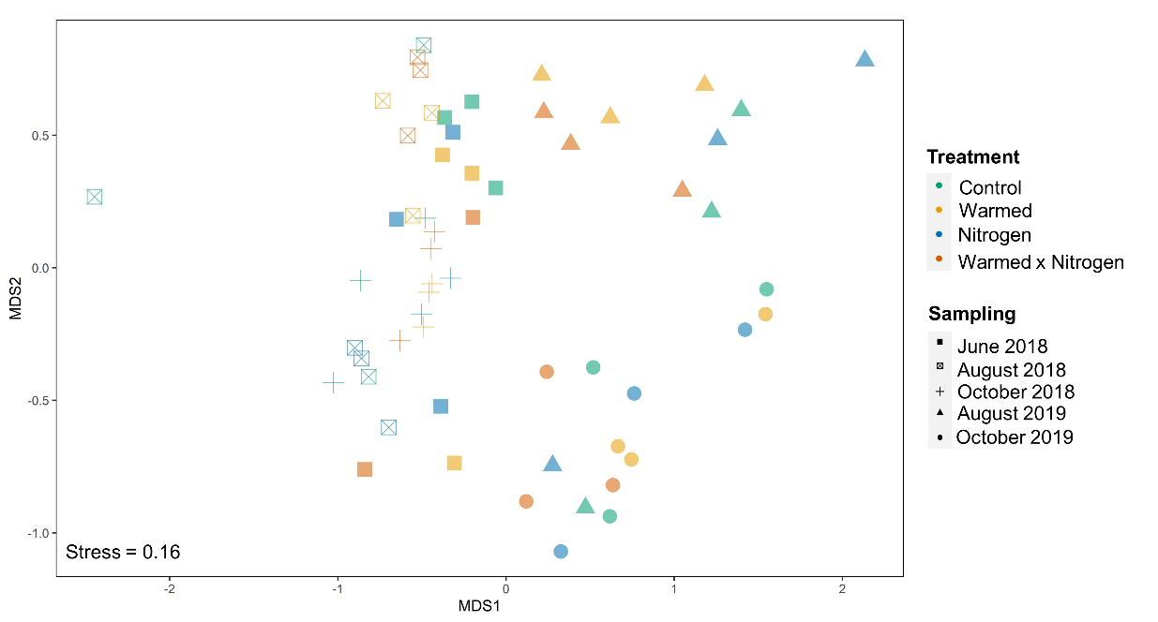

- Total VOCs in 2018.

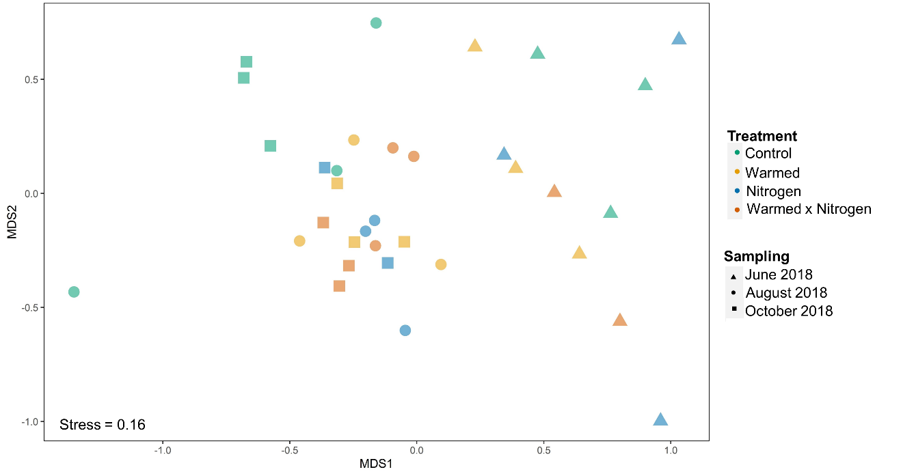

- Total VOCs in 2019.

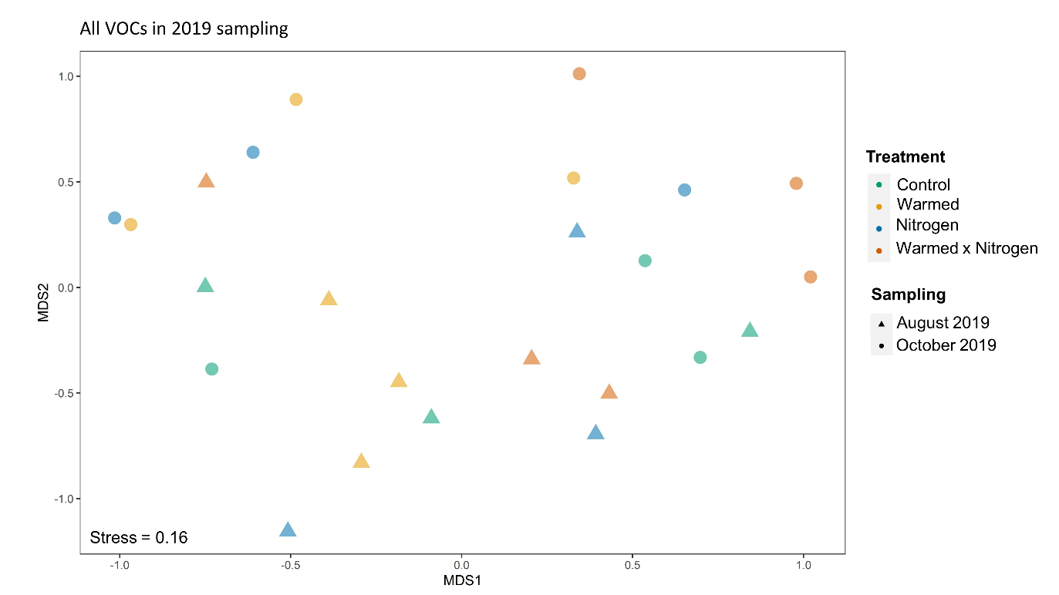

Supplementary Table 1. Average climatic conditions from 11 am to 3 pm on each sampling date collected from the closest meteorological station at Harvard Forest (i.e., Fisher Meteorological Station), which collects data every 15 minutes (Boose, 2021) and analysis date for each sampling.

Sampling | Air temperature  (°C) | Precipitation  (mm) | Relative humidity  (%) | Global solar radiation  (watt m⁻²) | Wind speed  (m sec⁻¹) | Barometric pressure  (millibar) | Analysis date
June 11, 2018 | 18.75 | 0 | 50.62 | 715.93 | 1.24 | 1019.37 | June 26, 2018
August 10, 2018 | 25.63 | 0 | 58.93 | 622.06 | 0.90 | 1014.00 | October 18-22, 2018
October 4, 2018 | 19.75 | 0 | 88.87 | 286.37 | 2.06 | 1014.43 | October 18-22, 2018
August 28, 2019 | 22.58 | 0.11 | 72.06 | 408.87 | 1.44 | 1013.87 | November 1-8, 2019
October 15, 2019 | 12.97 | 0 | 42.18 | 542.56 | 1.49 | 1019.87 | November 1-8, 2019

Other supplemental material provided as separate files
Supplementary Table 2. Complete list of VOCs by sampling date, treatment, and their emission rate. Benzenoids (Bz), monoterpenoids (MT), sesquiterpenoids (ST). Presented as a separate xlsx file.
Supplementary Text 1. VOCs in Venn diagrams. Scroll down for each sampling date, for each year, and for both years. Presented as a txt file.

