Supplemental Materials

Phytoplankton size-class contributions to new and regenerated production during the EXPORTS Northeast Pacific Ocean field deployment

Meredith G. Meyer¹, Weida Gong¹, Sile M. Kafrissen², Olivia Torano¹, Diana E. Varela^{2,3}, Alyson E. Santoro⁴, Nicolas Cassar⁵, Scott Gifford¹, Alexandria K. Niebergall⁵, Garrett Sharpe¹, and Adrian Marchetti^{1*}

¹Department of Earth, Marine and Environmental Sciences, University of North Carolina at Chapel Hill, Chapel Hill, NC, USA
²School of Earth and Ocean Sciences, University of Victoria, Victoria, Canada
³ Department of Biology, University of Victoria, Victoria, Canada
⁴Department of Ecology, Evolution and Marine Biology, University of California, Santa Barbara, CA, USA
⁵Division of Earth and Climate Sciences, Nicholas School of the Environment, Duke University, Durham, NC, USA

*corresponding author: amarchet@email.unc.edu

Figure Captions

Figure S1. Incubator temperature by day during the EXPORTS observational period. Temperature (ºC) for the incubator with a chiller to maintain ambient temperature at 1% I_{o} (blue line) and for the incubator without a chiller (black line) over the course of the observational period.

Figure S2. Size-fractionated summed total versus total net primary productivity and nitrate uptake rates. Summed totals of small (<5 µm) and large (≥5 µm) fractions versus total cells for a) net primary productivity (¹³C-ρDIC, NPP) and b) nitrate uptake rates (¹⁵N-ρNO₃⁻) for discrete samples throughout the euphotic zone over the course of the observational period.

Figure S3. Discrete size-fractionated ¹³C-ρDIC and ¹⁵N-ρNO₃⁻ for 6 hr incubations vs. 24 hr incubations. Small (<5 µm), large (≥5 µm), and total a) ¹³C-ρDIC (µmol C L⁻¹) and b) ¹⁵N-ρNO₃⁻ (nmol N L⁻¹) from the 6 hr incubations and the 24 hr incubations within the mixed layer. A 1:1 line is noted.

Figure S4. Daily photosynthetic active radiation. Irradiance levels (µmol photons m⁻² s⁻¹) measured at the percent of incidence irradiance (I_{o}) depths where sample collections occurred throughout the euphotic zone. The 6 hr primary productivity incubation periods are provided by the vertical dashed lines and the productivity saturation levels (E_{k}) by the horizontal dashed lines.

Figure S5. Depth profiles of ambient macronutrient concentrations by day. a) nitrate (µmol L⁻¹), b) ammonium (µmol L⁻¹), c) phosphate (µmol L⁻¹), and d) silicate (µmol L⁻¹) concentrations by depth and Julian day over the course of the observational period.

Figure S6. Size-fractionated particulate carbon to chlorophyll a ratios. Size-fractionated particulate carbon (PC) to chlorophyll a ratios for a) small fraction (<5 µm) and b) large fraction (≥5 µm) in the mixed layer throughout the observational period.

Figure S7. Size-fractionated chlorophyll a and total particulate carbon from the Canadian Line P cruise. a) Size-fractionated chlorophyll a (µg L⁻¹) and b) total particulate carbon (PC; µmol C L⁻¹) depth profiles from the Canadian Line P cruise on JD 264 at the EXPORTS site.

Figure S8. Size-fractionated depth-integrated primary productivity within and below the mixed layer. Depth-integrated total net primary productivity, new production, and regenerated production rates (mmol C m⁻² d⁻¹) a) in the mixed layer and b) from the base of the mixed layer to the base of the euphotic zone throughout the observational period.

Figure S9. ¹³C-ρDIC, ¹⁵N-ρNO₃⁻, ¹⁵N-ρNH₄⁺, and ¹⁵N-ρUrea uptake from the Canadian Line P cruise. Depth profiles of a) NPP (¹³C-ρDIC; µmol C L⁻¹), b) new production (¹⁵N-ρNO₃⁻; nmol N L⁻¹), c) ammonium uptake (¹⁵N-ρNH₄⁺; nmol N L⁻¹), and d) urea uptake (¹⁵N-ρUrea; nmol N L⁻¹) uptake from the Canadian Line P cruise on JD 264 at the EXPORTS site.

Figure S10. Comparison of size-fractionated f-ratios. Comparison of the method 1 ($\frac{(6 hr{}_{}^{15}{N{\text{-} NO}_{3}^{-}*6.6)}}{6 hr{}_{}^{13}{C\text{-} DIC}};$Equation 2) and method 2 ($\frac{6 hr{}_{}^{15}{N{\text{- }NO}_{3}^{-}}}{6 hr{}_{}^{15}{N{\text{-} NO}_{3}^{-}+6 hr{}_{}^{15}{N{\text{- }NH}_{4}^{+}}}}*6.6;$Equation 3) for f-ratio calculations on JD 246 and 250. The average f-ratios for the small fraction (<5 µm) and the large fraction (≥5 µm) differed by 0.10 and 1.01, respectively, depending on the calculation method used. Those f-ratios greater than one indicate a majority of new production.

Figure S11. Size-fractionated carbon and nitrate assimilation rates. Size-fractionated biomass-normalized a) carbon uptake rates (¹³C-VDIC; d⁻¹), and b) nitrate uptake rates (¹⁵N-VNO₃^{-;} d⁻¹) for the small fraction (<5μm), large fraction (≥5 μm) and total integrated throughout the euphotic zone for each sample day. Carbon uptake rates are normalized by particulate carbon concentrations and nitrate uptake rates are normalized by particulate nitrogen.

Figure S1.
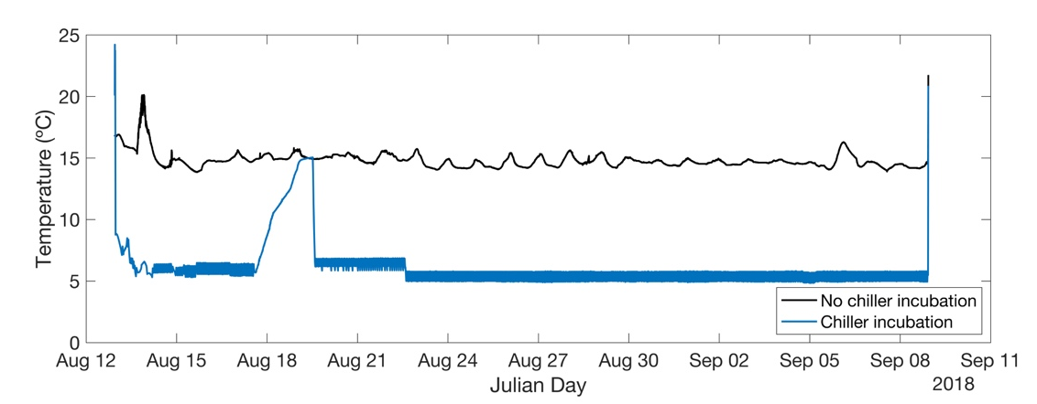

Figure S2.

Figure S3.

Figure S4.
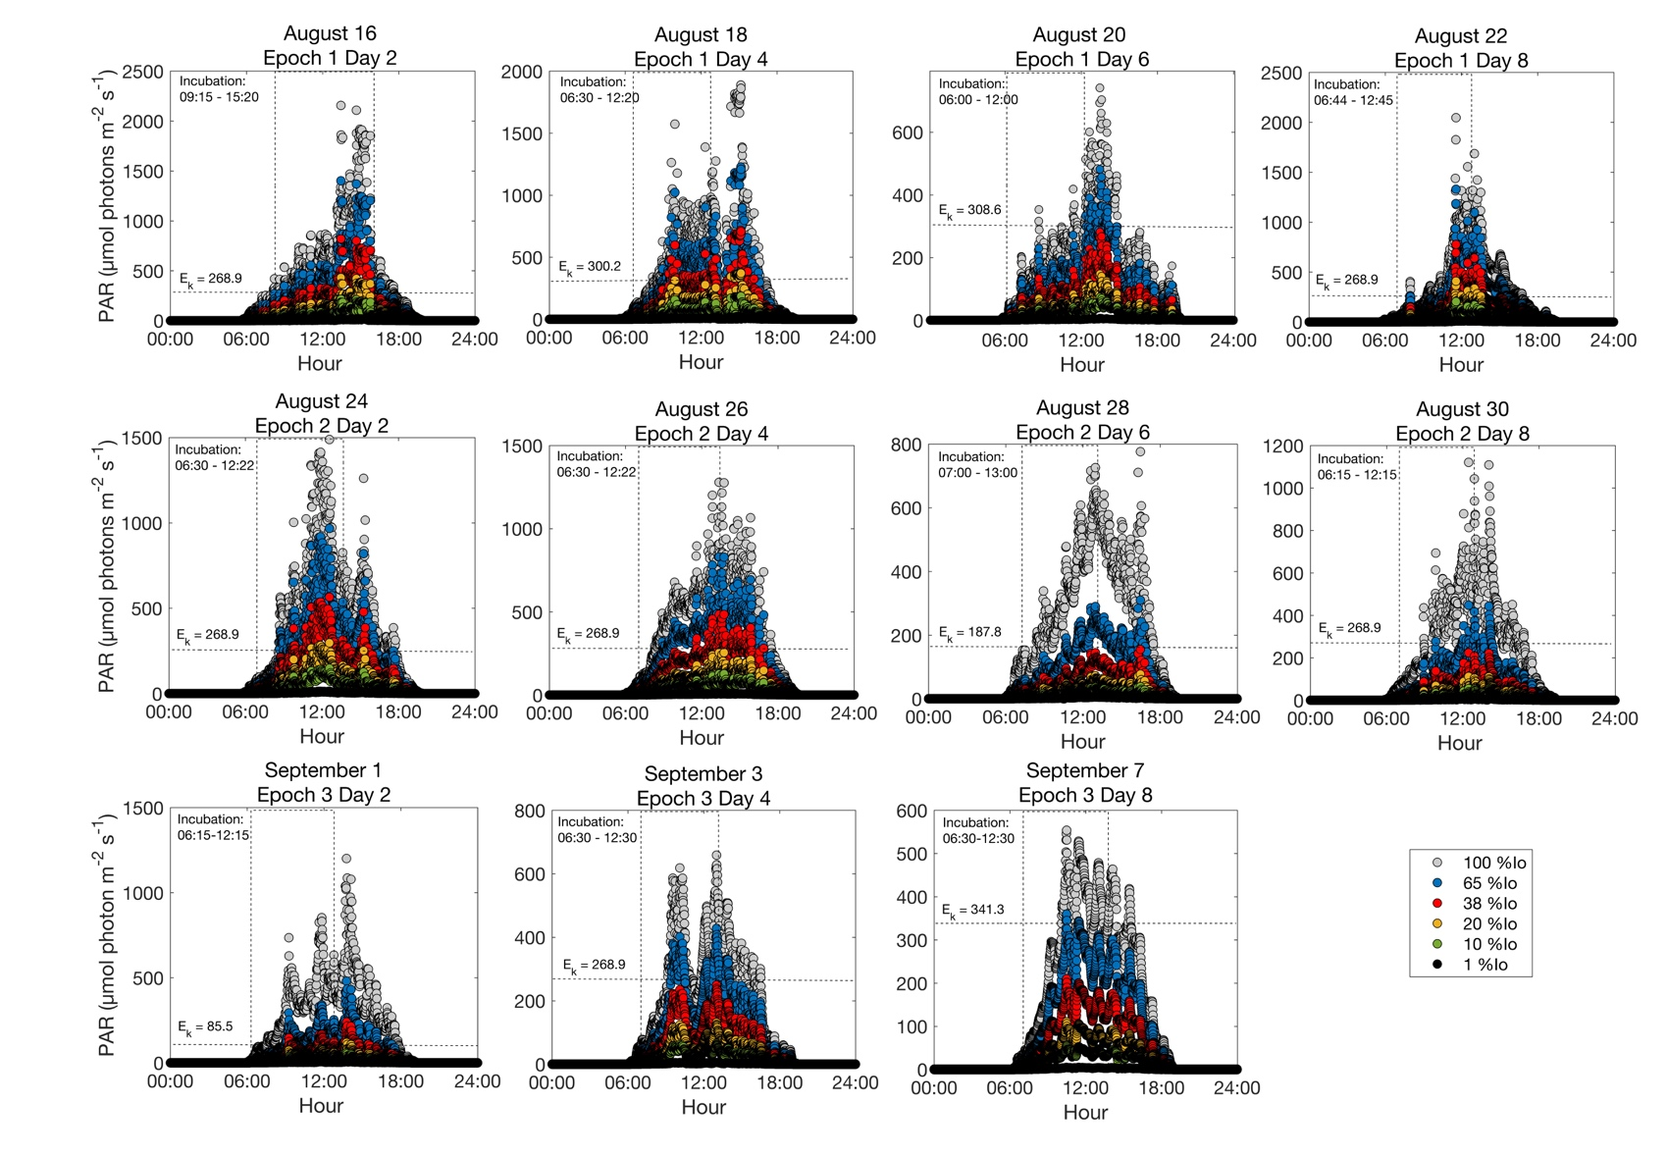

Figure S5.

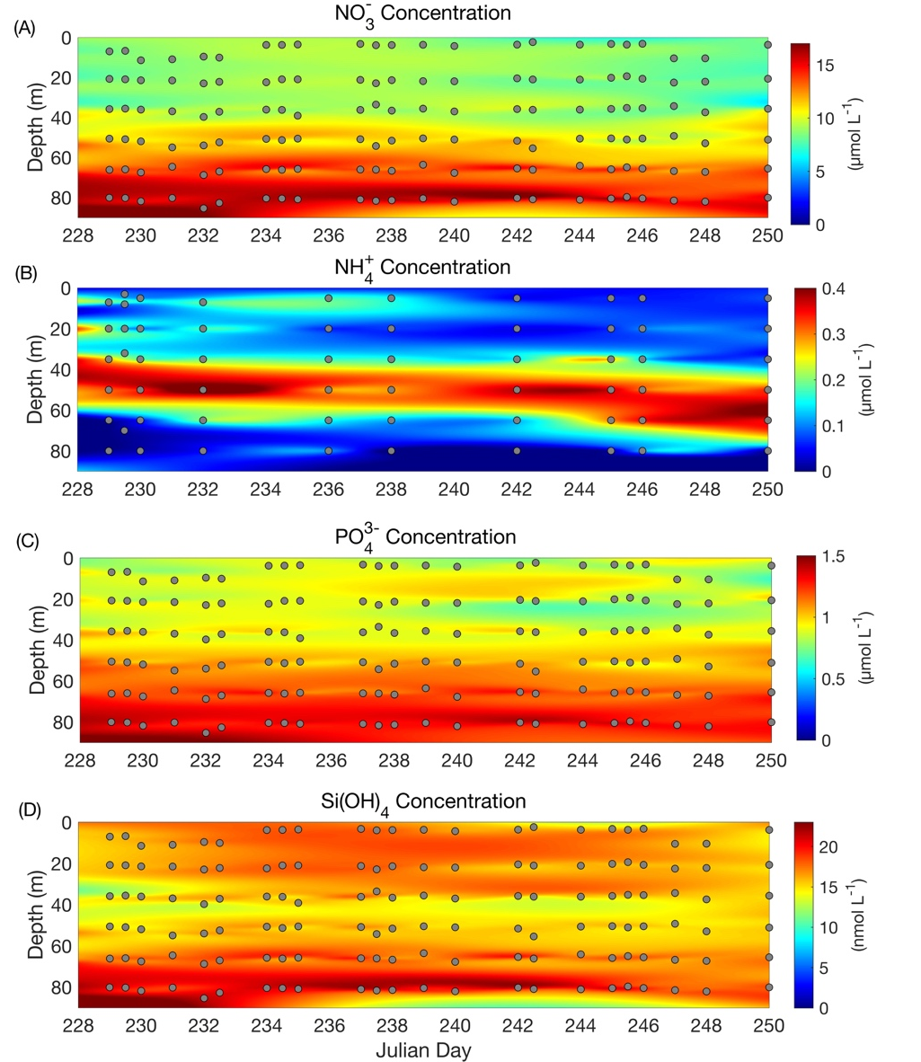
Figure S6.
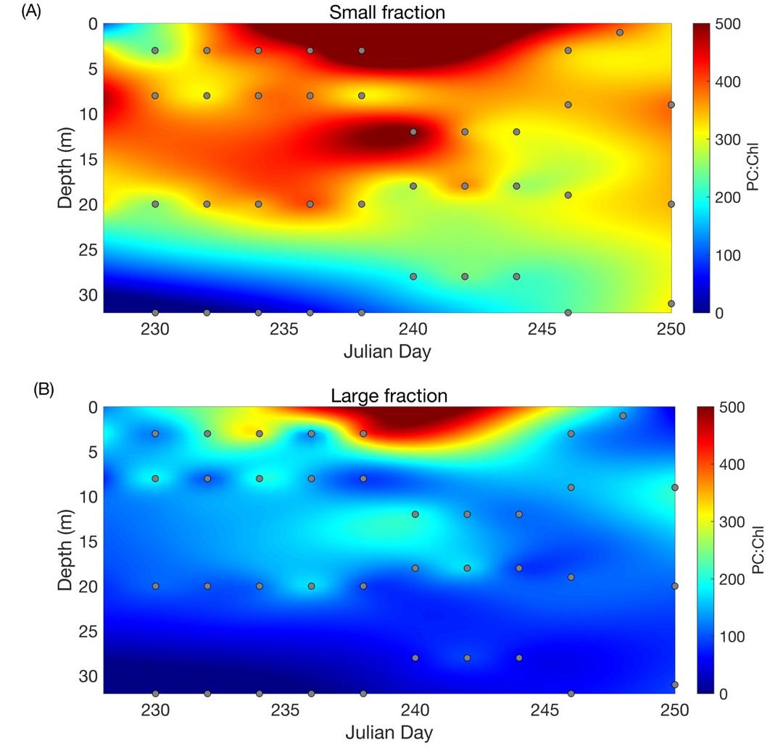
Figure S7.

Figure S8.

Figure S9.

Figure S10.

Figure S11.

Table S1. Percent deviations of the means for chlorophyll a, net primary productivity (¹³C-ρDIC), and nitrate uptake rate (¹⁵N-ρNO₃⁻) measurements for the small fraction (<5μm) and large fraction (≥5 μm) from JD 228-250 during the Northeast Pacific EXPORTS field campaign. For chlorophyll a, n = 3, and for productivity, n = 2.
 | Chlorophyll (%) |  | ¹³C-ρDIC (%) |  | ¹⁵N-ρNO₃⁻ (%)
Day | Small | Large | Small | Large | Small | Large
228 | 12.47 | 16.55 | 6.41 | 62.59 | 5.66 | 11.96
230 | 7.31 | 18.53 | 7.02 | 36.56 | 14.20 | 16.42
232 | 8.51 | 25.89 | 7.88 | 22.97 | 9.44 | 10.33
234 | 6.36 | 9.39 | 4.84 | 54.62 | 6.49 | 22.07
236 | 13.62 | 13.98 | 7.05 | 47.08 | 5.95 | 10.20
238 | 5.09 | 11.81 | 4.69 | 34.07 | 11.87 | 5.08
240 | 6.18 | 13.74 | 6.49 | 7.96 | -- | --
242 | 6.33 | 6.58 | 7.09 | 10.81 | 8.95 | 6.01
244 | 4.13 | 11.27 | 11.06 | 21.72 | 8.41 | 9.72
246 | 3.68 | 9.15 | 6.24 | 25.80 | -- | --
250 | 5.08 | 10.27 | 10.47 | 19.97 | -- | --
NP EXPORTS average: | 7.16 | 13.38 | 7.20 | 31.29 | 6.44 | 8.34

Table S2. Mixed layer f-ratios calculated from 24-hour incubations and 6-hour incubations and the percent difference between the two values.
-- indicates outlier
Date | Julian day | Depth | 24-hour incubation | 6-hour incubation | Percent difference
8/16/2018 | 228 | 3 | 0.39 | 0.19 | 51.05
8/16/2018 | 228 | 8 | 0.24 | 0.12 | 49.76
8/16/2018 | 228 | 20 | 0.30 | 0.21 | 32.02
8/18/2018 | 230 | 3 | 0.53 | 0.30 | 22.17
8/18/2018 | 230 | 8 | 0.54 | 0.29 | 41.52
8/18/2018 | 230 | 20 | 0.42 | 0.33 | 32.64
8/20/2018 | 232 | 3 | 0.41 | 0.24 | --
8/20/2018 | 232 | 8 | 0.38 | 0.25 | 44.81
8/20/2018 | 232 | 20 | 0.26 | 0.26 | 41.72
8/22/2018 | 234 | 3 | 0.26 | 0.14 | 27.81
8/22/2018 | 234 | 8 | 0.32 | 0.18 | 39.80
8/22/2018 | 234 | 20 | 0.28 | 0.20 | 40.89
8/24/2018 | 236 | 3 | 0.28 | 0.17 | 27.75
8/24/2018 | 236 | 8 | 0.36 | 0.21 | 42.11
8/24/2018 | 236 | 20 | 0.32 | 0.23 | 47.59
8/26/2018 | 238 | 3 | 0.55 | 0.32 | 31.48
8/26/2018 | 238 | 8 | 0.53 | 0.28 | 47.94
8/26/2018 | 238 | 20 | 0.52 | 0.35 | 34.39
8/28/2018 | 240 | 12 | 0.72 | 0.38 | 30.97
8/28/2018 | 240 | 18 | 0.63 | 0.41 | 42.91
8/28/2018 | 240 | 28 | 0.33 | 0.23 | 27.62
8/30/2018 | 242 | 12 | 0.69 | 0.39 | --
8/30/2018 | 242 | 18 | 0.61 | 0.44 | 47.81
9/1/2018 | 244 | 12 | 0.66 | 0.35 | 25.45
9/1/2018 | 244 | 18 | 0.54 | 0.40 | 23.00
9/1/2018 | 244 | 28 | 0.26 | 0.20 | 49.25
9/3/2018 | 246 | 3 | 0.72 | 0.37 | --
9/3/2018 | 246 | 9 | 0.65 | 0.19 | 29.97
9/3/2018 | 246 | 19 | 0.50 | 0.35 | 46.11
9/7/2018 | 250 | 9 | 0.54 | 0.31 | 41.80
9/7/2018 | 250 | 20 | 0.41 | 0.33 | 18.86
9/7/2018 | 250 | 31 | 0.36 | 0.34 | --

 | r | r² | p
Mixed layer
Small fraction (<5 μm)
Carbon uptake assimilation rate | 0.30 | 0.09 | <0.001
Nitrogen uptake assimilation rate | $-$0.23 | $-$0.05 | >0.001
Large fraction (≥5 µm)
Carbon uptake assimilation rate | $-$0.23 | $-$0.05 | <0.001
Nitrogen uptake assimilation rate | $-$0.40 | $-$0.16 | <0.001
Euphotic zone
Small fraction (<5 μm)
Carbon uptake assimilation rate | 0.77 | 0.60 | <0.001
Nitrogen uptake assimilation rate | 0.12 | 0.02 | <0.001
Large fraction (≥5 µm)
Carbon uptake assimilation rate | $-$0.16 | 0.03 | <0.001
Nitrogen uptake assimilation rate | $-$0.92 | 0.84 | <0.001
Table S3. Correlation analysis results between size-fractionated chlorophyll a-normalized ¹³C and ¹⁵N assimilation rates and photosynthetic active radiation (PAR).

