Supplementary material - Pelagic ecosystem dynamics between late autumn and the post spring bloom in a high latitude fjord

E. Zoe Walker^{1*2}, Ingrid Wiedmann¹, Anna Nikolopoulos³, Jofrid Skarðhamar³, Elizabeth M. Jones³, Angelika H. H. Renner³

¹ UiT The Arctic University of Norway, Tromsø, Norway
² University of Akureyri, University Centre of the Westfjords, Ísafjörður, Iceland
³ Institute of Marine Research, Tromsø, Norway
*corresponding author (zwyukon@gmail.com)

Supplementary Figures and Tables

Figure S1: Maps showing the location of station KaF and other relevant fjords. Sub-maps present the relevant fjords in a) Svalbard and b) Northern Norway.

Figure S2: Hydrographic time series in Malangen (see Figure S1) from August 2017 to February 2018. Sub-plots present a) potential temperature, b) practical salinity, and c) potential density in the upper 200 m at a sampling station in Malangen. Grey triangles along the top axis of each panel mark the sample times.

Figure S3: Nitrate (a) and silicate (b) concentration in inner Kaldfjorden (October 2017 to May 2018). The top figure shows the seasonal variation of the nitrate (NO₃⁻) concentration at position (69.700° N, 18.660° E) determined from water samples at subsurface, ~25m, ~50 m, ~75 m, and close to sea floor, while the bottom figure shows the silicate (Si(OH)₂) concentration determined from the same depths. The darker the color in the color scheme, the higher the concentration.

Figure S4: Nitrate (a) and silicate (b) concentration in outer Kaldfjorden (October 2017 to May 2018). The top figure shows the seasonal variation of the nitrate (NO₃⁻) concentration at position (69.800° N, 18.670° E) determined from water samples at subsurface, ~50 m, ~100 m, ~150 m and close to sea floor, while the bottom figure shows the silicate (Si(OH)₂) concentration determined from the same depths. The darker the color in the color scheme, the higher the concentration.
Table S1: Overview of the water volume used to determine the suspended and sinking biomass. The table gives the volume of water (mL) filtered to determine the concentration of suspended (susp) chlorophyll a (Chl a) and particulate organic carbon and nitrogen (POC/N) and the intensity of the vertical Chl a and POC/N flux. All filtrations were done in (at least) triplicates.

Table S2: Suspended biomass concentration at KaF. The table presents the average (av) concentrations (incl. the standard deviations (stand dev)) of the suspended chlorophyll a (Chl a) and phaeophytine (Phaeo), the ratio of Chl a to the total pigment concentration (= Chl a + Phaeo), the concentration of particulate organic carbon (POC) and particulate organic nitrogen (PON), as well as the atomic ratio of POC: PON (C: N). “Replicates” states the number of replicates used in filtration.

Table S3: Vertical flux of biomass at KaF. Average (Av) vertical flux (incl. standard deviation (stand dev)) of chlorophyll a (Chl a) and phaeophytine (Phaeo) as well as the ratio of Chl a flux to total pigment flux (= Chl a + Phaeo). In addition, the table presents the average flux of particulate organic carbon (POC), particulate organic nitrogen (PON), and the atomic POC: PON ratio (C: N) of the exported biomass. “Replicates” states the number of replicates used in the filtration.

Table S4: Zooplankton abundance at station KaF. Zooplankton (holoplankton and meroplankton) was sampled with a WP‐2, 180 µm mesh size, and abundances are given as the average number of individuals m^{‑3} in the given depth interval. Please note that the rather coarse mesh size of the WP-2 may have resulted in some undersampling of taxa < 200 µm.

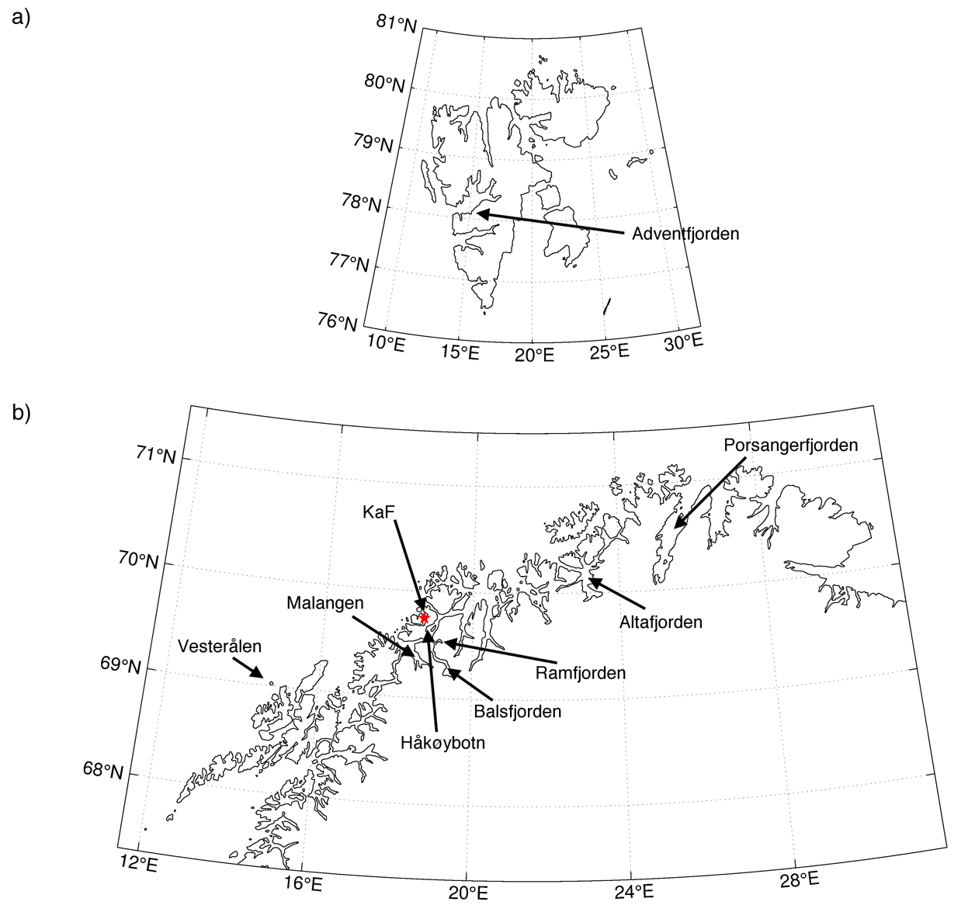
Figure S1: Maps showing the location of station KaF and other relevant fjords. Sub-maps present the relevant fjords in a) Svalbard and b) Northern Norway.

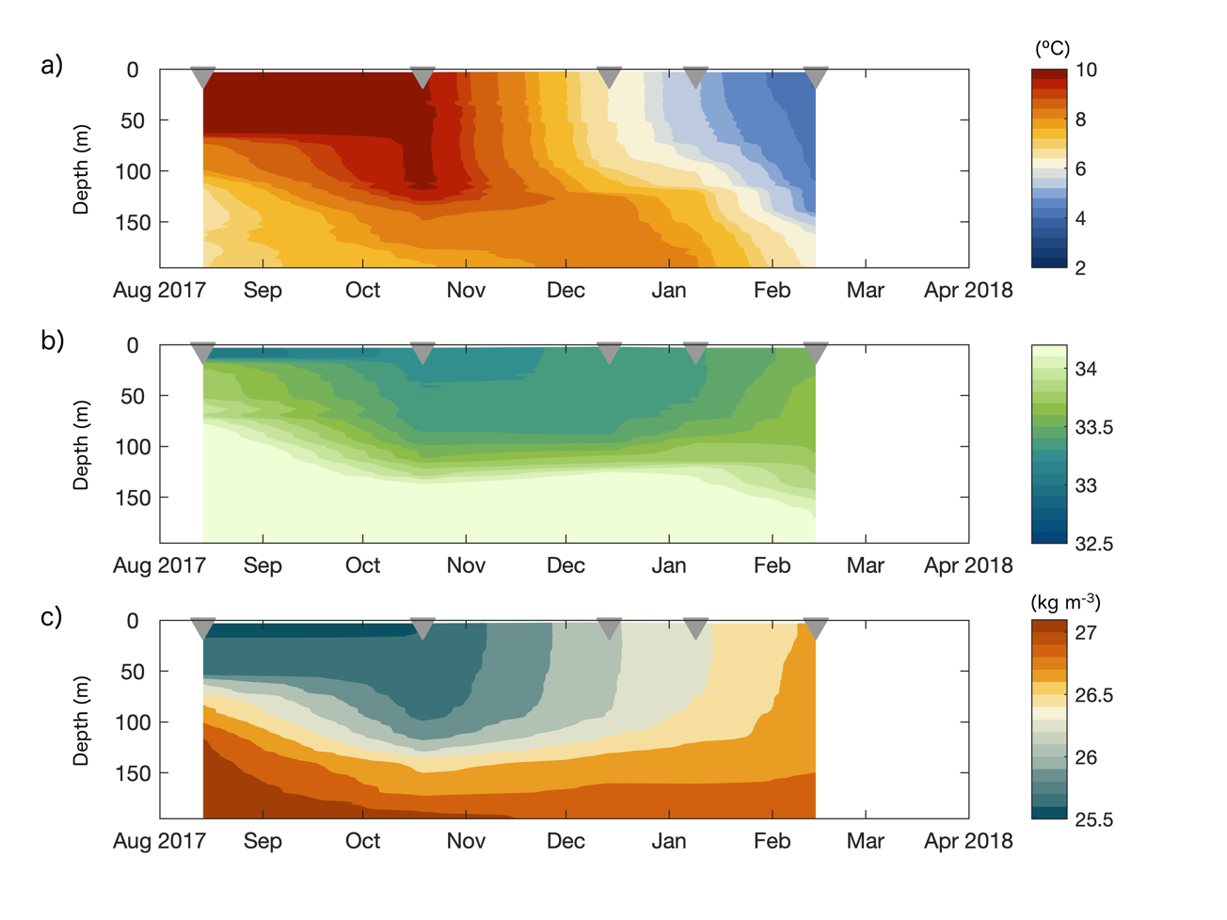Figure S2: Hydrographic time series in Malangen (see Figure S1) from August 2017 to February 2018. Sub-plots present a) potential temperature, b) practical salinity, and c) potential density in the upper 200 m at a sampling station in Malangen. Grey triangles along the top axis of each panel mark the sample times.

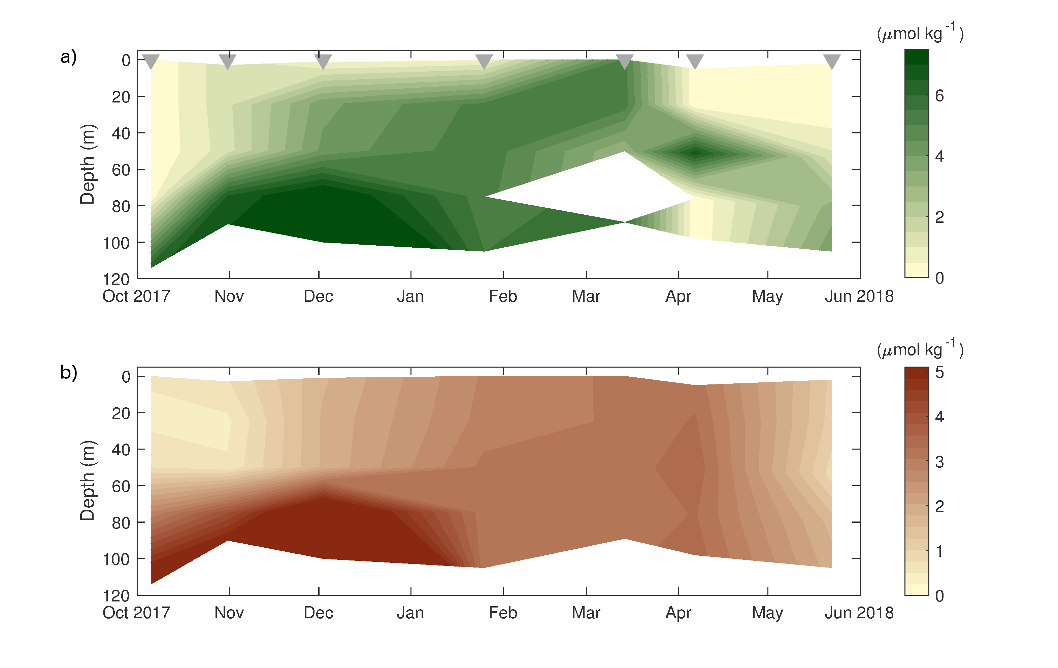
Figure S3: Nitrate (a) and silicate (b) concentration in inner Kaldfjorden (October 2017 to May 2018). The top figure shows the seasonal variation of the nitrate (NO₃⁻) concentration at position (69.700° N, 18.660° E) determined from water samples at subsurface, ~25m, ~50 m, ~75 m, and close to sea floor, while the bottom figure shows the silicate (Si(OH)₂) concentration determined from the same depths. The darker the color in the color scheme, the higher the concentration.

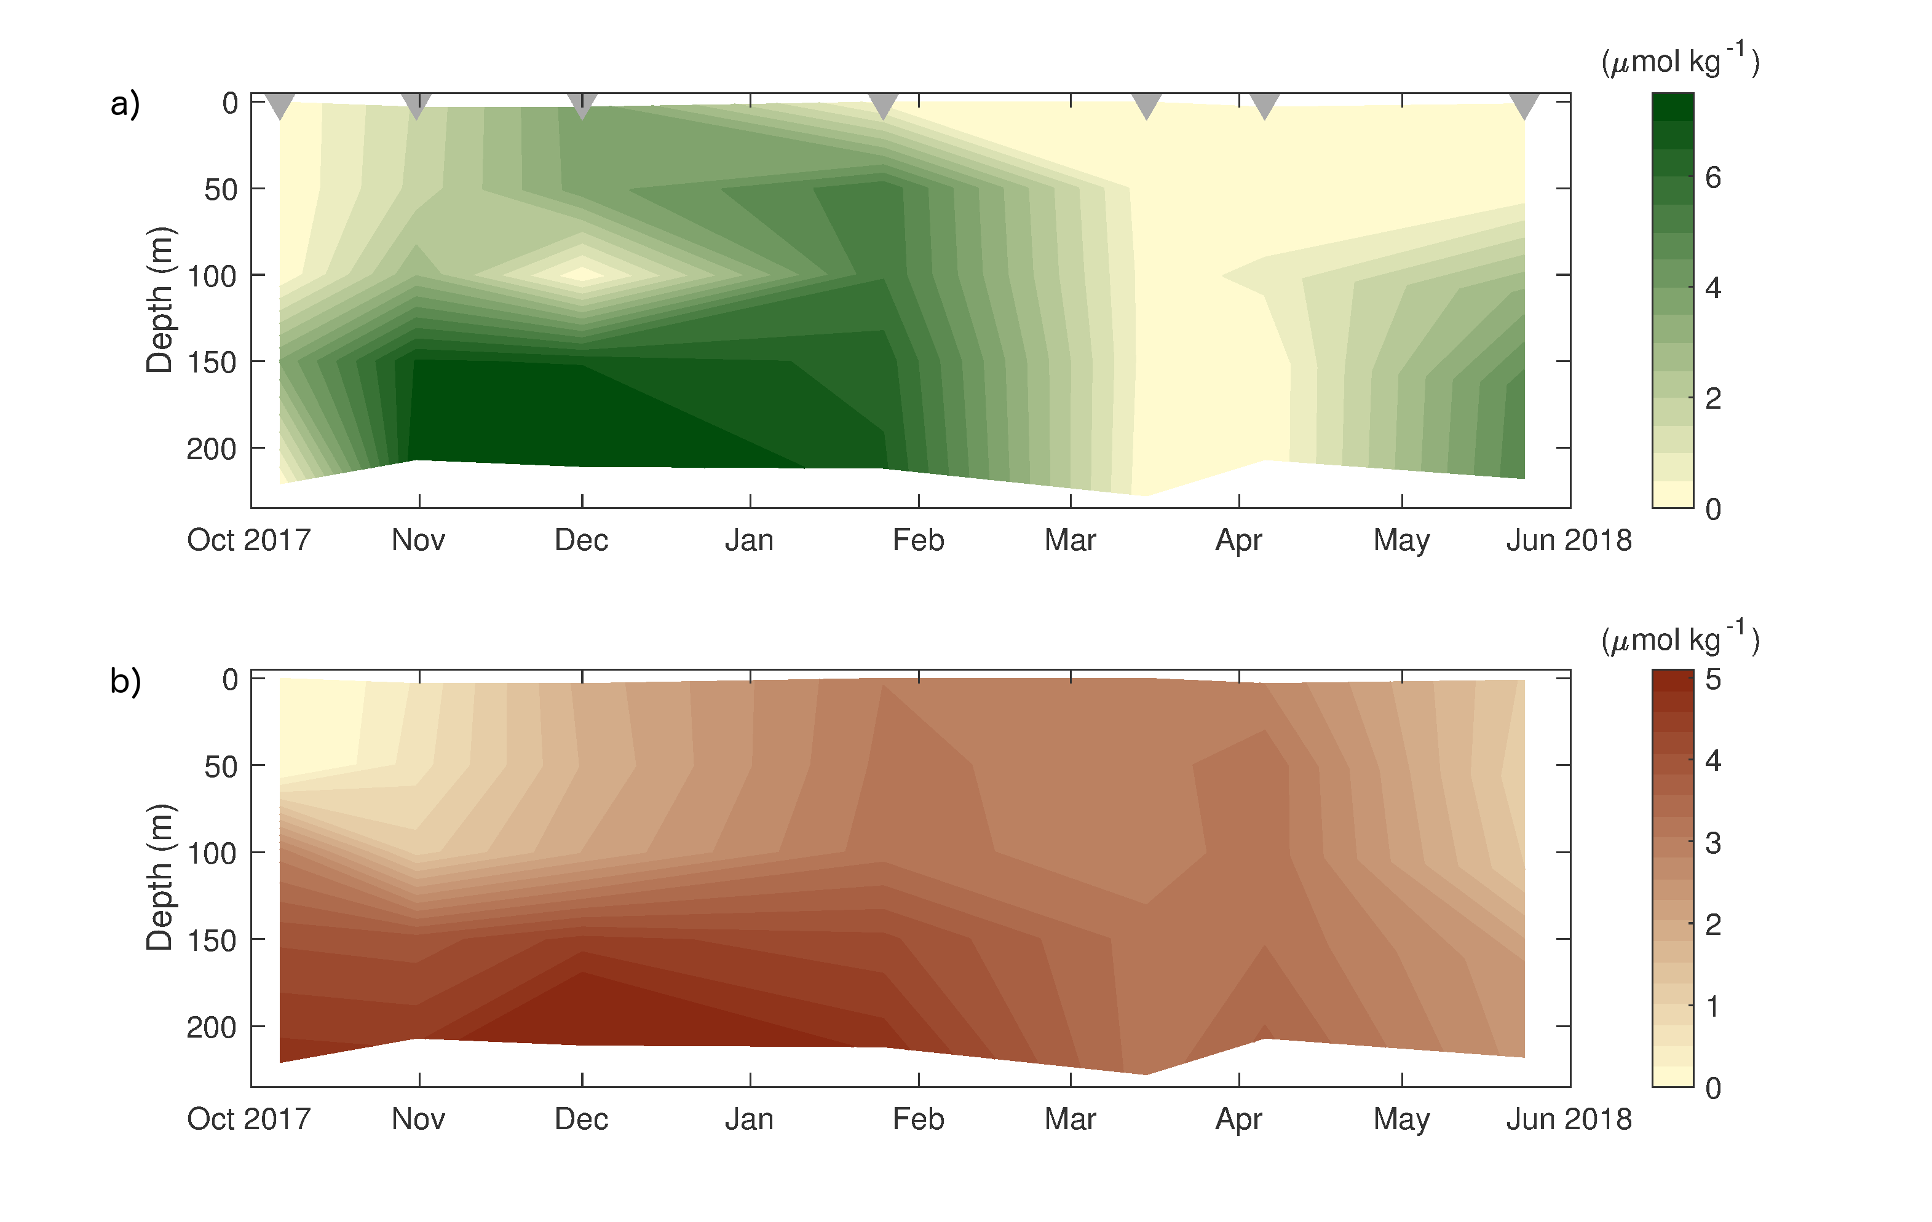
Figure S4: Nitrate (a) and silicate (b) concentration in outer Kaldfjorden (October 2017 to May 2018). The top figure shows the seasonal variation of the nitrate (NO₃⁻) concentration at position (69.800° N, 18.670° E) determined from water samples at subsurface, ~50 m, ~100 m, ~150 m and close to sea floor, while the bottom figure shows the silicate (Si(OH)₂) concentration determined from the same depths. The darker the color in the color scheme, the higher the concentration.

Table S1: Overview of the water volume used to determine the suspended and sinking biomass. The table gives the volume of water (mL) filtered to determine the concentration of suspended (susp) chlorophyll a (Chl a) and particulate organic carbon and nitrogen (POC, PO N) and the intensity of the downward Chl a , POC, and PO N flux. All filtrations were done in (at least) triplicates.
Month | Susp Chl a concentration (mL) | Downward Chl a flux (mL) | Susp POC and PO N concentration (mL) | Downward POC and PON flux (mL)
Oct | 300 | 200 | 400 | 300
Nov | 300 | 200 | 400 | 300
Dec | 300-400 | 300 | 400 | 300
Jan | 300 | 300 | 400 | 300
Feb | 300 | 300 | 400 | 300
Mar | 300 | 250 | 400 | 250
Apr | 200 | 200 | 400 | 250
May | 250 | 200 | 400 | 300

Table S2: Suspended biomass concentration at KaF. The table presents the average (av) concentrations (incl. the standard deviations (stand dev)) of the suspended chlorophyll a (Chl a) and phaeophytine (Phaeo), the ratio of Chl a to the total pigment concentration (= Chl a + Phaeo), the concentration of particulate organic carbon (POC) and particulate organic nitrogen (PON), as well as the atomic ratio of POC: PON (C: N). “Replicates” states the number of replicates used in filtration. NA - Data not available.
Date  (ddmmyyyy) | Depth  (m) | Replicates  (Chl a) | Av Chl a  (mg m⁻³) | Chl a  stand dev | Av Phaeo  (mg m⁻³) | Phaeo  stand dev | Ratio Chl a to (Chl a + Phaeo) | Replicates (POC, PON) | Av POC  (mg m⁻³) | POC  stand dev | Av PON  (mg m⁻³) | Av PON  stand dev | Av C:N ratio | C:N ratio stand dev | POC:  Chl a
05.10.2017 | 5 | 3 | 3.15 | 0.08 | 1.93 | 0.08 | 0.62 | 2 | 315.44 | 7.19 | 44.65 | 0.26 | 8.24 | 0.24 | 100
05.10.2017 | 15 | 3 | 2.42 | 0.23 | 1.47 | 0.10 | 0.62 | 3 | 231.85 | 49.99 | 36.22 | 8.62 | 7.49 | 0.16 | 96
05.10.2017 | 30 | 3 | 1.42 | 0.08 | 0.91 | 0.08 | 0.61 | 3 | 191.60 | 14.08 | 30.80 | 1.72 | 7.25 | 0.13 | 135
05.10.2017 | 90 | 3 | 0.09 | 0.01 | 0.17 | 0.03 | 0.35 | 3 | 124.87 | 34.30 | 19.80 | 3.24 | 7.28 | 1.03 | 1391
06.11.2017 | 5 | 3 | 1.03 | 0.02 | 0.66 | 0.06 | 0.61 | 3 | 102.43 | 22.26 | 17.05 | 4.22 | 7.07 | 0.88 | 99
06.11.2017 | 15 | 3 | 0.91 | 0.10 | 0.57 | 0.02 | 0.61 | 3 | 82.34 | 6.29 | 12.25 | 0.59 | 7.83 | 0.29 | 91
06.11.2017 | 30 | 3 | 0.90 | 0.09 | 0.65 | 0.06 | 0.58 | 3 | 117.21 | 8.03 | 18.50 | 0.62 | 7.41 | 0.72 | 130
06.11.2017 | 90 | 3 | 0.26 | 0.03 | 0.26 | 0.01 | 0.50 | 3 | 216.78 | 17.50 | 26.07 | 2.18 | 9.73 | 1.00 | 825
01.12.2017 | 5 | 3 | 0.12 | 0.02 | 0.17 | 0.01 | 0.41 | 3 | 31.94 | 9.29 | 5.94 | 0.30 | 7.40 | 2.01 | 268
01.12.2017 | 15 | 3 | 0.10 | 0.01 | 0.17 | 0.00 | 0.37 | 3 | 20.18 | 4.04 | 3.97 | 1.49 | 8.31 | 3.08 | 198
01.12.2017 | 30 | 3 | 0.11 | 0.01 | 0.17 | 0.01 | 0.40 | 3 | 32.76 | 5.90 | 6.80 | 1.32 | NA | 0.47 | 299
01.12.2017 | 90 | 3 | 0.12 | 0.01 | 0.18 | 0.02 | 0.40 | 3 | 132.70 | 50.44 | 11.18 | 2.29 | 13.48 | 3.06 | 1117
25.01.2018 | 5 | 3 | 0.03 | 0.00 | 0.08 | 0.01 | 0.25 | 3 | 80.82 | 15.85 | 10.24 | 1.52 | 9.18 | 0.78 | 3158
25.01.2018 | 15 | 3 | 0.03 | 0.00 | 0.07 | 0.01 | 0.26 | 3 | 55.02 | 6.48 | 7.63 | 0.91 | 8.56 | 1.95 | 2212
25.01.2018 | 30 | 3 | 0.02 | 0.00 | 0.06 | 0.00 | 0.28 | 3 | 57.45 | 3.54 | 7.83 | 1.08 | 8.63 | 0.82 | 2418
25.01.2018 | 90 | 3 | 0.03 | 0.00 | 0.06 | 0.01 | 0.29 | 3 | 101.39 | 25.44 | 14.75 | 0.58 | 8.05 | 2.17 | 4031
15.02.2018 | 5 | 3 | 0.03 | 0.00 | 0.09 | 0.01 | 0.24 | 3 | 56.70 | 8.86 | 6.32 | 0.31 | 10.45 | 1.30 | 1954
15.02.2018 | 15 | 3 | 0.03 | 0.00 | 0.10 | 0.03 | 0.23 | 3 | 67.61 | 2.58 | 8.84 | 1.45 | 9.07 | 1.27 | 2258
15.02.2018 | 30 | 3 | 0.03 | 0.00 | 0.06 | 0.01 | 0.31 | 3 | 81.37 | 10.78 | 11.72 | 2.82 | 8.26 | 1.18 | 2933
15.02.2018 | 90 | 3 | 0.03 | 0.01 | 0.07 | 0.01 | 0.31 | 3 | 114.39 | 6.08 | 17.78 | 0.72 | 7.52 | 0.63 | 3754
14.03.2018 | 5 | 3 | 0.03 | 0.00 | 0.04 | 0.00 | 0.44 | 3 | 35.48 | 1.21 | 6.04 | 2.01 | 7.33 | 2.22 | 1124
14.03.2018 | 15 | 4 | 0.03 | 0.00 | 0.04 | 0.00 | 0.42 | 4 | 39.97 | 13.54 | 4.54 | 1.49 | 10.94 | 3.78 | 1270
14.03.2018 | 30 | 4 | 0.03 | 0.00 | 0.04 | 0.01 | 0.44 | 4 | 24.58 | 0.37 | 4.44 | 1.00 | 7.25 | 1.51 | 796
14.03.2018 | 90 | 3 | 0.03 | 0.00 | 0.04 | 0.01 | 0.37 | 3 | 30.30 | 1.69 | 5.97 | 1.09 | 6.56 | 1.03 | 1225
04.04.2018 | 5 | 3 | 6.88 | 0.17 | 5.74 | 0.62 | 0.55 | 3 | 264.60 | 14.81 | 51.62 | 1.45 | 5.98 | 0.20 | 38
04.04.2018 | 15 | 3 | 7.18 | 0.20 | 5.33 | 0.08 | 0.57 | 3 | 253.62 | 4.63 | 51.82 | 3.27 | 5.72 | 0.34 | 35
04.04.2018 | 30 | 3 | 1.77 | 0.10 | 1.54 | 0.10 | 0.53 | 3 | 69.14 | 6.03 | 14.21 | 0.24 | 5.68 | 0.46 | 39
04.04.2018 | 90 | 3 | 0.10 | 0.00 | 0.18 | 0.01 | 0.36 | 3 | 54.36 | 12.60 | 6.80 | 2.37 | 9.90 | 2.78 | 558
22.05.2018 | 5 | 3 | 0.58 | 0.02 | 0.70 | 0.08 | 0.45 | 3 | 210.18 | 2.47 | 31.29 | 1.24 | 7.84 | 0.25 | 361
22.05.2018 | 15 | 3 | 0.89 | 0.01 | 1.10 | 0.04 | 0.45 | 3 | 153.47 | 14.61 | 26.52 | 0.65 | 6.74 | 0.52 | 173
22.05.2018 | 30 | 3 | 0.13 | 0.01 | 0.34 | 0.03 | 0.28 | 3 | 70.66 | 4.01 | 9.74 | 0.77 | 8.52 | 1.05 | 529
22.05.2018 | 90 | 3 | 0.02 | 0.00 | 0.10 | 0.02 | 0.17 | 3 | 93.87 | 8.26 | 9.94 | 1.08 | 11.06 | 0.91 | 4505
Table S3: Downward flux of biomass at KaF. Average (Av) downwards flux (incl. standard deviation (stand dev)) of chlorophyll a (Chl a) and phaeophytine (Phaeo) as well as the ratio of the Chl a to total pigment flux ratio (= Chl a + Phaeo) in the sediment trap cylinder. In addition, the table presents the average downward flux of particulate organic carbon (POC) and particulate organic nitrogen (PON), as well as the atomic POC: PON ratio (C: N) and the POC: Chl a ratio of the exported biomass in the trap cylinder. “Replicates” states the number of replicates used in the filtration.
Date  (ddmmyyyy) | Depth  (m) | Replicates  (Chl a) | Av Chl a flux  (mg m⁻² d⁻¹) | Av Phaeo flux  (mg m⁻² d⁻¹) | Phaeo flux  stand dev | Ratio Chl a: (Chl a + Phaeo) | Replicates  (POC, PON) | Av POC flux  (mg m⁻² d⁻¹) | Av PON flux  (mg m⁻² d⁻¹) | Av C:N ratio | Av POC: Chl a
05.10.2017 | 20 | 2 | 1.21 | 1.39 | 0.01 | 0.47 | 3 | 136.85 | 25.48 | 6.64 | 477
05.10.2017 | 30 | 3 | 1.37 | 2.13 | 0.05 | 0.39 | 3 | 160.08 | 30.39 | 6.56 | 215
05.10.2017 | 50 | 3 | 1.14 | 1.65 | 0.24 | 0.41 | 3 | 140.90 | 21.09 | 7.62 | 195
05.10.2017 | 90 | 3 | 1.10 | 2.05 | 0.15 | 0.35 | 3 | 259.64 | 37.47 | 7.99 | 244
06.11.2017 | 20 | 3 | 0.53 | 0.74 | 0.10 | 0.42 | 3 | 89.42 | 14.89 | 7.33 | 623
06.11.2017 | 30 | 3 | 0.58 | 0.94 | 0.13 | 0.38 | 3 | 46.04 | 6.49 | 7.81 | 239
06.11.2017 | 50 | 3 | 0.58 | 0.86 | 0.15 | 0.40 | 3 | 47.68 | 8.29 | 7.40 | 147
06.11.2017 | 90 | 3 | 0.66 | 1.24 | 0.06 | 0.35 | 3 | 166.60 | 24.66 | 8.46 | 306
01.12.2017 | 20 | 3 | 0.09 | 0.29 | 0.03 | 0.24 | 3 | 37.18 | 6.34 | 6.48 | 768
01.12.2017 | 30 | 3 | 0.11 | 0.35 | 0.03 | 0.24 | 3 | 33.84 | 5.42 | 6.70 | 519
01.12.2017 | 50 | 3 | 0.10 | 0.32 | 0.01 | 0.25 | 3 | 39.67 | 5.19 | 7.26 | 655
01.12.2017 | 90 | 3 | 0.10 | 0.35 | 0.01 | 0.23 | 3 | 8.52 | 3.79 | 9.04 | 164
25.01.2018 | 20 | 3 | 0.07 | 0.24 | 0.03 | 0.22 | 3 | 91.36 | 12.98 | 8.38 | 1579
25.01.2018 | 30 | 3 | 0.10 | 0.35 | 0.02 | 0.22 | 3 | 104.40 | 13.53 | 8.92 | 1171
25.01.2018 | 50 | 3 | 0.07 | 0.29 | 0.03 | 0.20 | 3 | 104.07 | 13.12 | 9.04 | 1594
25.01.2018 | 90 | 3 | 0.10 | 0.41 | 0.03 | 0.19 | 3 | 107.33 | 14.49 | 8.45 | 1221
15.02.2018 | 20 | 3 | 0.11 | 0.23 | 0.07 | 0.33 | 3 | 91.77 | 11.37 | 9.22 | 917
15.02.2018 | 30 | 3 | 0.08 | 0.25 | 0.04 | 0.24 | 3 | 69.77 | 9.14 | 8.63 | 984
15.02.2018 | 50 | 3 | 0.10 | 0.32 | 0.02 | 0.24 | 3 | 78.09 | 8.90 | 9.25 | 921
15.02.2018 | 90 | 3 | 0.08 | 0.24 | 0.02 | 0.24 | 3 | 69.21 | 7.05 | 9.45 | 1064
14.03.2018 | 20 | 3 | 0.04 | 0.08 | 0.01 | 0.33 | 3 | 28.76 | 4.72 | 7.73 | 938
14.03.2018 | 30 | 3 | 0.04 | 0.09 | 0.01 | 0.29 | 3 | 43.44 | 7.64 | 6.72 | 2045
14.03.2018 | 50 | 3 | 0.04 | 0.12 | 0.01 | 0.23 | 3 | 51.92 | 8.27 | 7.07 | 2177
14.03.2018 | 90 | 3 | 0.05 | 0.20 | 0.02 | 0.20 | 3 | 83.08 | 11.21 | 8.17 | 2263
04.04.2018 | 20 | 3 | 5.34 | 3.60 | 0.14 | 0.60 | 3 | 135.79 | 24.30 | 6.15 | 43
04.04.2018 | 30 | 3 | 3.87 | 3.39 | 0.26 | 0.53 | 3 | 117.40 | 21.12 | 6.32 | 37
04.04.2018 | 50 | 3 | 3.42 | 3.15 | 0.20 | 0.52 | 3 | 124.57 | 22.47 | 6.49 | 43
04.04.2018 | 90 | 3 | 3.15 | 3.18 | 0.18 | 0.50 | 3 | 157.74 | 28.02 | 6.82 | 51
22.05.2018 | 20 | 3 | 0.89 | 1.57 | 0.28 | 0.36 | 3 | 140.93 | 22.54 | 7.19 | 222
22.05.2018 | 30 | 3 | 0.40 | 1.22 | 0.16 | 0.25 | 3 | 100.95 | 16.65 | 7.39 | 293
22.05.2018 | 50 | 3 | 0.30 | 1.38 | 0.19 | 0.18 | 3 | 137.34 | 25.33 | 6.84 | 525
22.05.2018 | 90 | 3 | 0.22 | 1.18 | 0.28 | 0.16 | 3 | 85.12 | 16.60 | 7.07 | 396

Table S4: Zooplankton abundance at station KaF. Zooplankton (holoplankton and meroplankton) was sampled with a WP‐2, 180 µm mesh size, and abundances are given as the average number of individuals m^{‑3} in the given depth interval. Please note that the rather coarse mesh size of the WP-2 may have resulted in some undersampling of taxa < 200 µm.
Date (dd.mm.yyyy) | 06.11.2017 | 01.12.2017 | 25.01.2018 | 25.01.2018 | 15.02.2018 | 15.02.2018 | 14.03.2018 | 14.03.2018 | 04.04.2018 | 04.04.2018 | 22.05.2018 | 22.05.2018
Depth interval (m) | 0-50 | 0-100 | 100-50 | 50-0 | 100-50 | 50-0 | 100-50 | 50-0 | 100-50 | 50-0 | 100-50 | 50-0
Holoplankton (Copepoda)
Calanus | 35.00 | 0.28 | 7.92 | 16.24 | 7.28 | 16.32 | 16.20 | 12.80 | 0.80 | 9.20 | 7752.00 | 6480.00
Metridia | 26.67 | 0.08 | 3.84 | 2.48 | 0.64 | 0.48 | 10.00 | 6.40 | 2.80 | 2.80 | 1512.00 | 1253.33
Acartia | 366.67 | 40.53 | 1.04 | 7.44 | 4.48 | 3.04 | 0.20 | 1.07 | 0.00 | 0.80 | 132.00 | 13.33
Harpacticoida | 0.00 | 0.00 | 0.00 | 0.00 | 0.08 | 0.08 | 0.00 | 0.00 | 0.00 | 0.00 | 0.00 | 0.00
Microcalanous | 0.00 | 28.00 | 10.16 | 8.64 | 25.36 | 19.60 | 51.00 | 62.13 | 379.60 | 125.20 | 108.00 | 26.67
Oithona | 1133.33 | 115.20 | 14.80 | 68.24 | 34.88 | 45.84 | 28.20 | 30.40 | 32.40 | 70.00 | 468.00 | 360.00
Pseudocalanus | 3013.33 | 181.60 | 10.64 | 35.52 | 6.64 | 4.96 | 3.00 | 3.47 | 9.60 | 4.80 | 396.00 | 586.67
Unidentified copepod | 106.67 | 6.40 | 1.12 | 1.60 | 1.04 | 0.72 | 1.40 | 1.87 | 4.00 | 7.60 | 132.00 | 186.67
Holoplankton (Others)
Amphipoda | 23.75 | 0.16 | 0.16 | 0.32 | 0.00 | 0.00 | 0.08 | 0.16 | 0.32 | 0.00 | 0.00 | 0.00
Appendicularian | 60.00 | 0.00 | 0.00 | 0 | 0.00 | 0.24 | 0.00 | 0.00 | 0.00 | 1.36 | 0.00 | 0.16
Chaetognatha | 6.67 | 0.00 | 0.00 | 0.24 | 0.00 | 0.32 | 0.00 | 0.16 | 0.00 | 0.00 | 0.08 | 0.00
Cnidaria | 39.58 | 0.00 | 0.72 | 0.16 | 0.00 | 0.08 | 0.00 | 0.00 | 0.00 | 0.00 | 0.00 | 13.33
Ctenophora | 46.67 | 0.00 | 0.00 | 0.96 | 0.88 | 0.00 | 0.24 | 0.00 | 0.40 | 0.08 | 0.00 | 0.24
Ichthyoplankton | 0.00 | 0.00 | 0.00 | 0.00 | 0.00 | 0.00 | 0.00 | 0.00 | 0.00 | 0.00 | 0.00 | 1.28
Krill Nauplii | 0.00 | 0.00 | 0.00 | 0.00 | 0.00 | 0.00 | 0.16 | 0.08 | 0.24 | 0.80 | 0.00 | 0.00
Krill Juvenile | 0.00 | 0.00 | 0.00 | 0.00 | 0.00 | 0.00 | 0.00 | 0.00 | 0.00 | 0.00 | 12.00 | 126.67
Limacina | 510.00 | 37.07 | 0.00 | 0.00 | 0.00 | 0.00 | 0.00 | 0.00 | 0.00 | 0.00 | 0.00 | 0.00
Pelagic polychaeta | 96.67 | 0.00 | 0.00 | 0.00 | 0.08 | 0.00 | 0.00 | 0.00 | 0.00 | 0.08 | 18.00 | 0.00
Meroplankton larvae
Bivalvia | 0.00 | 0.00 | 0.00 | 0.08 | 0.08 | 0.00 | 0.00 | 0.08 | 0.00 | 0.00 | 0.00 | 0.00
Bryozoa | 0.00 | 0.00 | 0.00 | 0.08 | 0.08 | 0.88 | 0.00 | 0.00 | 0.00 | 0.00 | 0.00 | 13.33
Cirripedia | 0.00 | 0.53 | 0.32 | 0.08 | 0.00 | 0.00 | 0.00 | 0.24 | 4.88 | 286.80 | 6.00 | 166.67
Decapoda | 0.00 | 0.00 | 0.00 | 0.00 | 0.00 | 0.00 | 0.00 | 0.00 | 0.00 | 0.00 | 0.08 | 40.00
Echinodermata | 976.67 | 0.00 | 0.00 | 0.00 | 0.00 | 0.00 | 0.08 | 0.00 | 0.32 | 2.80 | 0.32 | 0.00
Gastropoda | 300.00 | 2.40 | 0.00 | 0.48 | 0.64 | 0.00 | 0.24 | 0.08 | 0.00 | 0.88 | 0.16 | 46.67
Polychaeta | 3.33 | 0.00 | 0.00 | 0.16 | 0.24 | 0.00 | 0.72 | 0.80 | 0.88 | 246.80 | 12.00 | 0.00
Total zooplankton abundance (ind. m^{‑3}) per month in the whole sampling interval | 6745 | 412 | 97 |  | 87 |  | 116 |  | 598 |  | 9931

