Supplementary Material

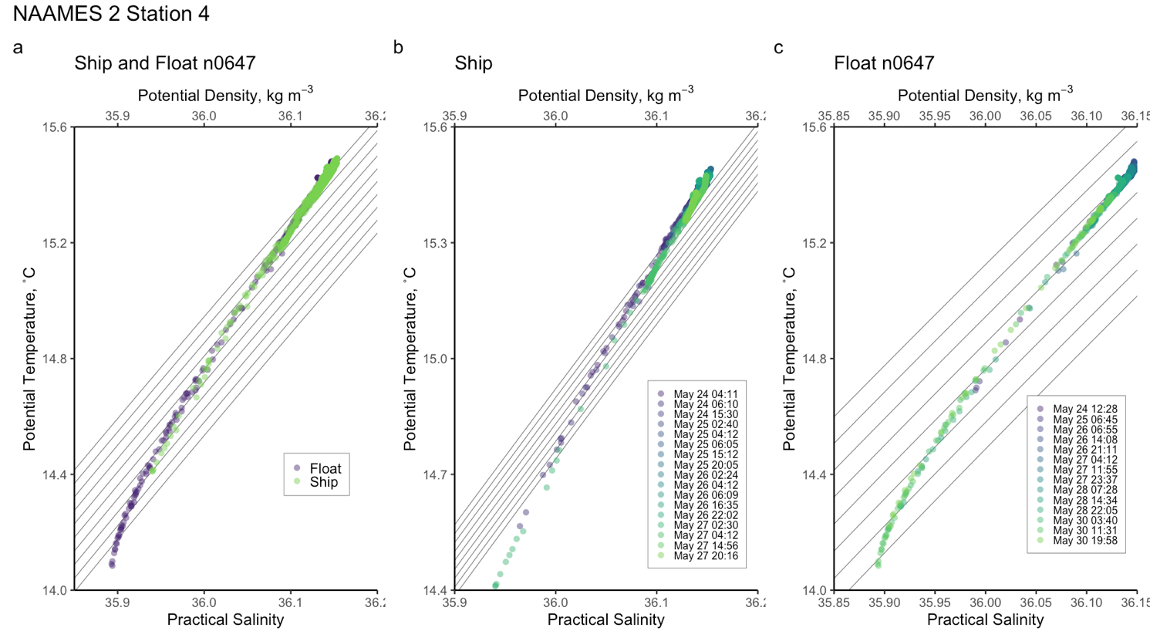

Figure S1. Temperature-Salinity diagrams for ship and float profiles taken at NAAMES 2 Station 4 (N2S4). Data represent depths from 50 to 200 m. Panel (a) shows data taken from the ship CTD between May 24 04:11 and May 27 20:16 as well as profiles taken from Float n0647 between May 24 12:28 and May 30 19:48. Panel (b) shows only data from the ship while panel (c) shows only data from the float.

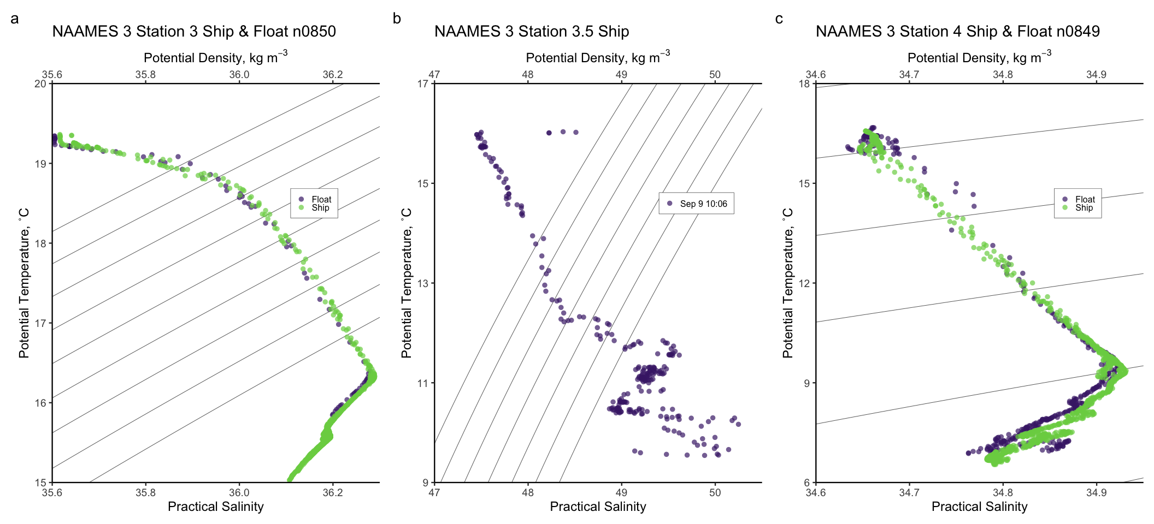

Figure S2. Temperature-Salinity diagrams for ship and float profiles taken at NAAMES 3 subtropical Stations 3, 3.5, and 4. Panel (a) shows data taken from the ship CTD and float n0850 upon the occupation of station 3. Panel (b) shows ship data from station 3.5, where a float was not deployed. Panel (c) shows data taken from the ship CTD and float n0849 upon the occupation of station 4.

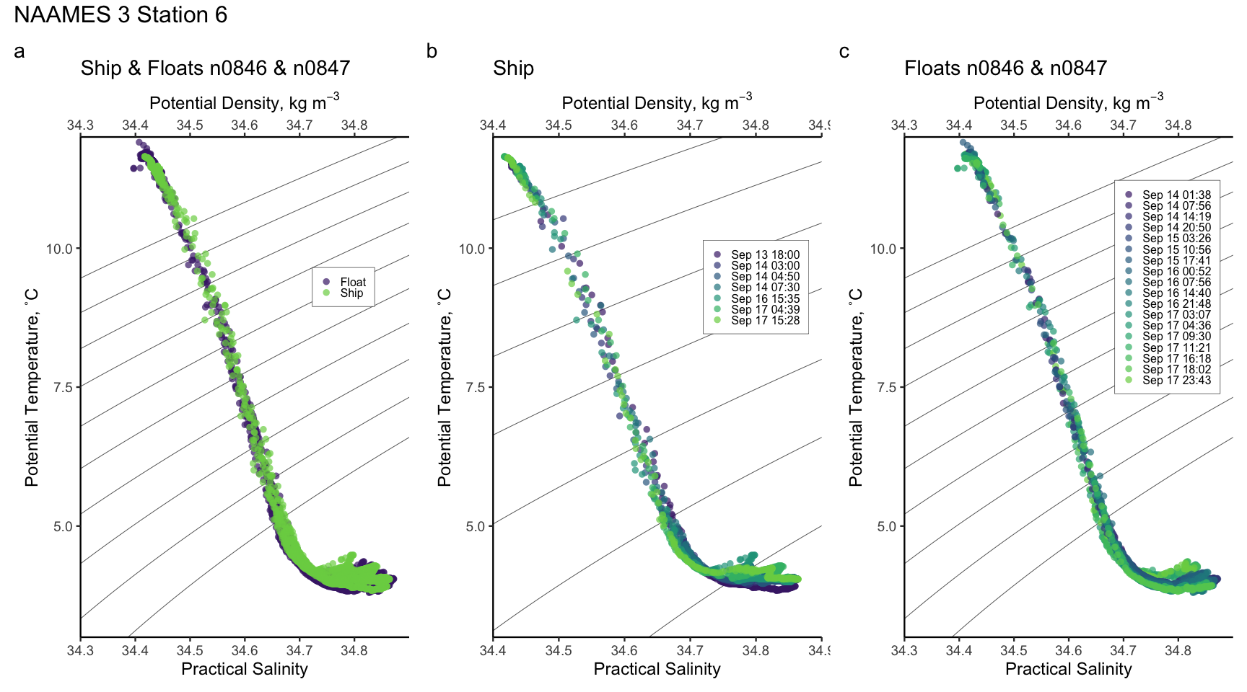
Figure S3. Temperature-Salinity diagrams for ship and float profiles taken at NAAMES 3 subpolar Station 6 (N3S6). Panel (a) shows data taken from the ship CTD between September 13 18:00 and September 17 15:26 as well as profiles taken from floats n0846 and n0847 between September 14 01:38 and September 17 23:43. Panel (b) shows only data from the ship while panel (c) shows only data from the float.

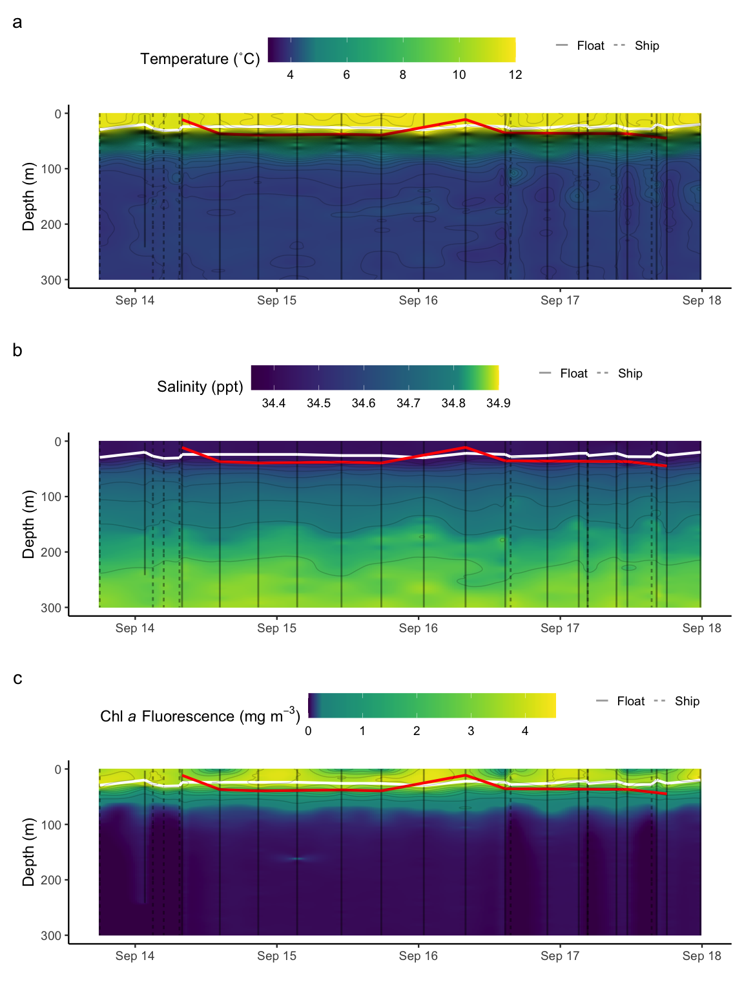

Figure S4. Composite time series from ship CTD and float data at NAAMES 3 Station 6 (N3S6). ﻿Vertical black lines denote when water column data were collected by the ship CTD (dotted) or by floats n0846 and n0847 (solid). The white line shows the mixed layer depth while the red line delineates the bottom of the euphotic zone (1% surface photosynthetically active radiation [PAR]). In the background are interpolated data of (a) temperature, (b) salinity, (c) chlorophyll a fluorescence.

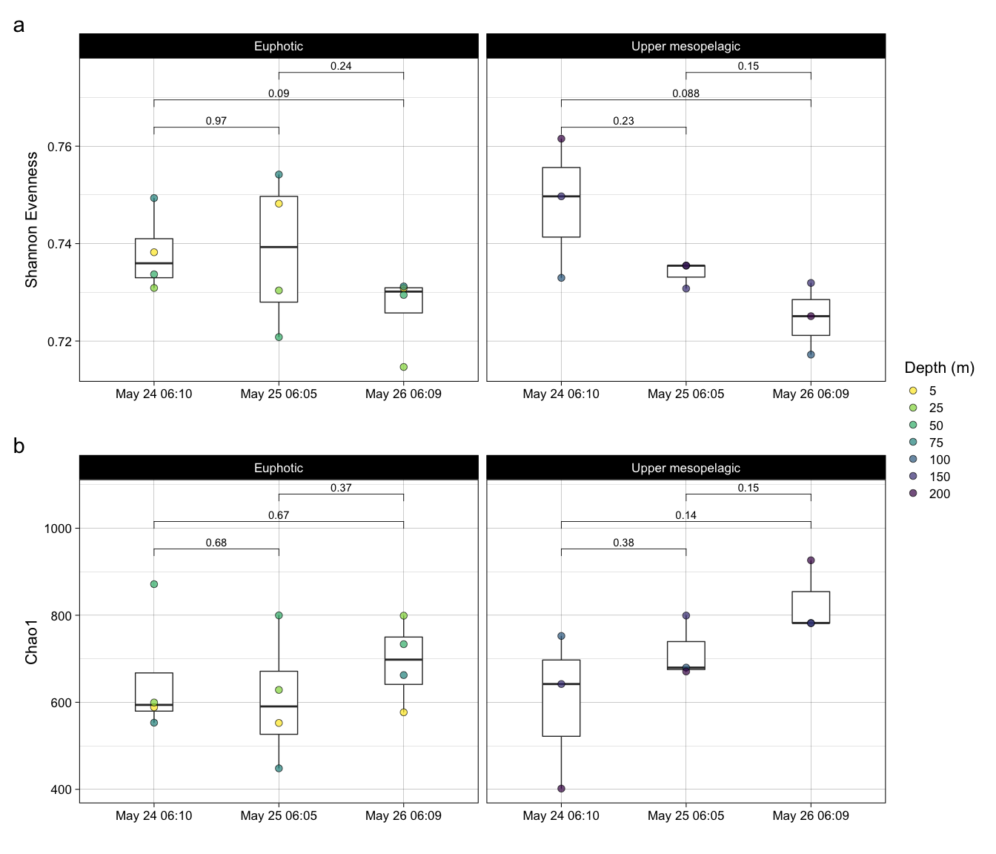
Figure S5. Alpha diversity of NAAMES 2 Station 4 (N2S4). (a) Shannon evenness index of bacterioplankton communities over the occupation of N2S4 in the euphotic zone (left) the upper mesopelagic zone (right). (b) Chao1 richness estimates of bacterioplankton communities over the occupation of N2S4 in the euphotic zone (left) the upper mesopelagic zone (right). Filled circles represent estimates of each sample, with color representing the depth at which each sample was collected. Boxes represent the 1.5 interquartile range, with the internal solid line representing the median. p-values are reported for pairwise t-tests between the means of the alpha diversity indices.

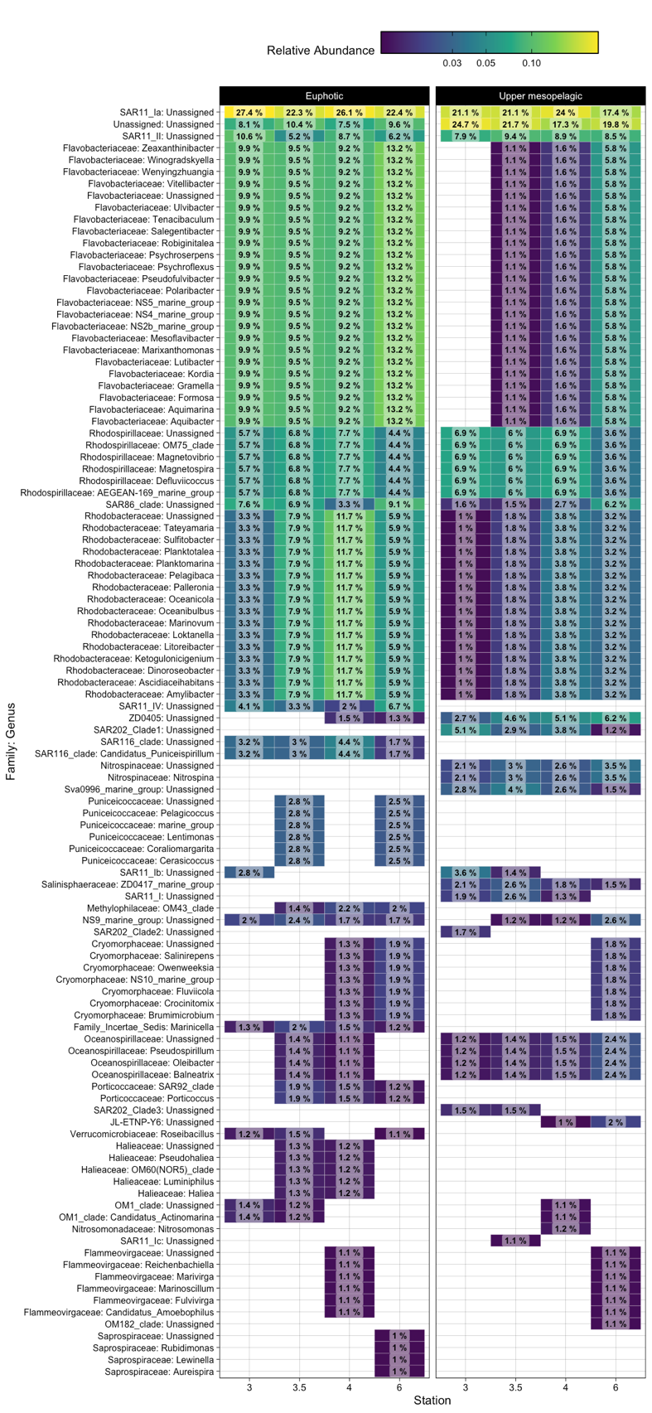

Figure S6. Taxonomic abundances at NAAMES 3 Stations 3, 3.5, 4, and 6. Relative abundances of taxonomic groups to the genus level for the euphotic (0 – 50 m) and upper mesopelagic (75 – 200 m) zones at each station. Only families that represent at least 1% of the total community are included. For each the euphotic and upper mesopelagic zones, the relative abundance of a taxonomic group was calculated by summing its ASV counts across all depths in the depth horizon and then dividing the summed counts by the total counts in the depth horizon.

