Supplemental Material

Impact of heat stress on foliar biogenic volatile organic compound emission and gene expression in tomato (Solanum lycopersicum) seedlings

Sanjeevi Nagalingam ^{1*}, Roger Seco ^{1, 2}, Kirill Musaev ³, Chhandak Basu ³, Saewung Kim ¹, and Alex Guenther ^{1*}

¹ Department of Earth System Science, University of California, Irvine, California, United States
² Institute of Environmental Assessment and Water Research (IDAEA-CSIC), Barcelona, Catalonia, Spain
³ Department of Biology, California State University, Northridge, California, United States

*Corresponding authors: snagalin@uci.edu and alex.guenther@uci.edu

February 14, 2022

List of Contents:

Table S1. Compound classes, molecular formula, and CAS numbers of the 31 compounds targeted for analysis and quantification via GC-MS. The major ion fragments used for quantification are also listed. (Page 2)
Table S2. β_{vp} values for various BVOCs calculated using the Antoine coefficients reported by Yaws and Satyro (2015). (Page 3)
Table S3. Time-averaged stomatal conductance for water vapor before the heat treatment (G_{sw, pre-stress}) and during the initial (G_{sw, HS-initial}) and final (G_{sw, HS-final}) periods of the heat treatment for the 15 heat-stressed tomato plants. (Page 4)
Table S4A-C. Storage pool depletion times (in days) calculated for the two Beefsteak and four Roma tomato plants used in the heat stress-VOC emissions study. (Pages 5–7)
Figure S1A-B. Maximum observed BVOC emission response and corresponding β coefficients for 31 compounds (quantified via GC-MS) from 15 individual tomato plants during the initial and final periods of the heat treatment. (Pages 8–9)
Figure S2A-C. Time series of total monoterpene emissions measured via online PTR-MS and discontinuous GC-MS, and fractional contribution of speciated monoterpenes for 9 individual tomato plants heat-stressed at 42°C. (Pages 10–12)
Figure S3. Time series of select speciated monoterpene emissions from three heat-stressed Roma tomato plants, Roma HS1, HS2, and HS3 measured via GC-MS. (Page 13)
Figure S4. VOC content (µg/g FW) in the stored pools of four Beefsteak and four Roma tomato plants (quantified via GC-MS). (Page 14)
Equation S1. Equation describing the overall uncertainty in the reported BVOC emission rates. (Page 15)
Table S1. Compound classes, molecular formula, and CAS numbers of the 31 compounds targeted for analysis and quantification via GC-MS. The major ion fragments used for quantification are also listed.

Compound | Class | Molecular formula | CAS number | Major ion fragment (m/z)
2-Carene | Monoterpene | C₁₀H₁₆ | 554-61-0 | 93
α-Copaene | Sesquiterpene | C₁₅H₂₄ | 3856-25-5 | 161
α-Humulene | Sesquiterpene | C₁₅H₂₄ | 6753-98-6 | 93
α-Phellandrene | Monoterpene | C₁₀H₁₆ | 99-83-2 | 93
α-Pinene | Monoterpene | C₁₀H₁₆ | 80-56-8 | 93
α-Terpinene | Monoterpene | C₁₀H₁₆ | 99-86-5 | 93
β-Caryophyllene | Sesquiterpene | C₁₅H₂₄ | 87-44-5 | 161
β-Elemene | Sesquiterpene | C₁₅H₂₄ | 515-13-9 | 93
β-Myrcene | Monoterpene | C₁₀H₁₆ | 123-35-3 | 93
β-Phellandrene | Monoterpene | C₁₀H₁₆ | 555-10-2 | 93
β-Pinene | Monoterpene | C₁₀H₁₆ | 127-91-3 | 93
Camphene | Monoterpene | C₁₀H₁₆ | 79-92-5 | 93
δ-Elemene | Sesquiterpene | C₁₅H₂₄ | 20307-84-0 | 93
γ-Terpinene | Monoterpene | C₁₀H₁₆ | 99-85-4 | 93
Hexenol | Stress compound | C₆H₁₂O | 928-96-1 | 67
Isoterpinolene | Monoterpene | C₁₀H₁₆ | 586-63-0 | 93
Limonene | Monoterpene | C₁₀H₁₆ | 138-86-3 | 68
MeSA | Stress compound | C₈H₈O₃ | 119-36-8 | 120
MT 18.69 | Monoterpene | UNK | UNK | 93
MT 21.75 | Monoterpene | UNK | UNK | 93
o-Cymene | C10 aromatic | C₁₀H₁₄ | 527-84-4 | 119
p-Menthatriene | Monoterpene | C₁₀H₁₄ | 18368-95-1 | 119
SQT 27.57 | Sesquiterpene | UNK | UNK | 93
SQT 28.12 | Sesquiterpene | UNK | UNK | 93
SQT 28.34 | Sesquiterpene | UNK | UNK | 93
SQT 28.50 | Sesquiterpene | UNK | UNK | 93
SQT 29.08 | Sesquiterpene | UNK | UNK | 93
SQT 29.46 | Sesquiterpene | UNK | UNK | 93
Terpinolene | Monoterpene | C₁₀H₁₆ | 586-62-9 | 93
TMTT | Stress compound | C₁₆H₂₆ | 62235-06-7 | 69
trans-Ocimene | Monoterpene | C₁₀H₁₆ | 3779-61-1 | 93

MT: monoterpene, SQT: sesquiterpene, MeSA: methyl salicylate, TMTT: trimethyltridecatetraene, UNK: unknown.

Table S2. β_{vp} values for various BVOCs calculated using the Antoine coefficients reported by Yaws and Satyro (2015).

Compound | β_{vp} (°C⁻¹)
Monoterpenes
α-Pinene | 0.056
Camphene | 0.059
Limonene | 0.064
β-Pinene | 0.060
α-Terpinene | 0.063
γ-Terpinene | 0.065
2-Carene | 0.065
3-Carene | 0.067
Sesquiterpenes
Cadinene | 0.093
C10 aromatics
o-Cymene | 0.064
p-Cymene | 0.066
m-Cymenene | 0.069
p-Cymenene | 0.073
Stress compounds
Eucalyptol | 0.062
cis-3-hexenol | 0.073
Methyl salicylate | 0.083

Table S3. Time-averaged stomatal conductance for water vapor before the heat treatment (G_{sw, pre-stress}) and during the initial (G_{sw, HS-initial}) and final (G_{sw, HS-final}) periods of the heat treatment for the 15 heat-stressed tomato plants.

Plant | G_{sw, pre-stress}  (mmol H₂O m⁻² s⁻¹) | G_{sw, HS-initial}  (mmol H₂O m⁻² s⁻¹) | G_{sw, HS-final}  (mmol H₂O m⁻² s⁻¹)
Beefsteak 1 | 80.9 | ND | ND
Beefsteak 2 | 61.7 | 67.3 (+9.0%) | 63.9 (+3.6%)
Black Cherry 1 | 44.9 | 48.5 (+8.0%) | 43.7 (-2.8%)
Cherokee 1 | 83.7 | ND | ND
Early Girl 1 | 130.5 | ND | ND
Husky Cherry 1 | 52.6 | 65.0 (+23.5%) | 58.6 (+11.3%)
Juliet 1 | 125.6 | ND | ND
Roma 1 | 110.0 | ND | ND
Roma HS1 | 69.9 | 90.4 (+29.3%) | 87.0 (+24.4%)
Roma HS2 | 50.2 | 65.5 (+30.5%) | 61.4 (+22.3%)
Roma HS3 | 81.4 | ND | 111.3 (+36.7%)
Summer Set 1 | 63.1 | ND | 48.3 (-23.4%)
Tami-G 1 | 63.9 | 72.1 (+12.8%) | 2.8 (-95.6%)
Tami-G 2 | 91.8 | ND | 4.9 (-94.6%)
Tami-G 3 | 83.5 | ND | 34.7 (-58.5%)

The values in parentheses indicate the percentage change in G_{sw} relative to pre-stress levels. G_{sw} values during the heat stress phase could not be calculated for some plants (ND: not determined) due to saturation of water vapor in the IRGA.

Table S4A-C. Storage pool depletion times (in days) calculated for the two Beefsteak and four Roma tomato plants used in the heat stress-VOC emissions study. S4A. Median pool depletion times before heat stress. S4B. Median pool depletion times during heat stress. S4C. Minimum pool depletion times. Conditions where results could not be quantified include emission present, but storage pool absent or BDL (EPSA; blue-shaded), emission absent or BDL, but storage pool present (EASP; green-shaded), and both emission and storage pool absent or BDL (EASA; brown-shaded).

Table S4A
Compound | Median pool depletion time before heat stress (days)
 | Beefsteak 1 | Beefsteak 2 | Roma 1 | Roma HS1 | Roma HS2 | Roma HS3
2-Carene | 15.2 | 20.2 | 25.2 | 267 | 524 | 595
α-Copaene | EASA | EASA | EPSA | EASA | EASA | EASA
α-Humulene | 194 | 174 | EASP | EASP | EASP | EASP
α-Phellandrene | 5.77 | 25.0 | 16.1 | 110 | 139 | 106
α-Pinene | 11.6 | 12.1 | 23.2 | 57.4 | 63.8 | 41.8
α-Terpinene | 7.84 | 21.8 | EASP | EASP | EASP | EASP
β-Caryophyllene | EASP | EASP | EASP | EASP | EASP | EASP
β-Elemene | EASP | EASP | EASP | EASP | EASP | EASP
β-Myrcene | 14.2 | 12.3 | 4.26 | 128 | EASP | EASP
β-Phellandrene | 32.9 | 33.1 | 65.0 | 1300 | 4150 | 1120
β-Pinene | EASP | 69.0 | EASP | EASP | EASP | EASP
Camphene | 2.12 | 1.90 | EASP | 14.8 | 2.86 | 3.69
δ-Elemene | EASP | EASP | EASP | EASP | EASP | EASP
γ-Terpinene | EASP | EASP | EASP | EASP | EASP | EASP
Hexenol | EASP | EASP | EASP | EASP | EASP | EASP
Isoterpinolene | EASP | EASP | EASP | EASP | EASP | EASP
Limonene | 20.2 | 19.4 | 35.9 | 123 | 186 | 191
MeSA | EASP | 32.4 | EASP | 2490 | 3150 | 7190
MT 18.69 | EASA | EASA | EASA | EASA | EASA | EASA
MT 21.75 | EASP | EASP | EASP | EASP | EASP | EASP
o-Cymene | 3.95 | 2.41 | 8.94 | 14.2 | 12.7 | 15.3
p-Menthatriene | 25.9 | 11.6 | 12.2 | 163 | 742 | 316
SQT 27.57 | EASA | EASA | EASA | EASA | EASA | EASA
SQT 28.12 | EASP | EASP | EASP | EASP | EASP | EASP
SQT 28.34 | EASP | EASP | EASP | EASP | EASP | EASP
SQT 28.50 | EASA | EASA | EASA | EASA | EASA | EASA
SQT 29.08 | EASP | EASP | EASP | EASP | EASP | EASP
SQT 29.46 | EASP | EASP | EASP | EASP | EASP | EASP
Terpinolene | EASP | EASP | EASP | EASP | EASP | EASP
TMTT | EPSA | EPSA | EPSA | EPSA | EPSA | EPSA
trans-Ocimene | EASP | EASP | EASP | EASP | EASP | EASP
Table S4B
Compound | Median pool depletion time during heat stress (days)
 | Beefsteak 1 | Beefsteak 2 | Roma 1 | Roma HS1 | Roma HS2 | Roma HS3
2-Carene | 9.89 | 5.31 | 13.7 | 71.9 | 135 | 63.1
α-Copaene | EPSA | EASA | EPSA | EPSA | EPSA | EASA
α-Humulene | EASP | 73.2 | EASP | EASP | EASP | EASP
α-Phellandrene | 2.10 | 1.39 | 2.58 | 17.4 | 14.7 | 18.8
α-Pinene | 6.65 | 4.02 | 7.59 | 19.9 | 10.7 | 12.1
α-Terpinene | 1.19 | 0.312 | 0.778 | 4.72 | EASP | 9.45
β-Caryophyllene | EASP | 266 | EASP | EASP | EASP | EASP
β-Elemene | EASP | EASP | EASP | EASP | EASP | EASP
β-Myrcene | 4.72 | 3.49 | 2.16 | 23.7 | 36.1 | 34.0
β-Phellandrene | 12.5 | 11.0 | 13.2 | 202 | 218 | 112
β-Pinene | 27.4 | 21.4 | 4.76 | EASP | EASP | EASP
Camphene | EASP | 0.358 | 5.56 | 4.55 | 2.42 | 2.61
δ-Elemene | EASP | EASP | EASP | EASP | EASP | EASP
γ-Terpinene | 15.3 | 1.04 | 5.41 | EASP | EASP | EASP
Hexenol | EASP | EASP | EASP | EASP | EASP | EASP
Isoterpinolene | EASP | 7.22 | EASP | EASP | EASP | EASP
Limonene | 8.00 | 4.48 | 15.4 | 59.9 | 76.9 | 46.7
MeSA | 51.4 | 74.3 | 340 | 111 | 77.6 | 653
MT 18.69 | EASA | EPSA | EASA | EASA | EASA | EASA
MT 21.75 | EASP | EASP | EASP | EASP | EASP | EASP
o-Cymene | 1.60 | 0.175 | 1.14 | 5.36 | 6.17 | 3.59
p-Menthatriene | 12.0 | 1.83 | 6.60 | 32.5 | 38.0 | 22.1
SQT 27.57 | EASA | EASA | EASA | EASA | EASA | EASA
SQT 28.12 | 0.433 | EASP | 4.28 | EASP | EASP | EASP
SQT 28.34 | 0.640 | EASP | 7.62 | EASP | EASP | EASP
SQT 28.50 | EPSA | EASA | EPSA | EASA | EASA | EASA
SQT 29.08 | 0.0213 | EASP | 3.16 | 12.2 | EASP | EASP
SQT 29.46 | 2.52 | EASP | EASP | EASP | EASP | EASP
Terpinolene | 27.9 | 2.33 | 6.99 | EASP | EASP | EASP
TMTT | EPSA | EPSA | EPSA | EPSA | EPSA | EPSA
trans-Ocimene | EASP | EASP | EASP | EASP | EASP | EASP

Table S4C
Compound | Minimum pool depletion time (days)
 | Beefsteak 1 | Beefsteak 2 | Roma 1 | Roma HS1 | Roma HS2 | Roma HS3
2-Carene | 1.36 | 2.41 | 2.07 | 33.2 | 28.8 | 42.8
α-Copaene | EPSA | EASA | EPSA | EPSA | EPSA | EPSA
α-Humulene | 1.73 | 23.8 | 35.7 | EASP | EASP | EASP
α-Phellandrene | 0.266 | 0.342 | 0.201 | 5.27 | 6.10 | 7.05
α-Pinene | 1.43 | 1.74 | 1.32 | 7.28 | 6.82 | 6.80
α-Terpinene | 0.179 | 0.0794 | 0.0168 | 0.848 | 2.65 | 2.50
β-Caryophyllene | 25.6 | 80.4 | 26.0 | EASP | EASP | EASP
β-Elemene | EASP | EASP | EASP | EASP | EASP | EASP
β-Myrcene | 3.41 | 1.09 | 0.410 | 10.9 | 16.2 | 17.9
β-Phellandrene | 1.65 | 5.29 | 4.64 | 36.2 | 50.1 | 82.8
β-Pinene | 2.92 | 6.84 | 1.15 | 7.63 | 12.5 | 13.1
Camphene | 0.363 | 0.145 | 0.723 | 1.47 | 1.56 | 1.56
δ-Elemene | EASP | EASP | EASP | EASP | EASP | EASP
γ-Terpinene | 1.17 | 0.266 | 0.331 | 4.40 | 11.6 | 29.6
Hexenol | 3.60 | 254 | 3.03 | EASP | EASP | EASP
Isoterpinolene | 5.79 | 0.733 | 6.04 | 30.3 | EASP | EASP
Limonene | 2.12 | 1.55 | 2.59 | 31.4 | 29.1 | 29.9
MeSA | 0.125 | 7.68 | 11.6 | 5.54 | 13.5 | 303
MT 18.69 | EPSA | EPSA | EPSA | EASA | EASA | EASA
MT 21.75 | EASP | 0.858 | 0.101 | EASP | EASP | EASP
o-Cymene | 0.291 | 0.0725 | 0.222 | 1.07 | 3.13 | 2.03
p-Menthatriene | 5.06 | 0.694 | 0.858 | 12.0 | 11.9 | 11.9
SQT 27.57 | EPSA | EPSA | EPSA | EASA | EASA | EASA
SQT 28.12 | 0.155 | 0.317 | 0.244 | EASP | EASP | EASP
SQT 28.34 | 0.467 | 0.586 | 0.462 | 5.75 | EASP | EASP
SQT 28.50 | EPSA | EPSA | EPSA | EPSA | EASA | EASA
SQT 29.08 | 0.0101 | 0.0168 | 0.0664 | 1.79 | EASP | EASP
SQT 29.46 | 0.221 | 0.514 | 0.677 | 1.29 | EASP | EASP
Terpinolene | 1.48 | 0.684 | 0.837 | 13.2 | EASP | EASP
TMTT | EPSA | EPSA | EPSA | EPSA | EPSA | EPSA
trans-Ocimene | 0.776 | EASP | 2.92 | EASP | 5.07 | 10.2

Figure S1A-B. Heat stress BVOC emission response.

S1A. Maximum observed BVOC emission response for 31 compounds (quantified via GC-MS) from 15 individual tomato plants during the initial (top plot) and final (bottom plot) periods of the heat treatment. The BVOC emission response is classified into 5 categories, as described in the main text.

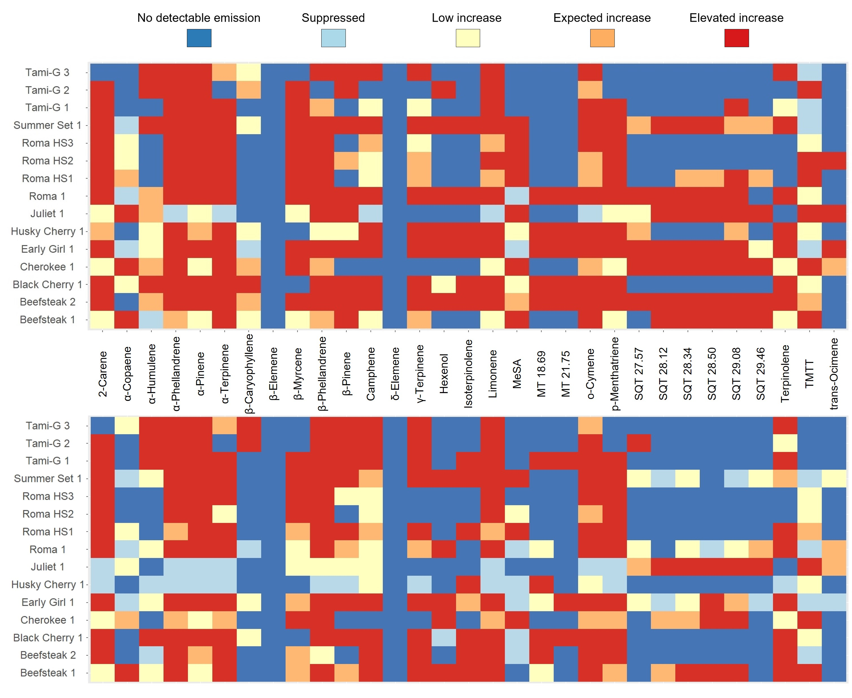

S1B. Quantitative illustration of the maximum observed BVOC emission response and corresponding β coefficients for 31 compounds (quantified via GC-MS) from 15 individual tomato plants during the initial (top plot) and final (bottom plot) periods of the heat treatment. Roma HS1, HS2, and HS3 were heat-stressed at 39°C with a pre-treatment temperature of 25°C, while the other 12 plants were heat-stressed at 42°C with a pre-treatment temperature of 30°C. The highest measured β coefficient was 0.838°C⁻¹, corresponding to TMTT emissions from Juliet 1 during the initial heat treatment period. BDL: below detection limit; ND: not determined.

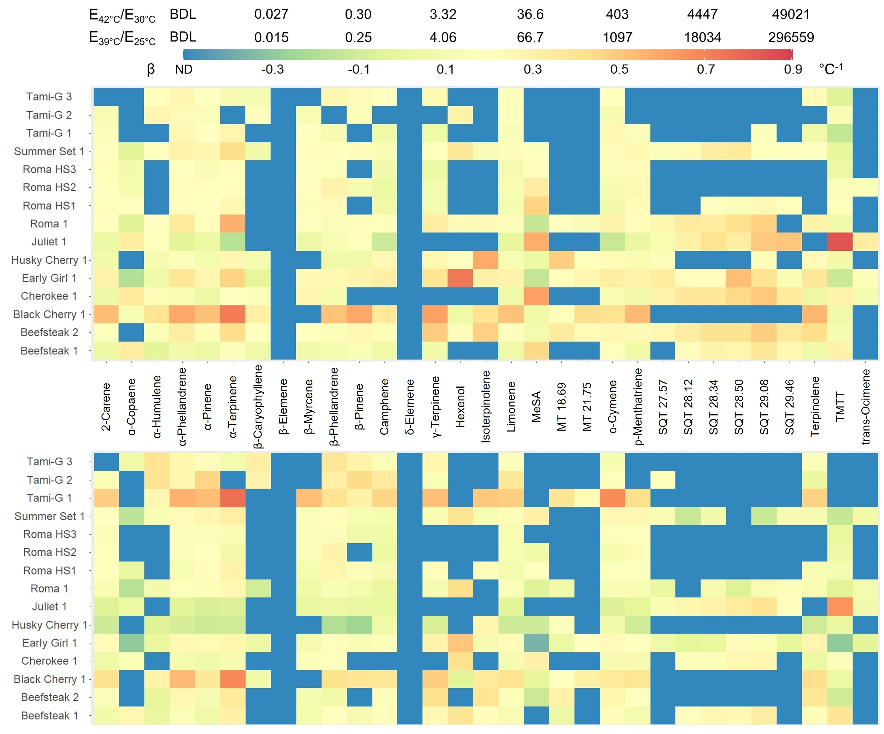

Figure S2A-C. Total and speciated monoterpene emissions. Time series of total monoterpene emissions measured via online PTR-MS and discontinuous GC-MS, and fractional contribution of speciated monoterpenes for 9 individual tomato plants heat-stressed at 42°C. The grey-shaded areas represent nighttime (i.e., plant chamber lights were turned off), while the beige-shaded area delineates the transitionary period from 30°C to 42°C. For 6 out of the 9 plants (B-C), emission rates were also measured during the post-heat stress recovery period; the cyan-shaded region delineates the brief transitionary period from 42°C back to 30°C. Note: PTR-MS-measured emission data is not available for 3 out of the 9 plants, i.e., Roma 1, Summer Set 1, and Early Girl 1 (C).

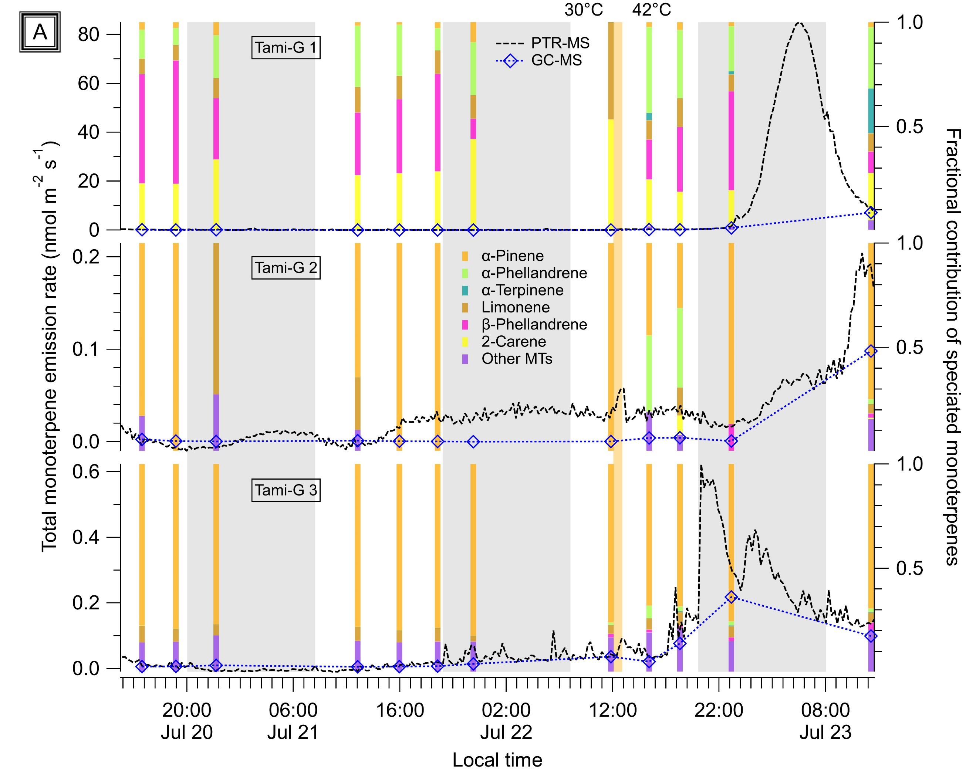

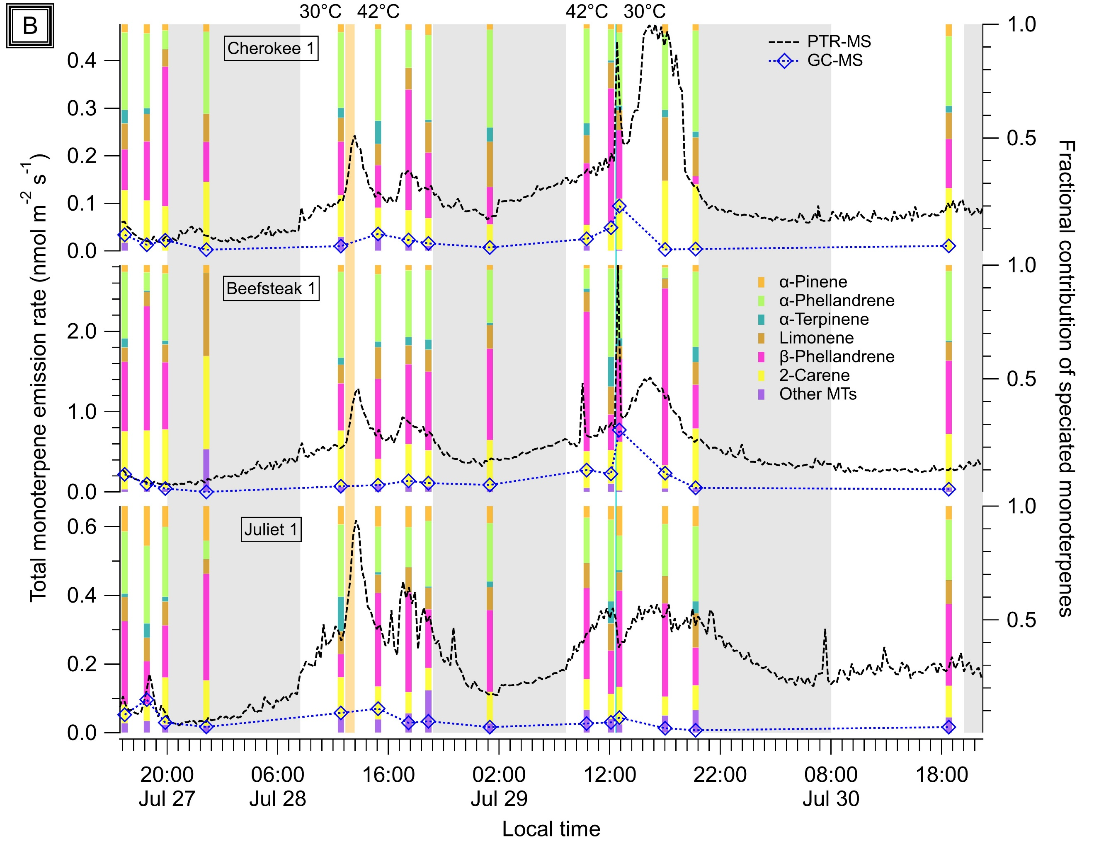

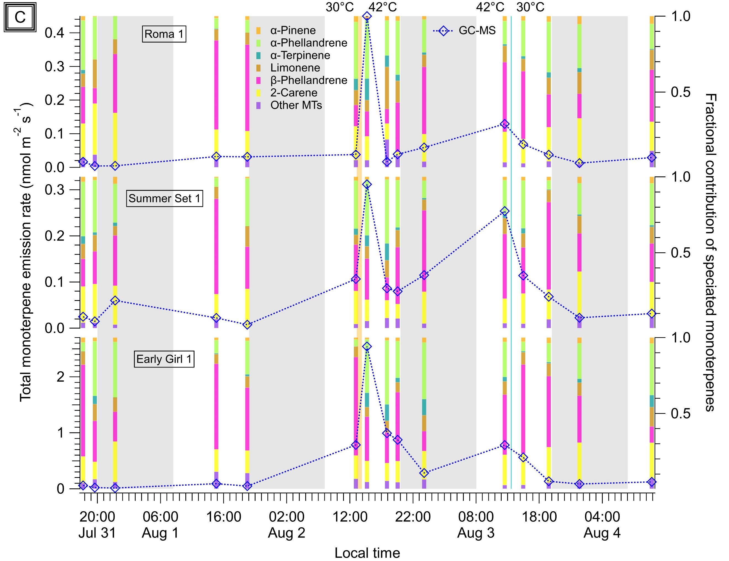

Figure S3. Speciated monoterpene emission time series. Time series of select speciated monoterpene emissions from three heat-stressed Roma tomato plants, Roma HS1, HS2, and HS3 measured via GC-MS. The grey-shaded areas represent nighttime (i.e., plant chamber lights were turned off), while the beige-shaded area delineates the transitionary period from 25°C to 39°C.

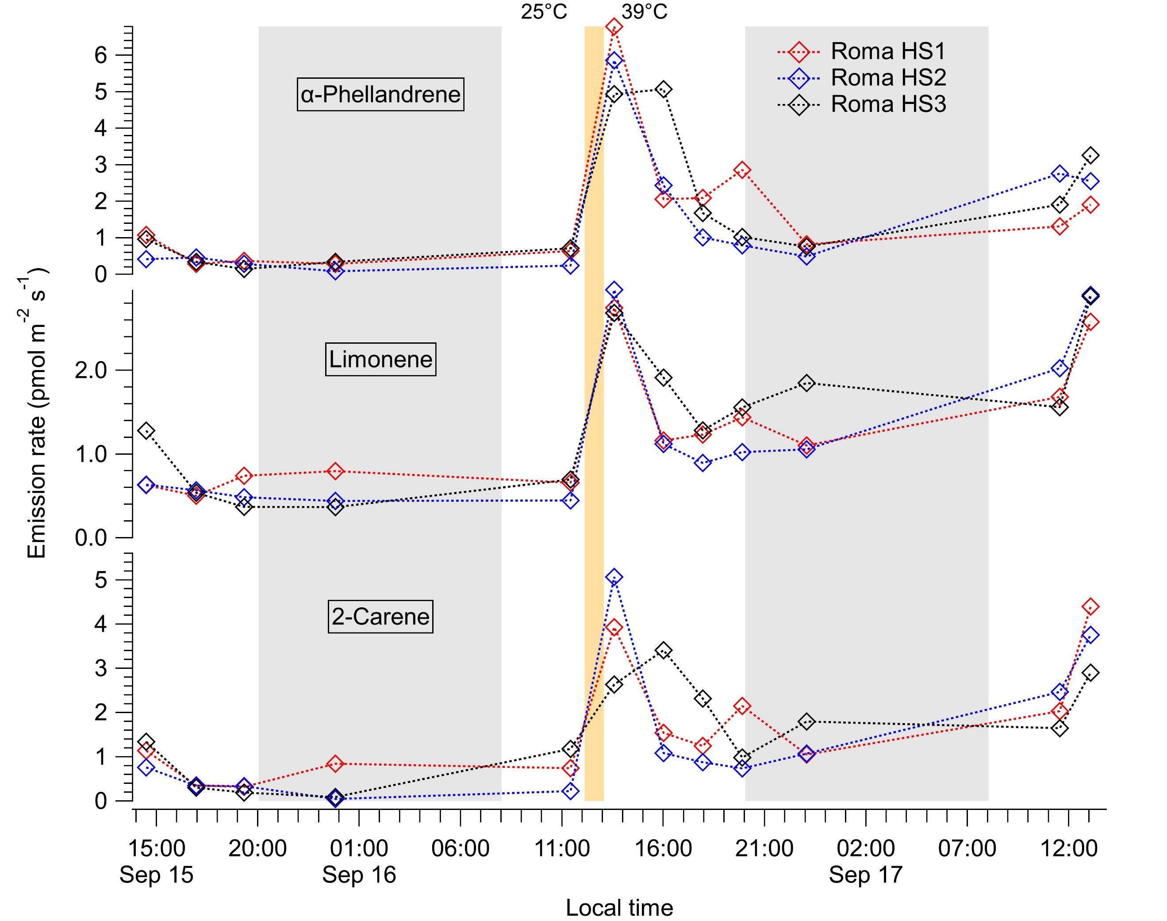

Figure S4. VOC storage pool sizes. VOC content (µg/g FW) in the stored pools of four Beefsteak and four Roma tomato plants (quantified via GC-MS).

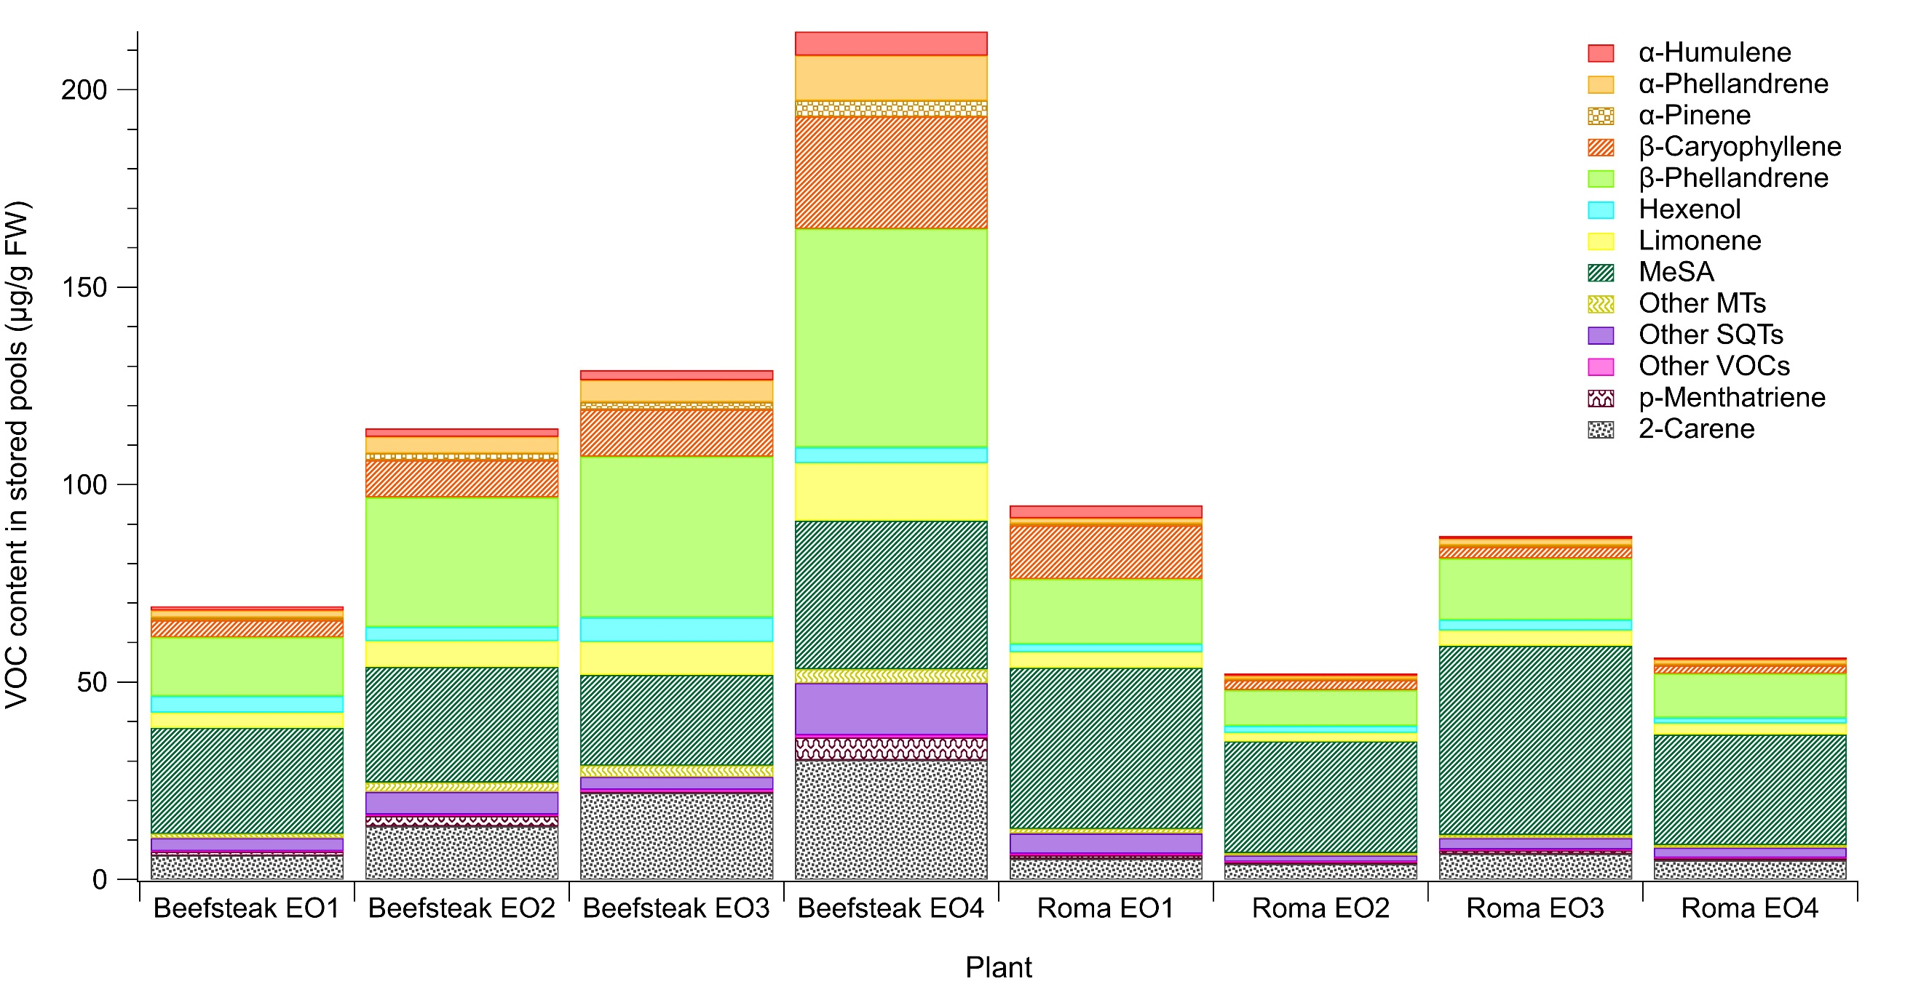

Equation S1. Equation describing the overall uncertainty in the reported BVOC emission rates.

The overall combined uncertainty in the BVOC emission rates is given by the following equation:

$$δE=\sqrt{{{δA}_{L}}^{2}+{δF}^{2}+{δV}^{2}+{δC}^{2}}$$

where
$δE$: overall uncertainty in the BVOC emission rate
${δA}_{L}$: uncertainty in leaf area
$δF$: uncertainty in airflow rate into the plant enclosure
$δV$: uncertainty in sample volume (for GC-MS measurements only)
$δC$: uncertainty in BVOC amount fraction

Data files

Two EXCEL data files (Data File S1 and Data File S2) are also included in the Supplemental Material of this article.

Data File S1 contains the tomato VOC emission rates (in pmol m⁻² s⁻¹), while Data File S2 contains the tomato VOC pool sizes (in µg/g FW), where both quantities were measured via GC-MS.

