**Supplemental Material**

**Snow albedo and its sensitivity to changes in deposited light-absorbing particles estimated from ambient temperature and snow depth observations at a high-altitude site in the Himalaya**

Johan Ström, Jonas Svensson*, Henri Honkanen, Eija Asmi, Nathaniel B. Dkhar, Shresth Tayal, Ved P. Sharma, Rakesh Hooda, Outi Meinander, Matti Leppäranta, Hans-Werner Jacobi, Heikki Lihavainen, Antti Hyvärinen

*Corresponding Author: jonas.svensson@fmi.fi

List of Contents:

1. List of acronyms and parameters used in the study.
2. Flow chart

Figure S1.

1. Automatic weather station data observed during the two seasonal snow cover periods

Figure S2

1. Albedo sensitivity to a 50% reduction in SSA

Table S1

1. Parametric relation proposed by Pedersen et al. (2015)

Table S2

1. List of acronyms used in the study and their units (where applicable).

Acronyms

1. AWS Automatic weather station
2. BC Black carbon
3. BrC Brown carbon
4. ECElemental Carbon
5. LAP Light-absorbing particles
6. MD Mineral dust
7. MOD Melt-out date
8. OC Organic carbon
9. SD Snow depth
10. SWE Snow water equivalent
11. ECeq Elemental carbon equivalent

|  |  |  |  |
| --- | --- | --- | --- |
| Parameters | *Symbol* | Unit | Value |
| Estimated broad band albedo | *a* |  |  |
| Observed broad band albedo | *aobs* |  |  |
| Broad band albedo of pristine snow | *ap* |  |  |
| Broad band albedo of snow free ground | *a*g |  |  |
| Characteristic depth of surface snow | *d* | mm |  |
| Equivalent elemental carbon concentration |  | ng g-1 |  |
| Equivalent elemental carbon concentration in snow precipitation |  | ng g-1 |  |
| Surface concentration of Equivalent elemental carbon |  | ng g-1 |  |
| Emissivity |  |  |  |
| Long wave radiation up | LWu | W m-2 |  |
| Long wave radiation down | LWd | W m-2 |  |
| Density of ice |  | kg m-3 | 910 |
| Density of fresh snow |  | kg m-3 | 100 |
| Density of water |  | kg m-3 | 1000 |
| Stefan-Boltzmann constant | ⬧ | W m-2K-4 | ⋅-8 |
| Relative humidity | RH | % |  |
| Effective snow grain radius | *re* | µm |  |
| Decreasing snow depth | SD- | cm |  |
| Increasing snow depth | SD+ | cm |  |
| Specific surface area | SSA | m2 kg-1 |  |
| Short wave radiation down | SWd | W m-2 |  |
| Short wave radiation up | SWu | W m-2 |  |
| Air temperature | *Ta* | °C |  |
| Surface temperature | Ts | °C |  |
| Wind speed | U | m s-1 |  |
| Weighting factor between *a* and *ag*as function of snow depth |  |  |  |
| Spectral albedo reduction due to LAP | *y* |  |  |
| Broad band albedo reduction due to LAP | *y*b |  |  |

*2. Flow chart*

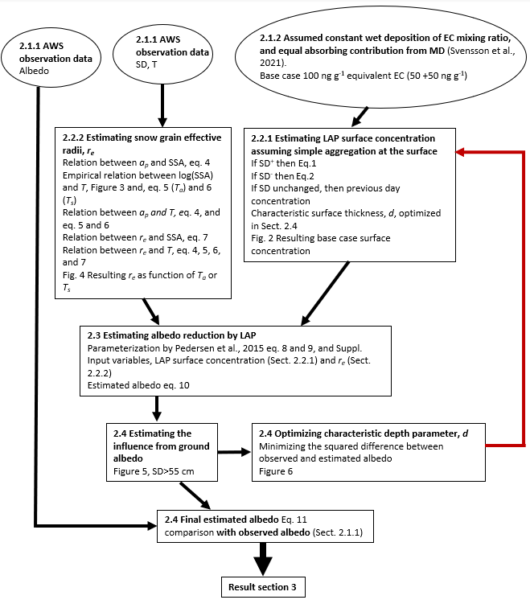

**Methodology schematics of section 2.** Black arrows correspond to workflow of estimating the surface albedo of snow including light-absorbing particles (LAP), while the red arrow refers to an optimization of the characteristic depth of surface snow, (*d)*. Circles depict observational input data, while each box correspond to a methodological step with the relevant section, assumptions, equations, and figures noted.

*3. AWS data*



Figure S2 shows the data observed during the two seasonal snow cover periods using the automatic weather station. The surface temperature *Ts* was derived from the long wave radiation up (LWu) data using the Stephan-Boltzmann Law. Data from Season 1 is presented in the column to the left and data from Season 2 is presented in the column to the right. Variables are indicated in the figures.

1. *Albedo sensitivity to a 50% reduction in SSA*

Table S1 compares the observed average seasonal albedo with the derived value for the base case and Ta as independent variable and for a reduced SSA. As outlined in the text, the fitting approach is likely an upper estimate of SSA, and we test the sensitivity by dividing SSA by a factor of two. The net effect of reducing SSA by 50% is a diminution of the albedo by 0.06 for the seasonal average or a relative change of less than 10% for both seasons.

Table S1

|  |  |  |  |  |  |  |  |
| --- | --- | --- | --- | --- | --- | --- | --- |
| Season 1 |  |  |  | Season 2 |  |  |  |
|  | SSA*1 | SSA*0.5 |  |  | SSA*1 | SSA*0.5 |  |
| Observed average albedo | Derived average albedo | Derived average albedo | Percent change between different SSA | Observed average albedo | Derived average albedo | Derived average albedo | Percent change between different SSA |
| 0.67 | 0.69 | 0.63 | 9 | 0.66 | 0.67 | 0.61 | 9 |

1. *Parametric relation proposed by Pedersen et al. (2015)*

Parameters A, B, and C used in equation 8 of the main text have the form , where l is the wavelength in nanometer between 400 and 900 nm.

Table S2

|  |  |  |  |
| --- | --- | --- | --- |
|  | *a* | *b* | *c* |
| A(l) | -3.5e-7 | 2.7e-4 | 0.95 |
| B(l) | 1.9e-8 | -2.0e-5 | 0.0062 |
| C(l) | -4.0e-7 | 3.5e-4 | 0.45 |