Supplementary Material

Towards a more realistic representation of surface albedo in NASA CERES-derived surface radiative fluxes: a comparison with the MOSAiC field campaign

Yiyi Huang¹, Patrick C. Taylor^{2, *}, Fred G. Rose¹, David A. Rutan¹, Matthew D. Shupe^{3,4}, and Melinda A. Webster⁵, Madison M. Smith⁶
¹Science Systems and Applications, Inc, Hampton, VA, USA
²NASA Langley Research Center, Hampton, VA, USA
³Cooperative Institute for Research in Environmental Sciences, University of Colorado Boulder, Boulder, CO, USA
⁴Physical Sciences Laboratory, National Oceanic and Atmospheric Administration, Boulder, CO, USA
⁵Geophysical Institute, University of Alaska Fairbanks, Fairbanks, AK, USA
⁶Applied Physics Laboratory, University of Washington, Seattle, Washington, USA
*Corresponding author: patrick.c.taylor@nasa.gov
April 10, 2022

List of Contents:
Figure S1. Comparison of measured surface broadband albedo from MOSAiC flux station and survey line during April-September 2020. The correlation (Corr) with p-value in parenthesis, absolute bias relative to the mean value of MOSAiC measurement (Bias) with relative bias (%) in parenthesis, and root-mean-squared-error (RMSE) are provided.
Figure S2. The time series of surface radiative fluxes between MOSAiC ASFS50 (black) and CERES SYN1deg (red) during April - September 2020 for (a) downward shortwave flux (SW_down); (b) upward shortwave flux (SW_up); (c) downward longwave flux (LW_down) and (d) upward longwave flux (LW_up).
Figure S3. The time series of surface radiative fluxes between MOSAiC Met City (black) and CERES SYN1deg (red) during April - September 2020 for (a) downward shortwave flux (SW_down); (b) upward shortwave flux (SW_up); (c) downward longwave flux (LW_down) and (d) upward longwave flux (LW_up).
Figure S4. The surface spectral albedo in CERES-like radiative transfer model (RTM) control run (solid line) and MOSAiC (dashed line) for each month during April-September 2020. Note that the MOSAiC measured spectral albedo is only available during June-September and the MOSAiC albedo has been extrapolated within bands 0.1754-0.2247 µm and 2.5000-4.000 µm to be matched with RTM spectral ranges.
Figure S5. The comparison of surface radiative fluxes between all three flux stations at MOSAiC and CERES SYN1deg during April - September 2020 for (a) downward shortwave flux (SW_down); (b) upward shortwave flux (SW_up); (c) downward longwave flux (LW_down); (d) upward longwave flux (LW_up); (e) net shortwave flux (SW_net) and (f) net longwave flux (LW_net). The blue dots represent measurements from ASFS30 station, red dots indicate ASFS50 flux station, and green dots represent Met City flux tower. The correlation (Corr) with p-value in parenthesis, absolute bias relative to the mean value of MOSAiC measurement (Bias) with relative bias (%) in parenthesis and root-mean-squared-error (RMSE) are provided for each radiative flux component.
Figure S6. The relationships between bias of CERES SYN1deg-Hour and spatial variability in MOSAiC measurements for (a) downward shortwave flux (SW_down); (b) upward shortwave flux (SW_up); (c) downward longwave flux (LW_down); (d) upward longwave flux (LW_up); (e) net shortwave flux (SW_net) and (f) net longwave flux (LW_net). The spatial variability (%) is defined as the ratio between the absolute variance and the average of all available MOSAiC measurements, while the absolute difference is the maximum difference among each pair of measurements at a given time.
Figure S7. Comparison of surface radiative fluxes between MOSAiC ground observations and CERES SYN1deg during April - September 2020 under high sea ice concentrations (>80%) for (a) downward shortwave flux (SW_down); (b) upward shortwave flux (SW_up); (c) downward longwave flux (LW_down); (d) upward longwave flux (LW_up); (e) net shortwave flux (SW_net) and (f) net longwave flux (LW_net). The correlation (Corr) with p-value in parenthesis, absolute bias relative to the mean value of MOSAiC measurement (Bias) with relative bias (%) in parenthesis and root-mean-squared-error (RMSE) are provided for each radiative flux component. The point-by-point comparison is shown between MOSAiC observations and SYN1deg only if there are at least two measurements available among ASFS30, ASFS50 and Met City. The MOSAiC observations are obtained by averaging all available measurements at a given time.
Figure S8. The validation of CERES SYN1deg input to Fu-Liou radiative transfer model by MOSAiC surface measurements during April - September 2020 under high sea ice concentrations (>80%) for (a) surface albedo; (b) surface pressure; (c) surface skin temperature derived from surface longwave fluxes; (d) surface water vapor mixing ratio and (e) surface wind speed. The correlation (Corr) with p-value in parenthesis, absolute bias relative to the mean value of MOSAiC measurement (Bias) with relative bias (%) in parenthesis and root-mean-squared-error (RMSE) are provided for each variable. The point-by-point comparison is shown between MOSAiC observations and SYN1deg only if there are at least two measurements available among ASFS30, ASFS50 and Met City. The MOSAiC observations are obtained by averaging all available measurements at a given time.
Figure S9. The comparison of surface radiative fluxes between MOSAiC observations and RTM calculations from experiment A1 during April - September 2020 for (a) downward shortwave flux (SW_down); (b) upward shortwave flux (SW_up); (c) downward longwave flux (LW_down); (d) upward longwave flux (LW_up); (e) net shortwave flux (SW_net) and (f) net longwave flux (LW_net). The blue dots represent RTM control run, while red dots indicate RTM perturbation run. The correlation (Corrp-value) with p-value in parenthesis, absolute bias (bias relative to the mean value of MOSAiC measurement (Bias) with relative bias (%) in parenthesis) and root-mean-squared-error (RMSE) are provided for each radiative flux component, and for control and perturbation run, respectively.
Table S1. The relative bias of shortwave fluxes to the mean value from MOSAiC measurements in Fu-Liou Radiative Transfer Model control run and surface albedo perturbation runs calculated from all data points and points with sea ice concentration is greater than 80%. The relative change in each perturbation run to control run is provided in parenthesis. Note that the values in parentheses for experiment A7 are the relative changes to A6.

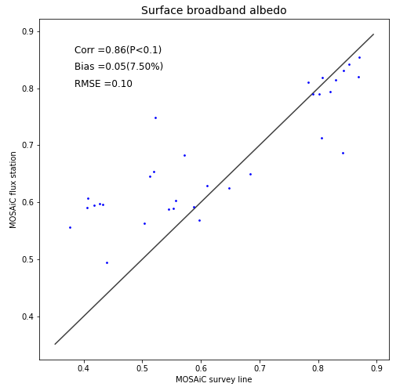
Figure S1. Comparison of measured surface broadband albedo from MOSAiC flux station and survey line during April-September 2020. The correlation (Corr) with p-value in parenthesis, absolute bias relative to the mean value of MOSAiC measurement (Bias) with relative bias (%) in parenthesis, and root-mean-squared-error (RMSE) are provided.

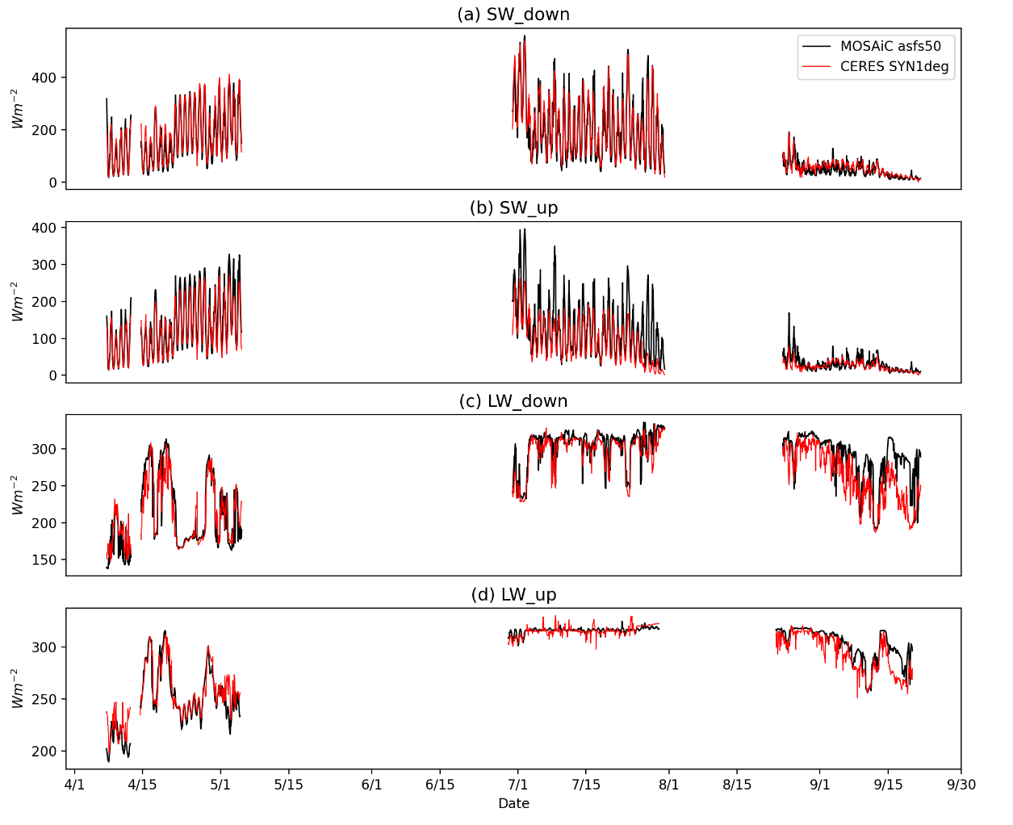Figure S2. The time series of surface radiative fluxes between MOSAiC ASFS50 (black) and CERES SYN1deg (red) during April - September 2020 for (a) downward shortwave flux (SW_down); (b) upward shortwave flux (SW_up); (c) downward longwave flux (LW_down) and (d) upward longwave flux (LW_up).

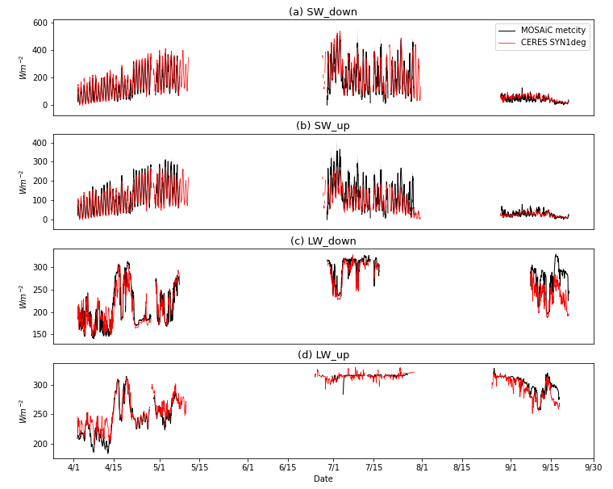
Figure S3. The time series of surface radiative fluxes between MOSAiC Met City (black) and CERES SYN1deg (red) during April - September 2020 for (a) downward shortwave flux (SW_down); (b) upward shortwave flux (SW_up); (c) downward longwave flux (LW_down) and (d) upward longwave flux (LW_up).
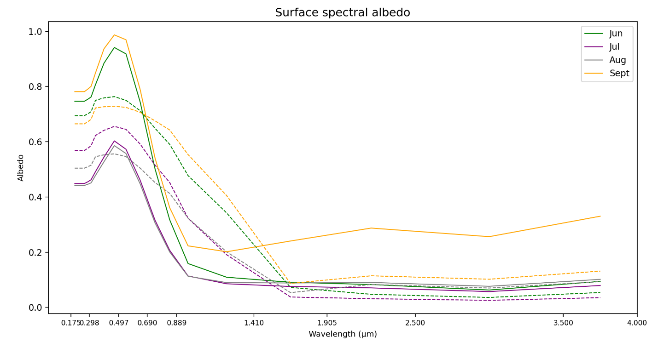
Figure S4. The surface spectral albedo in CERES-like radiative transfer model (RTM) control run (solid line) and MOSAiC (dashed line) for each month during April-September 2020. Note that the MOSAiC measured spectral albedo is only available during June-September and the MOSAiC albedo has been extrapolated within bands 0.1754-0.2247 µm and 2.5000-4.000 µm to be matched with RTM spectral ranges.

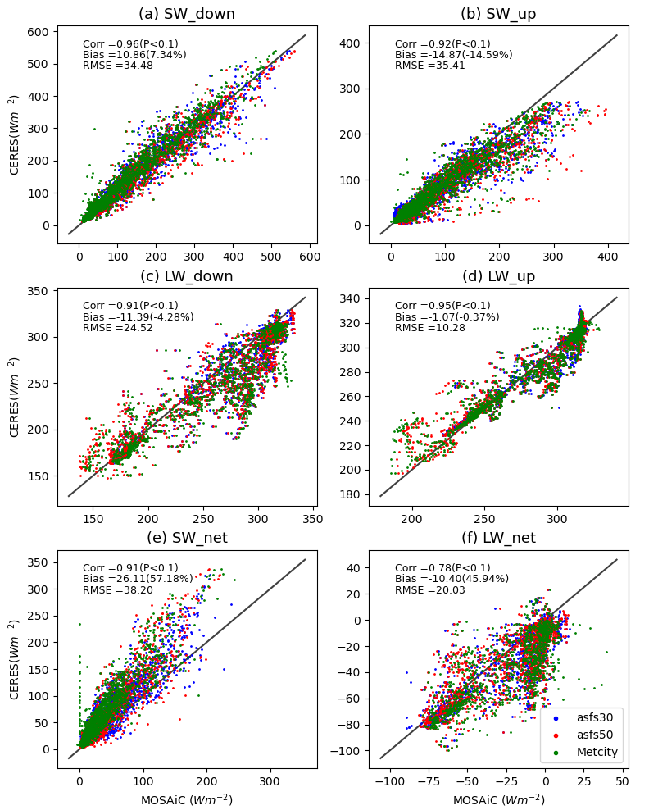
Figure S5. The comparison of surface radiative fluxes between all three flux stations at MOSAiC and CERES SYN1deg during April - September 2020 for (a) downward shortwave flux (SW_down); (b) upward shortwave flux (SW_up); (c) downward longwave flux (LW_down); (d) upward longwave flux (LW_up); (e) net shortwave flux (SW_net) and (f) net longwave flux (LW_net). The blue dots represent measurements from ASFS30 station, red dots indicate ASFS50 flux station, and green dots represent Met City flux tower. The correlation (Corr) with p-value in parenthesis, absolute bias relative to the mean value of MOSAiC measurement (Bias) with relative bias (%) in parenthesis and root-mean-squared-error (RMSE) are provided for each radiative flux component.
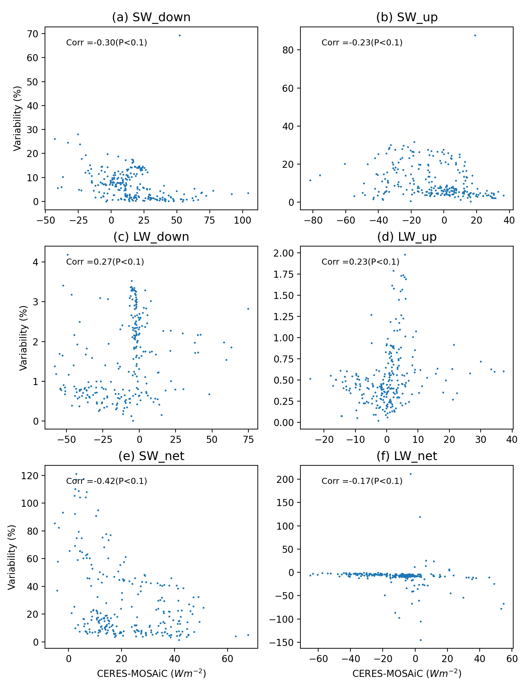
Figure S6. The relationships between bias of CERES SYN1deg-Hour and spatial variability in MOSAiC measurements for (a) downward shortwave flux (SW_down); (b) upward shortwave flux (SW_up); (c) downward longwave flux (LW_down); (d) upward longwave flux (LW_up); (e) net shortwave flux (SW_net) and (f) net longwave flux (LW_net). The spatial variability (%) is defined as the ratio between the absolute variance and the average of all available MOSAiC measurements, while the absolute difference is the maximum difference among each pair of measurements at a given time.
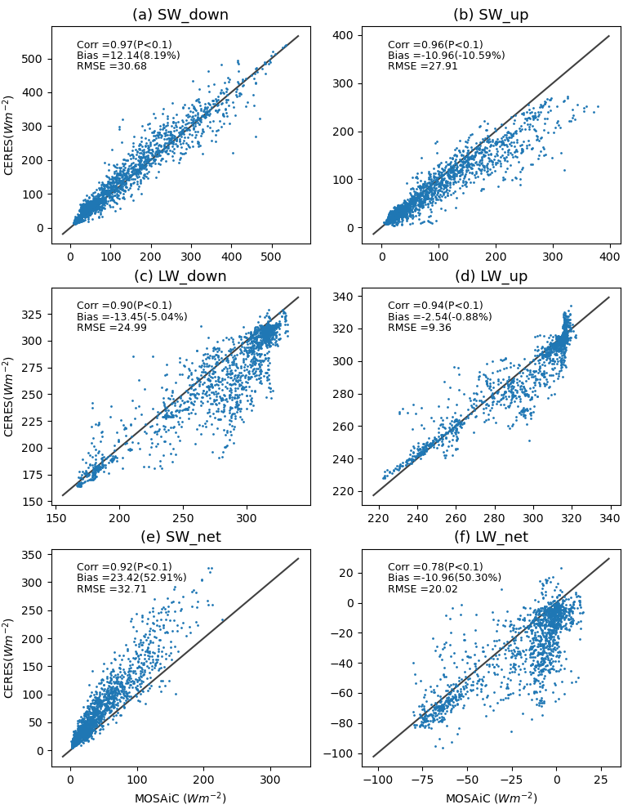
Figure S7. Comparison of surface radiative fluxes between MOSAiC ground observations and CERES SYN1deg during April - September 2020 under high sea ice concentrations (>80%) for (a) downward shortwave flux (SW_down); (b) upward shortwave flux (SW_up); (c) downward longwave flux (LW_down); (d) upward longwave flux (LW_up); (e) net shortwave flux (SW_net) and (f) net longwave flux (LW_net). The correlation (Corr) with p-value in parenthesis, absolute bias relative to the mean value of MOSAiC measurement (Bias) with relative bias (%) in parenthesis and root-mean-squared-error (RMSE) are provided for each radiative flux component. The point-by-point comparison is shown between MOSAiC observations and SYN1deg only if there are at least two measurements available among ASFS30, ASFS50 and Met City. The MOSAiC observations are obtained by averaging all available measurements at a given time.
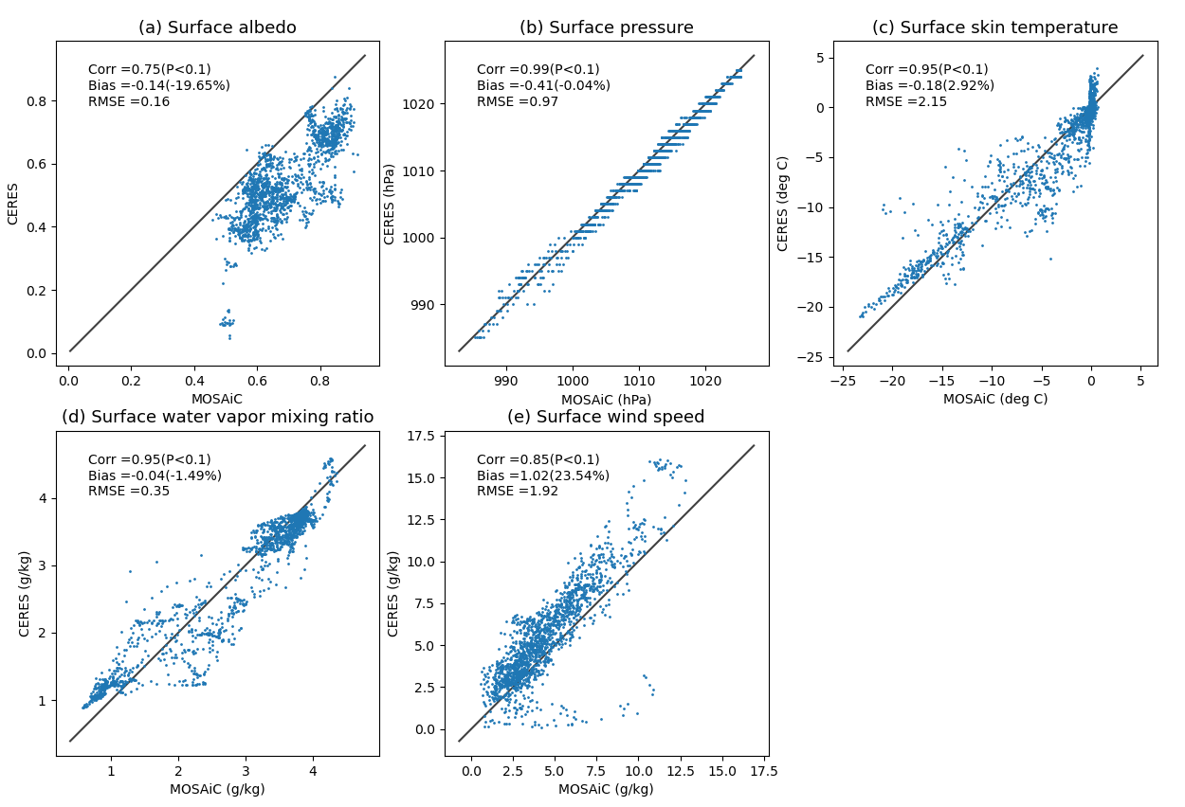
Figure S8. The validation of CERES SYN1deg input to Fu-Liou radiative transfer model by MOSAiC surface measurements during April - September 2020 under high sea ice concentrations (>80%) for (a) surface albedo; (b) surface pressure; (c) surface skin temperature derived from surface longwave fluxes; (d) surface water vapor mixing ratio and (e) surface wind speed. The correlation (Corr) with p-value in parenthesis, absolute bias relative to the mean value of MOSAiC measurement (Bias) with relative bias (%) in parenthesis and root-mean-squared-error (RMSE) are provided for each variable. The point-by-point comparison is shown between MOSAiC observations and SYN1deg only if there are at least two measurements available among ASFS30, ASFS50 and Met City. The MOSAiC observations are obtained by averaging all available measurements at a given time.

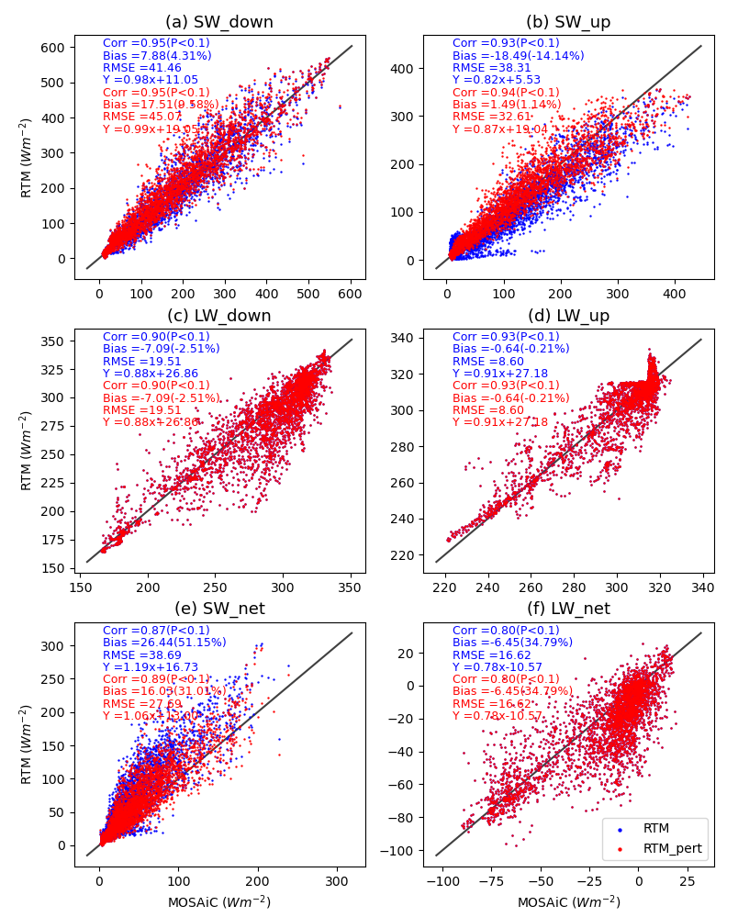
Figure S9. The comparison of surface radiative fluxes between MOSAiC observations and RTM calculations from experiment A1 during April - September 2020 for (a) downward shortwave flux (SW_down); (b) upward shortwave flux (SW_up); (c) downward longwave flux (LW_down); (d) upward longwave flux (LW_up); (e) net shortwave flux (SW_net) and (f) net longwave flux (LW_net). The blue dots represent RTM control run, while red dots indicate RTM perturbation run. The correlation (Corrp-value) with p-value in parenthesis, absolute bias (bias relative to the mean value of MOSAiC measurement (Bias) with relative bias (%) in parenthesis), root-mean-squared-error (RMSE), and regression equation are provided for each radiative flux component, and for control and perturbation run, respectively.
Table S1. The relative bias of shortwave fluxes to the mean value from MOSAiC measurements in Fu-Liou Radiative Transfer Model control run and surface albedo perturbation runs calculated from all data points and points with sea ice concentration is greater than 80%. The relative change in each perturbation run to control run is provided in parenthesis. Note that the values in parentheses for experiment A7 are the relative changes to A6.
Experiment | SW_down |  | SW_up |  | SW_net
 | All data points | Sea ice > 80% | All data points | Sea ice > 80% | All data points | Sea ice > 80%
Control run | +4.31% | +5.11% | -14.1% | -10.9% | +51.2% | +51.7%
A1 | +9.58%  (+5.27%) | +9.38%  (+4.27%) | +1.14%  (+15.3%) | +0.69%  (+11.6%) | +31.0%  (-20.1%) | +34.8%  (-17.0%)
A2 | +7.86%  (+3.55%) | +8.34%  (+3.23%) | -1.75%  (+12.4%) | -0.39%  (+10.5) | +32.3%  (-18.8%) | +34.2%  (-17.5%)
A3 | +8.61%  (+4.30%) | +9.21%  (+4.10%) | +1.88%  (+16.0%) | +3.47%  (+14.3%) | +25.7%  (-25.4%) | +26.0%  (-25.7%)
A4 | +8.88%  (+4.57%) | +9.19%  (+4.08%) | +2.68%  (+16.8%) | +4.25%  (+15.1%) | +26.7%  (-24.5%) | +24.7%  (-27.1%)
A5 | +8.05%  (+3.74%) | +8.73%  (+3.62%) | -0.18%  (+14.0%) | +1.86%  (+12.7%) | +29.0%  (-22.2%) | +28.8%  (-22.9%)
A6 | +6.38%  (N/A) | +8.63%  (N/A) | -13.5%  (N/A) | -6.70%  (N/A) | +44.4%  (N/A) | +41.9%  (N/A)
A7 | +5.36%  (-1.02%) | +7.36%  (-1.27%) | -16.1%  (-2.61%) | -9.84%  (-3.14%) | +46.4%  (+2.00%) | +44.7%  (+2.77%)

