Supplemental Material
Discrepancies in ozone levels and temporal variations between urban and rural North China Plain: implications for agricultural impact assessment
Xiaoyi Zhang^{1,2, §}, Wanyun Xu^{2, §, *}, Gen Zhang², Weili Lin³, Huarong Zhao⁴, Sanxue Ren⁴, Guangsheng Zhou⁴, Jianmin Chen¹ and Xiaobin Xu^{2,} *
1 Department of Atmospheric and Oceanic Sciences, Fudan University, Shanghai, China
2 State Key Laboratory of Severe Weather, Key Laboratory for Atmospheric Chemistry, Institute of Atmospheric Composition, Chinese Academy of Meteorological Sciences, Beijing, 100081, China
3 College of Life and Environmental Sciences, Minzu University of China, Beijing, 100081, China
4 State Key Laboratory of Severe Weather, Institute of Agricultural Meteorology, Chinese Academy of Meteorological Sciences, Beijing, 100081, China
§ These authors contributed equally to this work.
*E-mail: Wanyun Xu (xuwy@cma.gov.cn) and Xiaobin Xu (xiaobin_xu@189.cn)

May 1, 2020

List of Contents:
Figure S1. Distribution of annual (a) and seasonal (b-d) AOT40 change rates during 2013-2019 in the NCP. Data are from the CNEMC network and GC; dots represent sites with rates at a significance level of p<0.05, while crosses represent sites with rates that revealed p-values greater than 0.05, and the triangles represent GC.

Figure S2. The changes and relative differences in annual and seasonal AOT40 between GC and nearby cities. (a) Distinct levels, change rates; (b) relative differences in annual AOT40 between GC and nearby cities (BD, BJS, BJU, LF) and (c) relative differences in seasonal AOT40 between GC and BD during 2013-2019; the black error bars in (a) represent the standard deviations of the average O₃ mixing ratio for each city; numbers in (a) are change rates (in ppm h yr⁻¹) and p-values of annual AOT40 in BD, BJS, BJU, LF and GC .

Figure S3. The differences in seasonal AOT40 between suburban/rural and urban sites in BJ and SJZ during 2013-2019.

Figure S4. The average monthly change of AOT40 during 2013-2019 at the GC site. The grey dashed line represents the threshold of AOT40 (5 ppm h), which is the critical level for plant health protection. There was no O₃ mixing ratio higher than 40 ppb, so the AOT40 had no valid value in December.

Table S1. Annual and seasonal change rates of AOT40 levels at GC, BD, BJ, SJZ and CNEMC NCP sites during 2013-2019.

Table S2. Monthly average (± standard deviation) of O₃ mixing ratios at GC during 2013-2019 (Units: ppb).

Table S3. Annual AOT40 for wheat, maize and soybean during the growing seasons at GC from 2013 to 2019.

Table S4. The locations and types of the observation sites at GC, BD, LF, BJ, SJZ.

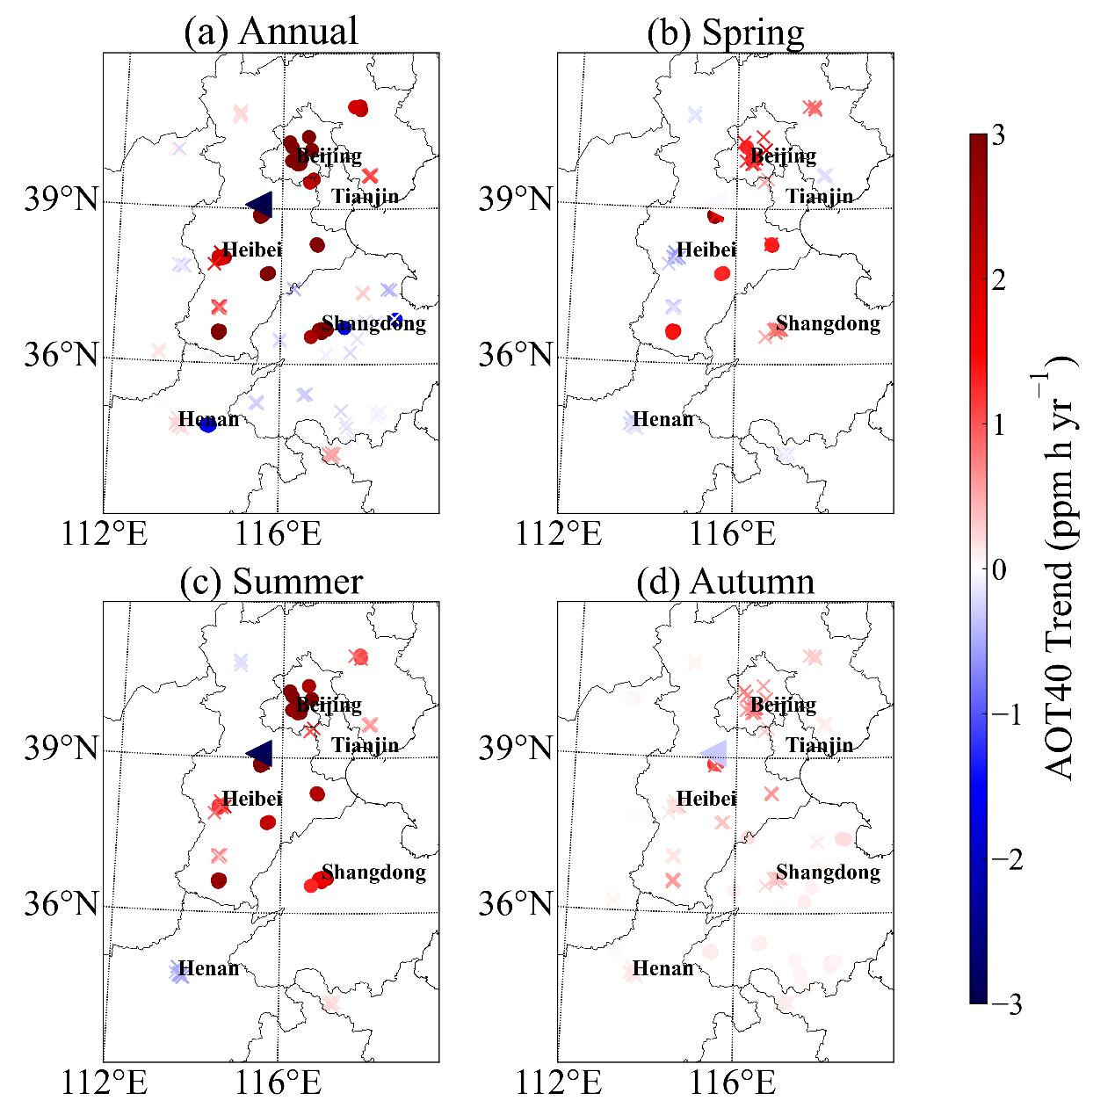
Figure S1. Distribution of annual (a) and seasonal (b-d) AOT40 change rates during 2013-2019 in the NCP. Data are from the CNEMC network and GC; dots represent sites with rates at a significance level of p<0.05, while crosses represent sites with rates that revealed p-values greater than 0.05, and the triangles represent GC.

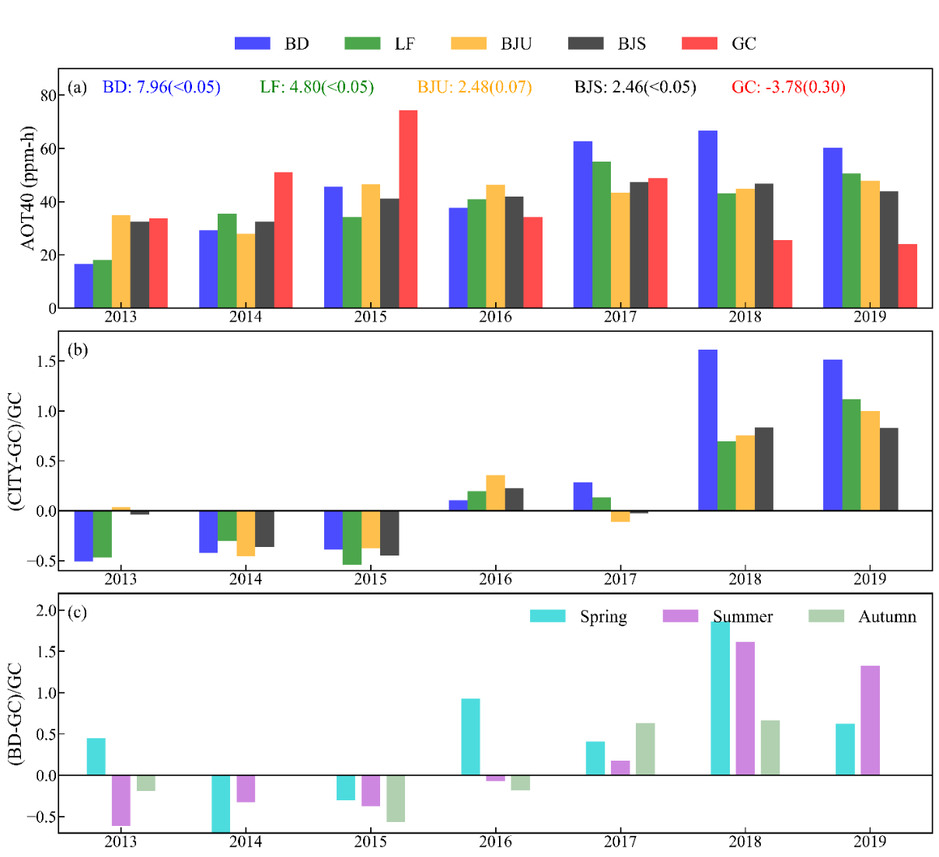

Figure S2. The changes and relative differences in annual and seasonal AOT40 between GC and nearby cities. (a) Distinct levels, change rates; (b) relative differences in annual AOT40 between GC and nearby cities (BD, BJS, BJU, LF) and (c) relative differences in seasonal AOT40 between GC and BD during 2013-2019; the black error bars in (a) represent the standard deviations of the average O₃ mixing ratio for each city; numbers in (a) are change rates (in ppm h yr⁻¹) and p-values of annual AOT40 in BD, BJS, BJU, LF and GC .

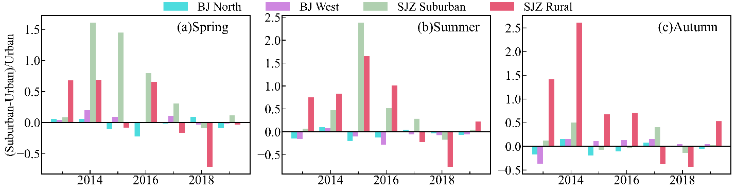

Figure S3. The differences in seasonal AOT40 between suburban/rural and urban sites in BJ and SJZ during 2013-2019.

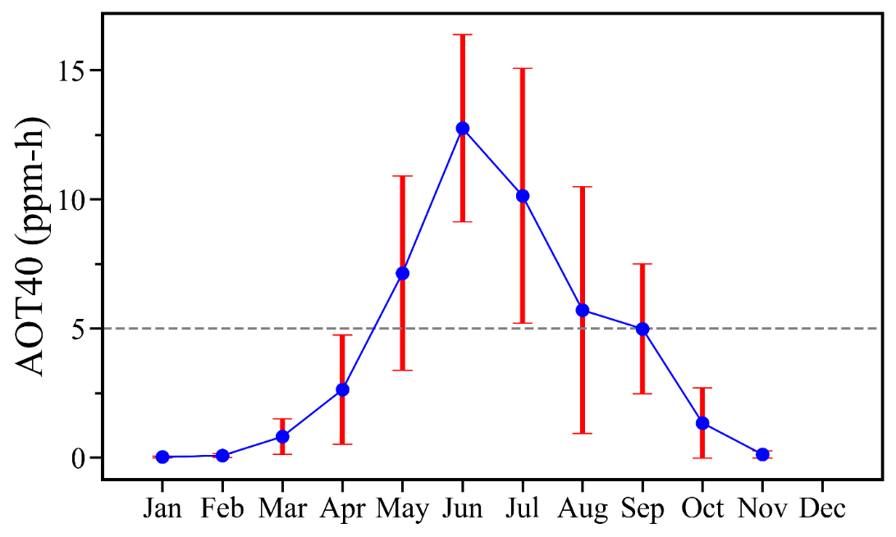

Figure S4. The average monthly change of AOT40 during 2013-2019 at the GC site. The grey dashed line represents the threshold of AOT40 (5 ppm h), which is the critical level for plant health protection. There was no O₃ mixing ratio higher than 40 ppb, so the AOT40 had no valid value in December. The red error bars represent the standard deviations of the monthly AOT40 mixing ratio during 2013-2019.

Table S1. Annual and seasonal change rates of AOT40 levels at GC, BD, BJ, SJZ and CNEMC NCP sites during 2013-2019.
Sites | Rates (ppm h yr⁻¹) |  | Annual | Spring | Summer | Autumn
BD | GC |  | -3.8 | -0.0 | -2.9 | -0.3ª
 | Urban/Suburban |  | 7.9 | 2.7 | 4.3 | 0.9
BJ | North |  | 2.5 | 0.6 | 1.4 | 0.5
 | Urban |  | 2.3 | 0.6 | 1.22 | 0.5
 | West |  | 2.3 | 0.4 | 1.2 | 0.7
SJZ | Suburban |  | 2.9 | 0.7 | 1.6 | 0.5
 | Urban |  | 5.4 | 1.6 | 3.1 | 0.6
 | Rural |  | -2.0 | -0.4 | -1.1 | -0.3
NCP | p<0.05 | upward | 4.5  (1.9 to 10.2)# | 1.8  (1.3 to 2.9)# | 2.7  (1.0 to 5.6)# | 0.2  (0.0 to 1.4)#
 |  | downward | -1.7  (-1.9 to -1.4)# | - | - | -
 |  | N_{Down}/N_{All-s} * | 6/51 | 0/15 | 0/38 | 0/39
 | p>0.05 | upward | 0.0 to 2.0# | 0.5 to 1.6# | 0.2 to 4.6# | 0.0 to 1.0#
 |  | downward | -0.4 to 0.0# | -0.6 to -0.0# | -0.6 to -0.2# | -
 |  | N_{Down}/N_{All-n} * | 38/78 | 33/58 | 11/35 | 0/79

Notes:

1. Bold numbers are rates that passed the 95% significant test.

2. * N_{Down} represents the number of sites with downward AOT40, while N_{All-s} and N_{All-n} are the total numbers of sites with significantly and non-significantly change rates of AOT40, respectively.

3. ª represents change rates calculated for 2013 to 2018

4. # variation range of the AOT40 change rates observed at distinct sites in the NCP.

Table S2. Monthly average (± standard deviation) of O₃ mixing ratios at GC during 2013-2019 (Units: ppb).
 | 2013 | 2014 | 2015 | 2016 | 2017 | 2018 | 2019
Jan. | 2.6±4.9 | 5.3±8.4 | 5.5±8.2 | 7.7±10.5 | 7.0±10.2 | 7.3±8.8 | 7.0±8.9
Feb. | 8.6±9.4 | 11.2±12.7 | 13.8±14.1 | 10.7±12 | 11.4±12.7 | 13.8±11.8 | 13±13.8
Mar. | 11.5±11.7 | 19.9±20 | 22.1±19.8 | 14.3±13.3 | 17.1±14.9 | 17.1±15.4 | 23.5±18.2
Apr. | 15.7±14.7 | 34.4±24.1 | 35.6±25.7 | 24.1±16.9 | 22.2±17.5 | 26.6±19.3 | 28.3±19.4
May | 28.6±22.8 | 44.9±28.6 | 48.4±33.7 | 34.3±24.7 | 43.1±32.3 | 32.9±22.1 | 37.4±24.8
Jun. | 44.3±32.7 | 49.9±31.3 | 57.3±35.9 | 46.1±30.5 | 61±38 | 49.6±31.3 | 46.5±30.9
Jul. | 43.7±30.7 | 45.9±31.4 | 58.8±37.8 | 39±28.8 | 52.4±38.6 | 34.5±23.6 | 31.6±25.4
Aug. | 39.3±30.7 | 41.2±30.6 | 46.6±36.4 | 28.9±24.6 | 27.8±21.3 | 28.4±21.5
Sep. | 25.8±25.5 | 25.9±26.1 | 36.1±34.8 | 30.9±30.7 | 26.9±29.2 | 20.2±20.3
Oct. |  | 16.1±20.5 | 20.2±26.8 | 10.4±15.6 | 9.8±11.3 | 13.6±16.7
Nov. |  | 9.5±11.6 | 11.1±13 | 6.5±9 | 8.7±9.5 | 7.4±11.2
Dec. |  | 8.4±9.4 | 5.4±7.6 | 3.3±5 | 6.9±8.5 | 5.4±7.5

Table S3. Annual AOT40 for wheat, maize and soybean during the growing seasons at GC from 2013 to 2019.
Year | AOT40_{wheat} (ppm h) | AOT40_{soybean/maize} (ppm h)
2013 | 6.9 | 27.9
2014 | 22.6 | 31.2
2015 | 26.0 | 48.5
2016 | 12.4 | 25.0
2017 | 18.5 | 34.0
2018 | 12.7 | 15.8
2019 | 14.0 | 11.7

Table S4. The locations and types of the observation sites at GC, BD, LF, BJ, SJZ.
City | Type | Location
GC | Rural | 39.15°N, 115.73°E
BD | Urban | 38.86°N, 115.49°E
 |  | 38.90°N, 115.52°E
 |  | 38.91°N, 115.47°E
 |  | 38.84°N, 115.46°E
 |  | 38.88°N, 115.44°E
 |  | 38.87°N, 115.52°E
LF | Urban | 39.57°N, 116.77°E
 |  | 39.52°N, 116.68°E
BJ | Urban | 39.87°N, 116.37°E
 |  | 39.95°N, 116.43°E
 |  | 39.87°N, 116.43°E
 |  | 39.97°N, 116.47°E
 |  | 39.94°N, 116.36°E
 |  | 39.99°N, 116.36°E
 |  | 40.00°N, 116.41°E
 |  | 39.93°N, 116.23°E
 | Suburban | 40.29°N, 116.17°E
 |  | 40.14°N, 116.72°E
 |  | 40.39°N, 116.64°E
 |  | 40.20°N, 116.23°E
 |  | 40.29°N, 116.17°E
SJZ | Urban | 38.04°N, 114.61°E
 |  | 38.05°N, 114.52°E
 |  | 38.02°N, 114.53°E
 |  | 38.01°N, 114.46°E
 |  | 38.05°N, 114.46°E
 | Suburban | 38.14°N, 114.50°E
 | Rural | 37.91°N, 114.35°E

