Supplemental material

Soil microbial communities vary in composition and functional strategy across soil aggregate size class regardless of tillage
- Lukas T. Bernhardt^{1*}, Richard G. Smith¹, A. Stuart Grandy¹, Jessica E. Mackay¹, Nicholas D. Warren¹, Kevin M. Geyer², Jessica G. Ernakovich¹
¹Department of Natural Resources and the Environment, University of New Hampshire, Durham, NH, USA
²Young Harris College, Young Harris, GA, USA

* Correspondence:
Lukas T. Bernhardt
Lukas.Bernhardt@unh.edu

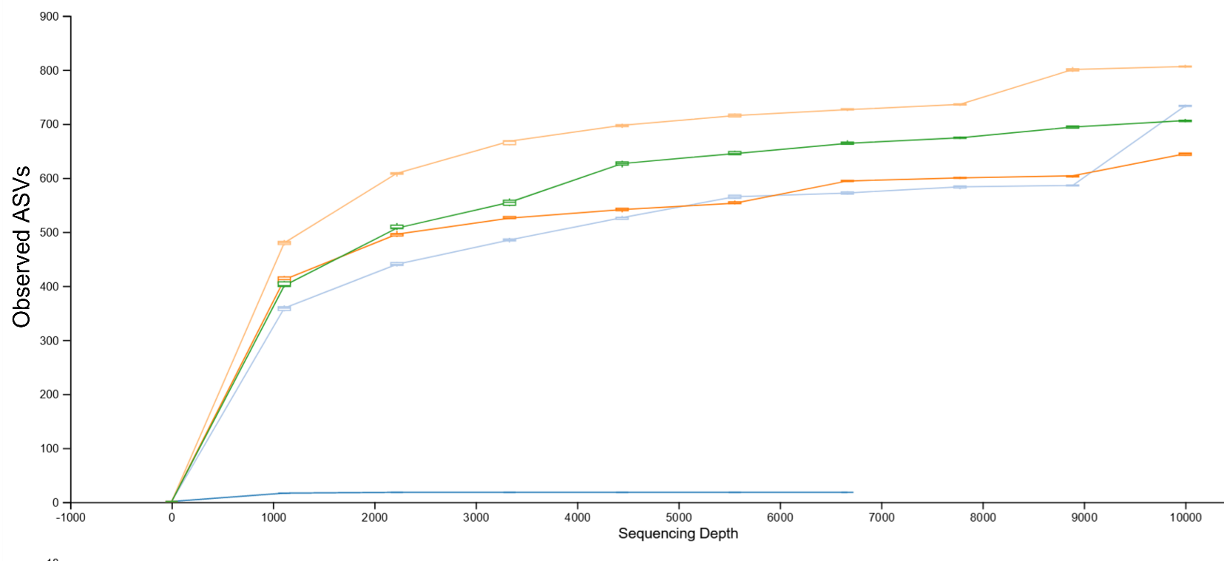
Figure S1: Rarefaction curve showing amplicon sequence variants (ASVs) observed at various sequencing depths
The colors represent aggregate size classes. Light blue- 1 mm- 2 mm; Dark orange 0.25 mm- 1 mm; Light orange <0.25 mm; Dark blue extraction blanks. The boxes along each curve are the median and 1st and 3rd quartiles of the data for observed ASVs at various sequencing depths.
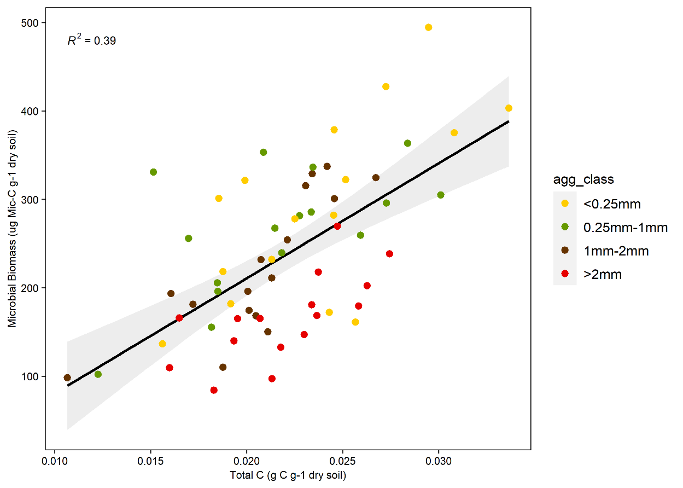

Figure S2: Linear regression of microbial biomass vs total carbon
Biomass was calculated via glucose respiration
with the equation from Anderson and Domsch, 1978 and plotted against total carbon. Linear modeling determined that the variables were significantly correlated p < 0.001.

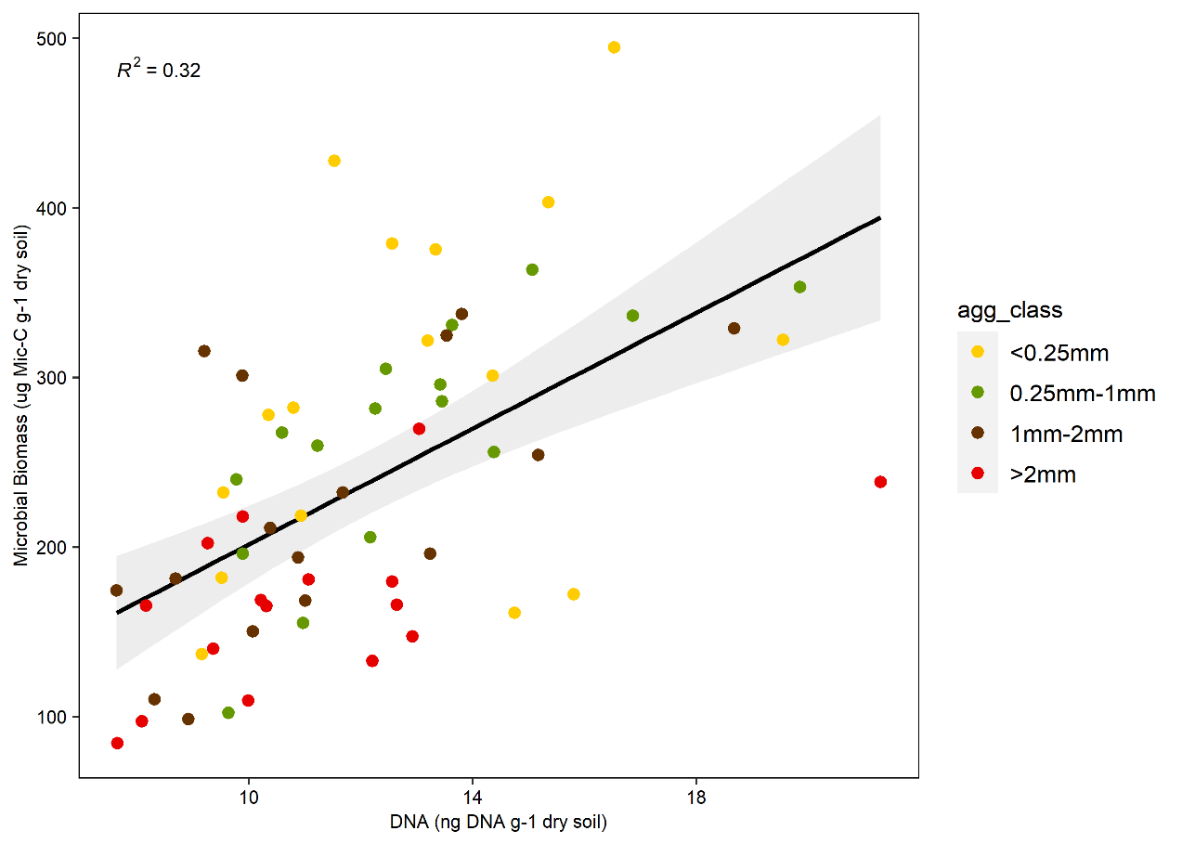

Figure S3: Linear regression of microbial biomass against soil DNA measured
Recovered DNA calculated as ng DNA per g dry soil⁻¹
. Biomass calculated via glucose respiration with the equation from Anderson and Domsch, 1978. Linear modeling determined that the variables were significantly correlated P<0.001.

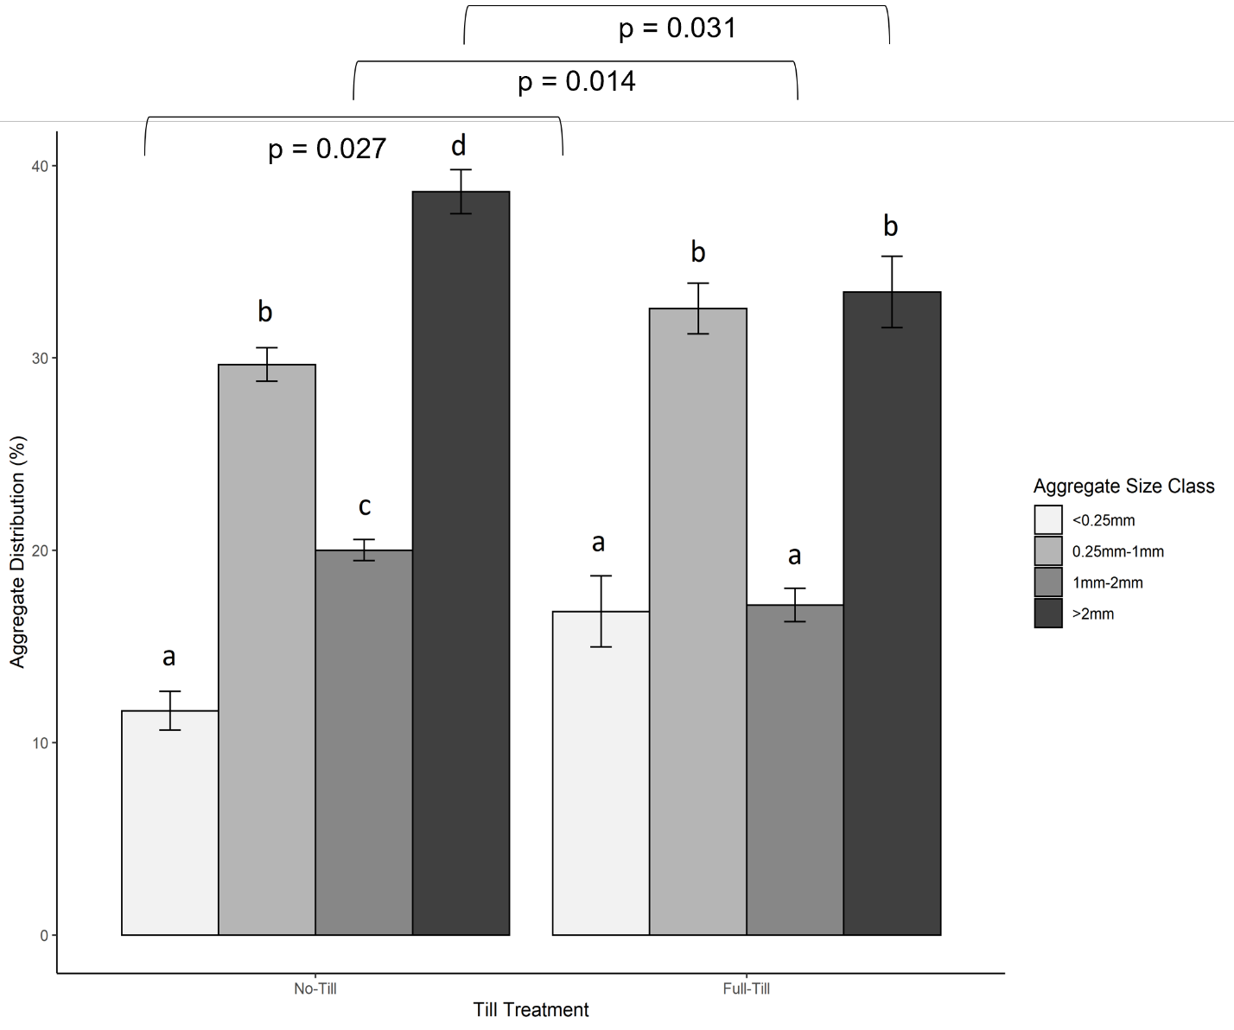
Figure S4: Aggregate size class distribution in no-till (left) and full-till (right) treatments

Lower case letters denote significance within tillage treatment. p-values denote significant differences between aggregates within the same size class when comparing no-till and full-till. There was no difference between the 0.25- 1mm aggregate size classes between no-till and full-till. Within full-till sites the <0.25 mm size class differed from both the 0.25-1 mm and >2 mm size class (p < 0.001) and the 1-2 mm size class differed from the 0.25- 1 and >2 mm size class (p <0.001). Within no-till sites, every aggregate size class differed significantly from one another (p < 0.001 for all comparrisons). p-values and significance within tillage treatment determined using two-way ANOVA and Tukey HSD post-hoc test.

Table S1: Community weighted NSTI values for samples included in Picrust2 analysis
Lower NSTI values indicate samples with good reference representation. NSTI values between 0.06 < NSTI < 0.15 are considered reliable values. Any OTU’s with NSTI > 2 standard deviations from mean were discarded from analysis. After quality control, 8149 OTU’s were retained.

sample | weighted_NSTI
LB_16S_1 | 0.081055
LB_16S_2 | 0.093029
LB_16S_3 | 0.085708
LB_16S_4 | 0.096764
LB_16S_5 | 0.110303
LB_16S_6 | 0.102728
LB_16S_7 | 0.10931
LB_16S_8 | 0.095926
LB_16S_10 | 0.112773
LB_16S_11 | 0.106172
LB_16S_12 | 0.097453
LB_16S_14 | 0.105701
LB_16S_15 | 0.109831
LB_16S_16 | 0.099343
LB_16S_18 | 0.094098
LB_16S_19 | 0.094662
LB_16S_20 | 0.094207
LB_16S_21 | 0.118401
LB_16S_22 | 0.101297
LB_16S_23 | 0.107071
LB_16S_24 | 0.094269
LB_16S_25 | 0.10373
LB_16S_26 | 0.098978
LB_16S_27 | 0.112357
LB_16S_28 | 0.101437
LB_16S_29 | 0.110311
LB_16S_30 | 0.103154
LB_16S_31 | 0.104774
LB_16S_32 | 0.067374
LB_16S_34 | 0.098465
LB_16S_35 | 0.101493
LB_16S_36 | 0.087087
LB_16S_37 | 0.090882
LB_16S_38 | 0.089149
LB_16S_39 | 0.101833
LB_16S_40 | 0.084779
LB_16S_41 | 0.112045
LB_16S_42 | 0.096271
LB_16S_43 | 0.113692
LB_16S_44 | 0.122051
LB_16S_45 | 0.100425
LB_16S_46 | 0.100742
LB_16S_47 | 0.110877
LB_16S_48 | 0.094318
LB_16S_49 | 0.115414
LB_16S_50 | 0.093069
LB_16S_51 | 0.097761
LB_16S_53 | 0.09217
LB_16S_54 | 0.1118
LB_16S_55 | 0.107273
LB_16S_57 | 0.104035
LB_16S_58 | 0.099947
LB_16S_59 | 0.106719
LB_16S_60 | 0.105085
LB_16S_61 | 0.097653
LB_16S_62 | 0.101817
LB_16S_63 | 0.103257
LB_16S_64 | 0.106076

Table S2: Soil and microbial community properties for no-till and full-till aggregate size classes.

Mean and standard error values are reported. Bold letters denote significant differences between aggregate size classes within tillage treatment analyzed by ANOVA and Tukey HSD post hoc test.
Soil properties | <0.25 mm |  |  |  | 0.25-1 mm |  |  |  | 1- 2 mm |  |  |  | >2 mm
 | NT |  | FT |  | NT |  | FT |  | NT |  | FT |  | NT |  | FT
 | Mean | + SE | Mean | + SE | Mean | + SE | Mean | + SE | Mean | + SE | Mean | + SE | Mean | + SE | Mean | + SE
pH | 6.52 | 0.11 | 6.28 | 0.13 | 6.63 | 0.16 | 6.37 | 0.13 | 6.93 | 0.28 | 6.44 | 0.11 | 6.46 | 0.095 | 6.3 | 0.11
EC | 32.72 | 2.89 | 21.25 | 2.17 | 31.07 | 3.41 | 18.29 | 2.15 | 26.04 | 2.6 | 18.97 | 1.86 | 29.97 | 2.94 | 20.18 | 2.67
Total C_{a} | 0.027 | 1.60E-03 | 0.021 | 1.10E-03 | 0.023 | 1.90E-03 | 0.02 | 1.40E-03 | 0.022 | 1.10E-03 | 0.019 | 1.40E-03 | 0.024 | 1.20E-03 | 0.02 | 8.00E-03
Total N_{b} | 0.003 | 1.4e-04a | 0.0019 | 8.77E-05 | 0.0021 | 1.4e-04b | 0.0018 | 1.02E-04 | 0.002 | 6.7e-05b | 0.0017 | 1.13E-04 | 0.0022 | 8.8e-05ab | 0.0018 | 6.68E-05
C:N | 10.53 | 0.13 | 10.48 | 0.12 | 10.9 | 0.23 | 10.69 | 0.21 | 10.85 | 0.22 | 10.95 | 0.19 | 10.87 | 0.2 | 10.68 | 0.12
Mic. Biomass_{c} | 332.2 | 41.9a | 253.67 | 27.44a | 315.8 | 12.9a | 213.41 | 21.76 a | 274.64 | 20.65ab | 172.46 | 21.97ab | 200.17 | 14.25b | 132.81 | 11.65b
WHC | 0.73 | 0.015a | 0.67 | 0.018a | 0.65 | 0.018b | 0.57 | 0.018ab | 0.58 | 0.02bc | 0.51 | 0.019bc | 0.52 | 0.02c | 0.46 | 0.02c
Enzyme Activity (µmol h⁻¹ g dry soil ⁻¹)
PHOS | 1003 | 318.71 | 734.04 | 79.50a | 813.86 | 168.85 | 511.45 | 113.51ab | 753.41 | 140.2 | 676.64 | 98.16ab | 613.56 | 81.87 | 374.45 | 31.91b
BG | 401.2 | 76.83 | 228.09 | 33.09 | 370.17 | 47.28 | 199.76 | 32.6 | 322.29 | 43.02 | 249.5 | 41.24 | 365.67 | 48.41 | 151.99 | 13.67
NAG | 98.88 | 15.28 | 57.73 | 8.88a | 94.94 | 8.302 | 54.63 | 7.66 | 84.01 | 11.11 | 65.46 | 9.64 | 101.12 | 5.28 | 48.57 | 7.61
LAP | 88.67 | 14.94 | 76.64 | 9.83 | 88.86 | 13 | 56.09 | 13.16 | 72.52 | 7.99 | 70.11 | 15.21 | 72.04 | 7.89 | 42.43 | 5.12
CBH | 92.76 | 16.77 | 40.66 | 5.93 | 85.94 | 11.01 | 36.61 | 6.68 | 73.97 | 10.19 | 41.64 | 7.7 | 79.63 | 5.98 | 31.64 | 6.45
Multiple substrate induced respiration (µg CO2-C g⁻¹ dry soil h⁻¹)
Arginine | 1.25 | 0.42 | 0.97 | 0.22 | 1.07 | 0.15 | 0.62 | 0.17 | 1.28 | 0.21 | 0.82 | 0.16 | 0.89 | 0.15 | 0.67 | 0.15
Lysine | 0.40 | 0.15 | 0.23 | 0.08 | 0.20 | 0.05 | 0.17 | 0.07 | 0.47 | 0.07 | 0.25 | 0.06 | 0.34 | 0.07 | 0.24 | 0.08
Citric Acid | 1.81 | 0.33 | 1.13 | 0.27 | 2.10 | 0.15 | 1.12 | 0.24 | 2.72 | 0.11 | 1.81 | 0.22 | 2.30 | 0.3 | 1.54 | 0.23
Malic Acid | 1.97 | 0.56 | 1.25 | 0.26 | 1.85 | 0.21 | 0.92 | 0.17 | 1.33 | 0.14 | 0.74 | 0.15 | 1.34 | 0.25 | 1.01 | 0.19
Trehalose | 1.69 | 0.39 | 1.09 | 0.23 | 1.63 | 0.15 | 0.88 | 0.14 | 1.44 | 0.12 | 0.78 | 0.18 | 1.31 | 0.2 | 1.09 | 0.16
Arabinose | 0.91 | 0.21 | 0.65 | 0.15 | 1.19 | 0.18 | 0.54 | 0.13 | 1.47 | 0.11 | 0.91 | 0.15 | 1.30 | 0.16 | 0.86 | 0.12
Glucose | 2.30 | 0.5 | 1.78 | 0.29a | 2.44 | 0.17 | 1.48 | 0.19ab | 2.30 | 0.18 | 1.19 | 0.26ab | 1.44 | 0.23 | 0.23 | 0.12b
Total MSIR | 10.34 | 2.44 | 7.1 | 1.32 | 10.49 | 0.81 | 5.73 | 0.86 | 11.03 | 0.77 | 6.5 | 0.11 | 8.94 | 1.24 | 6.22 | 0.94
Basal Resp._{d} | 1.76 | 0.19 | 1.32 | 0.19 | 1.42 | 0.13 | 1.12 | 0.14 | 1.05 | 0.11 | 0.92 | 0.11 | 1.00 | 0.09 | 0.79 | 0.08
a Measured via elemental analysis (g C g⁻¹ dry soil)
b Measured via elemental analysis (g N g⁻¹ dry soil)
c Microbial biomass calculated via method from Anderson and Domsch, 1978 (µg MIC- C g⁻¹ dry soil h⁻¹)
d Basal respiration calculated from water induced respiration during MSIR (µg CO2-C g⁻¹ dry soil h⁻¹

Table S3: Bacterial indicator species in aggregate size classes
.
Indicator species analysis was conducted using the “indicspecies” package in R. There were 2 amplicon sequence variants (ASV) identified as indicators of the <0.25 mm community and 0.25- 1mm communities. There were 5 ASVs identified as indicators of the >2 mm aggregate bacterial community. ASVs with p- values less than 0.05 were considered significant indicators.

Aggregate Size class | Phylum | Class | Order | Family | p value
<0.25 mm | Actinobacteria | Actinobacteria | Actinomycetales | Nocardioidaceae | 0.001 | ***
 | Actinobacteria | Actinobacteria | Actinomycetales | Sporichthyacaea | 0.007 | **
0.25- 1 mm | Verrucomicrobia | - | - | - | 0.016 | *
 | Actinobacteria | Actinobacteria | Actinomycetales | Actinosynnemataceae | 0.048 | *
>2 mm | Chloroflexi | Anaerolineae | Anaerolineales | Anaerolinaceae | 0.009 | **
 | Verrucomicrobia | Pedosphaerae | Pedosphaerales | R4.31B | 0.043 | *
 | Proteobacteria | Alphaproteobacteria | Rhizobiales | Bradyrhizobiaceae | 0.026 | *
 | Gemmatimonadetes | Gemmatimonadetes | Gemmatimonadales | A1.B1 | 0.046 | *
 | Bacteriodetes | Sphingobacteriia | Sphingobacteriales | Sphingobacteriaceae | 0.043 | *

