Supplemental Information
Black carbon and particulate matter mass concentrations in the Metropolitan District of Caracas, Venezuela. An assessment of temporal variation and contributing sources
Vanessa Engelhardt^{1,2}, Tibisay Pérez^{1,3*}, Loreto Donoso¹, Thomas Müller⁴, Alfred Wiedensohler⁴

¹Centro de Ciencias Atmosféricas y Biogeoquímica, Instituto Venezolano de Investigaciones Científicas, Caracas, 1020A, Venezuela.
²Atmospheric Chemistry Department, Leibniz Institute for Tropospheric Research, Leipzig, 04318, Germany.
³Department of Environmental Science, Policy, and Management, University of California, Berkeley, CA 94720, USA.
⁴Department of Experimental Aerosol and Cloud Microphysics, Leibniz Institute for Tropospheric Research, Leipzig, 04318, Germany.
Correspondence to: Tibisay Pérez (tibisayperez@berkeley.edu)
List of Contents:
Figure S1. Diurnal cycle for the mixing layer height in the urban site from January to May 1999 (Page 2).
Figure S2. Polar plots of the conditional bivariate probability function (CBPF) for percentile range 0 to 50, and 50 to 100, of the concentration of PM_{2.5} in the urban site, from hourly medians during the wet and dry seasons (Page 3).
Figure S3. Polar plots of the conditional bivariate probability function (CBPF) for percentile range 0 to 50, 50 to 100, of the concentration of PM_{2.5} in the forest site, during the wet and dry seasons, from medium hours (Page 4).
Figure S4. Summary plot of seasonal distribution of fire pixel counts for the north area of Venezuela for all the period of measurements. The blue area represents the wet season, while the red area represents the dry season. (FIRMS MCD14ML fire database) (Page 5).
Figure S5. Active fire locations during one-day backward trajectories arriving every 6 h at the forest site at 500 and 1000 m for January 05th, 2019, February 14th, 2019, March 15th, 2019, March 25th, 2019, April 11th, 2019, April 28th, 2019 (Page 6).
Table S1. Summary of the measurement interval and the number of data points used to generate polar plots for the Conditional Bivariate Probability Function for the urban and forest sites (Page 7).
Table S2. Summary of the median, mean, standard deviation, percentiles 25 and 75, and maximum and minimum for meteorological parameters, from the hourly data, for the urban and forest sites (Page 8).
Table S3. Summary of the median, average, standard deviation, and percentiles 25 and 75, for PM_{2.5} and eBC for weekdays and weekends, during the entire period of measurements, from daily values, for the urban and forest site (Page 9).

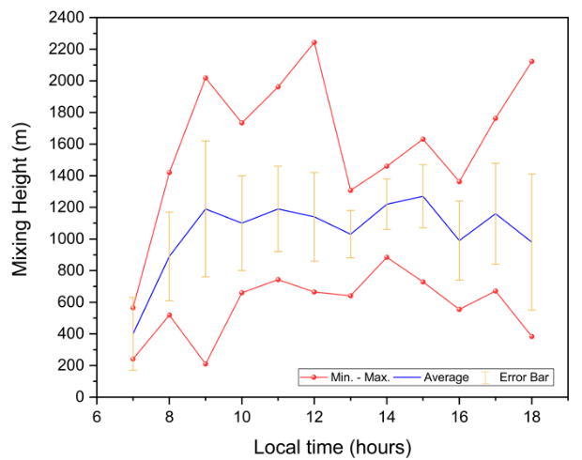
Figure S1.

Diurnal cycle for the mixing layer height in the urban site from January to May 1999 (Adapted from Sena, 2003).

Figure S2.
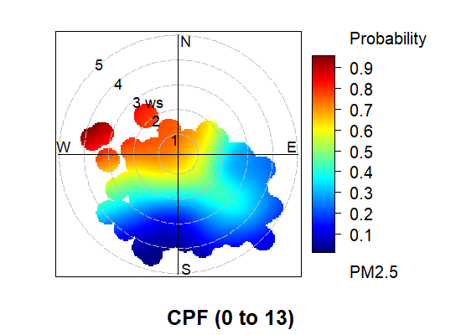
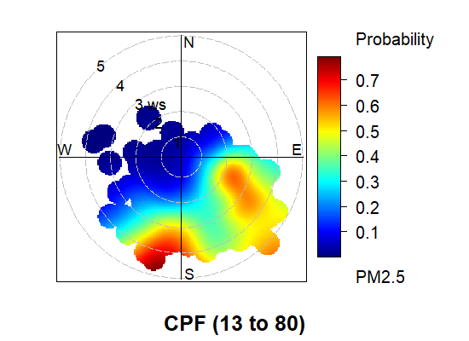
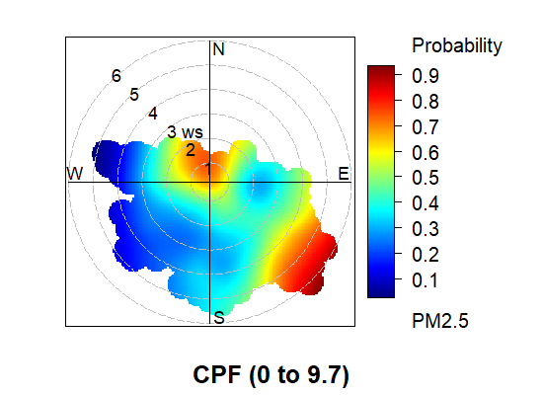
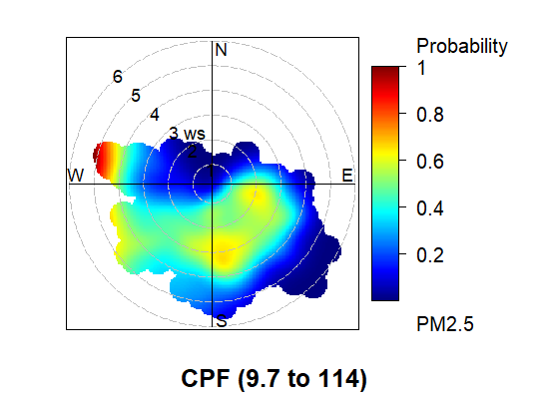
(a)
PM_{2.5} – Wet season (0 – 50 %)
PM_{2.5} – Wet season (50 – 100 %)
(b)
PM_{2.5} – Dry season (0 – 50 %)
(c)
PM_{2.5} – Dry season (50 – 100 %)
(d)
CBPF
CBPF
CBPF
CBPF

Polar plots of the conditional bivariate probability function (CBPF) for percentile range 0 to 50, and 50 to 100, of the concentration of PM_{2.5} in the urban site, from hourly medians during the wet and dry seasons. The color scale represents the probability of finding a higher PM_{2.5}, while the circles reflect the wind speed in each wind direction vector.

Figure S3
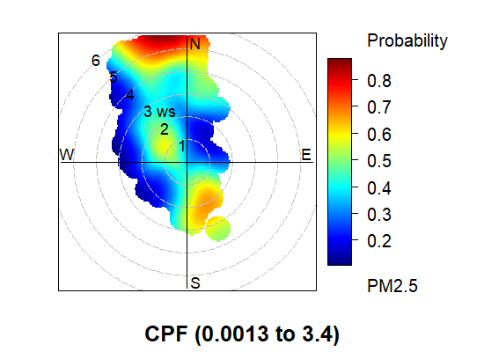
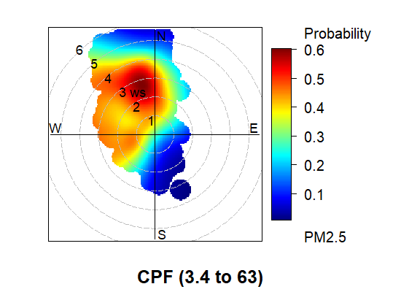
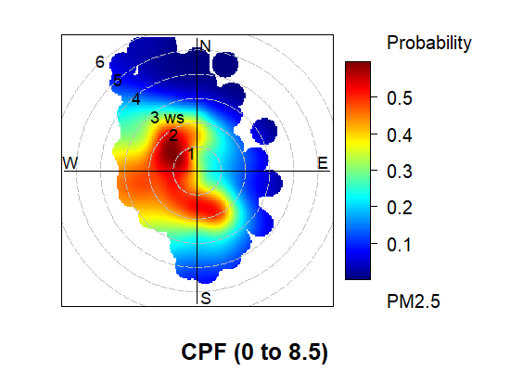
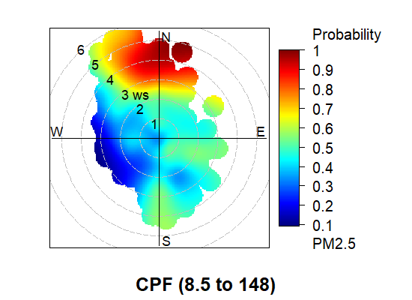
(a)
PM_{2.5} – Wet season (0 – 50 %)
(b)
PM_{2.5} – Wet season (50 – 100 %)
(c)
PM_{2.5} – Dry season (0 – 50 %)
(d)
PM_{2.5} – Dry season (50 – 100 %)
CBPF
CBPF
CBPF

CBPF

Polar plots of the conditional bivariate probability function (CBPF) for percentile range 0 to 50, 50 to 100, of the concentration of PM_{2.5} in the forest site, during the wet and dry seasons, from medium hours. The color scale represents the probability of finding a higher PM_{2.5}, while the circles reflect the wind speed in each wind direction vector.

Figure S4

Summary plot of seasonal distribution of fire pixel counts for the north area of Venezuela for all the period of measurements. The blue area represents the wet season, while the red area represents the dry season. (FIRMS MCD14ML fire database)

Figure S5

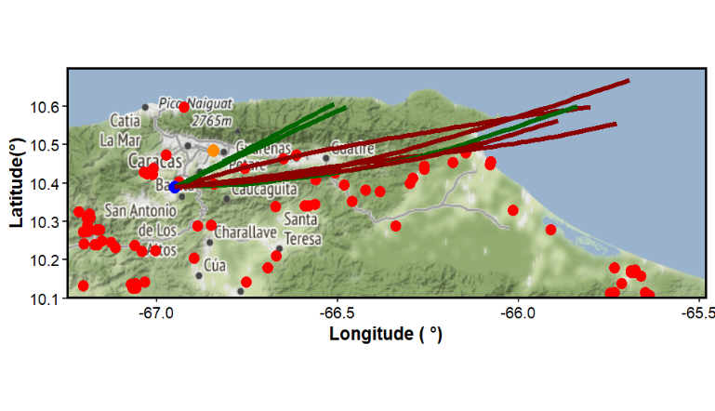
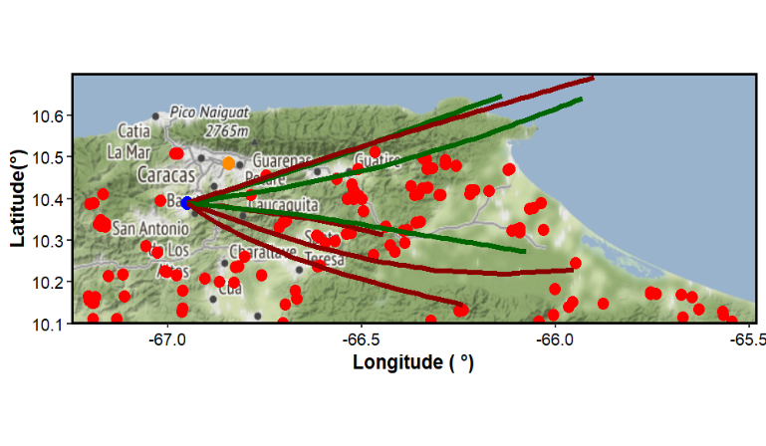
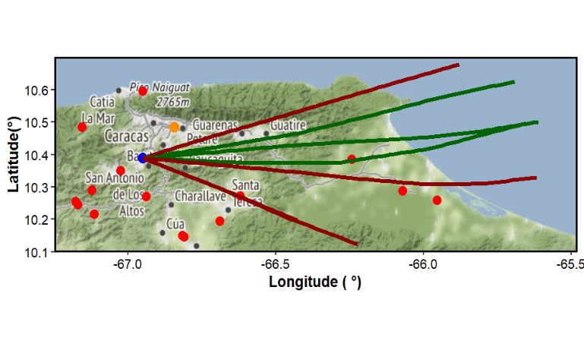
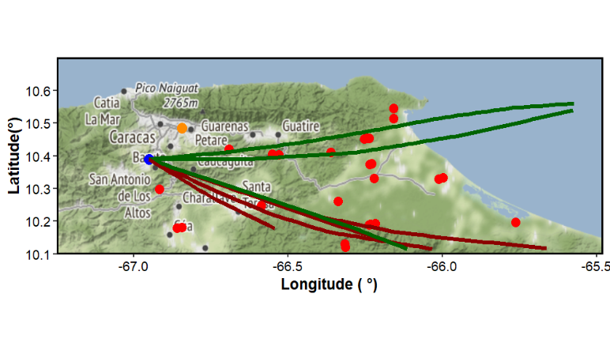
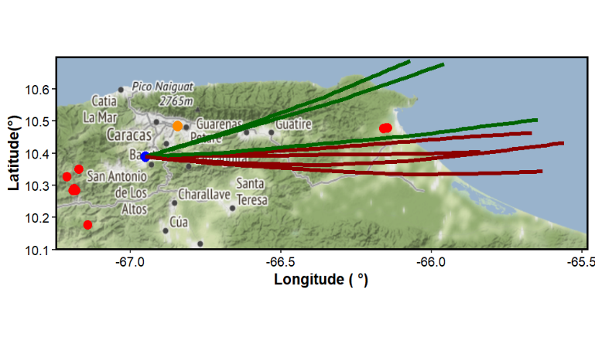
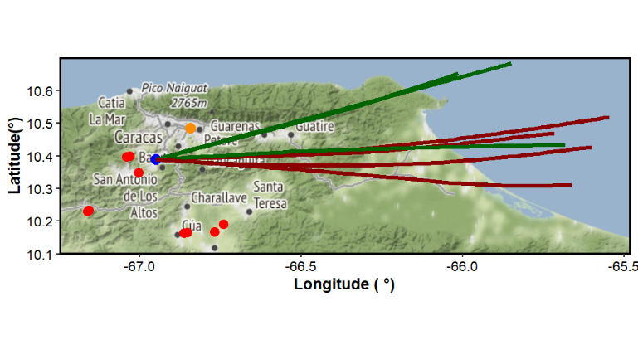
(d)
(e)
(b)
(f)
(c)
(a)

Active fire locations (red dots) during one-day backward trajectories arriving every 6 h at the forest site at 500 m (dark green) and 1000 m (dark red) for (a) January 05th, 2019, (b) February 14th, 2019, (c) March 15th, 2019, (d) March 25th, 2019, (e) April 11th, 2019, (f) April 28th, 2019. The blue dot is the forest site, and the yellow dot is the urban site.

Table S1.
Summary of the measurement interval and the number of hours used to generate polar plots for the Conditional Bivariate Probability Function for the urban and forest sites, per site and season.

Site | Season | Pollutant | Start-time | End-time | Number of hours to polar plots
Forest site | wet season | PM_{2.5} | June 1, 2018 | November 30, 2018 | 2614
Urban site | wet season | PM_{2.5} | June 1, 2018 | May 31, 2019 | 958
Urban site | wet season | eBC | June 1, 2018 | May 21, 2019 | 4331
Forest site | dry season | PM_{2.5} | December 1, 2018 | April 30, 2019 | 3644
Urban site | dry season | PM_{2.5} | December 1, 2018 | April 30, 2019 | 4067
Urban site | dry season | eBC | December 1, 2018 | April 30, 2019 | 3858

Table S2.
Summary of the median, mean, standard deviation, percentiles 25 and 75, and maximum and minimum for meteorological parameters, from the hourly data, for the urban and forest sites.
Parameter | Min. | 25 % | Median | Mean | Std. Dev.* | 75 % | Max.
Urban site
Temperature (°C) | 12.63 | 17.94 | 19.7 | 20.2 | 3.17 | 22.69 | 30.1
Relative humidity (%) | 38 | 73.2 | 78.75 | 77.36 | 10.22 | 85.57 | 95
Rain (mm.) | 0.2 | 0.6 | 1.8 | 5.55 | 9.17 | 6.80 | 60
Wind velocity (m s⁻¹) | 0.19 | 1.28 | 2.02 | 2.15 | 1.04 | 2.98 | 6.97
Wind direction (°) | 1.9 | 115.7 | 128 | 140.2 | 45.42 | 150.2 | 358.7
Forest site
Temperature (°C) | 9.9 | 15.17 | 16.59 | 16.84 | 2.45 | 18.4 | 27
Relative humidity (%) | 35.1 | 75.3 | 83.5 | 82.1 | 11.5 | 91.2 | 99
Rain (mm.) | 0.2 | 0.6 | 1.8 | 6.15 | 10 | 6.2 | 84.6
Wind velocity (m s⁻¹) | - | 0.96 | 1.47 | 1.68 | 0.98 | 2.2 | 5.97
Wind direction (°) | - | 251.4 | 317.2 | 277.1 | 87.46 | 335.4 | 360

*Standard deviation

Table S3.
Summary of the median, average, standard deviation, and percentiles 25 and 75, for PM_{2.5} and eBC for weekdays and weekends, during the entire period of measurements, from daily values, for the urban and forest site (µg m⁻³).
 |  | 25% | Median | Average | Standard deviation | 75%
 |  | (µg m⁻³)
Urban site
PM_{2.5} | Weekdays | 7.07 | 11.80 | 14.83 | 10.29 | 17.62
 | Weekend | 6.90 | 10.25 | 13.32 | 8.45 | 17.91
eBC | Weekdays | 1.18 | 1.63 | 1.84 | 0.98 | 2.18
 | Weekend | 0.92 | 1.28 | 1.44 | 0.91 | 1.60
Forest site
PM_{2.5} | Weekdays | 3.40 | 6.38 | 10.35 | 10.62 | 13.30
 | Weekend | 4.07 | 7.05 | 9.78 | 8.05 | 12.57

