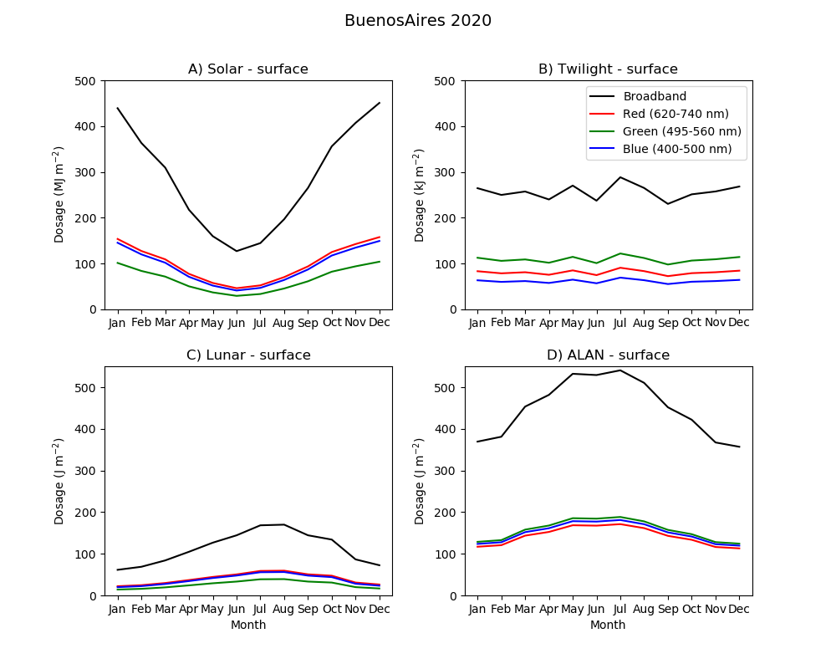
Figure S1: Monthly integrated dosages of irradiance at the surface calculated for Buenos Aires (2020). Model results for dosages of A) solar (MJ m^{–2}), B) twilight (kJ m^{–2}), C) lunar (J m^{–2}) and D) artificial light at night (ALAN, J m^{–2}); note the different units. Broadband (400–740 nm) is shown in black; spectral components, in blue (400–500 nm), green (495–560 nm) and red (620–740 nm).

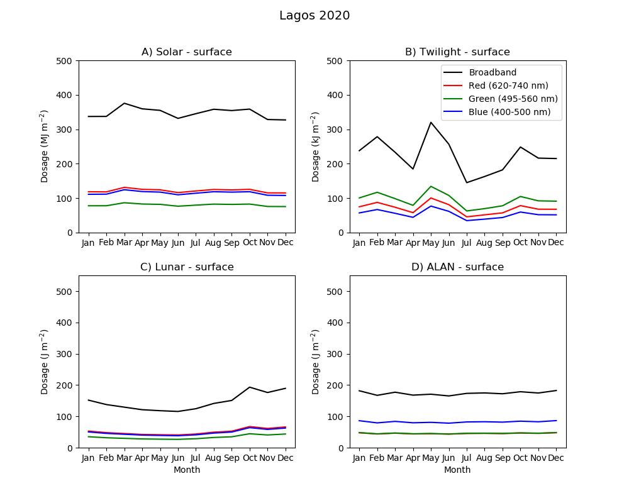
Figure S2: Monthly integrated dosages of irradiance at the surface calculated for Lagos (2020). Model results for dosages of A) solar (MJ m^{–2}), B) twilight (kJ m^{–2}), C) lunar (J m^{–2}) and D) artificial light at night (ALAN, J m^{–2}); note the different units. Broadband (400–740 nm) is shown in black; spectral components, in blue (400–500 nm), green (495–560 nm) and red (620–740 nm).

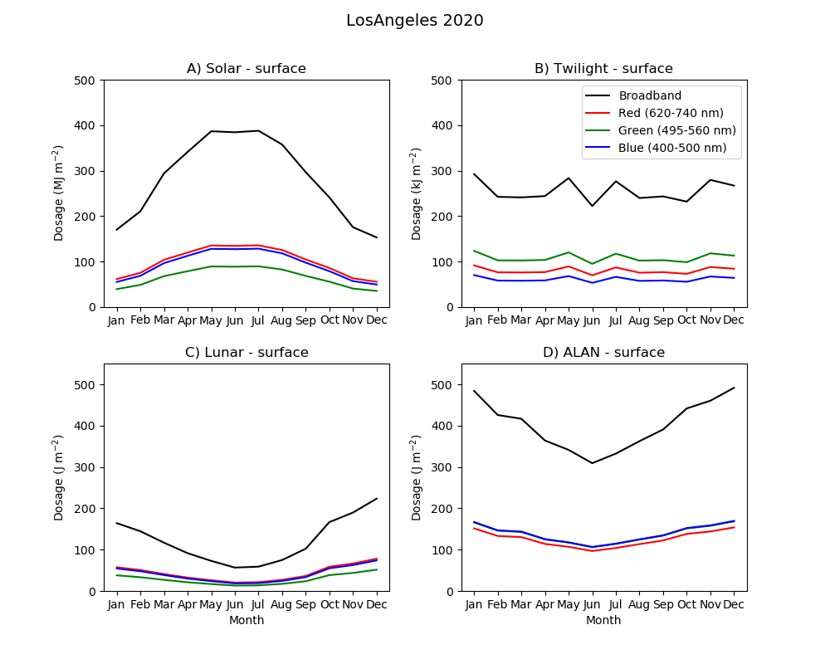
Figure S3: Monthly integrated dosages of irradiance at the surface calculated for Los Angeles (2020). Model results for dosages of A) solar (MJ m^{–2}), B) twilight (kJ m^{–2}), C) lunar (J m^{–2}) and D) artificial light at night (ALAN, J m^{–2}); note the different units. Broadband (400–740 nm) is shown in black; spectral components, in blue (400–500 nm), green (495–560 nm) and red (620–740 nm).

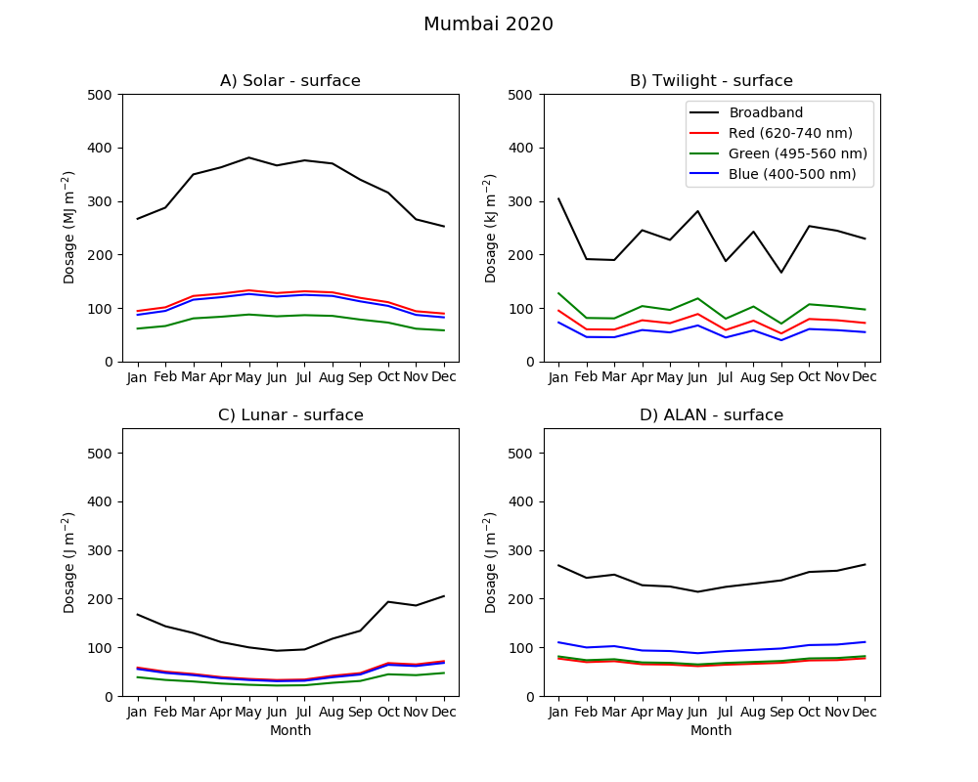
Figure S4: Monthly integrated dosages of irradiance at the surface calculated for Mumbai (2020). Model results for dosages of A) solar (MJ m^{–2}), B) twilight (kJ m^{–2}), C) lunar (J m^{–2}) and D) artificial light at night (ALAN, J m^{–2}); note the different units. Broadband (400–740 nm) is shown in black; spectral components, in blue (400–500 nm), green (495–560 nm) and red (620–740 nm).

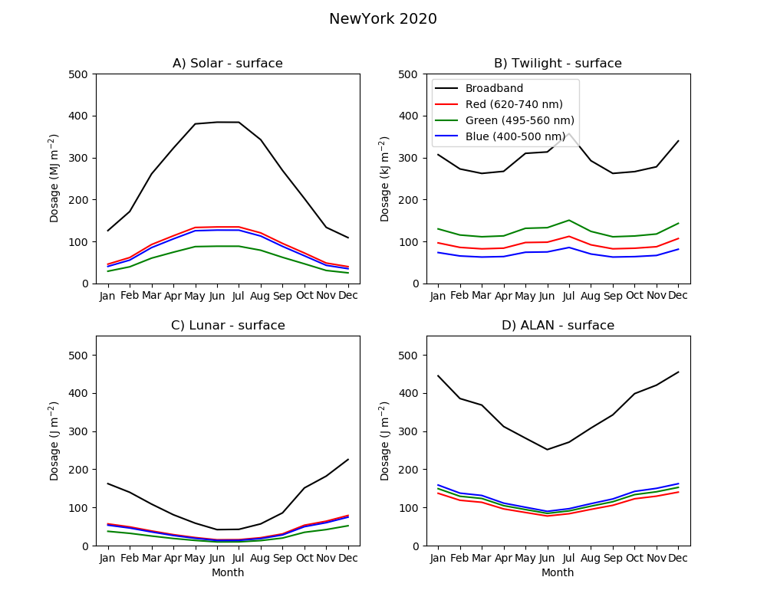
Figure S5: Monthly integrated dosages of irradiance at the surface calculated for New York (2020). Model results for dosages of A) solar (MJ m^{–2}), B) twilight (kJ m^{–2}), C) lunar (J m^{–2}) and D) artificial light at night (ALAN, J m^{–2}); note the different units. Broadband (400–740 nm) is shown in black; spectral components, in blue (400–500 nm), green (495–560 nm) and red (620–740 nm).

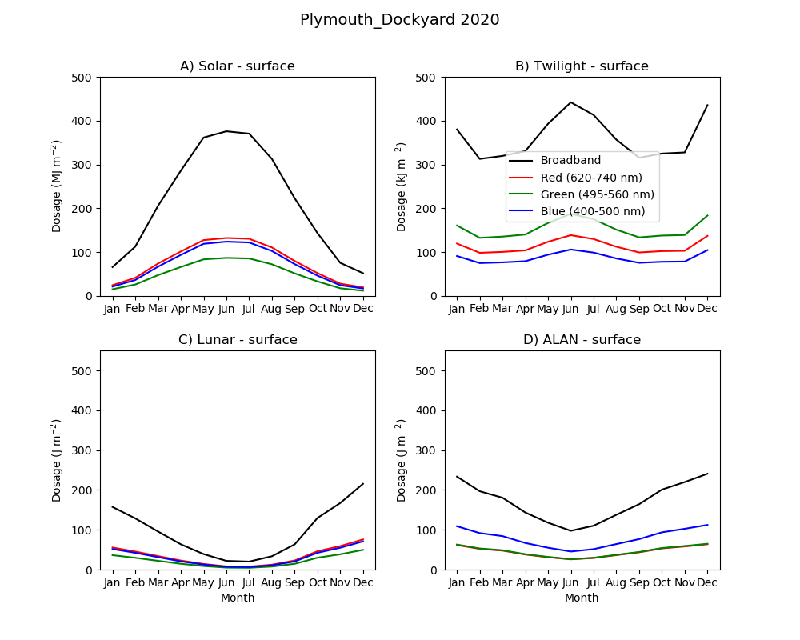
Figure S6: Monthly integrated dosages of irradiance at the surface calculated for Plymouth (2020) Model results for dosages of A) solar (MJ m^{–2}), B) twilight (kJ m^{–2}), C) lunar (J m^{–2}) and D) artificial light at night (ALAN, J m^{–2}); note the different units. Broadband (400–740 nm) is shown in black; spectral components, in blue (400–500 nm), green (495–560 nm) and red (620–740 nm).

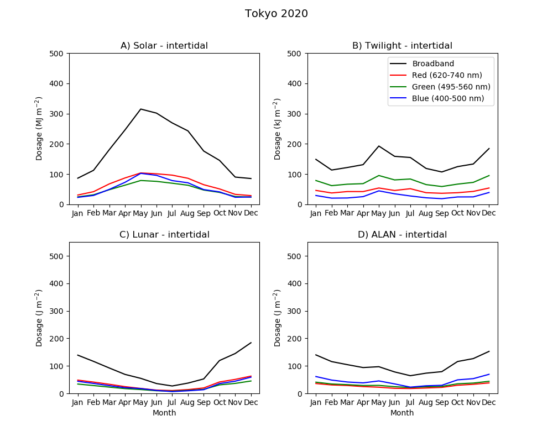
Figure S7: Monthly integrated dosages of irradiance at the surface calculated for Tokyo (2020). Model results for dosages of A) solar (MJ m^{–2}), B) twilight (kJ m^{–2}), C) lunar (J m^{–2}) and D) artificial light at night (ALAN, J m^{–2}); note the different units. Broadband (400–740 nm) is shown in black; spectral components, in blue (400–500 nm), green (495–560 nm) and red (620–740 nm).

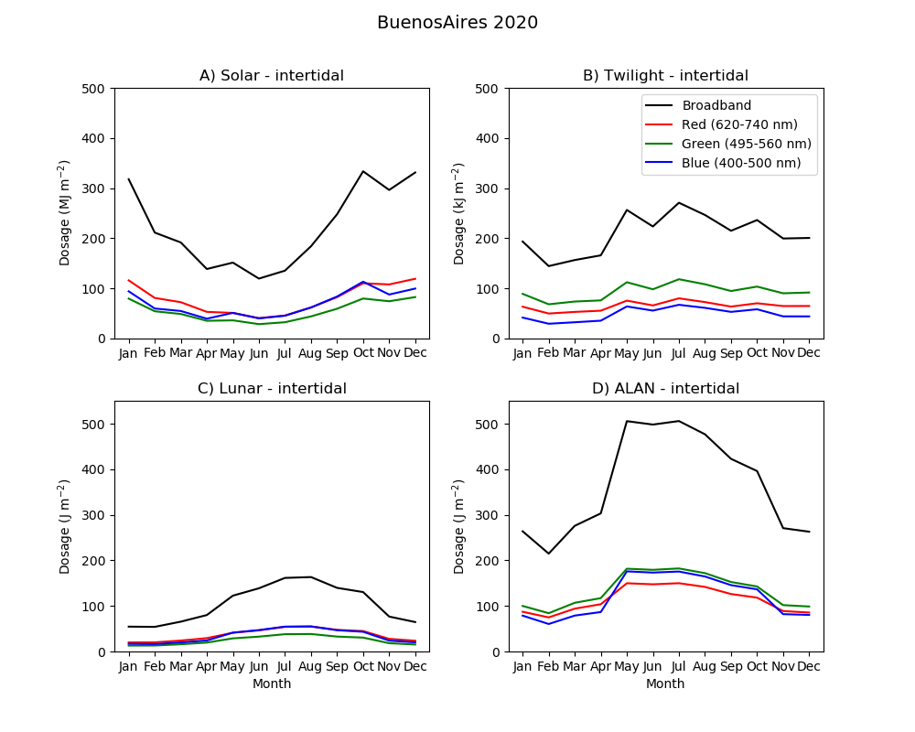
Figure S8: Monthly integrated dosages of irradiance at the intertidal point calculated for Buenos Aires (2020). Model results for dosages of A) solar (MJ m^{–2}), B) twilight (kJ m^{–2}), C) lunar (J m^{–2}) and D) artificial light at night (ALAN, J m^{–2}); note the different units. Broadband (400–740 nm) is shown in black; spectral components, in blue (400–500 nm), green (495–560 nm) and red (620–740 nm).

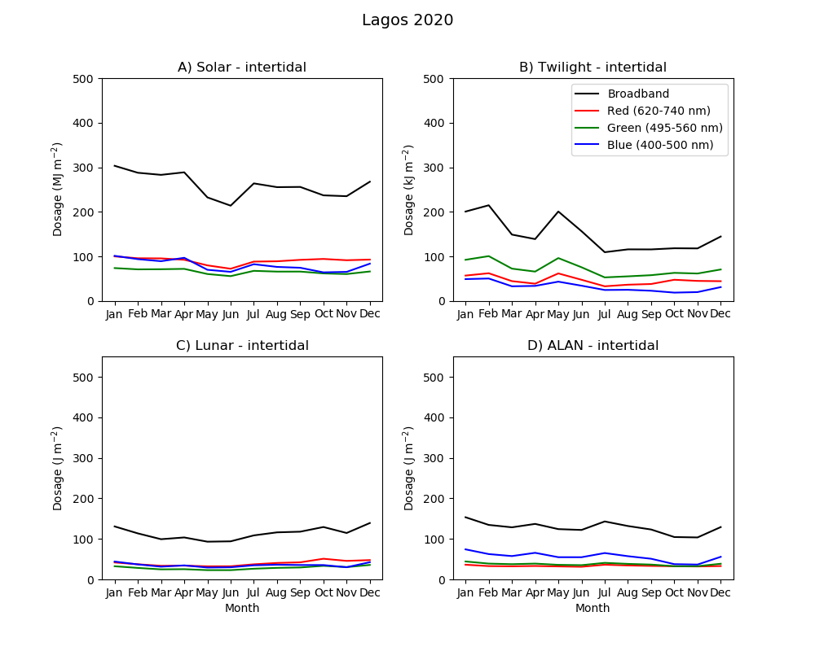
Figure S9: Monthly integrated dosages of irradiance at the intertidal point calculated for Lagos (2020). Model results for dosages of A) solar (MJ m^{–2}), B) twilight (kJ m^{–2}), C) lunar (J m^{–2}) and D) artificial light at night (ALAN, J m^{–2}); note the different units. Broadband (400–740 nm) is shown in black; spectral components, in blue (400–500 nm), green (495–560 nm) and red (620–740 nm).

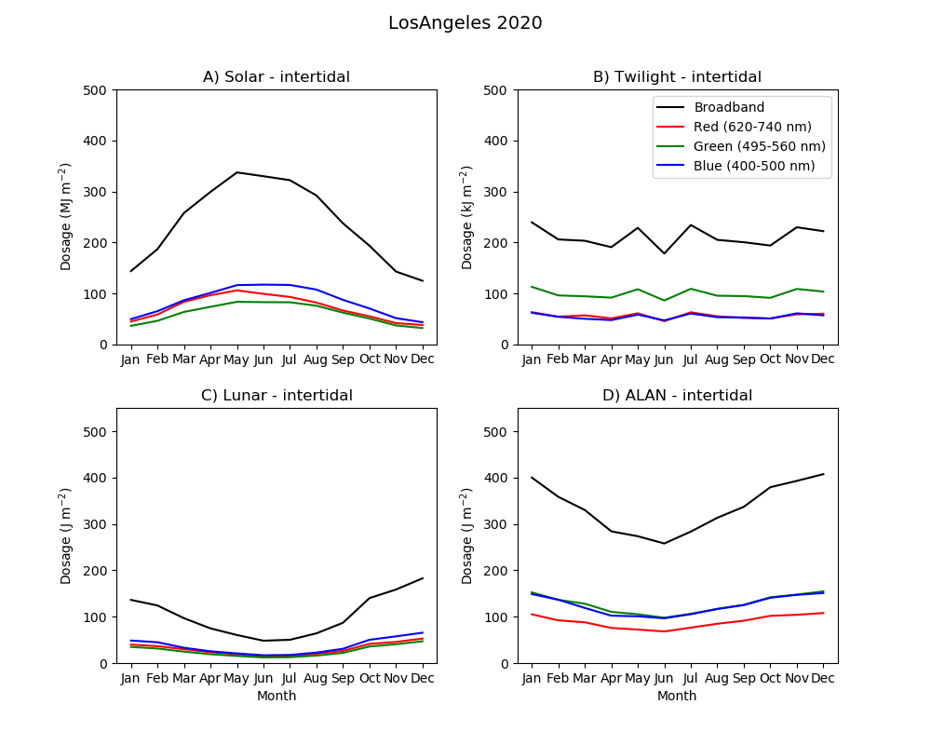
Figure S10: Monthly integrated dosages of irradiance at the intertidal point calculated for Los Angeles (2020). Model results for dosages of A) solar (MJ m^{–2}), B) twilight (kJ m^{–2}), C) lunar (J m^{–2}) and D) artificial light at night (ALAN, J m^{–2}); note the different units. Broadband (400–740 nm) is shown in black; spectral components, in blue (400–500 nm), green (495–560 nm) and red (620–740 nm).

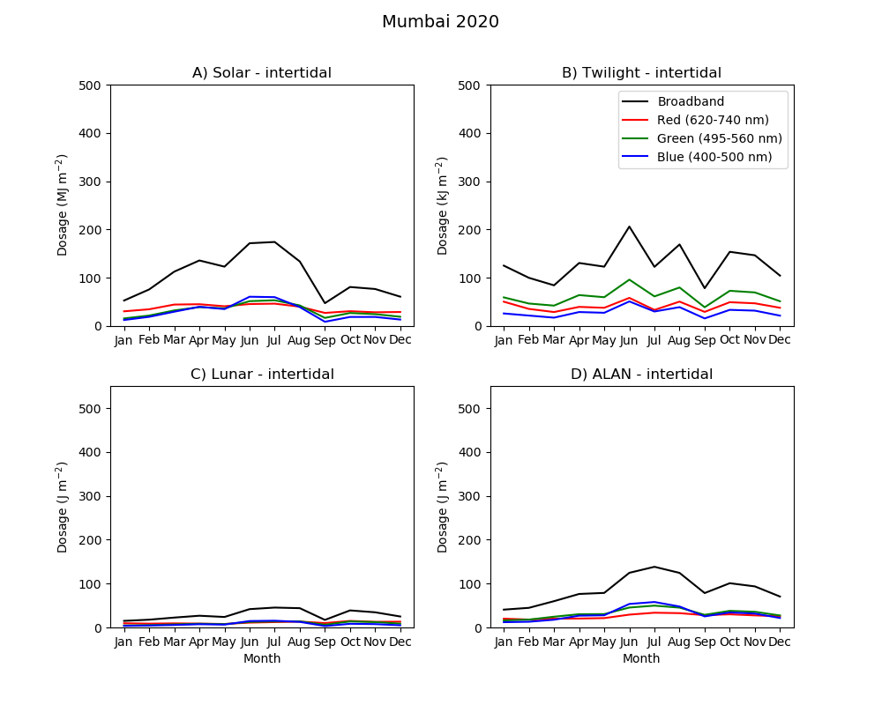
Figure S11: Monthly integrated dosages of irradiance at the intertidal point calculated for Mumbai (2020). Model results for dosages of A) solar (MJ m^{–2}), B) twilight (kJ m^{–2}), C) lunar (J m^{–2}) and D) artificial light at night (ALAN, J m^{–2}); note the different units. Broadband (400–740 nm) is shown in black; spectral components, in blue (400–500 nm), green (495–560 nm) and red (620–740 nm).

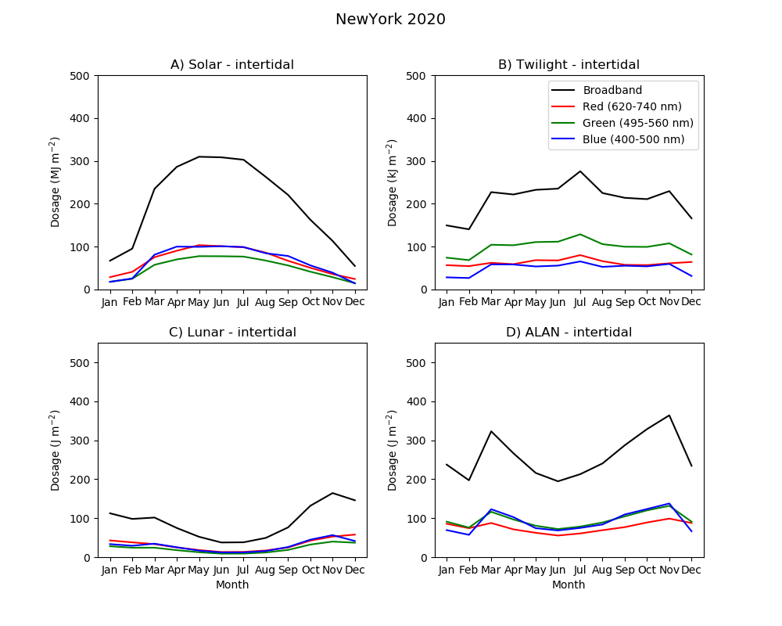
Figure S12: Monthly integrated dosages of irradiance at the intertidal point calculated for New York (2020). Model results for dosages of A) solar (MJ m^{–2}), B) twilight (kJ m^{–2}), C) lunar (J m^{–2}) and D) artificial light at night (ALAN, J m^{–2}); note the different units. Broadband (400–740 nm) is shown in black; spectral components, in blue (400–500 nm), green (495–560 nm) and red (620–740 nm).

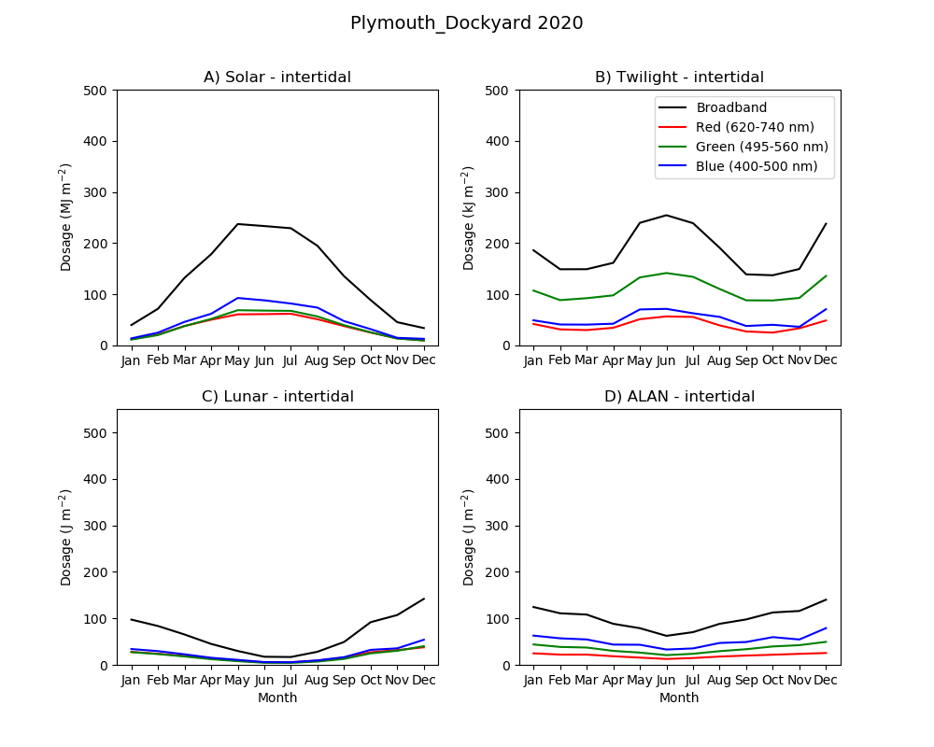
Figure S13: Monthly integrated dosages of irradiance at the intertidal point calculated for Plymouth (2020). Model results for dosages of A) solar (MJ m^{–2}), B) twilight (kJ m^{–2}), C) lunar (J m^{–2}) and D) artificial light at night (ALAN, J m^{–2}); note the different units. Broadband (400–740 nm) is shown in black; spectral components, in blue (400–500 nm), green (495–560 nm) and red (620–740 nm).

Figure S14: Monthly integrated dosages of irradiance at the intertidal point calculated for Tokyo (2020). Model results for dosages of A) solar (MJ m^{–2}), B) twilight (kJ m^{–2}), C) lunar (J m^{–2}) and D) artificial light at night (ALAN, J m^{–2}); note the different units. Broadband (400–740 nm) is shown in black; spectral components, in blue (400–500 nm), green (495–560 nm) and red (620–740 nm).

