Supplemental Material

Estimating methane emissions from underground natural gas pipelines using an atmospheric dispersion-based method

Shanru Tian¹, Kathleen M. Smits^{1,}*, Younki Cho¹, Stuart N. Riddick², Daniel J. Zimmerle^{2,3}, and Aidan Duggan²
¹Department of Civil Engineering, University of Texas Arlington, Arlington, Texas 76019, United States
²The Energy Institute, Colorado State University, Fort Collins, Colorado 80523, United States
³Department of Mechanical Engineering, Colorado State University, Fort Collins, Colorado 80523, United States
*Corresponding author: Kathleen M. Smits (kathleen.smits@uta.edu)

List of Contents:
Figure S-1. Time series of solar radiation, air temperature, wind direction, and wind speed at 1 m (blue line) and 6 m (red line) above the ground, and Obukhov length (L) from June 1st to June 5th, 2020. The Obukhov length was calculated using 1 min 3D sonic data (YOUNG Model 81000 Ultrasonic Anemometer) at 6 m height. Data were averaged in 10 minutes. The time is MDT (Mountain Daylight Time). The meteorological sensor ATMOS 41 was in an adjustment period before June 1st, 9:00 AM, 2020. Thus, meteorological data from ATMOS 41 showed abnormal values before this time. (Page 2)

Figure S-2. The surface CH₄ mole fraction plots for the four experiments (EXP1–4). The red contour is 100 ppm CH₄ mole fraction. The release rate is 0.08, 0.18, 0.27, 0.52 kg hr⁻¹ of CH₄ for Exp1-4 (Figure S-2a to 2d), respectively. (Page 3)
Figure S-3. Cumulative distribution frequency of 10-min averaged CH₄ mole fraction at 1 m above ground for all experiments (EXP1–4). (Page 4)
Figure S-4. The normalized CH₄ mole fraction ((C_{obs}-C_{b})/Q_{ctr}) and crosswind distance (Y) in the Pasquill-Gifford (PG) stability class A (extremely unstable) and E–F (stable), respectively. C_{b} is the background CH₄ mole fraction (ppm), C_{obs} is the measured CH₄ mole fraction (ppm), Q_{ctr} is the release rate (kg hr⁻¹). (Page 5)
References (Page 6)
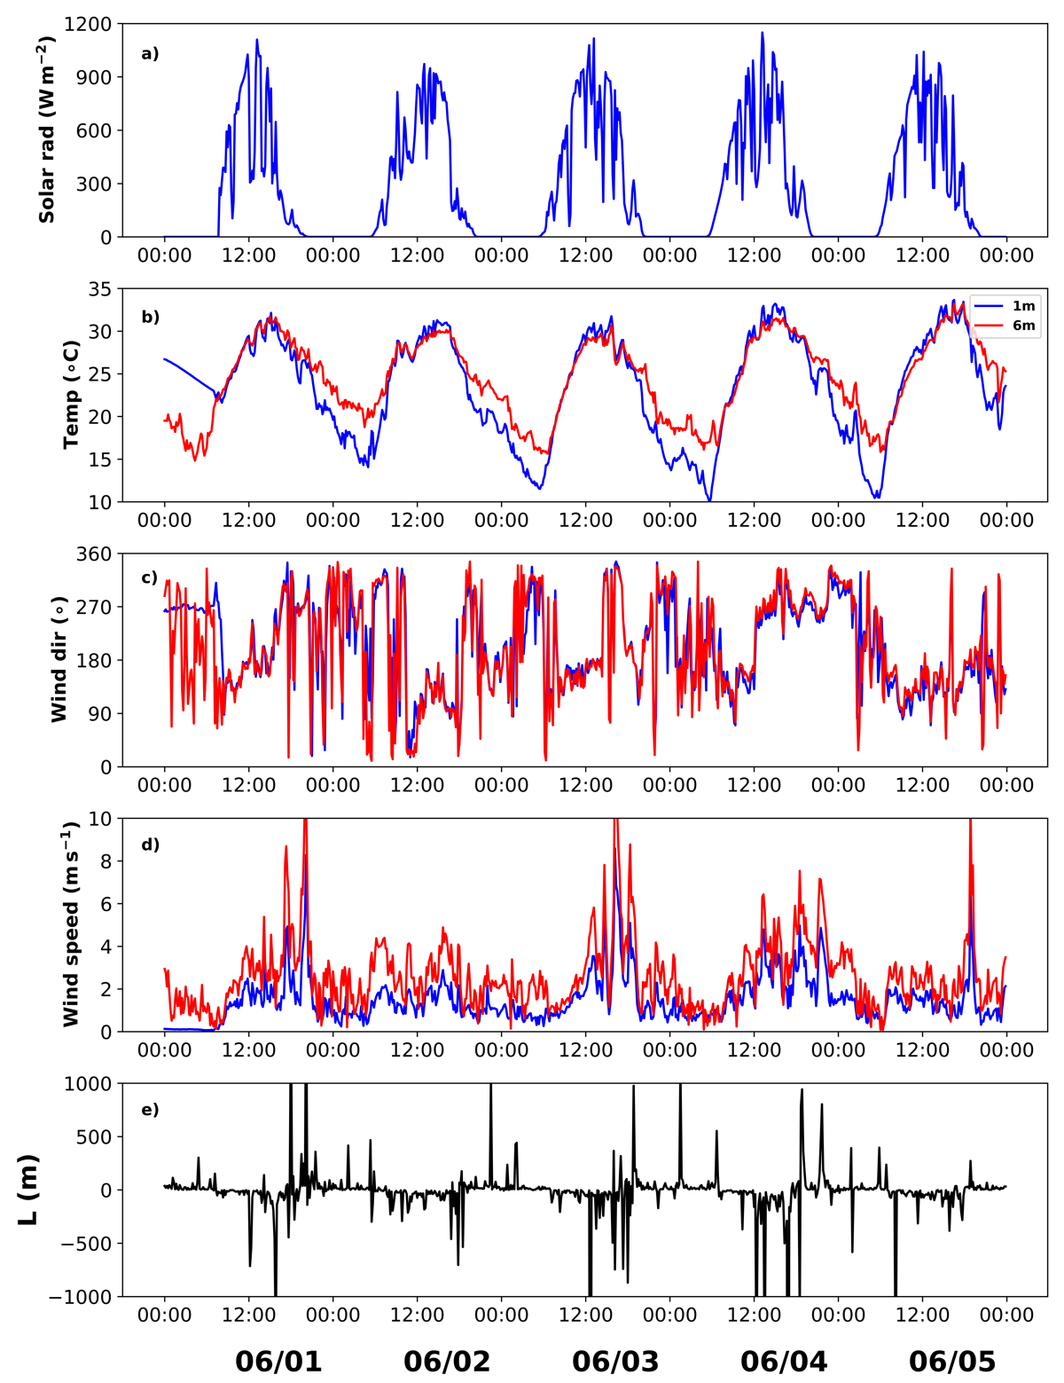
Figure S-1. Time series of solar radiation, air temperature, wind direction, and wind speed at 1 m (blue line) and 6 m (red line) above the ground, and Obukhov length (L) from June 1st to June 5th, 2020. The Obukhov length was calculated using 1 min 3D sonic data (YOUNG Model 81000 Ultrasonic Anemometer) at 6 m height. Data were averaged every 10 minutes. The time is MDT (Mountain Daylight Time). The meteorological sensor ATMOS 41 was in an adjustment period before June 1st, 9:00 AM, 2020. Thus, meteorological data from ATMOS 41 showed abnormal values before this time.
Figure S-1 shows the time series of solar radiation, air temperature, wind direction, and wind speed at 1 m (blue line) and 6m (red line) above the ground and Obukhov length during the experiments. In general, these meteorological variables showed a diurnal cycle. The solar radiation changed from as high as 1,000 W m⁻² at mid-noon to 0 W m⁻² at night. During the day (e.g., 10:00 AM-5:00 PM), air temperature at 1 m height was usually higher than at 6 m height, but it was usually lower at night (e.g., 7:00 PM-5:00 AM). Wind speed was higher during the day than at night, with a maximum wind speed of approximately 10 and 9 m s⁻¹ at 1 m and 6 m height, respectively. The wind direction usually changed from northerly at night to southerly during the day. The Obukhov length was about -500 m to 500 m for most of the time.

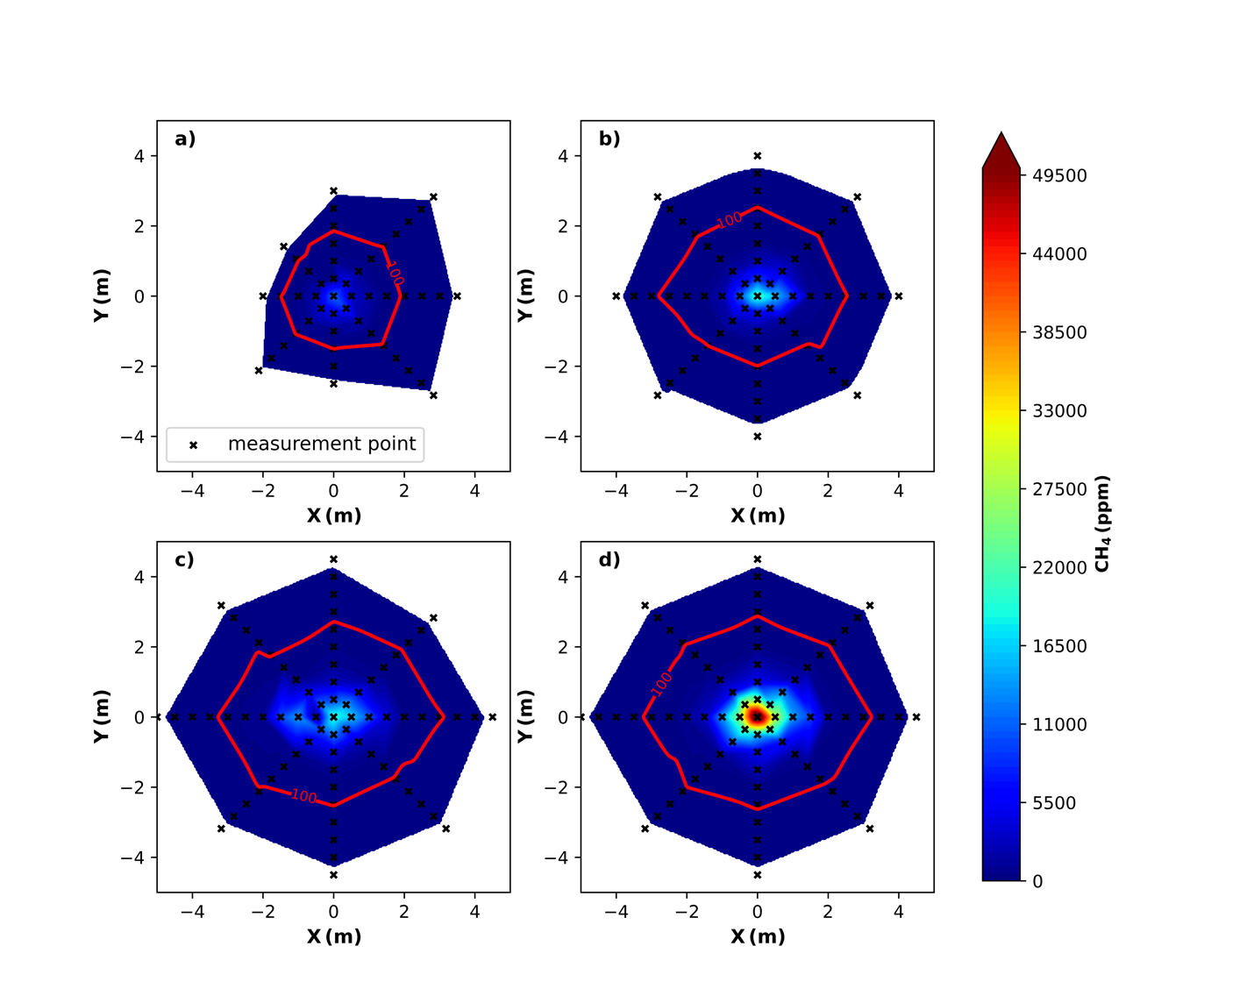
Figure S-2. The surface CH₄ mole fraction plots for the four experiments (Exp1–4). The red contour is 100 ppm CH₄ mole fraction. The release rate is 0.08, 0.18, 0.27, 0.52 kg hr⁻¹ of CH₄ for Exp1-4 (Figure S-2a to 2d), respectively.
Figure S-2 shows the surface CH₄ mole fraction plots for the four experiments (Exp1–4). The area surrounded by a 100-ppm contour was used to calculate the area of surface expression. We assumed that the surface mole fraction is at least one time larger than the observed maximum atmospheric CH₄ mole fraction (65 ppm at 0.5 m height) to represent the average conditions of the belowground release source for the four experiments. We also used 50 ppm and 200 ppm contours as the mapped surface area in the WindTrax model and found that the absolute percentage difference between the average surface CH₄ emissions and the controlled release rate was about 26% and 29%, respectively. It was 27% using the mapped surface area surrounded by 100 ppm contour. Thus, the sensitivity was about 1–3% for the surface area using 50–200 ppm.

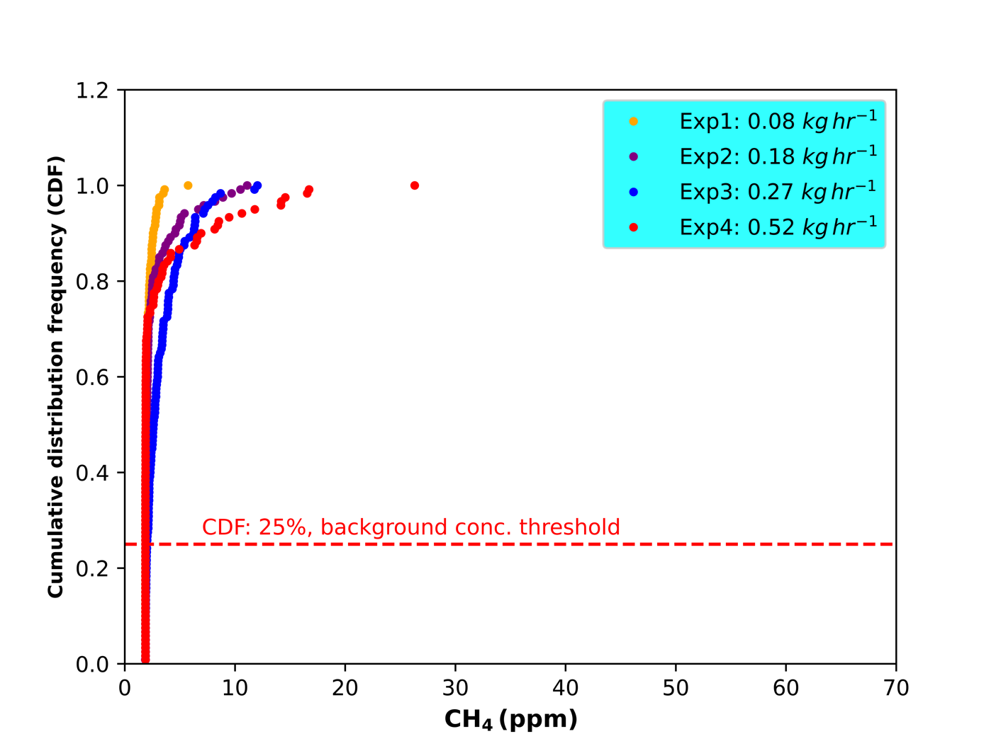
Figure S-3. Cumulative distribution frequency of 10-min averaged CH₄ mole fraction at 1 m above ground for all experiments (Exp1–4).
Figure S-3 shows the cumulative distribution frequency (CDF) of 10-min averaged CH₄ mole fraction at 1 m above ground for the four experiments, respectively. The CH₄ mole fraction within the lowest 25% quantile was approximately constant, which was used to calculate the local background CH₄ mole fraction for each experiment (Exp1–4) at the experimental site.

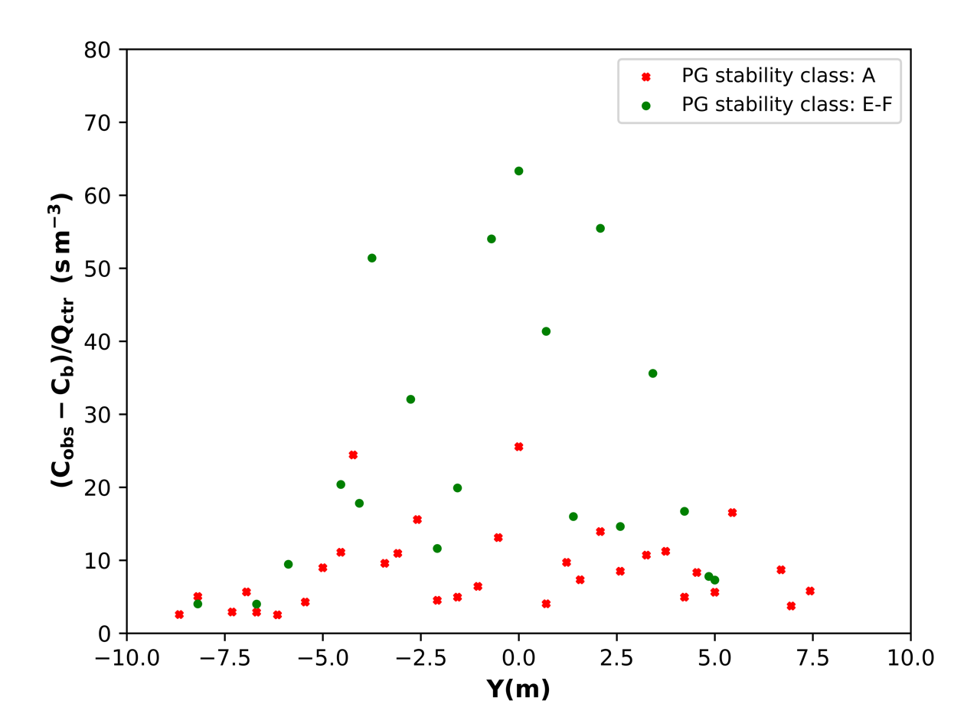
Figure S-4. The normalized CH₄ mole fraction ((C_{obs}-C_{b})/Q_{ctr}) and crosswind distance (Y) in the Pasquill-Gifford (PG) stability class A (extremely unstable) and E–F (stable), respectively. C_{b} is the background CH₄ mole fraction (ppm), C_{obs} is the measured CH₄ mole fraction (ppm), Q_{ctr} is the release rate (kg hr⁻¹).
Figure S-4 shows the normalized mole fraction with the crosswind distance in the Pasquill-Gifford (PG) stability class A (extremely unstable) and E–F (stable), respectively. Two periods of approximately two hours of constant wind direction (June 1st 1: 00 PM-3:20 PM, June 5th 6: 40 AM-8:00 AM, 2020) were chosen here to illustrate the characteristics of the plume (width and magnitude) under extremely unstable, and stable conditions. The data time interval was 1 min. We first calculated the average CH₄ mole fraction binned by four-degree interval of wind direction for each period. Then, the crosswind distance Y (Foster-Wittig et al., 2015) was calculated by
$$Y=s⋅sin δθ$$
where s is the measured distance from the leak center to the downwind measurement location, $δθ$ is the wind direction difference between the wind direction at the actual measurement time ($θ_{m}$) and the wind direction at the plume centerline ($θ_{c}$). The effective downwind region is within $±{90}^{∘}$of $θ_{c}$ ($\left|δθ\right|≤{90}^{∘}$).

The results showed a narrow plume with a larger maximum of normalized CH₄ mole fraction in PG stability class E–F (stable) but a broader one with a lower maximum of normalized CH₄ mole fraction in PG stability class A (very unstable). The maximum CH₄ mole fraction was about 65 s m⁻³, and the plume width was 12 m PG stability class E–F. However, it was about 27 s m⁻³ and 16 m wide in unstable conditions in PG stability class A.

References
Foster-Wittig, TA, Thoma, ED, Albertson, JD. 2015. Estimation of point source fugitive emission rates from a single sensor time series: A conditionally-sampled Gaussian plume reconstruction. Atmos Environ 115: 101–109. Elsevier Ltd. DOI: https://doi.org/ 10.1016/j.atmosenv.2015.05.042

