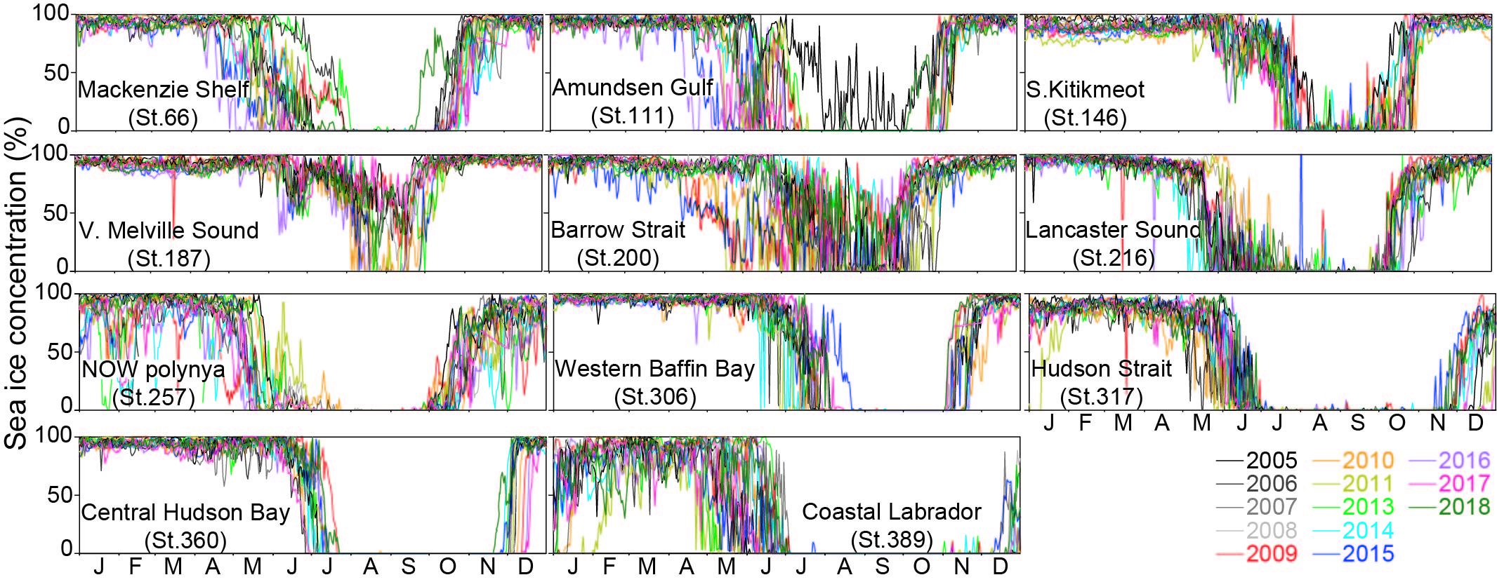
Figure S1. Annual time series of sea ice concentration at several sampling sites from 2005 to 2018.

