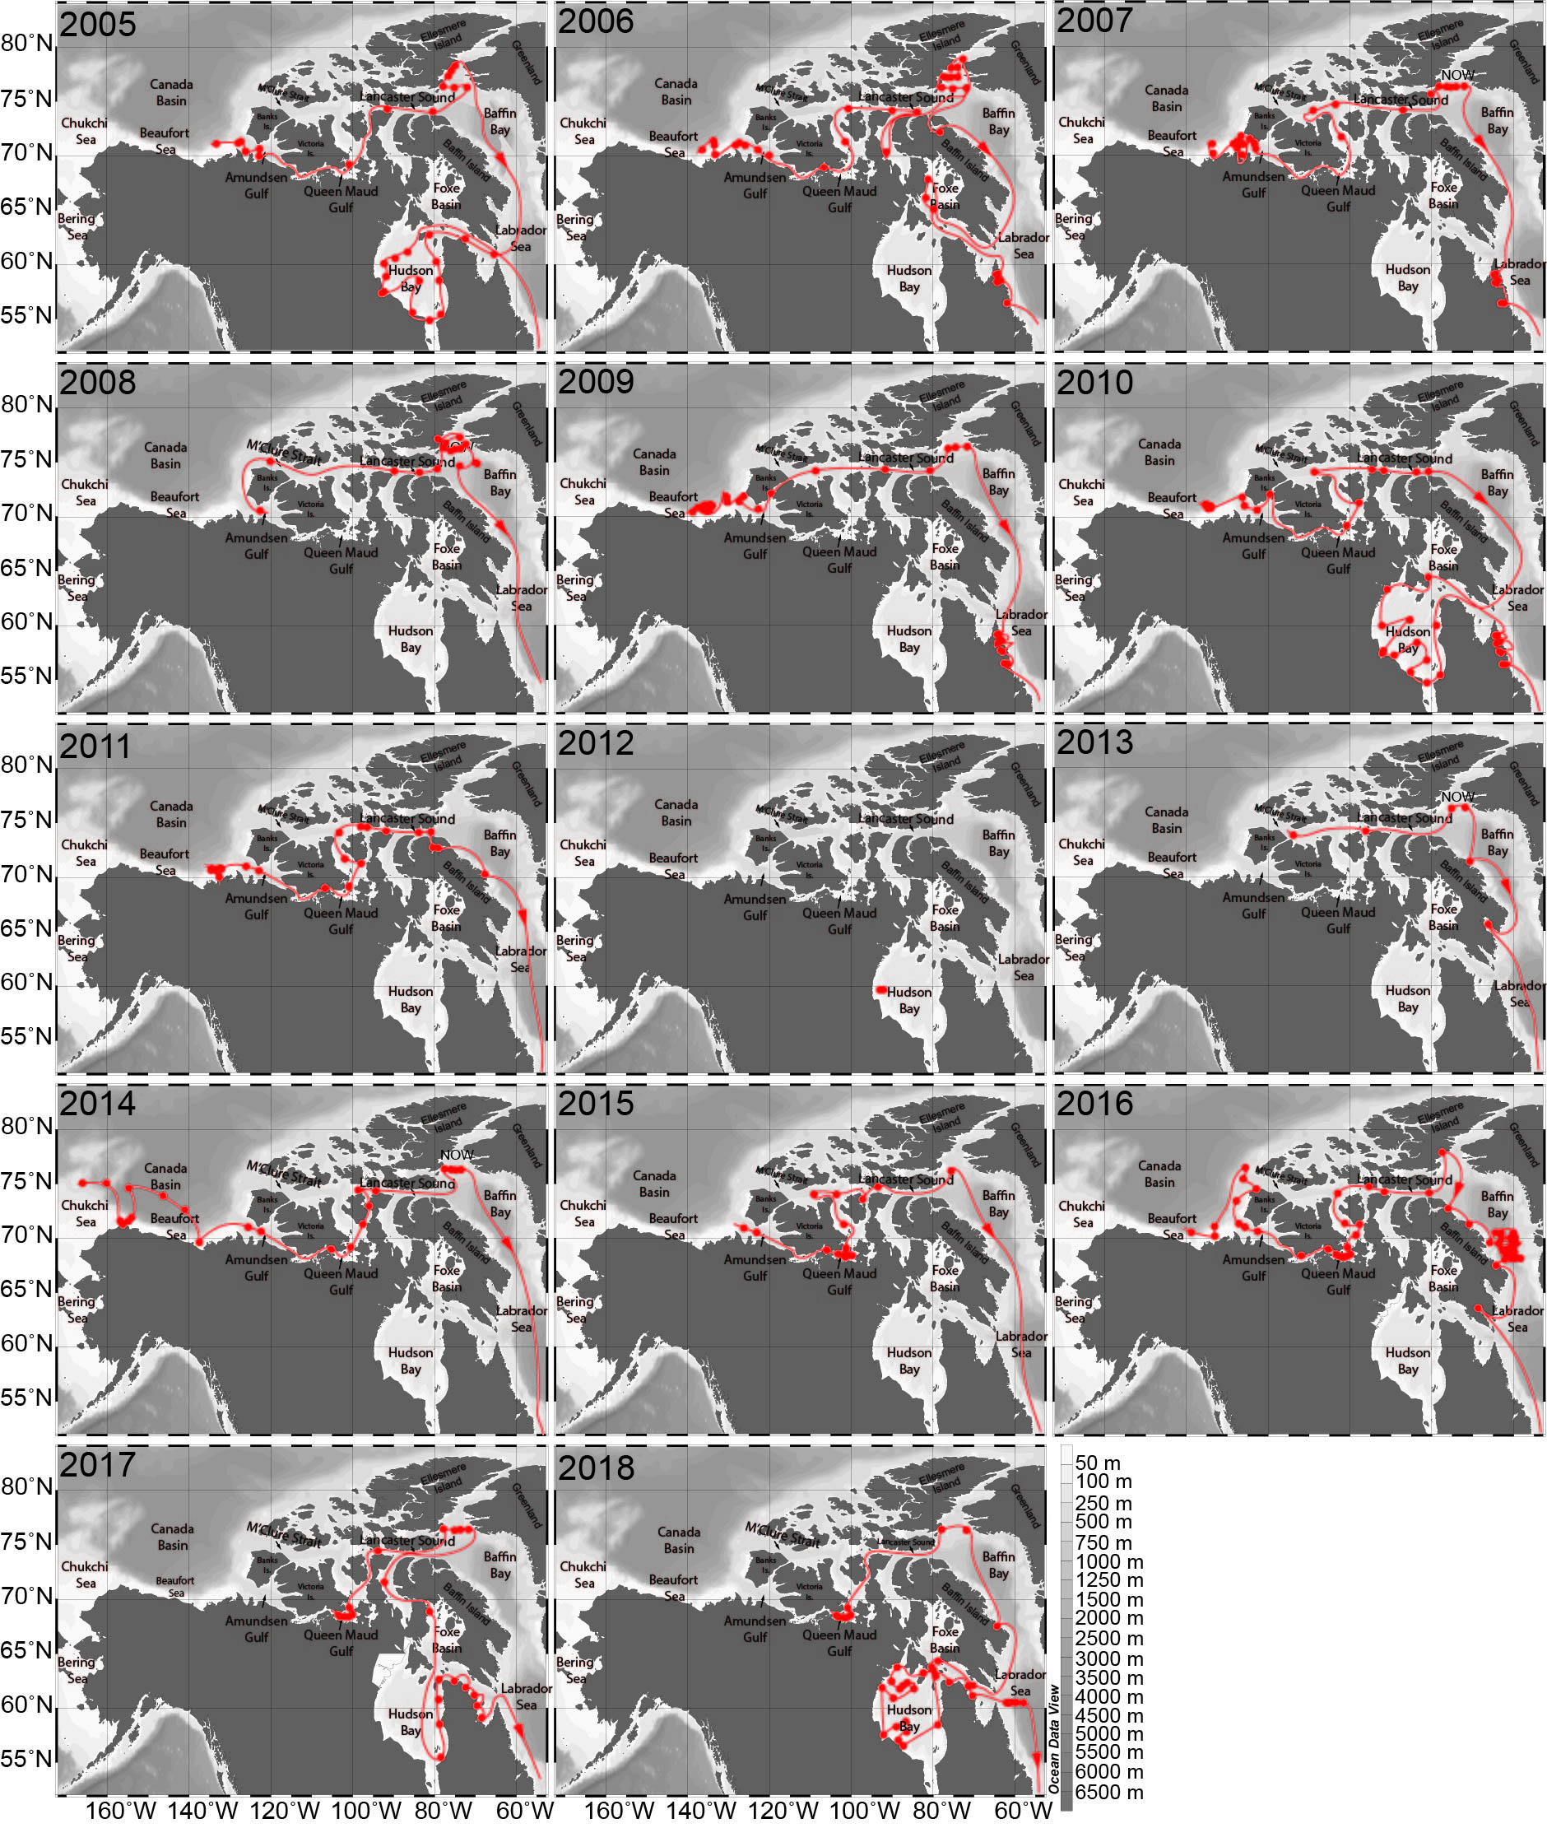
Figure S2. Zooplankton sampling sites along the annual west-east tracks of the ship from 2005 to 2018.

