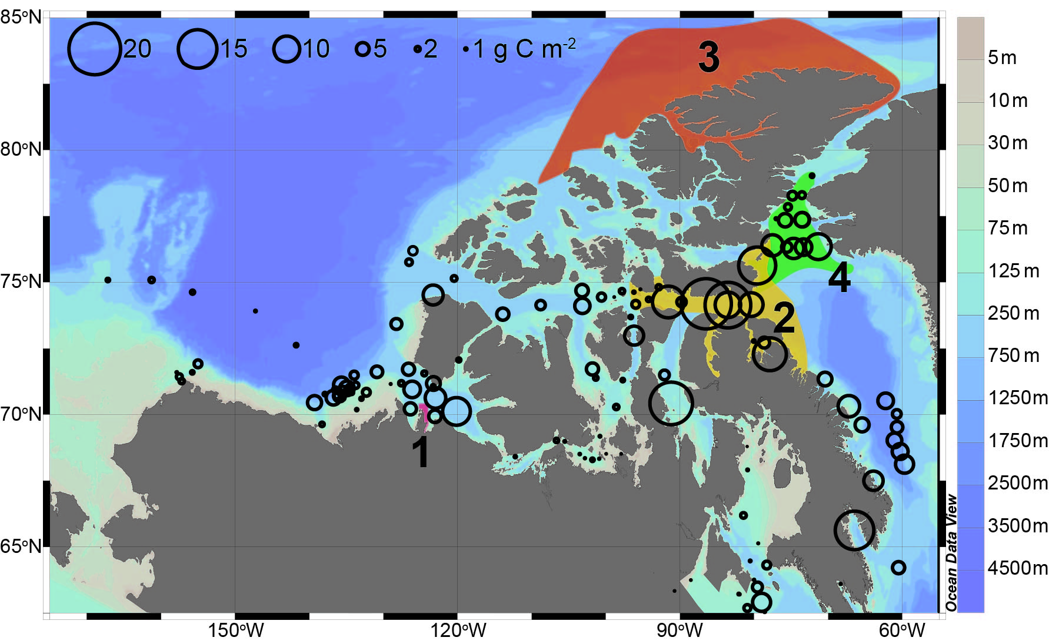
Figure S4. Copepod biomass and actual and proposed marine protected areas (MPA) in the North American Arctic.

