Supplemental Material

Low level jets over the Arctic Ocean during MOSAiC
Vania Lopez-Garcia^{1,*}, Ryan R. Neely III ^{1,2}, Sandro Dahlke³, Ian M. Brooks ^{1,*}
¹ School of Earth and Environment, University of Leeds, Leeds, UK
² National Centre for Atmospheric Science, University of Leeds, Leeds, UK
³Alfred Wegener Institute, Helmholtz Centre for Polar and Marine Research, Bremerhaven, Germany
* Corresponding author
eevnlg@leeds.ac.uk (VLG)
i.m.brooks@leeds.ac.uk (IMB)

June 6, 2022

List of contents:
Figure S1: Examples of ERA5 wind speed profiles, where the maximum does not satisfy the LLJ criteria if only looking in the lowest 1450 m, but does if looking just one level above (1600 m). Left, does not satisfy the criteria of 2 m s⁻¹ difference. In the right profile, the maximum is not 25% stronger than the speed at 1450 m. Both examples satisfy both criteria when looking just one more level above.
Figure S2: Frequency of occurrence for the entire datasets as a function of the maximum height allowed for the wind speed minimum.
Figure S3: Frequency of occurrence of LLJ on March from 2000 to 2010 changing the maximum profile height; left, up to 4 km, and right, up to 1.5 km, which is similar to that in Tuononen et. al. (2015).
Figure S4: Speed and height of all LLJs found for each dataset from (a) October 2019 to January 2020; (b) February to May 2020; and (c) June to September 2020. Shaded areas separate the freeze up and winter following Shupe et al. (2022). Blue and red markers show jets from the observations and ERA5 respectively. Dark shades indicate a jet occurs in both the observations and ERA5, pale shades indicate that a jet was found only in the observations or ERA5, but not both. Surface pressure, wind speed, and air temperature are from the Polarstern’s on-board meteorological measurements. (eps)
Figure S5: Probability distributions (as Figure 7) for LLJ speed and height at the North Pole (NP), the ice edge at longitude of 45° (IE), and at P1 and P2, by season.

Text S1: The number of LLJs found by the detection algorithm depends not only on the maximum height allowed for the jet maximum, but also on the maximum height allowed for the minimum in wind speed above the jet peak. In the Arctic, LLJs are typically located well below 1500 m, the upper limit used by Tuononen et al. (2015); however, we find that imposing an upper limit to the profile examined of 1500 m, we underestimate the number of LLJs within ERA5. There are profiles where the wind speed at 1500 m has not decreased enough below the peak speed to satisfy the LLJ criteria, but for which the criteria is satisfied at higher levels (Figure S2). This is especially relevant for ERA5, since the vertical resolution is modest, and decreases with height, so that the profile of the wind speed is smoothed and does not reproduce small-scale details found in the radiosonde profile. Figure S3 shows two examples of wind speed profiles from ERA5, where the maxima, clearly identifiable by eye as a jet does not meet the selection criteria if the uppermost model level used is below 1500 m (1450 m, for ERA5), but satisfies the criteria adding just one level above (1600 m in ERA5). Therefore, extending the vertical profile upwards increases the number of LLJs identified in ERA5. Figure S3 shows the frequency of occurrence as a function of the maximum height for both ERA5 and the radiosondes. The number of jets identified in ERA5 increases from around 27% for a maximum height of 1000 m, to almost 50% with a maximum height of 4000 m. The increase with maximum altitude is rapid up to 2500 m, then slows, approaching a constant value above about 3000 m. Therefore, even though no LLJs were found above 1450, it is necessary to extend the profile considerably above this, to about 4000 m, in order to establish a stable frequency of occurrence. The dependence of the number of jets identified on the upper limit of profile altitude for the radiosondes is weak, increasing from about 50% for an upper limit of 1500m to 53% at 2500 m, and is stable above this.
As an example of the impact this change makes on the ERA5 results, Figure S4 shows a comparison of the frequency of occurrence of LLJ for the whole Arctic for March from 2000 to 2010 using ERA5 using both a maximum profile height of 1.5 km and 4 km. Our criteria, which is similar to that in Tuononen et. al (2015), and with a maximum height profile of 1.5 km in the same years they used, produces a similar result to theirs, even though different models were used. In contrast, if the maximum profile height is increased up to 4km, the result changes considerably, increasing the frequency of occurrence over the entire area.

Text S2: Figure S5 shows the probability distribution of LLJ height and speed for each point, for the whole year and partitioned by season. These distributions are broadly similar for all points, and all have a peak height around 250-300 m during the entire year, varying little with season. P2 has a peak at higher altitude, around 1200 m, during the transition period, but the short duration of this period means the sampling statistics are poor, and too much significance should not be given to this. In contrast, LLJ speed varies between points with season, the peaks for P1 and P2 are 2 m s⁻¹ slower than for the North Pole and ice edge during the freeze up period and winter. As for the along-track points, the peaks of the speed distributions are all highest in winter and lowest in summer.

Figure S1. Examples of LLJs only if looking above 1500 m.
Examples of ERA5 wind speed profiles, where the maximum does not satisfy the LLJ criteria if only looking in the lowest 1450 m, but does if looking just one level above (1600 m). Left (from 04/05/2020 1100), does not satisfy the criteria of 2 m s⁻¹ difference. In the right profile (from 14/09/2022 1100), the maximum is not 25% stronger than the speed at 1450 m. Both examples satisfy both criteria when looking just one more level above.

Figure S2. Annual frequency of occurrence according to the minimum height.
Frequency of occurrence for the entire datasets as a function of the maximum height allowed for the wind speed minimum.

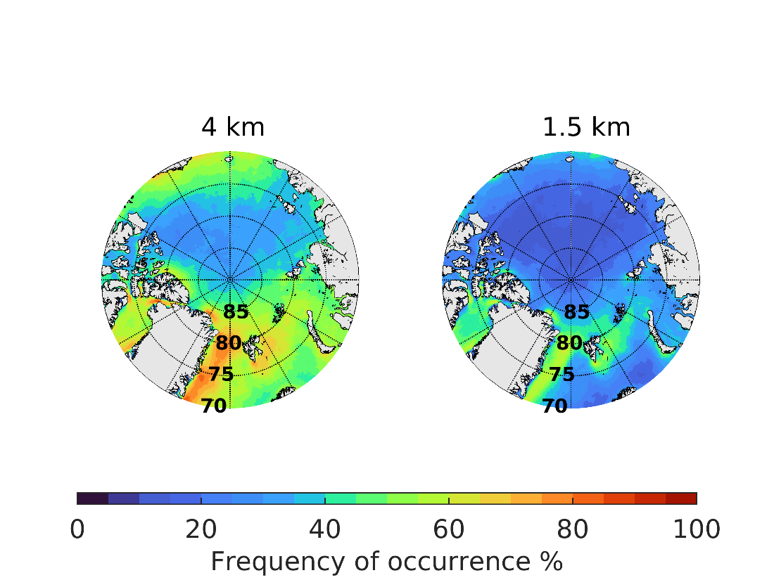
Figure S3. Frequency of occurrence from 2000-2010.
Frequency of occurrence of LLJ on March from 2000 to 2010 changing the maximum profile height; left, up to 4 km, and right, up to 1.5 km, which is similar to that in Tuononen et. al. (2015).

Figure S4a. Times series of the LLJ height and speed from October 2019 to January 2020

Figure S4b. Times series of the LLJ height and speed from February to May 2020.

Figure S4c. Times series of the LLJ height and speed from June to September 2020.
Speed and height of all LLJs found for each dataset from: (a) October 2019 to January 2020; (b) February to May 2020; and (c) June to September 2020. Shaded areas separate the freeze up and winter following Shupe et al. (2022). Blue and red markers show jets from the observations and ERA5 respectively. Dark shades indicate a jet occurs in both the observations and ERA5, pale shades indicate that a jet was found only in the observations or ERA5, but not both. Surface pressure, wind speed, and air temperature are from the Polarstern’s on-board meteorological measurements.

Figure S5. LLJ speed and height for the fixed points.
Probability distributions (as Figure 7) for LLJ speed and height at the North Pole (NP), the ice edge at longitude of 45° (IE), and at P1 and P2, by season.

