Supplemental Material

An investigation of petrochemical emissions during KORUS-AQ: Ozone Production, Reactive Nitrogen Evolution, and Aerosol Production.
Young Ro Lee, et al.

Georgia Institute of Technology, Atlanta, Georgia 30332, USA

*Corresponding author: L. Gregory Huey (greg.huey@eas.gatech.edu)

List of Contents:
Table S1. Aircraft Measurements aboard the NASA DC-8 research aircraft during the KORUS-AQ used in this study.
Table S2. Details of petrochemical plume transects used in this study during RF11 and RF18.
Table S3. The SOA yields of VOC precursors adapted from Ma et al. (2017).
Table S4. Model constraints used in 0-D box model simulations.
Table S5. Summary of PANs mixing ratios measured by Thermal Dissociation-Chemical Ionization Mass Spectrometry (TD-CIMS) at altitudes below 500m.
Figure S1. Time series of related species and relative abundance of alkenes to ethyne.
Figure S2: Estimation of OH exposure.
Figure S3. (a) The DC-8 flight data used to produce statistics in Table S5, and (b) bin-averaged mixing ratios of HCHO and PANs.
Figure S4. Enhancements of PANs and HNs over the South Sea.
Figure S5. Fractional contributions of VOC class to P(O₃) for the DPCC plume transects.
Figure S6. Histograms of instantaneous P(O₃) and OPE for all measurements when the WAS collected samples at altitude below 500m during RF11 and RF18.
Figure S7. (a) VOC-OH reactivity and (b) effective SOA yield of the speciated VOCs.
Figure S8. Correlation plots of photochemical products versus OA.
Figure S9. Comparison of SOA mass yields from previous studies.
Figure S10. The base case model simulations and sensitivity tests of 1,3-butadiene and acrolein.
Figure S11. The zero-out model simulations to investigate impacts of VOCs oxidation on PNs budget.
Figure S12. The Observed and modelled mixing ratios of glycolaldehyde and benzaldehyde.

Table S1. Aircraft Measurements aboard the NASA DC-8 research aircraft during the KORUS-AQ used in this study | Reference | Slusher et al. (2004) | Day et al. (2002) | Weinheimer et al. (1994) | Huey et al. (2004) | Müller et al. (2014)
 | Calibration Method | In-flight calibration by periodic addition of isotopically labeled PAN standard generated from a photolytic source described by Warneck and Zerbach (1992). | Kenagy et al. (2021) | In-flight calibration by periodic addition of NO standard (Scott-Marrin, 1.98 ppmv). In-flight determination of the photolytic conversion efficiency of NO₂ to NO using NO₂ formed from reaction between the standard NO and high concentration of O₃. Periodic intercomparison of O₃ instrument onboard the DC-8 with primary standard (Thermo Scientific Model 49i). | In-flight calibration by periodic addition of isotopically labeled SO₂ standard. Laboratory calibration of the relative sensitivity of HCl to SO₂ using the method described in Kim et al. (2007). | In-flight calibration by addition of VOCs standards dynamically diluted to 5 ppbv. The instrument sensitivity of acetone used as proxy for that of acrolein. The sensitivity of benzaldehyde estimated from ion-molecule reaction kinetics.
 | Uncertainty | 20-30% | 10% | 10-30% | 30-40% | 9-11%
 | Method | I- Chemical Ionization Mass Spectrometry (CIMS) | Thermal Dissociation Laser-Induced Fluorescence (TD-LIF) | Chemiluminescence | SF₆⁻ CIMS | Proton Transfer Reaction Time-of-Flight Mass Spectrometry (PTR-ToF-MS)
 | Measurement | PANs | PNs, ANs | NO, NO₂, NO_{y}, O₃ | SO₂ and HCl | VOCs, OVOCs

Table S1 (continued). Aircraft Measurements aboard the NASA DC-8 research aircraft during the KORUS-AQ used in this study | Reference | Blake et al. (2003), Simpson et al. (2020) | Sachse et al. (1987,1991) | Vay et al. (1999) | Richter et al. (2015),  Fried et al. (2020)  fF | Crounse et al. (2006),  Teng et al. (2015) | Bahreini et al. (2009),  Nault et al. (2018) | Faloona et al. (2004) | Shetter and Muller, (1999)
 | Calibration Method | Simpson et al. (2020) | In-flight single point calibration periodically using gas standard by NOAA Earth System Research Laboratory and traceable to WMO scales (CO: x2014A; CH₄: x2004A). | In-flight single point calibration periodically using gas standard by NOAA Earth System Research Laboratory and traceable to WMO scales (CO₂: x2007). | Fried et al. (2020) | Laboratory characterization of HNO₃ absolute sensitivities using HNO₃ permeation tube. Laboratory calibration of HNs using the method described in Lee et al. (2014) and Teng et al. (2015). Laboratory sensitivities were proxied to flight sensitivities using in-flight standard addition for H₂O₂ and ethylene glycol. | Nault et al. ( 2018) | Brune et al. (2022) | The absolute spectral sensitivity determined with 1000 W NIST-traceable tungsten-halogen sources.
 | Uncertainty | 5% | 2% | 0.25 ppm | 6% | 30-50%  + 3-50 pptv | 35% (NO₃⁻), 38% (Organic aerosol) | 35% | 12% (j-NO₂), 20% (j-O₃)
 | Method | Whole Air Sampling and Gas Chromatography (WAS and GC) | Mid-IR Wavelength Modulation Spectroscopy | Non-dispersive IR spectrometer | Compact Atmospheric Multi-Species Spectrometer (CAMS) | CF₃O⁻ CIMS | High-Resolution Time of Flight Aerosol Mass Spectrometer | Airborne Tropospheric Hydrogen Oxides Sensor Spectroscopy | Charged-coupled device Actinic Flux Spectroradiometers (CAFS)
 | Measurement | NMHCs | CO and CH₄ | CO₂ | HCHO | HNO₃, hydroxy-nitrates (HNs) | Nitrate, Organic- Aerosol | OH, HO₂ | Photolysis frequencies

Table S2. Details of petrochemical plume transects used in this study during RF11 and RF18
Date (RF) | Plume Number | Local Time | Locations
22 May (RF11) | 1 | 9:47–9:49 | Yellow Sea
22 May (RF11) | 2 | 11:50–11:55 | Yellow Sea
22 May (RF11) | 3 | 12:46–12:48 | Yellow Sea
5 June (RF18) | Near-source | 10:49–10:58 | DPCC
5 June (RF18) | Near-source | 14:27–14:33 | DPCC
5 June (RF18) | 4 | 11:37–11:40 | Yellow Sea

Table S3. The SOA yields of VOC precursors accounting for losses of semi-volatile gases to chamber walls adapted from Ma et al. (2017).
Class | Compound | Stoichiometric SOA yield (c* in μg m⁻³)
 |  | 1 | 10 | 100 | 1000
Alk5 | n-heptane, n-octane, n-nonane,  n-decane, cyclohexane | 0.157 | 0.000 | 0.000 | 0.000
Ole1 | propene, 1-butene, i-butene,  cis-butene, trans-butene | 0.014 | 0.000 | 0.098 | 0.088
Ole2 | styrene, 1,3-butadiene | 0.052 | 0.000 | 0.183 | 0.157
Aro1 | benzene, toluene, ethylbenzene, i-propylbenzene, n-propylbenzene | 0.276 | 0.002 | 0.431 | 0.202
Aro2 | m+p-xylene, o-xylene, ethyltoluenes, trimethylbenzenes | 0.310 | 0.000 | 0.420 | 0.209
Isop | isoprene | 0.034 | 0.000 | 0.005 | 0.000
Terp | alpha-pinene, beta-pinene | 0.210 | 0.000 | 0.348 | 0.297

Table S4. Model constraints used in 0-D box model simulations.
Meteorology |  | Model Inputª |  | Compound |  | Model Initial Constraint (ppbv) |  | Background  (ppbv) |  | Near  Source (ppbv)^{b}
Pressure (mbar) |  | 995 |  | Inorganics
Temperature (K) |  | 295 |  | O₃ |  | 70 |  | 96 |  | 70
RH (%) |  | 27.4 |  | NO |  | 10 |  | 0.61 |  | 10
j-NO₂ (s⁻¹) |  | 9×10⁻³ |  | NO₂ |  | 20 |  | 2.45 |  | 20
j-O₃ (s⁻¹) |  | 3.2×10⁻⁵ |  | PAN |  | 0.49 |  | 0.49 |  | 1.4
 |  |  |  | PPN |  | 0.04 |  | 0.04 |  | 0.09
 |  |  |  | Alkanes
 |  |  |  | Ethane |  | 4.24 |  | - |  | 5.2
 |  |  |  | Propane |  | 3.16 |  | - |  | 5.7
 |  |  |  | n-Butane |  | 4.73 |  | - |  | 4.1
 |  |  |  | i-Butane |  | 6.85 |  | - |  | 4
 |  |  |  | n-Pentane |  | 2.3 |  | - |  | 1.8
 |  |  |  | i-Pentane |  | 3.74 |  | - |  | 2.7
 |  |  |  | n-Hexane |  | 6.67 |  | - |  | 6.8
 |  |  |  | Alkenes
 |  |  |  | Ethene |  | 22.3 |  | - |  | 21.4
 |  |  |  | Propene |  | 6.76 |  | - |  | 5.9
 |  |  |  | Butene |  | 1.73 |  | - |  | 0.8
 |  |  |  | trans-2-Butene |  | 0.14 |  | - |  | 0.2
 |  |  |  | cis-2-Butene |  | 0.25 |  | - |  | 0.3
 |  |  |  | iso-Butene |  | 1.15 |  | - |  | -
 |  |  |  | 1,3-Butadiene |  | 5.4 |  | - |  | 2.5
 |  |  |  | Isoprene |  | 0.39 |  | - |  | 0.2
 |  |  |  | Aromatics
 |  |  |  | Benzene |  | 2.82 |  | - |  | 3.9
 |  |  |  | Toluene |  | 0.92 |  | - |  | 2.6
 |  |  |  | Ethylbenzene |  | 0.34 |  | - |  | 0.6
 |  |  |  | o-Xylene |  | 0.15 |  | - |  | 0.2
 |  |  |  | m,p-Xylene |  | 1.08 |  | - |  | 0.7
 |  |  |  | Styrene |  | 1.62 |  | - |  | 0.6
 |  |  |  | Oxygenates
 |  |  |  | HCHO |  | 1.9 |  | 1.9 |  | 8.5
 |  |  |  | Others
 |  |  |  | C₂H₂ |  | 1.55 |  | - |  | 1.4
 |  |  |  | CO |  | 340 |  | 245 |  | 340
 |  |  |  | CO₂ |  | 4.47x10⁵ |  | 4.15 x10⁵ |  | 4.47 x10⁵
 |  |  |  | CH₄ |  | 2028 |  | 1933 |  | 2179
ªMedian of measurements made within P1-P3 of RF11. ^{b}Transect average of near-source plume transects during RF18.

Table S5. Summary of PANs mixing ratios measured by TD-CIMS instrument at altitudes <500 m.
 | Mixing ratioª  (All) |  |  |  | Mixing ratio^{b}  (DPCC+Yellow Sea) |  |  |  | Mixing ratio^{c}  (Seoul)
 | Avg (1$σ$) | Med | Max |  | Avg (1$σ$) | Med | Max |  | Avg ($1σ$) | Med | Max
PAN | 8.4$×$10² (6.1) | 6.6$×$10² | 6.0$×$10³ |  | 1.4$×$10³ (0.7) | 1.3$×$10³ | 6.0$×$10³ |  | 9.5$×$10² (7.0) | 8.0$×$10² | 4.5$×$10³
PPN | 62 (49) | 48 | 6.4$×$10² |  | 1.1$×$10² (0.62) | 96 | 6.4$×$10² |  | 64 (50) | 54 | 3.4$×$10²
APAN | 8.7 (20) | 4.5 | 8.5$×$10² |  | 18 (38) | 11 | 8.5$×$10² |  | 9 (7.8) | 7.2 | 61
(a-c) All mixing ratios in pptv. The statistics are produced using the data points filtered by boundaries in Figure S3.

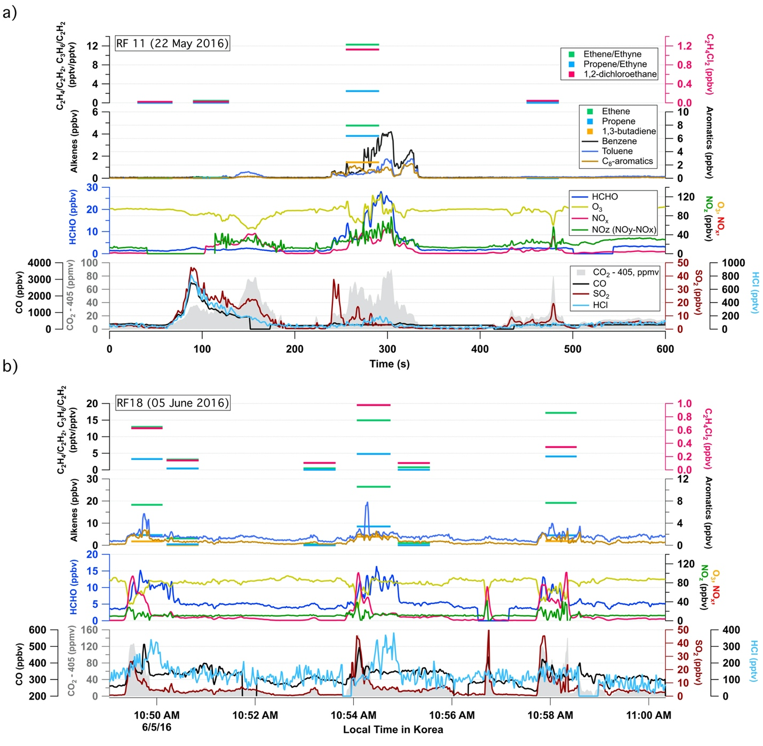
Figure S1. Time series of related species and relative abundance of alkenes to ethyne. (a) KORUS-AQ Research Flight (RF) 11 on 22 May 2016 and (b) RF18 on 5 June 2016.

Estimation of OH exposures
OH exposure, defined as the product of OH concentration and time averaged over the photochemical lifetime of an air mass, can represent a qualitative measure of photochemical processing in air masses (McKeen and Liu, 1993; Parrish et al., 2007). We estimate OH exposure based on the WAS-averaged (i.e., averaged over the WAS sampling interval) concentration ratios of hydrocarbon pairs (SE1) (de Gouw et al., 2005) and alkene to hydroxy nitrate in parent and daughter relationship (SE2) (Bertman et al., 1995). Emission ratios of ethyne and alkene (ER_{ethyne/alkene}) in SE1 are derived from the average instantaneous DPCC emissions flux of ethyne to that of alkenes in Fried et al. (2020). Hydroxy nitrate branching ratios of alkenes ($α_{i})$ in SE2 are from Teng et al. (2015).
$[OH]∆t= \frac{1}{k_{{alkene}_{i}+OH}-k_{ethyne+OH}}(ln(\frac{ethyne}{{alkene}_{i}})-ln({ER}_{ethyne/{alkene}_{i}}))$ (SE1)
$[OH]∆t = \frac{1}{k_{{alkene}_{i}+OH}-k_{{HN}_{i}+OH}}ln(1-\frac{{HN}_{i}}{{alkene}_{i}}(\frac{k_{{HN}_{i}+OH}-k_{{alkene}_{i}+OH}}{αk_{{alkene}_{i}+OH}}))$ (SE2)
Figure S2 illustrates the OH exposures estimated using equation SE1 and SE2 for P1-P3 along with the observed NO_{x} to NO_{y} ratios. In addition, the OH exposure of 2 x 10¹⁰ molecules cm⁻³ s based on the transect average OH concentration from the ATHOS measurements and plume transport time of ~2 hours at P1 was within the range of the OH exposures based on the concentration ratios.

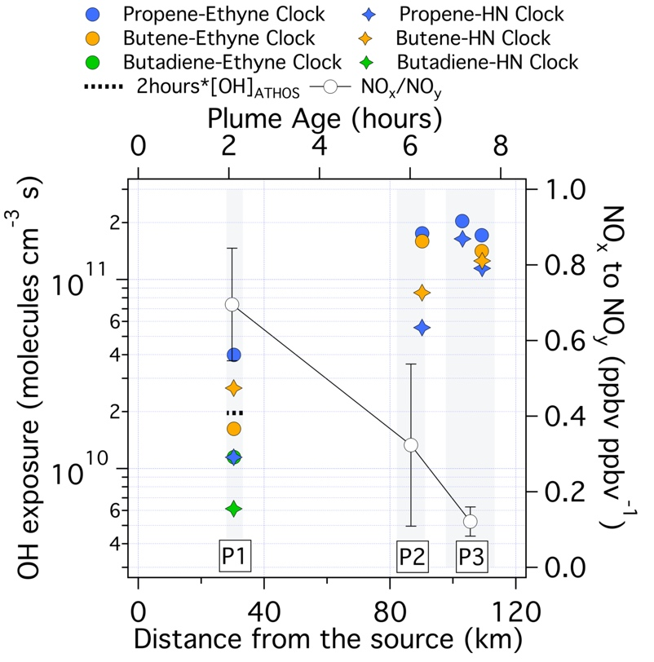

Figure S2. Estimates of the WAS-averaged OH exposures for P1, P2 and P3 (left axis). The transect averaged NO_{x} to NO_{y} ratios with vertical error bar indicating the standard deviation (right axis). The bottom and top axes illustrate distance from the DPCC and plume age based on 4 ms⁻¹ wind speed.

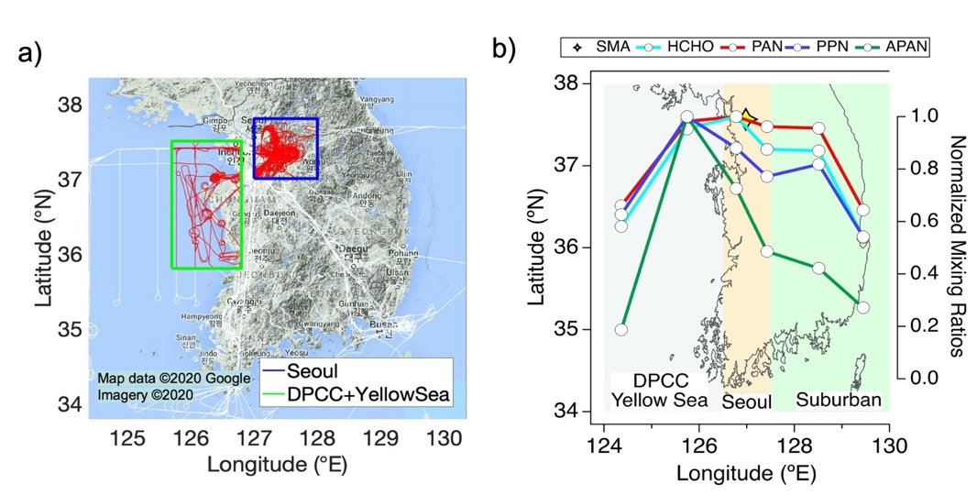
Figure S3. (a) Flight path of the DC-8 color-coded by the boundaries of Seoul (blue) and DPCC/Yellow Sea (green), which are used to filter data and produce statistics in Table S5. (b) The DC-8 data of PAN (red line), PPN (blue line), APAN (green line) and HCHO (cyan line) are averaged in 1-degree longitude bins and normalized to their peak value. The yellow marker indicates the location of the Seoul Metropolitan Area.
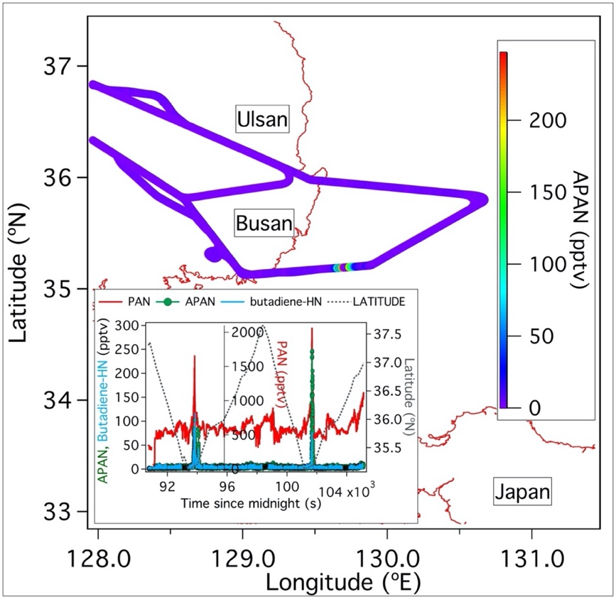

Figure S4. Enhancements of PAN, APAN and butadiene-hydroxy nitrate (HN) over the South Sea. The DC-8 flight tracks are color-coded by the mixing ratios of APAN. The inset shows time series of PAN (red line), APAN (green line with circle marker) and butadiene-HN (solid cyan lines) along with latitudes (dashed line).

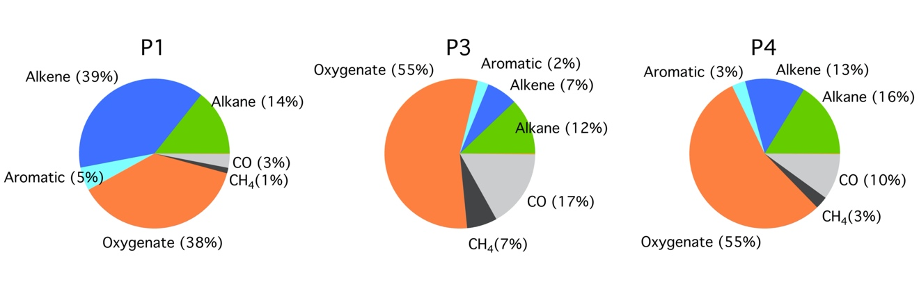

Figure S5. Fractional contributions of VOC class to P(O₃) for the plume transect P1, P3 and P4.

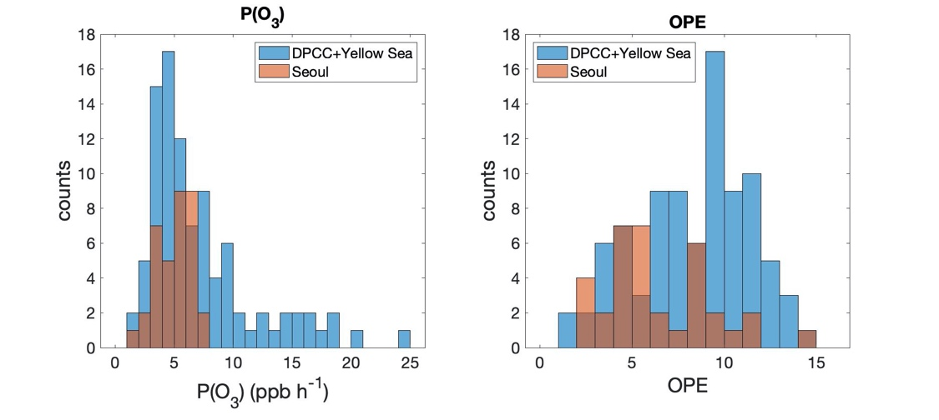

Figure S6. Histograms of instantaneous ozone production (P(O₃)) and ozone production efficiency (OPE) for all measurements when the WAS collected samples at altitude <500 m during RF11 and RF18. The calculated P(O₃) and OPE are based on the 1s-merged data and averaged to the collection interval of the WAS. P(O₃) and OPE for the DPCC and Yellow Sea (blue bars) include all measurements over the DPCC and Yellow Sea (i.e., both petrochemical and non-petrochemical samples).

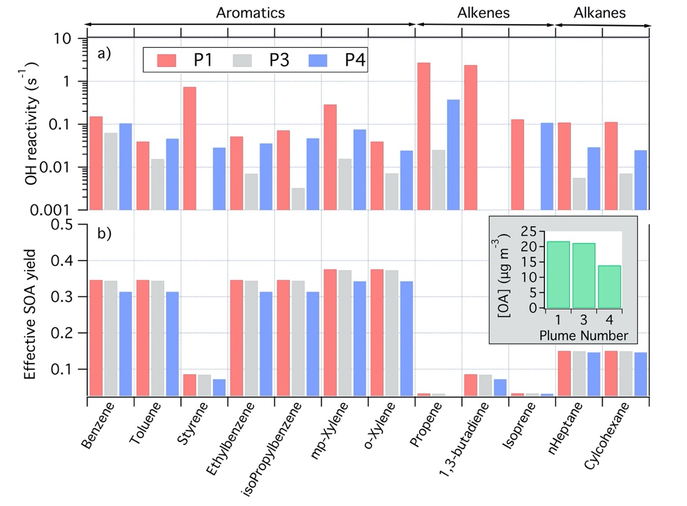

Figure S7. (a) VOC-OH reactivity and (b) effective SOA yield of the speciated VOCs. The inset in panel b shows OA mass concentrations measured by AMS within petrochemical plume transects.

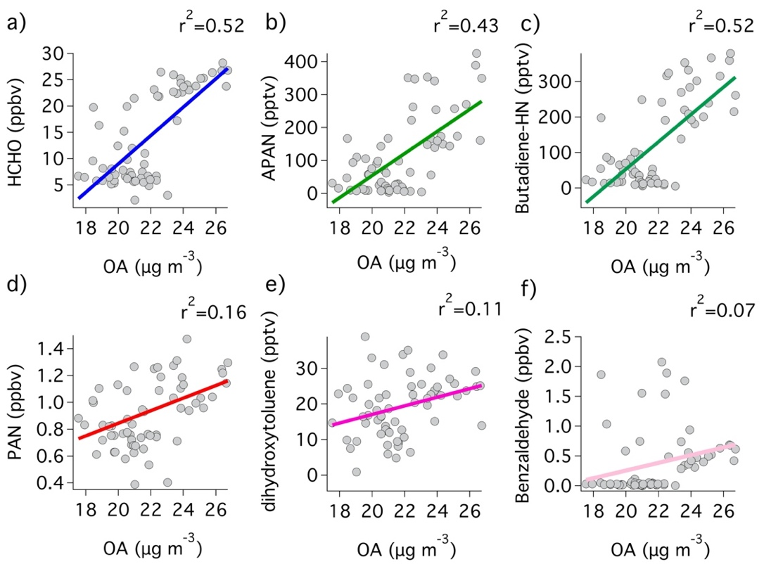

Figure S8. Correlation plots of (a) HCHO, (b) APAN, (c) butadiene-HN, (d) PAN, (e) dihydroxytoluene, and (f) benzaldehyde versus OA, where r² values are included in the upper right corner of each panel. Gray markers and solid lines in (a-f) correspond to the measurements within P1 and linear regression fit to the data, respectively.

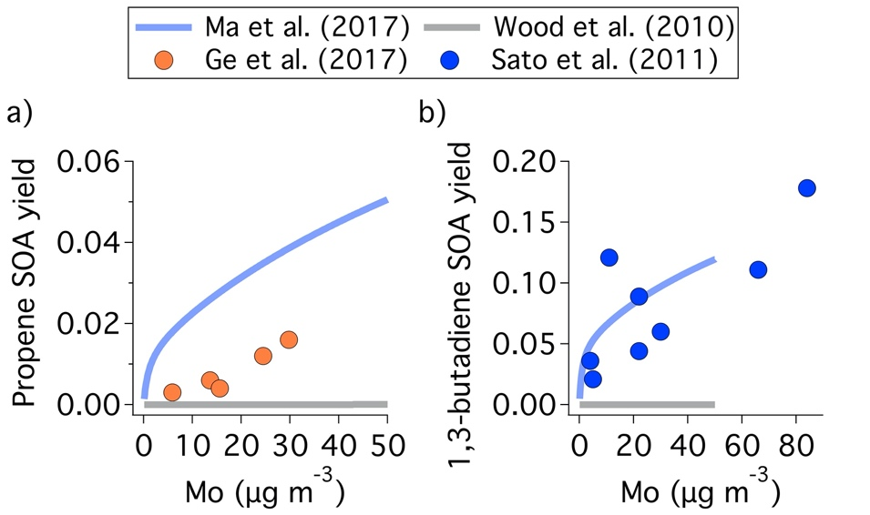

Figure S9. Comparison of SOA mass yield as a function of organic mass concentrations (M_{o}) from Ma et al. (2017) and Wood et al. (2010) to the empirical SOA yield from Ge et al. (2017) and Sato et al. (2011) for (a) propene and (b) 1,3-butadiene, respectively.

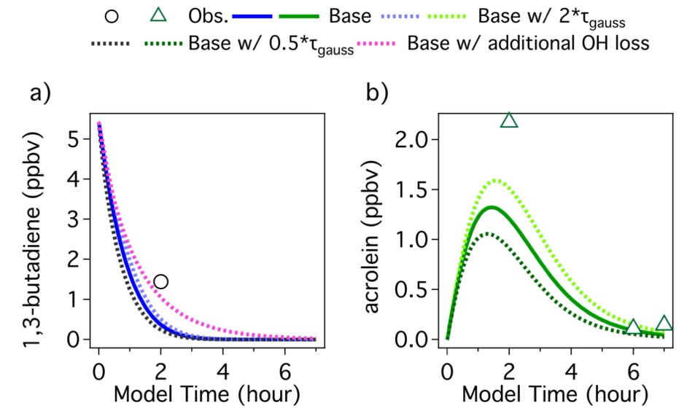

Figure S10. The model simulated results of (a) 1,3-butadiene and (b) acrolein over 7-hour model integration time. (a) The solid blue line, cyan dashed line, and black dashed line correspond to the base case, slower dilution case and faster dilution case for the modelled 1,3-butadiene, respectively. The magenta dashed line shows model sensitivity test with an additional first-order loss given to OH to reproduce the observed OH level (2.7×10⁶ molecules cm⁻³) at P1. Note that the better agreement between the model and the observations in the sensitivity test (magenta dashed line) indicates the impact of higher modelled OH in the base case on the fast decay of the modelled 1,3-butadiene. (b) The solid green line, lighter green dashed line, and darker green dashed line correspond to the base case, slower dilution case and faster dilution case for the modelled acrolein, respectively. The open markers in both (a) and (b) represent the averaged mixing ratios observed within the DPCC plume transects (P1-P3). Notably, the model agreed better with acrolein with 1,3-butadiene even with potential positive interference in acrolein signal detected by PTR-MS.

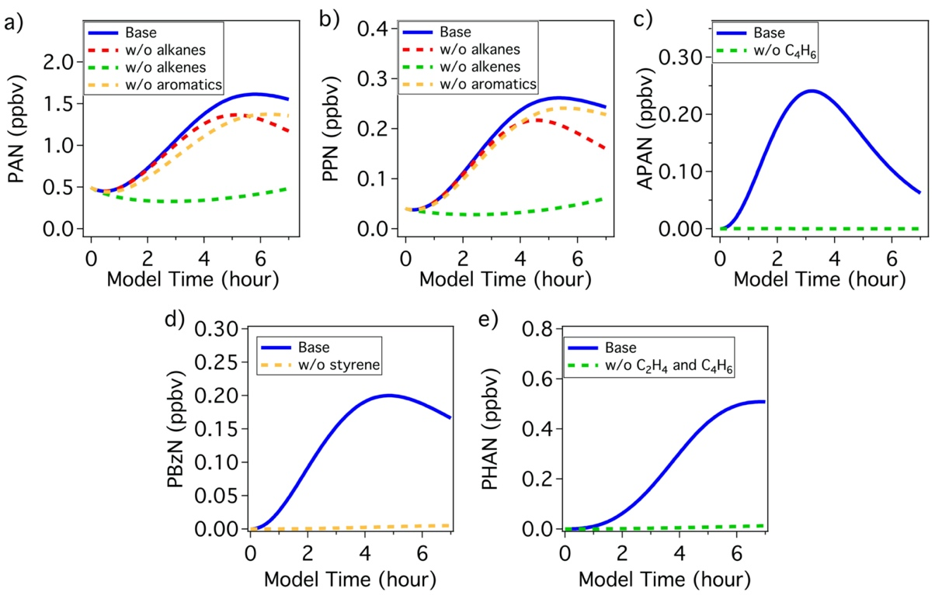

Figure S11. Zero-out model simulations by which the initial constraints of speciated and class of VOCs are set to zero. Model output of (a) PAN and (b) PPN from the base simulation (blue) and zero-out simulations without the initial constraints of alkanes (red line), alkenes (green) and orange (aromatics). Model output of (c) APAN, (d) PBzN, and (e) PHAN from base case (blue solid line) without their hydrocarbon precursors (dashed lines).

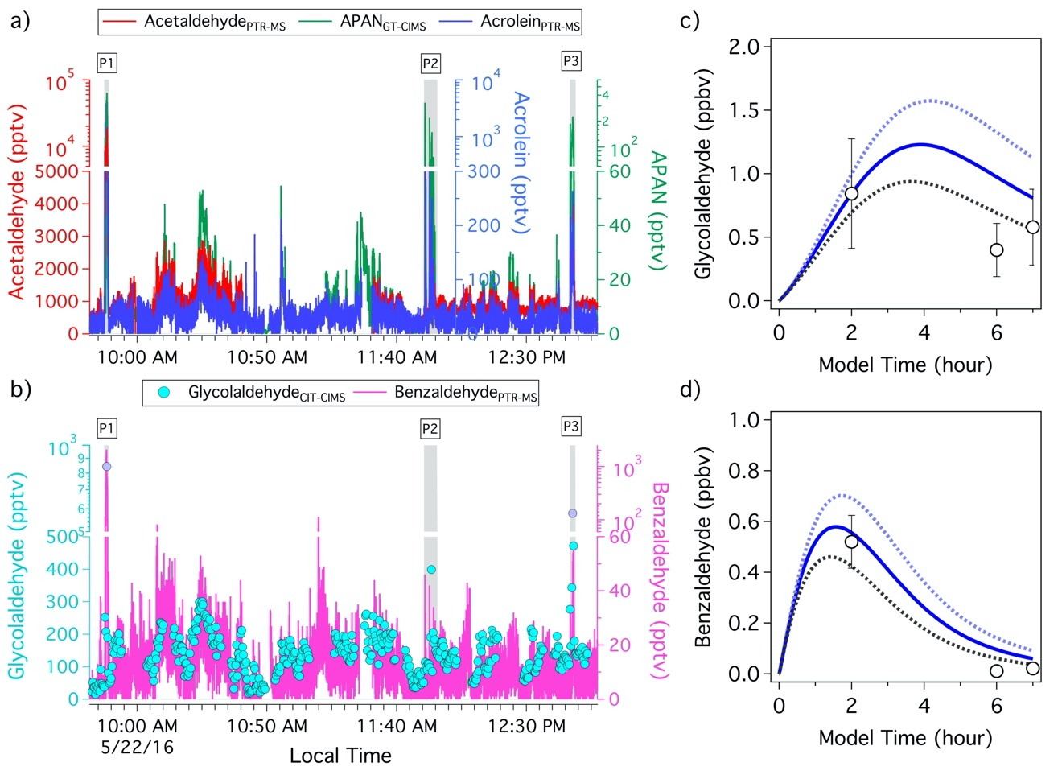

Figure S12. (a) Mixing ratios of acetaldehyde, acrolein and APAN observed over the Yellow Sea during RF11. Note that the mixing ratios of acrolein are upper limits due to potential interference on acrolein signal at 57 m/z detected by PTR-MS. (b) Mixing ratios of glycolaldehyde and benzaldehyde observed over the Yellow Sea during RF11. Gray shaded areas in panel (a) and (b) indicate the DPCC plume transects. (c) The simulated glycolaldehyde over 7-hour model integration time. The open circles represent the peak values of glycolaldehyde mixing ratios within the DPCC plumes transects (P1-P3). (d) The simulated benzaldehyde over 7-hour model integration time. The open circles represent the averaged mixing ratios of benzaldehyde within the DPCC plume transects (P1-P3). The solid blue lines, cyan dashed lines, black dashed lines, and vertical error bars in panel (c) and (d) correspond to the base case, slower dilution case, faster dilution case, and measurement uncertainties, respectively.

References
Bahreini, R, Ervens, B, Middlebrook, AM, Warneke, C, de Gouw, JA, DeCarlo, PF, Jimenez, JL, Brock, CA, Neuman, JA, Ryerson, TB, Stark, H, Atlas, EL, Brioude, J, Fried, A, Holloway, JS, Peischl, J, Ricther, D, Walega, J, Weibring, P, Wollny, AG, Fehsenfeld, FC. 2009. Organic aerosol formation in urban and industrial plumes near Houston and Dallas, Texas. Journal of Geophysical Research 114: D00F16. DOI: http://dx.doi.org/10.1029/2008JD01149.
Bertman, SB, Roberts, JM, Parrish, DD, Buhr, MP, Goldan, PD, Kuster, WC, Fehsenfeld, FC, Montzka, SA, Westberg, H. 1995. Evolution of alkyl nitrates with air mass age. Journal of Geophysical Research 100(D11): 22805–22813. DOI: http://dx.doi.org/10.1029/
95JD02030.
Blake, NJ, Blake, DR, Simpson, IJ, Meinardi, S, Swanson, AL, Lopez, JP, Katzenstein, AS, Barletta, B, Shirai, T, Atlas, E, Sachse, G. 2003. NMHCs and halocarbons in Asian continental outflow during the Transport and Chemical Evolution over the Pacific (TRACE-P) field campaign: Comparison with PEM West B. Journal of Geophysical Research 108(D20). DOI: http://dx.doi.org/10.1029/2002JD003367.
Brune, WH, Miller, DO, Thames, AB, Brosius, AL, Barletta, B, Blake, DR, Blake, NJ, Chen, G, Choi, Y, Crawford, JH, Digangi, JP, Diskin, G, Fried, A, Hall, SR, Hanisco, TF, Huey, GL, Hughes, SC, Kim, M, Meinardi, S, Montzka, DD, Pusede, SE, Schroeder, JR, Teng, A, Tanner, DJ, Ullmann, K, Walega, J, Weinheimer, A, Wisthaler, A, Wennberg, PO. 2022. Observations of atmospheric oxidation and ozone production in South Korea. Atmospheric Environment 269: 118854. DOI: http://doi.org/10.1016/j.atmosenv.2021.118854.
Crounse, JD, McKinney, KA, Kwan, AJ, Wennberg, PO. 2006. Measurement of Gas-Phase Hydroperoxide by Chemical Ionization Mass Spectrometry. Analytical Chemistry 78: 6726–6732. DOI: http://dx.doi.org/10.1021/ac0604235.
Day, DA, Wooldridge, PJ, Dillon, MB, Thornton, JA, Cohen, RC. 2002. A thermal dissociation laser-induced fluorescence instrument for in situ detection of NO₂, peroxy nitrates, alkyl nitrates, and HNO3. Journal of Geophysical Research 107(D6): ACH 4-1–ACH 4-14. DOI: http://dx.doi.org/10.1029/2001JD000779.
de Gouw, JA, Middlebrook, AM, Warneke, C, Goldan, PD, Kuster, WC, Roberts, JM, Fehsenfeld, FC, Worsnop, DR, Canagaratna, MR, Pszenny, AAP, Keene, WC, Marchewka, M, Bertman, SB, Bates, TB. 2005. Budget of organic carbon in a polluted atmosphere: Results from the New England Air Quality Study in 2002. Journal of Geophysical Research 110: D16305. DOI: http://dx.doi.org/10.1029/2004JD005623.
Faloona, IC, Tan, D, Lesher, RL, Hazen, NL, Frame, CL, Simpas, JB, Harder, H, Martinez, M, Di Carlo, P, Ren, X, Brune, WH. 2004. A laser-induced fluorescence instrument for detecting tropospheric OH and HO₂: Characteristics and calibration. Journal of Atmospheric Chemistry 47(2): 139–167. DOI: http://dx.doi.org/10.1023/B:JOCH.0000021036.53185.0e.
Fried, A, Walega, J, Weibring, P, Richter, D, Simpson, IJ, Blake, DR, Blake, NJ, Meinardi, S, Barletta, B, Hughes, SC, Crawford, JH, Diskin, G, Barrick, J, Hair, J, Fenn, M, Wisthaler, A, Mikoviny, T,Woo, J-H, Park, M, Kim, J, Min, K-E, Jeong, S, Wennberg, PO, Kim, MJ, Crounse, JD, Teng, AP, Bennett, R, Yang-Martin, M, Shook, MA, Huey, G, Tanner, D, Knote, C, Kim, JH, Park, R, Brune, W. 2020. Airborne formaldehyde and volatile organic compound measurements over the Daesan petrochemical complex on Korea’s northwest coast during the Korea-United States Air Quality study: Estimation of emission fluxes and effects on air quality. Elementa: Science of the Anthropocene 8(1): 121. DOI: http://dx.doi.org/10.1525/elementa.2020.121.
Huey, LG, Tanner, DJ, Slusher, DL, Dibb, JE, Arimoto, R, Chen, G, Davis, D, Buhr, MP, Nowak, JB, Mauldin III, RL, Eisele, FL, Kosciuch, E. 2004. CIMS measurements of HNO₃ and SO₂ at the South Pole during ISCAT 2000. Atmospheric Environment 38: 5411–5421. DOI: http://dx.doi.org/10.1016/j.atmosenv.2004.04.037.
Kenagy, HS, Romer Present, PS, Wooldridge, PJ, Nault, BA, Campuzano-Jost, P, Day, DA, Jimenez, JL, Zare, A, Pye, H.O.T, Yu, J, Song, CH, Blake, DR, Woo, JH, Kim, Y, Cohen, RC. 2021. Contribution of Organic Nitrates to Organic Aerosol over South Korea during KORUS-AQ. Environ. Science Technology 55: 16326–16338. DOI: http://dx.doi.org/10.1021/acs.est.1c05521.
Kim, S, Huey, LG, Stickel, RE, Tanner, DJ, Crawford, JH, Olson, JR, Chen, G, Brune, WH, Ren, X, Lesher, R, Wooldridge, PJ, Bertram, TH, Perring, A, Cohen, RC, Lefer, BL, Shetter, RE, Avery, M, Diskin, G, Sokolik, I. 2007. Measurement of HO2NO2 in the free troposphere during the Intercontinental Chemical Transport Experiment–North America 2004. Journal of Geophysical Research 112(D12S01). DOI: http://dx.doi.org/10.1029/2006JD007676.
Lee, L, Teng, AP, Wennberg, PO, Crounse, JD, Cohen, RC. 2014. On Rates and Mechanisms of OH and O3 Reactions with Isoprene-Derived Hydroxy Nitrates. Journal of Physical Chemistry 118: 1622–1637. DOI: http://dx.doi.org/10.1021/jp4107603.
McKeen, SA, Liu, SC. 1993. Hydrocarbon ratios and photochemical history of air masses. Geophysical Research Letters 20: 2363–2366. DOI: http://dx.doi.org/10.1029/93GL02527.
Müller, M, Mikoviny, T, Feil, S, Haidacher, S, Hanel, G, Hartungen, E, Jordan, A, Mark, L, Mutschlechner, P, Schottkowsky, R, Sulzer, P, Crawford, JH, Wisthaler, A. 2014. A compact PTR-ToF-MS instrument for airborne measurements of volatile organic compounds at high spatiotemporal resolution. Atmospheric Measurement Technique 7: 3763–3772. DOI:http://dx.doi.org/10.5194/amt-7-3763-2014.
Nault, BA, Campuzano-Jost, P, Day, DA, Schroder, JC, Anderson, B, Beyersdorf, AJ, Blake, DR, Brune, WH, Choi, Y, Corr, CA, de Gouw, JA, Dibb, J, Di- Gangi, JP, Diskin, GS, Fried, A, Huey, LG, Kim, MJ, Knote, CJ, Lamb, KD, Lee, T, Park, T, Pusede, SE, Scheuer, E, Thornhill, KL,Woo, J-H, Jimenez, JL. 2018. Secondary organic aerosol production from local emissions dominates the organic aerosol budget over Seoul, South Korea, during KORUS-AQ. Atmospheric Chemistry and Physics 18: 17769–17800. DOI: http://dx.doi.org/10.5194/acp-18- 17769-2018.
Parrish, DD, Stohl, A, Forster, C, Atlas, EL, Blake, DR, Goldan, PD, Kuster, WC, de Gouw, JA. 2007. Effects of mixing on evolution of hydrocarbon ratios in the troposphere. Journal of Geophysical Research 112(D10S34). DOI: http://dx.doi.org/10.1029/2006JD007583.
Richter, D, Weibring, P, Walega, JG, Fried, A, Spuler, SM, Taubman, MS. 2015. Compact highly sensitive multi species airborne mid-IR spectrometer. Applied Physics B 119: 119–131. DOI: http://dx.doi.org/10.1007/s00340-015-6038-8.
Sachse GW, Hill GF, Wade LO, Perry MG. 1987. Fast‐response, high‐precision carbon monoxide sensor using a tunable diode laser absorption technique. Journal of Geophysical Research: Atmospheres 92(D2): 2071–2081.
Sachse GW, Jr JEC, Hill GF, Wade LO, Burney LG, Ritter JA. 1991. Airborne tunable diode laser sensor for high-precision concentration and flux measurements of carbon monoxide and methane. Measurement of Atmospheric Gases 1433: 157–166. International Society for Optics and Photonics. doi: 10.1117/12.46162
Shetter, RE, Muller, M. 1999. Photolysis frequency measurements using actinic flux spectroradiometry during the PEM-Tropics mission: Instrumentation description and some results. Journal of Geophysical Research http://dx.doi.org/10.1029/98JD01381.
Simpson, IJ, Blake, DR, Blake, NJ, Meinardi, S, Barletta, B, Hughes, SC, Fleming, LT, Crawford, JH, Diskin, GS, Emmons, LK, Fried, A, Guo, H, Peterson, DA, Wisthaler, A,Woo, J-H, Barre, J, Gaubert, B, Kim, J, Kim, MJ, Kim, Y, Knote, C, Mikoviny, T, Pusede, SE, Schroeder, JR, Wang, Y, Wennberg, PO, Zeng, L. 2020. Characterization, sources and reactivity of volatile organic compounds (VOCs) in Seoul and surrounding regions during KORUS-AQ. Elementa: Science of the Anthropocene 8(1): 37. DOI: http://dx.doi.org/10.1525/elementa.434.
Slusher, DL, Huey, LG, Tanner, DJ. 2004. A thermal dissociation-chemical ionization mass spectrometry (TD-CIMS) technique for the simultaneous measurements of peroxyacyl nitrates and dinitrogen pentoxide. Journal of Geophysical Research 109: D19315. DOI: http://dx.doi.org/10.1029/2004JD004670.
Teng, AP, Crounse, JD, Lee, L, St. Clair, JM, Cohen, RC, Wennberg, PO. 2015. Hydroxy nitrate production in the OH-initiated oxidation of alkenes. Atmospheric Chemistry and Physics 15: 4297–4316. DOI: http://dx.doi.org/10.5194/acp-15-4297-2015.
Vay, SA, Anderson, BE, Conway, TJ, Sachse, G, Collins, JE, Blake, DR, Westberg, DJ. 1999. Airborne observations of the tropospheric CO₂ distribution and its controlling factors over the South Pacific Basin. Journal of Geophysical Research 104: 5663–5676. DOI: http://dx.doi.org/10.1029/98JD01420.
Weinheimer, AJ, Walega, JG, Ridley, BA, Gary, BL, Blake, DR, Blake, NJ, Rowland, FS, Sachse, GW, Anderson, BE, Collins, JE. 1994. Meridional distributions of NOx, NOy, and other species in the lower stratosphere and upper troposphere during AASE II. Geophysical Research Letter 21: 2583–2586. DOI: http://dx.doi.org/10.1029/94GL01897.

